Progress Report 4th week
souja450
Introduction:
In the development of mobile networks, efficient and seamless mobility management is important to maintaining service continuity, especially during the transition from 5G to 6G. The Layer 1/Layer 2 Triggered Mobility (LTM) method introduced in 3GPP Release 18 offers a a set of significant advancements in this domain. The traditional handover mechanisms in cellular networks depend on both Layer 3 (L3) signaling and measurements which can result in higher signaling overhead and latency. Lower layers L1/L2 measurements are used by LTM to resolve the problems and to enable faster and more reliable handover[1].
LTM procedure:
This is the LTM procedure:
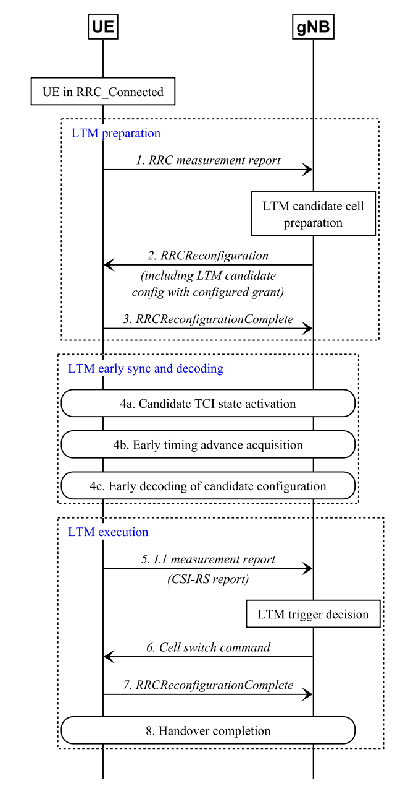
Figure 1: LTM Handover Procedure

The LTM procedure moves through these steps:
- LTM Preparation: The User Equipment UE sends the RRC measurement report to the gNB base station. The gNB prepares a set of LTM candidate cells for handover. The gNB configures the UE with candidate configurations using RRC configurations. The UE acknowledges with RRCReconfigurationComplete.
- LTM synchronization and decoding:
The UE activates a Transmission Configuration Indicator (TCI) state for the candidate cell. The Early Timing Advance (TA) acquisition ensures that the uplink alignment is before the handover. The early decoding of the candidate configuration minimizes delay.
- LTM Execution
The UE sends an L1 measurement report (CSI-RS report) to the gNB. Then, The gNB makes an LTM trigger decision based on the real-time conditions. The gNB issues a cell switch command to the User Equipment UE. The UE confirms handover completion via RRCReconfigurationComplete message. The handover is finalized with minimal service interruption.
Benefits of LTM Handover
- Reduced Interruption Time: The Pre-synchronization lowers service disruption to 20-30 milliseconds.
- Improved Mobility Robustness: L1-based triggers enable faster response to degrading link conditions.
- Lower Signaling Overhead: MAC-based signaling reduces reliance on higher-layer procedures to enhance network efficiency.
- Better Performance in High-Mobility Scenarios: LTM is particularly beneficial for fast-moving UEs, such as in vehicular and railway environments.

Challenges and Considerations
- Increased Handover Frequency: More frequent cell transitions may lead to ping-pong effects.
- Interference Management: LTM requires careful coordination to minimize inter-cell interference.
- Signaling Load on MAC Layer: While LTM reduces RRC signaling, it increases demand on MAC processing.
- Standardization and Future Enhancements: Ongoing 3GPP work aims to refine LTM procedures and expand support for inter-gNB mobility.

Redhawk Simulation:
The redhawk is installed and runned correctly. It is possible to trigger if there is handover.

References:

[1] B. a. G. S. a. G. M. a. S. J. a. K. A. a. T. R. a. B. A. a. S. P. a. M. C. Khodapanah, "On L1/L2-Triggered Mobility in 3GPP Release 18 and Beyond," IEEE Access, 2024.

