Progress report second week
souja450

- Cell search:
It is a procedure by User Equipment (UE) such as smartphone or an IoT device to detect and establish synchronization with a cell in a mobile network. It is required to establish an initial connection or handover to the network.

- The SS Block:
The synchronization signal is periodically transmitted on the downlink from each cell. The SS block is transmitted periodically with a time period between 5 up to 160ms. However, in the case of devices doing initial cell search, the SS block is repeated at least once every 20ms. This will let the device that is looking for an SS block in the frequency domain to know how long it must stay on each frequency before concluding that there is PSS/SSS present. Then, it should move on to the next frequency within the synchronization raster. While doing initial cell search the SS block is repeated once every 20 ms. There are a set of scenarios where it is good to use shorter or longer SS-block periodicity:
- Shorter SS-block periodicity: It is used to enable fast cell search for devices in connected mode.
- Longer SS-block periodicity: It is used to enhance network energy performance.
The SS-block time index identifies the SS-block location through a specific SS burst set. Each block has a well-defined position within an SS burst which is included within the first and second half of a 5ms frame.
Using the SS-block time index and half-fame bit the device can determine the frame boundary.

The goal of the SS Block is to enable devices finding a cell while entering a system. A synchronization signal that consists of two parts:
- PSS (The Primary Synchronization Signal):
It is the first signal that the device logging into the system will look for. During that phase, the device has no knowledge of the system timing. In LTE, the UE is trying to find when PSS is powered on and turned to a specific frequency to camp on. If the process of detecting the PSS was successful. it starts to decode the entire SSB.
It is transmitted in the first OFDM of the SS block and occupies 127 subcarriers as the PSS. There are eight and nine empty subcarriers on each side of the SS. Along with the Physical Broadcast Channel (PBCH) and SSS, it is referred to as a Synchronization Signal Block (SSB).

- SSS (The Secondary Synchronization Signal):
It is a physical layer signal used for radio frame synchronization. Furthermore, It is transmitted in the third OFDM symbol of the SS block and occupies the same set of subcarriers as the PSS. There are eight and nine empty subcarriers on each side of the SSS. Along with the Physical Broadcast Channel (PBCH) and PSS, it is referred to as a Synchronization Signal Block (SSB).

When a device just detected a PSS. It gets the transmission timing of the SSS. By detecting the SSS, the device can determine the PCI of the detected cell. There are about 1008 different PCIs. The set of candidate PCIs is reduced by a factor of 3 to enable large number of SSS sequences. The basic structure of the SSS is the same as that of the PSS and it consists of 127 subcarriers to which SSS sequence is applied.

- The PBCH:
It is a physical channel on which explicit channel-coded information can be transmitted. It carries the MIB (Master Information Block) which has a small amount of data that the device needs to get the remaining system information sent to all devices on the network.

- The PBCH is transmitted within the second and fourth OFDM symbols of the SS block. Furthermore, PBCH transmission uses 48 subcarriers on each side of the SS block. Overall, the total number of resource elements used for PBCH transmission per SS block is about 576. This includes resource elements for the PBCH itself as well the resource elements for the demodulation reference signals (DMRS) needed.

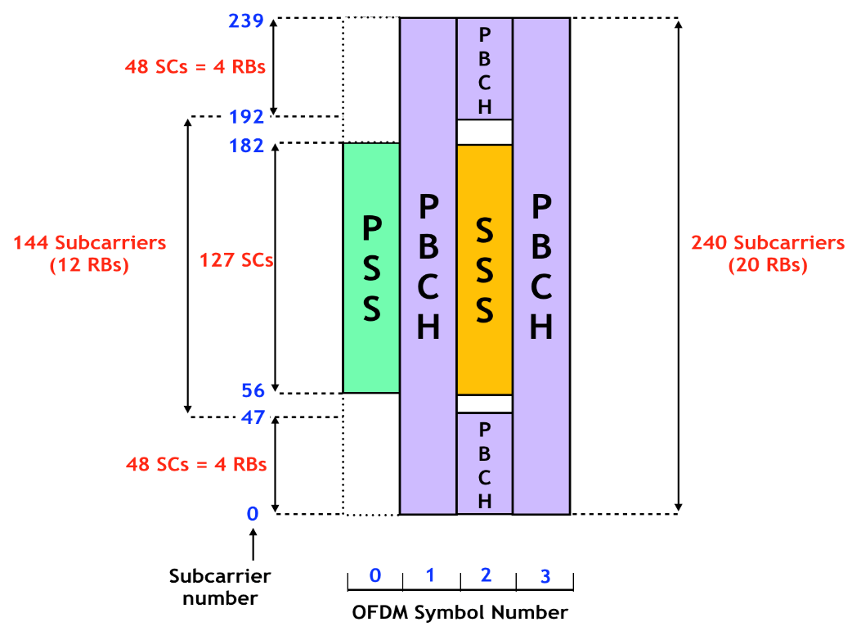
Figure 1: Transmission of the SSB

The figure above illustrates the transmission of the SSB carrying PSS, SSS and PBCH,

- Providing remaining system information:

The system information is a name that refers to all common information that the device acquires to properly operate within the network. They are carried with different system information blocks (SIB) in which each block consists of different types of system information.

For LTE, all system information is sent to all the devices over the entire cell in a specific time. This shows that that it is transmitted even though no device exists within the cell.

For NR, another approach has been taken in consideration where all the remaining system information (beyond the very limited information carried within the MIB) is divided into two parts:

SIB1: It is referred as the remaining system information (RMSI) which consists of the system information in which the device acquires to get an overall idea about it before accessing the system. It is broadcast periodically over the entire cell area. It is responsible to provide the information the device acquires to carry initial random access.

SIB: The remaining SIB are periodically broadcast the same as SIB1. However, they can also be transmitted on demand only when requested by a connected device. Thus improves the network energy performance.

- Random Access:
As part of random-access procedure when the device found a cell it can access it directly. NR moves by a set of steps for random-access procedure consisting of:
- Device transmission of a preamble: it is referred as the Physical Random-Access Channel (PRACH) transmission.
- Network transmission of a Random-Access Response:
It indicates that the reception of the preamble and it provides a time-alignment command which adjusts the transmission timing of the device based on the received preamble timing.
- The device and network exchange messages: (uplink “Message 3” and the subsequent downlink “Message 4”) with the goal to resolve the potential collisions due to simultaneous transmissions of the same preamble from multiple devices within the cell. Once there is a successful Message 4, it transfers the device to a connected state. When the random-access procedure is completed then the device is in a connected state and the communication of the network device can resume using the normal transmission.

