Progress Report Third week
souja450
5G needs a flexible layer 1(Physical layer) and Layer 2(Data link layer) to handle diverse use cases (high-speed streaming, low-latency applications) by dynamically adapting resources, optimizing performance, reducing latency, and managing interference across different network conditions and requirements.
The 5G downlink physical channels are pathways used to transmit data from the base station (gNodeB) to user devices. They are mapped to physical resources like time slots and frequency blocks in the physical layer. Key downlink physical channels include:
- Physical Downlink Shared Channel (PDSCH): It is carries user data, control plane signaling (e.g., RRC Messages) and remaining system information such as paging and messages needed for communication. It is the main channel for transferring user data and control plane information to devices. It uses dynamic resource allocation and adapts to network conditions such as signal quality.
- Physical Downlink Control Channel (PDCCH): It delivers control information, such as scheduling and resource allocation. It tells the devices how to receive and decode the PDSCH indicating where and how data is sent. It manages communication timing and resource assignments. Basically, it delivers information on the scheduling and decoding of the PDSCH channel.
- Physical Broadcast Channel (PBCH): It transmits system information needed for devices to access the network such as MIB (Master Information Block) for the initial access to the network. The devices use the PBCH to learn the essential parameters needed to connect to the network such as synchronization and frequency information.
- Physical Downlink Synchronization Signals (PSS/SSS): It helps devices synchronize in time and frequency with the network. The Primary Synchronization Signal (PSS) allows to time synchronization while the Secondary Synchronization Signal (SSS) provides additional cell identification and frame timing information.
- Demodulation Reference Signal (DMRS):

It is placed at the beginning of the slot. It is an estimate channel used for demodulation. It helps the base station demodulate and decode uplink signals (PUSCH or PUCCH) sent by the User Equipment. DMRS is transmitted alongside data and serves as a reference for the base station to estimate the channel and correct signal impairments (e.g., phase shift and noise).
- Phase-Tracking Reference Signal (PTRS)
It is used to estimate the phase noise of the local oscillator at both receiver and transmitter. It enables the suppression of the phase noise and common phase error especially at high carrier frequencies.

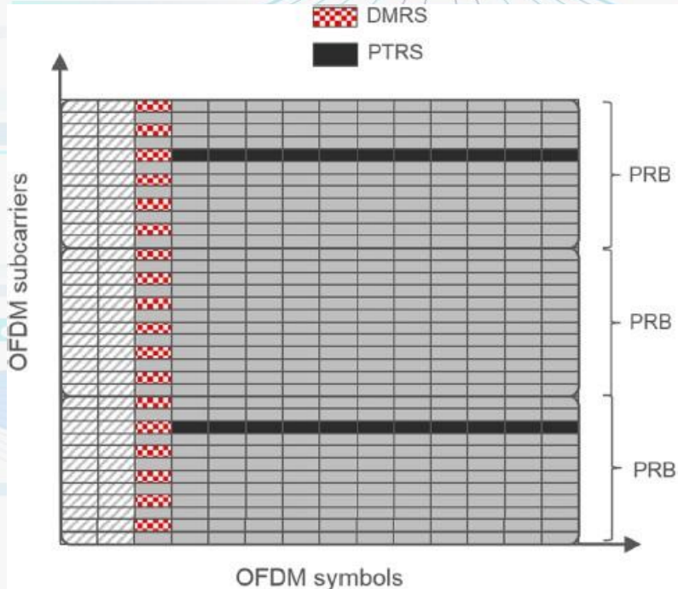
Figure 1:Phase-tracking reference signal
The figure illustrates the phase-tracking reference signal DMRS and PTRS
- Channel State Information Reference (CSI-RS)
It is used to enable the UE to assess downlink channel conditions and to provide feedback for optimal transmission adjustments.

In 5G NR, the uplink physical channels are used to transmit data, control information, and synchronization signals from the user equipment (UE) to the base station (gNodeB). There are the uplink physical channels:
- Physical Uplink Shared Channel (PUSCH):
It is responsible for carrying user data (uploads) and uplink signaling messages. It is the main channel for user-plane data, with dynamic resource allocation controlled by the base station. It supports modulation schemes such as QPSK, QAM, RRC messages and MIMO.
- Physical Uplink Control Channel (PUCCH):
It carries control information such as HARQ feedback, downlink CSI (Channel State Information) and uplink scheduling requests. It ensures that the base station receives necessary feedback for efficient scheduling and retransmissions.
- Physical Random-Access Channel (PRACH):
It is used for random-access procedures when a device initiates a communication or re-establishes a connection setup or performs handover. This channel carries physical layer preamble PRACH which allows the UE to request network access or re-sync after idle mode. This is crucial for initial access and handovers.

- Sounding Reference Signal (SRS):

SRS provides uplink channel quality information to the base station for scheduling and beamforming. It is transmitted periodically to help the base station assess the uplink channel conditions such as path loss, interference, enabling dynamic resource allocation and optimized transmission.

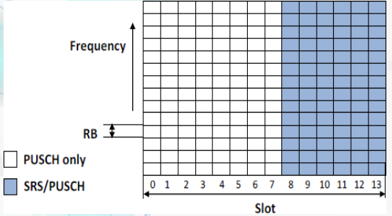
Figure 2: Sounding reference signal (SRS)
The figure above illustrates the Sounding reference signal (SRS)
- Demodulation Reference Signal (DMRS):
It is used by the receiver to produce channel estimations regarding the demodulation of the associated physical channel.
In 5G NR, uplink signals are used to assist the base station (gNodeB) in accurately receiving and processing uplink transmissions. These signals provide synchronization, reference information, and feedback for channel estimation and resource management. These signals are used by the physical layer.
Radio access mobility in cellular networks:
The UE measures signal strength and quality from the serving and neighboring base stations. If conditions are met, it sends a Measurement Report (MR) to the serving base station (S-BS). The S-BS prepares the handover by requesting resources from the target base station (T-BS). Once resources are allocated, the S-BS sends a handover command (HOcmd) to the UE. The UE then synchronizes with the target cell, performs a random access procedure, and confirms access by sending a handover confirmation (HOconf). The User Data Gateway (UDGW) switches the data path to the T-BS, and the S-BS releases resources, completing the handover. This process ensures seamless mobility and service continuity for the UE.
The Idle mode mobility keeps the UE reachable by paging and cell reselection without the need for active data transmission. The connected mode mobility relies on handover procedures to maintain continuous communication during data transfer. Both modes can optimize mobility for different connection states.
In cellular networks, mobility behavior differs based on whether the UE is in idle or connected mode. In idle mode, the UE is not transmitting data but the data needs to remain reachable. The network uses paging where short broadcast messages notify the UE of incoming service requests. The UE monitors the paging channel and performs cell reselection to stay connected to the best available cell. This process is lightweight and energy-efficient. However, in connected mode, the UE is actively transferring data and requires seamless connectivity. The network manages this through handover procedures, where the UE continuously reports signal strength to ensure smooth transitions between cells without data loss or interruption.
The key difference is that idle mode focuses on maintaining reachability with minimal signaling, while connected mode prioritizes uninterrupted data transmission through real-time handover management. Understanding this distinction is essential for optimizing network performance and user experience in various mobility scenarios.
- Inter-frequency handover: It involves operating using different frequency bands. As a result, it requires re-tuning which may introduce delays.
- Intra-frequency handover: It occurs within the same frequency band and faces challenges related to interference management since neighboring cells may cause overlapping signals while operating on the same frequency band.

Intra-Frequency Handover:
- It occurs when the serving and target base stations operate on the same carrier frequency.
- No frequency re-tuning is required which will make the handover process faster.
- A major challenge here is the interference management since overlapping signals from neighboring cells on the same frequency can affect the performance.
- It is common in dense urban deployments where multiple small cells use the same frequency for capacity optimization.

Inter-Frequency Handover:
- It occurs when the serving and target base stations operate on different frequency bands.
- The UE must re-tune to the target frequency which can cause delays.
- The network provides measurement gaps for the UE to measure and report target cell conditions.
- It is common in heterogeneous networks (HetNets), where macro cells use low-frequency bands for wide coverage, and small cells use high-frequency bands for local capacity enhancement.
UE Performance:
The UE performs signal strength and quality measurements using reference signals sent by the serving and neighboring base stations. These measurements help the network decide when to trigger handovers or optimize connectivity. Measurement reports provide real-time feedback for maintaining seamless communication, resource management, and interference control.
Handover (HO) performance metrics helps to evaluate the effectiveness of the handover process in maintaining seamless connectivity. The key metrics are:
- Handover Failure (HOF) Rate: It measures the percentage of failed handovers due to issues like poor signal conditions or synchronization errors.
- Handover Frequency: It indicates how often handovers occur increases with higher user speed and smaller cell sizes. There is a tradeoff between triggering early handovers and increasing handover frequency.
- Ping-Pong Rate: It measures how often a UE switches between two cells within a short period, indicating instability and inefficiency.
- Handover Energy Consumption: It assesses how much energy the UE uses during handover, important for energy-efficient operation.
- Handover Success Rate: The proportion of successfully completed handovers is crucial for ensuring stable connections.
- Data Latency: The delay between the last data packet received from the serving base station and the first packet from the target base station while affecting real-time services.
- Handover Interruption Time: The time during which the UE cannot exchange data with any base station, impacting service continuity.

Handover Management in NR:
5G NR introduces features like high-frequency operation, spectrum flexibility, forward compatibility, and an ultra-lean design to optimize performance and scalability. These features influence handover management by reducing signaling overhead, improving energy efficiency, and supporting future services. The dynamic use of frequencies and minimal always-on transmissions allows for better data rates and more efficient resource allocation.
Handover management in NR faces some challenges like frequent handovers, increased measurement demands, and higher signaling overhead due to smaller cells and high-frequency operations. The NG-RAN consists of gNBs (for NR) and ng-eNBs (for LTE), interconnected via the Xn and NG interfaces. These interfaces enable seamless handover between nodes and core network components, such as the AMF (for mobility management) and UPF (for data transfer).
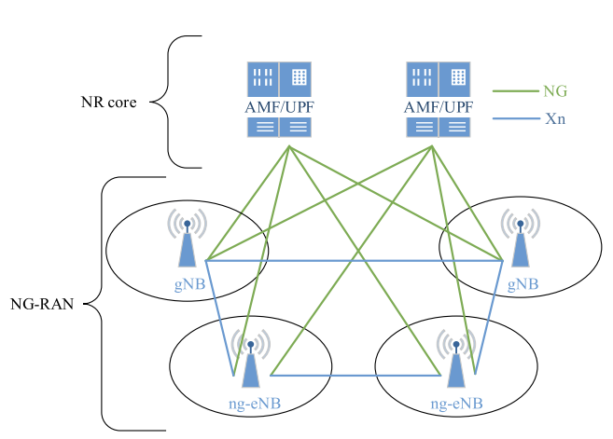
Figure 3: Overall Architecture of NR
The figure aboves describes the overall architecture of NR.

In active mode mobility, reference signals help the UE maintain a stable connection by continuously measuring signal quality and synchronization. These signals ensure accurate handover and resource management, even in challenging environments like small cells or mmWave frequencies.
- Synchronization Signals (PSS/SSS):
It allows the UE to synchronize with serving and neighboring cells, enabling handovers.
- CSI-RS (Channel State Information Reference Signal):
It helps the UE assess downlink channel quality and manage beam selection in high-frequency operations.
- DMRS (Demodulation Reference Signal):
It supports the reliable decoding of data during transmissions, crucial for uninterrupted data flow during handovers.
- SRS (Sounding Reference Signal):
It provides uplink channel quality feedback to the base station, optimizing uplink resource allocation and beamforming.
Key Metrics:
RSRP, RSRQ, and SINR are used to evaluate signal strength, quality, and interference levels, guiding handover and mobility decisions.

Time Domain Details
The SSB occupies 4 OFDM symbols in the time domain.
Burst Set:
SSBs are transmitted in a periodic pattern called an SSB burst set, typically within a 5 ms or 20 ms window.
Number of SSBs per Burst:
- Low-frequency bands (FR1): Up to 4 SSBs per burst.
- High-frequency bands (FR2): Up to 64 SSBs, to support beamforming.
SSB Periodicity Options:
It is defined by the network, with common values of 5 ms, 10 ms, 20 ms, 40 ms, 80 ms, or 160 ms.

Frequency Domain Details
- The SSB occupies 240 subcarriers (20 resource blocks) in the frequency domain.
- The exact frequency position of the SSB depends on the carrier frequency and bandwidth configuration.
- For mmWave (FR2), multiple SSBs are transmitted in different beams, with each beam having a separate SSB.

Components of the SSB
- Primary Synchronization Signal (PSS):
Provides initial synchronization and helps the UE obtain the cell identity.
- Secondary Synchronization Signal (SSS):
Provides frame timing and additional cell identity information.
- Physical Broadcast Channel (PBCH):
Contains essential system information (Master Information Block - MIB), required for the UE to establish communication with the network.

Beam-Based SSB Transmission (High-Frequency Bands)
- In high-frequency (FR2) bands, directional beams are used to overcome propagation challenges.
- Each SSB is transmitted on a separate beam, and the UE scans multiple beams to find the best one during initial access.

SSB Index and Reference

The UE uses the SSB index to identify which SSB (or beam) it is connected to. The index plays an important role in beam management and handover procedures.
- Frequency-Based Types:
FR1 (Sub-6 GHz):
It operates on a lower frequencies band(410 MHz to 7.125 GHz). It supports up to 4 SSBs per burst with wide coverage, common for macro deployments.
FR2 (mmWave):
It operates in high frequencies (24.25 GHz to 52.6 GHz). It supports up to 64 SSBs per burst, relying on multiple beams due to limited propagation.
- Transmission Types:
Single Beam SSB:
Used in low-frequency bands (FR1) where wide-area coverage can be achieved with fewer beams.
Multiple Beam SSB:
It is used in high-frequency bands (FR2) to overcome short-range and line-of-sight (LOS) issues, requiring beamforming and scanning for optimal connectivity.
Scenario-Based Types:
- Macro Cell: There are fewer beams, wide-area coverage such as rural and suburban areas.
- Dense Urban: There are many beams for high traffic and obstacle handling.
- Indoor: There are Beams optimized for short-range and high-frequency environments.
Components in All SSB Types:
- PSS: there is an initial synchronization for the UE.
- SSS: It provides frame timing and cell identity.
- PBCH: It transmits the Master Information Block (MIB) for network access.
SSB types vary by frequency range, beam configuration, and deployment scenario to optimize synchronization and initial access. The low frequencies support wide coverage with fewer beams, while high frequencies require multiple beams and beamforming for reliable connectivity in dense environments.
CSI-RS is a reference signal sent by the base station that helps the UE measure the channel quality for mobility-related decisions like handovers and resource allocation.
The CSI-RS supports mobility when the UE(User Equipment) uses CSI-RS to measure and report:
- Signal Strength (RSRP)
- Signal Quality (RSRQ)
- Interference and Noise (SINR)
These measurements help to decide when and where to perform handovers to neighboring cells.
The role of CSI-RS in handover is to help the network trigger handover events (such as Event A3 when a neighbor cell's signal becomes better than the serving cell).
The UE sends Measurement Reports (MR) based on CSI-RS measurements by allowing the network to make handover descisions.
Intra- and Inter-Frequency Mobility:
- Intra-Frequency Mobility:
CSI-RS helps the UE evaluate cells on the same frequency, where interference management is critical.
- Inter-Frequency Mobility:
The UE measures CSI-RS from cells on different frequencies, requiring measurement gaps to avoid interruptions.

Benefits:
- It ensures seamless handovers by providing accurate channel information.
- It improves beam selection in high-frequency scenarios.
- It helps the network manage resources and reduce interference effectively.

Challenges:
- Frequent CSI-RS measurements may increase signaling overhead and battery consumption in dense or fast-moving environments.
The UE performs handover with both serving and target base stations, using reference signals like SS-blocks, CSI-RS, and DMRS to evaluate signal quality and synchronize with the target cell. The network, through interfaces like Xn and core components like AMF, manages resource allocation, signaling, and data path switching to ensure seamless mobility. During execution, the random access procedure finalizes the UE’s connection to the target base station..
Content of handover command:
- Target Cell Information:
It includes the cell ID and timing information to help the UE locate and synchronize with the target cell. This ensures smooth mobility as the UE transitions between cells during handover.
- Measurement and Random Access Configuration:
The UE is provided with random access preamble and resource allocation details. This helps the UE establish a quick connection with the target base station without delays.
- Timing Instructions:
It specifies when the UE should disconnect from the serving cell and begin accessing the target cell. There is a proper timing which minimizes handover interruption time, crucial for maintaining active data sessions.

- Beam Information (For High-Frequency/Beamforming Scenarios):
In mmWave or beam-based networks, the UE receives beam ID and alignment parameters. This supports beam management during handover, allowing the UE to maintain a strong connection while moving.

- QoS and Mobility Context:
It Ensures that radio bearer configurations and QoS requirements are transferred to the target cell while preserving service quality. This allows for uninterrupted services such as voice calls and video streaming during mobility events.
In 5G, RRC messages are delivered between User Equipment (UE) and the gNB (gNodeB) using the SRBs (Signal Radio Bearers) such as SRB1 and SRB2 using RLC, PDCP, MAC, and PHY layers. The messages are transmitted using:
- Downlink (gNB->UE) via PDCCH/PDSCH
- Uplink (UE->gNB) via PUCCH/PUSCH
- Reliable delivery is ensured using RLC Acknowledged Mode (AM) for critical signaling.
These messages enable mobility procedures.
L3 Mobility:

Layer 3 handover:
- All handover signaling is taking place via the RRC messages which are control plane messages between the network and UE.
- They are transmitted via the higher layers not the lower layers. Lower layer means MAC layer and physical layer.
RRC connected mobility: the UE is not in connected mode with gnodeB.

- Uplink synchronization: When the UE is in uplink synchronization with the target cell
- 1)The source cell is sending this handover request to the target cell.
- 2)The target cell is acknowledging the handover request.
- 3) The RRC handover command is transmitted.
- 4) Once the handover command is received , UE performs uplink, downlink. Then, it sends RCD configuration to the target cell gNB indicating that the handover procedure is complete.
- RRC messages are between the network and UE or UE to network. They are not between network nodes.
- The handover decision is performed by the source cell when gNB receives the RRC measurement report
- Layered model in 5G NR:
There is PDCP, RLC, MAC and physical layer. There are common between user plane and control plane.
The PDCP is established and sometimes no upon layer 3 handover. This depends on the RLC used acknowledged or unacknowledged RLC. If it is the acknowledged RLC or AM RLC, the PDCP is not established because the pdcp has to keep track of the sequence number of the packets in that case. There can be possible security key chain and RLC is always reestablished during the handover and the MAC layer is always reset.

NR-SSS is used for SSB RSRP computation. The UE measure the Reference Signal Received Power (RSRP) from the SSB which impacts the signal quality of SSS and PSS. RSRP is used by the UE to evaluate the strength of signals from neighboring cells. L3-triggered mobility refers to the process where the gNB uses RSRP measurements to trigger cell reselection in idle mode or handover in connected mode based on a set of defined threshold. The NR-SSS enables UE(User Equipment) to calculate RSRP which helps to ensure efficient mobility management by choosing the best cell for the UE’s connection. Those are the steps for the L3 handover procedure:
- The handover is triggered based on the quality of signal measurements such as RSRP(Reference Signal Received Power) and RSRQ(Reference Signal Received Quality).
- There is coordination between the source and target gNB with the help of the AMF.
- The UE is receiving a handover command to connect to the new gNB and there is a possibility of forwarding data packets to ensure reliable service.
- When the UE connects to the target gNB, the source gNB confirms completion and releases its resources.
- The context transfer ensures that the UE data sessions continue seamlessly in the new cell.
- In the final step, The AMF acknowledges that the handover is complete.

Reference signals for RRM:
The UE is measuring based on reference signals. In connected mode, it is measuring the synchronization signal block and the channel estate information reference signal. The UE The UE is also searching the neighbor cells.

Measurement model.
The UE is measuring on the neighboring cell SSB and CSIRS reference signals to send the measurement report for layer 3 handover. The UE is performing measurement on each beam. They pass through Layer 1 filter. Then, the UE for each cell, the UE perform beam selection. It is configured by the network to define cell quality. Based on the selected beams. The UE creates the cell quality. Then it passes by another L3 coefficient filter. The UE uses the average of the beam in bema selection to define the cell quality. Then, the cell quality passes by another filter.
RRM(Radio Resource Management): It is something that tells the UI how to measure on the SSB of the neighbor cell. Beam is either SSB or CSI-RS. Beam is a direction in the space.
If reporting configuration is sent. The source cell will initiate handover to the target cell basically.
Measurement object provides information on neighbor cell SSB or CSI-RS.

Redhawk:
We proceed with the installation of Redhawk.

