Summary Report on LTM Handover and ML in 5G Networks

Introduction
This report provides an overview of Layer 1/Layer 2-triggered Mobility (LTM) handover techniques and Machine Learning (ML) applications for Radio Resource Management (RRM) in 5G networks, based on recent publications.

Layer 1/Layer 2 Triggered Mobility (LTM)
LTM was introduced by 3GPP Release 18 to enhance handover efficiency in 5G networks by utilizing Layer 1 and Layer 2 measurements. It significantly reduces handover latency compared to traditional Layer 3 procedures, initially supporting only intra-Central Unit (CU) scenarios.

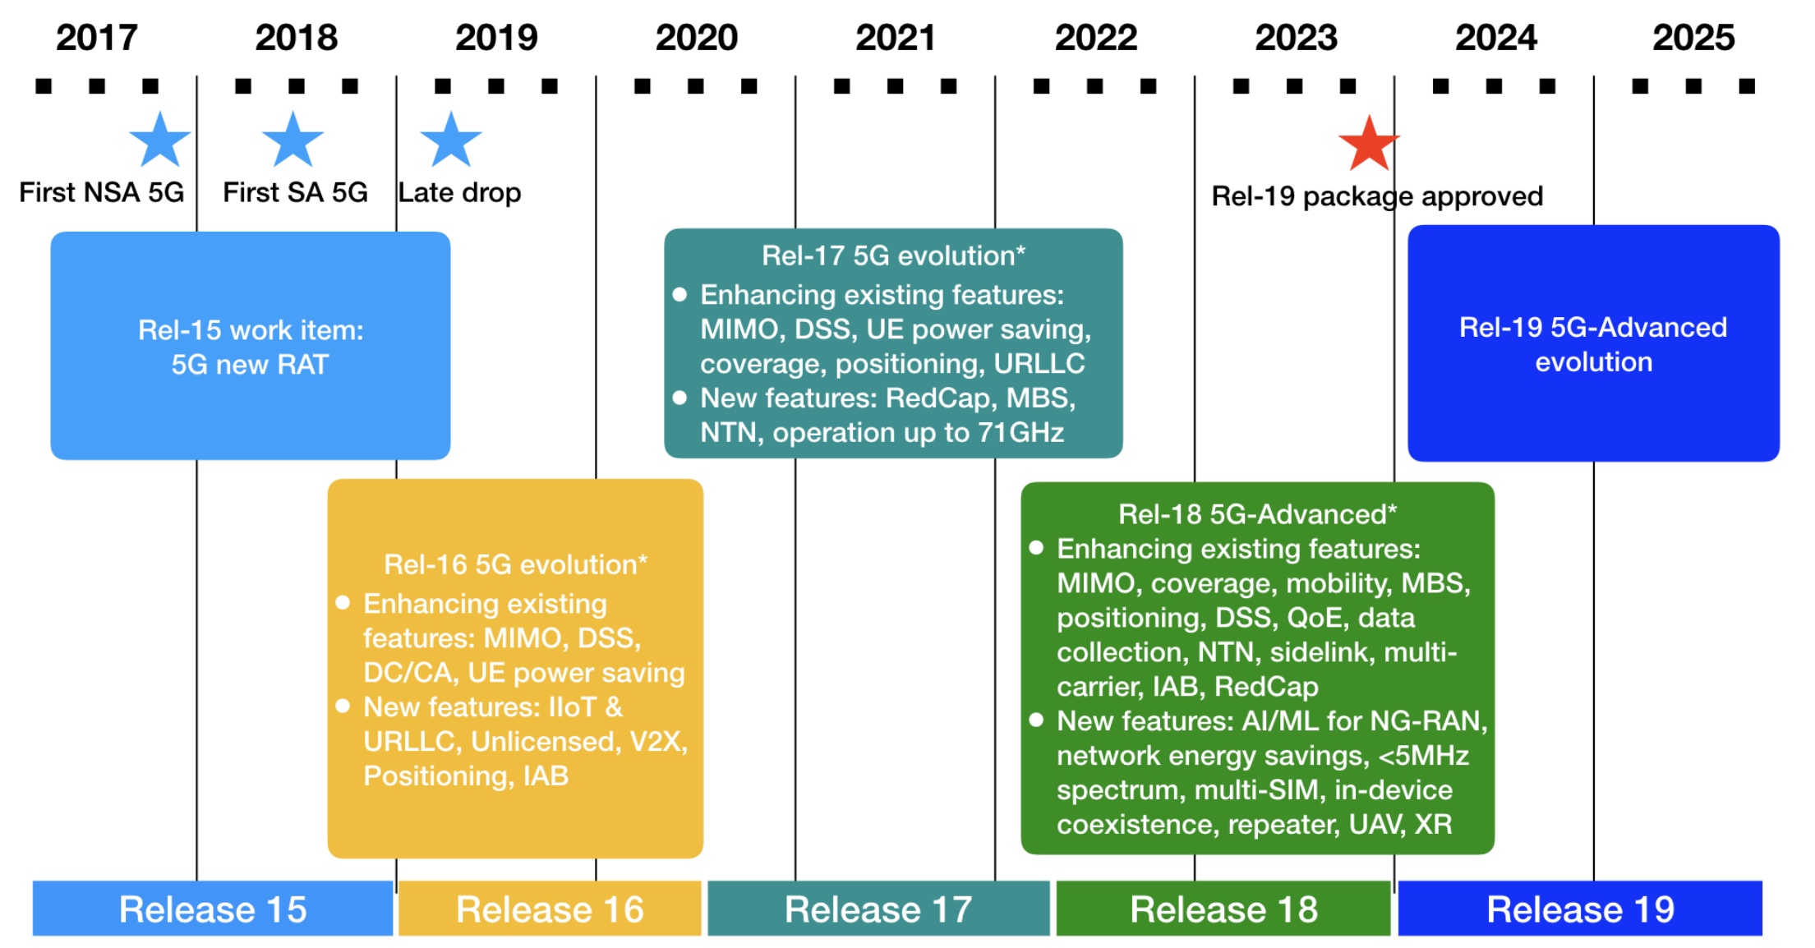
Figure 1: 3GPP's 5G Evolution Roadmap

Enhancements in 3GPP Release 19
- Support for inter-CU handovers
- Event-triggered measurement reporting for lower signaling overhead
- Channel State Information Reference Signal (CSI-RS) integration for improved accuracy
- Conditional LTM for enhanced mobility robustness

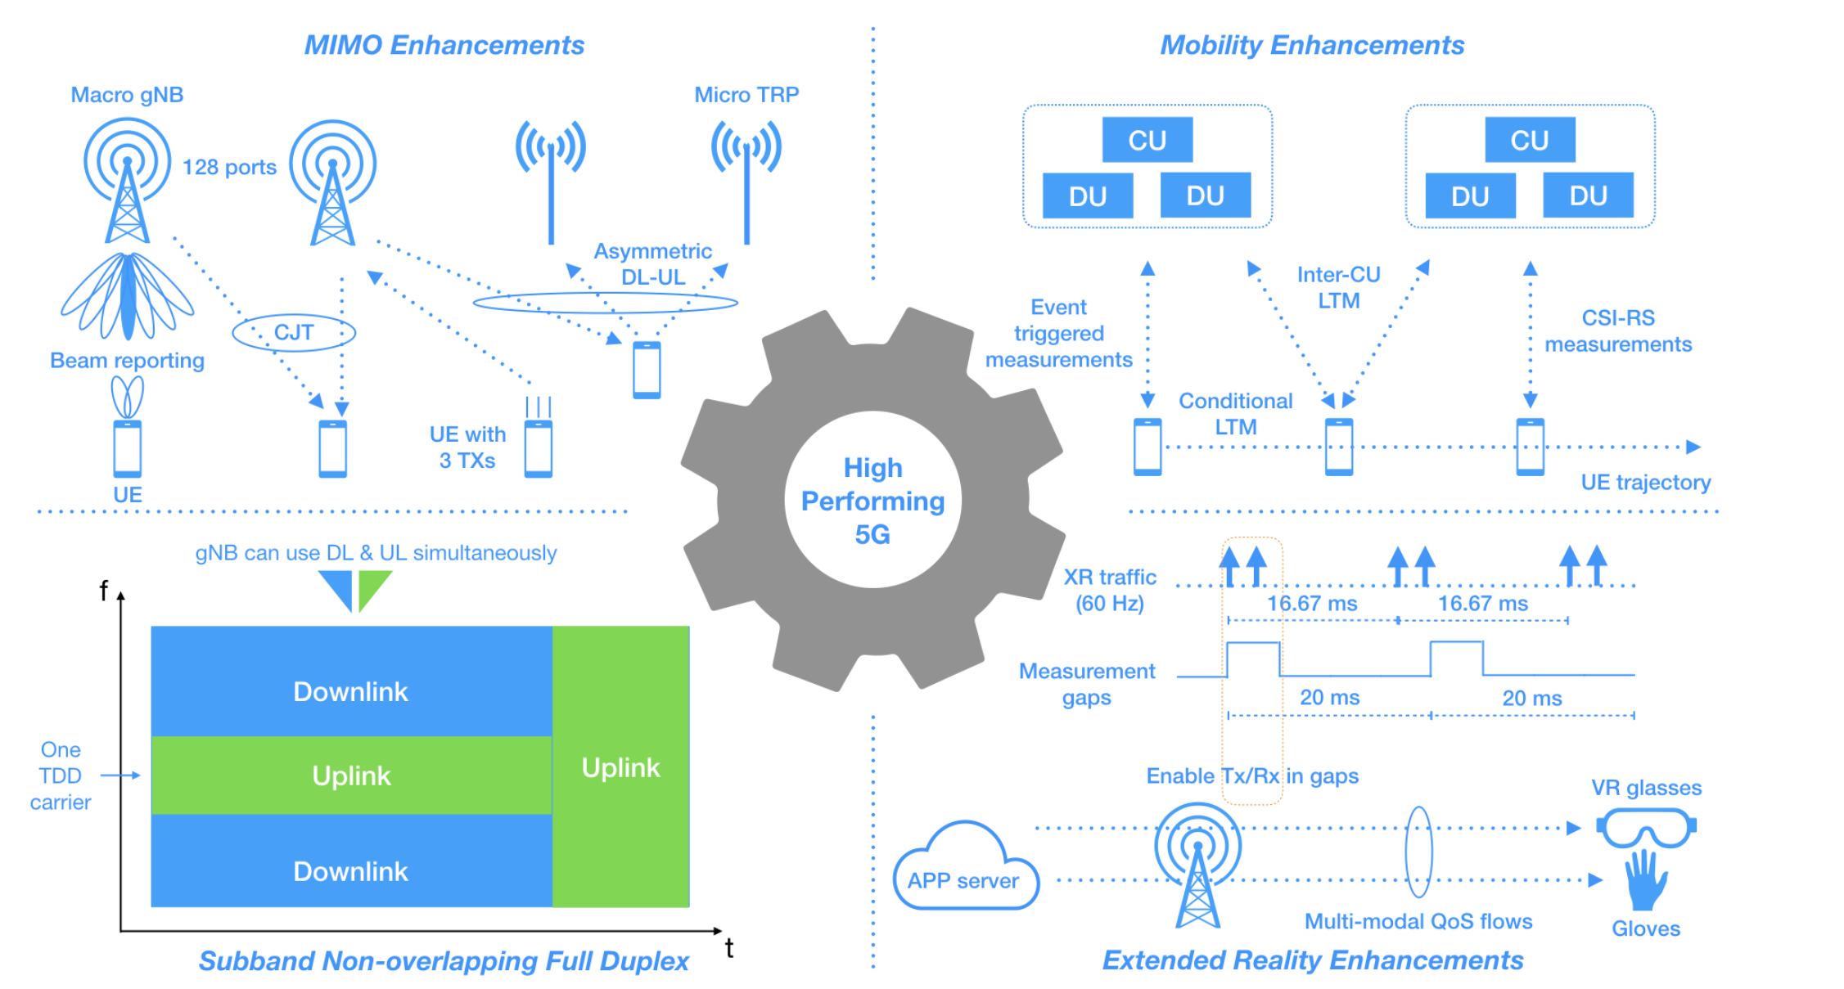
Figure 2: Key 3GPP Release-19 Mobility Enhancements

Machine Learning for Radio Resource Management (RRM)
ML algorithms have been identified as crucial for efficient RRM in complex multi-constraint scenarios characteristic of 5G and beyond (B5G) networks. ML improves network performance by optimizing throughput, latency, and energy efficiency, and adapts dynamically to network conditions.
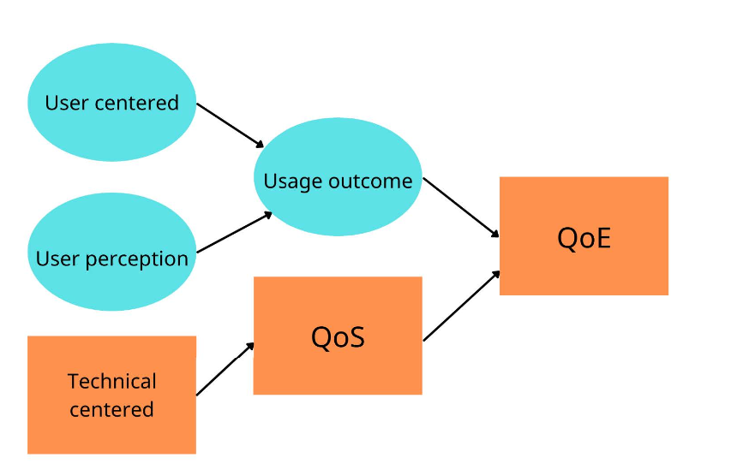
Figure 3: ML Techniques in RRM Placeholder

ML Techniques Detailed Analysis
- Supervised Learning: It is effective in predictive modeling tasks, such as throughput prediction and user demand forecasting.
- Unsupervised Learning: It is utilized for identifying patterns and clusters in network data to optimize resource allocation.
- Reinforcement Learning: It is used in dynamic real-time resource allocation scenarios, providing optimal decision-making based on continuous network feedback.

Benefits of Integrating LTM and ML
- Reduced handover latency and interruption times
- Improved accuracy and robustness in mobility management
- Enhanced Quality of Service (QoS) due to intelligent and adaptive resource allocation strategies

Future Directions
- Further evolution anticipated with Beyond 5G (B5G) and 6G technologies
- Increased adoption of AI/ML for comprehensive RRM solutions
- Potential for ML to handle even more diverse and challenging network scenarios effectively

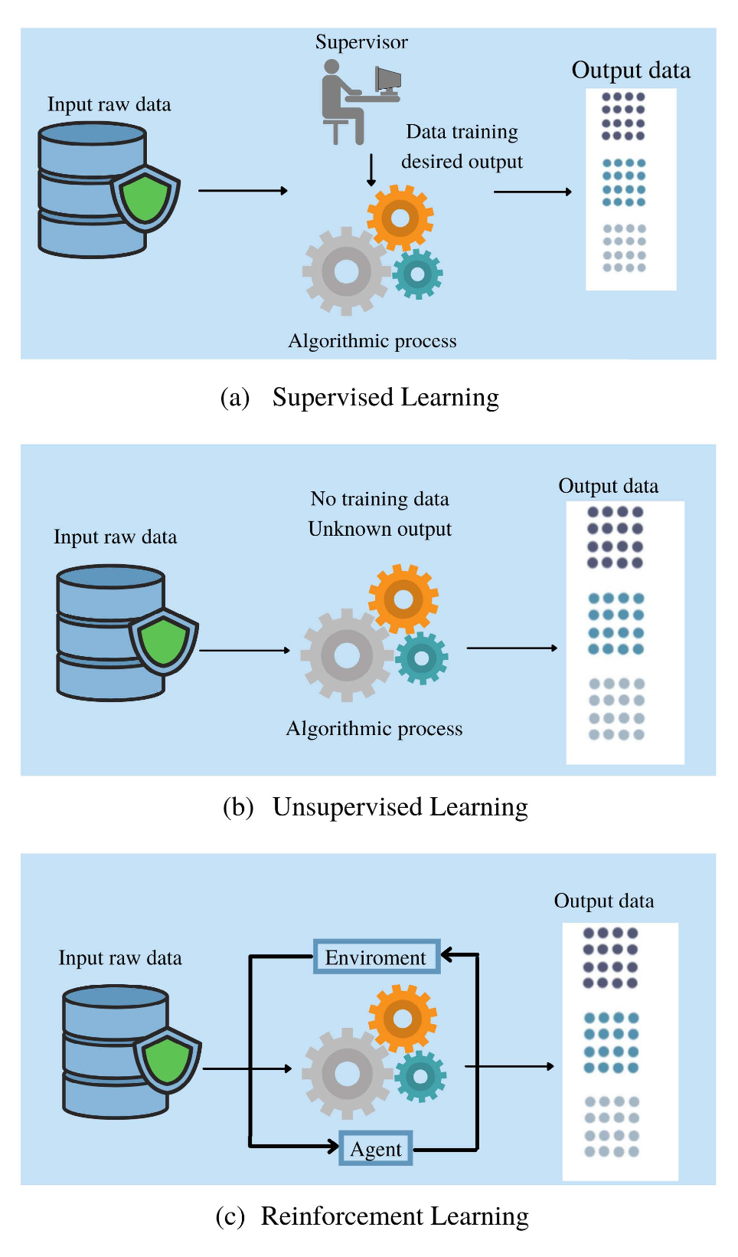
Figure 4: Future directions for ML Integration in RRM Placeholder

