Homework 4

Dmitriy Khomitskiy

**1. Butterfly - t = 90, S=100, X = 90-100-110, r = 10%, sigma = 30%**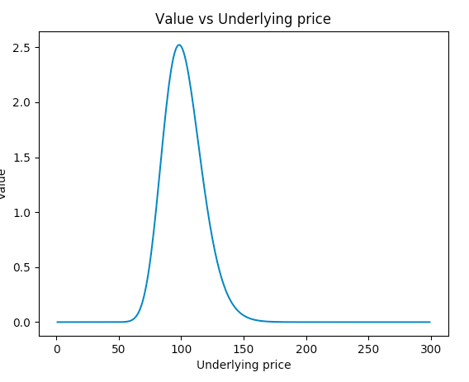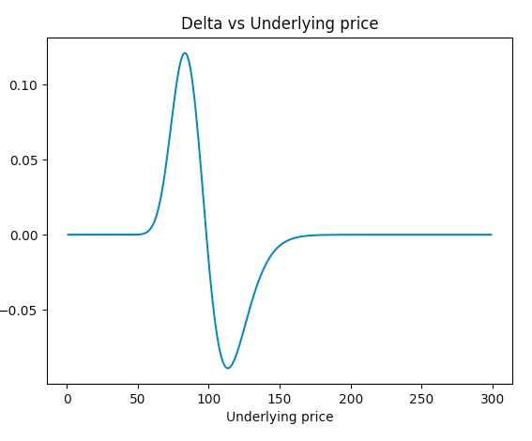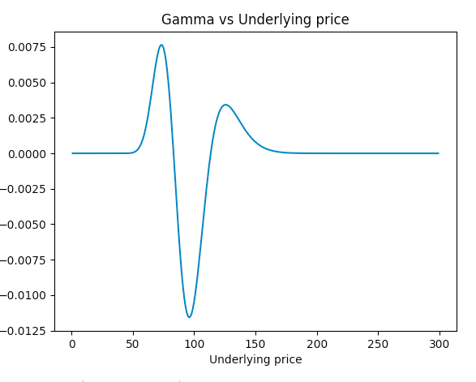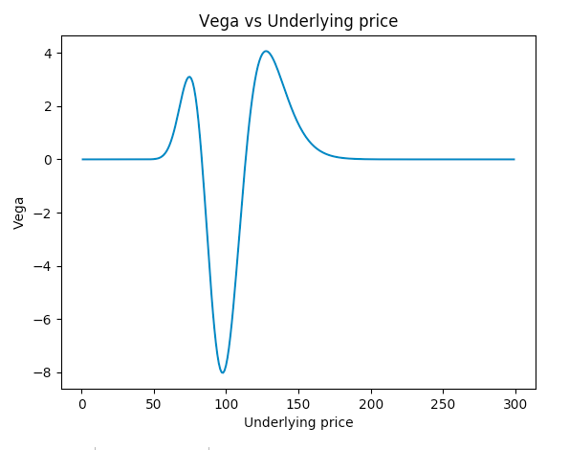

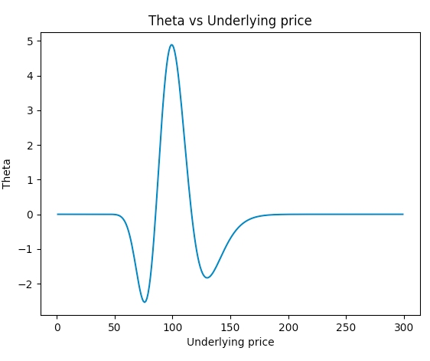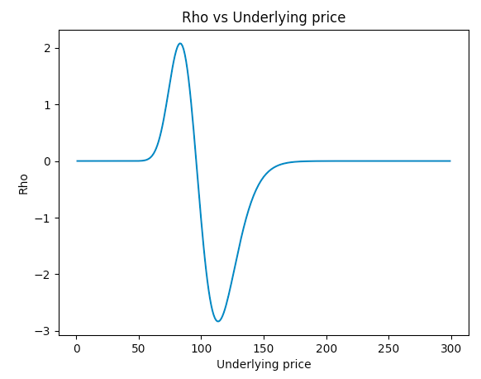

**2. Long ATM Straddle - S = 100, Strike = 100, sigma = 30%, interest = 10%**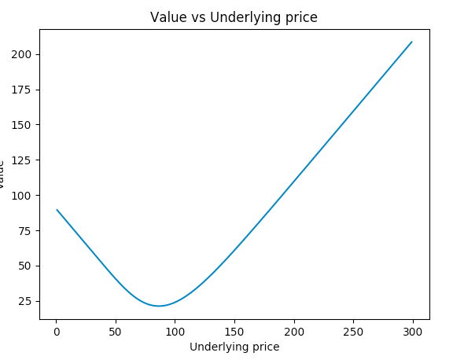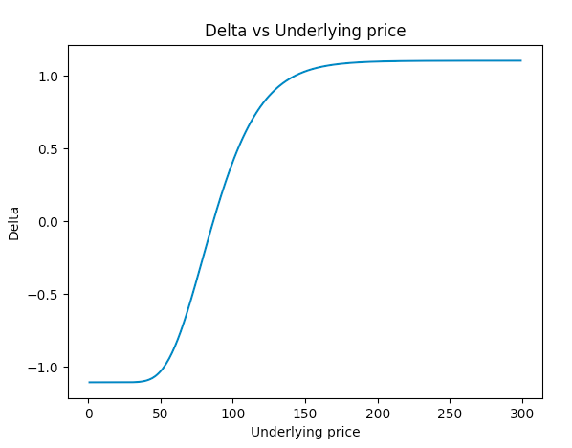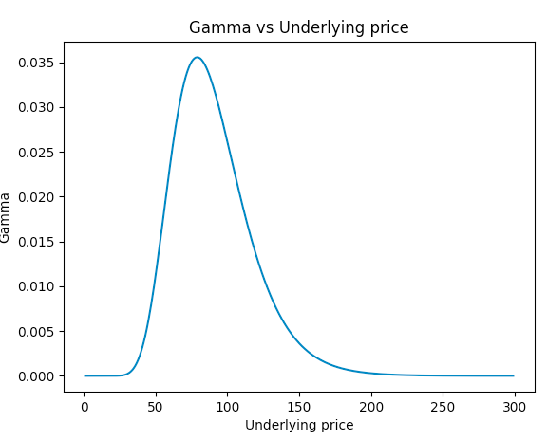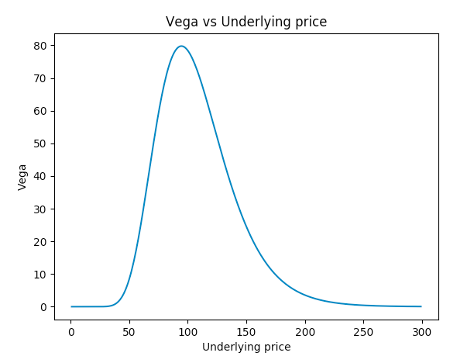

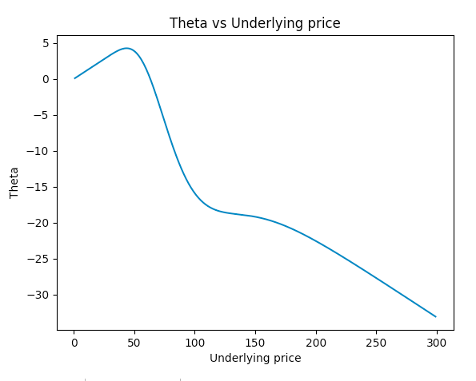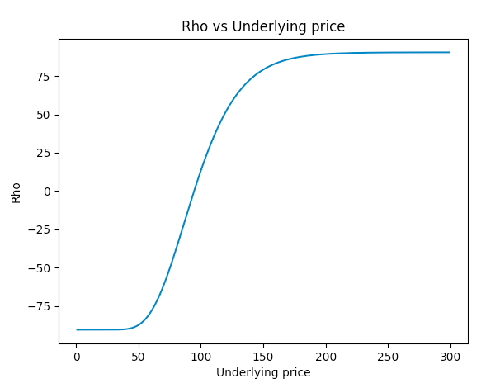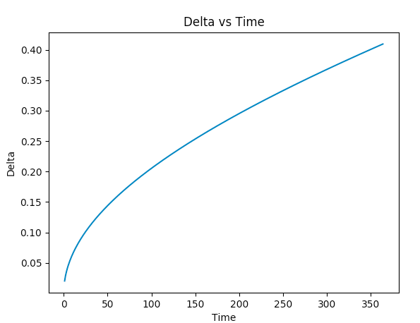

**Delta vs Time: Charm**

With Time decay the delta of the ATM “call” will go down towards the 0.5 while delta of the ATM “put” will go up towards 0.5. This is due to decreasing opportunity of stock price to move beyond its current value with time decrease.

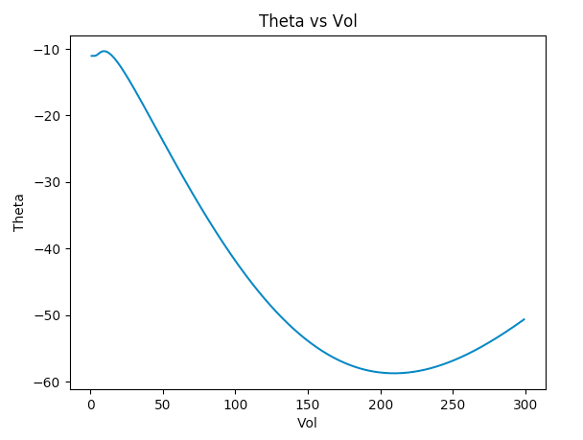

**Theta vs Vol:**

As seen from graph it depends on vol. For a reasonable vol it will be decreasing - however at some point the decrease will slow down.

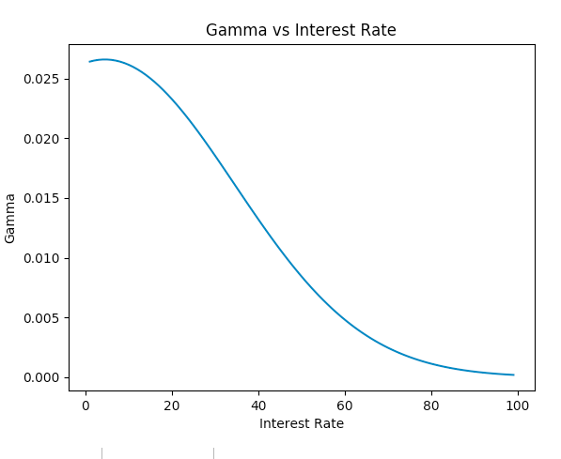

**Gamma vs interest rate:**

will continue decreasing as interest rate increases. The reason is because interest rate in gamma calculation is always negative as well as part of exponential function which decays faster than anything else in the equations. (e ^ -qt and e -d1 ^ 2 / 2)

**3. Risk reversal - long 25 delta put and short 25 delta call**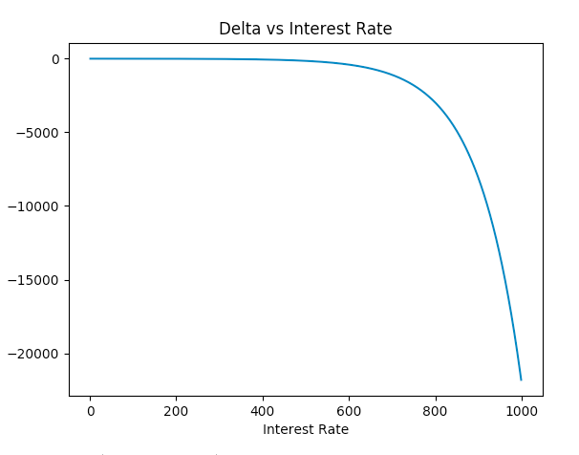

**Delta vs interest rate:**

The Delta will decrease with increase in interest rate. The short RR spread is negative in delta (long put is negative and short call is also negative). With increase of interest rate it will outweigh the other attributes in CDF calculation of N(d1)

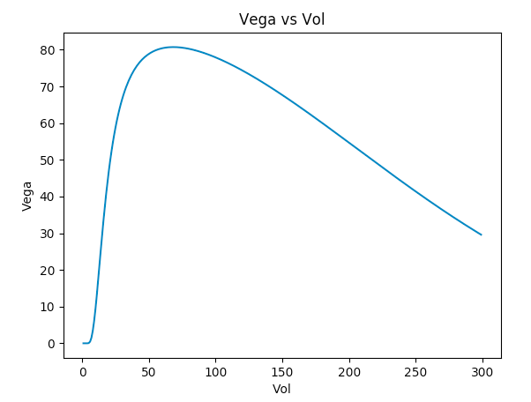

**Vega vs Vol:**

Vega will increase for smaller volatility and then will continue to decrease as vol continues to grow.

**Gamma vs Time:**

The Gamma will stay somewhat constant for majority of time. This i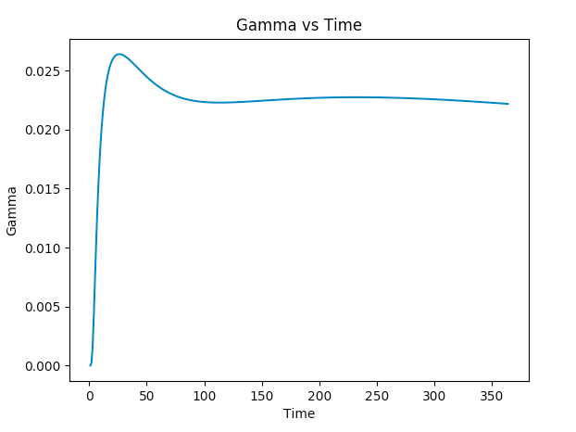s because the short position will mostly be offsetting the long one.