Program Description:

Running: Either run with .exe in bin folder or build from project file with vs2015.

Step 1.

At the Beginning Input number of Data’s to be used, lambda, mu and nu.

Lambda, mu and nu are parameters used in construction of GBR transform matrix. Input 0 will make the program to use its default value.

Step 2.

With input images loaded, you may select face region to be used. Navigate with “,(<)” or “.(>)”. Press space to select the region.

Step 3.

You can check and compare original image with simulated image with “,(<)” and “.(>)” keys. You can proceed to next step by pressing ESC.

Step 4.

Mouse right button will open menu for selecting version of z-map to be displayed. Mouse left-button will rotate the scene. Mouse middle button will zoom-in and zoom-out.

Problem Description

Given a set of images of same scene with different light conditions, we want to reconstruct the surface from the images. We are to consider both case of known and unknown light sources.

Result

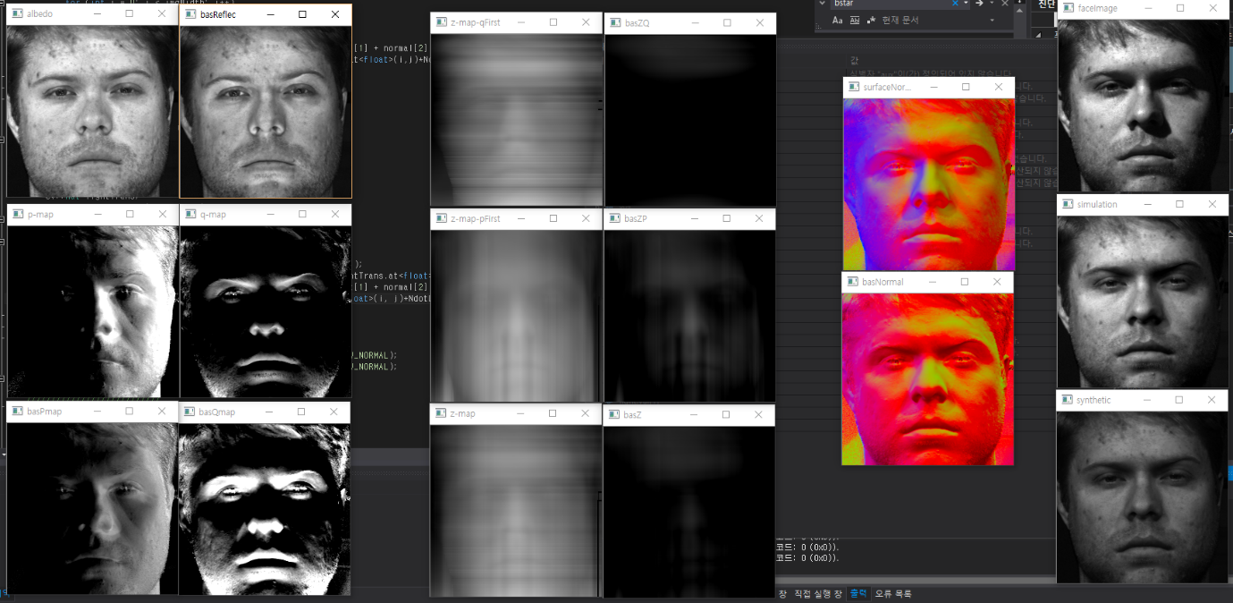

|  |  |  |  |  |  |
| --- | --- | --- | --- | --- | --- |
| Cal.Albedo | Uncal.Albedo | C.qFirst path | U.qFirst path |  | Original Img |
| Cal.p-map | Cal.q-map | C.pFirst path | U.pFirst path | C.SurfaceNor. | C.Synthetic |
| Uncal.p-map | Uncal.q-map | C.z averaged | U.z averaged | U.SurfaceNor. | U.Synthetic |

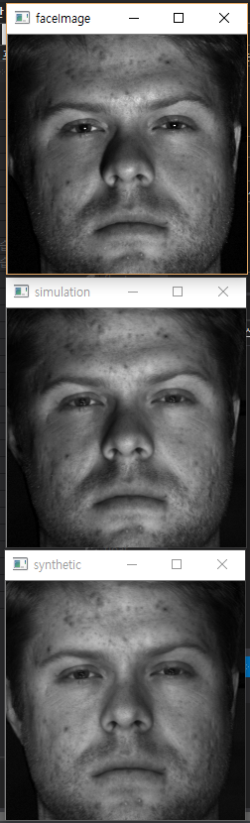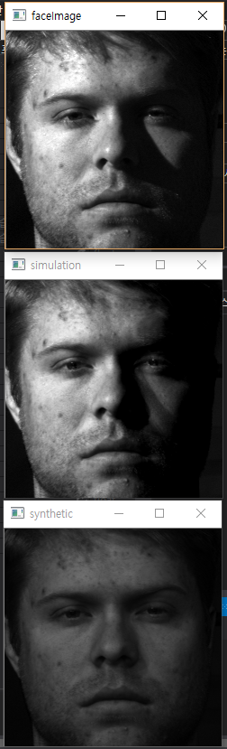

From the result of the synthetic images we can see that the shadow effects are not shown well. This is because of the assumption that there is no shadow which is not true. The shadow can be handled by use of binary function that masks shadowed region.

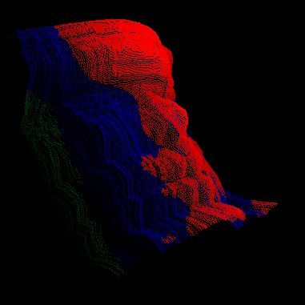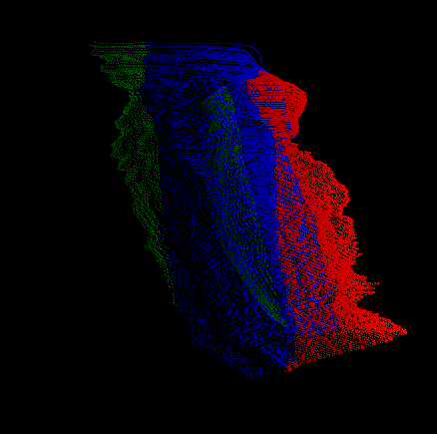

3D plot of height map from uncalibrated photometric (left) and calibrated photometric (right) shows that the result of uncalibrated is somewhat flattened due to the transformation. The uncalibrated version is quite noisy since the albedo assumption that we’ve made isn’t really true for human skin.

Discussions

1. As number of dataset used for photometric stereo increased, the quality of result got better.
2. The result could be made better if
   1. Images with minimum shadows are used as dataset
   2. Averaging the multiple path-integrations
   3. Use image without any controlled noises such as hair and backgrounds