CLOUD ENGINEERING | STUDENT ASSIGNMENT
AWS S3
Document Portal
Secure Document Sharing Platform using Amazon S3, IAM and CloudFormation
Prepared by
Souleymane Diallo
Junior Cloud Engineer | ABC Training Solutions

SERVICES  S3, IAM, CloudFormation | ENVIRONMENT  Lab | DATE  September 29, 2026

INTRODUCTION

Project Overview
ABC Training Solutions needs a reliable way to store and share documents in the cloud. As a Junior Cloud Engineer, I designed and deployed a secure document platform on Amazon S3. The infrastructure is created with AWS CloudFormation, protected by versioning, and shared through IAM users and a carefully scoped bucket policy.
Project goals
Deploy the bucket with CloudFormation • Enable versioning • Keep Block Public Access on at first • Give IAM users controlled access • Expose only the public/ folder • Protect private files • Prove that deleted or overwritten files can be recovered.

Architecture summary
Item | Value
Bucket name | abc-training-documents-souleymane-diallo
Region | us-east-1 (N. Virginia)
Tags | Environment = Lab, Owner = Souleymane Diallo
Versioning | Enabled
Folder structure | company-documents/ → public/, shared/, private/
IAM users | employee1 (read/write), contractor1 (read-only, shared/ only)
Stack name | S3-Document-Portal-Stack

PART 1

Create the S3 Bucket with CloudFormation
Objective
Deploy the bucket as infrastructure as code, with versioning on, Public Access Block on, and the required tags.

CloudFormation template (s3-document-portal.yaml)
AWSTemplateFormatVersion: "2010-09-09"
Description: ABC Training Solutions - Secure Document Portal

Parameters:
BucketName:
Type: String
Default: abc-training-documents-souleymane-diallo
OwnerName:
Type: String
Default: Souleymane Diallo

Resources:
DocumentBucket:
Type: AWS::S3::Bucket
Properties:
BucketName: !Ref BucketName
VersioningConfiguration:
Status: Enabled
PublicAccessBlockConfiguration:
BlockPublicAcls: true
BlockPublicPolicy: true
IgnorePublicAcls: true
RestrictPublicBuckets: true
Tags:
- Key: Environment
Value: Lab
- Key: Owner
Value: !Ref OwnerName

Outputs:
BucketArn:
Value: !GetAtt DocumentBucket.Arn

Deployment steps
- Open the AWS Console → CloudFormation → Create stack → With new resources.
- Upload the file s3-document-portal.yaml and click Next.
- Name the stack S3-Document-Portal-Stack and keep the default parameters.
- Review, acknowledge, and create the stack. Wait for CREATE_COMPLETE.
- In S3, open the bucket and create the folders public/, shared/ and private/.
CLI alternative: aws cloudformation deploy --template-file s3-document-portal.yaml --stack-name S3-Document-Portal-Stack
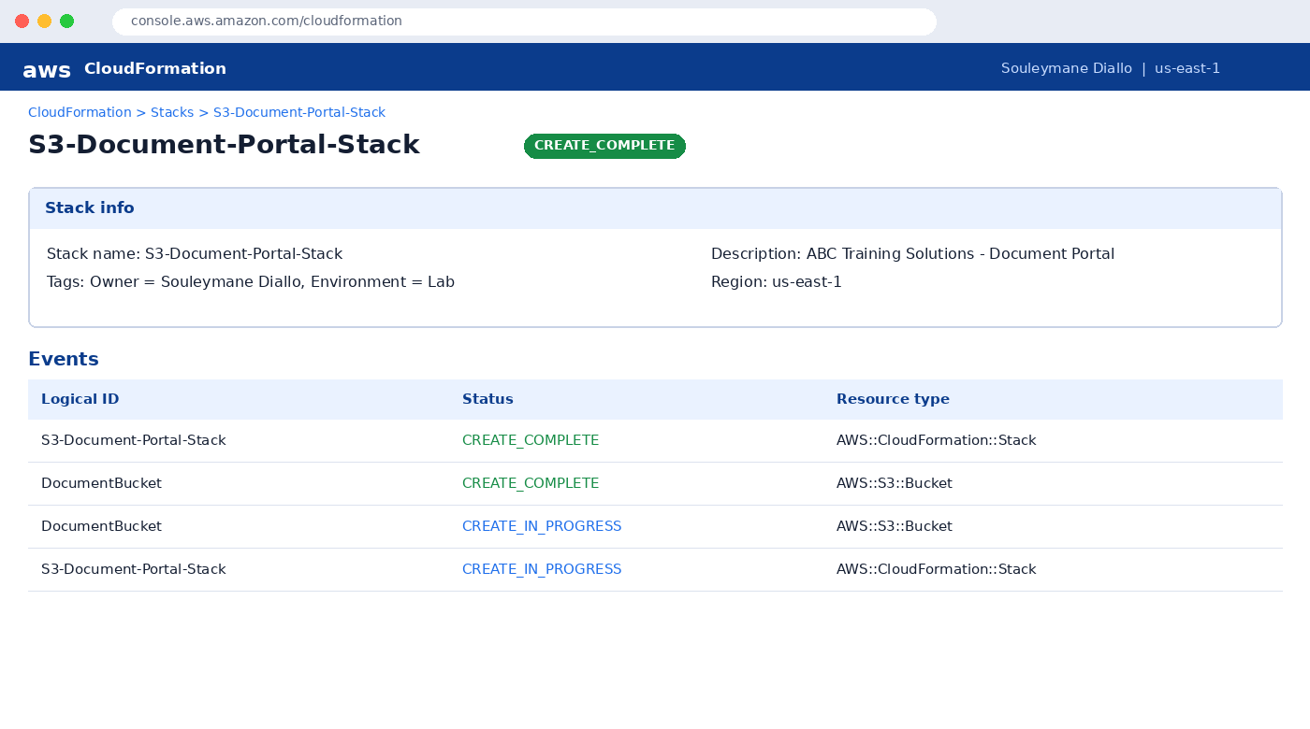
Figure 1: CloudFormation stack showing CREATE_COMPLETE.
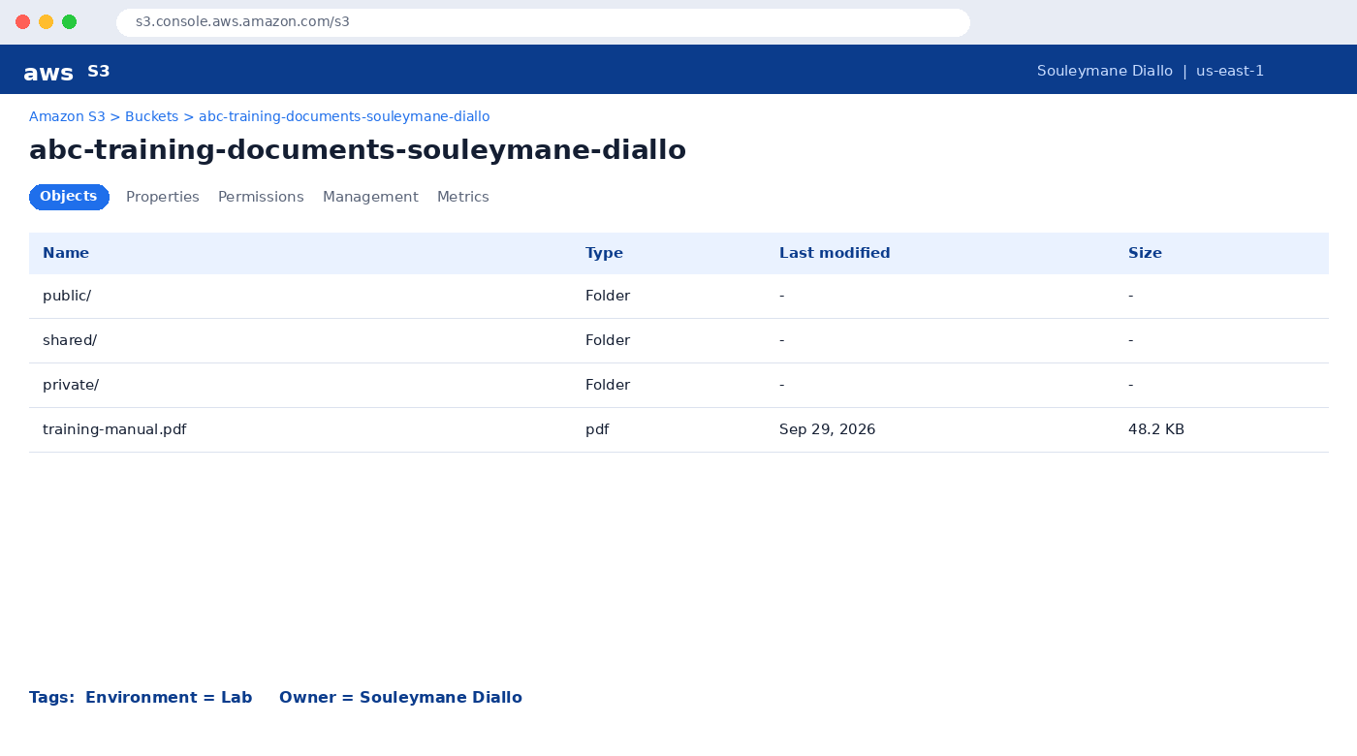
Figure 2: S3 bucket with the public/, shared/ and private/ folders.
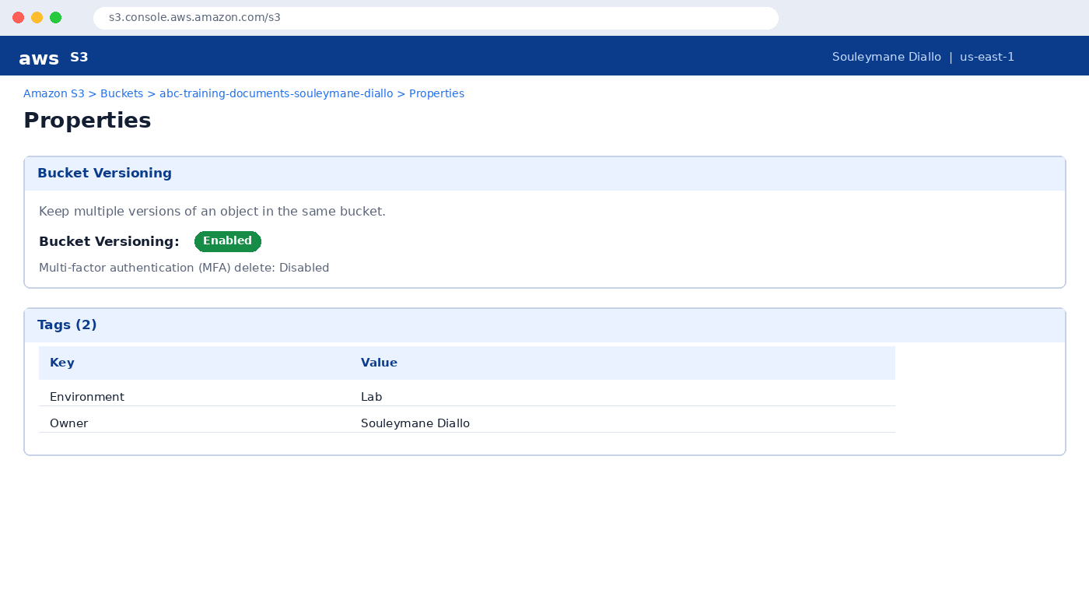
Figure 3: Bucket Versioning enabled and required tags applied.

PART 2

Enable Document Version Control
Objective
Show that S3 keeps every uploaded revision of training-manual.pdf.
- Upload training-manual.pdf to the bucket (Version 1).
- Edit the file locally (add a page or change the text) and upload it with the same name (Version 2).
- Edit it again and upload once more (Version 3).
- Open the object → Versions tab and confirm that three different Version IDs exist.
aws s3 cp training-manual.pdf s3://abc-training-documents-souleymane-diallo/training-manual.pdf
aws s3api list-object-versions --bucket abc-training-documents-souleymane-diallo --prefix training-manual.pdf

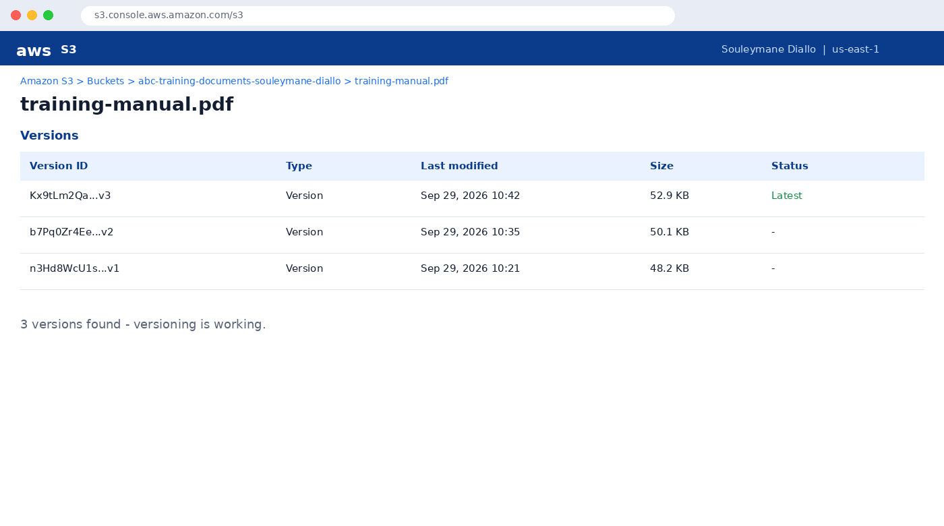
Figure 4: Object Versions: three versions of training-manual.pdf.

PART 3

Create the IAM User employee1
Objective
Give an employee the minimum permissions needed: list the bucket, download files and upload files.
- IAM → Users → Create user, named employee1.
- Enable console access and set a password (require change at first sign-in).
- Choose Attach policies directly → Create inline policy → JSON.
- Paste the policy below and save it as employee1-S3-Access.
{
"Version": "2012-10-17",
"Statement": [
{ "Effect": "Allow",
"Action": "s3:ListBucket",
"Resource": "arn:aws:s3:::abc-training-documents-souleymane-diallo" },
{ "Effect": "Allow",
"Action": ["s3:GetObject", "s3:PutObject"],
"Resource": "arn:aws:s3:::abc-training-documents-souleymane-diallo/*" }
]
}

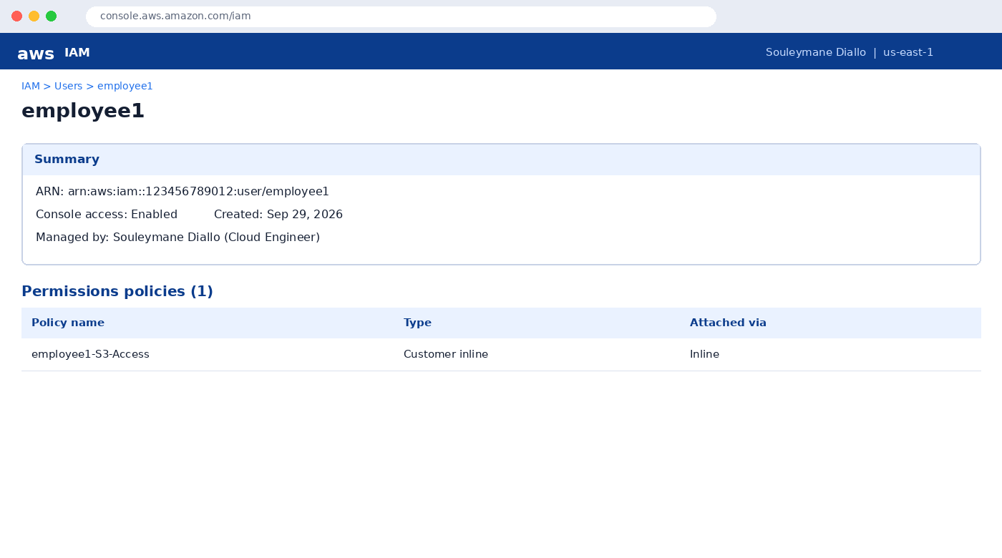
Figure 5: IAM user employee1 with its permissions policy.
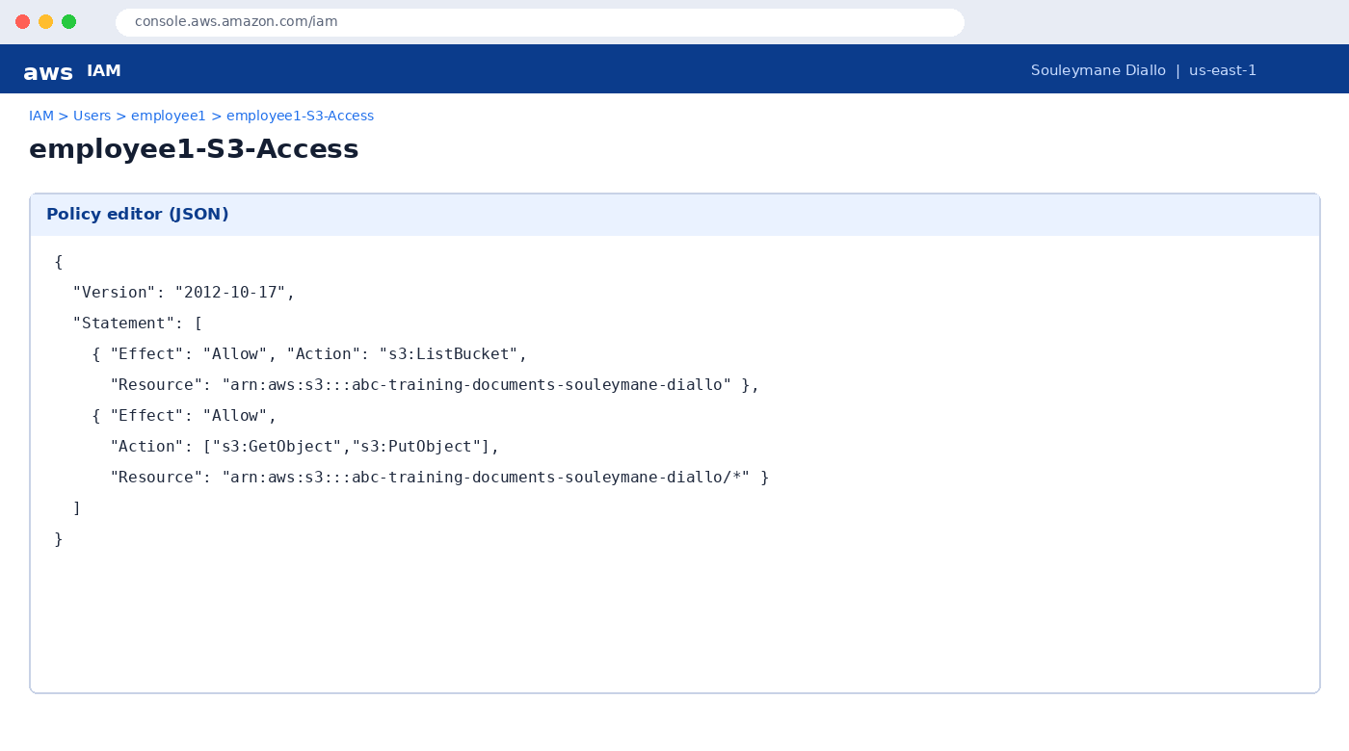
Figure 6: IAM policy granting ListBucket, GetObject and PutObject.

PART 4

Test IAM User Access
Objective
Confirm that employee1 can list, upload and download files, and cannot do anything more.
- Sign in to the IAM sign-in URL as employee1 (or configure a CLI profile).
- List the bucket contents.
- Upload a test file to the shared/ folder.
- Download training-manual.pdf.
- Try an action that is not allowed (for example, deleting an object) and note that it is denied.
aws s3 ls s3://abc-training-documents-souleymane-diallo/ --profile employee1
aws s3 cp test.txt s3://abc-training-documents-souleymane-diallo/shared/test.txt --profile employee1
aws s3 cp s3://abc-training-documents-souleymane-diallo/training-manual.pdf . --profile employee1

Result
All three allowed actions succeeded. Actions outside the policy are rejected with "AccessDenied", which proves least-privilege access works.

PART 5

Public Access for Non-IAM Users
Objective
Let anyone on the internet read files in public/ only, while private/ and shared/ stay protected.
- Bucket → Permissions → Block public access → Edit, and untick Block public access to buckets and objects granted through new public bucket or access point policies (and the matching restrict option). Confirm.
- Bucket → Permissions → Bucket policy → Edit.
- Paste the read-only policy below and save.
- Upload welcome.pdf into public/ and open its Object URL in a private browser window.
- Try the URL of a file in private/ and verify Access Denied.
{
"Version": "2012-10-17",
"Statement": [{
"Sid": "PublicReadForPublicFolder",
"Effect": "Allow",
"Principal": "*",
"Action": "s3:GetObject",
"Resource": "arn:aws:s3:::abc-training-documents-souleymane-diallo/public/*"
}]
}

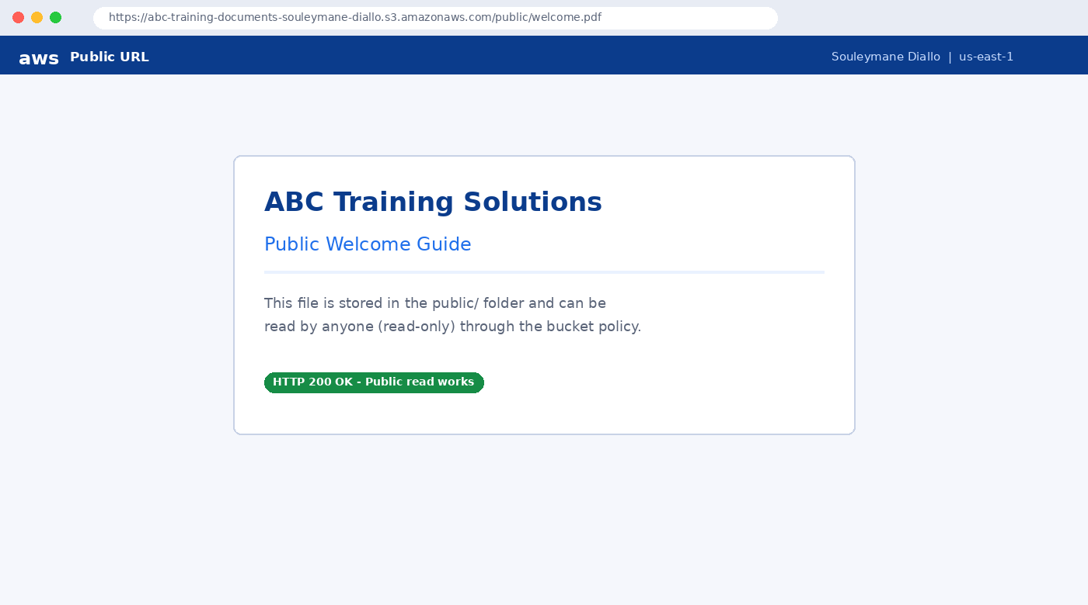
Figure 7: File in public/ opens for anyone (public read works).
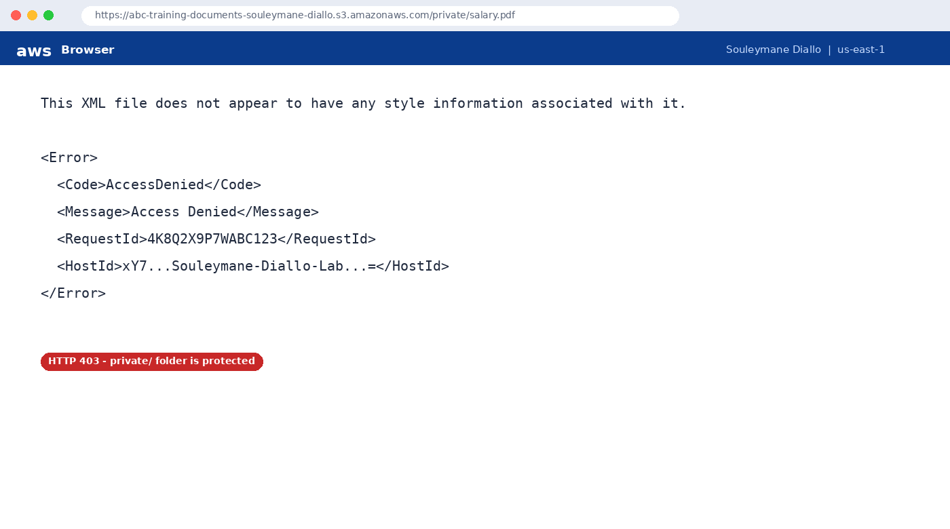
Figure 8: File in private/ returns Access Denied (403).
Security note
Only the public/ prefix is exposed. Never store confidential data in that folder, and re-enable Block Public Access when the lab is finished.

PART 6

S3 Versioning Recovery Lab
Objective
Recover a file after accidental deletion by removing the delete marker.
- Select training-manual.pdf and click Delete. Type "delete" to confirm. With versioning on, S3 adds a delete marker instead of erasing data.
- Switch on Show versions. The file now has a version of type Delete marker at the top.
- Select only the delete marker and choose Delete, then type "permanently delete".
- Turn off Show versions. training-manual.pdf is visible again.
aws s3api list-object-versions --bucket abc-training-documents-souleymane-diallo --prefix training-manual.pdf
aws s3api delete-object --bucket abc-training-documents-souleymane-diallo --key training-manual.pdf --version-id <DELETE_MARKER_VERSION_ID>

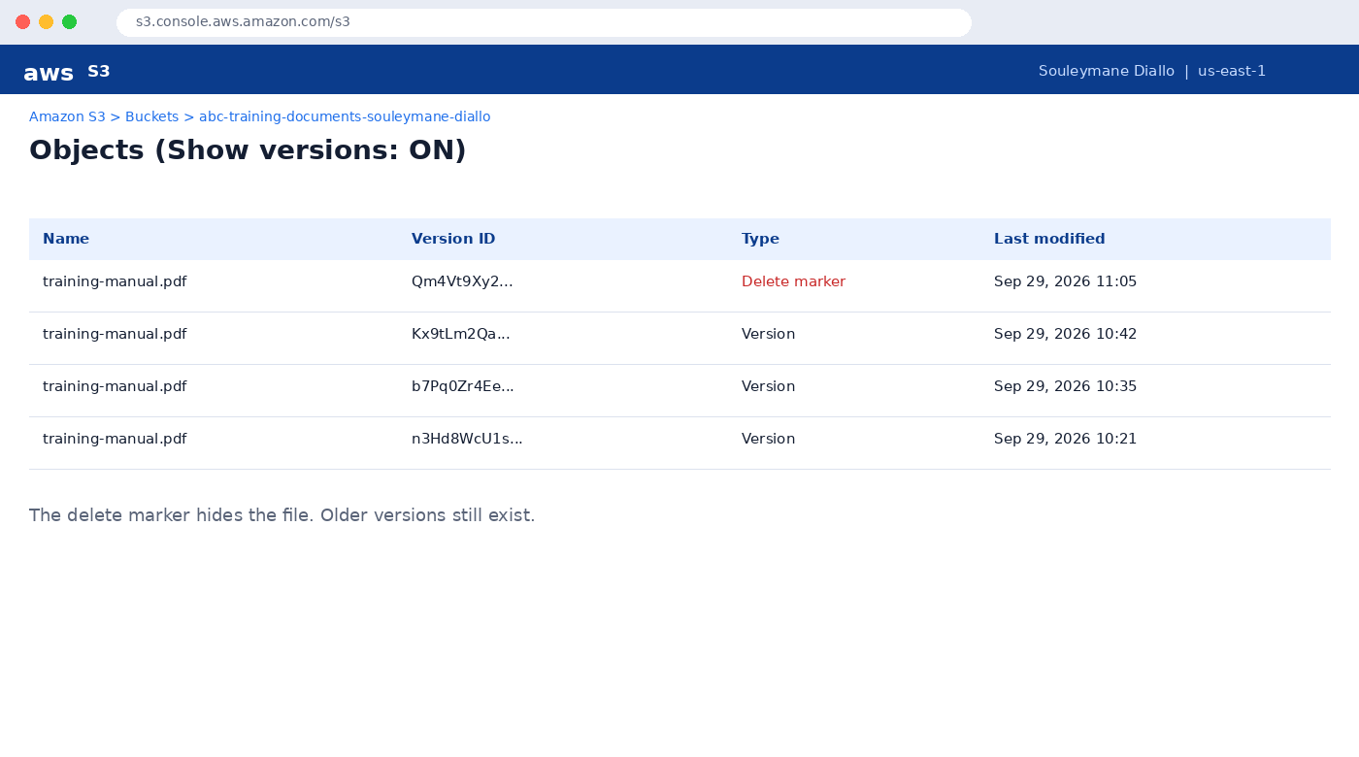
Figure 9: Delete marker shown above the earlier versions.
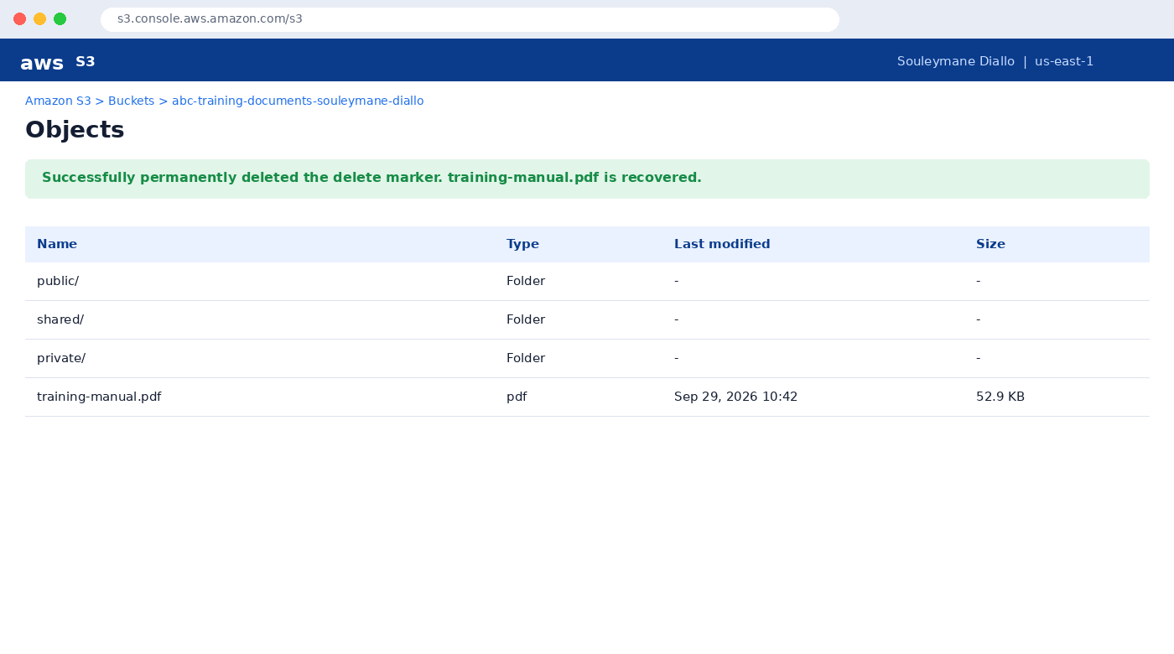
Figure 10: Recovery: delete marker removed and the file is back.

PART 7

Restore a Previous Version
Objective
Roll a file back to Version 1 after it was overwritten by later edits.
- Upload three different versions of the same file (already done in Part 2).
- Open the object → Versions tab and select Version 1.
- Download Version 1, then upload it again under the same key. It becomes the newest version.
- Alternatively, copy the old version onto itself with the CLI command below.
aws s3api copy-object --bucket abc-training-documents-souleymane-diallo \
--key training-manual.pdf \
--copy-source "abc-training-documents-souleymane-diallo/training-manual.pdf?versionId=<VERSION_1_ID>"

Why this works
S3 never overwrites old data when versioning is on. Restoring simply promotes an older version to become the current one.

BONUS CHALLENGE

contractor1: Read-Only Access to shared/
contractor1 may list and read only the shared/ folder. Everything else is implicitly denied.
{
"Version": "2012-10-17",
"Statement": [
{ "Effect": "Allow",
"Action": "s3:ListBucket",
"Resource": "arn:aws:s3:::abc-training-documents-souleymane-diallo",
"Condition": { "StringLike": { "s3:prefix": ["shared/*", "shared/"] } } },
{ "Effect": "Allow",
"Action": "s3:GetObject",
"Resource": "arn:aws:s3:::abc-training-documents-souleymane-diallo/shared/*" }
]
}

SUMMARY

Deliverables Checklist
Deliverable | Screenshot | Section
CloudFormation Stack | Figure 1 | Part 1
S3 Bucket | Figure 2 | Part 1
Versioning Enabled | Figure 3 | Part 1
IAM User | Figure 4 | Part 3
IAM Policy | Figure 5 | Part 3
Public Access | Figure 6 | Part 5
Access Denied | Figure 7 | Part 5
Object Versions | Figure 8 | Part 2
Delete Marker | Figure 9 | Part 6
Recovery | Figure 10 | Part 6

Learning outcomes achieved
Skill | What I demonstrated
AWS CloudFormation | Built and deployed the bucket as code
Amazon S3 | Folders, tags, object management
S3 Versioning | Multiple versions, delete markers, recovery
IAM Users & Policies | Least-privilege users employee1 and contractor1
Bucket Policies | Public read on public/ only
Public vs Private Access | Verified 200 vs 403 responses
Cloud Storage Administration | Secure, recoverable document storage

Conclusion
The ABC Training Solutions document portal is secure, versioned and recoverable. Public content is isolated in one folder, employees and contractors receive only the access they need, and accidental deletions or bad edits can be undone in minutes.
Prepared by Souleymane Diallo

