Souleymane Dembele

**Draft the Technical Essay**

**Title: Comparative Analysis of Image Filtering Techniques**

**Comparative Analysis of Image Filtering Techniques**

**Introduction**

Digital image processing enhances high-stakes fields such as medical imaging, autonomous vehicle navigation, and facial recognition technology. Image filtering, a foundational step, crucially enhances image quality by reducing noise, preserving edges, and accentuating boundaries. This project evaluates the effectiveness of three prominent image filtering techniques: Gaussian Blur, Median Filter, and Sobel Edge Detection, focusing on their processing efficiency, impact on image quality, and resource utilization.

**Implementation of Algorithms**

**Development Environment and Tools:**  
I implemented the algorithms in C++, using the OpenCV library for its robust image-processing functions. Since I did not encounter major challenges yet, I did not switch to Python. However, I am exporting the performance data into a .csv format then I am using Matlab to analyze and visualize.

**GitHub Repository:**  
I am maintaining all source code developed for this project and it is accessible via the following GitHub repository: [GitHub Repository for Image Filtering Project](https://github.com/souleymanedembele/image_filter).

**Algorithm Details:**

* **Gaussian Blur Filter:** This filter uses a Gaussian kernel to smooth the image and reduce noise. I implemented it with adjustable kernel size and sigma values to analyze its impact on noise reduction and edge blurring.
* **Median Filter:** Unlike Gaussian Blur, the Median Filter operates by selecting the median pixel value in a neighborhood defined by the kernel size. This method is particularly effective at preserving sharp edges while removing salt-and-pepper noise. The implementation challenges revolved around optimizing the median-finding algorithm, especially for larger kernel sizes. I enabled kernel size adjustments dynamically in the application interface to allow users to experiment with different settings and immediately see the impact on image clarity and edge integrity.
* **Sobel Edge Detection:** The Sobel operator is used for edge detection, a critical operation in many computer vision tasks that involve object detection and tracking. It works by calculating the gradient of image intensity at each pixel, providing a way to find regions of high spatial frequency that correspond to edges. I implemented this with configurable scale and delta values to refine the detection process based on different image qualities and noise levels. The scale adjusts the range of edge detection, allowing for more subtle edges to be captured, while the delta shifts the threshold for what constitutes an edge, which is crucial for different lighting conditions and contrast levels.

These implementations not only demonstrate the technical capabilities of the chosen filters but also allow comprehensive exploration of how different parameters affect the output and efficacy of each algorithm. Through this project, users can gain a hands-on understanding of image filtering effects and make informed choices about which filters to use in their own projects or research.

**Experimental Design**

**Test Data:**  
I used a set of standardized images, including natural scenes and synthetic images with added noise and varying contrast levels, to test each filter. This approach ensures comprehensive evaluation across a spectrum of real-world and controlled scenarios.

**Testing Procedure:**  
I applied each filter to the image set, and recorded performance metrics such as execution time and memory usage using profiling tools integrated into the development environment. I assessed image quality using the Structural Similarity Index (SSIM) and Peak Signal-to-Noise Ratio (PSNR).

**Results**

**Data Presentation:**  
I present the results in several graphical formats:

* Line graphs showing the execution time for each filter as image complexity varies.

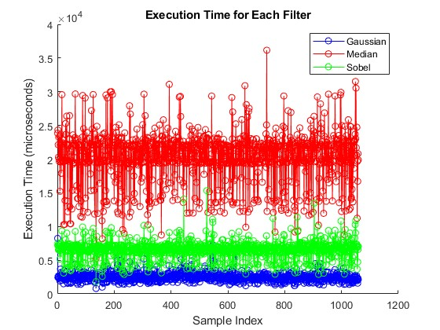

* Bar charts comparing memory usage across filters.

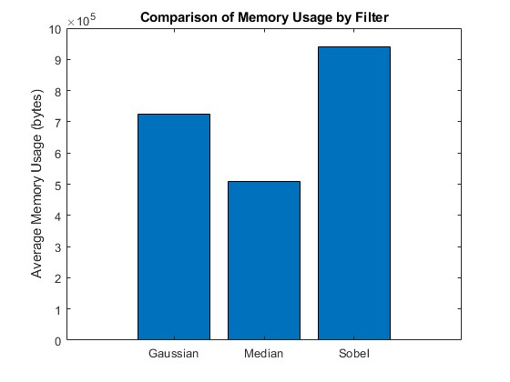

* Scatter plots illustrating the relationship between image quality metrics and filter settings.

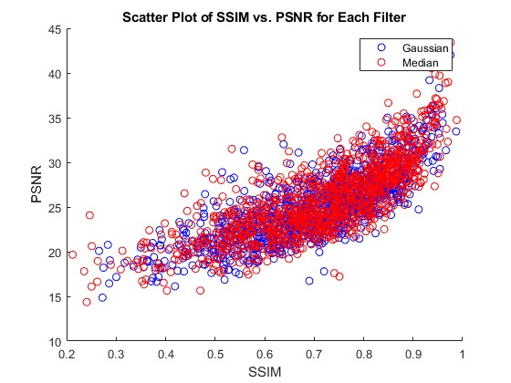

**Analysis:**  
The Gaussian Blur efficiently reduced noise but tended to blur edges significantly. The Median Filter demonstrated superior edge preservation but at a higher computational cost. The Sobel Edge Detection effectively defined clear boundaries but was sensitive to high noise levels.

**Discussion**

**Interpretation of Results**

The experimental data confirmed our initial hypotheses about the strengths and weaknesses of each filter, clearly defining their optimal applications in various image processing contexts.

**Gaussian Blur Filter:**  
The Gaussian Blur filter excels in environments where reducing noise is crucial, even at the cost of slight edge blurring. This characteristic makes it particularly suitable for background smoothing in portrait photography and preprocessing in facial recognition systems. For example, in security camera footage affected by environmental factors like rain or fog, applying Gaussian Blur reduces noise artifacts, simplifying the task for subsequent recognition algorithms to detect and recognize faces or objects.

**Median Filter:**  
The Median Filter stands out in applications where preserving edge integrity is critical while removing noise. It is indispensable in medical imaging, such as MRI or ultrasound, where clear delineation of anomalies from surrounding tissues can aid in more accurate diagnoses. Similarly, in digital forensics, the Median Filter enhances the readability of degraded documents without blurring the edges, crucial for identifying textual or graphical information.

**Sobel Edge Detection:**  
Sobel Edge Detection proves most effective in controlled environments where precise boundary definition is necessary, and noise levels are low. This filter is critical in machine vision systems used on manufacturing lines to detect component edges for quality control and assembly processes. In autonomous driving systems, it enhances road and lane boundary detection, essential for vehicle navigation and steering. Its effectiveness in low-noise environments is particularly beneficial for scenarios where we preprocess images or capture them under consistent lighting conditions.

These results not only validate the theoretical expectations of each filtering technique but also guide practical application choices in real-world scenarios. The ability of each filter to meet specific operational needs underscores the importance of selecting the appropriate image processing tool based on the specific requirements of the application.

**Challenges and Limitations:**  
Challenges included managing the computational load for high-resolution images and ensuring consistency in quantitative image quality assessment.

**Conclusions**

**Summary of Findings:**  
This study offers valuable insights into selecting appropriate image filtering techniques based on specific application needs, highlighting the trade-offs between noise reduction, edge preservation, and computational efficiency.

**Implications of the Study:**  
The findings from this study can significantly impact the development of more effective image processing pipelines in computer vision applications, particularly where real-time processing is crucial.

**Future Work:**  
Further research could explore integrating machine learning algorithms to dynamically select and apply image filters based on image content and desired outcomes.

**References**

1. Gonzalez, R.C., & Woods, R.E. (2018). Digital Image Processing.
2. Bradski, G., & Kaehler, A. (2008). Learning OpenCV: Computer Vision with the OpenCV Library.
3. Parker, J.R. (2010). Algorithms for Image Processing and Computer Vision.