UNIVERSITY OF PIRAEUS – DEPARTMENT OF INFORMATICS



Software as a Service: Social Media Web Application – Implementation Report & User Manual

Georgios Soulantikas
(P19153)

FEBRUARY-MARCH 2026
Table of Contents
1. Overview 3
2. For Developers 3
2.1 Instructions for local development 3
3. User Manual 4
3.1 Authentication 4
3.1.1 Sign Up 4
3.2 Posts 4
3.2.1 Create a post 5
3.2.2 Edit your post 5
3.2.3 Delete your post 5
3.2.4 Like a user’s post 6
3.3 Profile 6
3.3.1 Edit your profile 6
3.4 Search 7
3.5 Contacts 8
3.5.1 Sending a Contact Request 8
3.5.2 Accepting a Contact Request 8
3.5.3 View your Contacts 8
3.6 Chat 9
3.6.1 Creating a Group Chat 10
3.6.2 Editing a Group Chat 10
3.6.3 Deleting a Group Chat 10
3.6.4 Chat Page 10
4. Conclusion and Future Improvements 11

1. Overview

This project involved the construction and deployment of a full-stack social media like web application, where users can create posts and connect with others that share their interests. The platform implements core social networking features, including post creation, profile management, contact systems, and also features that require real-time connection with the server, specifically for notifications and chat.
The application was built using the Django framework, augmented by HTMX to enable dynamic DOM swapping. This approach provides a single-page application experience by making certain updates on the frontend without requiring full page refreshes. For real-time features, I implemented WebSockets to maintain persistent TCP connections between the clients and the server.
To ensure environment consistency and streamline the development workflow, I containerized the application using Docker. During development, the web application, PostgreSQL database, and Redis (used as the message broker for WebSockets) are managed as a multi-container architecture via Docker Compose. This setup allows for the entire stack to be orchestrated with a single command, ensuring that the development environment remains identical across different machines.
For the production environment, I deployed the application to Fly.io. The deployment process utilizes the project's Dockerfile to build a production-ready image, which is then hosted on Fly's platform. The production database and Redis instances are managed through Fly.io’s services.
The application’s GitHub page can be found here.
The deployed application can be accessed here.

2. For Developers

In this section it will be explained how to run the application locally in a development evnironment.
Docker & Docker Compose are required to run the application and the database locally.
https://www.docker.com/
https://docs.docker.com/compose/install/

2.1 Instructions for local development
Clone the repository from github:
> git clone https://github.com/soulgeo/grouper.git
Set up environment variables: Copy the example environment file to create your local configuration:
> cd grouper
> cp .env.example .env
(You can usually leave the default values in .env as-is for local development with Docker.)
Start the development server:
> docker compose up --build
The server will start listening for requests at port 8000. You can access the application here: http://localhost:8000/

3. User Manual

In this section we will explore all functionalities of the web application and how to properly use each one as a user.

3.1 Authentication
You’ll need an account to access all capabilities of Grouper. You can create an account by either filling out a signup form, or via connecting your Google or Facebook account to Grouper. Once your account is created, you can Log In and gain access to creating posts, adding contacts and using chat.

3.1.1 Sign Up
To create an account: on the Sign Up button on the top-right of the page. You’ll be navigated to a signup form, where you can either fill out your details (Email, Username, First Name, Last Name, Country, Password) and click on Sign Up to submit OR choose to sign up via a 3rd party provider (Facebook or Google).

3.2 Posts
On Grouper, you can share your input on any topic via a post. Pick an interesting title, write down your ideas, pick some fitting interests that other users can use to find your post, and share it with everyone —or just your contacts, if you prefer.
You can find all posts visible to you on your home page, newest posts at the top. Not all posts are displayed on page load; more posts will be loaded dynamically as your scroll down the page. Same is true for other pages where posts are visible, such as Search and Profiles.

3.2.1 Create a post
You need to be signed in to create a post.
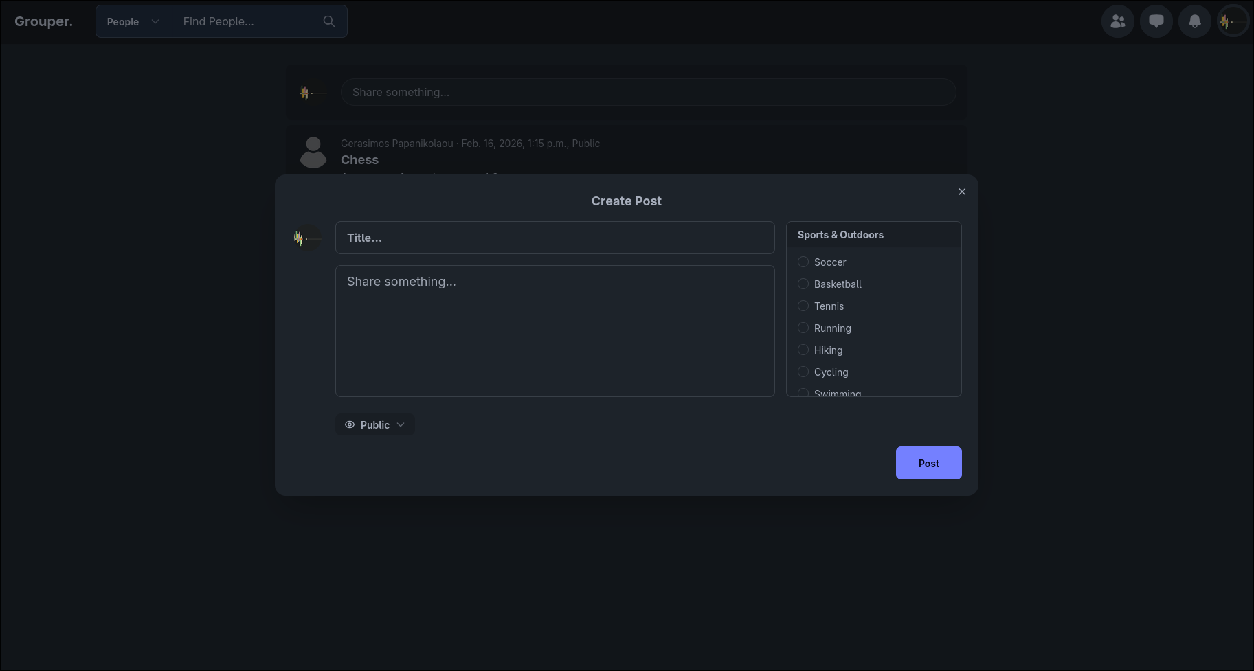
- On the home page or on your profile page, click on the “Share some-thing...” box that lies above all other posts.
- A post creation modal will open up, where you can give your post a title, some text and any number of relevant interests. You can also choose to make your post public or only visible to your contacts.
- Once done, click on the Post button on the bottom of the modal, and your post will be created.

3.2.2 Edit your post
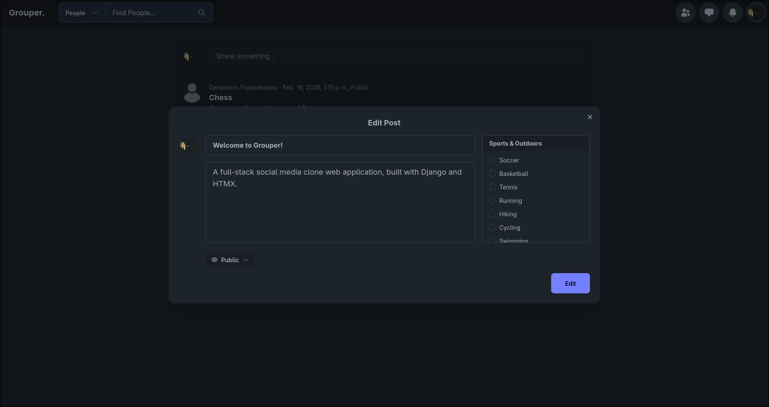
- Click on the three dots that appear on the right side of any of your posts, then choose Edit Post on the dropdown.
- A post edit modal will appear, where you can edit your post’s title, text, interests and visibility.
- Once done, click Edit on the bottom of the modal.

3.2.3 Delete your post
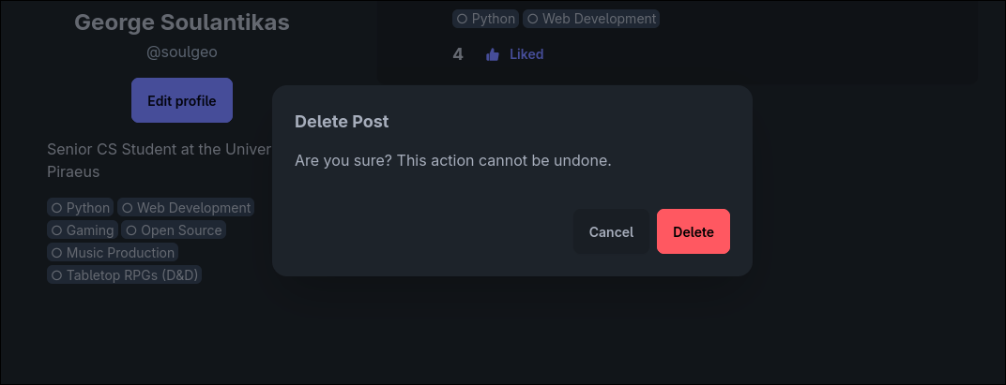
- Click on the three dots that appear on the right side of any of your posts, then choose Delete Post on the dropdown.
- You’ll be prompted with a confirmation message. If you’re sure, click on Delete and your post will be permanently deleted.

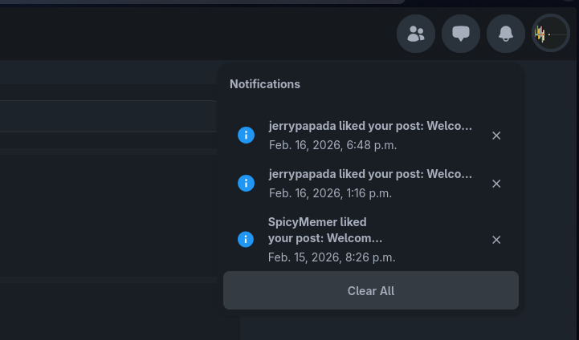
3.2.4 Like a user’s post
- You can show your approval of a user’s post by clicking on the Like button for their post. This will make the Like count of the post go up by 1.
- If a user likes one of your own posts, you’ll receive a notification informing you about it.

3.3 Profile
Every user has their own profile page, where one can see a list of their interests, read their bio, and find all of their posts in one place. You can access any user’s profile by clicking on their avatar picture. You can also access your own profile through the user menu on the top right of the screen.
- Click on your avatar picture – the rightmost button on the top-right of the screen.
- On the dropdown, click on “Profile”. You will be navigated to your own profile page.

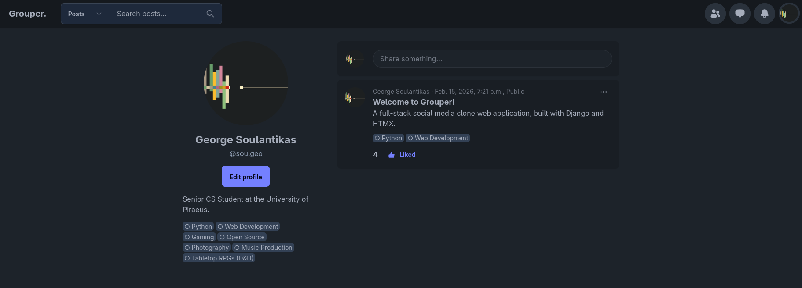

3.3.1 Edit your profile
- On your profile page, click on the large “Edit Profile” button (located on the left side on large screens and near the top on small screens.
- You will be navigated to a new page where you can edit your profile information, including:
  - Your Profile Image
  - Personal Information (First Name, Last Name, Country, Date of Birth)
  - Your Bio – a small piece of text, as a way to introduce yourself to someone visiting your profile.
  - Your Interests.
- Once done, click on “Save Changes” at the bottom of the form.
If no errors occur, you will be redirected to your profile page where you can see your newly edited information. Otherwise, you’ll be informed on the form about what went wrong.

3.4 Search
You can use Grouper’s Search function to connect with people you share interests with, or find posts about any topic.
- On the navigation bar, next to the “Grouper.” logo, there is a search box (or search button on small screens, click on the button to open the search box).
- From the dropdown on the left, choose to search for People or Posts.
- Type in your prompt, and hit Enter or click the search button on the right to search.
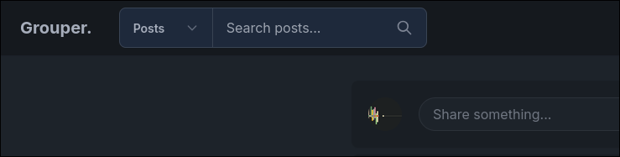
On the search results page you’ll arrive at, you’ll find all matching results, and you can add additional filters to your search from the sidebar on the left (on small screens, it’s accessed by clicking on the hamburger button at the top-left of the page).
The filters are the same for both Posts and Users:
- “In Contacts” checkbox:
Users that are in your contacts, or posts by those users
- “Matching Your Interests” checkbox:
Users that share one or more interests with you, or posts that include one or more of your interests.
- “Country” dropdown:
Users from the selected country, or posts by those users.
- “Interests” section:
Users or posts that have any of the selected interests (doesn’t filter if left empty).

3.5 Contacts
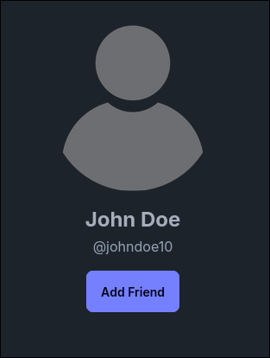
You can create contacts with other users, in order to be able to see their contacts-only posts and chat with them. First you need to send a contact request to a user, and if they accept it you’ll be added on each other’s contacts list.

3.5.1 Sending a Contact Request
- On another user’s profile, or when the user is displayed in user search, there is an “Add Friend” button near their name.
- By clicking on it, a contact request is sent by you to that user.
Now we have to wait for the other side to accept the contact request.

3.5.2 Accepting a Contact Request
- Click on the Contacts button (located on the navbar, left-most button of the right side), then on the dropdown select “Friend Requests”
- You will be navigated to the Friend Requests page, where you can see all your pending contact requests.
- To accept a user as your contact, simply click on the “Accept” button on the right.
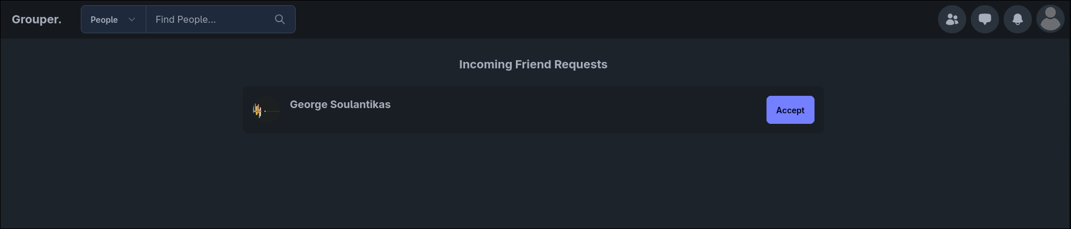

3.5.3 View your Contacts
Click on the Contacts button (located on the navbar, left-most button of the right side), then on the dropdown select “Contacts”. You will be navigated to the Contacts page, where you can see all your existing contacts.

3.6 Chat
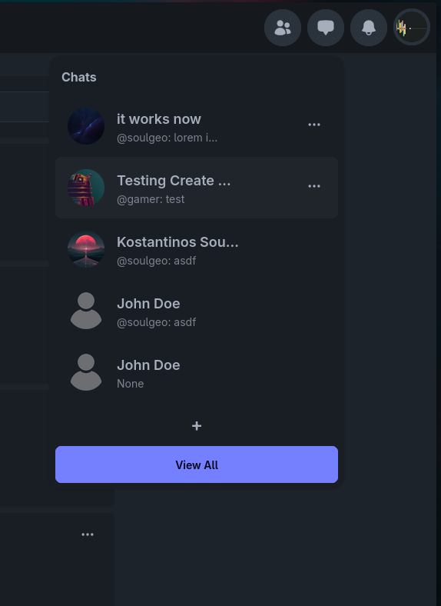
On Grouper, you can chat with your contacts directly or create group chats.
- Your chats can be accessed from the chat button on the navbar (2nd from the left).
- All of your contacts will appear in the chat dropdown that will open up, as well as any group chats that you’re a part of. They are ordered by latest message. If you receive a message from a chat or write a message to a chat, that chat will dynamically move to the top of the list.
- By clicking on any of the chats on the dropdown, a new chat popup will open up, where you can read and write messages in real time.
- You may minimize or close the popup from the corresponding buttons at its top-right.
- You can have multiple chat popups open at the same time, and your popups will remain open as you navigate from page to page.
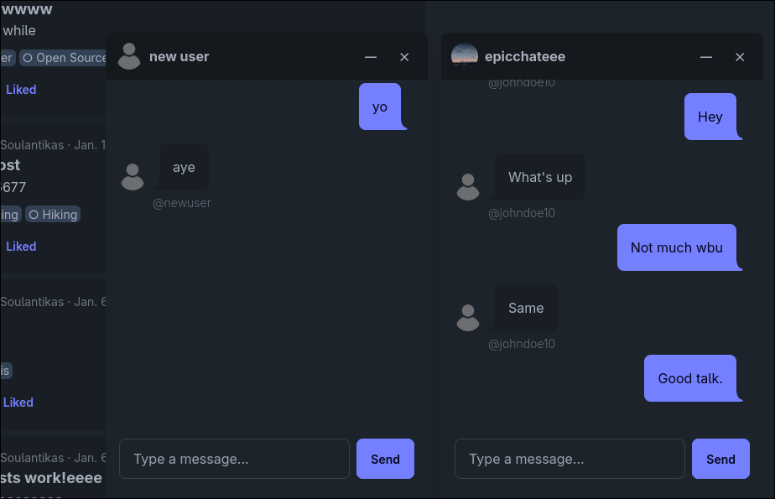

3.6.1 Creating a Group Chat
- Open the chat dropdown (Right-side buttons on navbar, 2nd from the left)
- On the chat dropdown, click on the “+” button at the bottom. This will open a Chat Creation Form popup.
- Fill out the form: Give your chat a name, select contacts to be included, and optionally upload a display image.
- Click on “Create”. Your new Group Chat will be created and added to your chat list at the top.

3.6.2 Editing a Group Chat
- Open the chat dropdown (Right-side buttons on navbar, 2nd from the left)
- On the chat dropdown, find the group chat you want to edit, and click on the three dots (“…”) on the right. On the new dropdown, select “Edit Chat Room”.
- Edit the form: Edit your chat’s name, select contacts to be included/excluded, and optionally update the display image.
- Click on “Edit”. Your Group Chat will be updated immediately.

3.6.3 Deleting a Group Chat
- Open the chat dropdown (Right-side buttons on navbar, 2nd from the left)
- On the chat dropdown, find the group chat you want to edit, and click on the three dots (“…”) on the right. On the new dropdown, select “Delete Chat Room”.
- You’ll be prompted with a confirmation message. If you’re sure, click on Delete and the chat room will be permanently deleted.

3.6.4 Chat Page
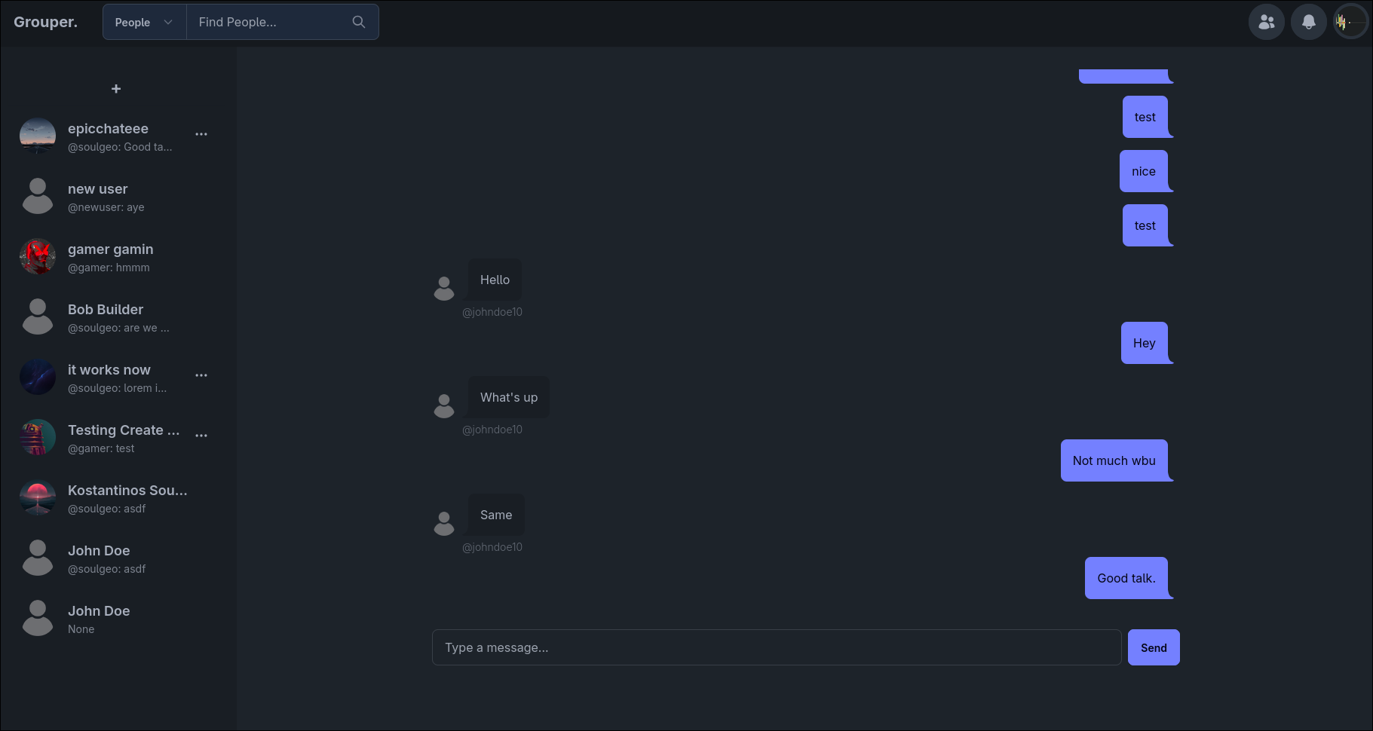
- If the popups don’t do it for you, you may access the chat page, where you can have a full page view of your chats.
- Access it by clicking on the “View All” button at the bottom of the Chat Dropdown.

4. Conclusion and Future Improvements
Building this application was a great way to get hands-on experience with full-stack web development. Using Django alongside HTMX and WebSockets allowed me to create a smooth, single-page app feel without having to rely on a heavy JavaScript framework. Setting up Docker and deploying the project to Fly.io was also a great opportunity to learn how web applications are actually launched and managed in the real world.
While the current version covers all the core requirements for a social media platform, there are a few features I would like to add or improve in the future:
- Comments: Something very common in social media apps that allow users to make posts: having the ability to write comments under a post, with their own like count. This one is top priority.
- More Notifications: The notification system is there, but its application is limited at the moment. It would be reasonable to have notifications sent for contact requests, first-time chat messages, post comments etc.
- Tagging: Having the ability to mention a user in a post or comment and have them notified for it.
- Automated Testing: Writing automated tests to make sure the app stays stable and bug-free as the codebase grows.
Overall, this project was a fantastic opportunity to put both backend coding and modern deployment strategies into practice, resulting in a fully working social networking app.

