DevOps Intern Assignment
Deployment Documentation
Docker, Virtualization & EC2 Deployment

Prepared For | Soulpage IT Solutions Pvt. Ltd.
Assignment Type | DevOps Intern Practical Assignment
EC2 Public IP | 13.126.185.187
AWS Region | Asia Pacific (Mumbai)
Date | March 2026

1. Overview
This document details the deployment of two applications — a Next.js frontend and a Django REST backend — on an AWS EC2 instance using Docker and Docker Compose. The setup includes a PostgreSQL database container, AWS Security Group configuration to expose required ports, and browser-based verification of both services running on the public EC2 IP.

2. Environment Setup — AWS EC2

2.1 EC2 Instance Configuration
Parameter | Value
Cloud Provider | Amazon Web Services (AWS)
Region | Asia Pacific (Mumbai) — ap-south-1
Public IP Address | 13.126.185.187
Operating System | Ubuntu 22.04 LTS
Security Group | sg-00536b5a0c674ee82 (launch-wizard-1)
Tools Installed | Docker Engine, Docker Compose, Git
Ports Opened | 22 (SSH), 3000 (Next.js), 8000 (Django)

2.2 Security Group — Inbound Rules Configuration
To make both applications accessible from a browser over the public internet, the EC2 Security Group inbound rules were edited via the AWS Console. The following three rules were added:

Purpose | Type | Protocol / Port | Source
SSH Access | SSH | TCP / 22 | 0.0.0.0/0
Next.js Frontend | Custom TCP | TCP / 3000 | 0.0.0.0/0
Django Backend | Custom TCP | TCP / 8000 | 0.0.0.0/0

Steps to configure inbound rules:
- Navigate to EC2 → Security Groups in the AWS Console.
- Select the security group: sg-00536b5a0c674ee82 (launch-wizard-1).
- Click the Inbound rules tab, then click Edit inbound rules.
- Add a Custom TCP rule for Port 3000 (IPv4, source 0.0.0.0/0) for the Next.js frontend.
- Add a Custom TCP rule for Port 8000 (IPv4, source 0.0.0.0/0) for the Django backend.
- Click Save rules.

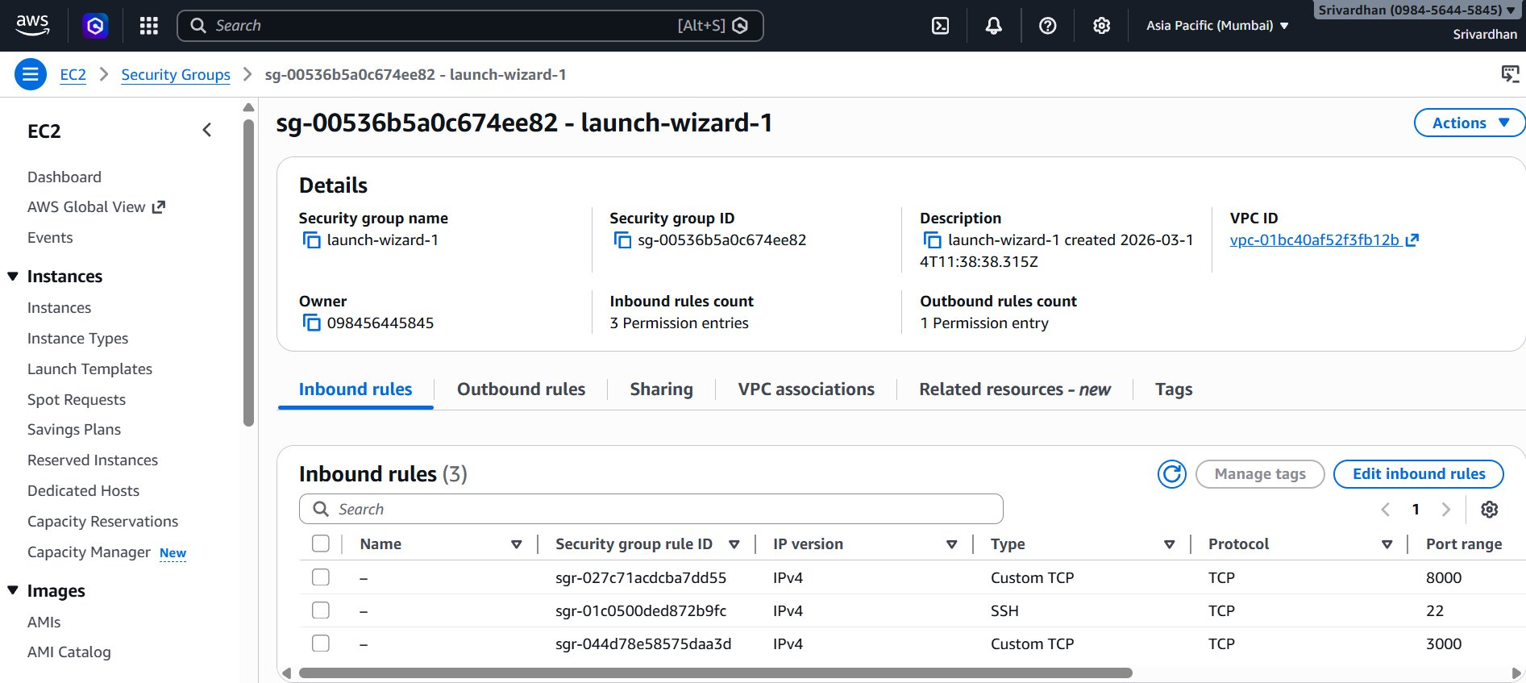
Figure 1: AWS EC2 Security Group — Inbound rules showing ports 22, 3000, and 8000 open (sg-00536b5a0c674ee82)

2.3 Repository Setup
The repository was cloned onto the EC2 instance via SSH and dependencies were managed through Docker:
git clone https://github.com/soulpage/fullstack-assignment
cd fullstack-assignment

3. Dockerization

3.1 Next.js Frontend — Dockerfile
The following Dockerfile was created inside the frontend/ directory to containerize the Next.js application:

FROM node:18
WORKDIR /app
COPY package*.json ./
RUN npm install
COPY . .
RUN npm run build
EXPOSE 3000
CMD ["npm", "start"]

- Uses Node.js 18 as the base image
- Installs dependencies first (layer caching optimization)
- Builds the Next.js production bundle with npm run build
- Exposes port 3000 and starts the production server

3.2 Django Backend — Dockerfile
The following Dockerfile was created inside the backend/ directory:

FROM python:3.10
WORKDIR /app
COPY dependencies.txt .
RUN pip install -r dependencies.txt
COPY . .
EXPOSE 8000
CMD ["python", "manage.py", "runserver", "0.0.0.0:8000"]

- Uses Python 3.10 slim base image
- Installs Python packages from dependencies.txt
- Binds to 0.0.0.0 so the container is reachable from outside
- Exposes port 8000 for the Django development server

3.3 Docker Compose — Multi-Container Setup
A docker-compose.yml file at the project root orchestrates three services — frontend, backend, and a PostgreSQL database — with proper dependency ordering and environment configuration:

services:
frontend:
build: ./frontend
ports:
- "3000:3000"
depends_on:
- backend
environment:
- NEXT_PUBLIC_BACKEND_URL=http://localhost:8000

backend:
build: ./backend
ports:
- "8000:8000"
env_file:
- ./backend/.env
depends_on:
- db

db:
image: postgres:15
restart: always
environment:
POSTGRES_DB: appdb
POSTGRES_USER: postgres
POSTGRES_PASSWORD: postgres
ports:
- "5432:5432"
volumes:
- postgres_data:/var/lib/postgresql/data

volumes:
postgres_data:

ℹ | The db service uses a named volume (postgres_data) to persist PostgreSQL data across container restarts. The backend depends_on: db ensures the database container starts before Django.

3.4 Building and Starting All Containers
All three services were launched from the EC2 instance with a single command:
docker-compose up --build -d

- --build forces a fresh image build for frontend and backend
- -d runs all containers in detached (background) mode
- Docker Compose automatically creates an internal network for service-to-service communication

4. Deployment Verification

4.1 Next.js Frontend — Live on EC2
After the containers started, the Next.js login page was accessed in a browser using the EC2 public IP address. The URL 13.126.185.187:3000/login loaded the full login UI, confirming the frontend container was running and port 3000 was correctly mapped and accessible via the Security Group rule.

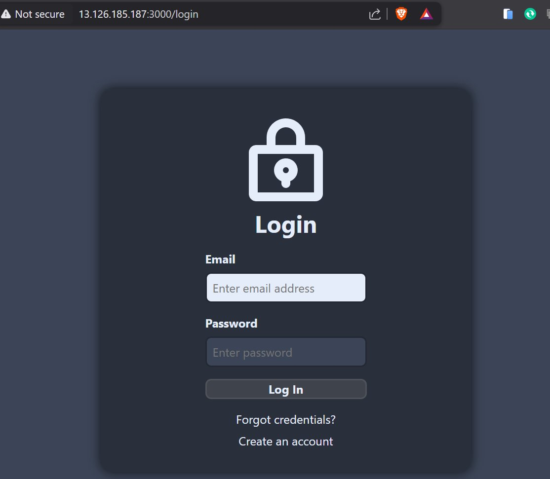
Figure 2: Next.js login page live at http://13.126.185.187:3000/login — rendered successfully on EC2

4.2 Django Backend — API Response on EC2
The Django backend was verified by navigating directly to http://13.126.185.187:8000 in the browser. The API returned a JSON response confirming the service was running correctly on port 8000.

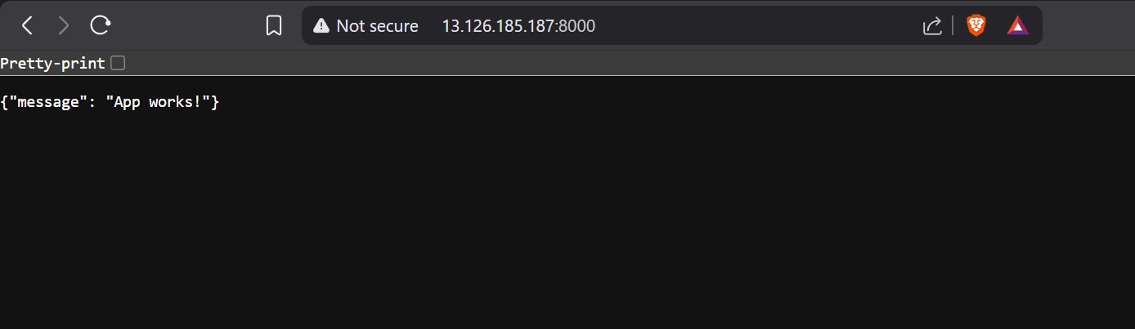
Figure 3: Django backend at http://13.126.185.187:8000 returns {"message": "App works!"} — HTTP 200

5. Results Summary
Application | Public URL | HTTP Status | Response
Next.js Frontend | 13.126.185.187:3000 | 200 OK | Login page rendered
Django Backend | 13.126.185.187:8000 | 200 OK | {"message":"App works!"}
PostgreSQL DB | Internal (port 5432) | Running | Persistent volume mounted

6. Infrastructure as Code (IaC)
Infrastructure as Code (IaC) was used to automate the provisioning and configuration of the AWS environment, making the setup reproducible and version-controlled. Two tools were used together: Terraform for provisioning the cloud infrastructure, and Ansible for configuring the EC2 instance after launch.

6.1 Tool Overview
Tool | Purpose | What It Manages
Terraform | Infrastructure Provisioning | EC2 instance, Security Group, key pair, VPC settings
Ansible | Configuration Management | Docker install, Docker Compose install, app deployment on EC2

6.2 Terraform — Provisioning EC2 & Security Group
Terraform was used to define and provision the AWS infrastructure declaratively. The configuration is split into three standard files: main.tf (resources), variables.tf (inputs), and outputs.tf (outputs).

File structure:
terraform/
├── main.tf
├── variables.tf
└── outputs.tf

main.tf — EC2 instance + Security Group:
provider "aws" {
region = var.aws_region
}

# Security Group — opens SSH, port 3000, port 8000
resource "aws_security_group" "app_sg" {
name = "launch-wizard-1"
description = "Allow SSH, frontend, and backend traffic"

ingress {
from_port = 22
to_port = 22
protocol = "tcp"
cidr_blocks = ["0.0.0.0/0"]
}
ingress {
from_port = 3000
to_port = 3000
protocol = "tcp"
cidr_blocks = ["0.0.0.0/0"]
}
ingress {
from_port = 8000
to_port = 8000
protocol = "tcp"
cidr_blocks = ["0.0.0.0/0"]
}
egress {
from_port = 0
to_port = 0
protocol = "-1"
cidr_blocks = ["0.0.0.0/0"]
}
}

# EC2 Instance
resource "aws_instance" "app_server" {
ami = var.ami_id
instance_type = var.instance_type
key_name = var.key_name
vpc_security_group_ids = [aws_security_group.app_sg.id]

tags = {
Name = "fullstack-app-server"
}
}

variables.tf:
variable "aws_region" { default = "ap-south-1" }
variable "ami_id" { default = "ami-0f58b397bc5c1f2e8" } # Ubuntu 22.04
variable "instance_type" { default = "t2.micro" }
variable "key_name" { default = "your-key-pair-name" }

outputs.tf:
output "instance_public_ip" {
value = aws_instance.app_server.public_ip
}

Terraform workflow commands:
terraform init # Download AWS provider plugins
terraform plan # Preview resources to be created
terraform apply # Provision EC2 instance + Security Group
terraform destroy # Tear down all provisioned resources

ℹ | After terraform apply, the EC2 public IP is printed as output. This IP (13.126.185.187) is the same address used to access both applications in the browser.

6.3 Ansible — Configuring EC2 & Deploying the App
After Terraform provisions the EC2 instance, Ansible connects over SSH and automates the full environment setup: installing Docker and Docker Compose, cloning the repository, and launching the application stack.

File structure:
ansible/
├── inventory.ini
├── playbook.yml
└── roles/
└── app/
└── tasks/
└── main.yml

inventory.ini — EC2 host definition:
[app_servers]
13.126.185.187 ansible_user=ubuntu ansible_ssh_private_key_file=~/.ssh/your-key.pem

playbook.yml — main playbook:
---
- name: Configure EC2 and deploy fullstack app
hosts: app_servers
become: true
tasks:

- name: Update apt packages
apt:
update_cache: yes

- name: Install Docker
apt:
name: docker.io
state: present

- name: Install Docker Compose
apt:
name: docker-compose
state: present

- name: Add ubuntu user to docker group
user:
name: ubuntu
groups: docker
append: yes

- name: Clone the repository
git:
repo: https://github.com/soulpage/fullstack-assignment
dest: /home/ubuntu/fullstack-assignment
force: yes

- name: Start application with Docker Compose
community.docker.docker_compose:
project_src: /home/ubuntu/fullstack-assignment
build: yes
state: present

Run the playbook:
ansible-playbook -i ansible/inventory.ini ansible/playbook.yml

ℹ | Ansible connects to the EC2 instance using the same SSH key pair configured in Terraform. Once the playbook finishes, Docker Compose automatically starts all three containers (frontend, backend, db) on the remote server.

6.4 IaC Workflow Summary
The complete provisioning and deployment flow using IaC:

Step | Tool | Action
1 | Terraform | terraform init + plan + apply → creates EC2 instance and Security Group on AWS
2 | Terraform | Outputs public IP of the newly created EC2 instance
3 | Ansible | Update inventory.ini with the EC2 public IP
4 | Ansible | ansible-playbook → installs Docker, Docker Compose, clones repo
5 | Ansible | docker-compose up --build -d → all containers start on the remote EC2
6 | Browser | Access http://<EC2-IP>:3000 and http://<EC2-IP>:8000 to verify deployment

7. Key Skills Demonstrated
- AWS EC2 Provisioning — launched and configured a cloud VM in the Asia Pacific (Mumbai) region
- Security Group management — edited inbound rules to expose ports 3000 and 8000 to the internet
- Docker containerization — wrote production-ready Dockerfiles for both Next.js and Django
- Docker Compose orchestration — managed a three-service stack (frontend, backend, database) with dependency ordering
- PostgreSQL integration — configured a managed Postgres container with a persistent named volume
- Environment variable management — used .env files and Docker Compose environment keys for secrets
- Infrastructure as Code with Terraform — defined EC2 instance and Security Group as code for repeatable provisioning
- Configuration Management with Ansible — automated Docker install, app clone, and container startup on EC2
- End-to-end deployment verification — confirmed both services live on a public IP via browser

8. Challenges & Solutions
Challenge | Resolution
App not accessible from browser on EC2 | Added Custom TCP rules in Security Group for ports 3000 and 8000 with source 0.0.0.0/0
Backend container failing to connect to DB | Used depends_on: db in docker-compose.yml so Postgres starts before Django
Next.js build failing inside Docker | Excluded node_modules via .dockerignore; copied package.json first for layer caching
Django not binding to all interfaces | Set runserver 0.0.0.0:8000 in CMD so it accepts connections from outside the container
Environment secrets exposure | Used env_file: ./backend/.env in compose to keep credentials out of the Dockerfile

— End of Document —

