ПИ

ПОИТ, 3к

**Протокол WebDAV**

1. **WebDAV**: Web Distributed Authoring and Versioning – расширение протокола HTTP/HTTPS, поддерживающее совместную работу по управление файлами на удаленных web-северах; применяется для создания сетевой файловой системы; в системах документооборота (document management system).
2. **WebDAV**: альтернатива FTP, SMB.
3. **WebDAV**: OS X (Apple) iDisk, Яндекс.Диск, Box.net, Google Drive, Amazon Microsoft IIS, Apache HTTP Server, Dropbox.
4. **WebDAV**: в Windows WebDAV API C++.
5. **WebDAV**: **унаследованные HTTP-методы**
6. **WebDAV**: **GET** – скачать файл.
7. **WebDAV**: **PUT** – загрузить файл на сервер.
8. **WebDAV**: **DELETE** – удалить серверный объект.
9. **WebDAV**: RFC 2291, RFC 4918, RFC 3648, RFC 3744, RFC 3253.

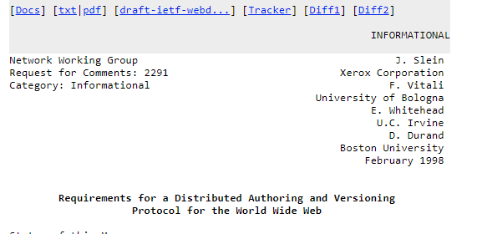

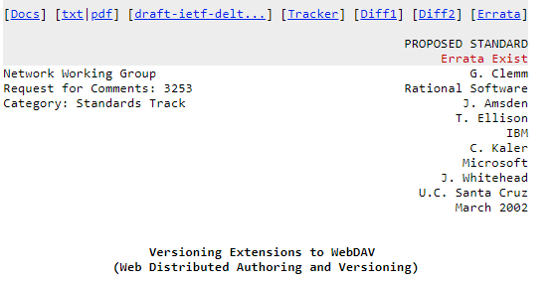

1. **WebDAV**: **RFC 3253**
2. **WebDAV RFC 3253**: **BASELINE-CONTROL**
3. **WebDAV RFC 3253: CHECKOUT**
4. **WebDAV RFC 3253: CHECKIN**
5. **WebDAV RFC 3253: LABEL**
6. **WebDAV RFC 3253: MERGE**
7. **WebDAV RFC 3253: MKACTIVITY**
8. **WebDAV RFC 3253: MKWORKSPACE**
9. **WebDAV RFC 3253: REPORT**
10. **WebDAV RFC 3253: UNCHECKOUT**
11. **WebDAV RFC 3253: UPDATE**
12. **WebDAV RFC 3253: VERSION-CONTROL**

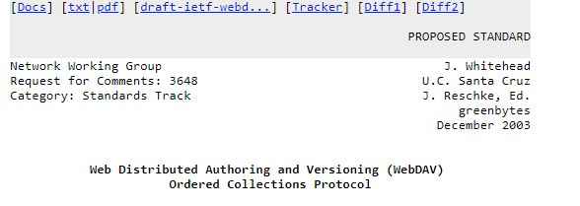

1. **WebDAV**: **RFC 3648**
2. **WebDAV** **RFC 3648: ORDERPATH**

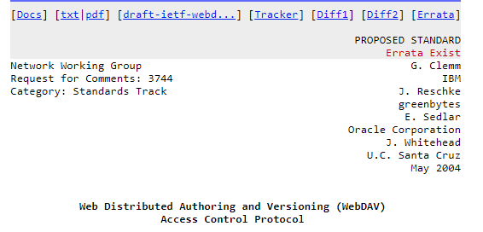

1. **WebDAV**: **RFC 3744**
2. **WebDAV** **RFC 3744: ACL**

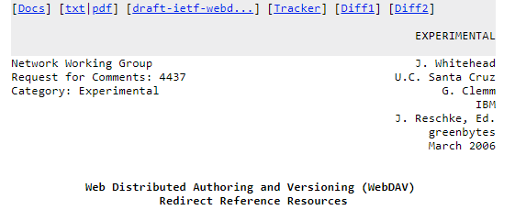

1. **WebDAV**: **RFC 4437**
2. **WebDAV** **RFC 4437: UPDATEREDIRECTREF**

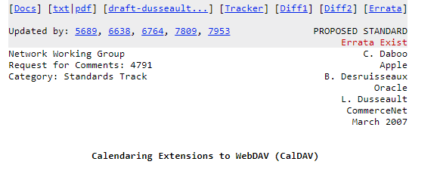

1. **WebDAV**: **RFC 4791**
2. **WebDAV** **RFC 4791: MKCALENDAR**

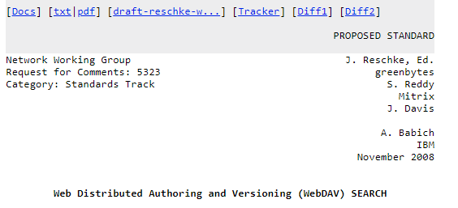

1. **WebDAV**: **RFC 5323**
2. **WebDAV** **RFC 5323: SEARH**

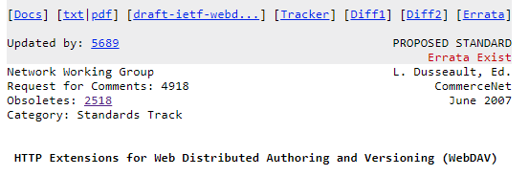

1. **WebDAV RFC 5618: PROPFIND** – получить свойства серверного объекта в XML-формате.
2. **WebDAV RFC 5618: PROPPATCH** – изменить свойства серверного объекта.
3. **WebDAV RFC 5618: MKCOL** – создать папку на сервере.
4. **WebDAV RFC 5618: COPY** – копировать на сервере.
5. **WebDAV RFC 5618: MOVE** – переместить на сервере.
6. **WebDAV RFC 5618: LOCK**  – заблокировать серверный объект.
7. **WebDAV RFC 5618: UNLOCK** – разблокировать серверный объект.

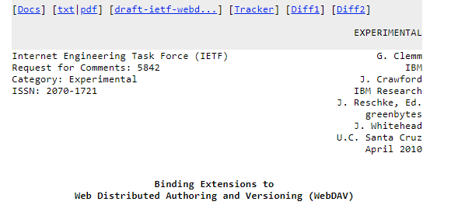

1. **WebDAV RFC 5842: BIND**.
2. **WebDAV RFC 5842: REBIND**.
3. **WebDAV RFC 5842: UNBIND**.
4. **WebDAV:** Яндекс.Диск

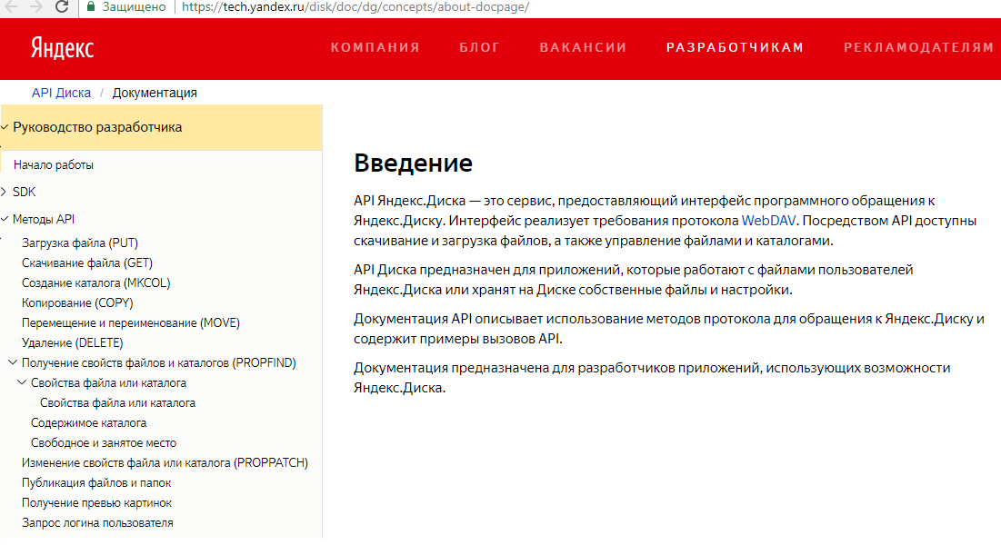

1. **WebDAV:** Яндекс.Диск, зарегистрироваться и получить имя и пароль
2. **WebDAV:** Яндекс.Диск - создать папку

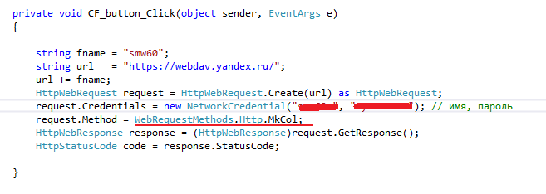

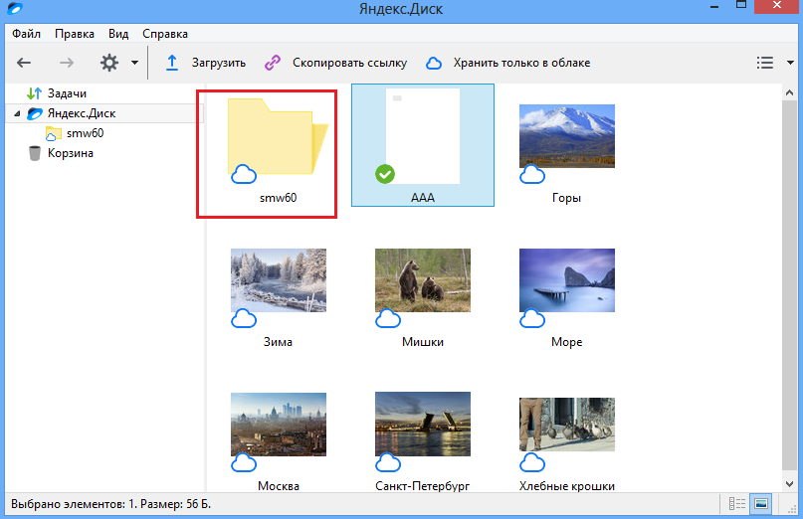

1. **WebDAV:** Яндекс.Диск - скачать файл

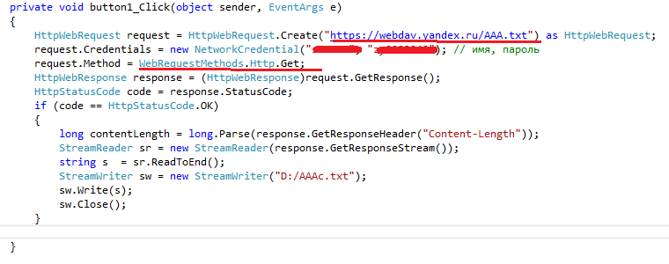

1. **WebDAV:** Яндекс.Диск - удалить файл

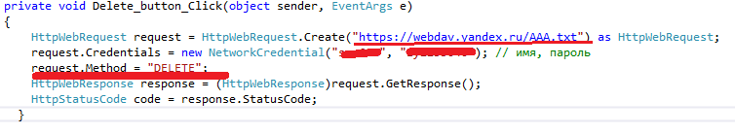

1. **WebDAV:** Яндекс.Диск - удалить папку

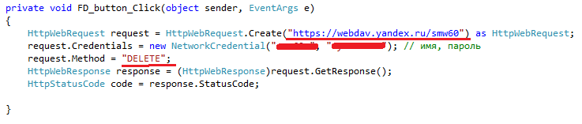

1. **Методы**
2. HTTP Request Methods
3. The following 39 HTTP Request Method values were found in [all available webconcepts.infospecifications](http://webconcepts.info/specs). Please be advised that the table shown here is maintained and compiled from [Web Concepts](http://webconcepts.info/) sources. The [official HTTP Request Method registry](http://www.iana.org/assignments/http-methods/http-methods.xhtml" \l "methods) is maintained by the *[Internet Assigned Numbers Authority (IANA)](http://www.iana.org/)*.

| **HTTP Request Method** | **Specification** |
| --- | --- |
| [ACL](http://webconcepts.info/concepts/http-method/ACL) | **[RFC 3744](http://webconcepts.info/specs/IETF/RFC/3744" \o "This document specifies a set of methods, headers, message bodies, properties, and reports that define Access Control extensions to the WebDAV Distributed Authoring Protocol. This protocol permits a client to read and modify access control lists that inst)**[: Web Distributed Authoring and Versioning (WebDAV) Access Control Protocol](http://webconcepts.info/specs/IETF/RFC/3744" \o "This document specifies a set of methods, headers, message bodies, properties, and reports that define Access Control extensions to the WebDAV Distributed Authoring Protocol. This protocol permits a client to read and modify access control lists that inst) |
| [BASELINE-CONTROL](http://webconcepts.info/concepts/http-method/BASELINE-CONTROL" \o "A collection can be placed under baseline control with a BASELINE-CONTROL request. When a collection is placed under baseline control, the DAV:version-controlled-configuration property of the collection is set to identify a new version-controlled configur) | **[RFC 3253](http://webconcepts.info/specs/IETF/RFC/3253" \o "This document specifies a set of methods, headers, and resource types that define the WebDAV (Web Distributed Authoring and Versioning) versioning extensions to the HTTP/1.1 protocol. WebDAV versioning will minimize the complexity of clients that are capa)**[: Versioning Extensions to WebDAV (Web Distributed Authoring and Versioning)](http://webconcepts.info/specs/IETF/RFC/3253" \o "This document specifies a set of methods, headers, and resource types that define the WebDAV (Web Distributed Authoring and Versioning) versioning extensions to the HTTP/1.1 protocol. WebDAV versioning will minimize the complexity of clients that are capa) |
| [BIND](http://webconcepts.info/concepts/http-method/BIND" \o "The BIND method modifies the collection identified by the Request-URI, by adding a new binding from the segment specified in the BIND body to the resource identified in the BIND body.) | **[RFC 5842](http://webconcepts.info/specs/IETF/RFC/5842" \o "This specification defines bindings, and the BIND method for creating multiple bindings to the same resource. Creating a new binding to a resource causes at least one new URI to be mapped to that resource. Servers are required to ensure the integrity of a)**[: Binding Extensions to Web Distributed Authoring and Versioning (WebDAV)](http://webconcepts.info/specs/IETF/RFC/5842" \o "This specification defines bindings, and the BIND method for creating multiple bindings to the same resource. Creating a new binding to a resource causes at least one new URI to be mapped to that resource. Servers are required to ensure the integrity of a) |
| [CHECKIN](http://webconcepts.info/concepts/http-method/CHECKIN" \o "A CHECKIN request can be applied to a checked-out version-controlled resource to produce a new version whose content and dead properties are copied from the checked-out resource.) | **[RFC 3253](http://webconcepts.info/specs/IETF/RFC/3253" \o "This document specifies a set of methods, headers, and resource types that define the WebDAV (Web Distributed Authoring and Versioning) versioning extensions to the HTTP/1.1 protocol. WebDAV versioning will minimize the complexity of clients that are capa)**[: Versioning Extensions to WebDAV (Web Distributed Authoring and Versioning)](http://webconcepts.info/specs/IETF/RFC/3253" \o "This document specifies a set of methods, headers, and resource types that define the WebDAV (Web Distributed Authoring and Versioning) versioning extensions to the HTTP/1.1 protocol. WebDAV versioning will minimize the complexity of clients that are capa) |
| [CHECKOUT](http://webconcepts.info/concepts/http-method/CHECKOUT" \o "A CHECKOUT request can be applied to a checked-in version-controlled resource to allow modifications to the content and dead properties of that version-controlled resource.) | **[RFC 3253](http://webconcepts.info/specs/IETF/RFC/3253" \o "This document specifies a set of methods, headers, and resource types that define the WebDAV (Web Distributed Authoring and Versioning) versioning extensions to the HTTP/1.1 protocol. WebDAV versioning will minimize the complexity of clients that are capa)**[: Versioning Extensions to WebDAV (Web Distributed Authoring and Versioning)](http://webconcepts.info/specs/IETF/RFC/3253" \o "This document specifies a set of methods, headers, and resource types that define the WebDAV (Web Distributed Authoring and Versioning) versioning extensions to the HTTP/1.1 protocol. WebDAV versioning will minimize the complexity of clients that are capa) |
| [CONNECT](http://webconcepts.info/concepts/http-method/CONNECT" \o "The CONNECT method requests that the recipient establish a tunnel to the destination origin server identified by the request-target and, if successful, thereafter restrict its behavior to blind forwarding of packets, in both directions, until the tunnel i) | **[RFC 7231](http://webconcepts.info/specs/IETF/RFC/7231" \o "The Hypertext Transfer Protocol (HTTP) is an application-level protocol for distributed, collaborative, hypertext information systems. This document defines the semantics of HTTP/1.1 messages as expressed by request methods, request header fields, respons)**[: Hypertext Transfer Protocol (HTTP/1.1): Semantics and Content](http://webconcepts.info/specs/IETF/RFC/7231" \o "The Hypertext Transfer Protocol (HTTP) is an application-level protocol for distributed, collaborative, hypertext information systems. This document defines the semantics of HTTP/1.1 messages as expressed by request methods, request header fields, respons) |
| [COPY](http://webconcepts.info/concepts/http-method/COPY" \o "The COPY method creates a duplicate of the source resource identified by the Request-URI, in the destination resource identified by the URI in the Destination header. The Destination header MUST be present. The exact behavior of the COPY method depends on) | **[RFC 4918](http://webconcepts.info/specs/IETF/RFC/4918" \o "Web Distributed Authoring and Versioning (WebDAV) consists of a set of methods, headers, and content-types ancillary to HTTP/1.1 for the management of resource properties, creation and management of resource collections, URL namespace manipulation, and re)**[: HTTP Extensions for Web Distributed Authoring and Versioning (WebDAV)](http://webconcepts.info/specs/IETF/RFC/4918" \o "Web Distributed Authoring and Versioning (WebDAV) consists of a set of methods, headers, and content-types ancillary to HTTP/1.1 for the management of resource properties, creation and management of resource collections, URL namespace manipulation, and re) |
| [DELETE](http://webconcepts.info/concepts/http-method/DELETE" \o "The DELETE method requests that the origin server remove the association between the target resource and its current functionality. In effect, this method is similar to the rm command in UNIX: it expresses a deletion operation on the URI mapping of the or) | **[RFC 7231](http://webconcepts.info/specs/IETF/RFC/7231" \o "The Hypertext Transfer Protocol (HTTP) is an application-level protocol for distributed, collaborative, hypertext information systems. This document defines the semantics of HTTP/1.1 messages as expressed by request methods, request header fields, respons)**[: Hypertext Transfer Protocol (HTTP/1.1): Semantics and Content](http://webconcepts.info/specs/IETF/RFC/7231" \o "The Hypertext Transfer Protocol (HTTP) is an application-level protocol for distributed, collaborative, hypertext information systems. This document defines the semantics of HTTP/1.1 messages as expressed by request methods, request header fields, respons) |
| [GET](http://webconcepts.info/concepts/http-method/GET" \o "The GET method requests transfer of a current selected representation for the target resource. GET is the primary mechanism of information retrieval and the focus of almost all performance optimizations. Hence, when people speak of retrieving some identif) | **[RFC 7231](http://webconcepts.info/specs/IETF/RFC/7231" \o "The Hypertext Transfer Protocol (HTTP) is an application-level protocol for distributed, collaborative, hypertext information systems. This document defines the semantics of HTTP/1.1 messages as expressed by request methods, request header fields, respons)**[: Hypertext Transfer Protocol (HTTP/1.1): Semantics and Content](http://webconcepts.info/specs/IETF/RFC/7231" \o "The Hypertext Transfer Protocol (HTTP) is an application-level protocol for distributed, collaborative, hypertext information systems. This document defines the semantics of HTTP/1.1 messages as expressed by request methods, request header fields, respons) |
| [HEAD](http://webconcepts.info/concepts/http-method/HEAD" \o "The HEAD method is identical to GET except that the server MUST NOT send a message body in the response (i.e., the response terminates at the end of the header section). The server SHOULD send the same header fields in response to a HEAD request as it wou) | **[RFC 7231](http://webconcepts.info/specs/IETF/RFC/7231" \o "The Hypertext Transfer Protocol (HTTP) is an application-level protocol for distributed, collaborative, hypertext information systems. This document defines the semantics of HTTP/1.1 messages as expressed by request methods, request header fields, respons)**[: Hypertext Transfer Protocol (HTTP/1.1): Semantics and Content](http://webconcepts.info/specs/IETF/RFC/7231" \o "The Hypertext Transfer Protocol (HTTP) is an application-level protocol for distributed, collaborative, hypertext information systems. This document defines the semantics of HTTP/1.1 messages as expressed by request methods, request header fields, respons) |
| [LABEL](http://webconcepts.info/concepts/http-method/LABEL" \o "A LABEL request can be applied to a version to modify the labels that select that version. The case of a label name MUST be preserved when it is stored and retrieved. When comparing two label names to decide if they match or not, a server SHOULD use a cas) | **[RFC 3253](http://webconcepts.info/specs/IETF/RFC/3253" \o "This document specifies a set of methods, headers, and resource types that define the WebDAV (Web Distributed Authoring and Versioning) versioning extensions to the HTTP/1.1 protocol. WebDAV versioning will minimize the complexity of clients that are capa)**[: Versioning Extensions to WebDAV (Web Distributed Authoring and Versioning)](http://webconcepts.info/specs/IETF/RFC/3253" \o "This document specifies a set of methods, headers, and resource types that define the WebDAV (Web Distributed Authoring and Versioning) versioning extensions to the HTTP/1.1 protocol. WebDAV versioning will minimize the complexity of clients that are capa) |
| [LINK](http://webconcepts.info/concepts/http-method/LINK" \o "The LINK method is used to establish one or more relationships between the resource identified by the effective request URI and one or more other resources.) | **[Internet Draft snell-link-method](http://webconcepts.info/specs/IETF/I-D/snell-link-method" \o "This specification defines the semantics of the LINK and UNLINK HTTP methods.)**[: HTTP Link and Unlink Methods](http://webconcepts.info/specs/IETF/I-D/snell-link-method" \o "This specification defines the semantics of the LINK and UNLINK HTTP methods.) |
| [LOCK](http://webconcepts.info/concepts/http-method/LOCK" \o "The LOCK method is used to take out a lock of any access type and to refresh an existing lock.) | **[RFC 4918](http://webconcepts.info/specs/IETF/RFC/4918" \o "Web Distributed Authoring and Versioning (WebDAV) consists of a set of methods, headers, and content-types ancillary to HTTP/1.1 for the management of resource properties, creation and management of resource collections, URL namespace manipulation, and re)**[: HTTP Extensions for Web Distributed Authoring and Versioning (WebDAV)](http://webconcepts.info/specs/IETF/RFC/4918" \o "Web Distributed Authoring and Versioning (WebDAV) consists of a set of methods, headers, and content-types ancillary to HTTP/1.1 for the management of resource properties, creation and management of resource collections, URL namespace manipulation, and re) |
| [MERGE](http://webconcepts.info/concepts/http-method/MERGE" \o "The MERGE method performs the logical merge of a specified version (the \"merge source\") into a specified version-controlled resource (the \"merge target\"). If the merge source is neither an ancestor nor a descendant of the DAV:checked-in or DAV:checked-out) | **[RFC 3253](http://webconcepts.info/specs/IETF/RFC/3253" \o "This document specifies a set of methods, headers, and resource types that define the WebDAV (Web Distributed Authoring and Versioning) versioning extensions to the HTTP/1.1 protocol. WebDAV versioning will minimize the complexity of clients that are capa)**[: Versioning Extensions to WebDAV (Web Distributed Authoring and Versioning)](http://webconcepts.info/specs/IETF/RFC/3253" \o "This document specifies a set of methods, headers, and resource types that define the WebDAV (Web Distributed Authoring and Versioning) versioning extensions to the HTTP/1.1 protocol. WebDAV versioning will minimize the complexity of clients that are capa) |
| [MKACTIVITY](http://webconcepts.info/concepts/http-method/MKACTIVITY" \o "A MKACTIVITY request creates a new activity resource. A server MAY restrict activity creation to particular collections, but a client can determine the location of these collections from a DAV:activity-collection-set OPTIONS request.) | **[RFC 3253](http://webconcepts.info/specs/IETF/RFC/3253" \o "This document specifies a set of methods, headers, and resource types that define the WebDAV (Web Distributed Authoring and Versioning) versioning extensions to the HTTP/1.1 protocol. WebDAV versioning will minimize the complexity of clients that are capa)**[: Versioning Extensions to WebDAV (Web Distributed Authoring and Versioning)](http://webconcepts.info/specs/IETF/RFC/3253" \o "This document specifies a set of methods, headers, and resource types that define the WebDAV (Web Distributed Authoring and Versioning) versioning extensions to the HTTP/1.1 protocol. WebDAV versioning will minimize the complexity of clients that are capa) |
| [MKCALENDAR](http://webconcepts.info/concepts/http-method/MKCALENDAR" \o "An HTTP request using the MKCALENDAR method creates a new calendar collection resource. A server MAY restrict calendar collection creation to particular collections.) | **[RFC 4791](http://webconcepts.info/specs/IETF/RFC/4791" \o "This document defines extensions to the Web Distributed Authoring and Versioning (WebDAV) protocol to specify a standard way of accessing, managing, and sharing calendaring and scheduling information based on the iCalendar format. This document defines th)**[: Calendaring Extensions to WebDAV (CalDAV)](http://webconcepts.info/specs/IETF/RFC/4791" \o "This document defines extensions to the Web Distributed Authoring and Versioning (WebDAV) protocol to specify a standard way of accessing, managing, and sharing calendaring and scheduling information based on the iCalendar format. This document defines th) |
| [MKCOL](http://webconcepts.info/concepts/http-method/MKCOL" \o "MKCOL creates a new collection resource at the location specified by the Request-URI. If the Request-URI is already mapped to a resource, then the MKCOL MUST fail. During MKCOL processing, a server MUST make the Request-URI an internal member of its paren) | **[RFC 4918](http://webconcepts.info/specs/IETF/RFC/4918" \o "Web Distributed Authoring and Versioning (WebDAV) consists of a set of methods, headers, and content-types ancillary to HTTP/1.1 for the management of resource properties, creation and management of resource collections, URL namespace manipulation, and re)**[: HTTP Extensions for Web Distributed Authoring and Versioning (WebDAV)](http://webconcepts.info/specs/IETF/RFC/4918" \o "Web Distributed Authoring and Versioning (WebDAV) consists of a set of methods, headers, and content-types ancillary to HTTP/1.1 for the management of resource properties, creation and management of resource collections, URL namespace manipulation, and re) |
| [MKREDIRECTREF](http://webconcepts.info/concepts/http-method/MKREDIRECTREF" \o "The MKREDIRECTREF method requests the creation of a redirect reference resource.) | **[RFC 4437](http://webconcepts.info/specs/IETF/RFC/4437" \o "This specification defines an extension to Web Distributed Authoring and Versioning (WebDAV) to allow clients to author HTTP redirect reference resources whose default response is an HTTP/1.1 3xx (Redirection) status code. A redirect reference makes it po)**[: Web Distributed Authoring and Versioning (WebDAV): Redirect Reference Resources](http://webconcepts.info/specs/IETF/RFC/4437" \o "This specification defines an extension to Web Distributed Authoring and Versioning (WebDAV) to allow clients to author HTTP redirect reference resources whose default response is an HTTP/1.1 3xx (Redirection) status code. A redirect reference makes it po) |
| [MKWORKSPACE](http://webconcepts.info/concepts/http-method/MKWORKSPACE" \o "A MKWORKSPACE request creates a new workspace resource. A server MAY restrict workspace creation to particular collections, but a client can determine the location of these collections from a DAV:workspace-collection-set OPTIONS request.) | **[RFC 3253](http://webconcepts.info/specs/IETF/RFC/3253" \o "This document specifies a set of methods, headers, and resource types that define the WebDAV (Web Distributed Authoring and Versioning) versioning extensions to the HTTP/1.1 protocol. WebDAV versioning will minimize the complexity of clients that are capa)**[: Versioning Extensions to WebDAV (Web Distributed Authoring and Versioning)](http://webconcepts.info/specs/IETF/RFC/3253" \o "This document specifies a set of methods, headers, and resource types that define the WebDAV (Web Distributed Authoring and Versioning) versioning extensions to the HTTP/1.1 protocol. WebDAV versioning will minimize the complexity of clients that are capa) |
| [MOVE](http://webconcepts.info/concepts/http-method/MOVE" \o "The MOVE operation on a non-collection resource is the logical equivalent of a copy (COPY), followed by consistency maintenance processing, followed by a delete of the source, where all three actions are performed in a single operation. The consistency ma) | **[RFC 4918](http://webconcepts.info/specs/IETF/RFC/4918" \o "Web Distributed Authoring and Versioning (WebDAV) consists of a set of methods, headers, and content-types ancillary to HTTP/1.1 for the management of resource properties, creation and management of resource collections, URL namespace manipulation, and re)**[: HTTP Extensions for Web Distributed Authoring and Versioning (WebDAV)](http://webconcepts.info/specs/IETF/RFC/4918" \o "Web Distributed Authoring and Versioning (WebDAV) consists of a set of methods, headers, and content-types ancillary to HTTP/1.1 for the management of resource properties, creation and management of resource collections, URL namespace manipulation, and re) |
| [OPTIONS](http://webconcepts.info/concepts/http-method/OPTIONS" \o "The OPTIONS method requests information about the communication options available for the target resource, at either the origin server or an intervening intermediary. This method allows a client to determine the options and/or requirements associated with) | **[RFC 7231](http://webconcepts.info/specs/IETF/RFC/7231" \o "The Hypertext Transfer Protocol (HTTP) is an application-level protocol for distributed, collaborative, hypertext information systems. This document defines the semantics of HTTP/1.1 messages as expressed by request methods, request header fields, respons)**[: Hypertext Transfer Protocol (HTTP/1.1): Semantics and Content](http://webconcepts.info/specs/IETF/RFC/7231" \o "The Hypertext Transfer Protocol (HTTP) is an application-level protocol for distributed, collaborative, hypertext information systems. This document defines the semantics of HTTP/1.1 messages as expressed by request methods, request header fields, respons) |
| [ORDERPATCH](http://webconcepts.info/concepts/http-method/ORDERPATCH" \o "The ORDERPATCH method is used to change the ordering semantics of a collection, to change the order of the collection's members in the ordering, or both.) | **[RFC 3648](http://webconcepts.info/specs/IETF/RFC/3648" \o "This specification extends the Web Distributed Authoring and Versioning (WebDAV) Protocol to support the server-side ordering of collection members. Of particular interest are orderings that are not based on property values, and so cannot be achieved usin)**[: Web Distributed Authoring and Versioning (WebDAV) Ordered Collections Protocol](http://webconcepts.info/specs/IETF/RFC/3648" \o "This specification extends the Web Distributed Authoring and Versioning (WebDAV) Protocol to support the server-side ordering of collection members. Of particular interest are orderings that are not based on property values, and so cannot be achieved usin) |
| [PATCH](http://webconcepts.info/concepts/http-method/PATCH" \o "The PATCH method requests that a set of changes described in the request entity be applied to the resource identified by the Request-URI. The set of changes is represented in a format called a \"patch document\" identified by a media type. If the Request-UR) | **[RFC 5789](http://webconcepts.info/specs/IETF/RFC/5789" \o "Several applications extending the Hypertext Transfer Protocol (HTTP) require a feature to do partial resource modification. The existing HTTP PUT method only allows a complete replacement of a document. This proposal adds a new HTTP method, PATCH, to mod)**[: PATCH Method for HTTP](http://webconcepts.info/specs/IETF/RFC/5789" \o "Several applications extending the Hypertext Transfer Protocol (HTTP) require a feature to do partial resource modification. The existing HTTP PUT method only allows a complete replacement of a document. This proposal adds a new HTTP method, PATCH, to mod) |
| [POST](http://webconcepts.info/concepts/http-method/POST" \o "The POST method requests that the target resource process the representation enclosed in the request according to the resource's own specific semantics.) | **[RFC 7231](http://webconcepts.info/specs/IETF/RFC/7231" \o "The Hypertext Transfer Protocol (HTTP) is an application-level protocol for distributed, collaborative, hypertext information systems. This document defines the semantics of HTTP/1.1 messages as expressed by request methods, request header fields, respons)**[: Hypertext Transfer Protocol (HTTP/1.1): Semantics and Content](http://webconcepts.info/specs/IETF/RFC/7231" \o "The Hypertext Transfer Protocol (HTTP) is an application-level protocol for distributed, collaborative, hypertext information systems. This document defines the semantics of HTTP/1.1 messages as expressed by request methods, request header fields, respons) |
| [PRI](http://webconcepts.info/concepts/http-method/PRI" \o "This method is never used by an actual client. This method will appear to be used when an HTTP/1.1 server or intermediary attempts to parse an HTTP/2 connection preface.) | **[RFC 7540](http://webconcepts.info/specs/IETF/RFC/7540" \o "This specification describes an optimized expression of the semantics of the Hypertext Transfer Protocol (HTTP). HTTP/2 enables a more efficient use of network resources and a reduced perception of latency by introducing header field compression and allow)**[: Hypertext Transfer Protocol Version 2](http://webconcepts.info/specs/IETF/RFC/7540" \o "This specification describes an optimized expression of the semantics of the Hypertext Transfer Protocol (HTTP). HTTP/2 enables a more efficient use of network resources and a reduced perception of latency by introducing header field compression and allow) |
| [PROPFIND](http://webconcepts.info/concepts/http-method/PROPFIND" \o "The PROPFIND method retrieves properties defined on the resource identified by the Request-URI, if the resource does not have any internal members, or on the resource identified by the Request-URI and potentially its member resources, if the resource is a) | **[RFC 4918](http://webconcepts.info/specs/IETF/RFC/4918" \o "Web Distributed Authoring and Versioning (WebDAV) consists of a set of methods, headers, and content-types ancillary to HTTP/1.1 for the management of resource properties, creation and management of resource collections, URL namespace manipulation, and re)**[: HTTP Extensions for Web Distributed Authoring and Versioning (WebDAV)](http://webconcepts.info/specs/IETF/RFC/4918" \o "Web Distributed Authoring and Versioning (WebDAV) consists of a set of methods, headers, and content-types ancillary to HTTP/1.1 for the management of resource properties, creation and management of resource collections, URL namespace manipulation, and re) |
| [PROPPATCH](http://webconcepts.info/concepts/http-method/PROPPATCH" \o "The PROPPATCH method processes instructions specified in the request body to set and/or remove properties defined on the resource identified by the Request-URI.) | **[RFC 4918](http://webconcepts.info/specs/IETF/RFC/4918" \o "Web Distributed Authoring and Versioning (WebDAV) consists of a set of methods, headers, and content-types ancillary to HTTP/1.1 for the management of resource properties, creation and management of resource collections, URL namespace manipulation, and re)**[: HTTP Extensions for Web Distributed Authoring and Versioning (WebDAV)](http://webconcepts.info/specs/IETF/RFC/4918" \o "Web Distributed Authoring and Versioning (WebDAV) consists of a set of methods, headers, and content-types ancillary to HTTP/1.1 for the management of resource properties, creation and management of resource collections, URL namespace manipulation, and re) |
| [PUT](http://webconcepts.info/concepts/http-method/PUT" \o "The PUT method requests that the state of the target resource be created or replaced with the state defined by the representation enclosed in the request message payload. A successful PUT of a given representation would suggest that a subsequent GET on th) | **[RFC 7231](http://webconcepts.info/specs/IETF/RFC/7231" \o "The Hypertext Transfer Protocol (HTTP) is an application-level protocol for distributed, collaborative, hypertext information systems. This document defines the semantics of HTTP/1.1 messages as expressed by request methods, request header fields, respons)**[: Hypertext Transfer Protocol (HTTP/1.1): Semantics and Content](http://webconcepts.info/specs/IETF/RFC/7231" \o "The Hypertext Transfer Protocol (HTTP) is an application-level protocol for distributed, collaborative, hypertext information systems. This document defines the semantics of HTTP/1.1 messages as expressed by request methods, request header fields, respons) |
| [REBIND](http://webconcepts.info/concepts/http-method/REBIND" \o "The REBIND method removes a binding to a resource from a collection, and adds a binding to that resource into the collection identified by the Request-URI. The request body specifies the binding to be added (segment) and the old binding to be removed (hre) | **[RFC 5842](http://webconcepts.info/specs/IETF/RFC/5842" \o "This specification defines bindings, and the BIND method for creating multiple bindings to the same resource. Creating a new binding to a resource causes at least one new URI to be mapped to that resource. Servers are required to ensure the integrity of a)**[: Binding Extensions to Web Distributed Authoring and Versioning (WebDAV)](http://webconcepts.info/specs/IETF/RFC/5842" \o "This specification defines bindings, and the BIND method for creating multiple bindings to the same resource. Creating a new binding to a resource causes at least one new URI to be mapped to that resource. Servers are required to ensure the integrity of a) |
| [REPORT](http://webconcepts.info/concepts/http-method/REPORT" \o "A REPORT request is an extensible mechanism for obtaining information about a resource. Unlike a resource property, which has a single value, the value of a report can depend on additional information specified in the REPORT request body and in the REPORT) | **[RFC 3253](http://webconcepts.info/specs/IETF/RFC/3253" \o "This document specifies a set of methods, headers, and resource types that define the WebDAV (Web Distributed Authoring and Versioning) versioning extensions to the HTTP/1.1 protocol. WebDAV versioning will minimize the complexity of clients that are capa)**[: Versioning Extensions to WebDAV (Web Distributed Authoring and Versioning)](http://webconcepts.info/specs/IETF/RFC/3253" \o "This document specifies a set of methods, headers, and resource types that define the WebDAV (Web Distributed Authoring and Versioning) versioning extensions to the HTTP/1.1 protocol. WebDAV versioning will minimize the complexity of clients that are capa) |
| [SEARCH](http://webconcepts.info/concepts/http-method/SEARCH" \o "The client invokes the SEARCH method to initiate a server-side search. The body of the request defines the query. The server MUST emit an entity matching the WebDAV multistatus format.) | **[RFC 5323](http://webconcepts.info/specs/IETF/RFC/5323" \o "This document specifies a set of methods, headers, and properties composing Web Distributed Authoring and Versioning (WebDAV) SEARCH, an application of the HTTP/1.1 protocol to efficiently search for DAV resources based upon a set of client-supplied crite)**[: Web Distributed Authoring and Versioning (WebDAV) SEARCH](http://webconcepts.info/specs/IETF/RFC/5323" \o "This document specifies a set of methods, headers, and properties composing Web Distributed Authoring and Versioning (WebDAV) SEARCH, an application of the HTTP/1.1 protocol to efficiently search for DAV resources based upon a set of client-supplied crite) |
| [TRACE](http://webconcepts.info/concepts/http-method/TRACE" \o "The TRACE method requests a remote, application-level loop-back of the request message. The final recipient of the request SHOULD reflect the message received, excluding some fields described below, back to the client as the message body of a 200 (OK) res) | **[RFC 7231](http://webconcepts.info/specs/IETF/RFC/7231" \o "The Hypertext Transfer Protocol (HTTP) is an application-level protocol for distributed, collaborative, hypertext information systems. This document defines the semantics of HTTP/1.1 messages as expressed by request methods, request header fields, respons)**[: Hypertext Transfer Protocol (HTTP/1.1): Semantics and Content](http://webconcepts.info/specs/IETF/RFC/7231" \o "The Hypertext Transfer Protocol (HTTP) is an application-level protocol for distributed, collaborative, hypertext information systems. This document defines the semantics of HTTP/1.1 messages as expressed by request methods, request header fields, respons) |
| [UNBIND](http://webconcepts.info/concepts/http-method/UNBIND" \o "The UNBIND method modifies the collection identified by the Request-URI by removing the binding identified by the segment specified in the UNBIND body.) | **[RFC 5842](http://webconcepts.info/specs/IETF/RFC/5842" \o "This specification defines bindings, and the BIND method for creating multiple bindings to the same resource. Creating a new binding to a resource causes at least one new URI to be mapped to that resource. Servers are required to ensure the integrity of a)**[: Binding Extensions to Web Distributed Authoring and Versioning (WebDAV)](http://webconcepts.info/specs/IETF/RFC/5842" \o "This specification defines bindings, and the BIND method for creating multiple bindings to the same resource. Creating a new binding to a resource causes at least one new URI to be mapped to that resource. Servers are required to ensure the integrity of a) |
| [UNCHECKOUT](http://webconcepts.info/concepts/http-method/UNCHECKOUT" \o "An UNCHECKOUT request can be applied to a checked-out version-controlled resource to cancel the CHECKOUT and restore the pre-CHECKOUT state of the version-controlled resource.) | **[RFC 3253](http://webconcepts.info/specs/IETF/RFC/3253" \o "This document specifies a set of methods, headers, and resource types that define the WebDAV (Web Distributed Authoring and Versioning) versioning extensions to the HTTP/1.1 protocol. WebDAV versioning will minimize the complexity of clients that are capa)**[: Versioning Extensions to WebDAV (Web Distributed Authoring and Versioning)](http://webconcepts.info/specs/IETF/RFC/3253" \o "This document specifies a set of methods, headers, and resource types that define the WebDAV (Web Distributed Authoring and Versioning) versioning extensions to the HTTP/1.1 protocol. WebDAV versioning will minimize the complexity of clients that are capa) |
| [UNLINK](http://webconcepts.info/concepts/http-method/UNLINK" \o "The UNLINK method is used to remove one or more relationships between the resource identified by the effective request URI and other resources.) | **[Internet Draft snell-link-method](http://webconcepts.info/specs/IETF/I-D/snell-link-method" \o "This specification defines the semantics of the LINK and UNLINK HTTP methods.)**[: HTTP Link and Unlink Methods](http://webconcepts.info/specs/IETF/I-D/snell-link-method" \o "This specification defines the semantics of the LINK and UNLINK HTTP methods.) |
| [UNLOCK](http://webconcepts.info/concepts/http-method/UNLOCK" \o "The UNLOCK method removes the lock identified by the lock token in the Lock-Token request header. The Request-URI MUST identify a resource within the scope of the lock.) | **[RFC 4918](http://webconcepts.info/specs/IETF/RFC/4918" \o "Web Distributed Authoring and Versioning (WebDAV) consists of a set of methods, headers, and content-types ancillary to HTTP/1.1 for the management of resource properties, creation and management of resource collections, URL namespace manipulation, and re)**[: HTTP Extensions for Web Distributed Authoring and Versioning (WebDAV)](http://webconcepts.info/specs/IETF/RFC/4918" \o "Web Distributed Authoring and Versioning (WebDAV) consists of a set of methods, headers, and content-types ancillary to HTTP/1.1 for the management of resource properties, creation and management of resource collections, URL namespace manipulation, and re) |
| [UPDATE](http://webconcepts.info/concepts/http-method/UPDATE" \o "The UPDATE method modifies the content and dead properties of a checked-in version-controlled resource (the \"update target\") to be those of a specified version (the \"update source\") from the version history of that version-controlled resource.) | **[RFC 3253](http://webconcepts.info/specs/IETF/RFC/3253" \o "This document specifies a set of methods, headers, and resource types that define the WebDAV (Web Distributed Authoring and Versioning) versioning extensions to the HTTP/1.1 protocol. WebDAV versioning will minimize the complexity of clients that are capa)**[: Versioning Extensions to WebDAV (Web Distributed Authoring and Versioning)](http://webconcepts.info/specs/IETF/RFC/3253" \o "This document specifies a set of methods, headers, and resource types that define the WebDAV (Web Distributed Authoring and Versioning) versioning extensions to the HTTP/1.1 protocol. WebDAV versioning will minimize the complexity of clients that are capa) |
| [UPDATEREDIRECTREF](http://webconcepts.info/concepts/http-method/UPDATEREDIRECTREF" \o "The UPDATEREDIRECTREF method requests the update of a redirect reference resource.) | **[RFC 4437](http://webconcepts.info/specs/IETF/RFC/4437" \o "This specification defines an extension to Web Distributed Authoring and Versioning (WebDAV) to allow clients to author HTTP redirect reference resources whose default response is an HTTP/1.1 3xx (Redirection) status code. A redirect reference makes it po)**[: Web Distributed Authoring and Versioning (WebDAV): Redirect Reference Resources](http://webconcepts.info/specs/IETF/RFC/4437" \o "This specification defines an extension to Web Distributed Authoring and Versioning (WebDAV) to allow clients to author HTTP redirect reference resources whose default response is an HTTP/1.1 3xx (Redirection) status code. A redirect reference makes it po) |
| [VERSION-CONTROL](http://webconcepts.info/concepts/http-method/VERSION-CONTROL" \o "A VERSION-CONTROL request can be used to create a version-controlled resource at the request-URL. It can be applied to a versionable resource or to a version-controlled resource.) | **[RFC 3253](http://webconcepts.info/specs/IETF/RFC/3253" \o "This document specifies a set of methods, headers, and resource types that define the WebDAV (Web Distributed Authoring and Versioning) versioning extensions to the HTTP/1.1 protocol. WebDAV versioning will minimize the complexity of clients that are capa)**[: Versioning Extensions to WebDAV (Web Distributed Authoring and Versioning)](http://webconcepts.info/specs/IETF/RFC/3253" \o "This document specifies a set of methods, headers, and resource types that define the WebDAV (Web Distributed Authoring and Versioning) versioning extensions to the HTTP/1.1 protocol. WebDAV versioning will minimize the complexity of clients that are capa) |

1. **тт**
2. **тт**
3. **тт**
4. **тт**