IRIS INTELLIGENCE AGENCY

SURVEILLANCE REPORT
Classification: TOP SECRET // OMEGA
Case: BLACK IRIS

Frame A
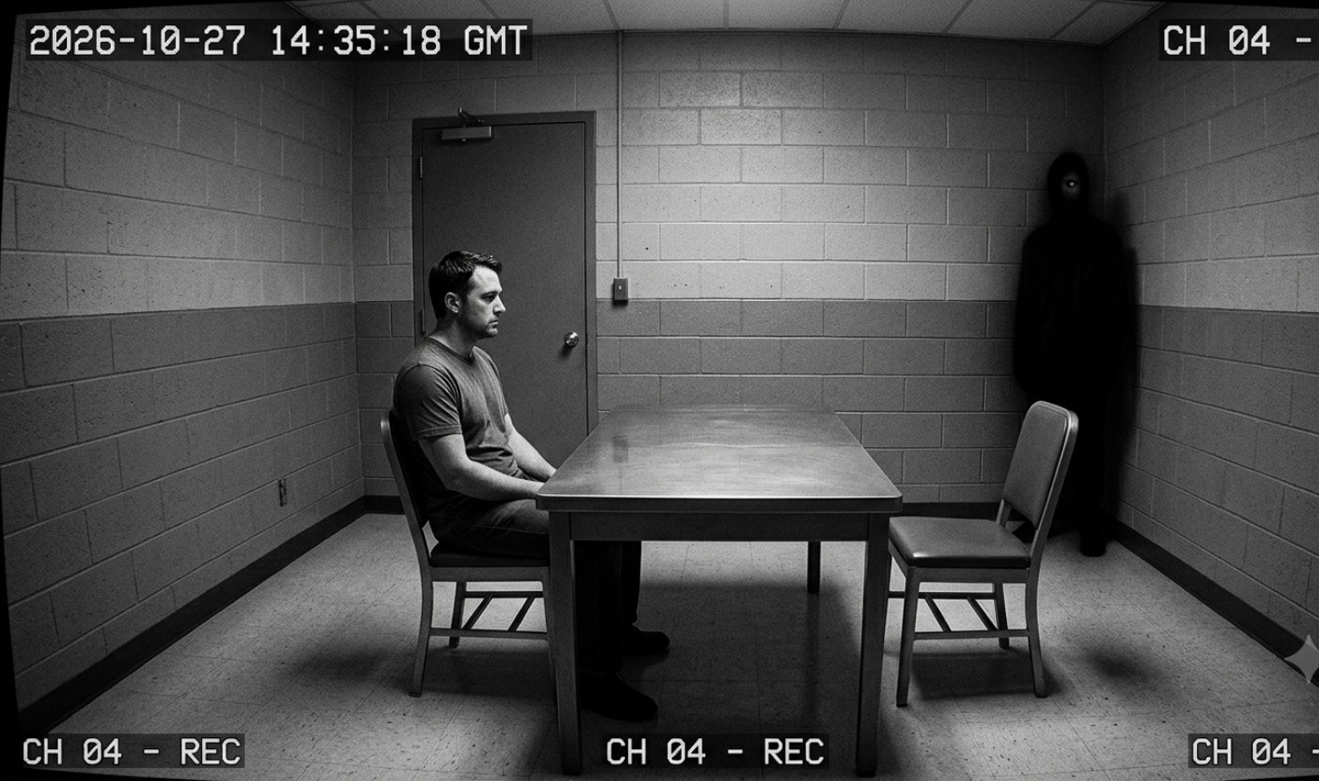
The subject remained seated during questioning. A shadow-like humanoid figure is visible in the rear corner of the room. Only a single reflective eye can be distinguished. Automated monitoring did not detect the anomaly.

Frame B
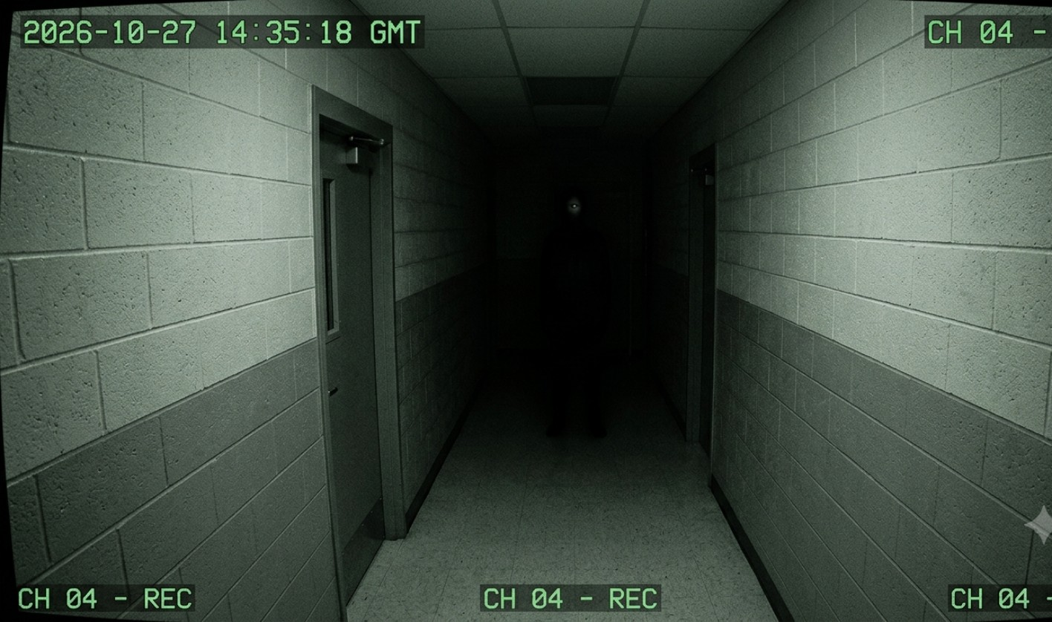
The east corridor appeared empty during live observation. Later analysis identified an unidentified silhouette positioned at the far end of the hallway. The figure blends with the darkness except for one reflective eye.

Frame C
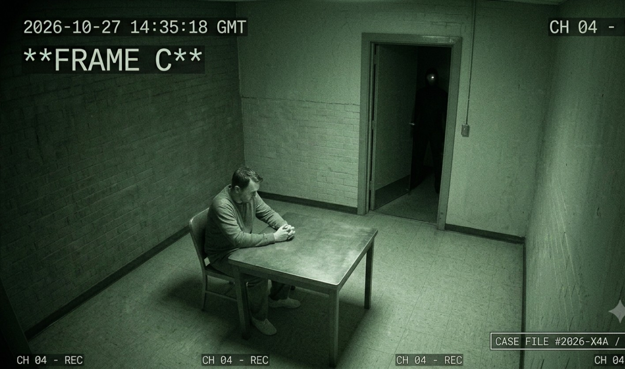
The overhead camera recorded the subject inside Interview Room 03. An unidentified figure is visible in the doorway. Access-control records show no second individual entered the room.

Analyst Conclusion
Review of all recovered frames indicates a recurring unidentified presence unofficially designated THE EYE. The anomaly appears across multiple cameras without corresponding access logs. Further investigation authorized.

