CLOUD ARCHITECTURE DESIGN
Course Project Report
Shop Pipeline Demo
A Serverless, Event-Driven Order-Processing Pipeline on AWS
Prepared by: Soumadip
AWS Account Region: ap-south-1 (Asia Pacific – Mumbai)
Date: October 2026

Table of Contents
Table of Contents
Executive Summary
1. Introduction and Objectives
1.1 Objectives
2. System Overview
3. Architecture Diagram
4. AWS Services Used
4.1 Amazon Cognito — Authentication
4.2 Amazon API Gateway — REST API
4.3 AWS Lambda — Compute
4.4 Amazon DynamoDB — Data Storage
4.5 Amazon SQS — Asynchronous Job Queue
4.6 AWS Step Functions — Workflow Orchestration
4.7 Amazon SNS — Order Event Notification
4.8 Amazon SES — Email Notification
4.9 Amazon CloudWatch Logs — Observability
4.10 AWS IAM — Least-Privilege Access
5. Infrastructure as Code
6. Data Flow — Request Lifecycle
6.1 Successful order
6.2 Failed order (payment declined)
7. Security Considerations
8. Cost Optimization — Free-Tier Design
9. Known Limitations and Future Work
10. Conclusion
Appendix A: Screenshots
References

Executive Summary
This report documents the cloud architecture of Shop Pipeline Demo, a project built to demonstrate a complete, honest, event-driven order-processing pipeline on Amazon Web Services. Rather than a static architecture diagram, the project is a working system: a customer logs in, browses a product catalog, adds items to a cart, checks out, and watches a live timeline as their order moves through real AWS services — a message queue, a state-machine workflow, a notification topic, and an email service — with every stage backed by an actual event recorded in a database, not a simulated animation.
The architecture was deliberately built entirely from AWS serverless, managed services — no servers are provisioned or patched — and deliberately scoped to stay within AWS's perpetual Free Tier: DynamoDB tables run with provisioned 5/5 read/write capacity, Lambda and SQS/SNS usage sits far under their always-free monthly quotas, and Cognito's Essentials tier is free for up to 10,000 monthly active users. The entire stack is defined as code using the AWS Serverless Application Model (SAM) and was deployed and validated against a live AWS account in region ap-south-1.
Ten distinct AWS services are used: Amazon Cognito, Amazon API Gateway, AWS Lambda, Amazon DynamoDB, Amazon SQS, AWS Step Functions, Amazon SNS, Amazon SES, Amazon CloudWatch Logs, and AWS IAM. Sections 3 through 5 describe each service's role and exact configuration; Section 6 walks through the full request lifecycle; Sections 7 and 8 cover security and cost design decisions.

1. Introduction and Objectives
Cloud architecture courses commonly ask students to design systems on paper. This project instead builds and deploys one, with the specific objective of demonstrating asynchronous, event-driven processing rather than a simple synchronous CRUD API. The guiding requirement was: a customer must be able to place one order and follow its journey from cart to confirmed order to a delivered email, while the underlying infrastructure actually performs — and can be shown to perform — inventory validation, workflow orchestration, queuing with retry and dead-letter handling, and publish/subscribe notification, exactly as a production e-commerce backend would.

1.1 Objectives
- Design a serverless architecture using managed AWS services with no EC2 instances or self-managed servers.
- Demonstrate asynchronous decoupling between the web-facing API and the order-processing workflow using a message queue.
- Demonstrate a stateful orchestration (AWS Step Functions) with multiple ordered steps and a compensating action on failure.
- Demonstrate a publish/subscribe fan-out pattern for order notifications using Amazon SNS.
- Secure the API with real user authentication (Amazon Cognito) rather than a mock login.
- Keep every resource inside AWS's Free Tier limits, and document exactly why each choice is free-tier-safe.
- Define all infrastructure as code (AWS SAM / CloudFormation) so the system is reproducible and reviewable.

2. System Overview
The application is a minimal storefront: a customer logs in through Cognito, browses a small product catalog, adds items to a cart, and checks out with an email address and a mock card number (no real payment network is contacted). Checkout does not process the order synchronously. Instead, the API hands the order off to a queue, and the browser polls a status endpoint to display a live, stage-by-stage timeline — the Live Order Pipeline panel — as the backend actually completes inventory validation, (mock) payment, order persistence, event publication, and email notification.
Two deliberate failure paths are built in and can be triggered from the checkout form, to demonstrate that the pipeline behaves correctly under failure, not just under the happy path:
- Insufficient inventory — the workflow fails at the validation step before anything is reserved, so no compensation is needed; the job is retried by SQS and ultimately dead-lettered.
- Payment declined — the workflow fails after inventory has already been reserved, so a compensating step releases the reserved stock before the job is retried and dead-lettered.
The result is a system where every row the frontend displays corresponds to a real write made by a real Lambda function, queried back from DynamoDB — there is no client-side simulation in the AWS-connected deployment.

3. Architecture Diagram
Figure 1 shows the complete architecture: every AWS resource, every Lambda function, and the direction of every call between them, grouped by role (client, authentication, API, compute, data, messaging, orchestration, and notification).
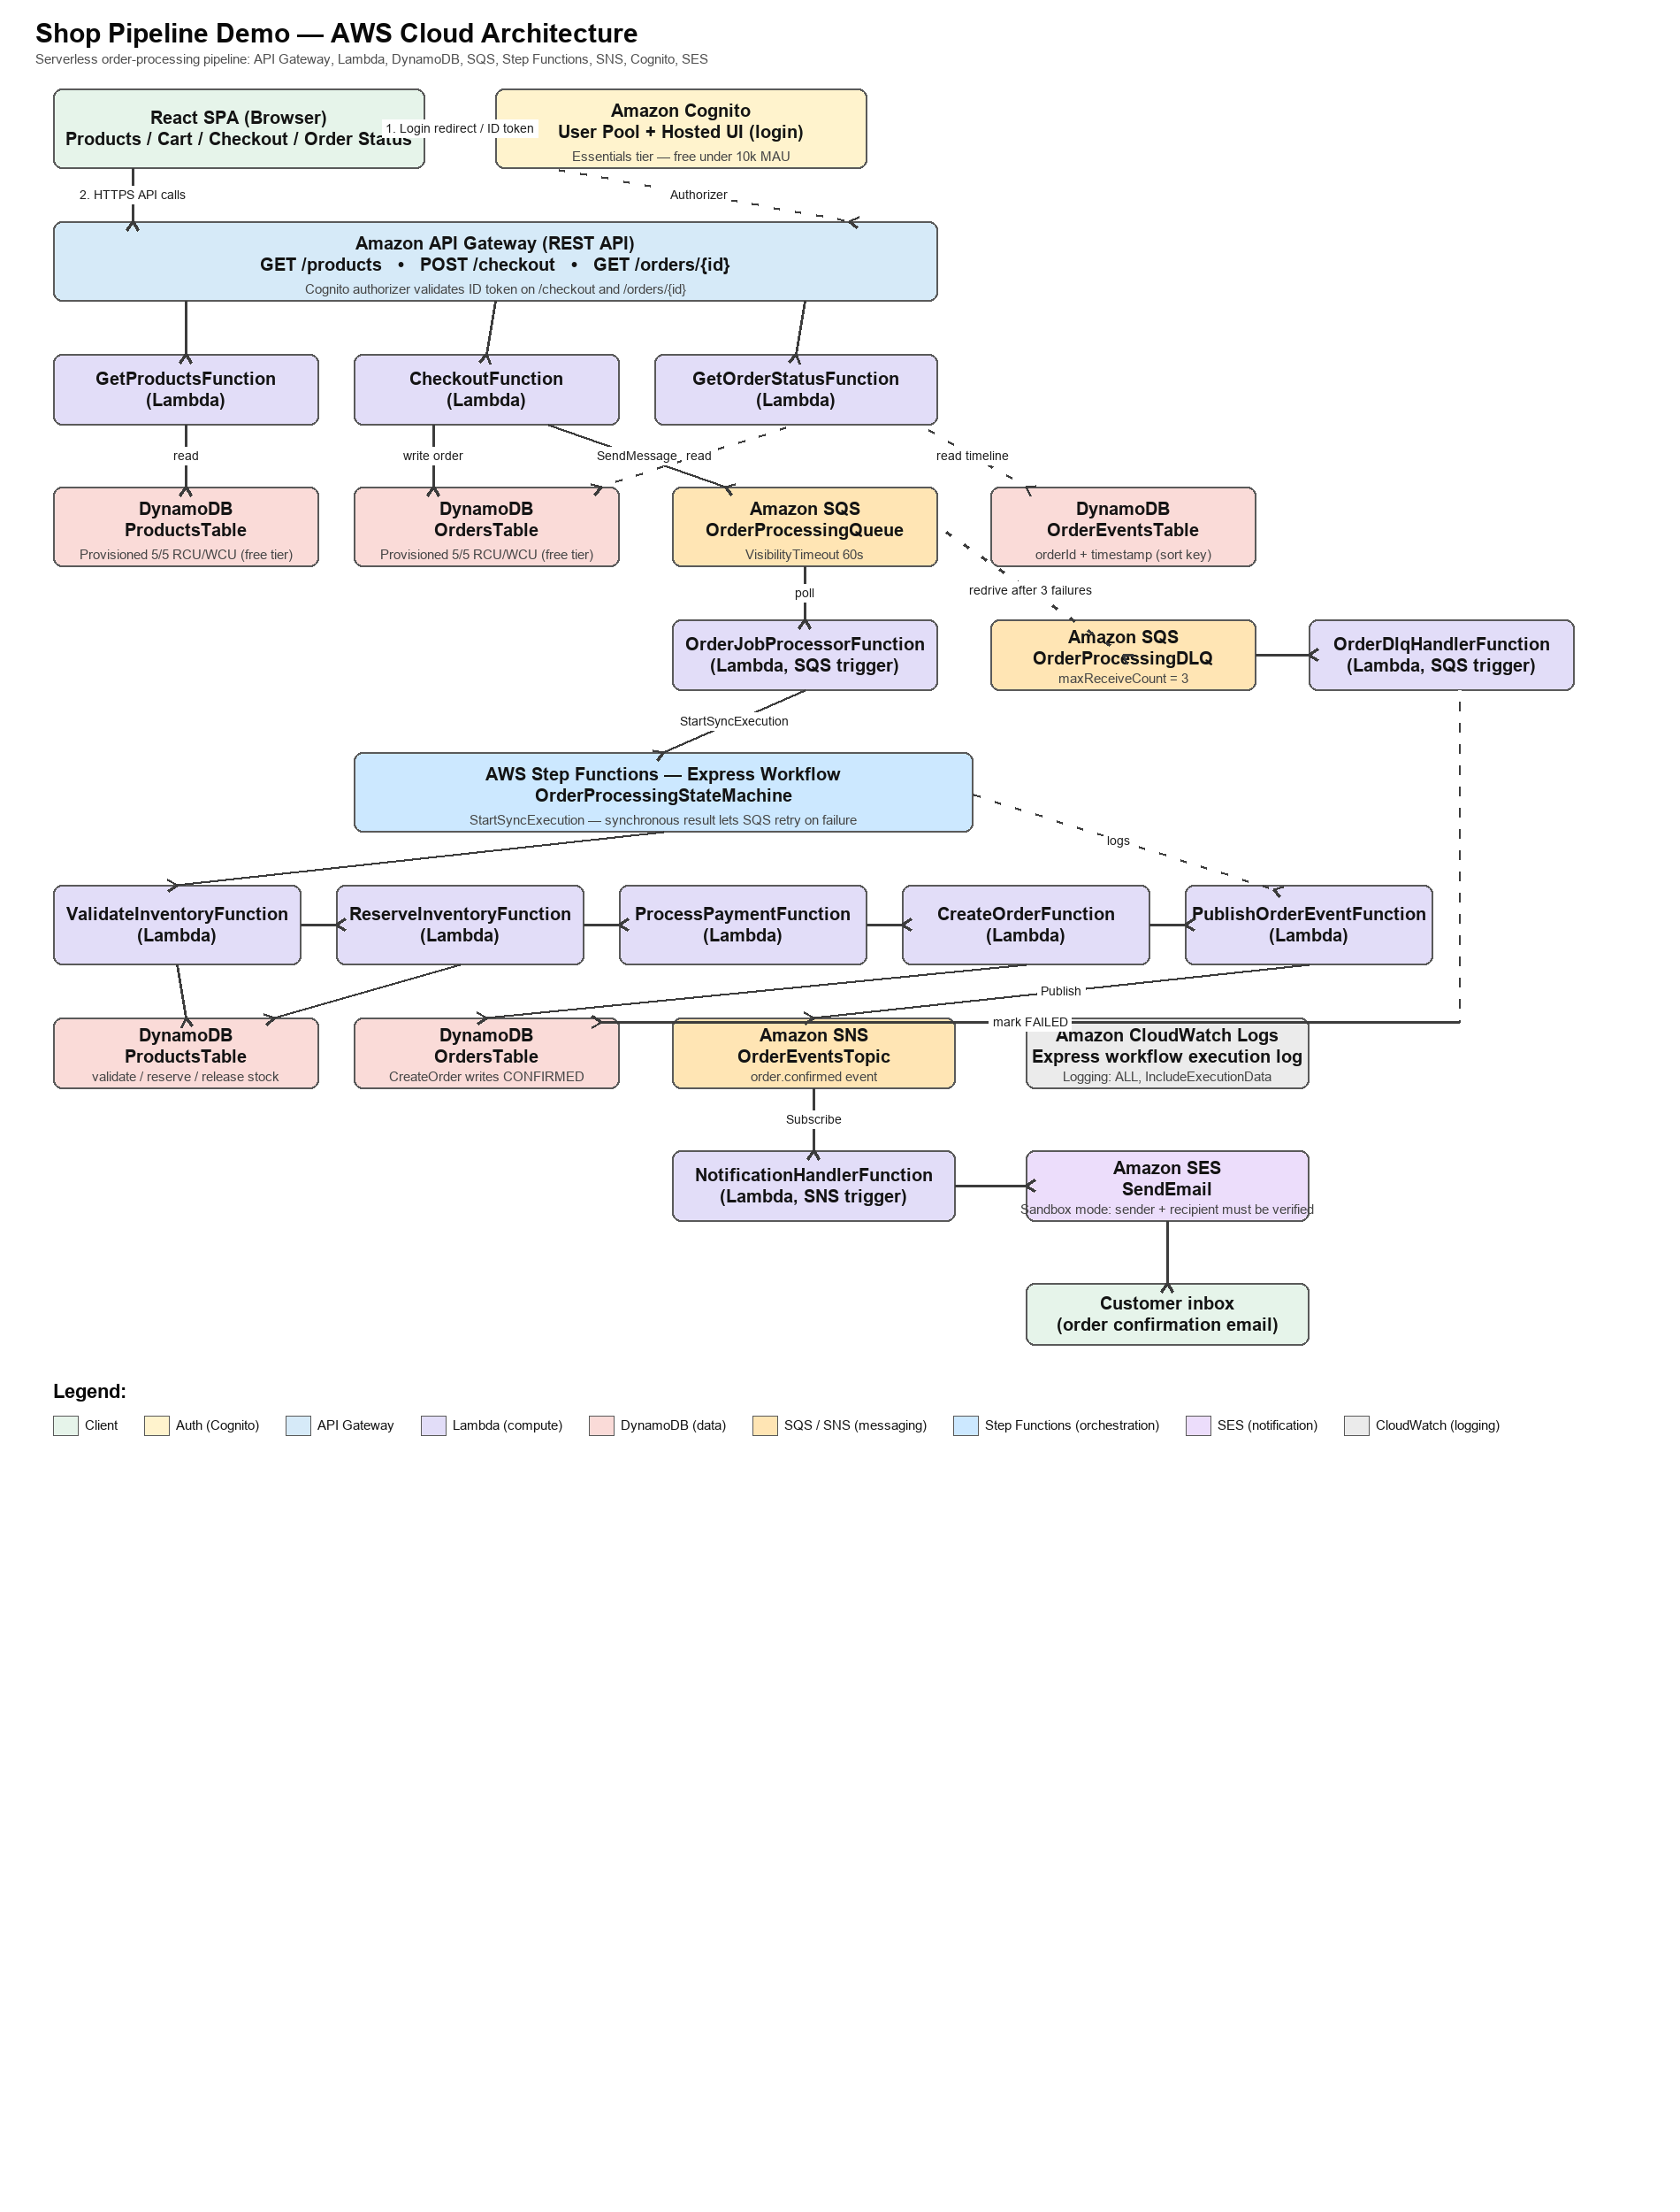
Figure 1. Shop Pipeline Demo — full AWS architecture and data flow.

4. AWS Services Used
This section describes every AWS service in the architecture, the exact resources configured for it, and why it was chosen over alternatives.

4.1 Amazon Cognito — Authentication
Resources: one User Pool (CheckoutFunction and GetOrderStatusFunction require a valid identity), one User Pool Client (public, no client secret, since the browser cannot keep a secret), and one Hosted UI domain.
Cognito is the only identity provider in the system — there is no custom username/password table to secure. The frontend redirects to the Cognito Hosted UI for login and sign-up; Cognito itself emails the verification code. On return, the browser holds a signed ID token (JWT), which it sends as the Authorization header on every protected API call. The login flow uses the OAuth 2.0 implicit grant for simplicity in a single-page app; Section 7 discusses why Authorization Code + PKCE would be the production choice instead.
Free-tier basis: the Cognito Essentials tier is free for the first 10,000 monthly active users — several orders of magnitude above this project's test traffic.

4.2 Amazon API Gateway — REST API
Resources: one REST API (OrderApi) with three routes.
Method & Path | Backing Lambda | Auth
GET /products | GetProductsFunction | None — public catalog browsing
POST /checkout | CheckoutFunction | Cognito authorizer (ID token required)
GET /orders/{orderId} | GetOrderStatusFunction | Cognito authorizer (ID token required)

API Gateway terminates TLS, applies the Cognito authorizer where configured, and proxies the request to the corresponding Lambda function with CORS enabled so the browser-hosted frontend can call it directly.

4.3 AWS Lambda — Compute
All business logic runs in eleven single-purpose Lambda functions (Node.js 24.x, bundled with esbuild), each doing exactly one job and holding only the IAM permissions that job needs:
Function | Trigger | Responsibility | Key AWS calls
GetProductsFunction | API Gateway  GET /products | Scans ProductsTable and returns the catalog. | dynamodb:Scan
CheckoutFunction | API Gateway  POST /checkout | Validates the request, writes the order (PROCESSING) to OrdersTable, sends the job to OrderProcessingQueue. | dynamodb:PutItem, sqs:SendMessage
GetOrderStatusFunction | API Gateway  GET /orders/{id} | Reads the order and its full event timeline for the Live Order Pipeline panel. | dynamodb:GetItem, Query
OrderJobProcessorFunction | SQS  OrderProcessingQueue | Starts the Step Functions execution synchronously and throws on failure so SQS retries. | states:StartSyncExecution
OrderDlqHandlerFunction | SQS  OrderProcessingDLQ | Records the terminal failure once SQS gives up retrying, marks the order FAILED. | dynamodb:UpdateItem
ValidateInventoryFunction | Step Functions task | Checks requested quantities against ProductsTable stock. | dynamodb:GetItem
ReserveInventoryFunction | Step Functions task | Reserves stock (and, as compensation, releases it) with a conditional update. | dynamodb:UpdateItem
ProcessPaymentFunction | Step Functions task | Mock payment capture; declines on a specific test card or a simulated-failure flag. | none (mock only)
CreateOrderFunction | Step Functions task | Prices the order from ProductsTable and persists it as CONFIRMED. | dynamodb:GetItem, UpdateItem
PublishOrderEventFunction | Step Functions task | Publishes the order.confirmed event to the SNS topic. | sns:Publish
NotificationHandlerFunction | SNS  OrderEventsTopic | Verifies the recipient in SES and sends the confirmation email, or records why it was skipped. | ses:SendEmail, GetIdentityVerificationAttributes

4.4 Amazon DynamoDB — Data Storage
Three tables, all provisioned at 5 read / 5 write capacity units rather than on-demand billing — a deliberate Free Tier choice explained in Section 8.
Table | Key schema | Written by | Read by
ProductsTable | Partition key: id (String) | Seeded once via AWS CLI | GetProductsFunction, ValidateInventoryFunction, ReserveInventoryFunction, CreateOrderFunction
OrdersTable | Partition key: orderId (String) | CheckoutFunction, CreateOrderFunction, OrderDlqHandlerFunction | GetOrderStatusFunction
OrderEventsTable | Partition key: orderId, sort key: timestamp (String) | Every Lambda in the pipeline, via a shared putEvent() helper | GetOrderStatusFunction (queried per order, in time order)

OrderEventsTable is the backbone of the Live Order Pipeline panel: every stage of every workflow — success, failure, retry, or skip — is an item in this table, and the sort key's ISO-timestamp-plus-random-suffix design guarantees correct ordering even when two events are written in the same millisecond.

4.5 Amazon SQS — Asynchronous Job Queue
Resources: OrderProcessingQueue (the main job queue) and OrderProcessingDLQ (its dead-letter queue).
CheckoutFunction does not run the order workflow itself; it writes the order and sends one message to OrderProcessingQueue, then returns immediately. This decouples the user-facing API from the (slower, more failure-prone) workflow. OrderJobProcessorFunction consumes the queue and starts the Step Functions execution synchronously; if that execution fails, the function throws, and SQS's built-in visibility-timeout/redelivery mechanism retries the message. The queue's redrive policy sends a message to OrderProcessingDLQ after 3 failed receives (maxReceiveCount: 3), where OrderDlqHandlerFunction records the terminal failure — this is the "retries and dead-letter handling" requirement made real, not simulated.

4.6 AWS Step Functions — Workflow Orchestration
Resources: OrderProcessingStateMachine, an Express-type state machine.
The order workflow is defined declaratively as an Amazon States Language (ASL) document, not as a long if/else chain inside one Lambda. Its states run in this order:
- ValidateInventory — checks requested quantities against current stock.
- ReserveInventory — decrements stock with a conditional DynamoDB update (fails atomically if stock is insufficient).
- ProcessPayment — the mock payment step; a specific test card or a simulate-failure flag forces a decline.
- CreateOrder — prices the order from current product prices and persists it as CONFIRMED.
- PublishOrderEvent — publishes the confirmed order to the SNS topic.
A Catch clause on ProcessPayment and CreateOrder routes failures to a compensating ReserveInventory call (with action: "release") before failing the execution — so stock reserved earlier in the workflow is never silently lost if a later step fails. The Express type (rather than Standard) was chosen specifically so OrderJobProcessorFunction can call StartSyncExecution and get a pass/fail result back within the same Lambda invocation, which is what lets SQS's retry mechanism drive the retry behavior described in 4.5.

4.7 Amazon SNS — Order Event Notification
Resources: OrderEventsTopic, with NotificationHandlerFunction subscribed.
SNS implements the publish/subscribe step of the pipeline: PublishOrderEventFunction (inside the Step Functions workflow) does not know or care who consumes the order.confirmed event — it simply publishes to the topic. Today there is exactly one subscriber (the email notifier), but the architecture supports adding more subscribers later — an analytics pipeline or an SMS notifier, for example — without any change to the workflow.

4.8 Amazon SES — Email Notification
NotificationHandlerFunction, triggered by the SNS subscription, sends the order confirmation email through Amazon Simple Email Service. Because new SES accounts start in sandbox mode (deliverable only to verified addresses), the handler first checks the recipient's verification status; if unverified, it asks SES to send them a one-time verification link and records the EMAIL_SENT stage as SKIPPED with a clear explanation, rather than ever claiming an email was sent when it was not. This directly implements the project's requirement to never report a successful send that did not actually happen.

4.9 Amazon CloudWatch Logs — Observability
Because OrderProcessingStateMachine is an Express workflow, its executions do not appear in the Step Functions console's Executions tab the way Standard workflows do. Logging is explicitly enabled (Level: ALL, IncludeExecutionData: true) to a dedicated CloudWatch Logs log group, so every state transition of every execution remains inspectable after the fact — this is how "real workflow execution" is verified in AWS mode, as opposed to taking it on faith.

4.10 AWS IAM — Least-Privilege Access
Every Lambda function has its own execution role, generated by SAM from narrowly-scoped policy templates (e.g. DynamoDBReadPolicy, DynamoDBCrudPolicy, SQSSendMessagePolicy, SNSPublishMessagePolicy) rather than one broad shared role. Two permissions needed explicit statements beyond SAM's built-in templates: states:StartSyncExecution for OrderJobProcessorFunction (SAM's StepFunctionsExecutionPolicy only grants the plain StartExecution action, verified directly against AWS's policy-template source during development), and the CloudWatch Logs log-delivery permissions required for Express workflow logging, which AWS does not allow to be scoped to a single log group ARN.

5. Infrastructure as Code
The entire backend — 23 CloudFormation resources — is defined in one AWS SAM template (template.yaml) and an Amazon States Language file for the workflow. Nothing was clicked together manually in the console.
- Build: sam build bundles each Lambda's handler and its dependencies with esbuild into a deployable artifact.
- Validate: sam validate --lint checks both structural correctness and best-practice warnings (this caught the nodejs20.x deprecation warning during development, leading to an upgrade to nodejs24.x before deployment).
- Deploy: sam deploy --guided provisions every resource and prints the API URL, Cognito IDs, and table names needed to configure the frontend.
- Teardown: sam delete removes every resource the template created, in dependency order.
Defining the stack this way means the architecture in Section 3 is not just a diagram drawn after the fact — it is a direct, verifiable rendering of the deployed template.

6. Data Flow — Request Lifecycle

6.1 Successful order
- Browser → API Gateway → CheckoutFunction: order written to OrdersTable (status PROCESSING), message sent to OrderProcessingQueue.
- OrderJobProcessorFunction polls the queue, calls StartSyncExecution on OrderProcessingStateMachine.
- ValidateInventory → ReserveInventory → ProcessPayment → CreateOrder → PublishOrderEvent all succeed in sequence; OrdersTable is updated to CONFIRMED.
- PublishOrderEvent's SNS message triggers NotificationHandlerFunction, which sends the confirmation email via SES.
- Throughout, every Lambda writes a stage event to OrderEventsTable; the browser polls GET /orders/{id} and renders the Live Order Pipeline panel in real time.

6.2 Failed order (payment declined)
- Checkout and inventory reservation succeed as above.
- ProcessPayment fails (test card ending 0000, or the simulate-failure flag); the Catch clause routes to the compensating ReserveInventory(action: release) call, which restores the reserved stock.
- The Step Functions execution reports FAILED to OrderJobProcessorFunction, which throws — SQS redelivers the message up to 3 times.
- After the third failed receive, SQS's redrive policy moves the message to OrderProcessingDLQ; OrderDlqHandlerFunction records the terminal failure and marks the order FAILED.

7. Security Considerations
- All write/read-sensitive endpoints (checkout, order status) require a valid Cognito ID token, verified by API Gateway's built-in authorizer before the request ever reaches Lambda.
- The mock card number is never stored or logged in full — only the last 4 digits (cardLast4) are persisted, exactly as a PCI-conscious design would treat even a mock payment field.
- Each Lambda's IAM role is scoped to only the tables/queues/topics it actually touches — a Lambda compromised through a dependency vulnerability could not, for example, read arbitrary DynamoDB tables outside its own role.
- Known simplification: the Cognito login uses the OAuth implicit grant (ID token returned directly in the URL fragment) for frontend simplicity. A production system should use Authorization Code + PKCE, which never exposes a token in a redirect URL.
- Known simplification: API CORS is configured as AllowOrigin: '*' for ease of local development; a production deployment should restrict this to the deployed frontend's exact origin.
- SES is deliberately left in sandbox mode for this project — this is itself a safety feature during development, since it makes it impossible to accidentally email a real, unverified address.

8. Cost Optimization — Free-Tier Design
Every service in this architecture was chosen or configured specifically to stay inside AWS's Free Tier for a project of this traffic volume:
Service | Free-tier allowance | Design choice made here
DynamoDB | 25 GB storage + 25 RCU/25 WCU, forever | 3 tables at 5/5 provisioned capacity each (15/15 total) — well under the 25/25 ceiling, and this is the classic, unconditional Free Tier rule rather than a newer on-demand policy.
AWS Lambda | 1M requests + 400,000 GB-seconds / month, forever | 11 functions, each invoked only on demand by test traffic — negligible usage.
Amazon SQS | 1M requests / month, forever | One message sent per checkout, polled at low frequency.
Amazon SNS | 1M publishes / month, forever (plus 1,000 free email notifications) | One publish per confirmed order.
Amazon Cognito | 10,000 MAU free (Essentials tier) | Single-digit test users during development.
API Gateway (REST) | 1M calls / month free for 12 months; fractions of a cent per call after | Low call volume makes even post-free-tier cost negligible.
Step Functions (Express) | No fixed free tier; billed per request + duration | Short-duration workflow (a few seconds); cost per execution is a small fraction of a cent.
CloudWatch Logs | 5 GB ingestion / month free | 14-day retention set explicitly; demo-scale logs are kilobytes, not gigabytes.
Amazon SES | 62,000 free sends/month when sent from an AWS compute service | Test-scale email volume stays far under this limit.

The one deliberate departure from AWS's newest default (on-demand DynamoDB billing) was made specifically for this report: provisioned 5/5 capacity is the Free Tier allowance AWS has guaranteed unconditionally since the service launched, rather than relying on a newer, less universally documented on-demand free allowance. The project's own setup documentation (AWS_SETUP.md) also instructs running sam delete after grading/demonstration to guarantee zero ongoing cost.

9. Known Limitations and Future Work
- OAuth implicit grant should be replaced with Authorization Code + PKCE for production use.
- CORS and the SES IAM policy (Resource: "*" for ses:SendEmail) are intentionally permissive for a course/demo deployment and should be tightened before any real-world use.
- Express Step Functions executions are not visible in the Step Functions console's Executions list (by AWS design); CloudWatch Logs is the only way to inspect past executions. A Standard workflow would restore console visibility at the cost of losing the synchronous StartSyncExecution call used to drive SQS retries.
- The product catalog is seeded once via a shell script rather than managed through an admin interface — acceptable for a fixed demo catalog, but a real store would need a product-management API.
- No automated test suite (unit or integration) was included in this phase of the project; local Lambda logic could be tested with sam local invoke in a future iteration.

10. Conclusion
This project set out to prove, not just diagram, that a realistic order-processing pipeline can be built entirely from managed AWS services, kept inside the Free Tier, and still exhibit the properties that matter in production systems: decoupling via queues, multi-step orchestration with compensation on failure, retry and dead-letter handling, event-driven notification, and least-privilege access control. Every component described in this report was deployed to a live AWS account (ap-south-1) and validated with sam validate --lint and a successful sam build, demonstrating that the architecture is not only sound on paper but operable in practice.

Appendix A: Screenshots
The boxes below are placeholders sized for pasting evidence screenshots directly in Word (click inside a box, then paste). Delete any box you don't need, or copy one to add more.
Paste screenshot here (click inside the box, then Ctrl/Cmd+V)
Figure 2. Login page (Cognito Hosted UI).
Paste screenshot here (click inside the box, then Ctrl/Cmd+V)
Figure 3. Product catalog and cart.
Paste screenshot here (click inside the box, then Ctrl/Cmd+V)
Figure 4. Live Order Pipeline — successful checkout.
Paste screenshot here (click inside the box, then Ctrl/Cmd+V)
Figure 5. Live Order Pipeline — simulated failure (SQS retry / DLQ).
Paste screenshot here (click inside the box, then Ctrl/Cmd+V)
Figure 6. AWS Console — CloudWatch Logs for a Step Functions execution.
Paste screenshot here (click inside the box, then Ctrl/Cmd+V)
Figure 7. AWS Console — DynamoDB OrderEventsTable contents.

References
AWS Serverless Application Model (SAM) Developer Guide — docs.aws.amazon.com/serverless-application-model
AWS Step Functions Developer Guide, Express Workflows — docs.aws.amazon.com/step-functions
Amazon SQS Developer Guide, Dead-Letter Queues — docs.aws.amazon.com/AWSSimpleQueueService
Amazon Cognito Developer Guide, User Pools — docs.aws.amazon.com/cognito
Amazon SES Developer Guide, Sandbox Mode — docs.aws.amazon.com/ses
AWS Free Tier — aws.amazon.com/free

