

Submitted On: **10.05.2023**

**Design, Development of a Nearby Temple Search Mobile Application**

**Business Proposal for**

Prepared by Submitted by

**Business Analyst Shyam Future Tech**







ISO-27001-2013-LOGO.png

**Document Control**

1. Document Statistics

|  |  |
| --- | --- |
| **Type of Information** | **Details** |
| Title | Design, Development of a Nearby Temple Search Mobile Application |
| Document Revision No. | 1.0 |
| Last Update | 10th May, 2023 |
| Document Owner | Shyam Future Tech |
| Reference No. | SFTRFP052023060106 |

Table of Contents

1 Executive Summary 4

2 Project Synopsis 6

3 Project Entities 6

4 Proposed Approach 6

5 User Interface 7

6 Our Deliverables 7

7 Feature Listing 7

7.1 End User 7

7.2 Admin Functionality 8

8 Proposed Technology Stack 11

9 Client Deliverables 11

10 Effort Hours Estimation & Milestones: 11

11 Shyam Future Tech Profile: 13

11.1 Shyam Future Tech – Your IT ally 13

11.2 Mobile App Development | Custom CRM Solution | Custom ERP System 13

11.3 Expertise and technologies in practice 13

# Executive Summary

Shyam Future Tech (SFT) is a leading Web and Mobile Application Development Company. We are a team of 120+ who are dedicated to serve the customers and have been functioning in the IT industry since 2017. Shyam Future Tech (SFT) specializes in the fields of web development and mobile application development. We engage in a massive endeavor of inventing and developing multiple web and mobile applications that are suitable for all verticals of the industry.

The company customizes mobile application development for all the major platforms like android, iPhone, Windows. The company even offers solutions for cross platform mobile application development and have succeeded in completing plenty of projects.

We are also involved in website design and development and undertake all types of website development projects which includes CMS, Shopping carts, commercial websites, e-commerce websites, social networking sites, blogs website, corporate websites, personal websites and the list goes on. We do custom website design and development.

Shyam Future Tech (SFT) will custom design and develop a distinct mobile friendly app with state of the art mobile features designed to increase customer interaction.

Thank you for considering Shyam Future Tech (SFT) for your mobile application project. We are excited to work with you and are excited to bring some of our creative, innovative and strategic plans to your front door.

# Project Synopsis

The main goal is to develop a mobile application from where user will able to get the nearby temple details. This would be an informative App for Templates. Here the Android App User will be able to search and find temples with various pre-defined filters. All the temples will have their individual details page where all the information pertaining to that specific temple can be found. User will be able to view the information. Admin will have a backend panel to manage the contents of the App. Temples and their detailed listing will be created by the Admin from backend.

User will able to see the temples and all the details of temples like –

* + Location
  + View on Map
  + Open and Close Timings
  + Close Timings
  + Amenities
  + How to reach
* Contact Details

These aforementioned information fields will be modified during the development phase, based on the client requirement.

The system will be highly scalable, robust and will be developed to deliver high performance. Our prime approach will be to build a system which will have an intuitive and user friendly interface.

We take immense care to successfully offer a system to our Clients that are highly secured and encrypted

# Project Entities

* End User
* Administrator

# Proposed Approach

* Unique & Fully Customized Design
* Intuitive and User Friendly Interface.
* Fully Responsive Design for admin panel which will be compatible across all devices
* Firebase Integration for Push Notification on App
* SMS Gateway Integration.
* OTP verification.
* Web & App language will be in English only

# User Interface

|  |  |
| --- | --- |
| User Type | User Interface |
| Admin | **Web** |
| End User | **Android App for Mobile** |

# Our Deliverables

* Admin web portal
* End user mobile application (Android)

# Feature Listing

## End User

* Login in to the app. There are no registration functionalities. User will come to the platform and put the mobile number after putting the mobile no an OTP will be received by the user and user will validate the OTP to enter in to the app. User also skip the process.
* User will able to search the nearby temples through the mobile application
* User can also search the Template State and City wise
* User will notified regarding any kind of updation or new addition
* Notification only for the users who’s number stored in the admin database
* User can able to see the temple details like –
  + Location
  + View on Map
  + Open and Close Timings
  + Close Timings
  + Amenities
  + How to reach
* Contact Details
* User will able to see the any kind of upcoming Puja details
* There will be a nearby features in the app when user will open the app will ask to allow the current location based on the location user will able to see the temples.

## Admin Functionality

The Site Owner or Head of the Project who will have unrestricted access to the system with Master Panels & Access Permissions & a Dashboard to have entire overview of the application at a glance, with various data records.

* **Admin Log in:**

Admin log in using Secure User ID and Password

* **Reset Password:** Admin can reset Password and the reset link will go to the registered

Email of Admin

* **Content Management System:** CMS is a module that allows publishing, editing and modifying content as well as maintenance from a central interface without the knowledge of programming. It typically makes use of a WYSIWYG (What you see is what you get) editor where you page content as you would write in a Word document.
* **Manage Role:**
* Admin can create a new User role from this section.
* Admin can set a user role active or inactive.
* Admin can add new delivery person from this section.
* Admin can make any delivery person active/Inactive from this section.
* **Manage Access Permission:**
* There would be a list of Modules / Menus of the application for which Admin will give access permission to the User Role
* Admin can set the access permissions for any Module / Menu (View, Edit, Delete) to the available User Role
* There would be Checkbox for each permission and for giving permission to role, Admin needs to select the checkbox
* Admin needs to select the role and select the user access permissions they want to allow to that User Role.
* Admin can edit the permission by selecting / unselecting the check box of the Access Permission
* **How to add User:**
* Admin needs to add the First and last name of the User. Middle name is optional.
* Admin needs to provide the Email, Mobile Number of the User.
* Admin can set Date of birth and gender of the User.
* Admin can set the Role of the user
* As per the Role, user will get access permission automatically
* User will get an invitation email to create password and login into the system
* Email / Mobile Number will be the user name and users can set the password from the invitation mail
* User can reset password any point of time
* **FAQ Management:**
* Create topics for FAQ
* Provide answers for FAQ
* Publish FAQ on website
* Edit any FAQ
* Un-publish any FAQ
* **Push Notification:**
* Admin can send the custom notification through the portal
* **Category Management:**
* Create Category
* Set Category Name
* Create Sub Category under the category section
* Add Category Description
* Edit Category Details
* Enable/Disable Category Status
* **Amenities Management:**
* Add amenities
* Mange amenities
* Enable/Disable amenities status
* **Temple Management:**
* Add /Edit Temple
* Add/Edit Temple Address
* Add/Edit Temple Details
* Add/Edit Temple Contact Details
* Add/ Edit Rules & Regulation of Template
* Add/Edit Temple Open and Close Time
* Add/Edit Temple Pooja types with timing (data will come from drop down)
* **Festival Management:**
* Create Type of Festival (Upcoming Festival)
* Add festival
* In the festival date it will show on the section ongoing festival
* Manage festival
* Enable/Disable festival
* **Puja Management:**
* Create Pooja Name
* Add Pooja Details
* Manage Pooja Details
* Enable/Disable Pooja Status
* **Time Management/Time Details Management:**
* Add Time
* Add Time under Pooja and Temple
* Manage Pooja time under temple
* Manage generic Pooja time
* **News Management:**
* Add any kind of news regarding temple/Pooja timing
* Mange the news
* Enable/Disable news status

# Proposed Technology Stack

|  |  |
| --- | --- |
| **Technology Tier** | **Language / Entails** |
| **Database** | MySQL |
| **Programming Language** | PHP |
| **Framework** | Laravel |
| **Mobile App** | Kotlin (Android) |
| **Front End** | HTML/CSS/JavaScript |

# Client Deliverables

* Domain and Hosting
* Brand Logo
* Any kind of 3rd Party API (SMS, Email, Google Map)
* Google Play store account credential

# Effort Hours Estimation & Milestones:

1. **Total Amount:** INR XX,XXX.XX
2. **Total Effort Hours: 280 Hours**
3. **Estimated Man Month: 35 Days after UI approval**

|  |  |  |
| --- | --- | --- |
| **Milestone** | **Service to be Provided** | **Payments linked to milestones**  **(in INR)** |
| **01** | Project Advance | 30% |
| **02** | App Graphical UI Approval (Adobe XD/Figma) | 25% |
| **03** | Development   * Web Backend Admin Panel * Android App | 25% |
| **04** | Final Delivery   * UAT * Bugs Fixing * Go -Live | 20% |
| **Total** | | **Xxxx** |

**Please note**:

* Payment Milestones will need to be maintained as per mutual agreement.
* Payment should be received within 7 days from receipt of the invoice.
* Please note the cost doesn’t include any traveling of resource or any person from SFT to Client premises
* 18% GST will be added with above mentioned cost

# Shyam Future Tech Profile:

## Shyam Future Tech – Your IT ally

Shyam Future Tech is the ISO 27001: 2013 & 9001:2015 certified IT arm of Shyam Steel Industries Ltd., based in Kolkata. We are a 400+ team of expert professionals designated with classified responsibilities in different departments. We are commonly referred to as SFT.

We create custom ERP systems, CRM solutions, mobile applications, websites, digital solutions and other allied products that specifically serve your business goals. The best of technologies and its latest versions are implemented in creating products and services that specifically serve your goals.

## Mobile App Development | Custom CRM Solution | Custom ERP System

Want your business to thrive? Drive to your goals with the latest technologies and robust solutions. We got some dynamic tools and solutions to automate your business.

**How hiring us can benefit your business?**

* Updated with the latest technologies and market trends
* Suggest you products and solutions most effective in a dynamic and diverse business ecosphere
* Smaller units of expert professionals with specific responsibilities
* Transparent work process and everyday update to key project stakeholders
* Flawless and timely project delivery
* Indisputable trust and confidence
* A great number of returning clients
* Reputably working overseas

## Expertise and technologies in practice

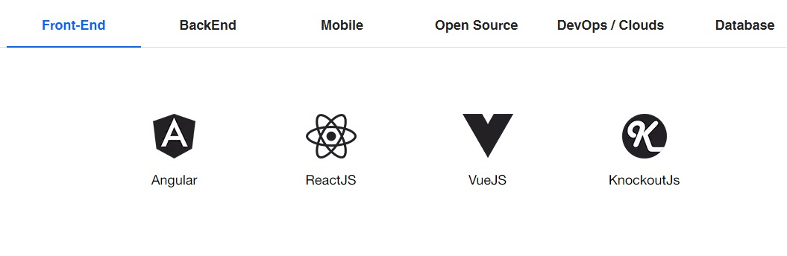

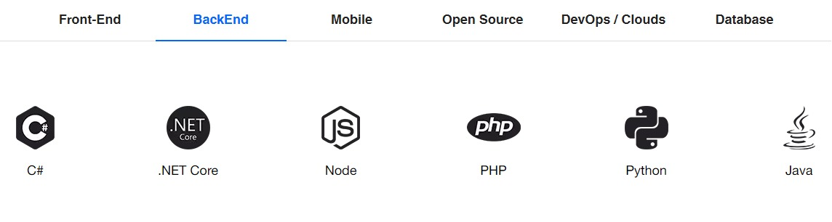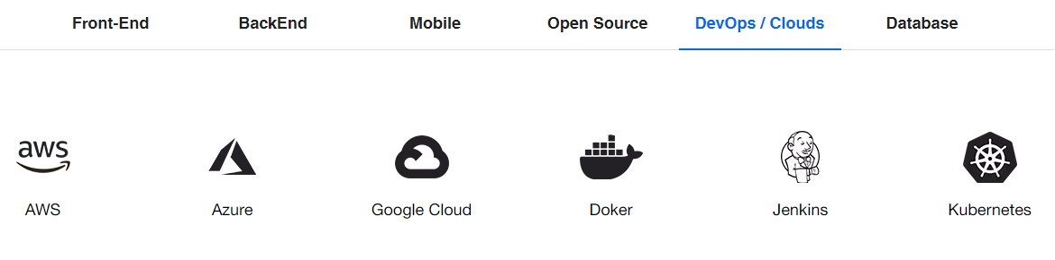

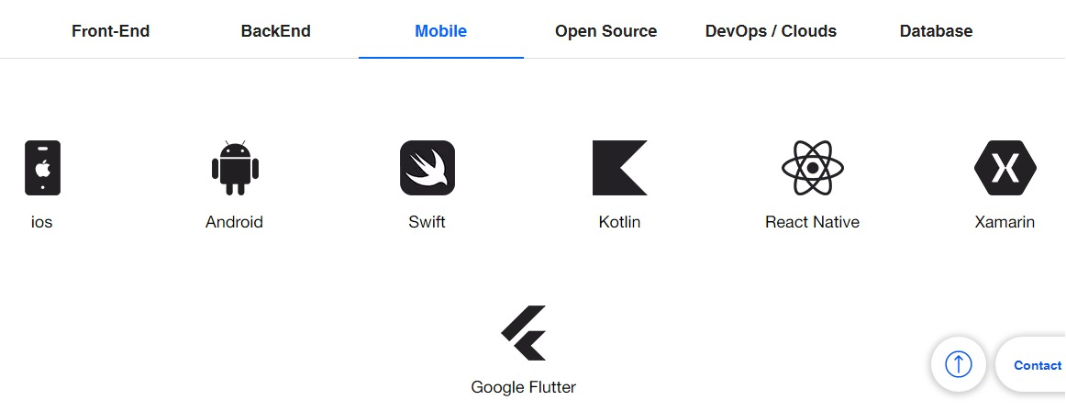

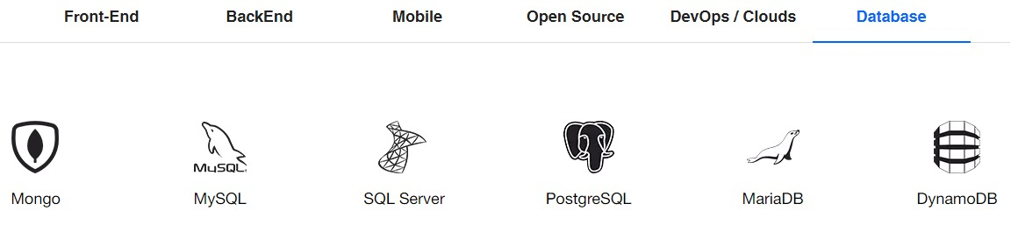

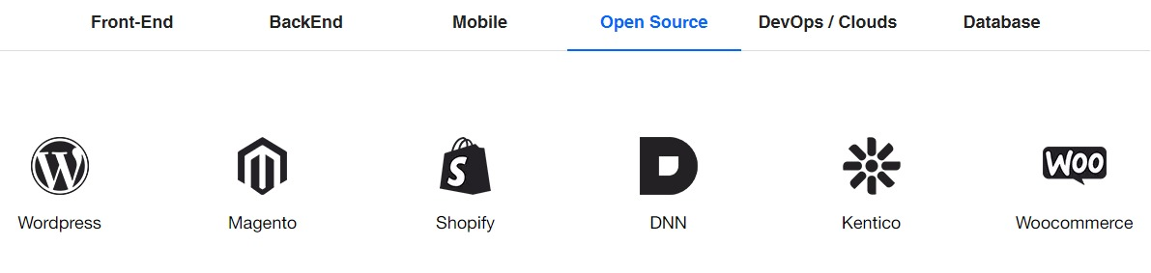

**Highlights:**

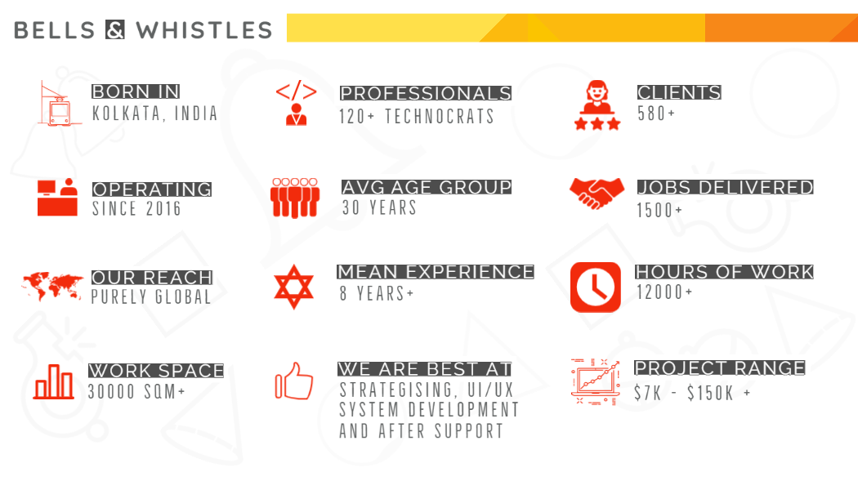

**End of Document**

**-------xxxx------**