Snake

user manual

Vít Soumar, Marek Jirků



Loading screen

Loads the game with animated process bar.
The user can continue to main menu after the loading is completed.

Controls:
- Press any of the knobs (red, green, blue) to continue

Loading screen
Loading 39%

Main menu

Main menu allows the user to navigate through the app.

Controls:

- Change button: rotate red (left) knob
- Select button: press red (left) knob

Buttons:

- 1 player - go to choose player scene
- 2 players - start game for two players.
- Leaderboard - go to leaderboard scene
- Options - go to options scene
- Exit - exit the app

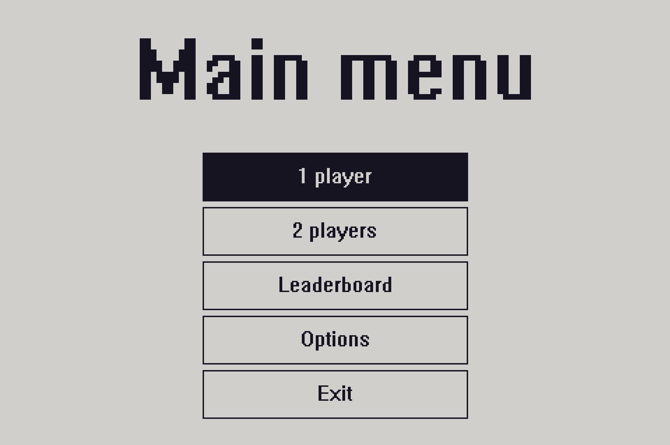Main menu

Choose player scene

The user can select as what player they wants to play.
The button shows selected player and the selected players highscore.

Controls:

- Change player: rotate green (middle) knob
- Select player: press green (middle) knob

- Change buttons: rotate red (left) knob
- Select button: press red (left) knob

Buttons:

- Back - go back to main menu
- Save and play - start game for one player

- Player button
  - Shows selected player with that players highscore
  - Available names:
    - Player_1
    - Player_2
    - Player_3
    - Player_4
    - Player_5
    - Player_6

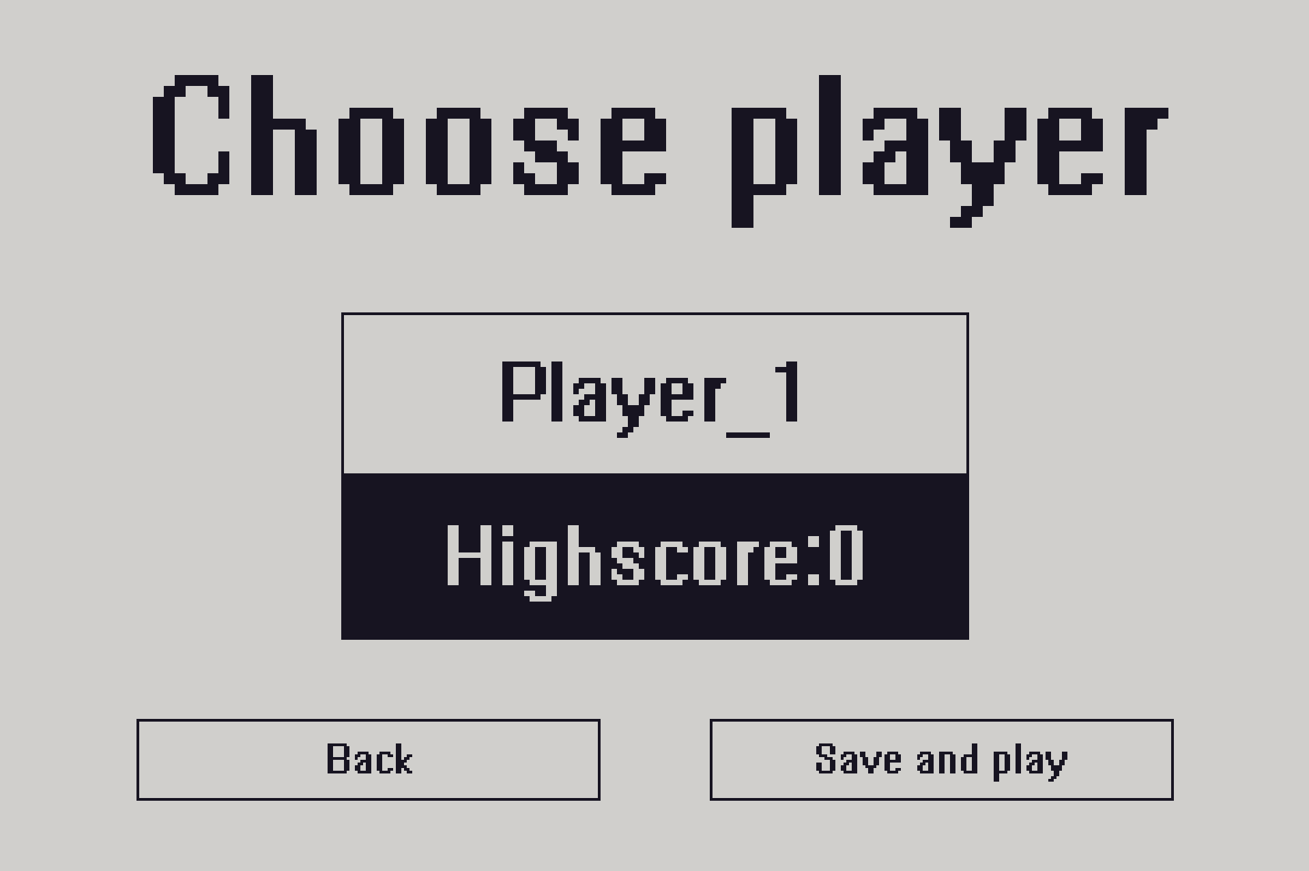Choose player
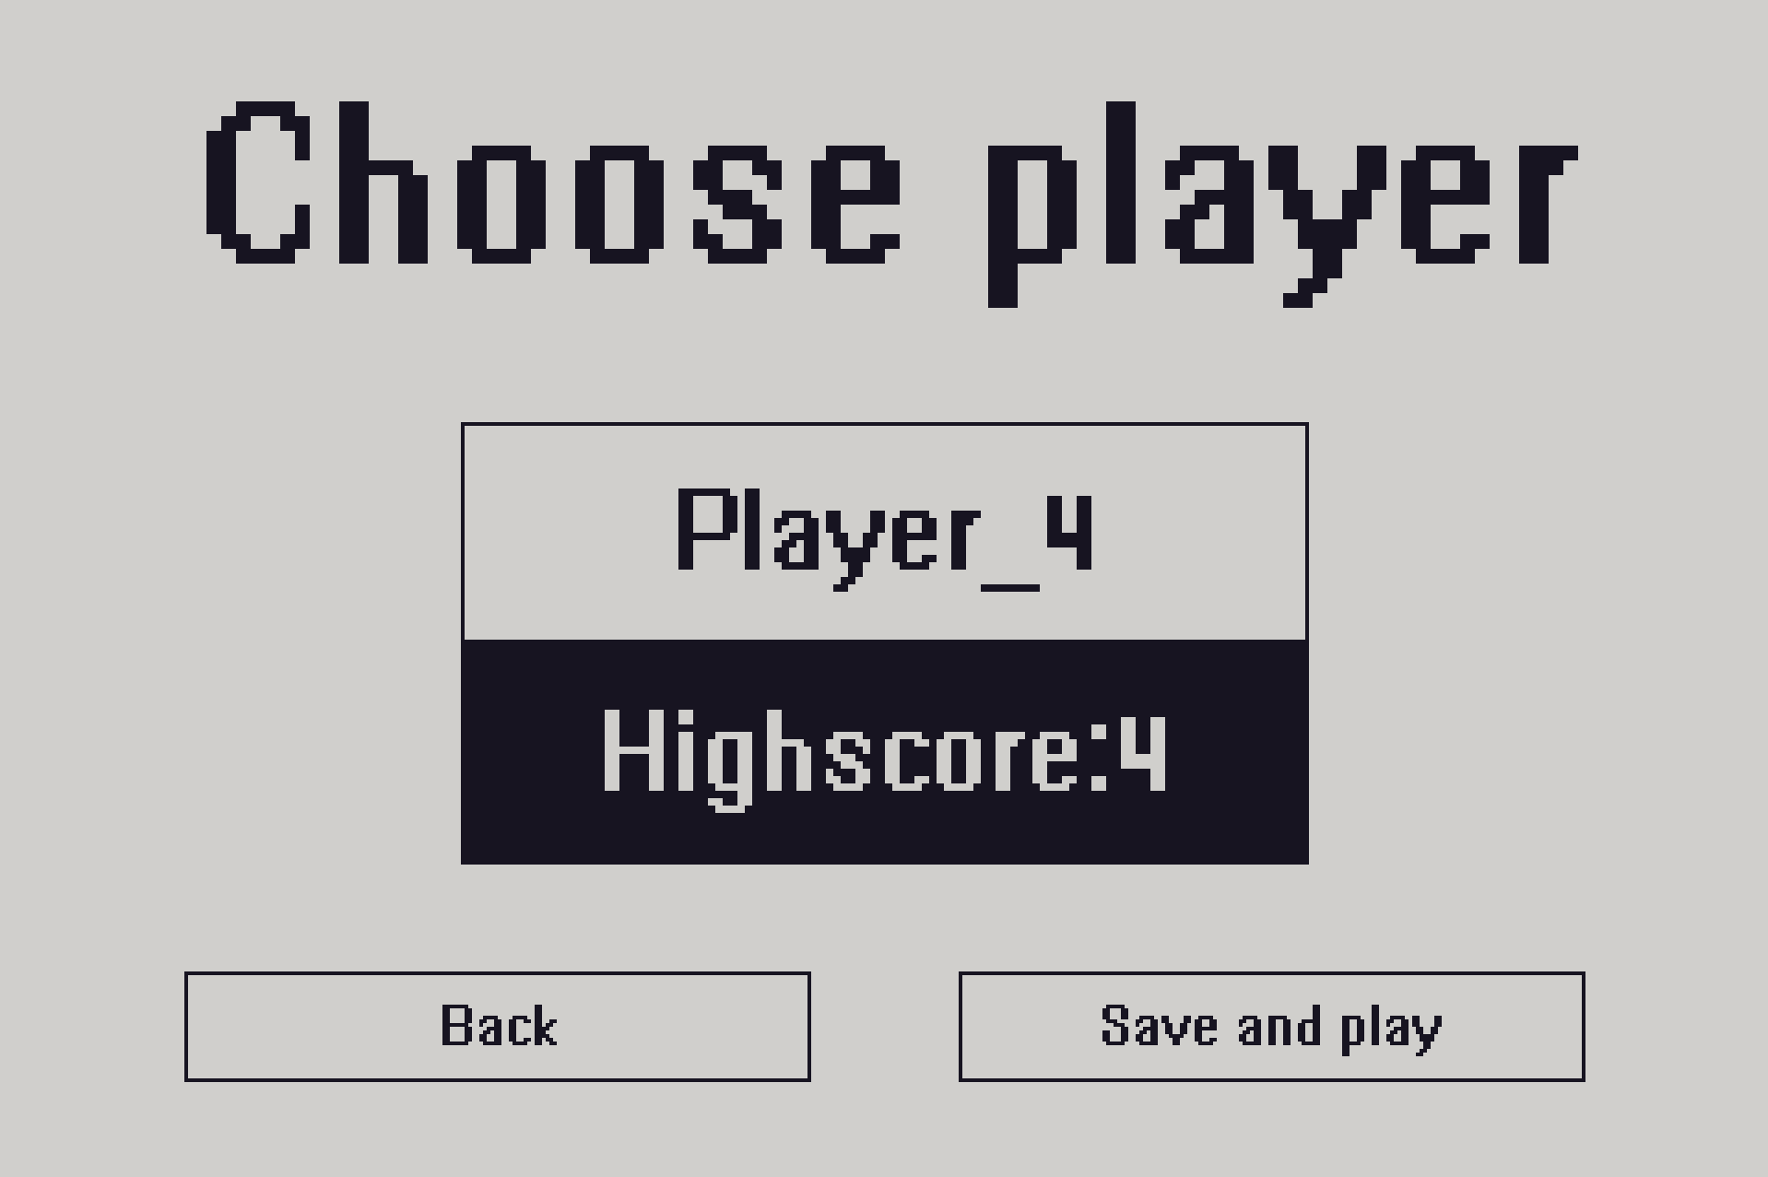Player_4 and Player_4 highscore

Game (1 player)

Snake for one player. The main goal of this game mode is to eat as many fruits as possible.

Controls:

- Change snake direction: rotate blue (right) knob

Score: number of eaten fruits = length of the snake – starting size (2)

Snake starting position: top left

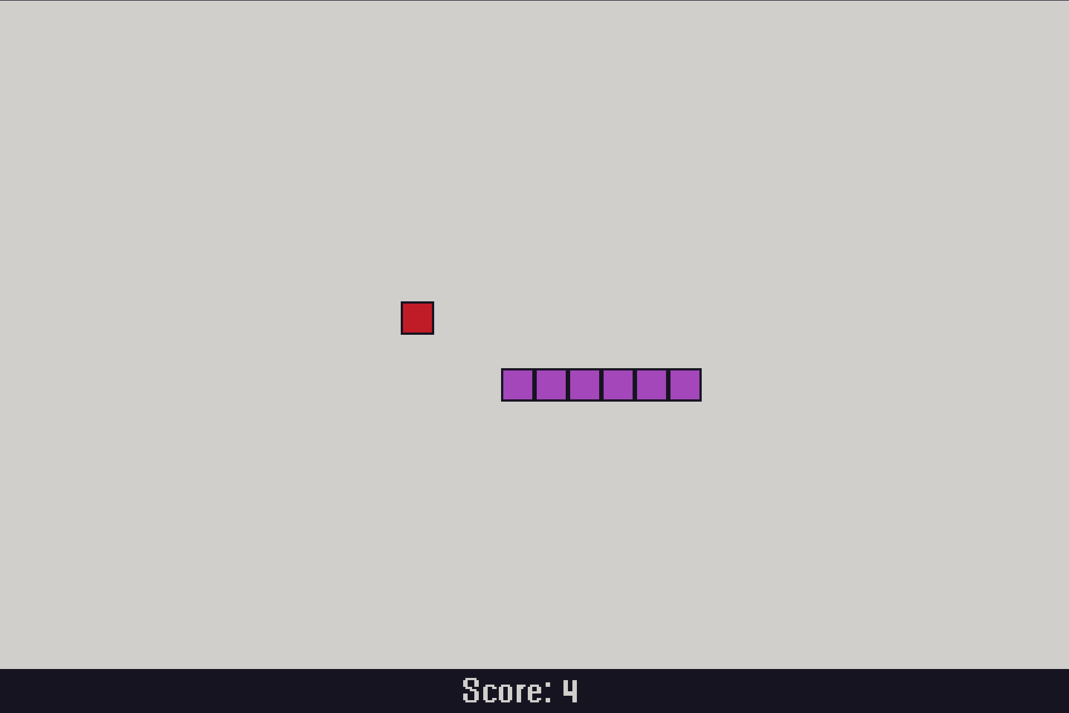Game (1 player)

Game over (1 player)

Controls:
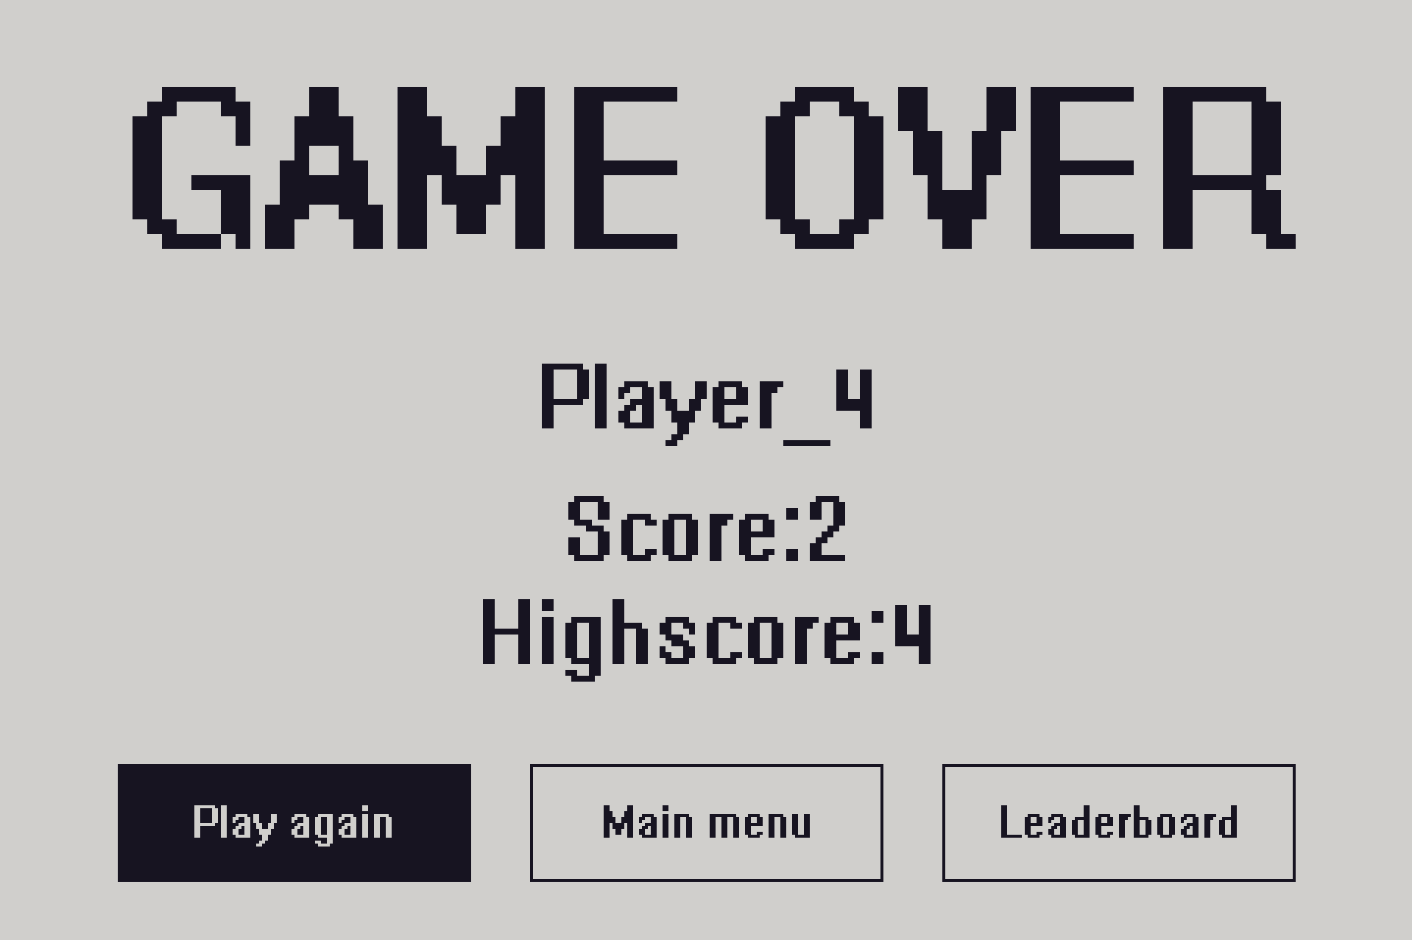Game over (1 player)

- Change button: rotate red (left) knob
- Select button: press red (left) knob

Buttons:

- Play again – start game for one player
- Main menu – go to main menu
- Leaderboard – go to leaderboard

Game (2 Players)

Snake for two players. The main goal of this game mode is to have fun with a friend.

Controls:

- Change snake 1 (player 1) direction: rotate red (left) knob
- Change snake 2 (player 2) direction: rotate blue (right) knob

Snake 1 (player 1) starting position: top left
Snake 2 (player 2) starting position: bottom right

Score: Number of eaten fruits = length of the snake – starting size (2)
Score is different for each snake, score counter colors correspond to snake colors.

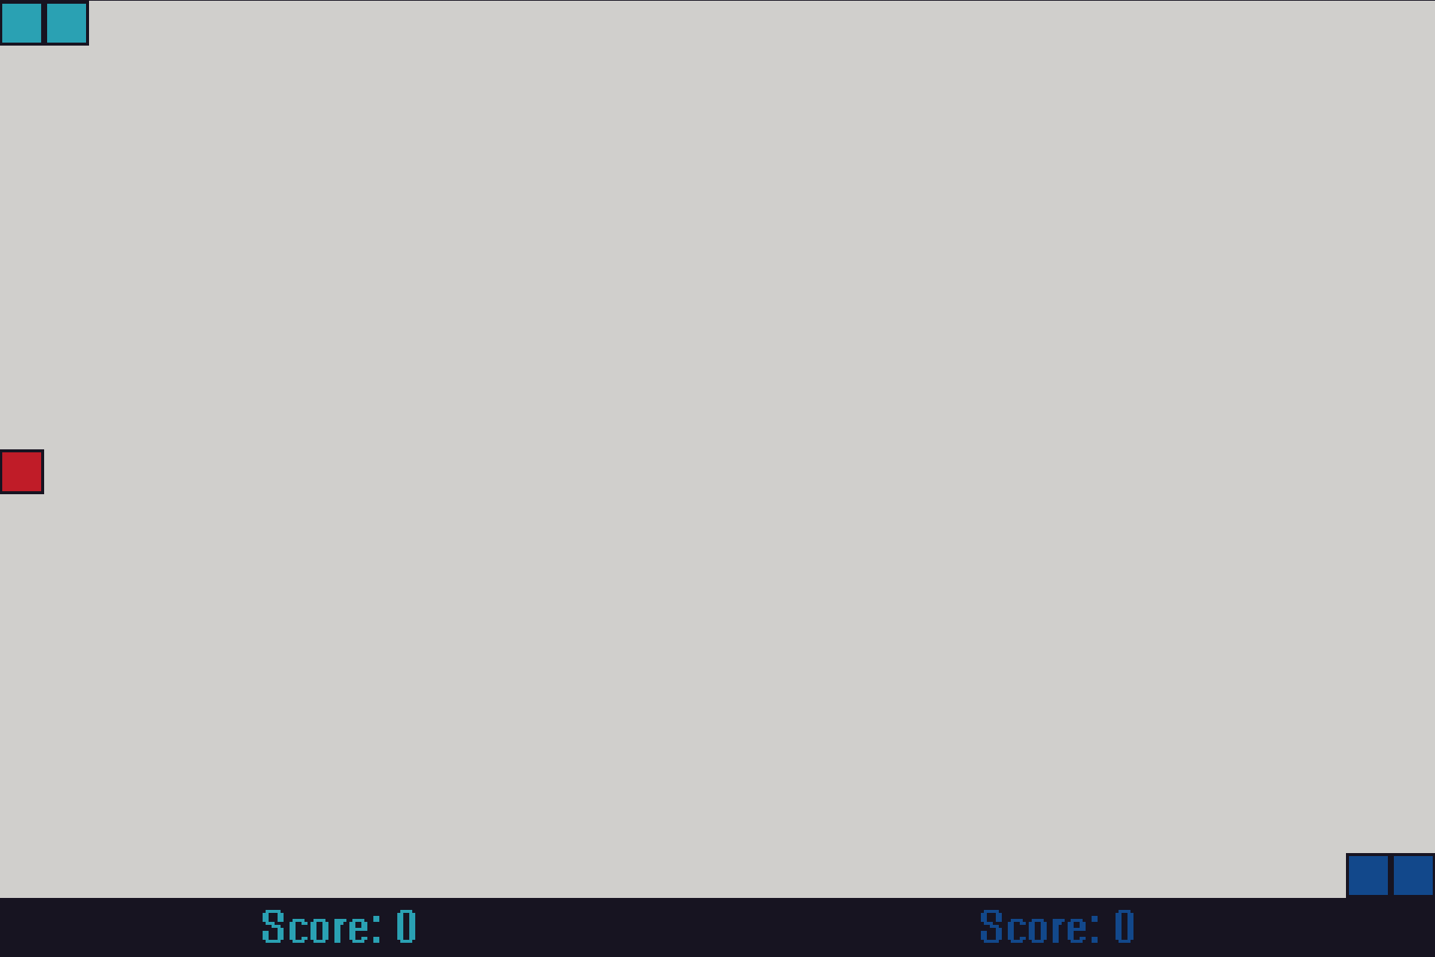Game (2 players)

Game over (2 players)
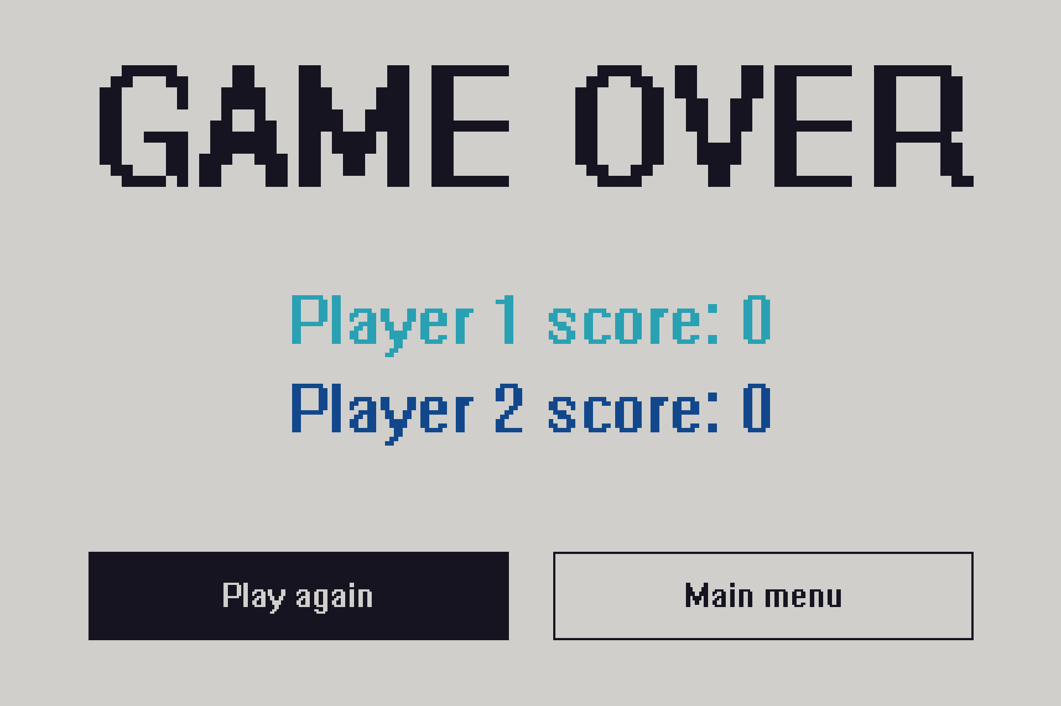Game over (2 players)

Controls:

- Change button: rotate red (left) knob
- Select button: press red (left) knob

Buttons:

- Play again – start game for two players
- Main menu – go to main menu

Options

Options allow the user to change app and game settings.

Controls:

- Change button: rotate red (left) knob
- Select button: press red (left) knob

- Change button with options value: rotate green (middle) knob
- Confirm button with option: press green (middle) knob

Buttons:
- Snake size – change snake tile size
  - Available sizes:
    - 5px
    - 10px
    - 15px
    - 20px
    - 30px

- Snake speed – change snake speed
  - Available speeds:
    - 1
    - 2
    - 3
    - 4
    - 5

- Snake 1 color – change snake 1 color (this snake is the one in 1 player mode)
- Snake 2 color – change snake 2 color
- Fruit color – change fruit color
  - Available colors:
    - Pink
    - Red
    - Orange
    - Yellow
    - Lime
    - Green
    - Cyan
    - Blue

- Color theme – change app color theme
  - Available themes:
    - Classic theme (green-black)
    - Dark theme (black-white)
    - Light theme (white-black)

- Save – save the settings and go to main menu
- Default – set all settings to default values

How to change the settings:

1) Go to options
2) Choose which setting you want to change, navigate to it using the red (left) knob.

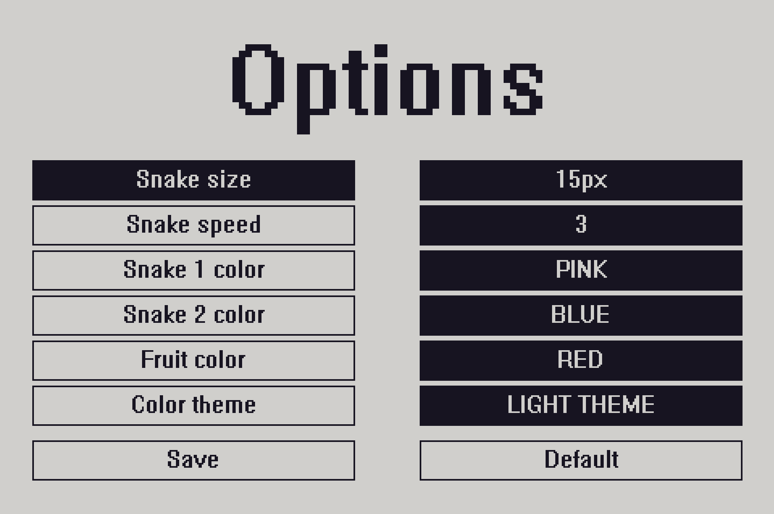Open options
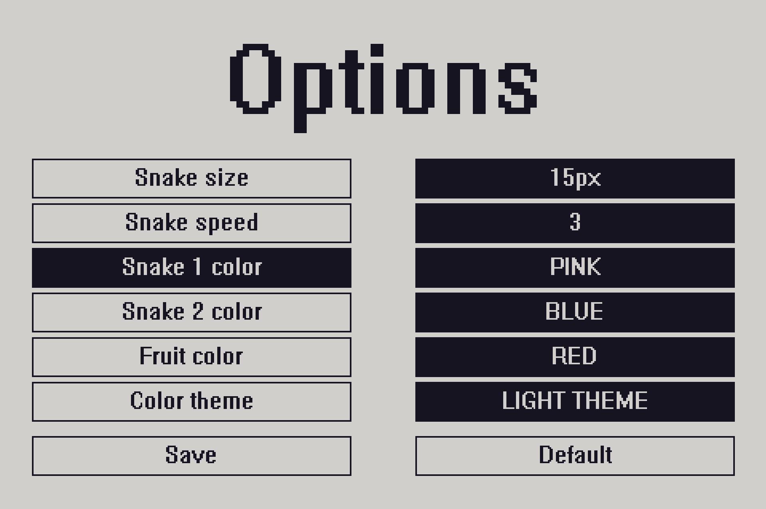Choose button

3) Press the red (left) knob to select it
4) Choose from predefined values using the green (middle) knob

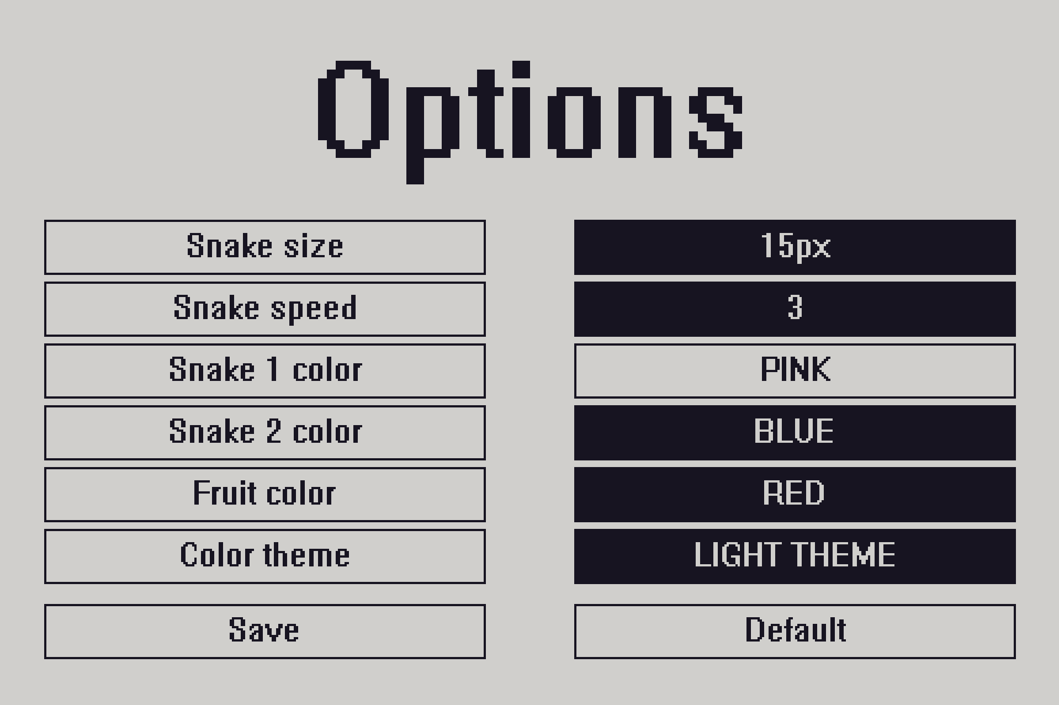Select the button
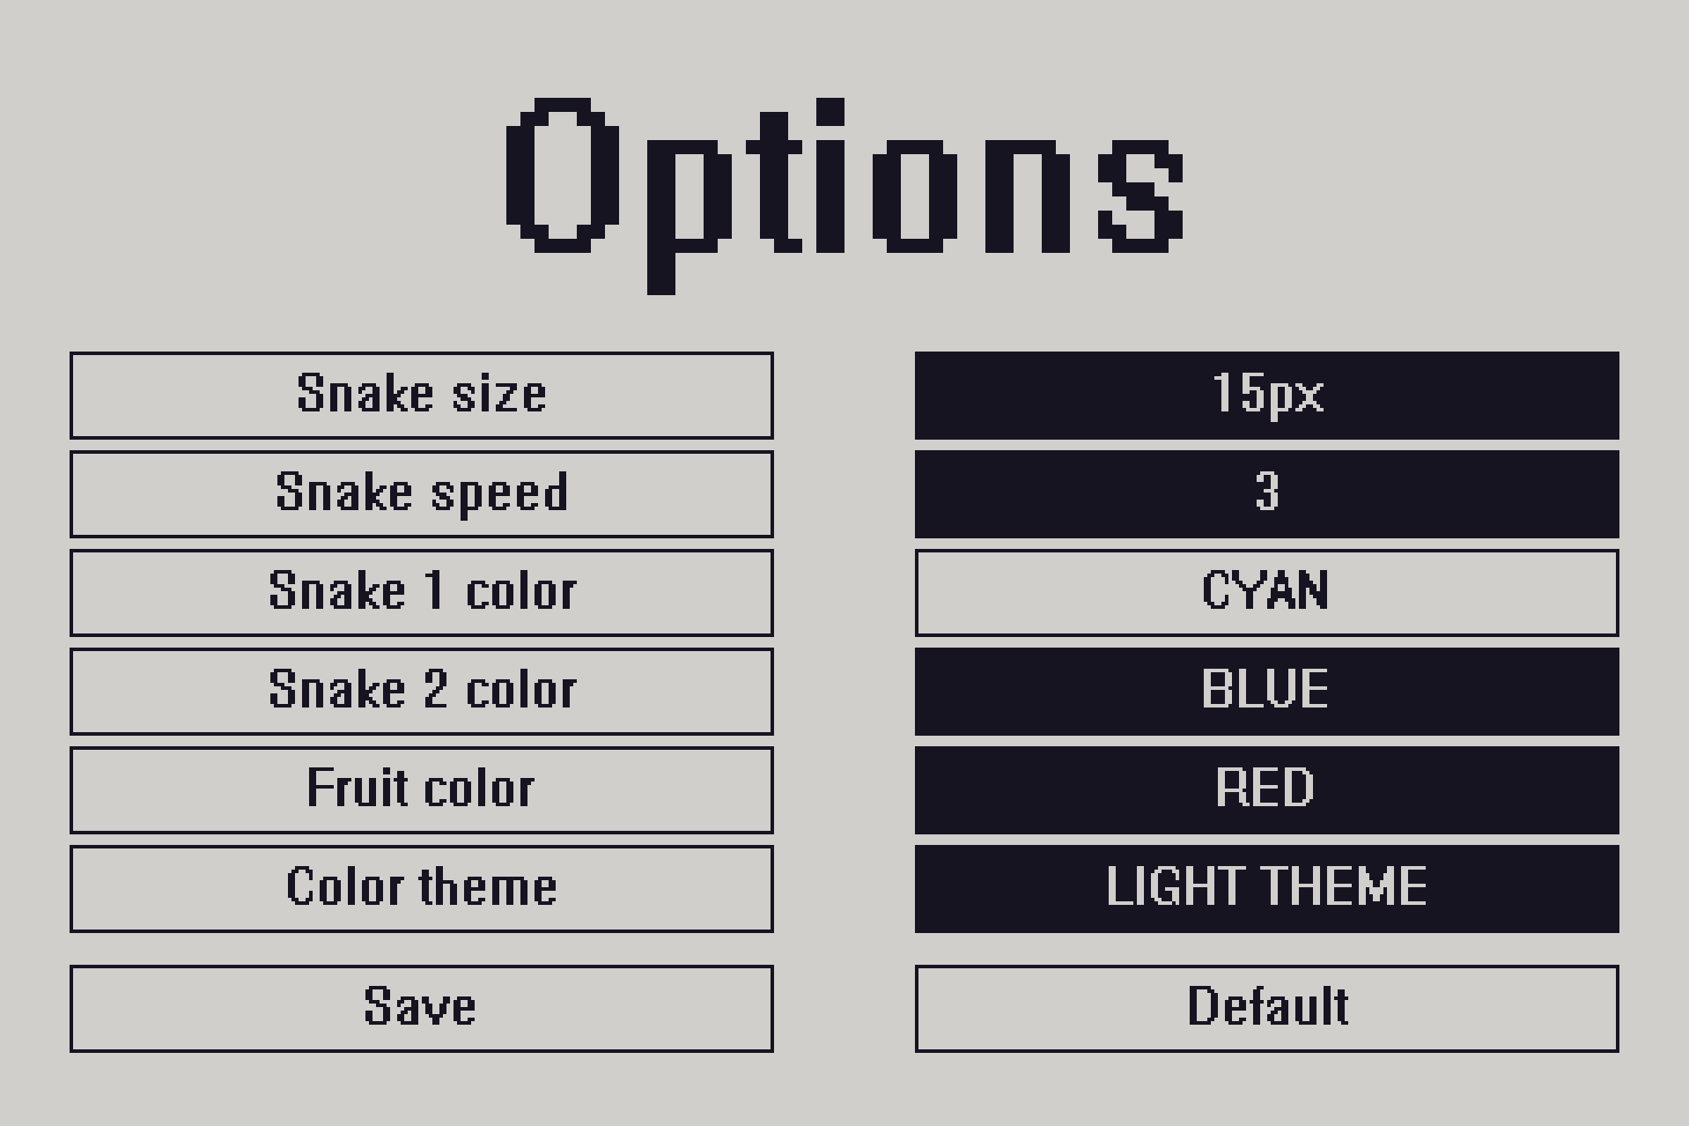Change value

5) Press the green (middle) knob to confirm.
6) Save

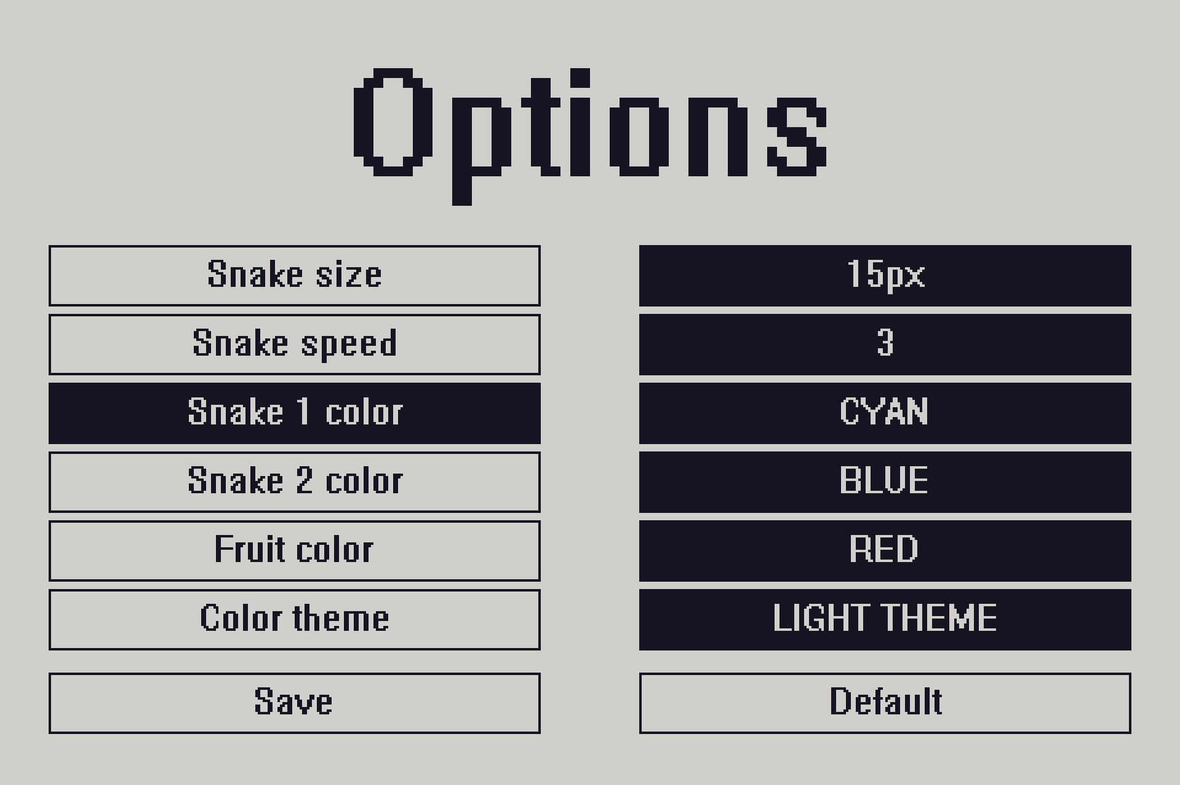Confirm new value
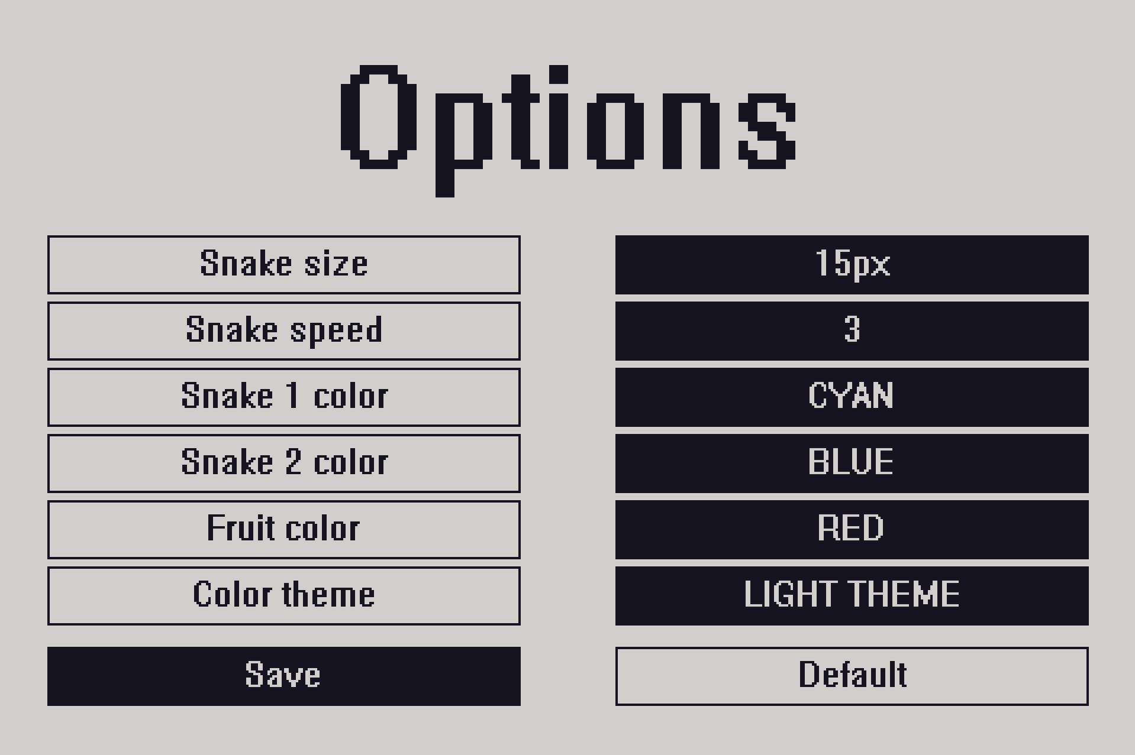Save

Leaderboard

Leaderboard shows rank and highscore of each player.

The rank is set by the highscore:

- Best highscore = 1st
- Second best highscore = 2nd
- …
- Worst highscore = 6th

If two players have the same highscore, the rank is set depending on the player numbers.
For example:

Player_3 highscore = 5
Player_1 highscore = 5
Player_5 highscore = 5

1st Player_1
2nd Player_3
3rd Player_5

Controls:

- Change button: rotate red (left) knob
- Select button: press red (left) knob

Buttons:

- Main menu – go to main menu
- Reset – delete all highscores

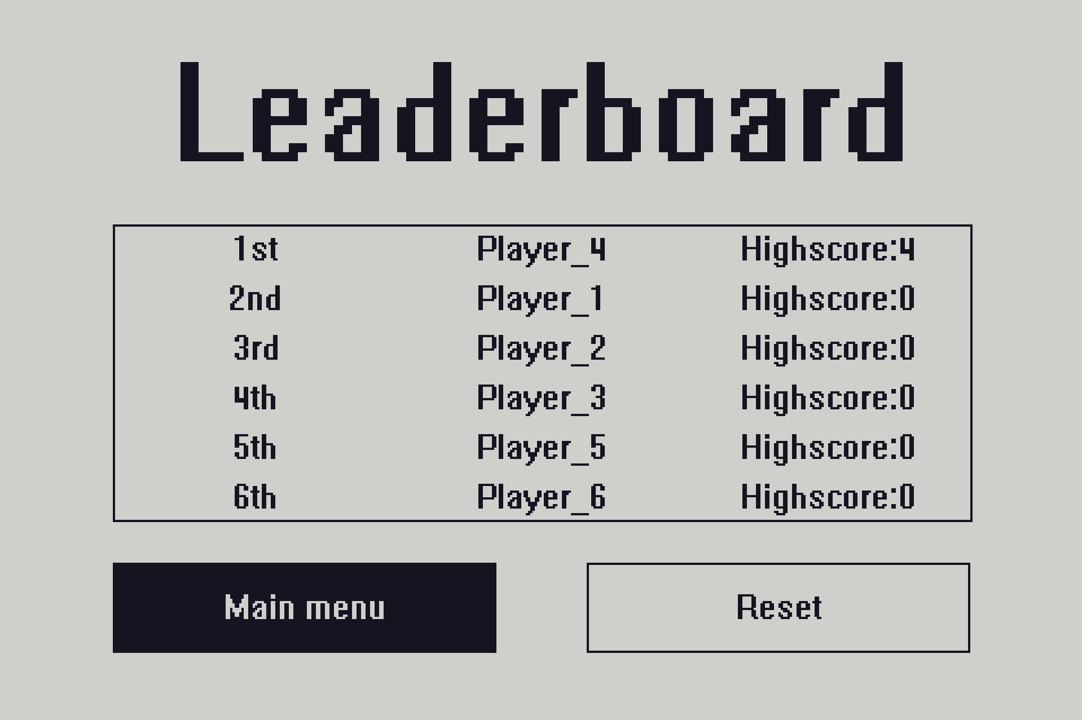Leaderboard
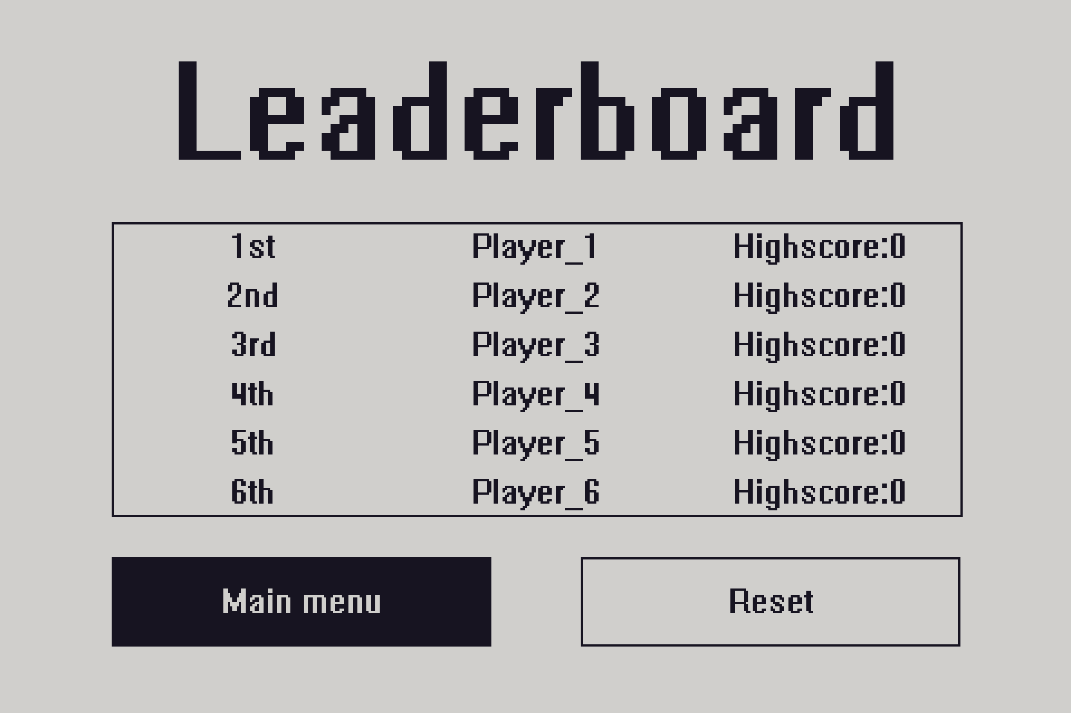Default leaderboard

