ASSIGNMENT – JAVASCRIPT -2
By Soumay Kumar PGCPAC Aug-2026
Q.1 Create an array of four values: green, blue, orange, red. Print the second element of the array in a paragraph with id as &quot;ashoka&quot;. Also add two colors after blue color and print the final array in a paragraph with id as &quot;ashoka1&quot;.
CODE:
<!DOCTYPE html>
<html>
<head>
<title>Array</title>
<style>
p{
background-color: aliceblue;
}
span{
background-color: skyblue;
}
</style>
</head>
<body>
<h2>Array of Colors</h2>
<p>Original Array of Colors: <span id="c"></span></p>
<p>Second Element of array: <span id="ashoka"></span></p>
<p>Final Array of Colors: <span id="ashoka1"></span></p>
<script>
var colors =["green", "blue", "orange", "red"];
document.getElementById("c").innerHTML= colors;
document.getElementById("ashoka").innerHTML = colors[1];
colors.splice(2,0,"yellow","brown");
document.getElementById("ashoka1").innerHTML = colors;
</script>
</body>
</html>
OUTPUT:
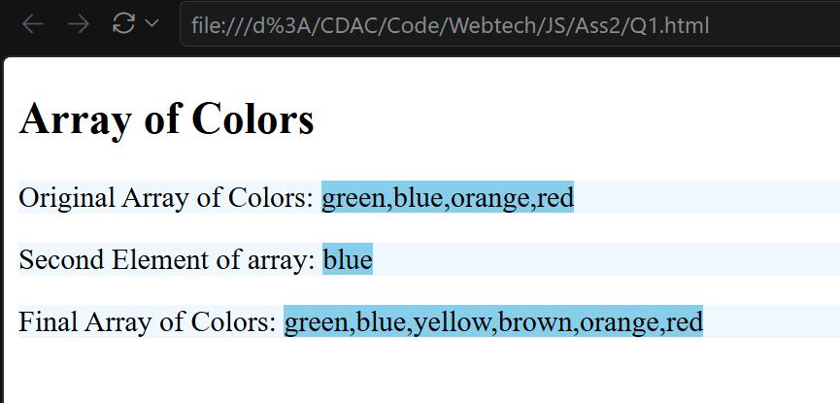

Q.2 Write a JavaScript program to print current date, number of milliseconds till date, year and day.
CODE:
<!DOCTYPE html>
<html>
<head>
<title>Date Program</title>
</head>
<body>
<h2>Print Date</h2>
<p>CurrentDate:<span id="d"></span></p>
<p>Number of Milliseconds till date:<span id="msec"></span></p>
<p>Year:<span id="year"></span></p>
<p>Day:<span id="day"></span></p>
<script>
var d= new Date();
document.getElementById("d").innerHTML = d
document.getElementById("msec").innerHTML = d.getTime();
document.getElementById("year").innerHTML = d.getFullYear();
document.getElementById("day").innerHTML = d.getDay();
</script>
</body>
</html>
OUTPUT:
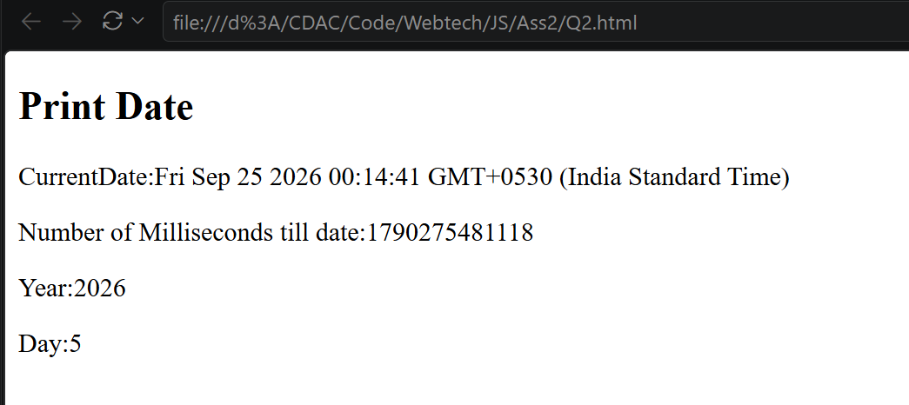
Q.3 Write a JavaScript program to make a form (Name, Roll number , exam center choice drop down ,telephone number and email id, submit button) and validate the input fields of form.
CODE:
<html>
<head>
<title>Form Validation Example</title>
<style>
fieldset{
background-color: aliceblue;
}
input[type=text]{
background-color: skyblue;
}
select{
text-decoration-color: blue;
}
</style>
<script>
function ValidateStudentForm()
{
var name = document.StudentForm.Name;
var roll = document.StudentForm.Roll;
var center = document.StudentForm.Center;
var phone = document.StudentForm.Telephone;
var email = document.StudentForm.Email;
var file = document.StudentForm.File;
if (name.value == "")
{
window.alert("Please enter your name.");
name.focus();
return false;
}
if (!/^[a-zA-Z]+$/.test(name.value))
{
window.alert("Name should contain only alphabets.");
name.focus();
return false;
}
if (roll.value == "")
{
window.alert("Please enter roll number.");
roll.focus();
return false;
}
if (!/^[a-zA-Z0-9]+$/.test(roll.value))
{
window.alert("Roll number should contain only alphanumeric characters.");
roll.focus();
return false;
}
if (center.selectedIndex < 1)
{
window.alert("Please select an exam center.");
center.focus();
return false;
}
if (phone.value == "")
{
window.alert("Please enter telephone number.");
phone.focus();
return false;
}
if (!/^[0-9]{10}$/.test(phone.value))
{
window.alert("Telephone number must contain exactly 10 digits.");
phone.focus();
return false;
}
if (email.value == "")
{
window.alert("Please enter email address.");
email.focus();
return false;
}

if (!/^[a-zA-Z0-9._%+-]+@[a-zA-Z0-9.-]+\.[a-zA-Z]{2,}$/.test(email.value))
{
window.alert("Please enter a valid email address.");
email.focus();
return false;
}
if (file.value == "")
{
window.alert("Please upload a file.");
file.focus();
return false;
}
if (!/\.(doc|pdf)$/i.test(file.value))
{
window.alert("Only DOC or PDF files are allowed.");
file.focus();
return false;
}
window.alert("Form submitted successfully!");
return true;
}
</script>
</head>
<body>
<div>
<form name="StudentForm" onsubmit="return ValidateStudentForm();">
<h2>Please fill the form:</h2>
<fieldset>
<legend>
<h3>Student Information</h3>
</legend>
<p>Name:<input type="text" size="50" name="Name"></p>
<p>Roll Number:<input type="text" size="50" name="Roll"></p>
<p>Exam Center:
<select name="Center">
<option>Please Choose</option>
<option>Delhi</option>
<option>Noida</option>
<option>Pune</option>
<option>Bangalore</option>
</select></p>
<p>Telephone:<input type="text" size="50" name="Telephone"></p>
<p>Email:<input type="text" size="50" name="Email"></p>
<p>Upload File:<input type="file" name="File"></p>
<p><input type="submit" value="Submit" name="submit">
<input type="reset" value="Reset" name="reset"></p>
</fieldset>
</form>
</div>
</body>
</html>
OUTPUT:
