RO-EXPLORER

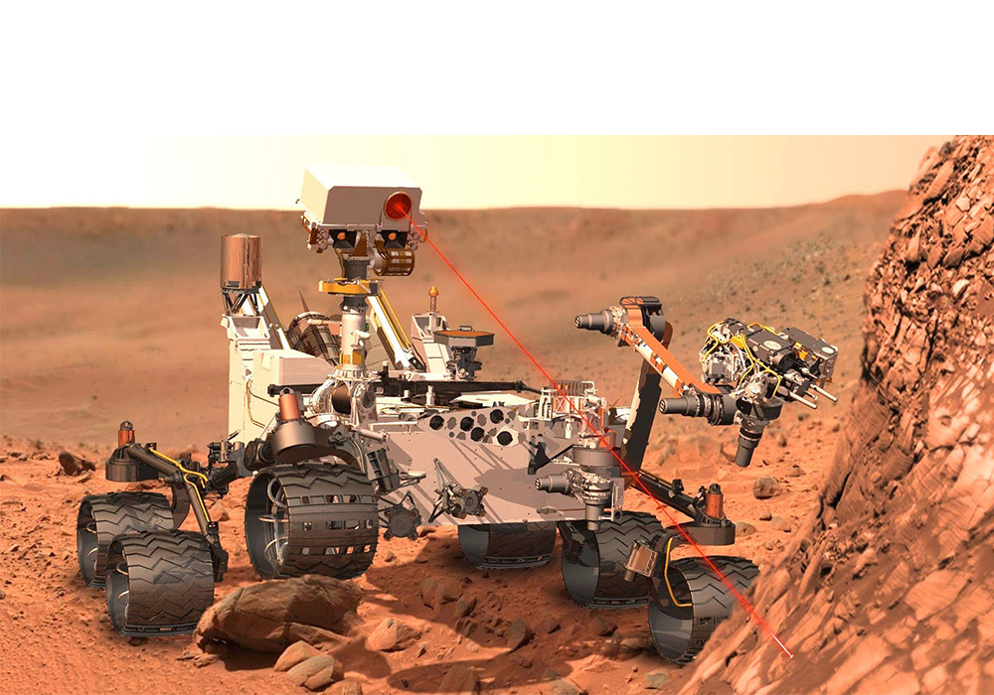

“**The winner isn’t the one with the fastest bot, it’s the one who refuses to lose... Will it be the same with you??Show your guts and adrenaline at sankalp**!!!!

It's time to place your robot in the challenging arena comprising of all possible terrains like sand, pebbles, obstacles, bumps, bridges, inclines, sea-saw, dips, cliffs, ramps, banks, etc.

HEAD CO-ORDINATOR:

**SANJAY KUMAR**

**Contact : 7699913279**

**KAJAL KUMARI**

**QUAINAT JAHAN**

CO-ORDINATORS:

AVNIT SINHA

VAIBHAV GUPTA

PRAGATI MISHRA

ROBOT SPECIFICATIONS

* The maximum dimensions of the robot should be 25x25x25 cm (± 5% allowance)
* The bots can be powered on-board as well as externally.
* In case of external power supply, the wires must be kept long enough to cover the whole track and wire should remain slack during the complete run.
* Maximum weight of the bot must not exceed 4kgs. (Maximum)
* The power supply must not exceed 18V DC (Maximum).
* Readymade toy cars not allowed.

ARENA SPECIFICATIONS

* Track width is 40 cm normally and it may change at some places.
* The track surface and course line may have unevenness.
* There will be an inclination, but this will not exceed 45 degrees.
* The arena will consist of various obstacles along with sand, bumps, water and other multi-terrain features.

GENERAL RULES

* This is a team event. The maximum number of participants allowed in a team is 4.
* A team may consist of students from different colleges/institutes.
* The bot must be controlled manually.
* All students must have their respective college/institute ID cards.
* A participant cannot be a member of 2 different teams in this event.
* Any action violating fair play will lead to immediate disqualification.
* It should be noted that the main chassis should remain the same throughout the event.
* The participants will be provided with 220 volts, 50 Hz standard AC supply.
* Scoring rules will be briefed by co-ordinators on spot.
* **Note**: All the above rules and specifications may change without prior notice. Decision of event Co-ordinators will be final and binding.