You are a AI Architect and assigned to design and build a capestone project including documentation system architecture, step by step implementation steps, agent workflow, api Documentation, Limitation and security considerations

Below is folder structure at project folder and already created. Please generate scripts and provide mapping of script to place at folder; Please read through below images for implementation and understanding requirement and details. Documents uploaded by user to be placed at doc folder. Requirement.txt should have all python libraries to be installed using codes and reference this file

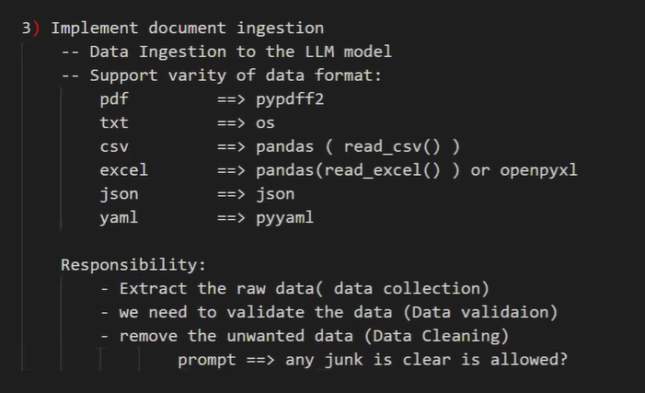

Please consider FASTAPI for user Interface with below UI screens

Screen 1 - User can upload file contains natural language for prompt; also include Text box for question and upload documents with multiple questions

Screen 2 - Contains Health of API which fetch RAG and upload documents

Screen 3 - Contains Upload document to RAG and Vector database

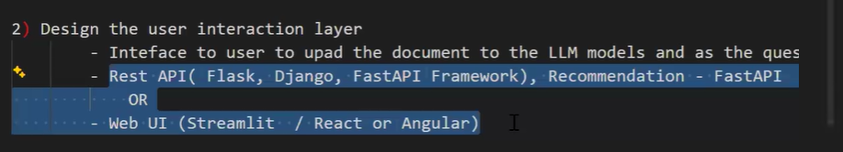
Please refer below screen for semantic search

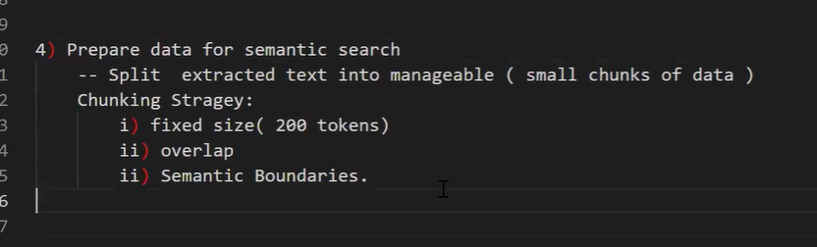

Please consider chroma as vector database and follow below screen for steps
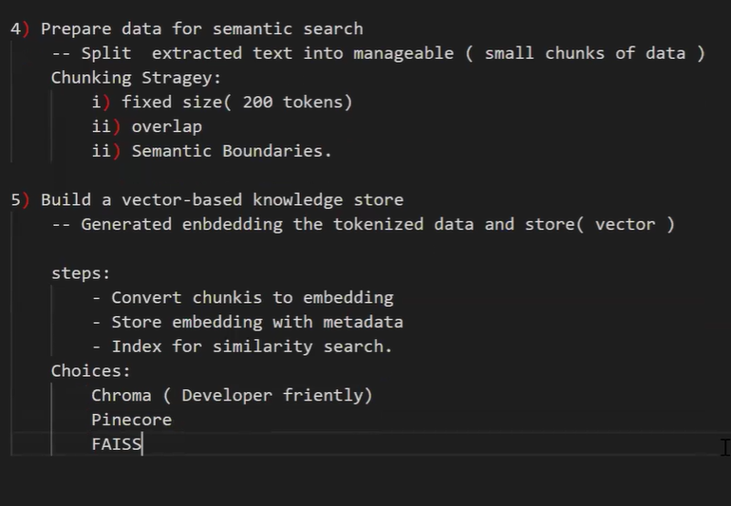

Below screen contains steps for RAG and retrieve information from Document
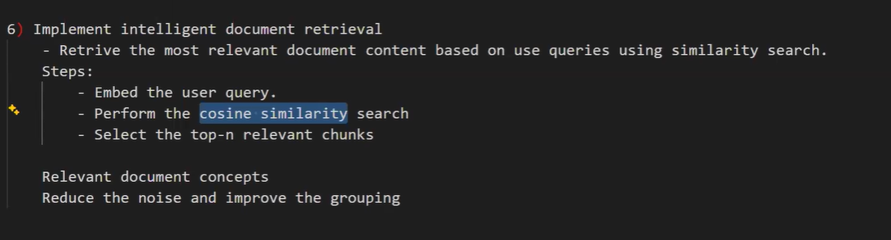

Please use llama_index and pandas for pipeline and share details steps for implementation and architecture

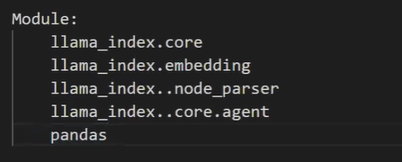

Below is details of RAG pipeline for implementation

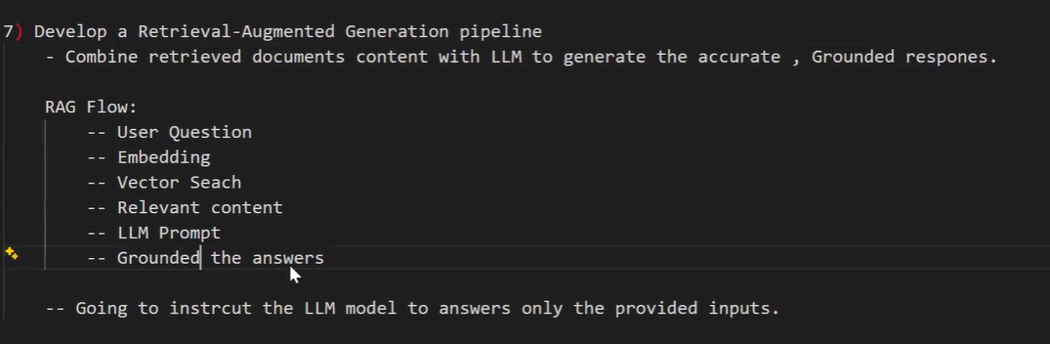

Please create a agent using llama_index agent for RAG, please review below screen for Agent roles and integrate at solution
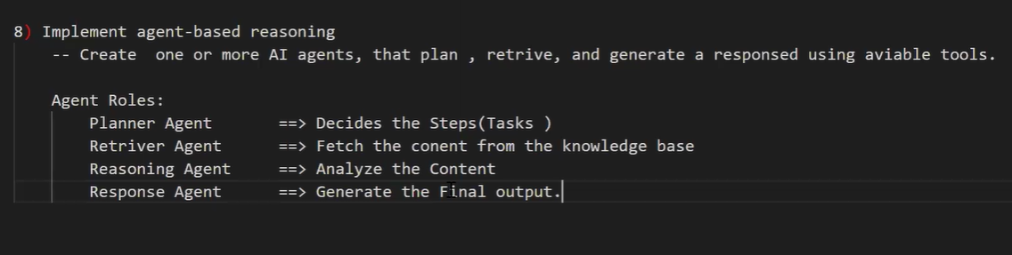

Create agent using lama_index..coreagent - reactagent. Single agent will do all above roles

Please consider in solution of below error handlings and guardrail at solution

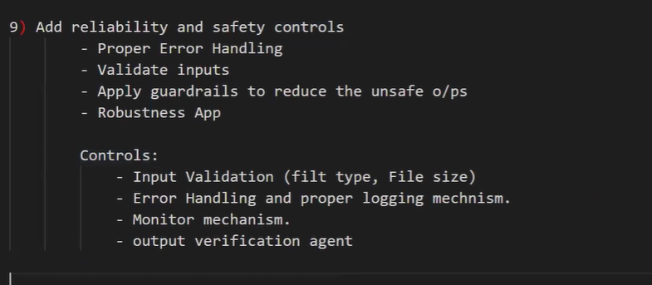

Please consider deployment using Render Tool and provide step by step approach for deployment
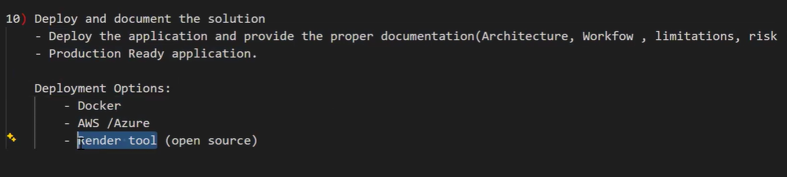

Please prepare document with below contains
