RAG Capstone Agent Documentation
FastAPI + LlamaIndex + Chroma + Single ReActAgent
Prepared for the capstone requirement to design and build a RAG application with architecture, implementation steps, agent workflow, API/UI usage, limitations, assumptions, security considerations, and Render deployment guidance.

1. Requirement Summary
- FastAPI user interface with three screens: query, health, and upload-to-RAG.
- Document ingestion for PDF, TXT, CSV, Excel, JSON, and YAML; this solution also supports DOCX.
- Semantic search preparation with small chunks, about 200 tokens, overlap, and semantic boundaries.
- Chroma as the vector database.
- LlamaIndex and pandas in the ingestion and RAG pipeline.
- A single LlamaIndex ReActAgent implementing planner, retriever, reasoning, and response roles.
- Error handling, validation, guardrails, logging, output verification, and monitoring/health checks.
- Render deployment approach and production-ready documentation.

2. System Architecture Diagram
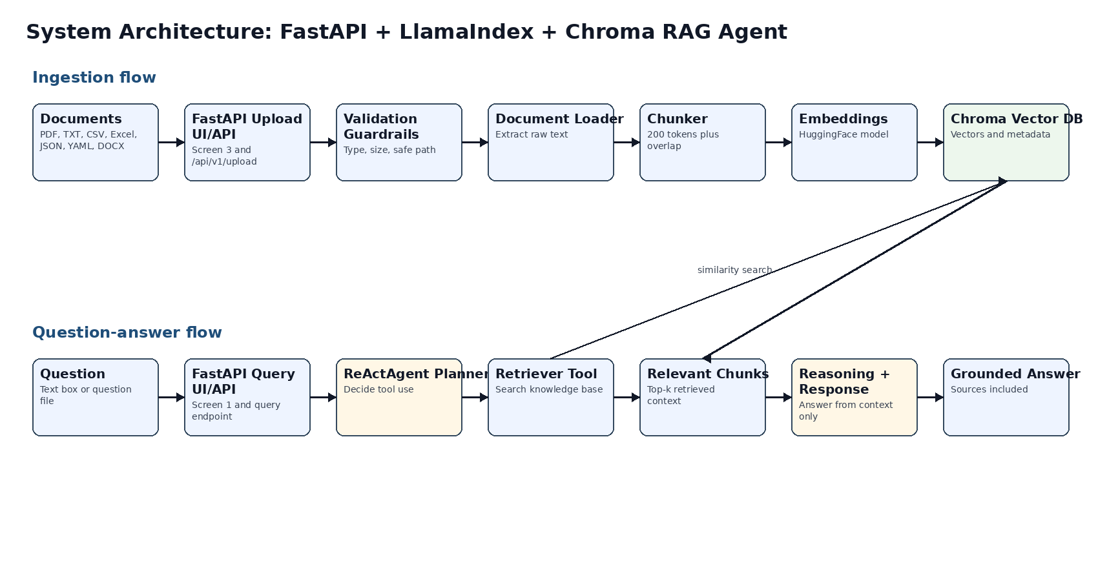

3. Architecture Layers
Layer | Responsibility | Implementation files
User Interaction | Forms and API calls for query, health, and upload. | app/templates, app/api/routes.py
Validation/Security | File type, file size, prompt guardrails, safe names. | app/core/security.py
Ingestion | Extract raw text from supported document formats. | app/services/document_loader.py
Semantic Prep | Clean text and chunk using overlap and boundaries. | app/services/chunker.py
Vector Store | Persist embeddings and metadata to Chroma. | app/services/vector_store.py
Agent/RAG | Retrieve, reason, and answer from context only. | app/services/rag_pipeline.py, app/services/agent.py

4. Agent Workflow
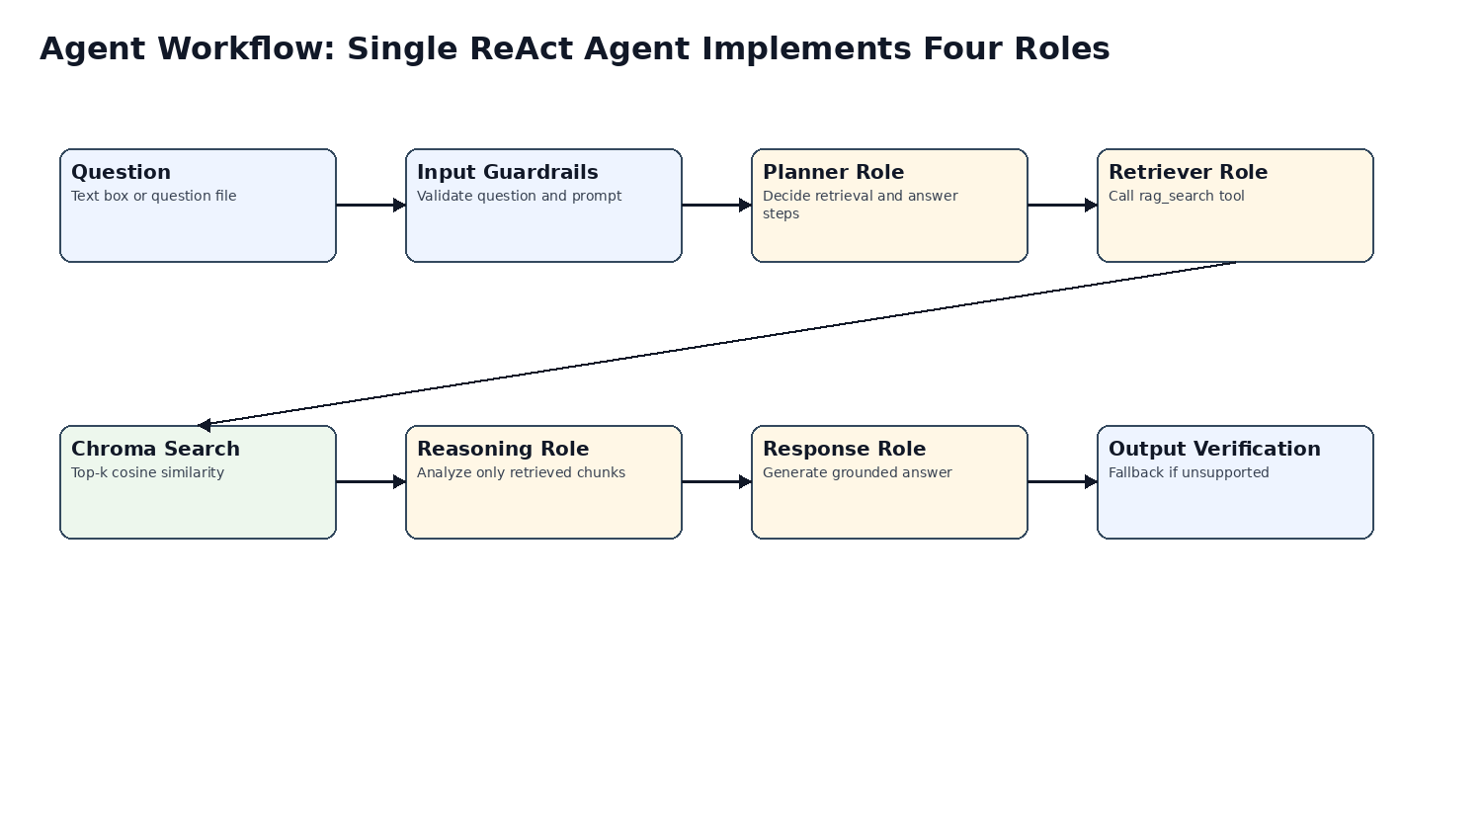
The single ReAct agent performs all required roles. The planner decides the task path, the retriever calls rag_search, the reasoning step analyzes only retrieved chunks, and the response role writes the grounded answer. If the LLM agent is unavailable, the system falls back to an extractive RAG answer so the application remains usable.

5. Step-by-Step Implementation
1. Create a Python 3.11 virtual environment.
2. Install libraries using pip install -r requirements.txt.
3. Copy .env.example to .env and set OPENAI_API_KEY when LLM-based answers are required.
4. Place documents in doc/ or upload them through the Upload screen.
5. Run python scripts/ingest_folder.py --folder doc or use the UI ingest option.
6. Start the app with uvicorn app.main:app --reload --host 0.0.0.0 --port 8000.
7. Open / for query, /upload-ui for ingestion, /health-ui for status, and /docs for OpenAPI.
8. Ask one question from the text box or many questions from a TXT, CSV, or JSON file.

6. Script Mapping
Script | Folder | Purpose
app/main.py | app/ | FastAPI app, startup, middleware, exception handler.
app/api/routes.py | app/api/ | REST endpoints and three UI screens.
app/core/config.py | app/core/ | Environment settings and directory creation.
app/core/security.py | app/core/ | Validation and guardrails.
app/services/document_loader.py | app/services/ | Document text extraction.
app/services/chunker.py | app/services/ | 200-token semantic chunking with overlap.
app/services/vector_store.py | app/services/ | Chroma and LlamaIndex vector store.
app/services/rag_pipeline.py | app/services/ | Ingestion, retrieval, grounded answer generation.
app/services/agent.py | app/services/ | Single LlamaIndex ReActAgent wrapper.
scripts/ingest_folder.py | scripts/ | CLI ingestion from doc/ folder.
requirements.txt | root | Python libraries to install.
render.yaml | root | Render deployment blueprint.

7. API/UI Usage
Method | Endpoint | Purpose
GET | / | Screen 1: query UI.
GET | /health-ui | Screen 2: health UI.
GET | /upload-ui | Screen 3: upload UI.
GET | /api/v1/health | API, Chroma, document, vector, and agent status.
POST | /api/v1/upload | Upload documents to doc/ and optionally ingest.
POST | /api/v1/ingest-local | Ingest all supported documents already in doc/.
POST | /api/v1/query | Multipart query with prompt file, question file, and documents.
POST | /api/v1/query-json | JSON question endpoint.
GET | /api/v1/search | Raw semantic search results.

8. Limitations
- Scanned PDFs require OCR, which is not included.
- Local Chroma persistence is suitable for capstone use; production should use durable storage.
- Prompt-injection detection is pattern-based and should be expanded for regulated environments.
- Without OPENAI_API_KEY, answers are extractive rather than synthesized by an LLM.
- Authentication and authorization must be added before public production use.

9. Assumptions
- Documents are uploaded by trusted users in allowed formats and within configured size limits.
- The runtime can download the configured embedding model on first startup.
- OPENAI_API_KEY is provided through environment variables when the ReActAgent is expected to call an LLM.
- Render deployment uses environment variables for secrets and optional persistent disk for long-term vector storage.

10. Security Considerations
- Validate extension and size for every upload.
- Sanitize filenames to prevent path traversal.
- Treat prompt files and document contents as untrusted input.
- Do not reveal secrets, system messages, or environment variables.
- Return no-answer fallback when no relevant chunks are retrieved.
- Use environment variables for keys and do not commit secret values.
- Add authentication, rate limiting, HTTPS, malware scanning, and retention policies for production.

11. Render Deployment
- Push the project to a Git repository.
- Create a Render Blueprint using render.yaml.
- Set OPENAI_API_KEY in the Render dashboard as a secret value.
- Deploy the web service with build command pip install -r requirements.txt.
- Use start command uvicorn app.main:app --host 0.0.0.0 --port $PORT.
- Open the Render URL and validate /health-ui, /upload-ui, and /.

