**Soumen Sarker**

**Dhaka: 1204, Bangladesh** 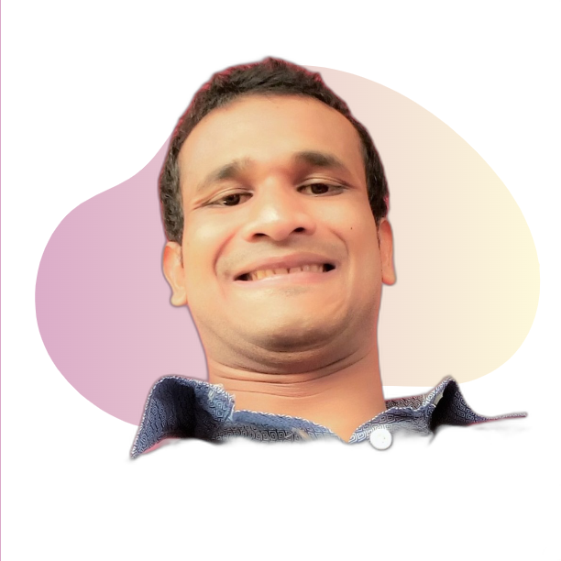

 [**Mail**](mailto:sks0007771@gmail.com) ******[**LinkedIn**](https://www.linkedin.com/in/soumen-sarker-61302216b/)  [**GitHub**](https://github.com/%20soumenksarker)

**CAREER OBJECTIVE**

**Dedicated to finding solutions to problems, passionate about**

**software engineering, machine learning, and data science.**

**Working in a collaborative setting with experts in my areas of**

**interest will help me advance my professional career**.

**EXPERIENCE**

* **Working with research teams in the domain of computer visions, medical image analysis**
* **Data Science, Machine Learning, and Deep Learning (NLP, Computer Vision) projects**
* **Kaggle Competitions**
* **Problem Solving, OOP**

**EDUCATION**

○␣ **Islamic University, Kushtia, Bangladesh** *B.Sc. in ICT*

CGPA: 3.52 out of 4.0 *March 2016 – September 2021*

○␣ **Govt. Azizul Haque College, Bogura:5800** *HSC, Science group*

**PUBLICATIONS & PROJECTS**

**Publication:**

**Title**: WhyMyFace: A Novel Approach to Recognize Facial Expressions Using CNN and Data Augmentations

[*Conference Paper*](https://link.springer.com/chapter/10.1007/978-981-19-4676-9_48)

**Deep learning projects:**

**i. Final Year Project:**

* **A Sentiment Classification model by comparing naive Bayes, DNN, RNN, and LSTM**

**classification models.**

* **Automatic Text Summarization with Transformer Architecture.**

**Key aspects:**

**TF-IDF, stem/lemmatize, tokenization, vector embedding, n-gram, NMT, seq2seq, attention, gradient**

**descent, rmsProp, transformer architecture!**

[**Link**](https://github.com/soumenksarker/NLP-Specialization)

**ii. Built and Deployed an NLP application that reveals named entities, classifies sentiment, and**

**does text summarization using spacy, textblob, genism, streamlit and heroku.**

[**Link**](https://github.com/soumenksarker/text-summarizer-and-others)

**iii. Image Classification/Browser based model to classify Rock/Paper/Scissors**

Browser-based model, node.js, training with and without transfer learning, evaluating,

alerting on browser!

* Model created with Tensorflow Keras in python
* Convert the Keras model into JSON format using the Tensorflow.js converter

[Link](https://github.com/soumenksarker/TF-in-Deployment)

**iv. Built and deployed a CV application that detects faces, smiles, and eyes, do enhance as well**

**as filters like cartoonish.** [**App link**](https://face-detection-opencv-strmlt.herokuapp.com/)

**Machine Learning & Data Science Projects:**

**i.House Price Prediction**

* Feature Engineering and Selection
* Model building
* Creating an ML pipeline
* In-house software using Scikit-learn API( OOP, Inheritance, Transformers, Pipeline) and recreating an optimized pipeline(python environment)
* Packaging the model for production(requirements files, tox, pyproject.toml)
* Serving and deploying the model via REST API(Fast API, HTML, UVicorn web server, Heroku)

[APP Link](https://fathomless-falls-91100.herokuapp.com/docs)

**TECHNICAL SKILLS**

* **C**
* **C++**
* **Python**
* **Javascript**
* ␣ **OOP**
* **Data Structures**
* **Machine Learning**
* **Deep Learning**
* **Data Science**
* **Tensorflow**
* **Pytorch**
* **Computer Vision**
* **NLP**
* **Git**
* **Scikit-Learn**
* **SQL**
* **Scipy**
* **Numpy**
* **Pandas**

**COURSES & CERTIFICATES**

* **DeepLearning.AI TensorFlow Developer** -[Coursera](https://www.coursera.org/account/accomplishments/specialization/certificate/TT4H374ADBHZ)
* **Deep Learning Specialization** – [*Coursera*](http://www.coursera.org/account/accomplishments/specialization/247QCPRWMMY5)
* **Machine Learning** – [*Coursera*](https://www.coursera.org/account/accomplishments/verify/F5ENWFZKEZPY)
* **Algorithmic Toolbox by UCSanDiego-** [Coursera](https://coursera.org/share/88a76058eda654df91d12d93851db345)

**LANGUAGE PROFICIENCIES**

**Bangla**: native language

**English**: fluent (speaking, reading, writing)

**References:**