Is it possible to show image in datatable.

Okk I got the solution for it also

"columnDefs" : [{  
"targets" : 6 ,  
"data": "img",  
"render" : function ( url, type, full) {  
return '<img height="75%" width="75%" src="'+full[7]+'"/>';  
}]

Great Link : <https://jsfiddle.net/yg1w6gen/64/>

<script>

$(document).ready(function () {

$('#example').dataTable({

"processing": true, // control the processing indicator.

"serverSide": true, // recommended to use serverSide when data is more than 10000 rows for performance reasons

"info": true, // control table information display field

"stateSave": true, //restore table state on page reload,

"lengthMenu": [[10, 20, 50, -1], [10, 20, 50, "All"]], // use the first inner array as the page length values and the second inner array as the displayed options

"ajax":{

"url": "@string.Format("{0}://{1}{2}", Request.Url.Scheme, Request.Url.Authority, Url.Content("~"))/Home/AjaxGetJsonData",

"type": "GET"

},

"columns": [

{ "data": "Name", "orderable" : true },

{ "data": "Age", "orderable": false },

{ "data": "DoB", "orderable": true },

{

"render": function (data, type, JsonResultRow, meta) {

return '<img src="Content/'+JsonResultRow.ImageAddress+'">';

}

}

],

"order": [[0, "asc"]]

});

});

</script>

[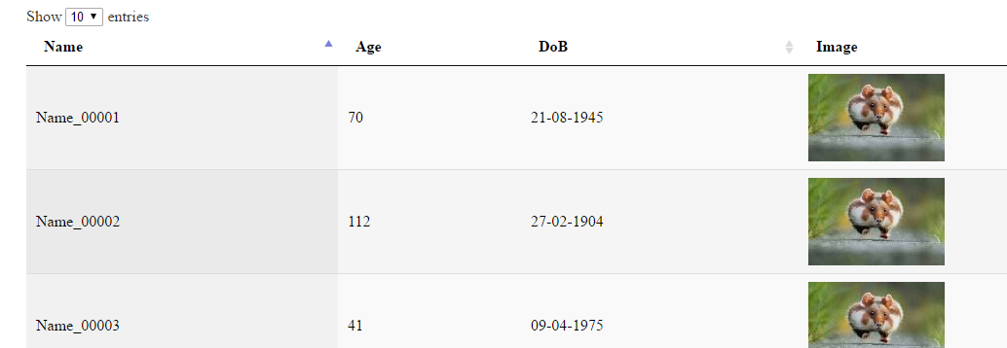](https://i.stack.imgur.com/1As1W.png)

[share](https://stackoverflow.com/a/37234013)[improve this answer](https://stackoverflow.com/posts/37234013/edit)

[edited Apr 18 '17 at 9:30](https://stackoverflow.com/posts/37234013/revisions)

answered May 15 '16 at 2:43

[[https://lh5.googleusercontent.com/-9vgvQTF1FDU/AAAAAAAAAAI/AAAAAAAAABg/krteJnLkVLk/photo.jpg?sz=32](https://stackoverflow.com/users/5237614/edathadan-chief-aka-arun)](https://stackoverflow.com/users/5237614/edathadan-chief-aka-arun)

[Edathadan Chief aka Arun](https://stackoverflow.com/users/5237614/edathadan-chief-aka-arun)

**2,611**12531

* Hello can you share you controller code?. "render": function (data, type, full, meta) { return '<img src="Content/'+full.Image+'">'; } can't seems get quite this code. – [KiRa](https://stackoverflow.com/users/6847776/kira" \o "449 reputation) [Mar 7 '17 at 5:43](https://stackoverflow.com/questions/8206419/view-pictures-or-images-inside-jquery-datatable#comment72409259_37234013)
* @KiRa Not the same code, but you can find what you need, [stackoverflow.com/questions/12596400/…](http://stackoverflow.com/questions/12596400/how-can-i-implement-jquery-datatables-plugin-using-c-asp-net-sql-server-side) – [Edathadan Chief aka Arun](https://stackoverflow.com/users/5237614/edathadan-chief-aka-arun" \o "2,611 reputation) [Mar 7 '17 at 5:46](https://stackoverflow.com/questions/8206419/view-pictures-or-images-inside-jquery-datatable#comment72409330_37234013)
* I'm trying to understand that line and to apply it on my code.. I am looking on how to display an image into Data Table. – [KiRa](https://stackoverflow.com/users/6847776/kira" \o "449 reputation) [Mar 7 '17 at 5:52](https://stackoverflow.com/questions/8206419/view-pictures-or-images-inside-jquery-datatable#comment72409475_37234013)
* 1

Thanks.. Got it now. I search on how to add first an image into a folder then retrieve it. – [KiRa](https://stackoverflow.com/users/6847776/kira" \o "449 reputation) [Mar 7 '17 at 8:57](https://stackoverflow.com/questions/8206419/view-pictures-or-images-inside-jquery-datatable#comment72414882_37234013)

* 1

Yes it's very easy { "render": function (data, type, JsonResultRow, meta) { return '<img src="/plugins/images/flags/'+JsonResultRow.CountryImg+'" /> '+JsonResultRow.CountryName + ' [' +JsonResultRow.CountryKey + '] '; } }, – [kamal.shalabe](https://stackoverflow.com/users/889537/kamal-shalabe" \o "67 reputation) [Jul 19 '17 at 22:31](https://stackoverflow.com/questions/8206419/view-pictures-or-images-inside-jquery-datatable#comment77371290_37234013)

**Jquery:**

$('#tblUserSalaryDetails').dataTable({

"bJQueryUI": true,

"bAutoWidth": false,

"bProcessing": true,

"bDestroy":true,

"bPaginate": true,

"aLengthMenu": [[5, 10, 25, 50, 100, -1], [5, 10, 25, 50, 100, "All"]],

"iDisplayLength": 10,

"ServerSide": true,

"bFilter": true,

"bScrollAutoCss": true,

"bSort": true,

"bInfo": false,

"sAjaxSource": '@Url.Action("getUserDetails","Home")',

"aoColumns": [

{ sWidth: '2%', "mData": "Sno", "bSortable": false, "sClass": "center", "sTitle": "S.No", "bSearchable": false },

{ sWidth: '4%', "mData": "EmpID", "sClass": "center", "sTitle": "Emp Id" },

{ sWidth: '7%', "mData": "EmpSalary", "sClass": "center", "sTitle": "Emp Salary" },

{

"bSortable": false, "mData": null, "sTitle": "Actions", "bSearchable": false, "mRender": function () {

return '<img alt="Edit" src="/Content/images/ApplicationSetup/Action-edit-icon.png" title="Edit" style="height:18px;width:19px;cursor:pointer;" /> <img alt="Delete" src="/Content/images/ApplicationSetup/Trash-can-icon.png" title="Delete" style="height:18px;width:19px;cursor:pointer" />';

}

}

],

"sAjaxDataProp": "EmpSalDetails",

"sPaginationType": "full_numbers",

"oLanguage": {

"sZeroRecords": "No Records Found"

},

"aoColumnDefs": [

{ "sWidth": "9%", "aTargets": [-1] }

]

});

<script type="text/javascript">

$(document).ready(function () { $("#btnExport").click(function(e) { window.open('data:application/vnd.ms-excel,' + encodeURIComponent($('#myDataTable').html())); e.preventDefault(); }); $.datepicker.regional[""].dateFormat = 'dd/mm/yy'; $.datepicker.setDefaults($.datepicker.regional['']); var tab= $('#myDataTable').dataTable({ "bProcessing": true, "bServerSide": true, "sAjaxSource": "Company/DataProvider", "bJQueryUI": true, "aoColumns": [ { "sName": "ID" }, { "sName": "COMPANY_NAME" }, { "sName": "ADDRESS" }, { "sName": "TOWN" } ] }); tab.makeEditable({ "aoColumns": [ null, null, null, { indicator: 'Saving...', tooltip: 'Click to select town', loadtext: 'loading...', type: 'select', onblur: 'submit', loadurl: 'AjaxDataProvider1' }] }); });

</script> }

<table id="myDataTable" class="display">

<thead>

<tr>

<th>ID</th>

<th>Company name</th>

<th>Address</th>

<th>Town</th>

</tr>

</thead>

<tbody> </tbody>

</table> <input type="button" id="btnExport" value="Export to Excel" />

**Export Datatable Column Image to Excel File**

http://jsfiddle.net/AnilAwadh/qt32a/

**https://www.base64-image.de/**