Ghani Khan Choudhury Institute of Engineering and Technology
PROJECT REPORT
Unsupervised Learning for Cryptocurrency Market Analysis
Presented by: Soumen Mondal
Roll No.: 35530824078
Registration No.: 243550120261
Department: CSE (AI & ML)
Year / Semester: 3rd Year / 2nd Semester
Academic Year: 2025–26

Abstract
This project presents an unsupervised-learning approach for cryptocurrency market analysis using historical Solana price data. The actual dataset contains 1,368 observations and the five numerical features Open, High, Low, Close, and Volume. StandardScaler is used for K-Means and DBSCAN, while MinMaxScaler is used before a Restricted Boltzmann Machine (RBM). K-Means groups observations into three clusters, DBSCAN identifies density-based noise points, and RBM learns two hidden features. The outputs are combined and saved as Solana_ML_Results.csv.

Keywords
Cryptocurrency, Solana, Unsupervised Learning, K-Means, DBSCAN, RBM, Clustering, Outlier Detection, Feature Learning

Table of Contents
- Introduction
- Problem Statement
- Objectives
- Dataset Description
- Methodology
- Data Preprocessing
- Algorithms Used
- Implementation
- Results
- Discussion
- Limitations
- Future Scope
- Conclusion
- Requirements
- References

1. Introduction
Cryptocurrency markets generate continuous numerical observations such as opening price, high price, low price, closing price, and trading volume. When predefined labels are unavailable, unsupervised learning can be used to explore hidden structure in the data. This project applies three complementary methods: K-Means for clustering, DBSCAN for density-based anomaly detection, and RBM for hidden feature learning.
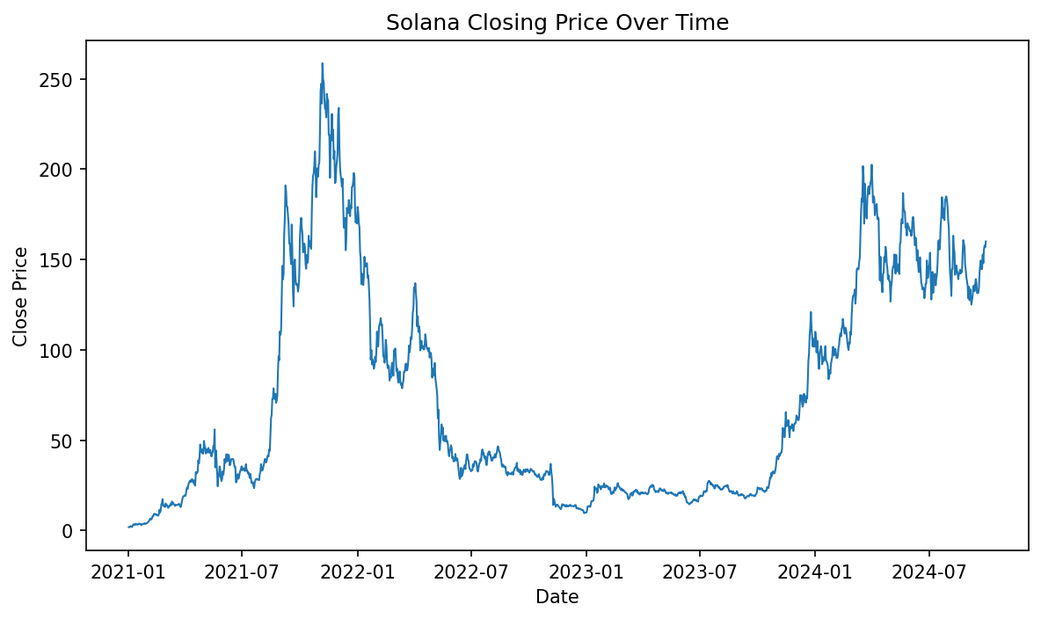
Figure 1. Solana closing-price trend in the project dataset.

2. Problem Statement
The objective is to extract useful patterns from Solana market data without relying on predefined class labels. The project investigates whether market observations can be grouped, whether isolated observations can be detected, and whether a neural unsupervised model can learn a compact representation.

3. Objectives
- Analyze Solana market data using unsupervised machine learning.
- Group similar observations using K-Means clustering.
- Detect density-based outliers using DBSCAN.
- Learn two hidden features using an RBM.
- Visualize the results of all three methods.
- Save the combined results for later analysis.

4. Dataset Description
The project uses the uploaded Solana_Price_data.csv file. Unlike the small dummy dataset shown in the presentation, this implementation uses the full uploaded dataset. It contains 1,368 records, six columns, and no missing values in the five machine-learning features.
Property | Value
Dataset | Solana_Price_data.csv
Records | 1,368
Columns | 6
Features | Open, High, Low, Close, Volume
Date range | 2021-01-01 to 2024-09-29
Missing ML values | 0
Learning type | Unsupervised Learning
Final output | Solana_ML_Results.csv

4.1 Feature Description
Feature | Description
time | Trading date
Open | Opening price
High | Highest price
Low | Lowest price
Close | Closing price
Volume | Trading volume

5. Methodology
- Load the CSV dataset.
- Select Open, High, Low, Close, and Volume.
- Standardize the five features for K-Means and DBSCAN.
- Run K-Means with three clusters.
- Run DBSCAN with eps=0.9 and min_samples=2.
- Normalize the five features with MinMaxScaler.
- Train RBM with two hidden components.
- Add all algorithm outputs to the original dataset.
- Save the final processed dataset.

6. Data Preprocessing
The five numerical variables have different scales, particularly Volume compared with price. Scaling is therefore applied before distance-based clustering. StandardScaler is used for K-Means and DBSCAN. MinMaxScaler is used for the RBM input.

7. Algorithms Used

7.1 K-Means
K-Means partitions observations into a specified number of clusters using distance to cluster centroids. The implementation uses n_clusters=3, random_state=42, and n_init=10.

7.2 DBSCAN
DBSCAN is density-based. It identifies dense groups and labels observations that do not belong to a sufficiently dense region as noise. The implementation uses eps=0.9 and min_samples=2. Label -1 denotes noise.

7.3 Restricted Boltzmann Machine
RBM learns a hidden representation of the input. Two hidden components are used and stored as Hidden1 and Hidden2. The parameters are learning_rate=0.01, n_iter=300, and random_state=42.

8. Python Implementation
The implementation uses Pandas for data handling, Matplotlib for visualization, and scikit-learn for scaling, clustering, and RBM feature learning.
Algorithm | Parameters
K-Means | n_clusters=3; random_state=42; n_init=10
DBSCAN | eps=0.9; min_samples=2
RBM | n_components=2; learning_rate=0.01; n_iter=300; random_state=42

9. Experimental Results

9.1 K-Means Results
K-Means produced three clusters with 177, 517, and 674 observations respectively.
Cluster | Observations
0 | 177
1 | 517
2 | 674
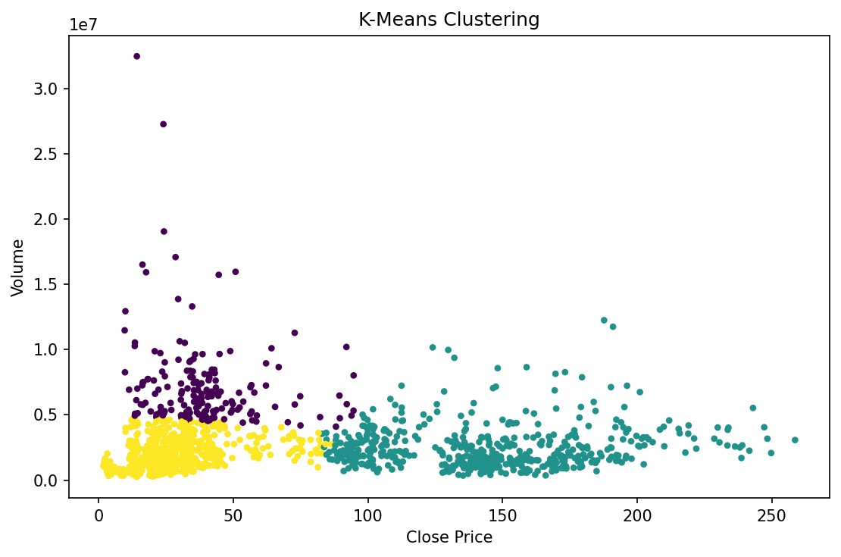
Figure 2. K-Means clustering using Close Price and Volume.

9.2 DBSCAN Results
With the selected DBSCAN parameters, most observations belong to one dense group, while three observations receive the noise label -1.
DBSCAN Label | Observations
-1 | 3
0 | 1357
1 | 2
2 | 6
Date | Close | Volume
2022-01-24 | 91.99 | 10,200,729.81
2022-11-08 | 24.02 | 27,262,061.11
2022-11-09 | 14.17 | 32,460,754.83
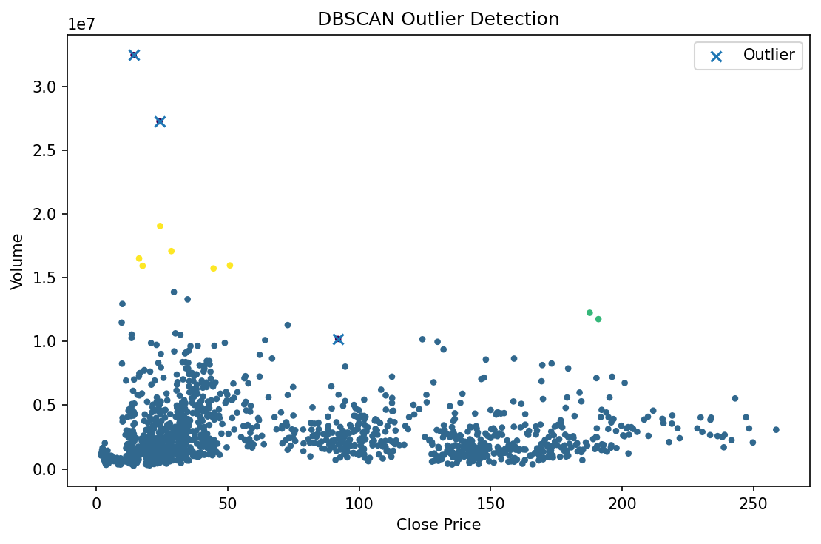
Figure 3. DBSCAN clustering and noise observations.

9.3 RBM Results
RBM produces two hidden features for each of the 1,368 observations. The first five are:
Row | Hidden1 | Hidden2
0 | 0.533407 | 0.534603
1 | 0.532966 | 0.534160
2 | 0.532149 | 0.533340
3 | 0.531839 | 0.533028
4 | 0.531732 | 0.532921
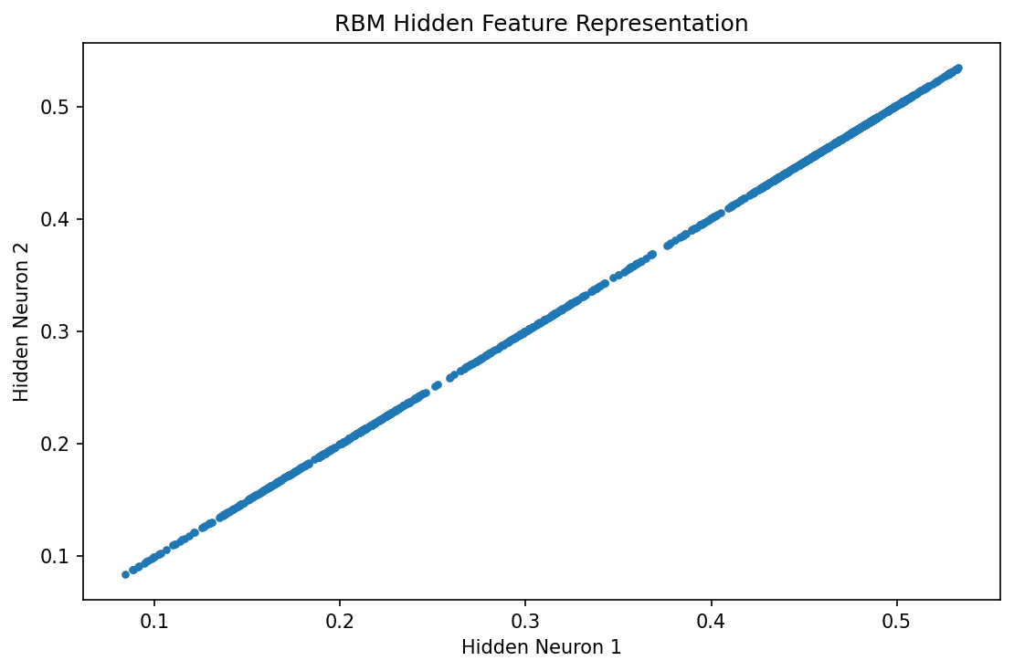
Figure 4. RBM hidden-feature representation.

9.4 Combined Result
Component | Result
K-Means | 3 clusters
DBSCAN | 3 noise/outlier observations
RBM | 2 hidden features
Final processed records | 1,368
Output file | Solana_ML_Results.csv

10. Discussion
The algorithms provide different analytical views. K-Means assigns each observation to one of three groups, which can be used to explore broad similarities in market conditions. DBSCAN identifies density structure and isolated observations under the selected parameter settings. RBM provides a two-dimensional learned representation that can be visualized and potentially used as input to later models.
The numerical cluster labels themselves do not automatically mean bullish, bearish, or stable. Such semantic interpretation would require additional examination of the characteristics of each cluster.

11. Limitations
- This is an unsupervised analysis, so conventional prediction accuracy is not directly applicable.
- K-Means results depend on the selected number of clusters.
- DBSCAN results depend on eps and min_samples.
- RBM hidden features are learned representations and are not directly interpretable as financial indicators.
- The analysis is exploratory and does not guarantee future cryptocurrency price behavior or investment outcomes.

12. Future Scope
- Tune K-Means and DBSCAN parameters and compare clustering quality.
- Use silhouette score and other internal clustering metrics.
- Add derived features such as returns and volatility.
- Compare with hierarchical clustering, Gaussian mixture models, or other unsupervised methods.
- Compare RBM with autoencoders and other representation-learning methods.
- Build an interactive dashboard for clusters and anomalies.
- Study whether clusters remain stable across different time periods.

13. Conclusion
The project implements an end-to-end unsupervised-learning pipeline for Solana cryptocurrency market data. Using the actual 1,368-row dataset, K-Means produces three clusters, DBSCAN identifies three noise observations with the selected parameters, and RBM learns two hidden features. The combined output is stored in Solana_ML_Results.csv. The project demonstrates how multiple unsupervised methods can be applied to the same market dataset for clustering, anomaly exploration, and feature learning.

14. Requirements
Library | Purpose
pandas | Data loading and manipulation
matplotlib | Data visualization
scikit-learn | Scaling, K-Means, DBSCAN, and RBM
A requirements.txt file containing these dependencies is included with the project.

15. References
- Project presentation: Unsupervised Learning for Cryptocurrency Market Analysis.
- Solana_Price_data.csv supplied for this project.
- scikit-learn documentation for KMeans, DBSCAN, StandardScaler, MinMaxScaler, and BernoulliRBM.
- Pandas documentation for data processing.
- Matplotlib documentation for visualization.

Appendix A: Final Output Columns
Column | Meaning
time | Trading date
Open | Opening price
High | Highest price
Low | Lowest price
Close | Closing price
Volume | Trading volume
KMeans_Cluster | K-Means cluster label
DBSCAN_Cluster | DBSCAN cluster/noise label
Hidden1 | RBM hidden feature 1
Hidden2 | RBM hidden feature 2

