Tech Task : Unit Tests

Task : Schedule a meeting

* + Should be a POST request
  + Use JSON request body
  + URL should be ‘/meetings’
  + Must return the meeting in JSON format

Test :

POST Link =>

<http://localhost:8090/meetings>

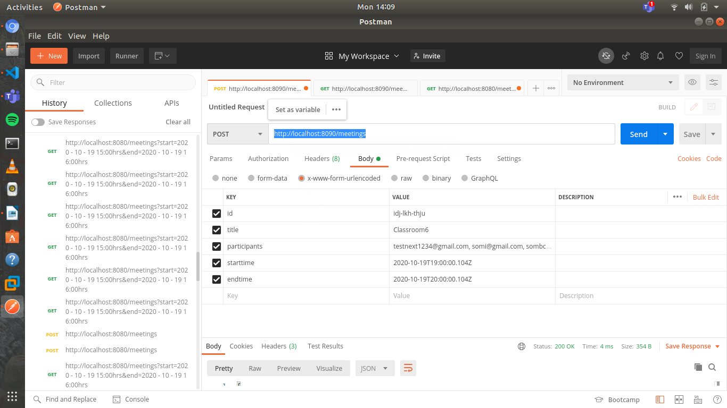INPUTS 1

id : idj-lkh-thju

title : Classroom6

participants : testnext1234@gmail.com, somi@gmail.com, [somboi@gmail.com](mailto:somboi@gmail.com)

starttime : 2020-10-20T19:00:00.104Z

endtime : 2020-10-20T20:00:00.104Z

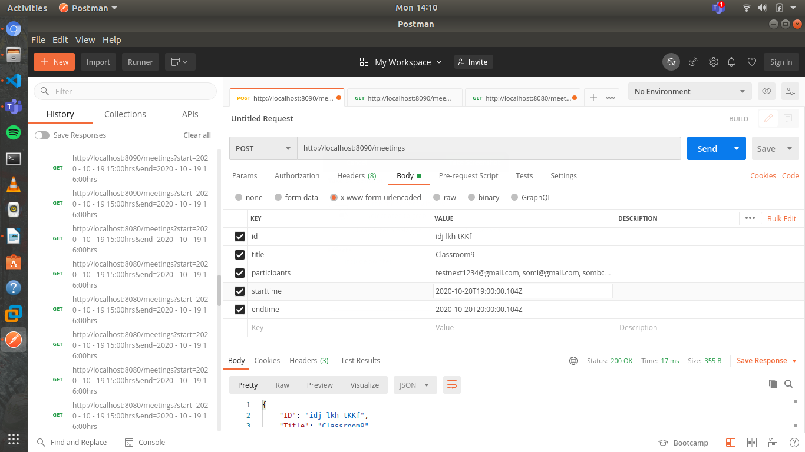INPUTS 2

id : idj-lkh-tKKf

title : Classroom9

participants : [test1234@gmail.com](mailto:test1234@gmail.com), sahil@gmail.com

starttime : 2020-10-20T19:00:00.104Z

endtime : 2020-10-20T20:00:00.104Z

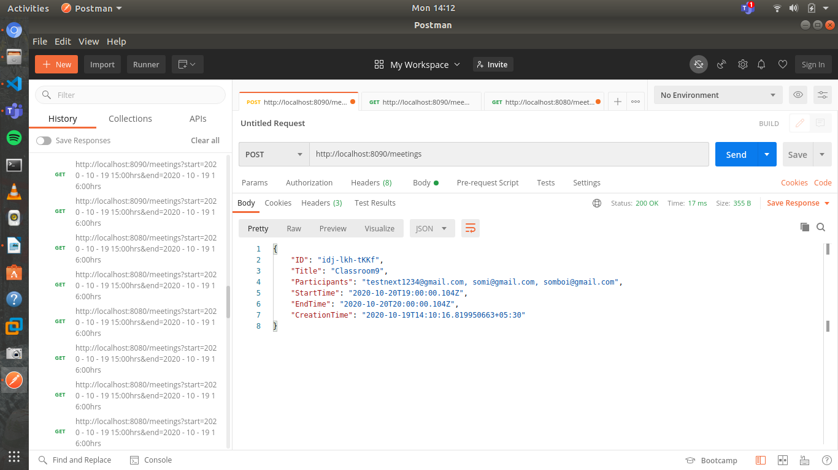OUTPUT for 2

Task : Get a meeting using id

* + Should be a GET request
  + Id should be in the url parameter
  + URL should be ‘/meeting/<id here>’
  + Must return the meeting in JSON format

Test:

GET request at <http://localhost:8090/meetings/idj-lkh-thju>

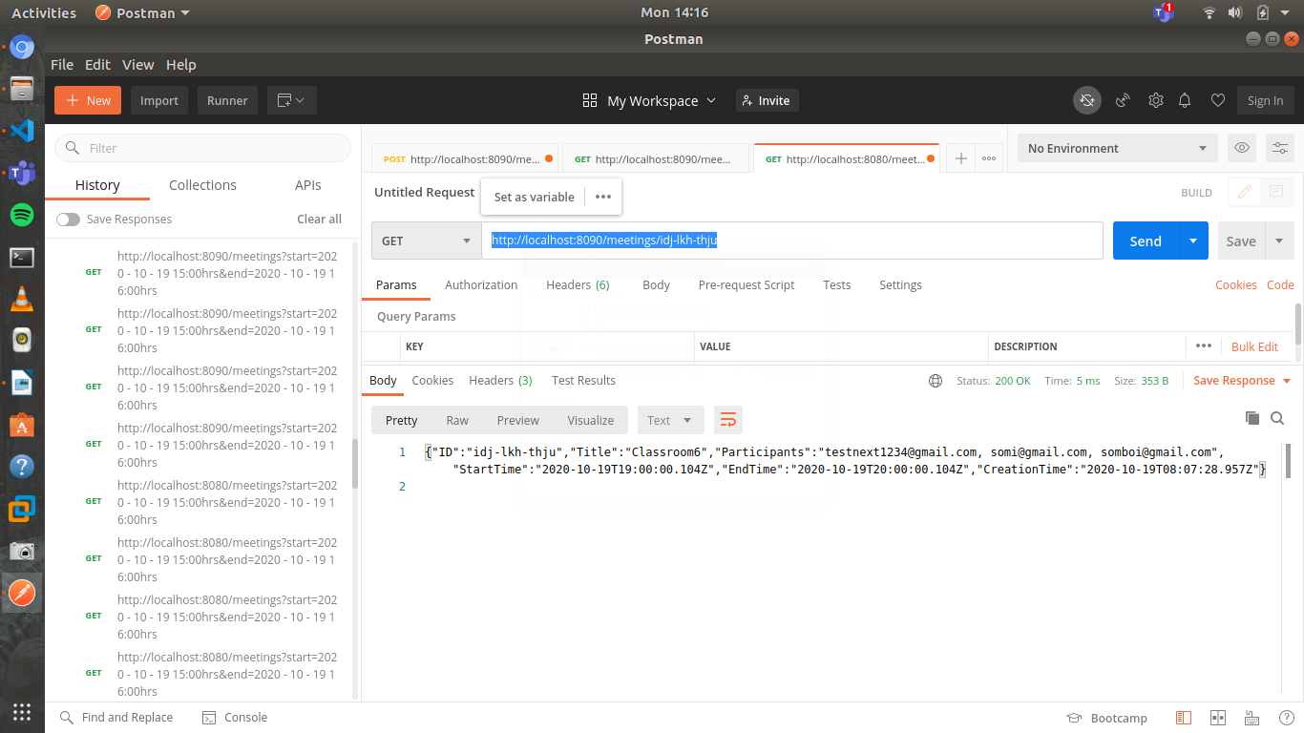

Task : List all meetings within a time frame

* + Should be a GET request
  + URL should be ‘/meetings?start=<start time here>&end=<end time here>’
  + Must return a an array of meetings in JSON format that are within the time range

Test :

<http://localhost:8090/meetings?start=2020-10-19T10:00:00.104Z&end=2020-10-19T20:00:00.104Z>

Output:

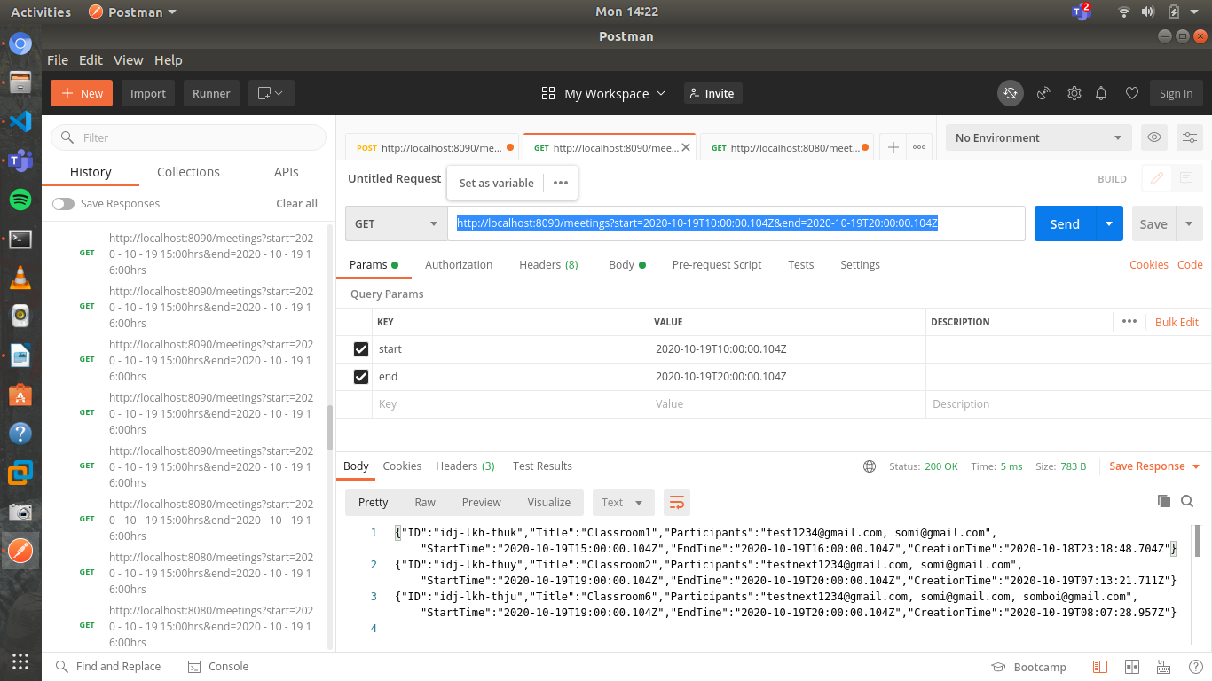

Task : List all meetings of a participant

* + Should be a GET request
  + URL should be ‘/meetings?participant=<email id>’
  + Must return a an array of meetings in JSON format that have the participant received in the email within the time range

Test :

<http://localhost:8090//meetings?participant=testnext1234@gmail.com>

Output:

