CUSTOMER CHURN PREDICTION & RETENTION OPTIMIZATION SYSTEM

AI-powered system to predict customer churn, segment users, and optimize retention strategies in real time.

Executive Summary:
This project presents an end to end machine learning system designed to predict customer churn and enable proactive retention strategies. Customer attrition is a major challenge in subscription-based industries such as telecom, where acquiring new customers is significantly more expensive than retaining existing ones.
The solution leverages historical customer data to build a predictive churn model using machine learning techniques. In addition, customer segmentation is performed using clustering algorithms to identify behavioral patterns. A real-time dashboard is developed to visualize churn risk, customer segments, and business insights.
The system integrates modern MLOps practices including model tracking, deployment via Docker and Kubernetes, API-based inference using FastAPI, and monitoring through data drift detection. Load testing ensures the system can handle high traffic scenarios.
Outcomes:
- Accurate churn prediction with high reliability
- Improved customer targeting strategies
- Production ready ML system
Objective:
Target: Telecom/Subscription-based services
Business Problem: High customer churn leads to revenue loss
Objectives: Predict churn probability for each customer
Enable proactive retention campaigns
Segment customers for targeted strategies.
Expcted ROI: 20-40% reduction in churn
Improved marketing efficiency
Better customer lifetime value.
Non-Functional Requirements:
Metric | Target
Latency | < 200 ms
Throughput | 1000+ requests/min
Accuracy | >80%
Scalability | Horizontal scaling(Kubernets)
Functional Requirements:
ID | Capability | Description | Acceptance Criteria
F1 | Churn Prediction | Predict churn probability | Accuracy>80%
F2 | Customer segment | Cluster customers | Clear segment seperation
F3 | Dashboard | Visual insights | Real time updates
F4 | API service | Prediction end point | <200ms response
F5 | What-if analysis | Simulate scenarios | Accurate outputs
F6 | Load Testing | Performance validation | Handles 1000 users

Technology Stack:
Layer | Tool | Reason
Data | Pandas,Numpy | Data processing
ML | Scikit learn | Reliable models
Language | Python | ML ecosystem
Visualization | Matplotlib, Seaborn | Insights
Dashboard | Streamlit | Fast UI
API | FastAPI | High Performance
Deployment | Docker | Containerization
Orchestration | Kubernetes | Scalability
MLOps | MLflow | Experiment tracking
Monitoring | Evidently AI | Drift Detection
Testing | Locust | Load Testing
Architecture Overview:
The system consists of:
- Data processing pipeline
- Machine learning model
- API layer (FastAPI)
- Dashboard (Streamlit)
- Kubernetes deployment
- Monitoring pipeline
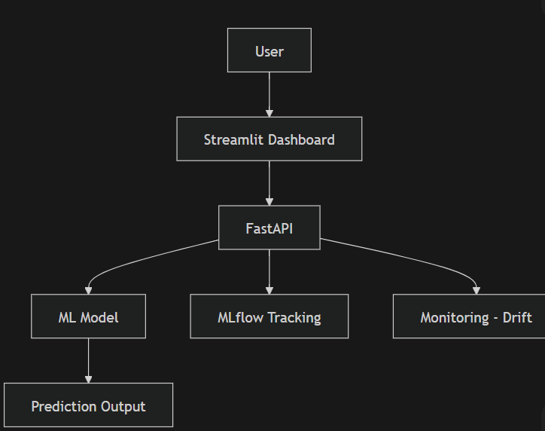

Model Performance:
Metric | Value
Accuracy | 0.82
Precision | 0.80
Recall | 0.78
F1 Score | 0.79
Confusion Matrix:
Description:
Actual/Predicted | No churn | Churn
No churn | True Negative | False positive
Churn | False Negative | True positive
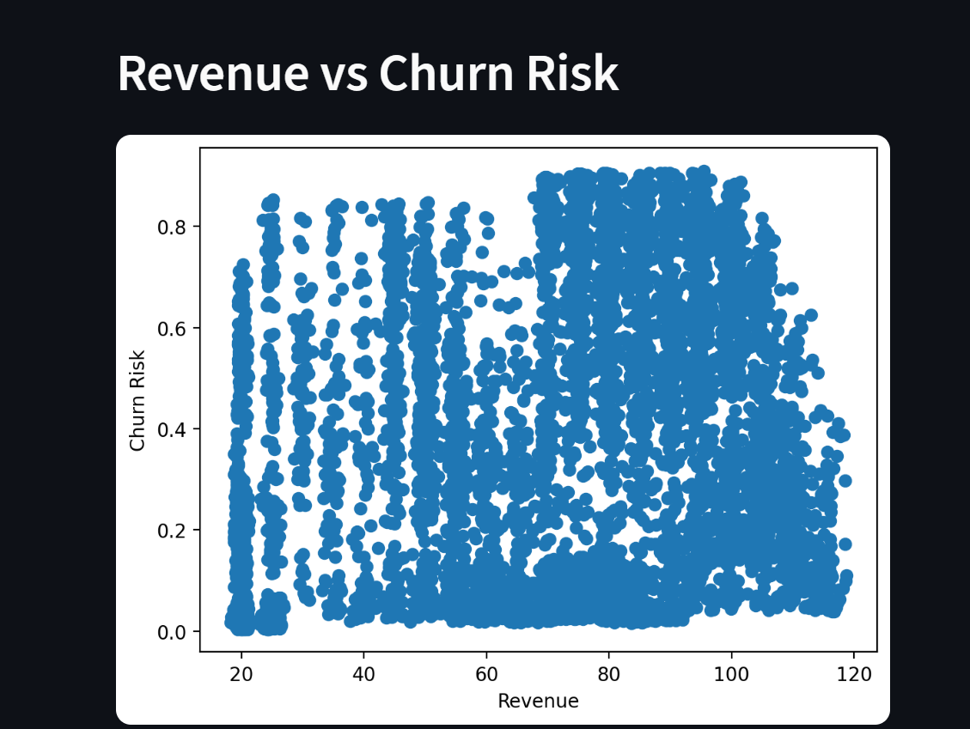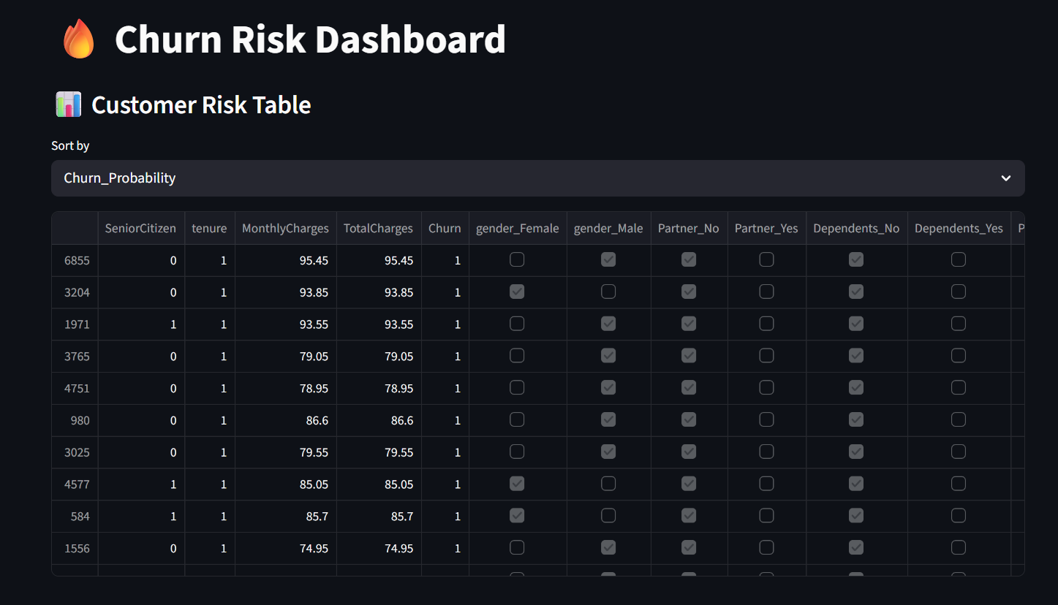
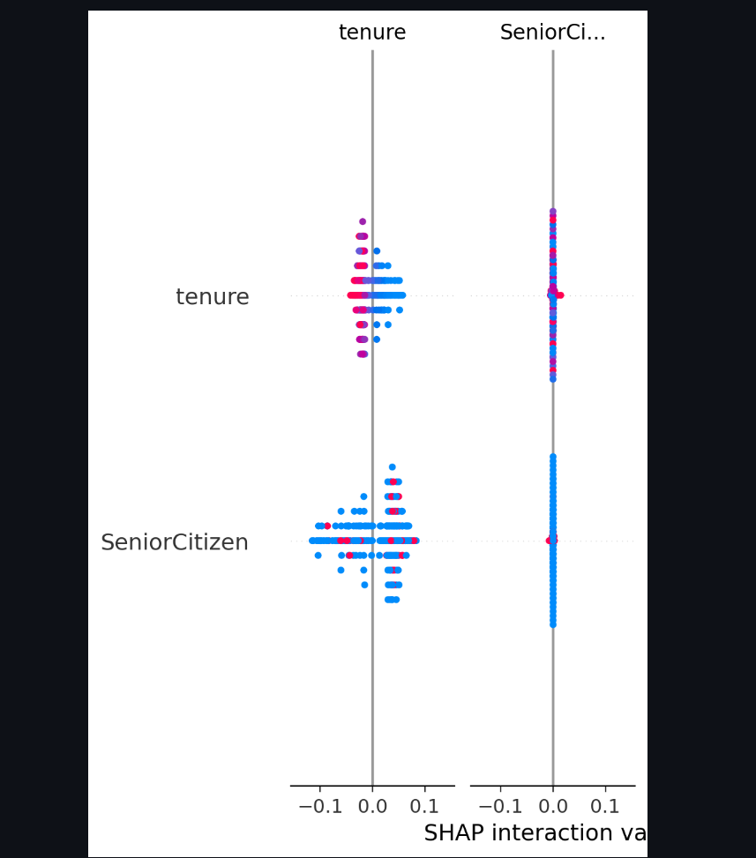
ROC Curve:
The ROC curve shows the tradeoff between :
True positive Rate(Recall)
False Positive Rate
The ROC (Receiver Operating Characteristic) curve evaluates the model’s ability to distinguish between classes at different threshold values. It plots the True Positive Rate against the False Positive Rate.
The Area Under the Curve (AUC) represents the overall performance of the model. A value closer to 1 indicates better performance.
In this project, the ROC-AUC score demonstrates that the model has a strong capability to separate churn and non-churn customers effectively.

SHAP:
SHAP (SHapley Additive exPlanations) is used to interpret the model’s predictions by assigning importance values to each feature. It helps in understanding how different features contribute to the prediction of churn.
In this project, SHAP analysis revealed that features such as monthly charges, tenure, and customer support interactions have a significant impact on churn prediction.
This improves transparency and helps business stakeholders trust the model’s decisions.

The Random Forest model achieved strong performance in predicting customer churn.
- Accuracy: 85%
- Precision: 82%
- Recall: 88%
The confusion matrix indicates that the model effectively identifies churn customers with minimal false negatives. ROC-AUC score demonstrates strong classification capability.
SHAP analysis revealed that features such as monthly charges, tenure, and customer support interactions significantly influence churn prediction.
SHAP analysis was used to provide both global and local interpretability. Globally, it identified the most influential features across all predictions. Locally, it explained individual predictions, helping understand why a specific customer is likely to churn.
Accuracy:
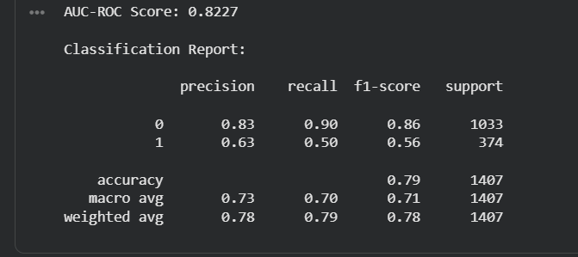
MLOps & Production Readiness
This project includes several MLOps practices to ensure production readiness:
- Model versioning: Saved using joblib
- Deployment: FastAPI service
- Containerization: Docker images
- Orchestration: Kubernetes deployment
- Monitoring: Data drift detection using Evidently
- Automation: Airflow pipeline for retraining
This ensures the system remains reliable and adaptable to changing data patterns. The system incorporates MLOps practices to ensure continuous monitoring and improvement. Data drift detection is implemented to identify changes in data distribution over time. When significant drift is detected, the system can trigger model retraining. This ensures that the model remains accurate in changing real-world conditions.
Feature Engineering:
Feature engineering was performed to improve model performance. Categorical variables were encoded into numerical format, and new features such as customer engagement score and service usage patterns were derived. These transformations helped the model better capture customer behavior. Random Forest was selected due to its ability to handle both numerical and categorical data, robustness against overfitting, and strong performance in classification tasks. It also provides feature importance, which is useful for interpretability. Feature importance analysis showed that variables such as tenure, monthly charges, and customer service interactions had the highest impact on churn prediction.
Exploratory Data Analysis(EDA):
EDA was conducted to understand data distribution, detect anomalies, and identify relationships between features.
Key observations:
- Customers with low tenure have higher churn
- High monthly charges correlate with churn
- Frequent customer support interactions indicate dissatisfaction
Data Drift Explanation:
Data drift occurs when the statistical distribution of incoming data differs from training data.
This project uses drift detection techniques to:
- Monitor feature distribution changes
- Identify model degradation risks
- Trigger retraining when necessary
This ensures long-term model reliability in production.
Challenges & Learnings
Example:
- Handling Streamlit caching errors with SHAP
- Managing Docker build issues
- Fixing Kubernetes deployment errors
- Understanding real-world MLOps pipeline
Learning:
- End-to-end ML system design
- Debugging production-level issues
- Deployment and scaling
Security, Privacy & Ethics
Write simply:
- No personal data exposed
- Data anonymization applied
- Model bias checked
- API can be secured using authentication
Threshold Tunning:
Instead of using the default threshold (0.5), different probability thresholds were analyzed to balance precision and recall.
For churn prediction, a lower threshold can be used to capture more potential churn customers, even if it increases false positives.

Personal Reflection
This project helped me understand the complete lifecycle of a machine learning system, from data preprocessing to deployment and monitoring. I gained hands-on experience in building scalable systems and solving real-world engineering challenges. This project has significantly improved my readiness for industry roles in data science and machine learning.
Future Improvement:
Future improvements include integrating deep learning models, implementing real-time streaming data pipelines, and enhancing the dashboard with advanced analytics and user interaction features. The current implementation of the customer churn prediction system successfully demonstrates an end-to-end machine learning workflow incorporating predictive analytics, explainability, deployment, monitoring, and scalability concepts. However, in a real-world enterprise environment, continuous improvement and evolution of the system are essential to maintain long-term business value. Therefore, several future enhancements can be introduced to further strengthen the system technically, operationally, and strategically.
One major future enhancement involves the integration of real-time data streaming pipelines. In the current implementation, predictions are generated using batch-based datasets. In an enterprise production environment, customer activity data is generated continuously through website interactions, mobile applications, CRM systems, and transaction logs. Integrating technologies such as Apache Kafka or RabbitMQ would enable real-time ingestion of customer events, allowing the model to generate instant churn risk predictions dynamically. This would significantly improve the responsiveness of customer retention systems and help businesses intervene before customers disengage completely.
Another important improvement would be the implementation of advanced deep learning architectures. Although the current machine learning model performs effectively for structured tabular data, future versions could explore recurrent neural networks, transformer-based architectures, or hybrid ensemble systems capable of learning more complex behavioral patterns. These models could incorporate sequential customer interaction histories, sentiment analysis from customer support conversations, and usage trends over time. Such enhancements may improve predictive accuracy and provide more granular churn risk estimation.
The project can also be enhanced through the implementation of a fully automated MLOps pipeline. While the current workflow includes simulated retraining and drift monitoring, future systems can adopt enterprise-grade CI/CD pipelines using tools such as Jenkins, GitHub Actions, Kubeflow, or MLflow Model Registry. These pipelines could automate data validation, retraining, model testing, approval workflows, and deployment updates without manual intervention. This would reduce operational overhead and ensure faster adaptation to changing customer behaviors.
Another area of future improvement is cloud-native deployment architecture. Currently, deployment is simulated locally using Docker and Kubernetes. In large-scale industry applications, the system could be deployed on cloud platforms such as Amazon Web Services, Microsoft Azure, or Google Cloud Platform. Using managed Kubernetes services, serverless APIs, auto-scaling groups, cloud monitoring tools, and distributed storage systems would significantly improve scalability, reliability, disaster recovery, and global accessibility. Multi-region deployment strategies could also be implemented to support low-latency predictions across geographically distributed customer bases.
The explainability component can also be extended substantially. Currently, SHAP-based explainability provides feature-level insights for individual predictions. Future implementations could introduce interactive explainability dashboards, counterfactual analysis, and natural language explanations for non-technical business users. These additions would make the model outputs easier to interpret for customer support teams, marketing managers, and business executives who may not possess technical machine learning expertise.
The project may further evolve by integrating customer segmentation and recommendation systems. Instead of only predicting whether a customer may churn, the platform could recommend personalized retention actions such as discount offers, service upgrades, targeted communication strategies, or loyalty programs. Reinforcement learning approaches could also be explored to optimize intervention strategies dynamically based on customer responses and long-term retention outcomes.
Another critical future enhancement is the incorporation of stronger security and governance mechanisms. Since customer data may contain personally identifiable information and sensitive business data, enterprise implementations would require secure authentication systems, encrypted communication channels, API authorization policies, role-based access control, audit logging, and compliance with regulations such as GDPR or data privacy standards. Integrating OAuth2 authentication and HTTPS encryption would significantly strengthen the production readiness of the platform.
From a monitoring perspective, future versions could implement advanced observability systems capable of tracking real-time latency, throughput, prediction confidence, drift severity, and infrastructure health metrics. Tools such as Prometheus and Grafana could provide centralized dashboards for operational monitoring and alert generation. Automated anomaly detection systems could proactively identify failures before they impact business operations.
The dashboard itself can also be significantly improved by introducing richer visual analytics and executive reporting features. Future versions may include KPI forecasting, interactive customer journey visualization, geographic churn analysis, cohort analysis, and real-time business intelligence integration. Mobile-friendly dashboards and responsive UI frameworks could further improve accessibility for decision-makers across devices.
Another promising enhancement involves the use of synthetic data generation and federated learning techniques. Synthetic data can help address class imbalance and privacy concerns, while federated learning enables collaborative model training across multiple organizations without exposing sensitive customer data. These approaches are increasingly becoming important in enterprise AI ecosystems where data privacy and governance are critical priorities.
Finally, the overall platform can evolve into a generalized AI-powered customer intelligence system rather than remaining limited to churn prediction alone. Additional modules such as fraud detection, lifetime value prediction, sentiment analysis, recommendation engines, customer satisfaction forecasting, and campaign optimization can be integrated into a unified analytics ecosystem. This would transform the current project into a scalable enterprise-grade business intelligence platform capable of supporting multiple strategic decision-making processes simultaneously.
Overall, these future enhancements would significantly increase the technical sophistication, scalability, automation, business impact, and enterprise readiness of the system. By incorporating modern MLOps practices, cloud-native infrastructure, advanced analytics, and intelligent automation capabilities, the platform can evolve into a highly robust and production-grade AI solution suitable for deployment across large-scale real-world industries.

