Variable:

Variable is nothing but a container which helps to store a particular type of value and the type is defined by its data type.

e.g. int a;

* a is a variable of integer type and at a single point of time it can able to store only one value.
* 32-bit compiler takes 4 bytes of memory for integer variable.

Constant:

The value which is assigned to a variable is called constant.

e.g. int a; a=5;

Keywords:

* The reserved words that are present in every programming language are known as keywords.
* User can’t use them for other purpose.
* In C language there are 32 keywords:

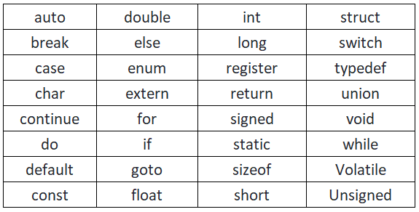

Definition:

Definition simply means memory allocation i.e. whenever variable is defined memory is allocated for it.

e.g. int x; [ 4 bytes is allocated for x ]

Declaration:

It means information given to the compiler about the data type of the variables.

e.g. int x; [ Here information is given to the compiler that data type of x is int ]

Initialization:

It means first value that is assigned to a variable.

e.g. int x=10;