

PROJECT REPORT SUBMITTED IN FULFILLMENT OF THE REQUIREMENT FOR THE DEGREE OF BACHELOR OF COMPUTER APPLICATION
By

SABITA JANA
12211700216
SAYANIKA ROY
12211700151
SOUMIK SAHA
12211700343
AKASH BAG
12211700219

UNDER THE SUPERVISION OF
SWETA MANNA

AT
BRAINWARE (LC CODE: 1170)
Learning Centre of PUNJAB TECHNICAL UNIVERSITY, JALANDHAR,
INDIA
SESSION: SEPT-2012
PUNJAB TECHNICAL UNIVERSITY, JALANDHAR,
INDIA

FORWARD
I hereby forward the partial project titled as “BRAIN TWISTER” presented by SABITA JANA , SAYANIKA ROY , SOUMIK SAHA , AKASH BAG of BCA, Semester-IV, Session SEPT-2014, under my guidance in partial fulfillment of the requirements for the Degree of BACHELOR OF COMPUTER APPLICATION of this University.
Internal Supervisor:

(Ms. SWETA MANNA)
Date:
Countersigned, Center Head
Official Seal
(Mr. TONOJIT SARKAR)
Date:
:: Document of Evaluation ::
Signature of the Examiner/s:

Date:

Date:

CERTIFICATE

this is to certify that this project of “BRAIN TWISTER ” embodies the original work done by SABITA JANA , SAYANIKA ROY , SOUMIK SAHA , AKASH BAG during this project submission.

As a partial fulfillment of the requirement for the VB (Visual Basic) Project of “BRAIN TWISTER”. It is a quiz portal where users are required to create a profile first and then they chose a topic on which they play the quiz. Then they get a score based on their performance.
For this we used VISUAL BASIC and MICROSOFT ACCESS.

Acknowledgement

Acknowledgement is not only a ritual but also an expression of indebtedness to all those who help the process of project development. One of the most pleasant aspects in collecting the necessary information, compiling it, is the opportunity to think of those who actively contributed to it. I wish to express my heartfelt thanks to all those who assisted me during this project.
I would like to express my profound and deep sense of gratitude to my guide Ms. Sweta Manna for his invaluable help, guidance and suggestions without which this project would not have been successful.
I offer my sincere thanks to all my batch mates for their unconditional help and inspiration at BRAINWARE (Dunlop Branch). Lastly, I would like to express my sincere gratitude to all the staffs, who helped me in their own way whenever I needed.
Signature of the Students:

SABITA JANA
SAYANIKA ROY
SUOMIK SAHA
AKASH BAG

BRAIN TWISTER

INTRODUCTION :
BRAIN TWISTER is an application where user gets to test their knowledge on various topic such as ENGLISH SCIENCE and etc. Over here users can create their own profile and then chose a topic based on which a game will start after playing it you will get to know your score.
It helps to test your skills and IQ on the topics like ENLISH SCIENCE and etc.

USING HARDWARE :
Intel(R) Pentium(R) D CPU 2.80GHz , 504 MB of RAM

USING SOFTWARE :
- System Software : Microsoft Windows XP Professional
- Application Softwares :
  - Visual Basic 6.0
  - Microsoft Office Access 2007

INTERFACES :

            - Introduction
            - Help
            - Login interface and Create user
            - User details
            - Topic selection
            - Questions forms
            - Result

- INTRODUCTION:

This is the first interface of the project. It provides 2 interfaces.One for login page and another for instruction or about the BRAINTWISTER.

- HELP:
This interface provides knowledge about the procedure or working of BRAINTWISTER.

- LOGIN INTERFACE :
In login interface, we provide authorization to the user getting in and creation of a new user.
- USER PAGE:
This interface provides information about the user details.

- TOPIC SELECTION :
This interface provides information about the topic the user wants to play.

- QUESTION FORMS :
After selecting topic from the previous interface the user will starts to play 20 questions under one topic.
(7.)RESULT:
After playing 20 questions the user will get to know about his/her score.

FUNCTIONAL CAPABILITIES :
The basic functionalities of this BRAINTWISTER quiz program are:
1. This provides the easy way of answering questions to the user.
2. The admin can increase or change the number of questions.
3. It is highly user defined.

SAFETY :
A person can login, only when he/she enters a correct username and password.

QUALITY :
The most user friendly software, Microsoft Visual Basic 6.0 is used to build this project. This software is checked for its working in exceptional conditions. The various features used in this project enhances the quality of the project. Each and every module individually serves its purpose and ultimately provides a quality product.

INTRODUCTION:
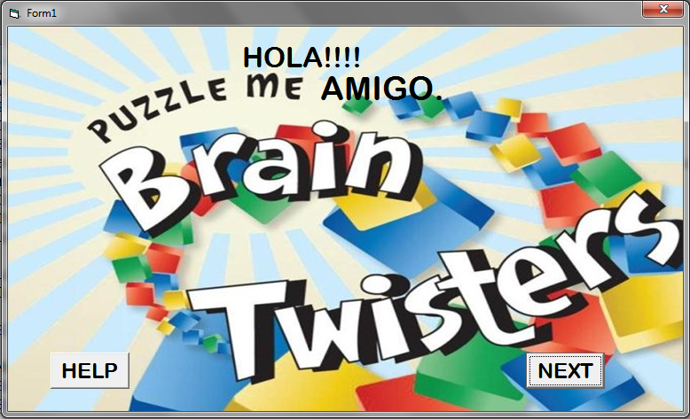

HELP:

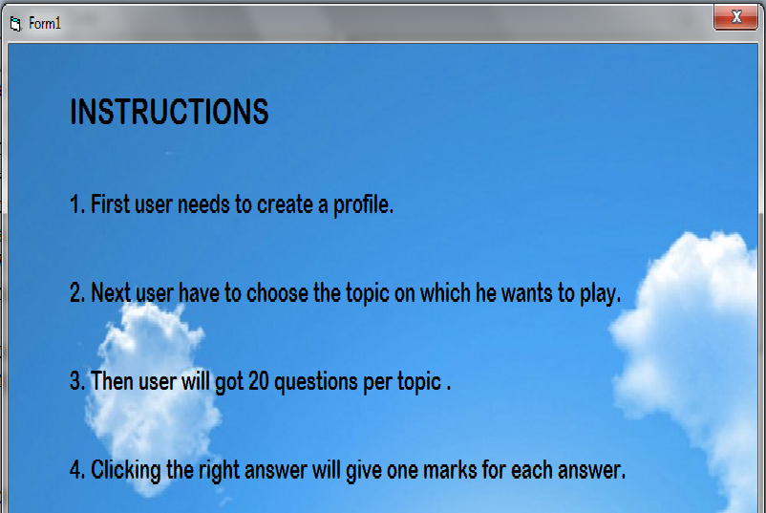

LOGIN FORM :

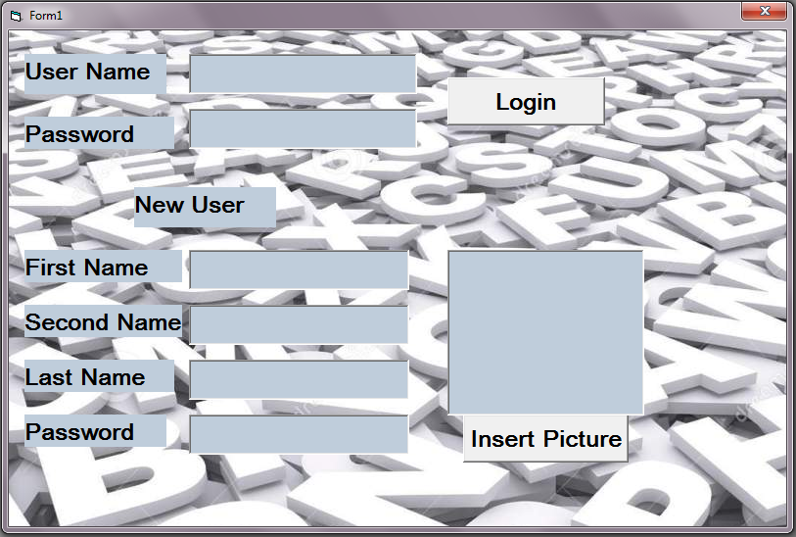

LOGIN FORM CODING :

Private Sub Command1_Click()
Call connect
Set rs = New ADODB.Recordset
sql = "select * from newuser where password ='" & Text2.Text & "' and username='" & Text1.Text & "' "
rs.Open sql, con
If rs.EOF <> True Then
Text7.Text = rs.Fields("pic")
userpage.Text1.Text = loginpage.Text1.Text

userpage.Show
Else

MsgBox ("user not exist")
End If
End Sub

Private Sub Command2_Click()
CommonDialog1.ShowOpen

'Text1.Text
Text7.Text = CommonDialog1.FileName

Picture1.Picture = LoadPicture(Text7.Text)
Picture1.ScaleMode = 3
Picture1.AutoRedraw = True

Picture1.PaintPicture Picture1.Picture, 0, 0, Picture1.ScaleWidth, Picture1.ScaleHeight, 0, 0, Picture1.Picture.Width / 26.46, Picture1.Picture.Height / 26.46

Call connect
Set rs = New ADODB.Recordset
a = Text3.Text & Text4.Text & Text5.Text

sql = "insert into newuser values('" & a & "','" & Text6.Text & "', '" & Text7.Text & "') "
rs.Open sql, con
MsgBox ("user updated")

userpage.Text1.Text = Text3.Text & Text4.Text & Text5.Text
userpage.Text3.Text = Text7.Text
userpage.Show

End Sub

USER DETAILSFORM:

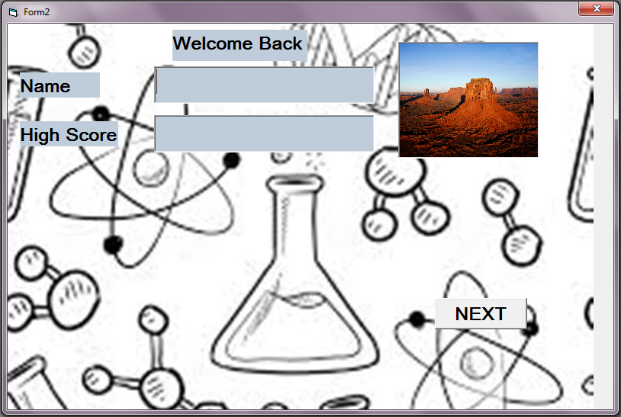

USER DETAIL FORM CODING :

Private Sub Command2_Click()
Call connect
Set rs = New ADODB.Recordset
sql = "select * from newuser where password ='" & Text4.Text & "' "
rs.Open sql, con
If rs.EOF <> True Then
sql = "update newuser set password=('" & Text5.Text & "')"
MsgBox ("Password changed successfully")

End If

End Sub

Private Sub Command3_Click()
topic.Show
userpage.Hide
End Sub

Private Sub Form_Load()
Picture1.Picture = LoadPicture(loginpage.Text7.Text)

Picture1.ScaleMode = 3
Picture1.AutoRedraw = True
Picture1.PaintPicture Picture1.Picture, 0, 0, Picture1.ScaleWidth, Picture1.ScaleHeight, 0, 0, Picture1.Picture.Width / 26.46, Picture1.Picture.Height / 26.46

End Sub

TOPIC SELECTION FORM :

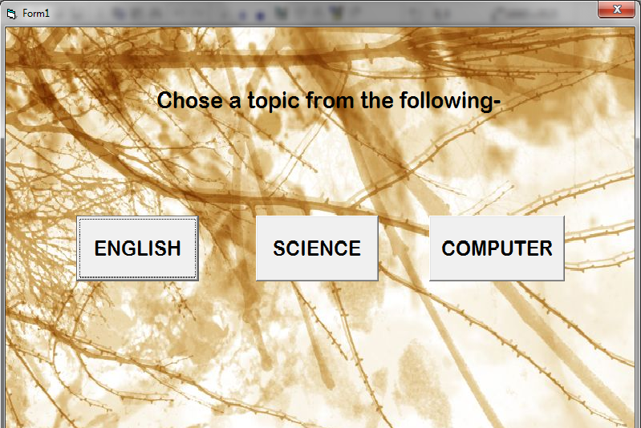

TOPIC SELECTION FORM CODING:

Private Sub Command1_Click()
Eng10.Show
topic.Hide
End Sub

Private Sub Command2_Click()
ARTS.a1.Show
topic.Hide
End Sub

Private Sub Command3_Click()
c50.Show
topic.Hide
End Sub

Private Sub Command5_Click()
sci30.Show
topic.Hide
End Sub

QUESTION FORM :

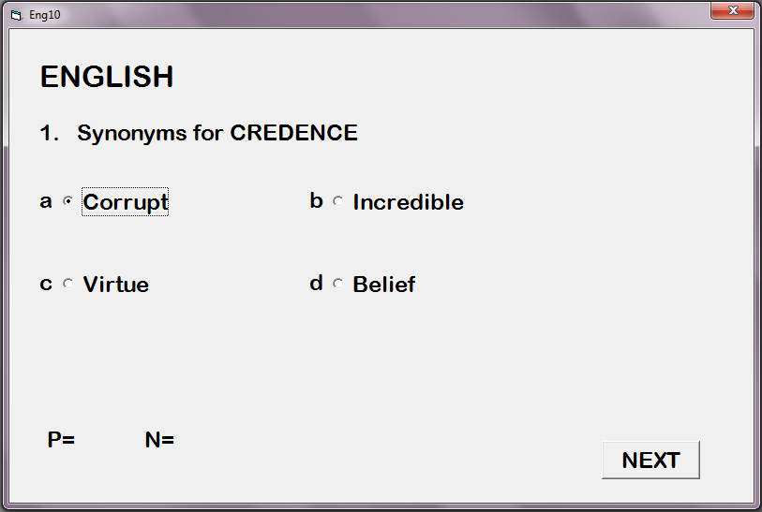

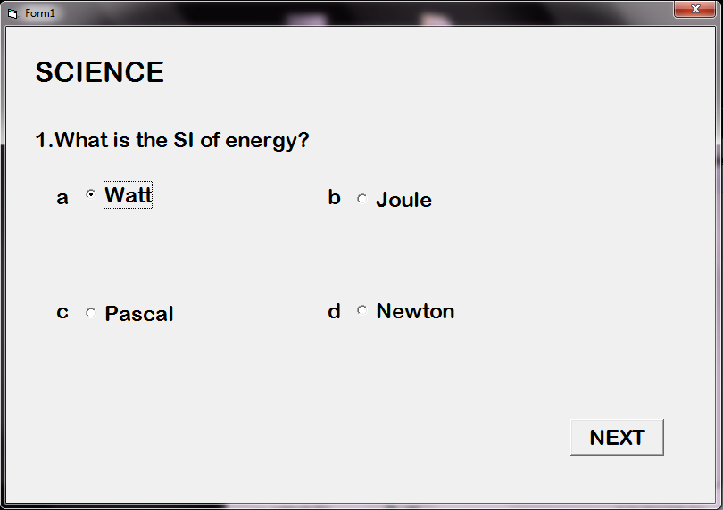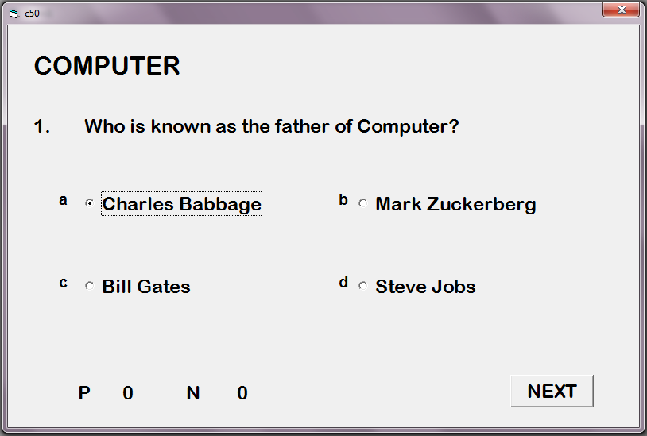

QUESTION FORM CODING:

Dim cnt As Integer
Dim negcnt, flag As Integer
Private Sub Command1_Click()
cnt = sci30.Text1.Text
negcnt = sci30.Text2.Text

For i = 0 To 3
If Option1(i).Value = True And Option1(i).Caption = "1000" Then
cnt = cnt + 1
flag = 1
Exit For

End If
Next
If flag = 0 Then
negcnt = negcnt + 1
End If
Text1.Text = cnt
Text2.Text = negcnt

Print Text1.Text
Print Text2.Text
sci32.Label4.Caption = sci31.Text1.Text
sci32.Label5.Caption = sci31.Text2.Text
sci32.Show
'sci31.Hide
End Sub

MODULES CODE :

Option Explicit

Public con As New ADODB.Connection
Public rs As New ADODB.Recordset
Public sql As String

Public Sub connect()
sql = "Provider=Microsoft.Jet.OLEDB.4.0;Data Source=" & App.Path & "\ab.mdb;Persist Security Info=False"
If con.State = adStateClosed Then
con.Open (sql)
End If
MsgBox ("user connected")
End Sub

RESULT:

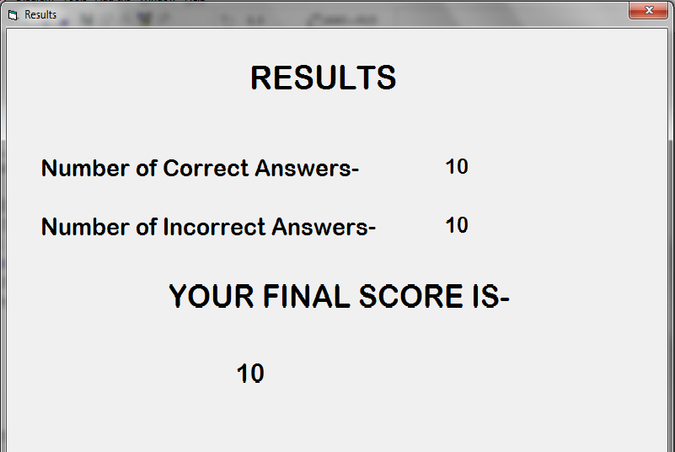

DATA FLOW DIAGRAM :
QUIZ PORTAL/
LOGIN PAGE
ADMIN
USERS

Level 0

QUIZ PORTAL/
LOGIN PAGE
PROFILE CREATION
SCORE
USERS

ADMIN

Level 1

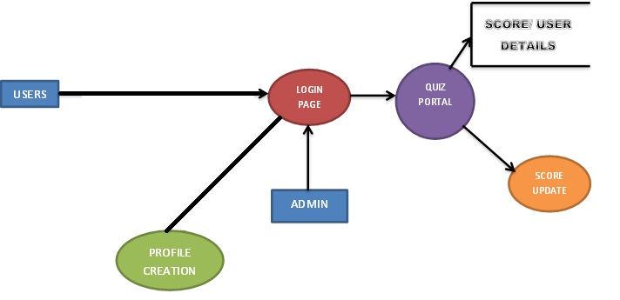

PROFILE CREATION

Level 2

ENTITY RELATIONSHIP DIAGRAM :

USERS
ADMIN
Quiz
Portal

topic
Profile creation

Update
Database

CONCLUSION:
The Visual Basic project of “BRAIN TWISTER” has completed successfully and executed using Microsoft Office Access 2007 connection.

……………………………………….**************……………………………………….
PROFILE CREATION
SCORE UPDATE
PROFILE CREATION
SCORE UPDATE
ADMIN
ADMIN

