horizontal line

**APOORVA PANDEY and TEG KHANNA**

Trainees

Software Incubator Department.

The Online Bidding Web

**31st August 2016**

# OVERVIEW

The online bidding system is a web application that provides live bidding of articles to the users for other users to bid for. The website/web application will be build on Python.

# GOALS

1. To provide an effective and user-friendly and secured interface for putting up articles for bidding and for putting up bids for the articles
2. Effective user satisfaction. Users will be provided suggestions based on their preference.
3. Provide a balanced interaction providing equal opportunities to each bidder

# SPECIFICATIONS/FEATURES/THINGS WE WILL IMPLEMENT

1. **Landing Page**
   1. The web app will have a landing page that will broadcast the live bids going on.
   2. If a user is new or the page is out of session, clicking on any bid will redirect you to the login / registration page.
   3. The same landing page will have side panes for options for the genre of the bid(computer, home, etc) and the pane on the other side will provide for logging in, register, user page, etc links.
2. **Signup and Login**
   1. Simple form for signing up and a page for logging in.
3. **User Portal**
   1. After logging in, the user will be led to a user portal. This will have info about the user profiles, successful bids, option to put up bids.
   2. All the active articles placed by the user can be viewed here and new articles can be set for bidding
   3. User can set his/her preferences here for the type of bids(articles put by other users) he is interested in.
4. **Article Put Up for Bids**
   1. The user can access this page from the portal.
   2. The user will be asked to upload a pic of the article.
   3. Then minimum price for bid
   4. And then product descriptions

# WORKING

1. **How The Bids Work**
   1. A user can set the time at which the bid will take place.
   2. The bid will be active for 1 hour
   3. The first 30 mins, other users can place bids normally above a bare minimum.
   4. Then after 30 mins, the bids will become “active 10 seconds bid”, this means, the bids will be sold out if no higher bid is placed each 10 seconds of the previous bid placement.
2. **On the Backend**
   1. A table for each registered user will be maintained.
   2. Each entry of that table will be linked to another table providing details about the active Visa card or bank accounts connected with the account.
   3. Further each entry will be connected to another table having details about successful and active article bids of the user.
   4. Managing the session of the user, login, placing article for bidding, successful selling out of bids, active bids updation will be managed at the backend
3. **Balance of Bidding**
   1. To prevent any user from spam bidding, any user wishing to place a bid on an active article will have to spend BID COINS.
   2. BID COINS can be buyed for Money to avail bidding.
   3. To prevent fraud, a user can put up an article for sale and place bids on other’s article, only when his/her Visa is registered with his account

# WORK DIVISION

Each point of the Previous Section wIll be implemented as follows:

1. Each Point can be associated with a different sub-point of the backend table.
2. Our first Task will be to create a very basic user portal and set up the database with each such table as described above.
3. Registration form and the tables will be linked first to create dummy entries for testing other features.
4. Up next will be Setting up of the article put up for the bid by the users. Here Some features will be implemented in the user portal.
5. After article put up is set, the landing page can be worked upon as there will be bid available for displaying(point 4) and the bids can be linked to the active bids table(point 2) for the live updating(active 10 second bids). This live updation will be handled by python.
6. After the live updation will be handled, the side panes will be activated and sorted out bids can be displayed by them.
7. After completion of all this, the final completion can be done at the user portal like preferred bids, multiple active bid articles, profile management, updation of bank accounts

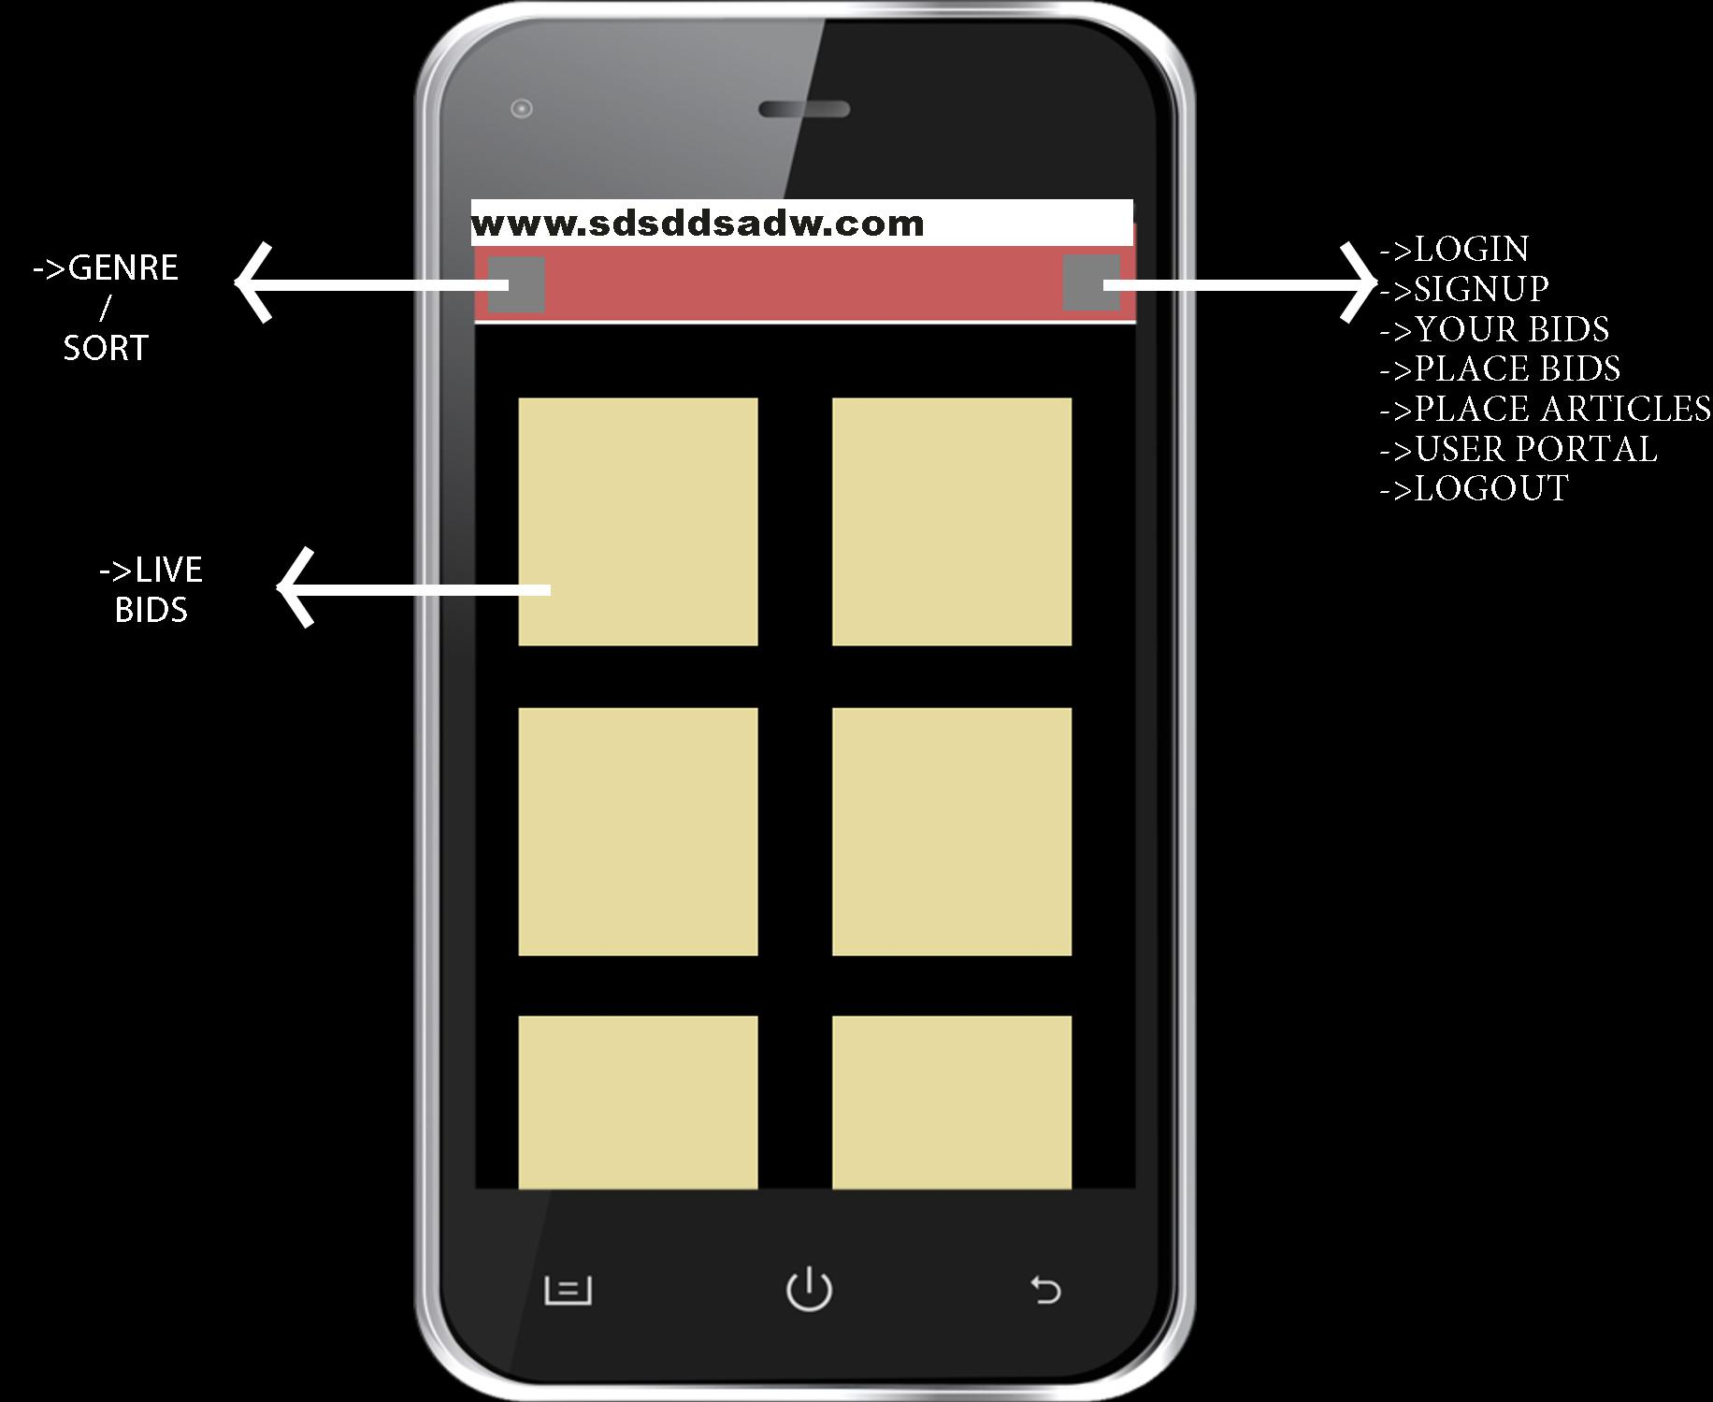

LANDING PAGE

1. The desktop page will be same as the web app view
2. The live tiles will be placed in flex display
3. The side panes will be fixed