**Rain Fall prediction**



A Project Report in partial fulfillment of the degree

# Bachelor of Technology

in

# Computer Science & Engineering

## By

**2103A51453** CH.SOUMIKA

**2103A51363** K.SRILEKHA

**2103A51575** V.ASHWINI

**Under the Guidance of**

# D. Ramesh

**Submitted to**



# DEPARTMENT OF COMPUTER SCIENCE & ENGINEERING

## S R UNIVERSITY, ANANTHASAGAR, WARANGAL



**DEPARTMENT OF COMPUTER SCIENCE & ENGINEERING**

**CERTIFICATE**

This is to certify that the Project Report entitled “MACHINE FAILURE PREDICTION” is a record of Bonafide work carried out by **ch.soumika, k.srilekha, v.ashwini** bearing Roll No(s) **2103A51453, 2103A51363, 2103A51575** during the academic year 2022-2023 in partial fulfillment of the award of the degree of ***Bachelor of Technology*** in **Computer Science Engineering** by the SR UNIVERSITY, WARANGAL.

# Supervisor Head of the Department

Mr. D. Ramesh Dr. M. Sheshikala

SR University SR University

**External Examiner**

**ACKNOWLEDGEMENT**

We express our thanks to course coordinator Mr. D. Ramesh, Asst. prof. for guiding us from the beginning through the end of the course project. We express our gratitude to head of the department CS&AI, Dr. M. Sheshikala, Associate Professor for encouragement, support and insightful suggestions. We truly value their consistent feedback on our progress, which was always constructive and encouraging and ultimately drove us to the right direction.

We wish to take this opportunity to express our sincere gratitude and deep sense of respect to our beloved Dean, School of Computer Science and Artificial Intelligence, Dr C. V. Guru Rao, for his continuous support and guidance to complete this project in the institute.

Finally, we express our thank to all teaching and non-teaching staff of the department for their suggestions and timely support.

2103A51453-ch.soumika

2103A51363-k.srilekha

2103A51575-v.ashwini

# ABSTRACT

Rainfall prediction is an important area of research , as it has significant implication for agriculture, water resources management, and disaster preparedness. The prediction of rainfall involves the use of various techniques and models ,ranging from statical methods to machine learning algorithms.

These models take into account a variety of variable such as temperature, humidity wind speed and atmospheric pressure, which are all known to affect rainfall patterns.

In recent years, there has been significant progress in the development of rainfall prediction models, thank to advancement in computing power and data collection. These models have been used to provide accurate prediction of rainfall patterns in different regions, helping farmers and policy makers make informed decision about crop planning

And water resource management.

However, despite these advancement ,prediction rainfall patterns remain a complex and challenging task, a weather patterns can be highly unpredictable and influenced by a range of factor. Therefore , continued research in this field is needed to further improve the accuracy and reliability of rainfall prediction models, and to develop new approaches that can better account for the complexity of weather pattern.

# Table of Contents

|  |  |  |
| --- | --- | --- |
| **Sno** | **Content** | **Page no** |
| **1** | **Introduction** | **1** |
| **2** | **Literature survey** | **2** |
| **3** | **Dataset description** | **4** |
| **4** | **Data visualization** | **5** |
| **5** | **Methodology** | **8** |
| **6** | **Model architecture** | **12** |
| **7** | **Results** | **13** |
| **8** | **Conclusion and future scope** | **16** |
| **9** | **References** | **17** |

**1.INTRODUCTION:**

Our project is about rainfall prediction it predict the rainfall in each state for all the months form Jan to Dec. As global warming is increasing earths temperature due to which our local regions yearly rainfall patterns have been affecting This harms the farmers and other people who depend on rainfall Proper water supply keeps farm land in a good condition For this rainfall prediction there are many researches conducted using data mining and machine learning proper rainfall should be there to in correct way to prevent flooding, drought, landslides, mass movements and avalanches Timely and accurate forecasting can help reduce human and financial loss The main theme of this project is to study and identify atmosphere that cause rainfall and to the intensityIt describes the relationship between atmospheric variables that affect the rainfall Rainfall is a climate factor that affects many human activities like agricultural production construction,power generation,foresty and tourism A study is conducted and identified solar radiation,perceptible water vapor are important variables for daily rainfall prediction This is using data driven machine learning algorithm but it is better to use simple linear regression which has only one independent feature.

# 2.LITERATURE REVIEW

# In previous research papers, we have observed that different machine learning algorithms have been used. Few papers are based on deep learning also. The field of Artificial Intelligence has been the suitable area to carry out all types of predictions on the dataset by extracting and data preprocessing. Logistic Regression, Support Vector Machine, Naïve Bayes Classification, Linear regression and ridge regression etc. are the various machine learning algorithms the have been used. We have observed that the algorithms work together by generating the pattern among the available dataset and proceeding with prediction. Mid Infrared Spectroscopy combined with few machine learning algorithms. Deep learning is something that works by generating biases and weights in the layers, rule based takes the bulk values and signifies a rule in it. SVM are used with algorithms especially which follows a close correlation among the variables taken into consideration. Artificial Neural Network inspired by the structure and function of the human brain. PLS regression stands for Partial Square regression, which is a statistical technique used for modelling the relationship between the two sets of variables. In PLS regression, both the predictor variables and the response variables are transformed into new sets of variables called latent variables, which are linear combination of the original variables. PLS regression is useful for predicting a response variable from a large number of predictor variables, even when these variables are highly correlated. It is commonly used in fields such as chemistry, biology, and engineering, where there are many variables to consider in modelling complex systems. It is also used in data analysis and machine learning to identify important variables and reduce dimensionality of the data

|  |  |  |  |  |
| --- | --- | --- | --- | --- |
| Authors | Region | Techniques | Rainfall predicting attribute | Accuracy measure |
| *M.Kannan et al.* | *Global* | *Regression* | *Rainfall,humidity* | *MSE* |
| *S. Chattopadhyay* | *Global* | *ANN* | *Rainfall* | *MSE* |
| *P. Dutta, H. Tahbilder* | *Global* | *Regression* | *Rainfall* | *MSE* |
| *P. Goswami, Srividya* | *Global* | *ANN* | *Mean rainfall* | *Relative percentage error* |
| *S. Kannan, S. Ghosh* | *Local**(river)* | *Decision tree, CART, K-mean* | *Rainfall,humidity* | *MSE* |
| *A. Naik* | *Global* | *Monthly* | *Wind,speed,temperature,humidity* | *RMSE* |
| *S.nanda* | *Global* | *Yearly* | *Min_max temperature* | *MSE* |
| *R.Deshpande* | *Local* | *Monthly* | *Rainfall* | *MSE* |
| *G.shrivastava* | *Local* | *Yearly* | *Humidity,dew point,pressure* | *MSE* |
| *P.dutta,H.Tahbilder* | *Global* | *Monthly* | *Min-Max,temperature,wind direction,humidity,rainfall* | *RMSE* |

# 3.DATA SET DESCRIPTION

# This dataset contains 641number of rows and 19 columns each row has Indian state name ,district ,rainfall amount in cm/inches of each and every month from January to December

# As this dataset considered as supervised because it is labelled dataset to train algorithms that to classify data or predict outcomes accurately

# JAN

# FEB

# MAR

# APR

# MAY

# JUNE

# JUL

# AUG

# SEP

# OCT

# NOV

# DEC

# JAN-FEB

# MAR-MAY

# JUN-SEP

# 

**4.DATA VISULAZATION:**

The following are plotting of each feature against the target.

# 

# Jan vs annual

feb

# 

# 

# 

apr

mar

mar

# 

# 

# 

june

# may

# 

august

july

# 

# September october

# 

November December

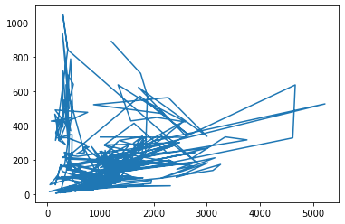 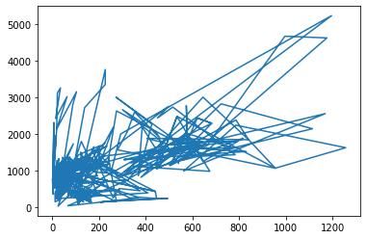

Jan-feb vs mar-may mar-may vs jun-sep

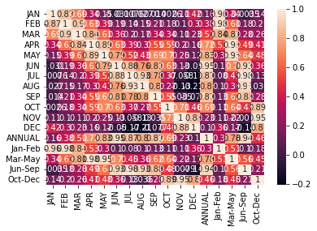 

Co variance co relation

**5. METHODOLOGY**

**PROCEDURE TO SOLVE THE GIVEN PROBLEM**

In this project Dogecoin price prediction and prediction, we use three approaches:

•Linear regression

• K-Nearest Neighbour

• Support Vector Machine

• Decision Tree

**Linear regression:**

Linear regression is a supervised machine learning method that is

used by the Train Using AutoML tool and finds a linear equation that best describes

the correlation of the explanatory variables with the dependent variable. This is

achieved by fitting a line to the data using least squares. The line tries to minimiz

the sum of the squares of the residuals. The residual is the distance between the line

and the actual value of the explanatory variable. Finding the line of best fit is an

iterative process.

**Advantages of linear regression algorithm:**

• Linear regression performs exceptionally well for linearly separable data

• Easier to implement, interpret and efficient to train

• It handles overfitting pretty well using dimensionally reduction techniques,

regularization, and cross-validation

• One more advantage is the extrapolation beyond a specific data set

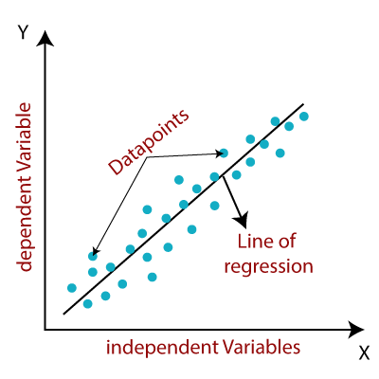

**K-Nearest Neighbour:**

The k-nearest neighbors algorithm, also known as KNN or k-NN, is a non-parametric, supervised learning classifier, which uses proximity to make classifications or predictions about the grouping of an individual data point.

While it can be used for either regression or classification problems, it is typically used as a classification algorithm, working off the assumption that similar points can be found near one another.

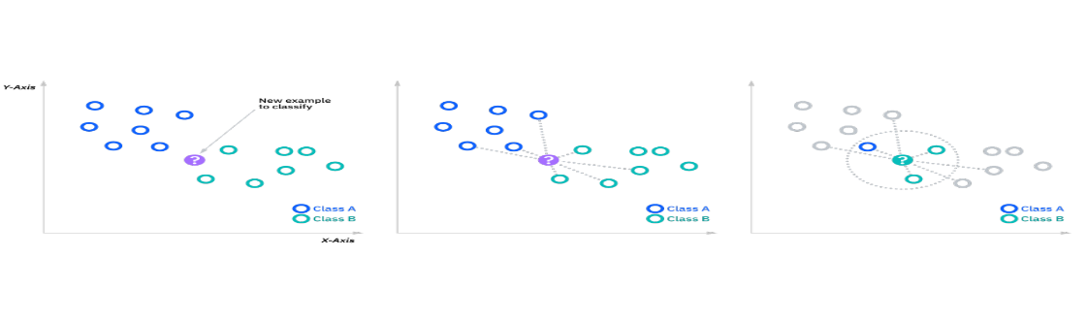

**KNN Formula:**

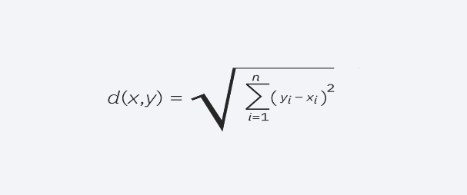

**Support Vector Machine**

Support Vector Machine or SVM is one of the most popular Supervised Learning algorithms, which is used for Classification as well as Regression problems. However, primarily, it is used for Classification problems in Machine Learning.

The goal of the SVM algorithm is to create the best line or decision boundary that can segregate n-dimensional space into classes so that we can easily put the new data point in the correct category in the future. This best decision boundary is called a hyperplane.

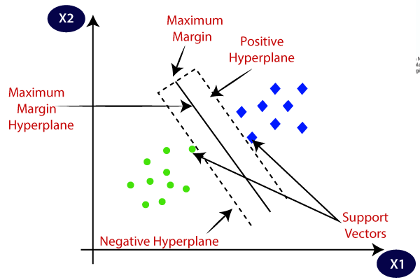

**Decision tree**

Decision trees are a nonparametric supervised learning method used for classification and regression. The deeper the tree, the more complex the decision rules and the fitter the model. Decision tree uses the tree representation to solve the problem. In which each leaf node corresponds to a class label and attributes are represented on the internal node of the tree. The primary challenge in the decision tree implementation is to identify the attributes. There are two popular attribute selection measures they are Entropy and Gini index. Entropy is the measure of uncertainty of a random variable, it characterizes the impurity of an arbitrary collection of examples. The higher the entropy more the information content

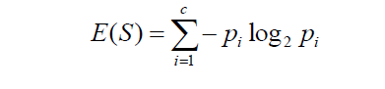



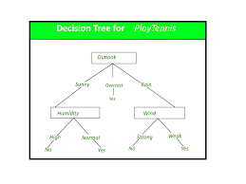

**6. MODEL ARCHITECTURE**

RAINFALL PREDICTION

DATASET



LOADING DATA SET



IDENTIFYING THE ATTRIBUTES PERTAINING THE RAINFALL DATASET



COLLECTION OF DATA AND PRE -PROCESSING

-



LINEAR REGRESSION, KNN, DECISION TREE,SVM



OBTAIN RESULTS



CONCLUSION

**SOFTWARE DESCRIPTION**

**Software requirements:**

**Operating system:** Windows

**Platform**: google Collab

**Programing language:** python

**7. RESULTS**

**CODE**

**Dataset:**

import pandas as pd

d=pd.read_csv(‘/content/rainfall prediction.csv’)

print(d)

**output:**

STATE_UT_NAME DISTRICT JAN FEB MAR APR \

0 ANDAMAN And NICOBAR ISLANDS NICOBAR 107.3 57.9 65.2 117.0

1 ANDAMAN And NICOBAR ISLANDS SOUTH ANDAMAN 43.7 26.0 18.6 90.5

2 ANDAMAN And NICOBAR ISLANDS N & M ANDAMAN 32.7 15.9 8.6 53.4

3 ARUNACHAL PRADESH LOHIT 42.2 80.8 176.4 358.5

4 ARUNACHAL PRADESH EAST SIANG 33.3 79.5 105.9 216.5

.. ... ... ... ... ... ...

636 KERALA IDUKKI 13.4 22.1 43.6 150.4

637 KERALA KASARGOD 2.3 1.0 8.4 46.9

638 KERALA PATHANAMTHITTA 19.8 45.2 73.9 184.9

639 KERALA WAYANAD 4.8 8.3 17.5 83.3

640 LAKSHADWEEP LAKSHADWEEP 20.8 14.7 11.8 48.9

MAY JUN JUL AUG SEP OCT NOV DEC ANNUAL Jan-Feb \

0 358.5 295.5 285.0 271.9 354.8 326.0 315.2 250.9 2805.2 165.2

1 374.4 457.2 421.3 423.1 455.6 301.2 275.8 128.3 3015.7 69.7

2 343.6 503.3 465.4 460.9 454.8 276.1 198.6 100.0 2913.3 48.6

3 306.4 447.0 660.1 427.8 313.6 167.1 34.1 29.8 3043.8 123.0

4 323.0 738.3 990.9 711.2 568.0 206.9 29.5 31.7 4034.7 112.8

.. ... ... ... ... ... ... ... ... ... ...

636 232.6 651.6 788.9 527.3 308.4 343.2 172.9 48.1 3302.5 35.5

637 217.6 999.6 1108.5 636.3 263.1 234.9 84.6 18.4 3621.6 3.3

638 294.7 556.9 539.9 352.7 266.2 359.4 213.5 51.3 2958.4 65.0

639 174.6 698.1 1110.4 592.9 230.7 213.1 93.6 25.8 3253.1 13.1

640 171.7 330.2 287.7 217.5 163.1 157.1 117.7 58.8 1600.0 35.5

Mar-May Jun-Sep Oct-Dec

0 540.7 1207.2 892.1

1 483.5 1757.2 705.3

2 405.6 1884.4 574.7

3 841.3 1848.5 231.0

4 645.4 3008.4 268.1

.. ... ... ...

636 426.6 2276.2 564.2

637 272.9 3007.5 337.9

638 553.5 1715.7 624.2

639 275.4 2632.1 332.5

640 232.4 998.5 333.6

[641 rows x 19 columns]

**Linear regression:**

from sklearn.linear_model import LinearRegression

lr=LinearRegression()

mm=lr.fit(x_train,y_train)

yp=mm.predict(x_test)

print(yp)

**output:**

[1233.9 1223.4 1327.9 1057.6 2641.8 646.5 961.1 1070.6 485.7 1122.9

1029.6 3470.6 1209.3 308.1 2958.4 498. 2814.4 1796.5 1068.5 646.1

2440.7 1973.9 1081.4 2859.3 1293.1 3468.3 898.2 992.9 1235.7 1535.5

3094.5 966.7 793.4 449.2 747.1 544. 1803.2 818. 508.1 3218.7

746.9 2480.6 839.2 1336.5 460.6 1533.5 6379.9 1003.3 837. 1087.7

2127.5 622.8 1123.6 685.6 1366.2 1680.7 1481.6 788.4 777. 2512.6

992.2 747.1 1336.5 388.8 863.6 2805.2 1416.2 708.4 1293.3 902.6

974.9 747.1 1474.3 613.9 449.4 700.4 2731.1 1921.1 807.8 2123.9

1528.2 655. 1091.6 1618.3 3302.5 572. 1146.8 1385.5 1148.6 1109.9

2374.1 886.1 2116.9 818.7 897.4 2098. 1005.6 419.5 714.4 1363.3

1448.3 936.2 1155.4 1062.7 871.5 720. 1008.4 455.6 1192.2 1191.5

2814.4 986.3 963.9 252.9 850.1 1229. 1104.7 301.6 1474.1 3399.4

1010.8 1504.4 1530.9 1392.7 1584.9 1462.1 692.7 2556.6 1206.7]

from sklearn.metrics import mean_squared_error

print(mean_squared_error(yp,y_test))

**output:**

2.862281872213113e-25

from sklearn.metrics import mean_absolute_error

print(mean_absolute_error(yp,y_test))

**output:**

3.615505827542091e-13

mse = mean_squared_error(y_test, yp)

print("Mean Squared Error:", mse)

**output:**

Mean Squared Error: 2.862281872213113e-25

mae = mean_absolute_error(y_test, yp)

print("Mean Absolute Error:", mae)

**output:**

Mean Absolute Error: 3.615505827542091e-13

**K-Nearest Neighbour:**

from sklearn.neighbors import KneighborsRegressor

knn = KNeighborsRegressor(n_neighbors=3)

knn.fit(x_train, y_train)

y_pred = knn.predict(x_test)

mae = mean_absolute_error(y_test, y_pred)

print("Mean Absolute Error:", mae)

**output:**

Mean Absolute Error: 50.94470284237724

mse = mean_squared_error(y_test, y_pred)

print("Mean Squared Error:", mse)

**output:**

Mean Squared Error: 7804.861584840647

from sklearn.metrics import mean_squared_error

print(mean_squared_error(yp,y_test))

**output:**

70357.10162790696

from sklearn.metrics import mean_absolute_error

print(mean_absolute_error(yp,y_test))

**output:**

101.26434108527131

**Support Vector Machine:**

from sklearn.svm import SVR

model = SVR(kernel='linear')

model.fit(x_train,y_train)

y_pred=model.predict(x_test)

mae = mean_absolute_error(y_test, y_pred)

print("Mean Absolute Error:", mae)

**output:**

Mean Absolute Error: 0.04753588620007877

mse = mean_squared_error(y_test, y_pred)

print("Mean Squared Error:", mse)

**output:**

Mean Squared Error: 0.003450724484773055

from sklearn.metrics import mean_squared_error

print(mean_squared_error(yp,y_test))

**output:**

70357.10162790696

from sklearn.metrics import mean_absolute_error

print(mean_absolute_error(yp,y_test))

**output:**

101.26434108527131

**Decision Tree:**

from sklearn.tree import DecisionTreeRegressor

model=DecisionTreeRegressor()

model.fit(x_train,y_train)

yp=model.predict(x_test)

print(yp)

from sklearn.metrics import mean_squared_error

print(mean_squared_error(y_test,yp))

from sklearn import tree

tree.plot_tree(model,filled=True)

**output:**

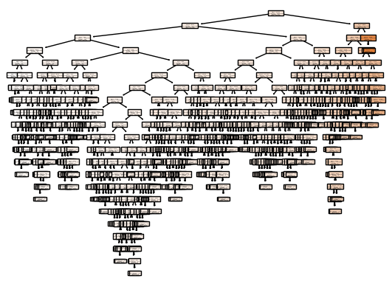

|  |  |  |
| --- | --- | --- |
| **sno** | **Machine Learning Model** | **Mean square error** |
| **1** | **Linear regression** | 2.862281872213113e-25 |
| **2** | **k-nearest neighbour** | 7804.861584840647 |
| **3** | **Decision tree** | 24676.522558139535 |
| **4** | **Support vector machine** | 0.003450724484773055 |

**8. CONCLUSION AND FUTURE SCOPE**

•There are some specific problems in the world that pushes the capability of data

science and the technology available in this field to their edge among them one is

rainfall predicition

•We can easily conclude that for rainfall prediction this is the best way to use it by

forming a range of highest and lowest predicted values by adding bias in the model

•Rainfall prediction main objective is prediction of amount of rain in a specific well or

division by using various techinques and finding out which one is best

•Future scope of rainfall prediction

The future scope of rainfall prediction is very promising, with advancements in technology and data analysis techniques. Some of the potential developments in this field include:

•Improvements in Data Collection

•Integration of Big Data

•Advances in Cloud Computing

•Development of Early Warning Systems

•In summary, the future of rainfall prediction looks bright, and with continued research and innovation, we can expect more accurate and reliable predictions that can help people and communities prepare for extreme weather events.

**9.REFERENCES**

[**http://repository.wit.ie/3326/1/InfomationScience_postprint.pdf**](http://repository.wit.ie/3326/1/InfomationScience_postprint.pdf)

[**https://www.sciencedirect.com/science/article/pii/S0022030215004932**](https://www.sciencedirect.com/science/article/pii/S0022030215004932)

[**https://www.kaggle.com/code/darsh79/starter-rainfall-in-india-99bfc809-4**](https://www.kaggle.com/code/darsh79/starter-rainfall-in-india-99bfc809-4)

[**https://www.tandfonline.com/doi/abs/10.4081/ijas.2009.s2.399**](https://www.tandfonline.com/doi/abs/10.4081/ijas.2009.s2.399)

[**https://orbi.uliege.be/handle/2268/224000**](https://orbi.uliege.be/handle/2268/224000)

[**https://www.sciencedirect.com/science/article/pii/S0022030221005099**](https://www.sciencedirect.com/science/article/pii/S0022030221005099)