**CSE 114 -Lab Report**

**Conditional Statement (If, if else, if else if ladder, nested if-else, switch)**

**Write a program in C to check whether a year is a leap year using if...else statements.**

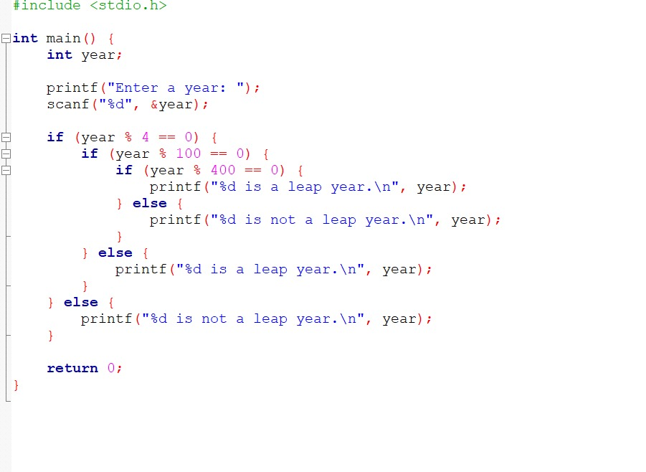

**OUTPUT**

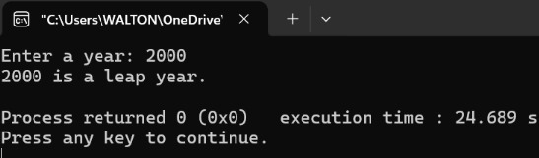

**Write a program in C to calculate a student's grade based on marks using only if...else statements (no loops).**

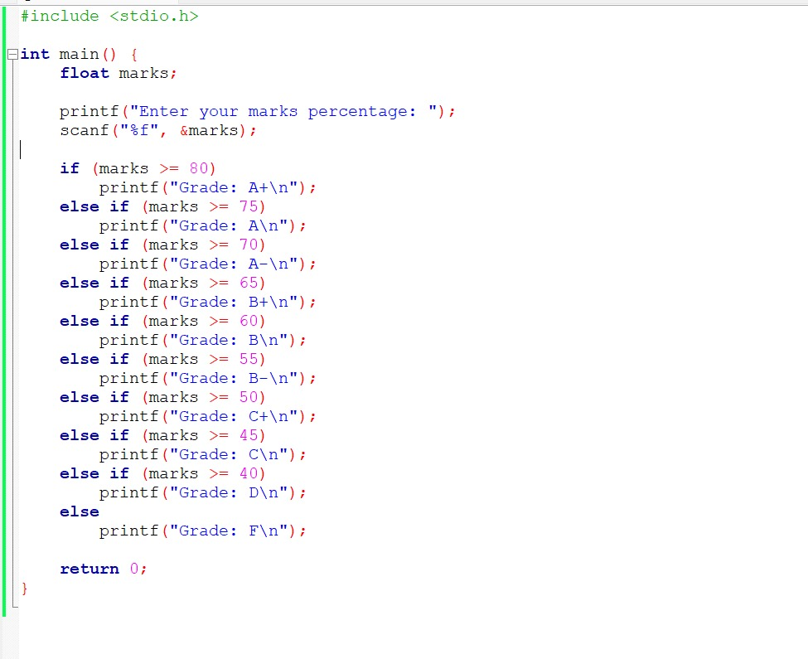

**OUTPUT**

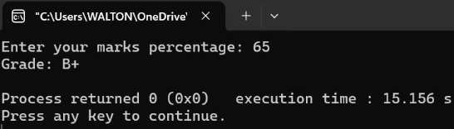

**Write a program in C to find the largest of three numbers using if...else statements.**

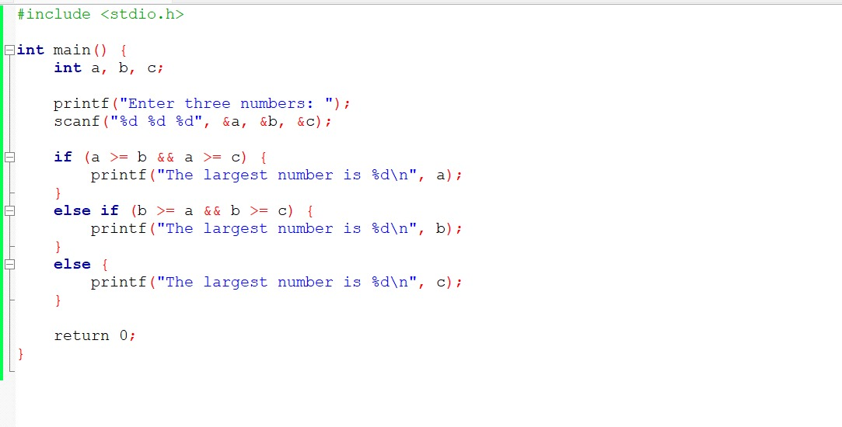

**OUTPUT**

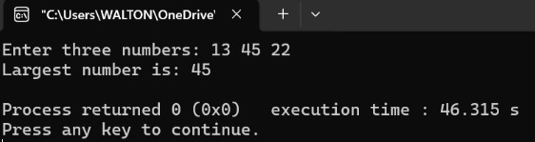

**Write a program in C to find the smallest of three numbers using if...else statements.**

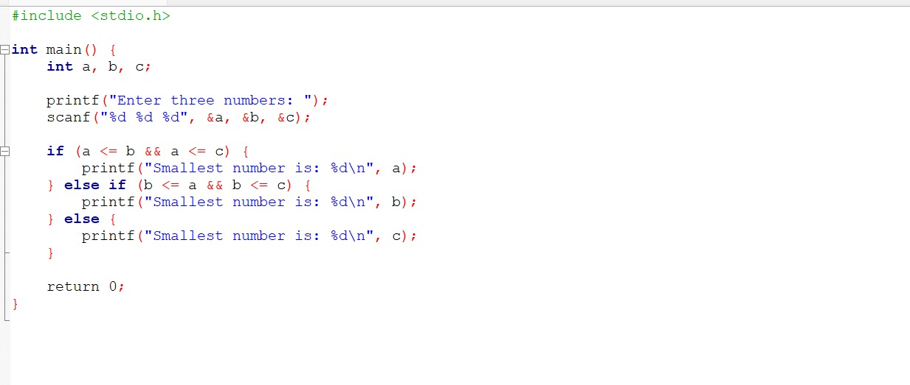

**OUTPUT**

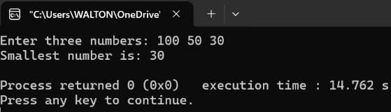

**Write a program in C to check whether a number is even or odd using if...else statements.**

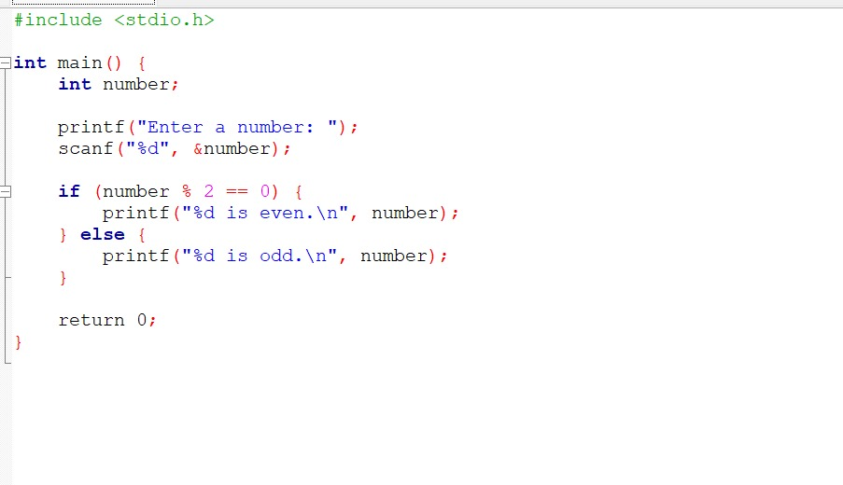

**OUTPUT**

* **Even:**

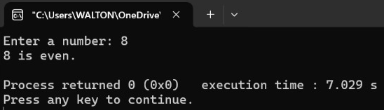

* **Odd:**

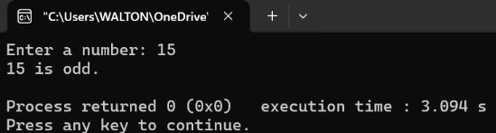

**Write a program in C to swap two numbers without using an extra variable.**

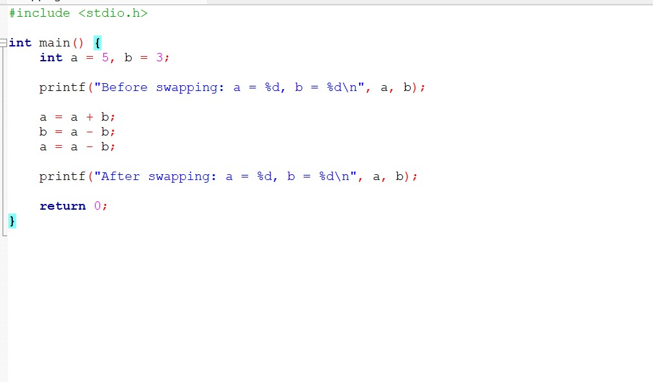

**OUTPUT**

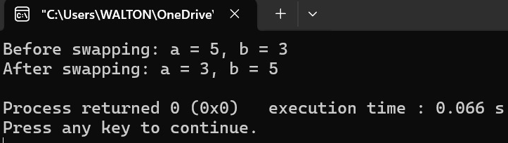

**Write a program in C to check whether a given character is a vowel or not using if...else statements.**

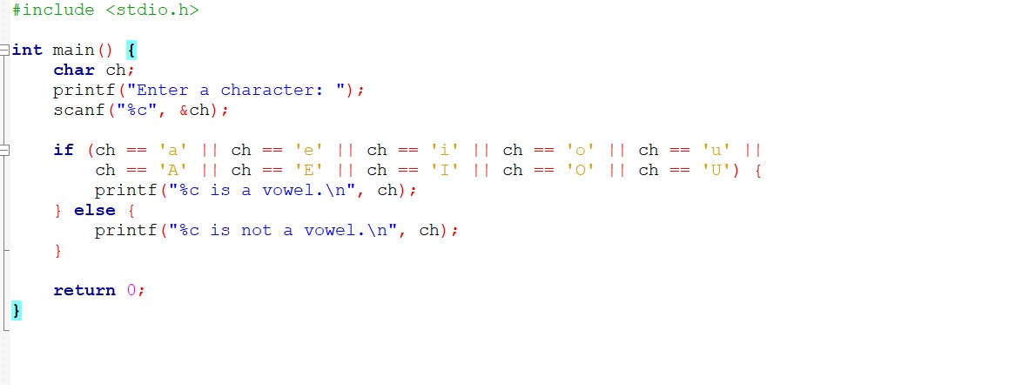

**OUTPUT**

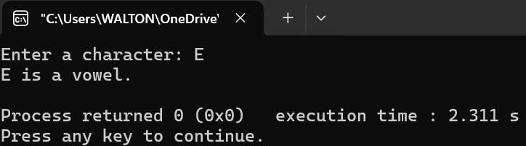

**Write a calculator program in C that performs addition, subtraction, multiplication, and division using switch statements.**

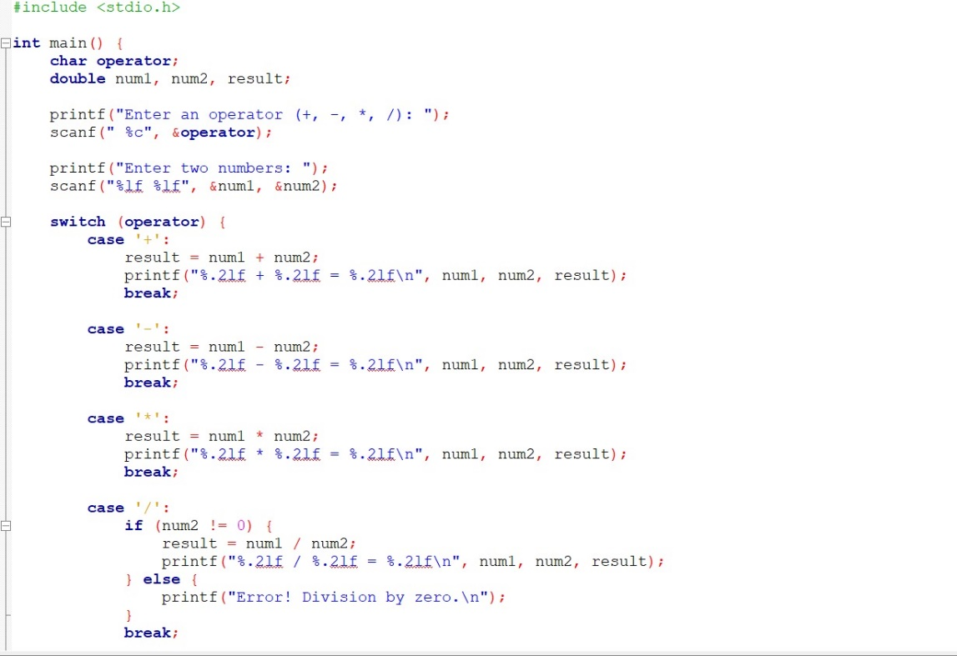

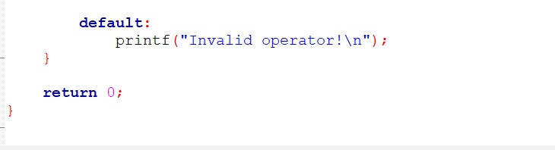

**OUTPUT**

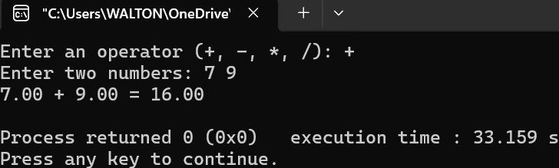

***Loop Control Statement (For, Nested For, While, Do-While)***

**Write a program in C to check whether a number is prime or not using loop control statements (for, nested for, while, or do-while).**

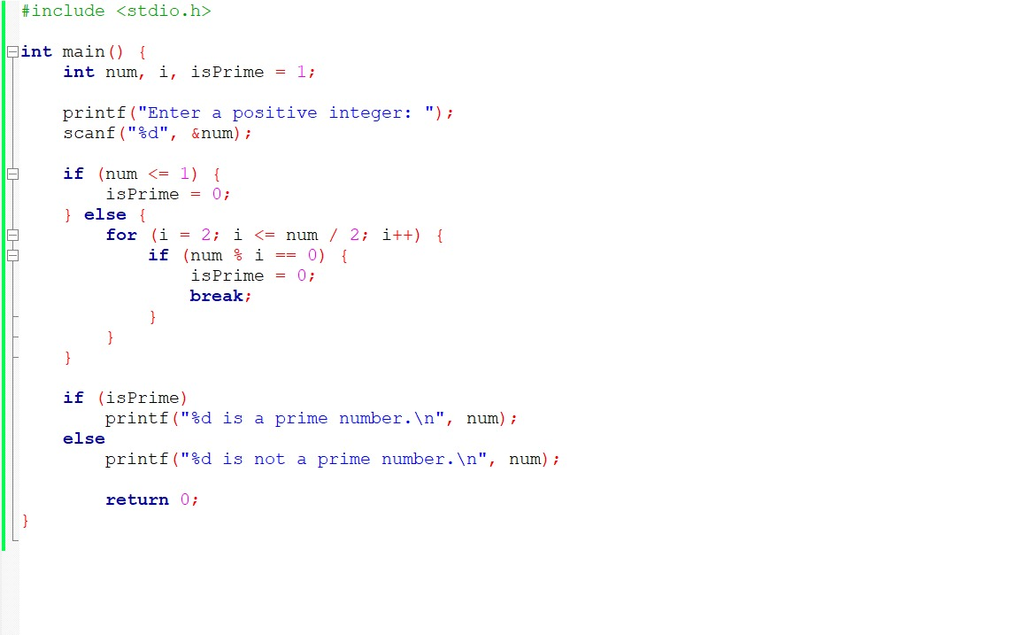

**OUTPUT**

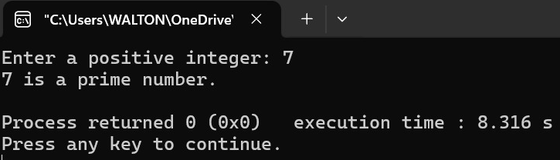

**Write a program in C to count the number of digits in a given number using loop control statements.**

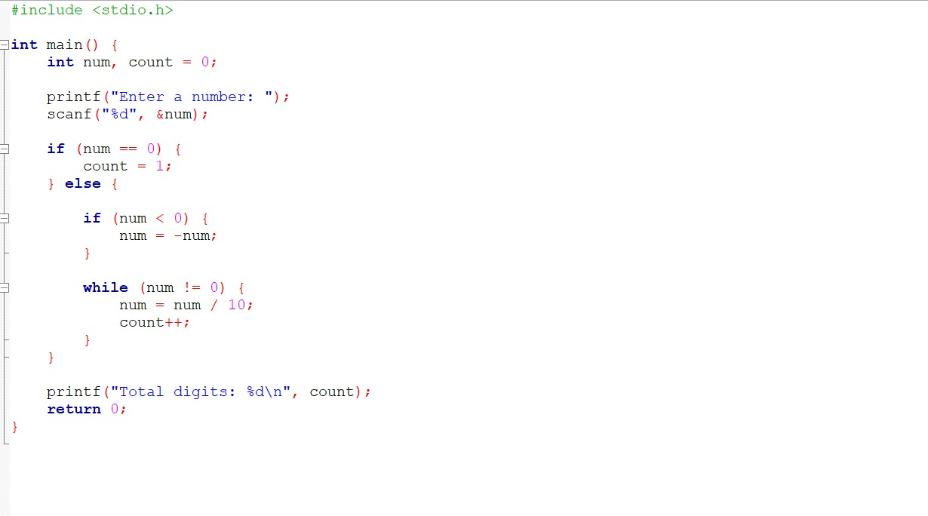

**OUTPUT**

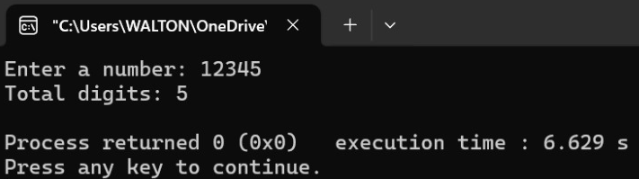

**Write a program in C to find the sum of the digits of a given number using loop control statements.**

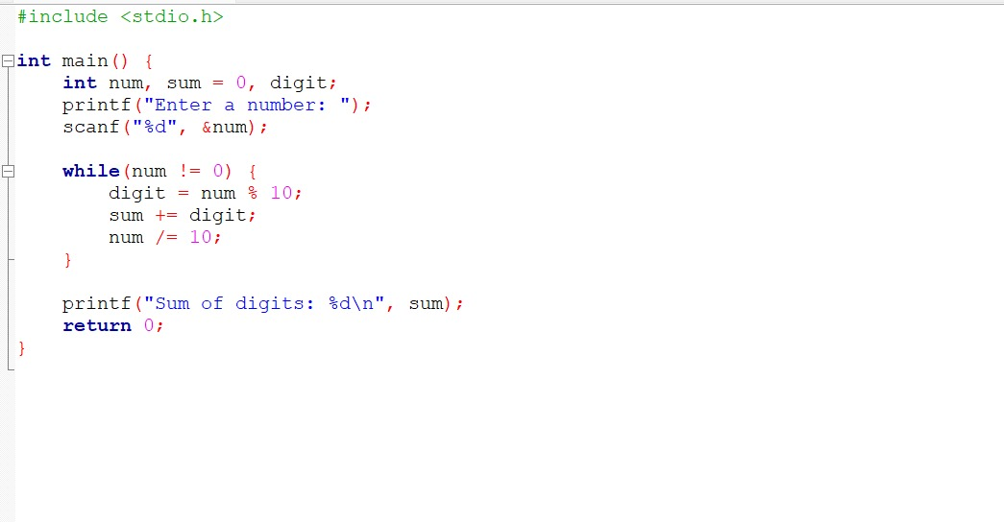

**OUTPUT**

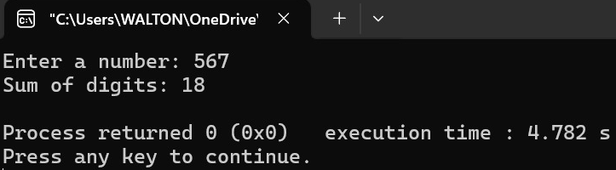

**Write a program in C to reverse a given number using loop control statements.**

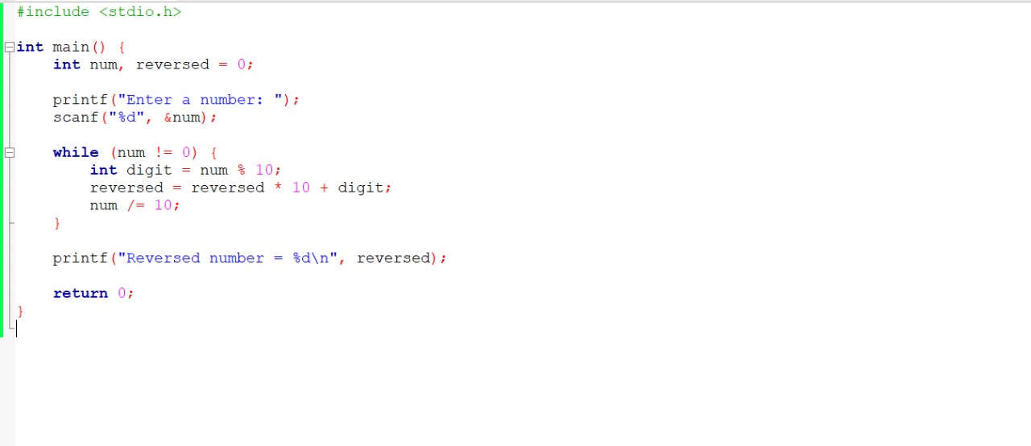

**OUTPUT**

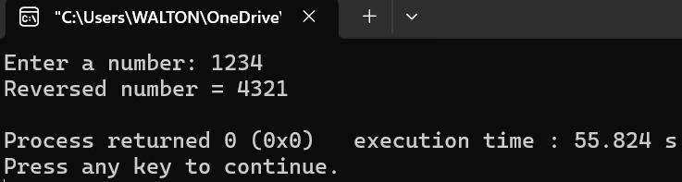

**Write a program in C to find the factorial of a number using loop control statements.**

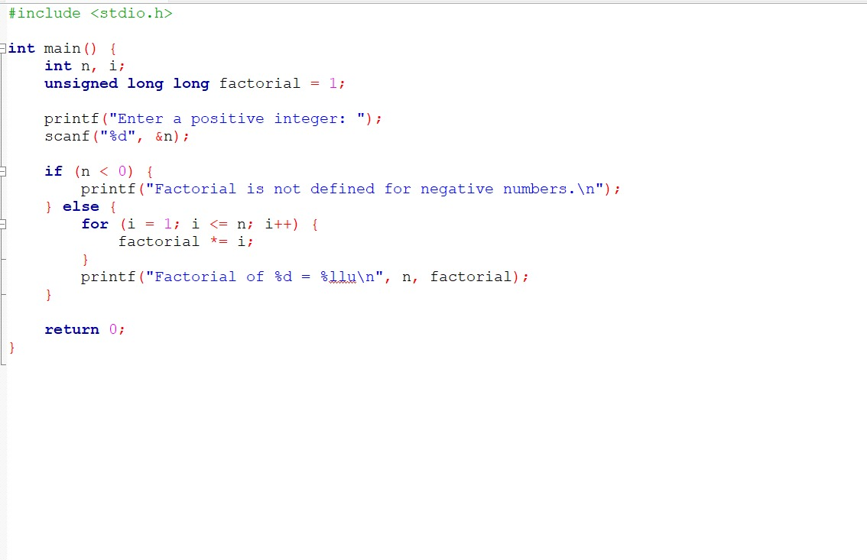

**OUTPUT**

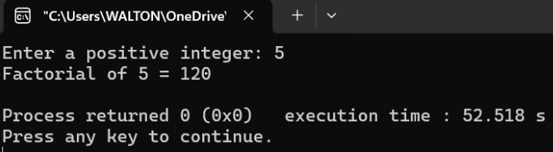

**Write a program in C to print the first N natural numbers using loop control statements.**

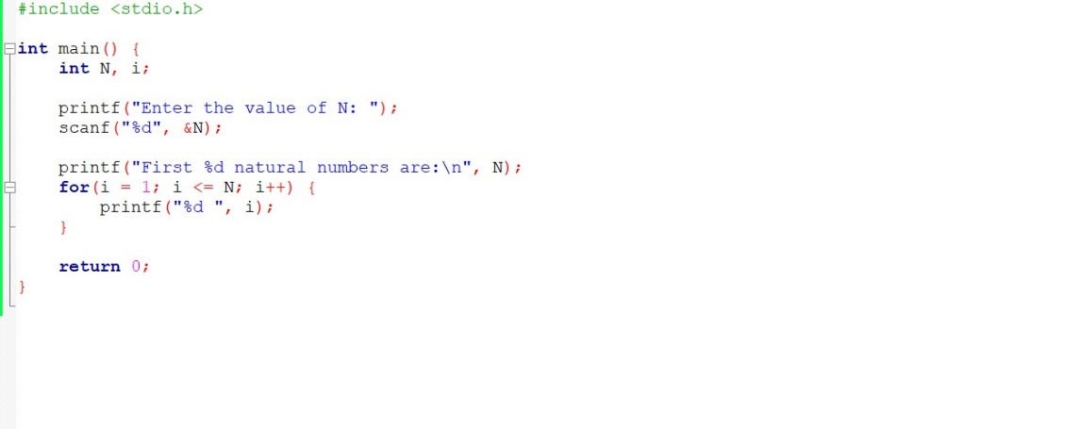

**OUTPUT**

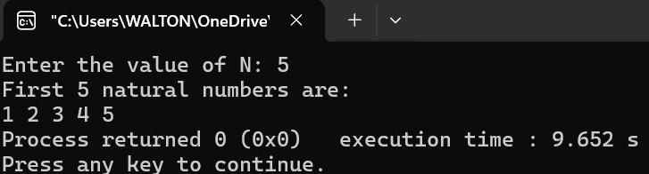

**Write a program in C to print the squares of the first N natural numbers using loop control statements.**

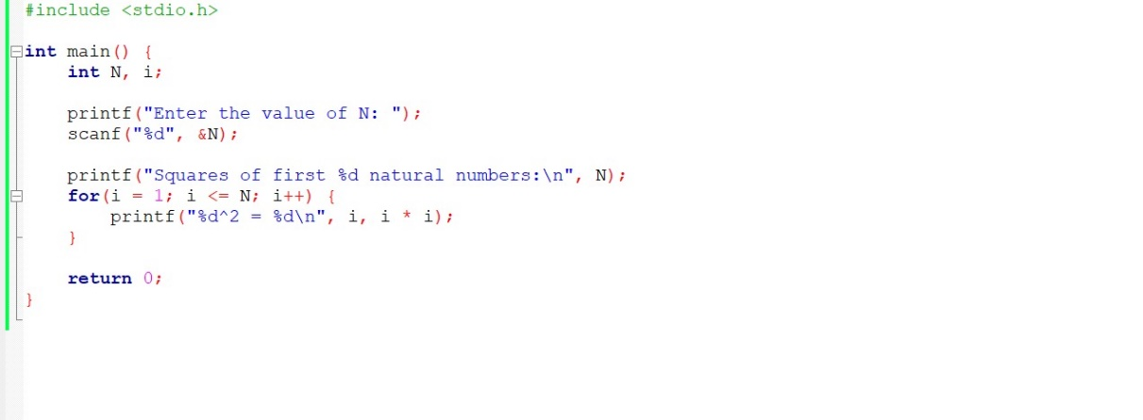

**OUTPUT**

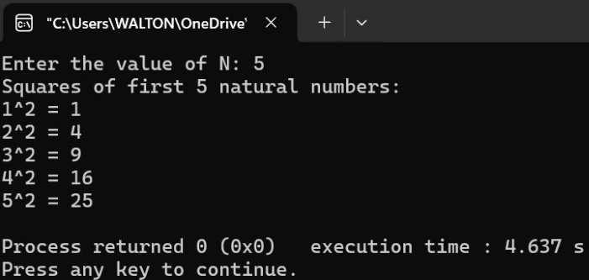

**Write a program in C to print the Fibonacci series up to N terms using loop control statements.**

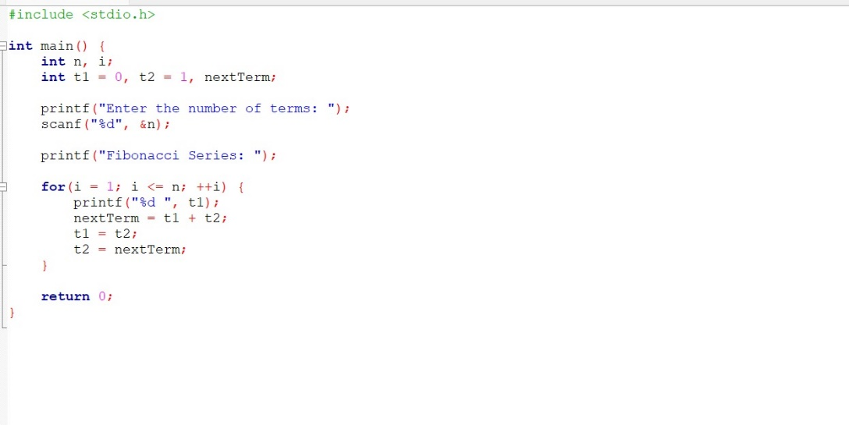

**OUTPUT**

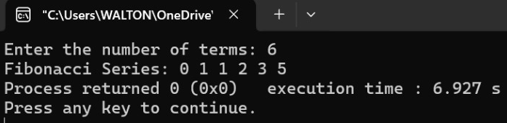

**Write a C program to print the series like below using for loop 2 3 6 18 108 1944.... .... ..**

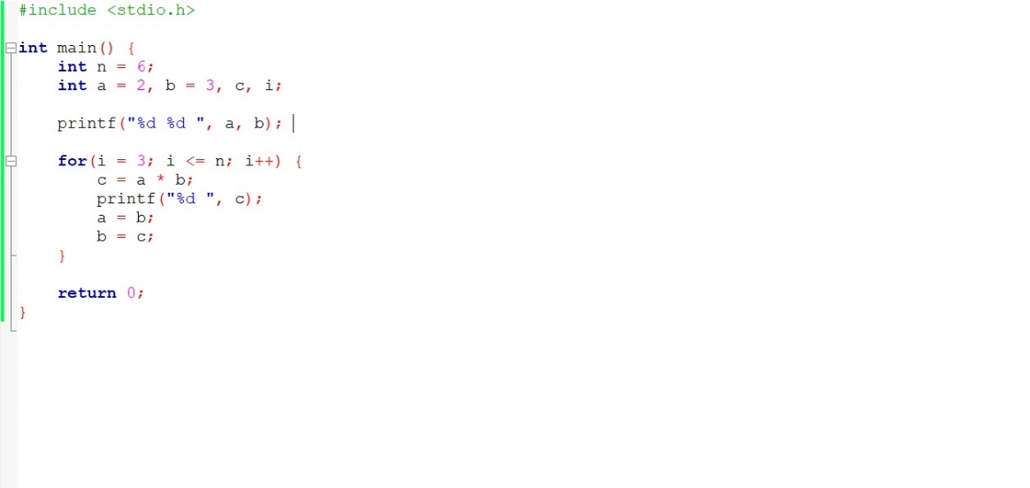

**OUTPUT**

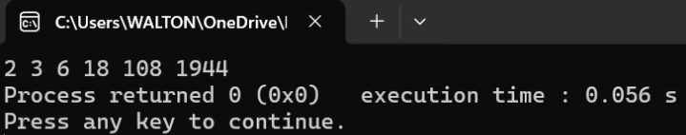

**Rectangle Pattern (3 rows, 5 columns)**

**Output:**

* * * * *

* * * * *

* * * * *

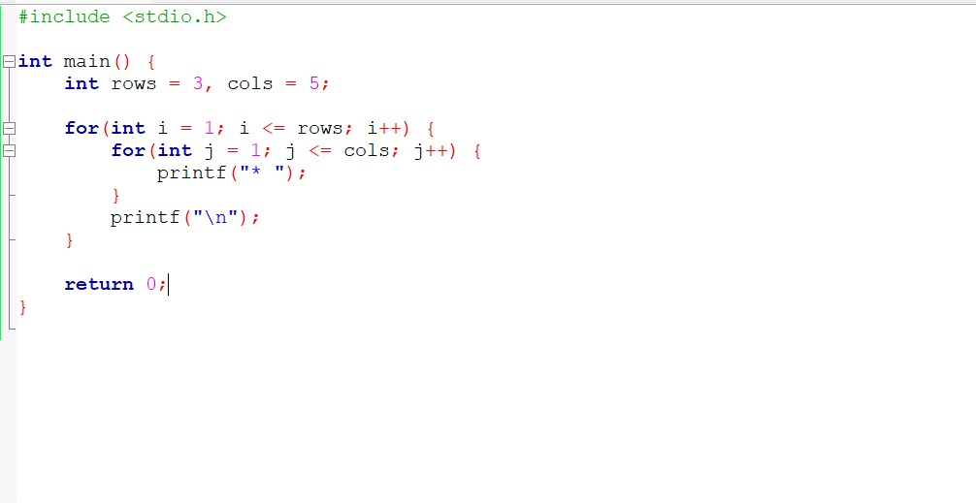

**OUTPUT**

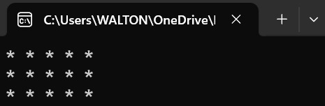

**Right-Angled Triangle (Ascending)**

**Output:**

*

* *

* * *

* * * *

* * * * *

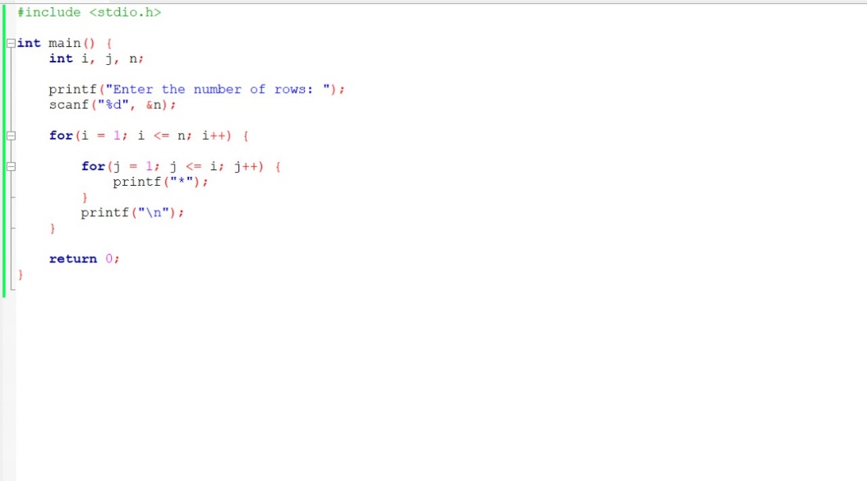

**OUTPUT**

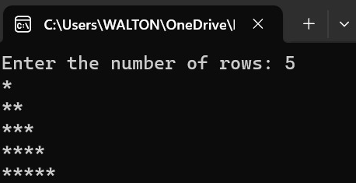

**Right-Angled Triangle (Descending)**

**Output:**

* * * * *

* * * *

* * *

* *

*

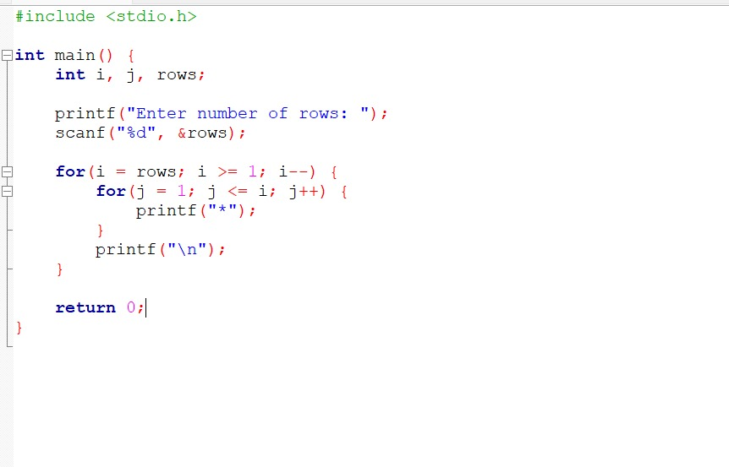

**OUTPUT**

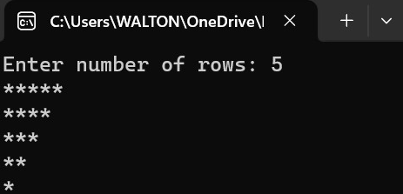

**Pascal's Triangle**

**Output:**

1

1. 1

1 2 1

1 3 3 1

1 4 6 4 1

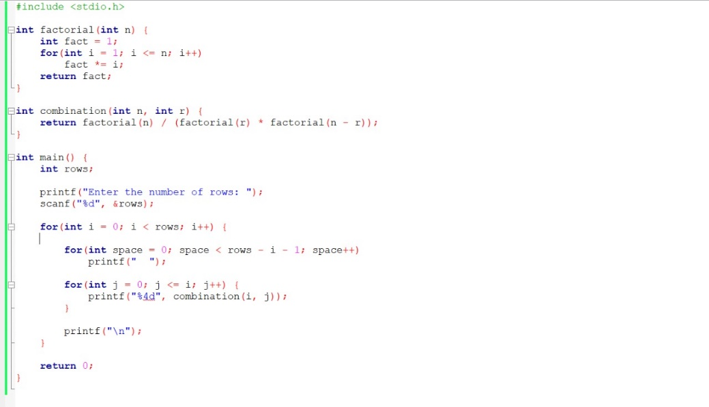

**OUTPUT**

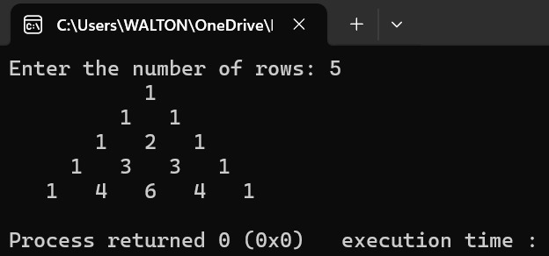

**Alphabet Triangle**

**Output:**

**A**

**AB**

**ABC**

**ABCD**

**ABCDE**

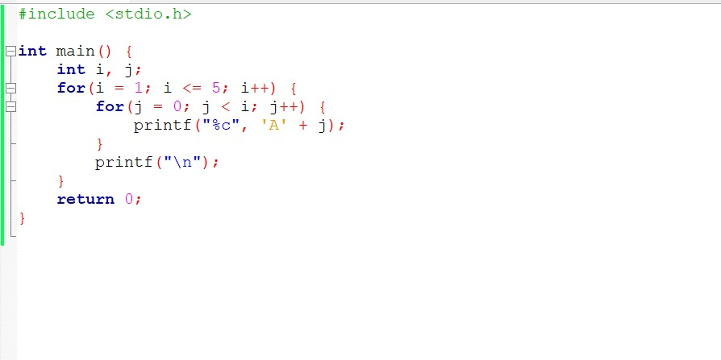

**OUTPUT**

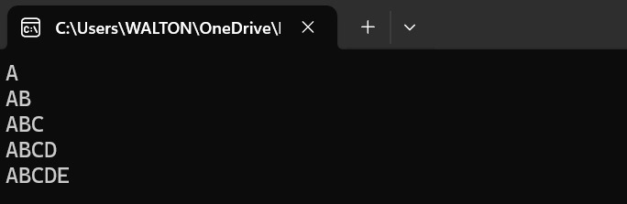

**Write a program in C to find the sum of squares Sum of Squares: 1+2+3+...+n² using a loop.**

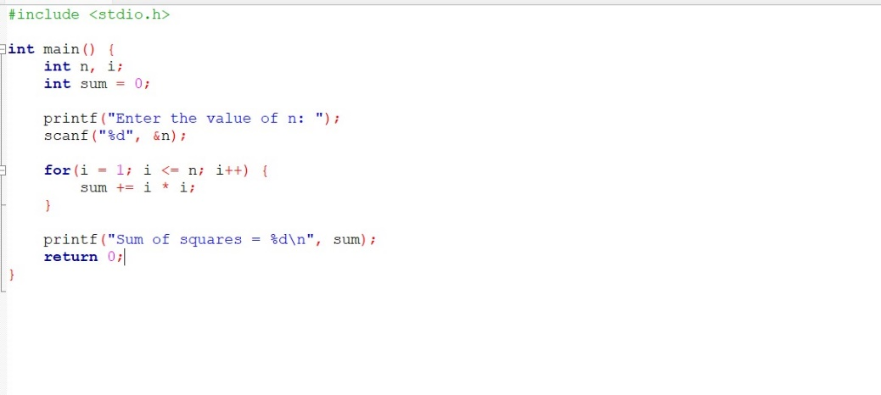

**OUTPUT**

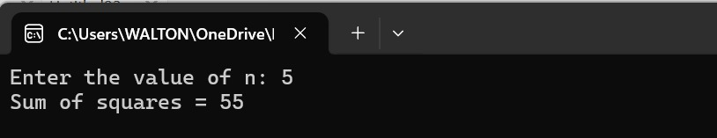

**Write a program in C to print a diamond pattern using for, while, and do-while loops.**

**\***

**\* * \***

**\* * * * \***

**\* * \***

**\***

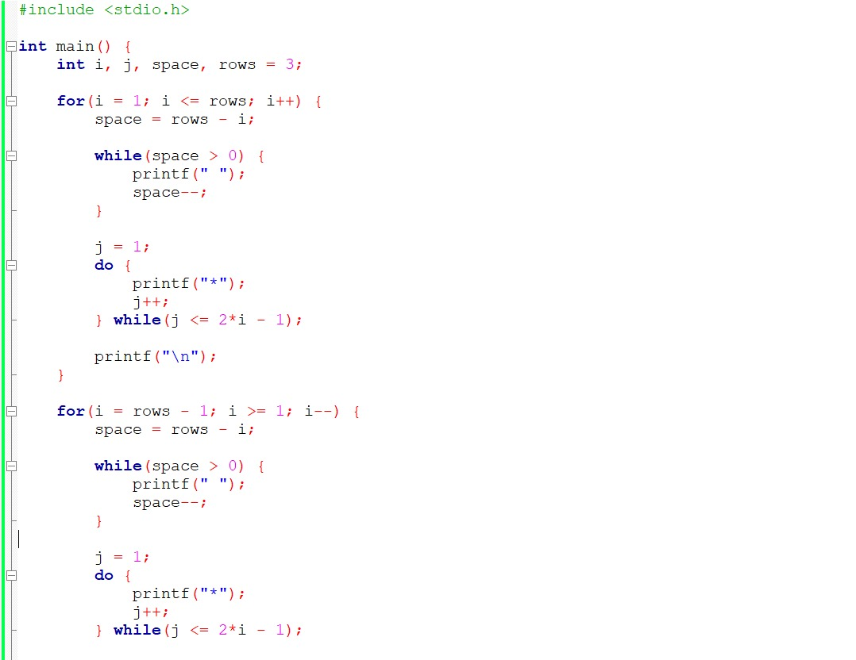

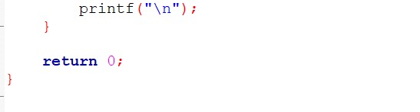

**OUTPUT**

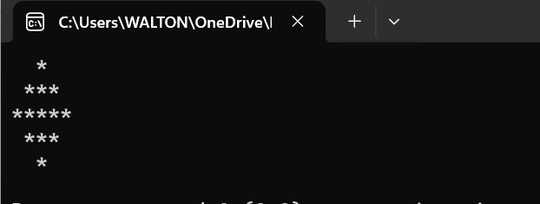

**Write a program in C to print a heart shape pattern using loop control statements**

**\* \***

**\* * * * * \***

**\* * * * * * * * * \***

**\* * * * * * * * * \***

**\* * * * * * * \***

**\* * * * * \***

**\* * * \***

**\* \***

**\***

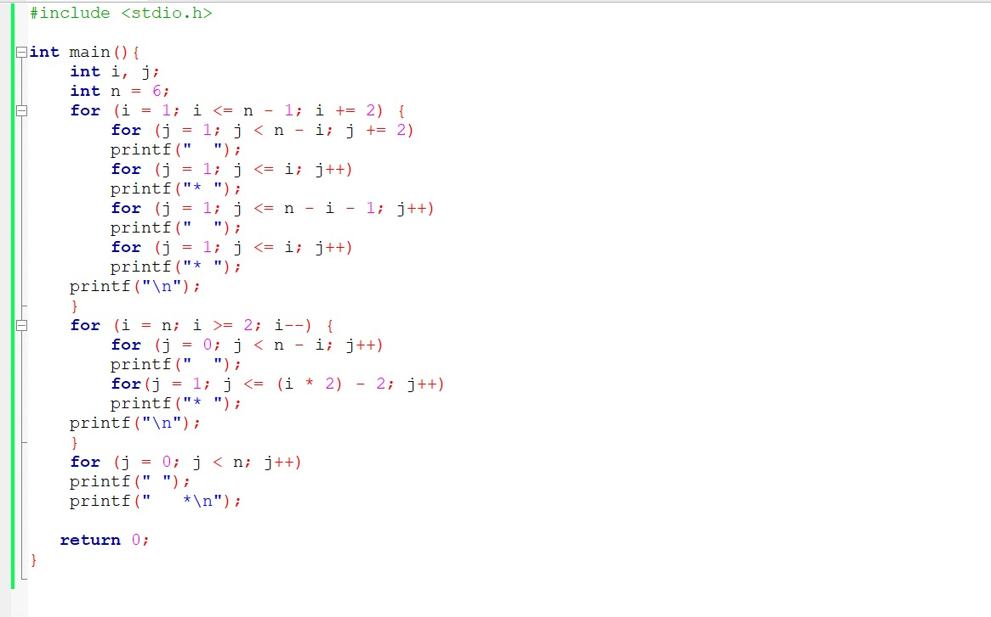

**OUTPUT**

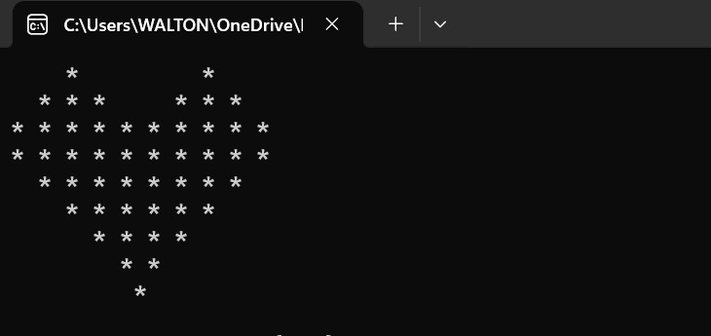

***ARRAY***

**Write a program in C to find the largest element in an array**

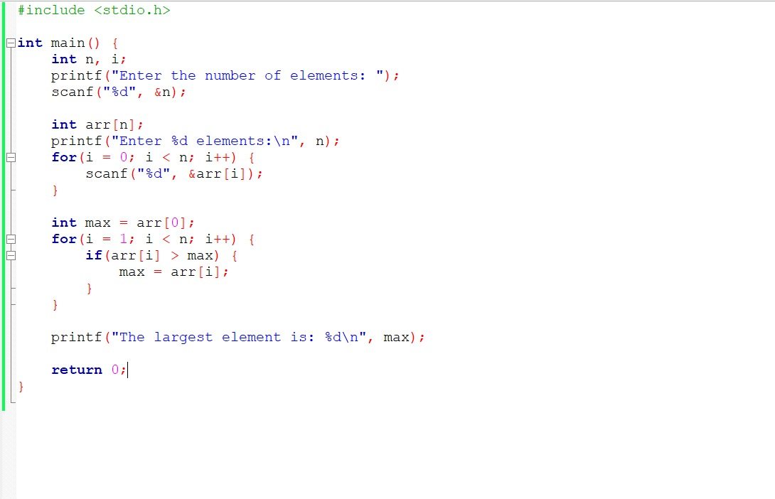

**OUTPUT**

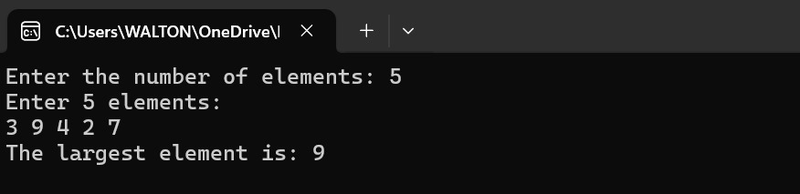

**Write a program in C to find the smallest element in an array**

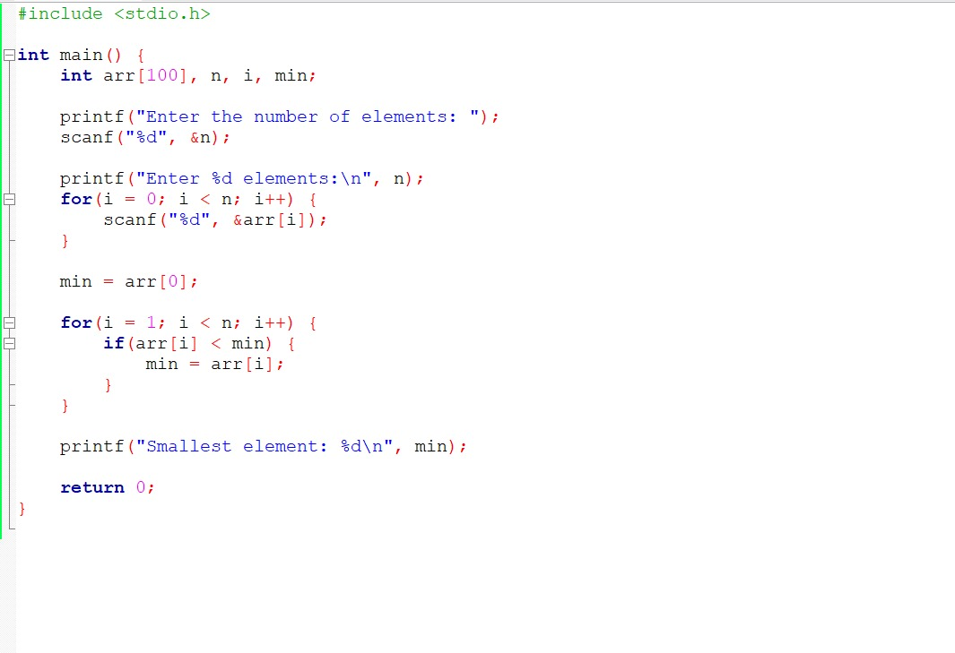

**OUTPUT**

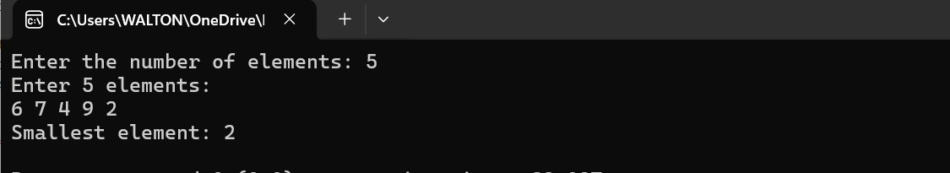

**Write a program in C to calculate sum and average of array elements**

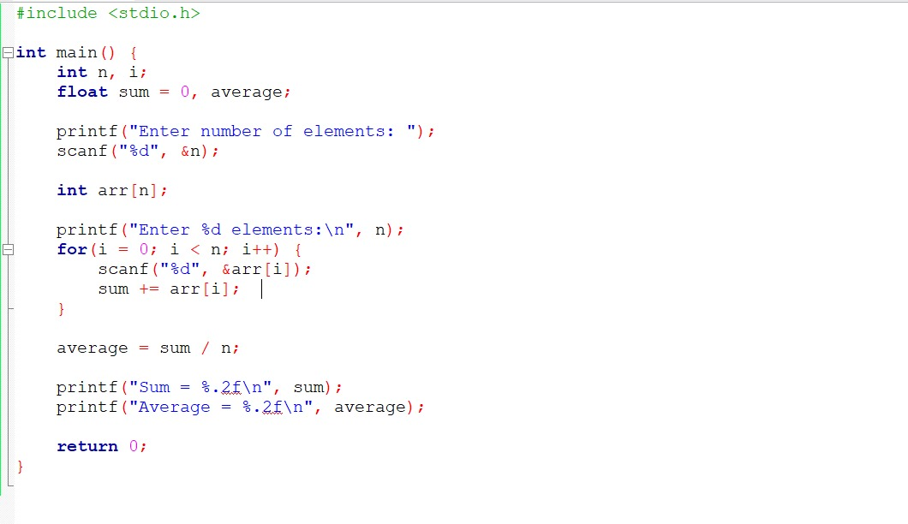

**OUTPUT**

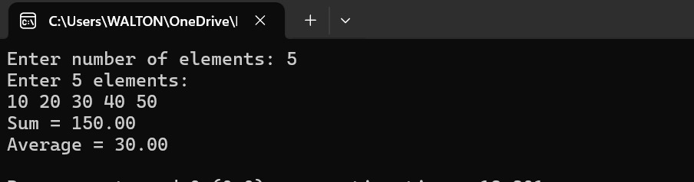

**Write a program in C to reverse the elements of an array**

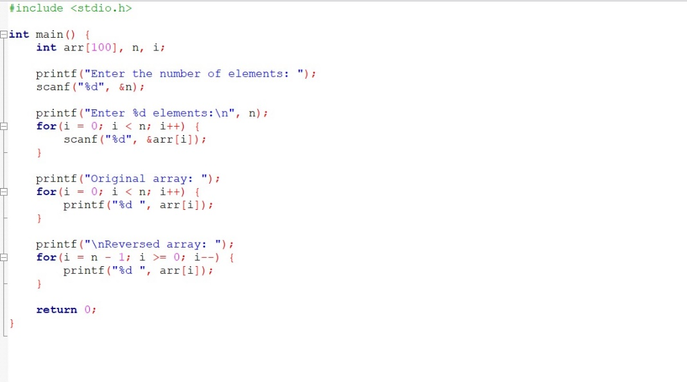

**OUTPUT**

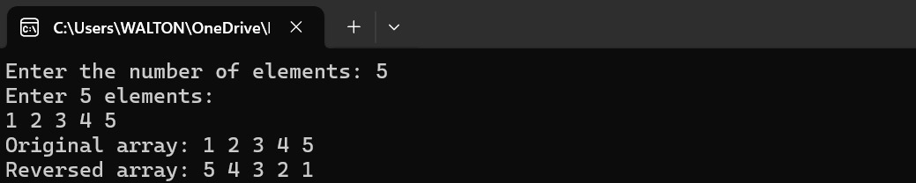

**Write a program in C to check whether a given number is a palindrome or not**

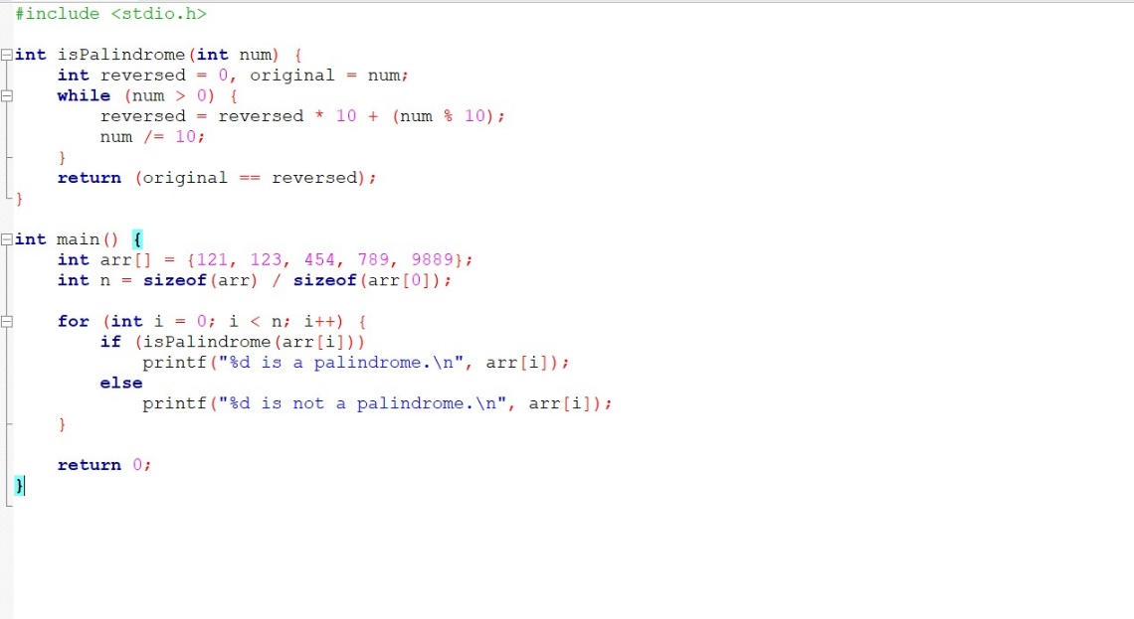

**OUTPUT**

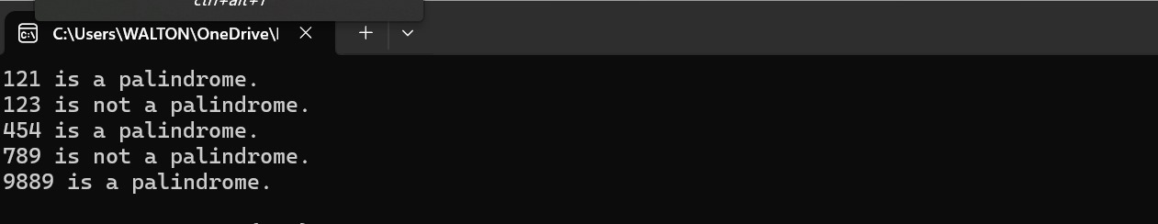

**Write a program in C to check whether a given number is an Armstrong number (153 = 1³ + 5³ + 3³)**

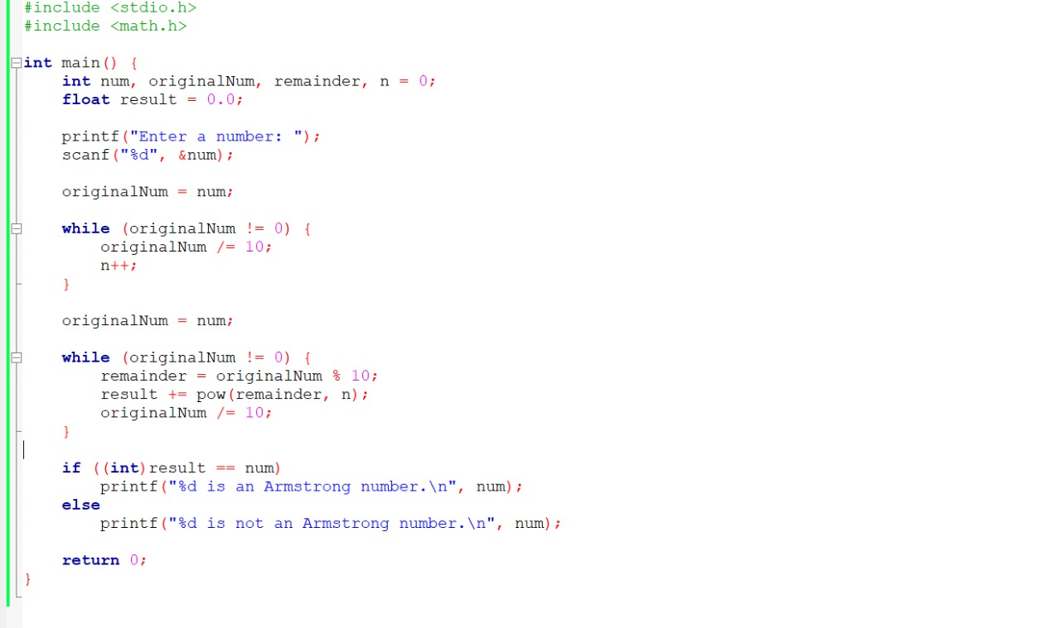

**OUTPUT**

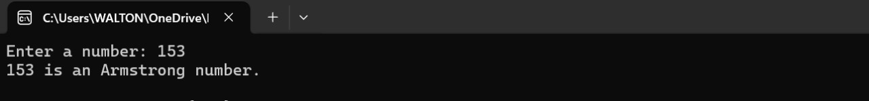

**Write a program in C to perform matrix addition, subtraction, and multiplication using arrays.**

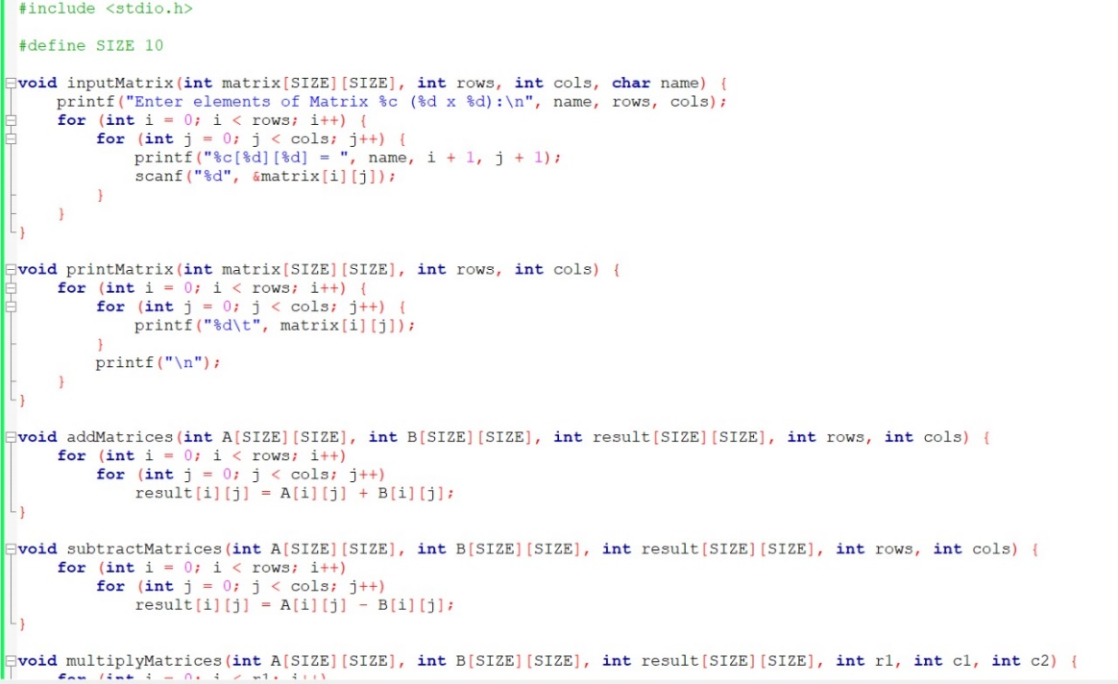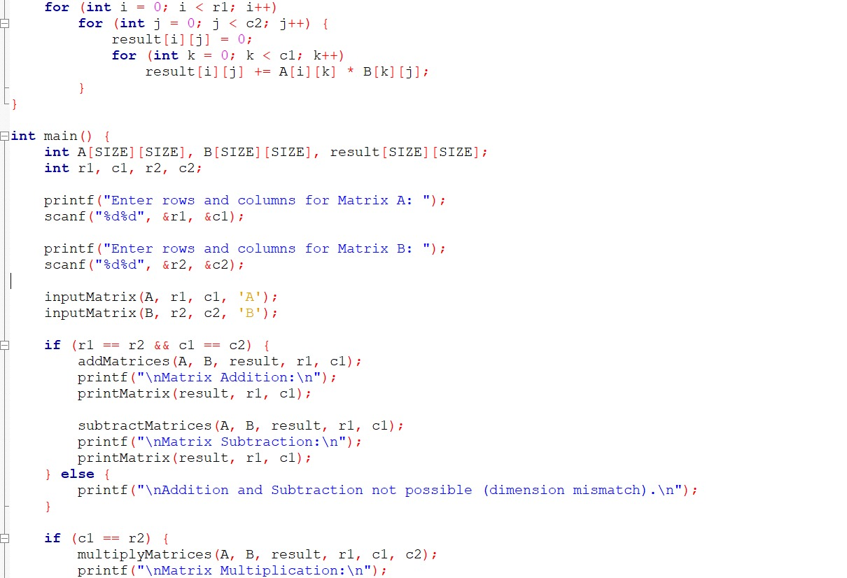

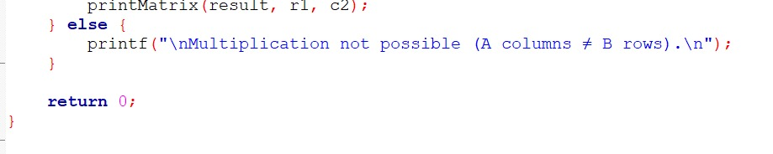

**OUTPUT**

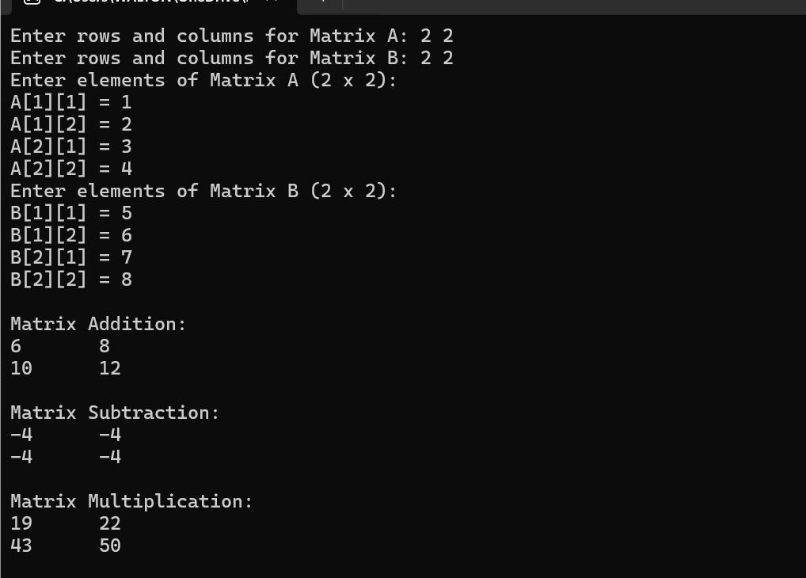

**Write a program in C to calculate CGPA and grade using arrays.**

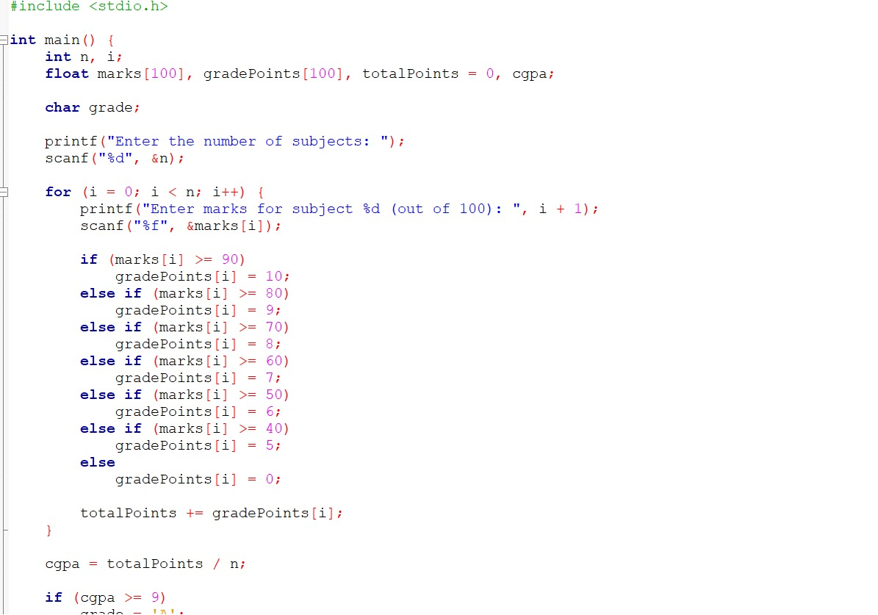

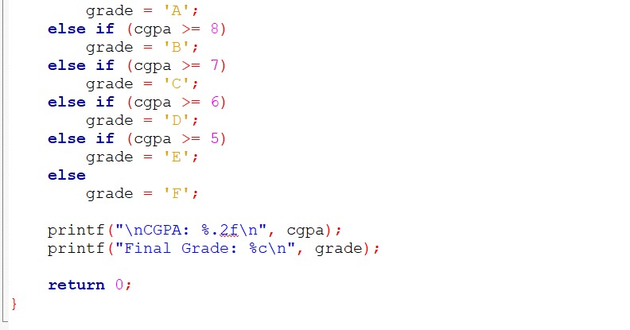

**OUTPUT**

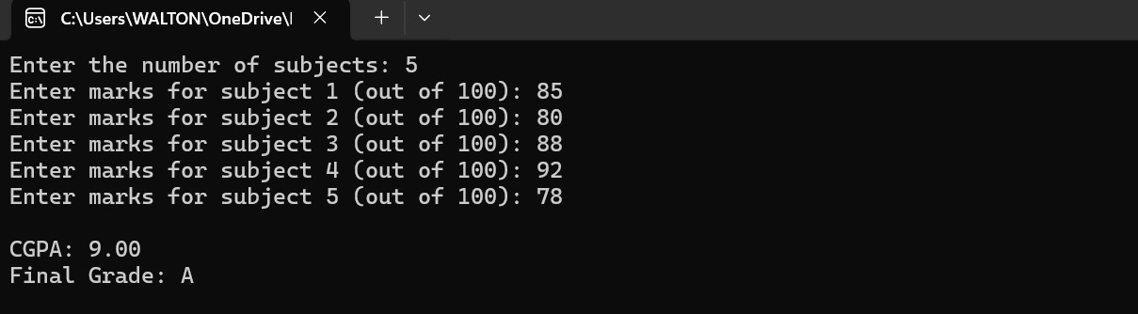

***Function***

**Write a function to check if a number is prime**

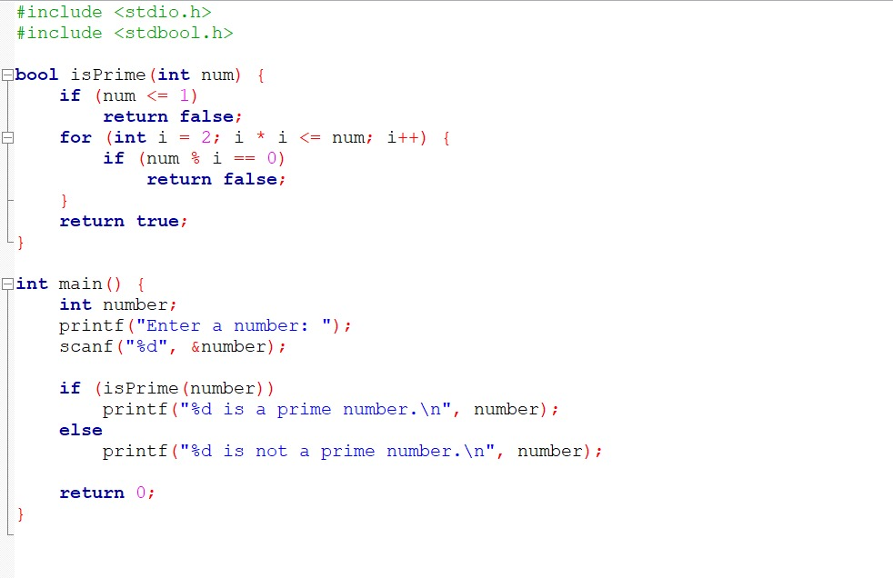

**OUTPUT**

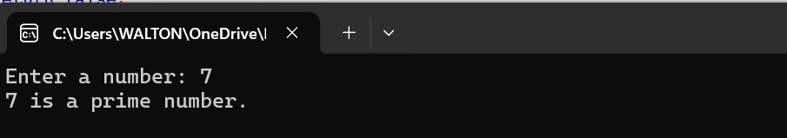

**Write a function to find the GCD of two numbers**

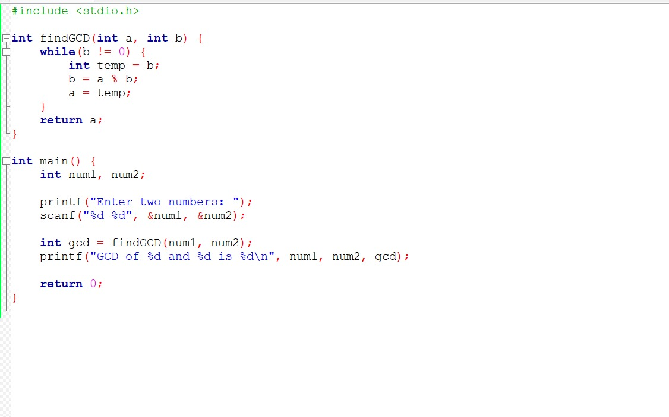

**OUTPUT**

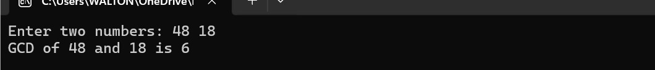

* **What is Transpose Matrix?**

The transpose of a matrix means converting its rows into columns and columns into rows.

**Write a function in C to find the transpose of a matrix**

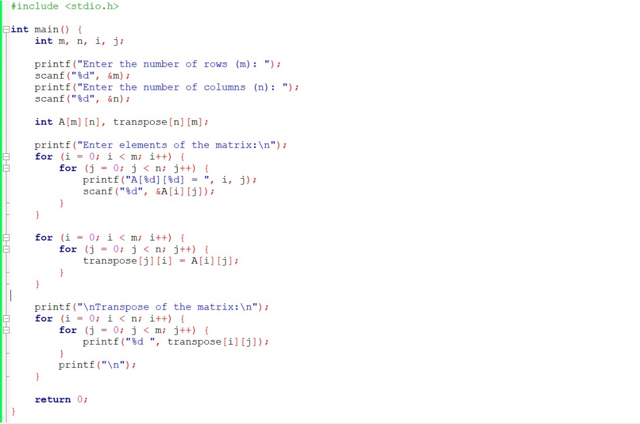

**OUTPUT**

