INSURANCE CLAIM ANALYTICS
BY: SOUMIK DALEI
TECHNOLOGIES:PYTHON,SNOWFLAKE,PYSPARK,SQL,POWER BI

Insurance companies face challenges such as:
->Increasing fraudulent claims
->Difficulty in risk profiling
->Lack of unified analytics
->Slow manual claim evaluation
This project delivers a complete modern data pipeline that ingests, transforms, analyzes, and visualizes insurance claim data to identify fraud patterns and high risk customers.

The existing insurance claim process struggles with:
->Detecting fraud in real time
->Understanding customer risk
->Identifying high-risk policies
->Poor visibility of claims across regions
The project solves these issues using Snowflake, Python ETL & Power BI

Project Objectives:
-> Build a modern Data Warehouse using Star Schema
-> Automate ETL pipeline using Python & Snowflake
-> Implement RBAC, Data Masking, Governance
-> Develop advanced SQL analytics
-> Create interactive Power BI dashboards
-> Build actionable insights for fraud detection
-> Integrate Apache Spark

Data Set Overview:
customers.csv
- customer_id, name, age, gender, city, state
policies.csv
- policy_id, policy_type, premium, coverage
claims.csv
- claim_id, customer_id, policy_id, amount, status, fraud_probability
date_dimension.csv
- date_key, date, month, year

ARCHITECTURE DIAGRAM
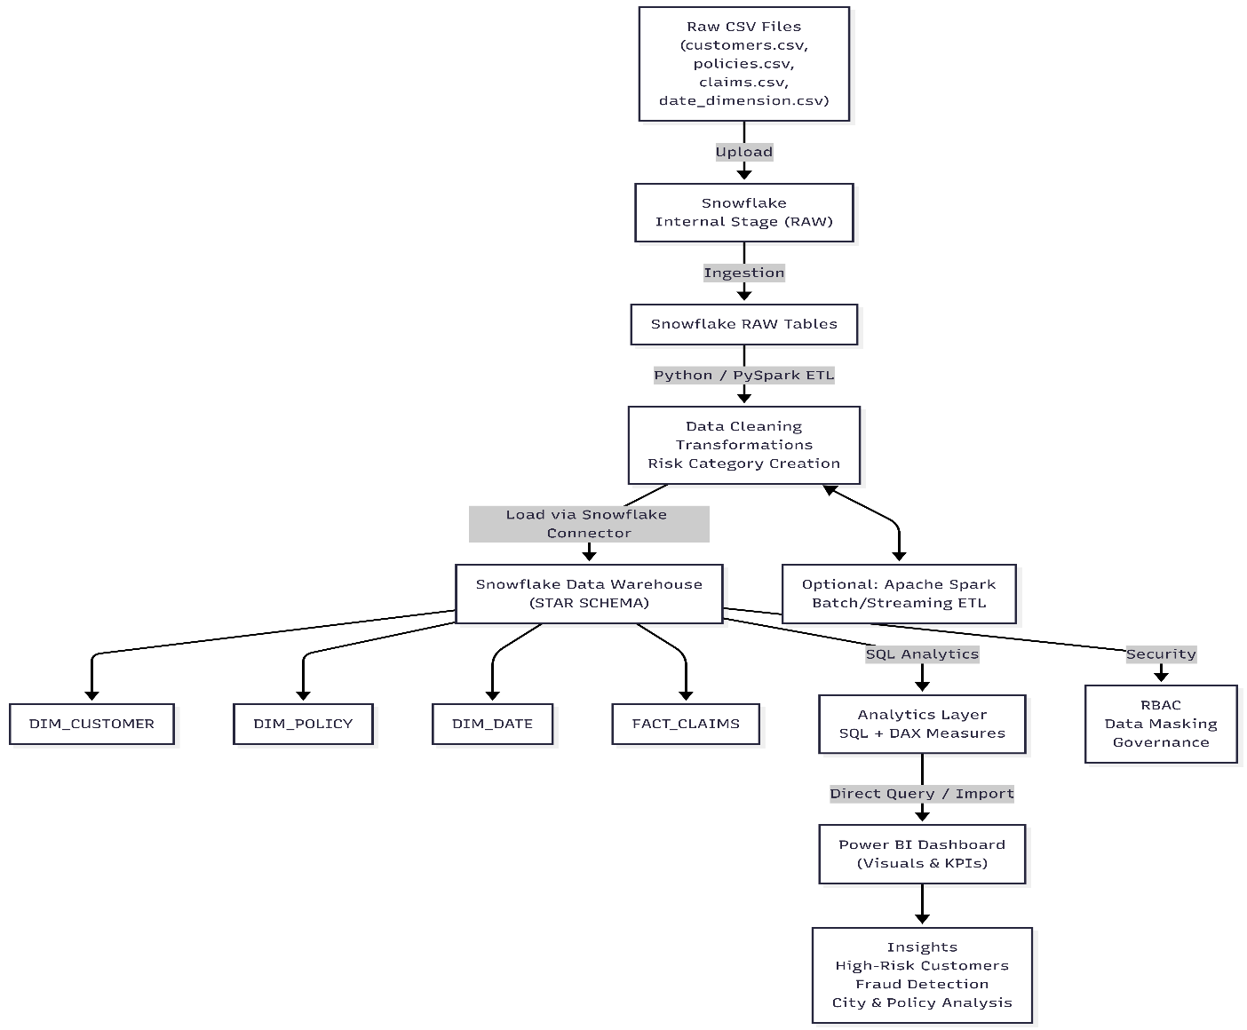

Data Warehouse Schema (STAR MODEL)
Dimensions:
- DIM_CUSTOMER
- DIM_POLICY
- DIM_DATE
Fact Table:
- FACT_CLAIMS
Relationships:
- customer_id → customer_id
- policy_id → policy_id
- date_key → incident_date_key

ETL Pipeline (Python → Snowflake)
- ETL Steps:
- Load CSV using Pandas or Spark
- Clean missing values
- Create RiskCategory based on fraud probability
- Map date_key → DIM_DATE
- Load into Snowflake RAW
- Transform + Insert into DWH tables
Technologies: Snowflake Connector, Pandas
(Code in GitHub)
Key analytical queries:
- High-risk claims (fraud_probability > 0.7)
- Monthly claims trend
- Average fraud probability per policy
- Customer risk ranking
- Premium vs claim correlation
(Queries in GitHub)

DAX Measures (Power BI)
Includes:
- HighRiskClaims
- ApprovedClaims
- RejectedClaims
- TotalClaimAmount
These measures enable interactive, dynamic analytics.
Power BI Dashboard
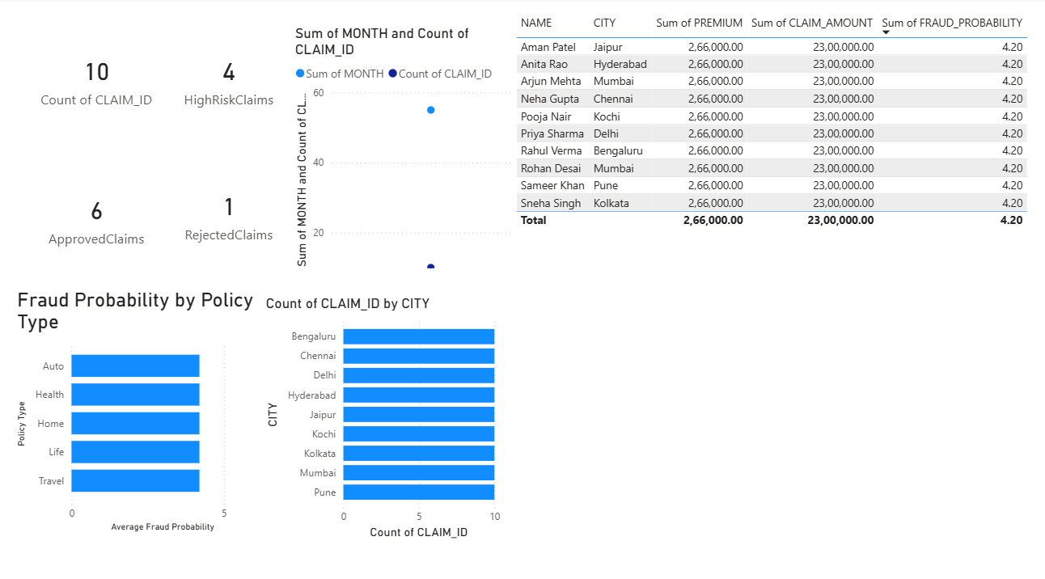Security Implementation
Security in Snowflake:
- RBAC (Role-Based Access Control):
- DATA_ENGINEER
- ANALYST
- VIEW_ONLY
- Data Masking:
- Mask customer name for low-permission roles
- Governance:
- PII tagging
- Access logs
- Ownership rules
Spark used for:
- Large-scale ETL
- Fraud risk aggregation
- Real-time streaming (future)
- Spark job example:
- Load FACT_CLAIMS from Snowflake
- Group by policy → avg(fraud_probability)
- Output risk distribution
(Outputs in GitHub)
Insights & Findings
- Auto & Health policies show higher fraud probability
- Certain cities have higher claim frequency
- Premium amount correlates with claim amount
- High-risk customers identified via FraudScore
- Trend lines show seasonal claim patterns
Future Enhancements
- Deploy Spark Streaming for real-time fraud alerts
- Build ML model for fraud classification
- Automate pipeline using Airflow or Azure Data Factory
- Deploy Power BI dashboard to service for refresh
- Add more policy & hospital datasets
Conclusion
The project successfully builds a complete:
- Modern Data Warehouse
- Automated ETL Pipeline
- High-quality BI Dashboard
- Security-hardened Snowflake environment
- Scalable Spark-compatible architecture
- This system supports real-world insurance fraud analytics and risk detection.

