An Agent-Based Model (ABM) has been designed to execute the simulation outlined in Aim 2. This model will simulate a heterogeneous population of agents with features representative of the VHA population.

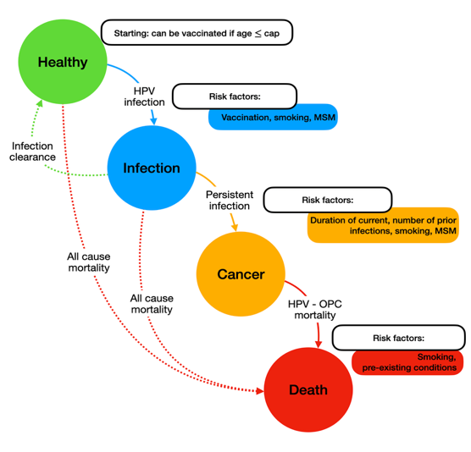
The ABM is structured around the following components:
- Agent Attributes: Each agent in the simulation is defined by key attributes, including age, vaccination status, HPV status, duration of infection, number of previous infections, and covariates such as vaccine hesitancy, smoking history, and number of sexual partners.
- Transition States: A transition diagram (see Figure 1) maps the primary pathways of interest. Agents move between health states including "Healthy," "HPV infection," "Persistent infection," "Cancer" (HPV-OPC), and "Death" (either all-cause mortality or HPV-OPC mortality).
- Risk Factors: The model is designed to simulate how high-risk factors—such as smoking, MSM status, and infection history—make transitions to infection, persistent infection, and cancer more likely.
Figure 1: Transition diagram for agent-based model, where agents move between different health states including Healthy, Infection, Cancer, and Death through cycles of the simulation.

The simulation model is functional and can achieve the goals of Aim 2.
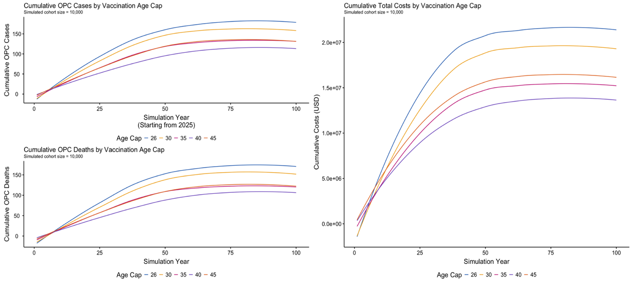
- Cost Analysis: The model tracks key outcomes associated with each scenario, including vaccination costs, OPC treatment costs, and long-term care costs.
- Scenario Comparison: As specified in Aim 2, the model is configured to run simulations comparing outcomes for different vaccination age caps, namely: 26, 30, 35, 40, and 45.
- Visualization & Initial Results: As a proof-of concept. we have generated preliminary visualizations from a simulated cohort of 10,000 agents (see Figure 2). These plots show the Cumulative OPC Cases (top left), Cumulative OPC Deaths (bottom left), and Cumulative Total Costs (right) over the simulation period, stratified by the different vaccination age caps.
Figure 2: Model outputs comparing cumulative OPC cases, OPC deaths, and total costs by vaccination age cap. The simulation compares five policy scenarios (age caps 26, 30, 35, 40, and 45) for a cohort of 10,000 agents

Next, we will calibrate this model with real VHA data. This calibration will involve integrating data on:
- Age distribution of Veterans
- Smoking prevalence
- Vaccination uptake rates by age
- HPV prevalence
- Mortality rates
- Actual VHA costs for vaccination and OPC treatment
For parameters where VHA-specific data may be unavailable, we will use national data

