Title
Drug Overdose Mortality Decline and Kidney Transplant in the US
Abstract
Background With nearly 60,000 patients dying on the organ transplant waiting lists between 2014 to 2023, organ scarcity remains a major public health crisis in the US. This crisis has been partially mitigated over the last two decades through a dramatic expansion of donor pool from drug overdose decedents (ODD). For example, drug overdose deaths were linked to 42.2% of the overall rise in deceased donations from 2009 to 2019. Recent mortality data suggests that drug overdose deaths declined by an almost 27% from 2023 to 2024, the largest year-over-year decline in multiple decades. Trends in transplants associated with ODDs during the national overdose mortality decline have not been analyzed.
Methods We used Joinpoint analysis to investigate trends in deceased donor kidney transplant rates by donor mechanisms of death from January 2015 to December 2024. Temporal association between monthly declines in ODD-associated kidney transplant rates and overdose mortality rates was analyzed through Pearson’s coefficient and ordinary least square model with Newey-West robust standard errors. To determine the downstream impact of falling ODD-associated kidney transplant rates, a segmented regression interrupted time series analysis was conducted on monthly active kidney transplant waitlist size. State level variations in relative changes in ODD-associated kidney transplant rates from 2023 to 2024 were analyzed through a random effects meta-regression analysis model.
Results ODD-associated kidney transplant rates (per million) rose at monthly percentage change (MPC) of 1.21 (95% CI, 1.11 to 1.35) between January 2015 to May 2023 following which the trend significantly reversed, and transplants declined at MPC -2.89 (95%CI, -4.47 to -1.89) thereafter. In 19 months, ODD-associated kidney transplants fell by 45.40% from their May 2023 peak. Trends of kidney transplants associated with other donor mechanisms of death remained unchanged during this period. A contemporaneous decline was also seen among ODD-associated liver and heart transplant rates, suggesting a system, rather than organ, level impact.
A strong, positive temporal association was found between monthly decline in ODD-associated kidney transplant rates and monthly decline in drug overdose death rates (Pearson’s r, 0.81 (95%CI, 0.57 to 0.92); β=0.042, p <0.001)). The active kidney transplant waitlist which had been contracting since 2015 plateaued following the ODD-associated kidney transplant decline. It changed non-significantly at a monthly rate of -0.018 (95%CI, -0.11 to 0.08) patients per million from May 2023 to December 2024.
In the state-level analysis, 33 out of 37 (89.19%) states experienced significant declines in overdose mortality rates between 2023 and 2024. During this time, 10 out of 37 (27.03%) states experienced significant ODD-associated kidney transplant rate declines with no state experiencing a significant relative increase in transplant rates. A random effects meta-regression model showed substantial between-state variance (Q = 69.45, p < 0.001; I² = 51.72%) in relative change in ODD-associated kidney transplant rates. The model revealed that states with higher baseline ODD-associated kidney transplant rates in 2023 experienced disproportionately larger relative declines in 2024 [QM= 14.39, p<0.001; R²=72.00%; I² = 22.50%)].
Conclusion The 2023-2024 national decline in drug overdose mortality was accompanied by a clinically significant decline in kidney transplant activity and a substantial downstream impact on transplant waitlist dynamics. These findings highlight paradoxical consequences of public health policy successes achieved in the overdose epidemic and underscore the vulnerability of transplant system to disruptions in donor pool. As we continue efforts in preventing overdose deaths, a simultaneous effort needs to be made in diversifying the donor pool by encouraging living donation, reducing discard rates, and promoting research in xenotransplantation.

Introduction
Organ scarcity remains a major public health crisis in the United States. From 2014 to 2023, nearly 60,000 waitlist patients died, and a similar number decompensated without getting organ transplant¹. Among patients waiting to get the most commonly transplanted organ, the kidney, the median wait time to transplant was nearly 4 years in 2021-2022². In addition to relatively low living donation rates and relatively high non-use rates, an important reason driving this crisis has been a lack of medically suitable deceased donors. For example, among the 3 million decedents in 2023³, there were 16,000 (0.53%) deceased donors⁴ while more than 100,000 patients waited on the transplant waiting lists⁵.
Over the last 2 decades, this crisis has partially been mitigated by the tragic drug overdose epidemic⁶. Drug overdose deaths have been linked to 42.2% of the overall rise in deceased donations from 2009 to 2019⁷ and drug overdose decedents (ODDs) comprised 16.6% of all deceased donors in 2023. ODDs are predominantly young adults with few comorbidities and recovered organs are associated with long graft survival- characteristics which increase their suitability for organ donation⁸. Given that a decedent may donate up to 8 major organs, the impact of increased donations from ODDs has amplified across the transplant system over the last two decades⁹.
In May 2025, predicted provisional mortality data from Center for Disease Control and Prevention (CDC)’s National Center for Health Statistics (NCHS) indicated a major year-over-year decline of nearly 27% in drug overdose deaths between 2023 and 2024-the largest such decline observed since the beginning of opioid epidemic¹⁰. Associated patterns in transplants have not been characterized. We therefore studied contemporaneous trends in the most donated and transplanted organ, the kidney.
Methods
Scientific Registry of Transplant Recipients (SRTR) standard analysis files (SAFs) (June 2025 version), database of all solid organ transplants conducted in the US, were utilized to get data on monthly kidney, liver or heart transplants from US-recovered deceased donors from January 2015 to December 2024. Puerto Rico-recovered donors and Puerto Rico-conducted transplants were excluded to maintain consistency with NCHS’ national drug overdose mortality data which excludes Puerto Rico. To estimate the state recovering a particular donor, we obtained additional data on hospitals recovering deceased donors from SRTR. This database did not contain hospital state names, so we mapped zip codes of hospitals to their states using HUD-USPS ZIP-County crosswalk files¹¹. We manually confirmed the accuracy of state estimation for known multi-state zip codes¹² by checking websites of hospitals located in these multi state zip codes.
Donor mechanisms of death information was obtained from DON_DEATH_MECH variable in SRTR DONOR_DECEASED SAF, where one donor is linked to one mechanism of death. SRTR mechanism of death “Drug Intoxication” was used as a proxy for drug overdose death^{6,7,9}.
US Census 2010 database was used for monthly US resident population estimates from January 2015 to December 2020 and US Census 2020 database was used for monthly US resident population estimates from January 2021 to December 2024. July 1, 2023 and July 1, 2024 resident population estimates for different states were obtained from US Census Bureau and used as denominators for state-level analysis.
Joinpoint regression was used to analyze trend changes and calculate monthly percentage change (MPC) in monthly transplant rates (counts per million residents) using Joinpoint Regression Program, version 5.4.0.0. A minimum of 0 and maximum of 3 joinpoints were permitted in the model to balance parsimony with ability to detect up to 4 unique trends. First order autocorrelation was estimated from data by the software. BIC3 method was used for model selection to favor a parsimonious model while optimizing computational load per recommendations of the National Cancer Institute¹³.
We utilized the NCHS predicted provisional drug overdose mortality data (available as 12-month rolling monthly counts) at national and state level to study overdose mortality trends. The finalized 2024 data was not available at the time of study. The predicted provisional data adjusts for incomplete provisional data and has historically closely approximated finalized data¹⁴. Temporal association between changes in ODD-associated transplant rates and overdose mortality rates (both measured as 12-month rolling per million) was estimated using first-differenced data through Pearson’s correlation and Ordinary Least Square (OLS) regression model with Newey-West robust standard errors (lag=1). A Ljung-Box test (lag 4) as well as ACF and PACF plots were used for residual diagnostics.
Active kidney transplant waitlist size was estimated through SRTR SAF STATHIST_KIPA file. Patients listed on pancreas only waiting list were excluded. Patients associated with status code 4010, 4050, 4060 or 5010 at any time during a month were considered as active. A unique patient was counted as active only once during a month. When active status end date was missing, patients were considered as active until censored at the end of study period.
To test if decline in ODD-associated kidney transplants impacted the active transplant waitlist size, we conducted a segmented regression interrupted time series analysis with May 2023 as the intervention time. Visual analysis revealed disruption in linear trends in preintervention period. Breakpoints in preintervention period determined through Joinpoint analysis (February 2020 and May 2020) corresponded with disruptions experienced around COVID-19 public health emergency declaration¹⁵. These breakpoints were incorporated in the model. OLS method was used to estimate slope and level changes. Newey-West estimator was used to calculate heteroscedasticity and autocorrelation-consistent robust standard errors.
For state-level analysis, we calculated 95% confidence intervals for absolute transplant and mortality rate differences from 2023 to 2024 using the delta method based on a Poisson regression model . Exact Poisson method was used to calculate 95% confidence intervals for relative rate differences in mortality and transplant rates. P values were adjusted through Benjamini-Hochberg correction. Random effects meta regression of relative change in ODD-associated transplant rates was conducted using rma function of metafor package in R to study between-state heterogeneity and study moderators. Models were fit using restricted maximum likelihood method. For a test of moderator, states were categorized into Organ Procurement and Transplant Network regions (OPTN) regions¹⁶. Among states which are parts of more than one OPTN region, the state of Virginia was categorized in region 11 and the state of Ohio, in Region 10.
Statistical analyses were done in SPSS (IBM) and R Studio, v.2025.05.1+513 (Posit). Two-tailed P value < 0.05 was considered significant. Large language models helped in generating statistical code and improving clarity in manuscript.
Results
Between January 2015 to December 2024, among a total of 176,086 deceased donor kidney transplants, 29,525 (16.77%) kidney transplants were associated with ODDs, 30,256 (17.18%) kidney transplants with cardiovascular deaths, 35,294 (20.04%) kidney transplants with blunt injury deaths, 38,027 (21.60%) kidney transplants with stroke or intracranial hemorrhage deaths, 15987 (9.08%) kidney transplants with gunshot wound deaths and 26,997 (15.33%) kidney transplants with all other mechanisms of death. ODD-associated kidney transplant rates (per million residents) increased from January 2015 to May 2023 at a monthly percentage change (MPC) of 1.21 (95% CI, 1.11 to 1.35) following which the trend significantly reversed, and transplant rates declined at MPC -2.89 (95%CI, -4.47 to -1.89) until December 2024. Overall, in a span of 19 months, ODD-associated kidney transplant rates fell by approximately 45.40% from their May 2023 peak. In contrast, rates of kidney transplants associated with remaining mechanisms of death remained unchanged in direction as well as slope and rose throughout study. Rates (per million residents) of kidney transplants associated with cardiovascular deaths increased at MPC 0.66 (95% CI, 0.60 to 0.73), with blunt injury deaths increased at MPC 0.21 (95% CI, 0.08 to 0.35), with stroke/ICH deaths increased at MPC 0.28 (95% CI, 0.22 to 0.33), with gunshot wound deaths increased at MPC 0.12 (95% CI, 0.05 to 0.19), and with other mechanisms of deaths increased at MPC 0.56 (95% CI, 0.48 to 0.65) (Figure 1)
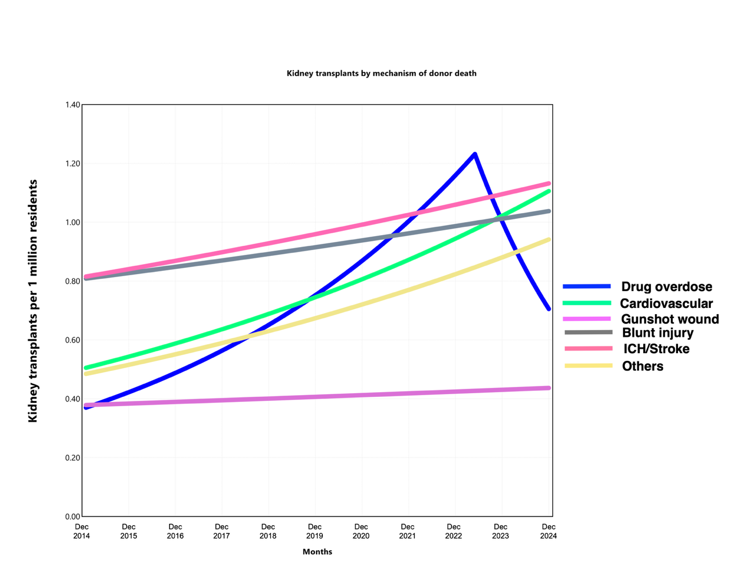

In a sensitivity analysis, to test if the phenomenon was limited to kidney transplants, we analyzed trends in ODD-associated liver and heart transplants. ODD-associated liver transplant rates (per million residents) rose from Jan 2015 to June 2016 at MPC 2.95 (95% CI, 1.12 to 11.67) and then at MPC 0.77 (95%CI, 0.53 to 0.91) until Aug 2023. The trend significantly reversed thereafter, and transplant rates fell at MPC -2.44 (95%CI, -4.62 to -1.15). Similarly, after rising at MPC 1.25 (95% CI, 1.15 to 1.40) from Jan 2015 to July 2023, ODD-associated heart transplant rates (per million residents) declined at MPC -2.64 (95%CI, -4.52 to -1.46) until December 2024 (Figure 2). This suggested that the decline in transplants from overdose decedents was felt system wide. Further analyses were done among kidney transplants given that kidney is the most transplanted organ and patients with end stage kidney disease comprise a majority of candidates on transplant waiting lists.
Given the magnitude of decline among ODD-associated kidney transplants and lack of other major policy shocks in 2023, we asked if the transplant decline was correlated with decreases in overdose mortality. From May 2023 to December 2024, a strong temporal association was observed between monthly change in ODD-associated kidney transplant rates and monthly change in drug overdose death rates (both measured as first differences of 12-month rolling rates per million) (Pearson’s r, 0.81 (95%CI, 0.57 to 0.92)). Linear regression with Newey-West standard errors revealed that for every 100 (per million) fewer overdose deaths, 4.17 (per million) fewer ODD-associated kidney transplants took place (β=0.042; p <0.001). Uncorrelated residuals were revealed in ACF and PACF plots as well as through Ljung Box test (p= 0.21)

(Need to exclude Puerto Rico listed candidates ) We hypothesized that a decline in a major donor pool would have downstream consequences. We therefore examined contemporaneous changes in the transplant waitlist size when ODD-associated kidney transplants declined. For this we conducted an interrupted time series analysis of monthly active kidney transplant waitlist size with May 2023 as intervention point (identified from Figure 1). During the preintervention period, the active kidney transplant waitlist size had been declining. It changed at a monthly rate of -0.15 (95%CI, -0.21 to -0.093) patients (per million) from January 2015 to February 2020, experienced inflections around COVID public health emergency declaration¹⁵ and then declined again at monthly rate of -0.91 (95% CI, -1.03 to -0.79) patients (per million) from May 2020 until May 2023 (intervention). In May 2023, concurrent with decline in ODD-associated kidney transplants, the active waitlist size experienced a significant increase in level by 3.35 patients (per million) (p=0.013) and in monthly slope by 0.89 patients (per million) (p<0.001). Following this inflection, trend in active waitlist size plateaued with a nonsignificant monthly slope of -0.018 (95% CI: -0.11 to 0.08) patients (per million ) from May 2023 to December 2024 (Figure 3).

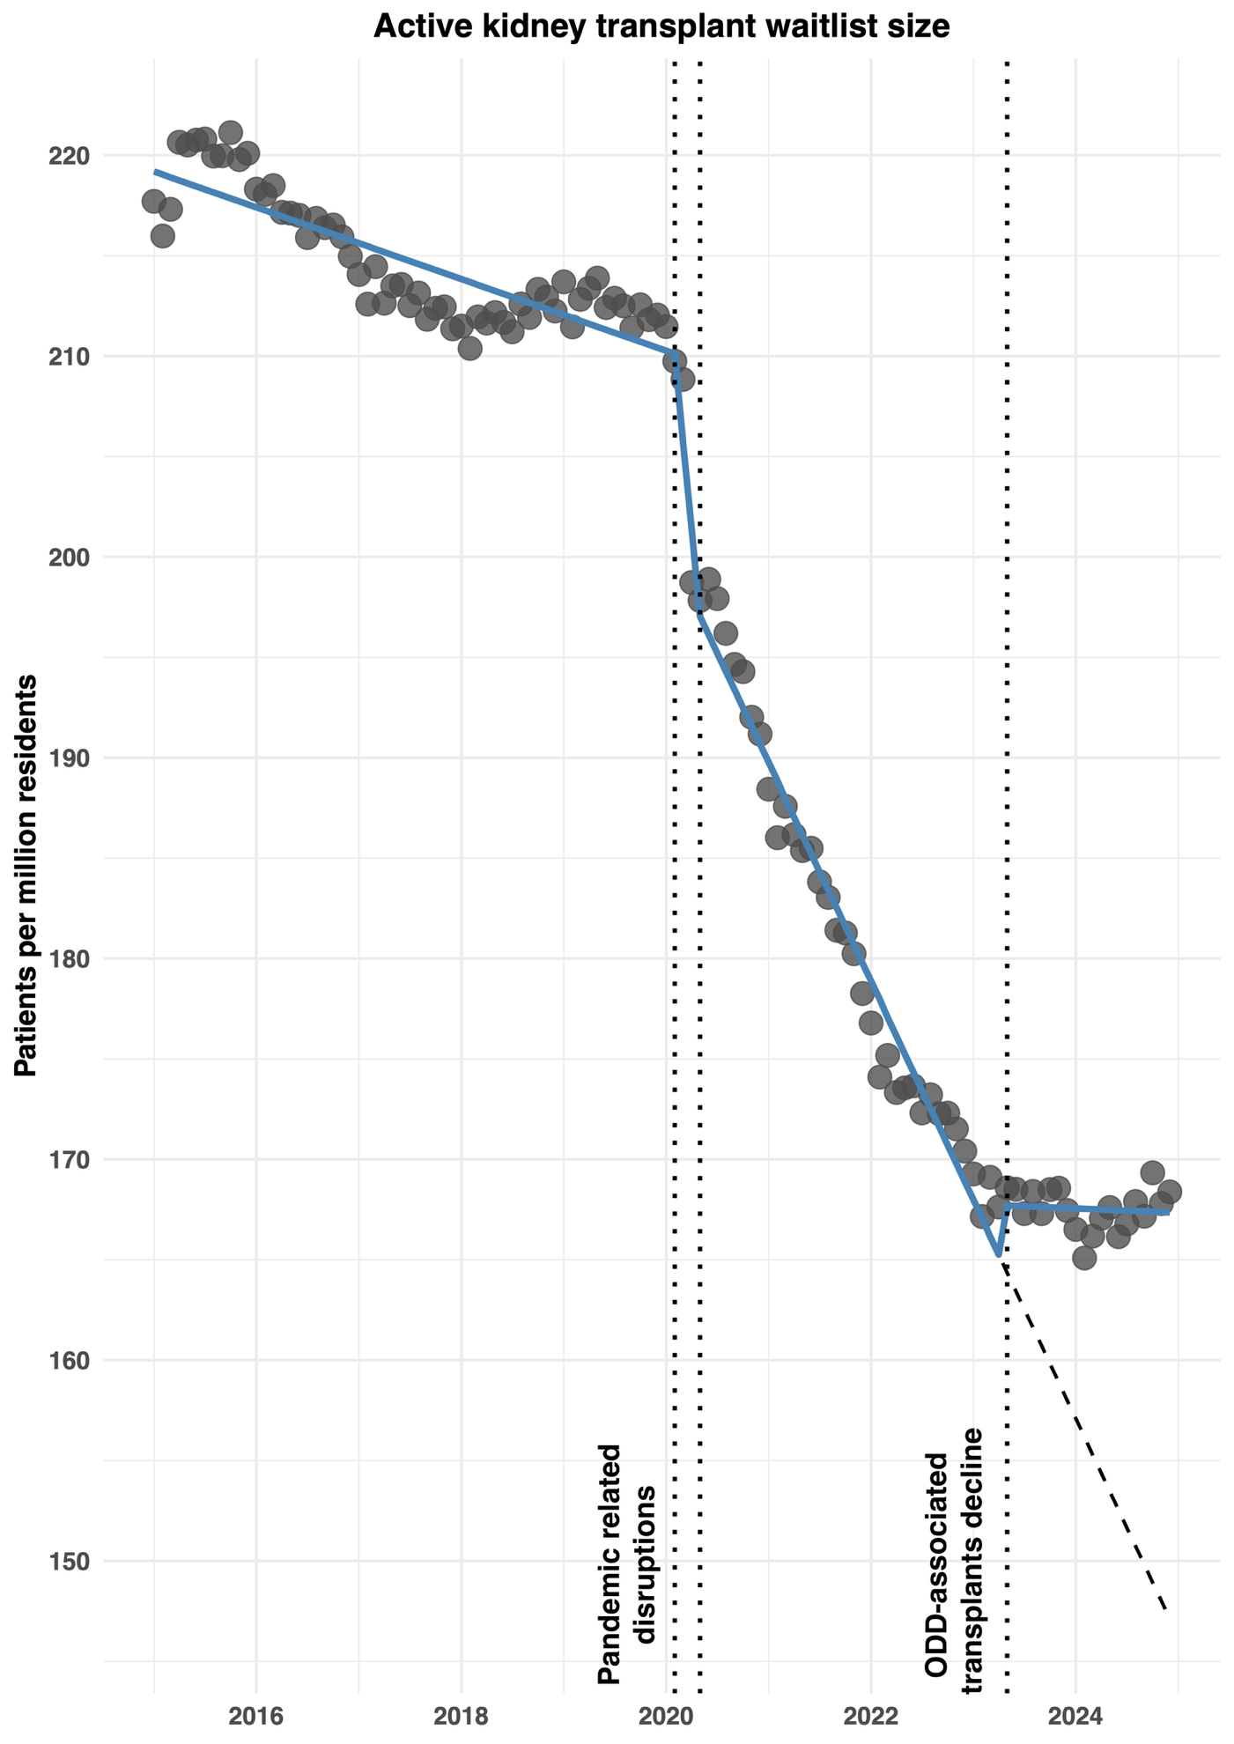

US states signficantly differ in the degree to which they have been impacted by the drug overdose epidemic¹⁷. Additionally, there exists a marked between-state variation in transplant infrastructure¹⁸ ¹⁹. We, therefore, examined the distribution of national decline in ODD-associated kidney transplants among US states from 2023 to 2024- a time period when most states concurrently saw overdose mortality declines¹⁰.
37 states, each with at least 10 ODD-associated kidney transplants in 2023 and 2024, were included in this analysis. Between 2023 to 2024, 33 out of 37 (89.19%) states experienced significant OD mortality rate declines whereas only 10 out of 37 (27.03%) states saw significant declines in ODD-associated kidney transplant rates. Notably, no state saw a significant increase in the transplant rates (Figure 3A, 3B, Supplementary figures ) .
The 10 states experiencing significant declines in ODD-associated kidney transplants contained major population centers and spanned the geographical breadth of the country. These included California [absolute change (transplants per million) -2.54 (95%CI, -4.07 to -1.01) , relative change (%) -19.21 (95%CI, -29.13 to -7.94], Florida [absolute change -4.86 (95% CI, -6.84 to -2.88, relative change -34.17 (95% CI, -44.78 to -21.63], New York [absolute change -6.28 (95%CI, -8.96 to -3.61), relative change -29.11 (95%CI, -39.01 to -17.67)], Pennsylvania [absolute change -4.28 (95%CI, -7.07 to- 1.49), relative change -27.84 (95%CI, -42.13 to -10.19)], Illinois [absolute change, -6.56 (95%CI,-9.82 to -3.30), relative change -31.55(95% CI, -43.67 to -16.97) ] and Ohio [absolute change -10.47 (95%CI, -14.03 to -6.92) , relative change -42.41 (95% CI, -52.64 to -30.16) ]
We specified a random effects meta regression model to explain between-state heterogeneity in relative changes in ODD-associated transplant rates. The baseline model confirmed substantial heterogeneity (Q = 69.45, p < 0.001; I² = 51.72% ). We, therefore, tested several moderators. A state’s relative overdose mortality rate decline (proxy for the local supply shock in 2024) was not a significant moderator of heterogeneity (QM= 2.79, p= 0.095; R²=9.47%; I² = 48.91% ). Similarly, a state’s OPTN region (geography in the transplant system) did not significantly explain the heterogeneity (QM= 8.33, p= 0.60, R²=0.00%, I² = 45.60%), However, a state’s baseline ODD-associated transplant rates in 2023 moderated a substantial amount of between-state variation (QM= 14.39, p<0.001; R²=72.00%; I² = 22.50%) with no significant residual heterogeneity remaining (QE= 46.17, p = 0.098) This suggested that states performing more ODD-associated transplants in 2023 experienced disproportionately larger relative declines in ODD-associated transplant rates from 2023 to 2024 suggesting an increased sensitivity to the systemic shock (Figure 4) .

Discussion
This study highlights the unintended consequences of recent public health successes achieved in curbing drug overdose epidemic. The historic decline in drug overdose deaths was accompanied by nearly 45% reduction in kidney transplants from overdose decedents nationally. Consequently, the active kidney transplant waitlist which had been shrinking, also plateaued for the first time in a decade. Further, this national decline in ODD-associated transplants was distributed heterogeneously among US states. States which utilized this donor pool more were disproportionately more vulnerable to decline.
Over the last two decades, the tragic drug overdose crisis has paradoxically mitigated the organ scarcity crisis. Between 2000 and 2016, while the numbers of trauma decedent donors grew at an annual rate of 1.6%, those of overdose donors rose at 17%⁹ . This led to a concurrent increase in their proportion in the overall deceased donor pool from 1.1% to 12.7%. As our data shows, in May 2023, ODDs contributed to nearly one in five deceased donor kidney transplants nationally. Since many other donor deaths may also be partially attributable to drug overdoses, their impact is likely higher⁷.
Given their relatively young age, lack of major chronic comorbidities and higher rates of anoxic brain injury, kidneys recovered from ODDs are associated with relatively low kidney donor profile index (KDPI) scores (where lower KDPI scores are associated with higher graft survival rates)⁸. At the same time, due to higher association of ODDs with CDC-defined high-risk behavior, the expansion of this donor pool has also been accompanied by a concurrent rise in transplant of hepatitis C virus antibody positive organs and increased discard rates. Consequently, as the ODD donor pool shrinks, the proportion of younger, deceased-after-brain death donors is expected to decline, potentially impacting median graft survival rates among kidney transplant recipients in the long term. Due to the life prolonging nature of solid organ transplants, the sudden contraction of a major donor pool may be expected to lead to increased wait list mortality among patients with end stage liver disease and end stage heart failure, at least in the short term .
This study highlights differential vulnerability of different transplant systems to similar systemic shocks. Between 2023 and 2024, US states either saw a significant year-over-year decline or no change in ODD-associated transplant rates with no state experiencing significant increases . A state’s baseline exposure to ODD donor pool (i.e. its ODD-associated transplant rate in 2023), but neither its geography nor the local overdose mortality rate changes it experienced, drove 72% of between-state variations in transplant rate changes in 2024. As an example, Ohio and Pennsylvania, two bordering states with large Appalachian regions, have both been significantly impacted by the overdose crisis²⁰. These states have experienced some of the highest overdose mortality rates in the country and saw comparative mortality declines from 2023 to 2024. Despite similar geography and overdose mortality patterns, Ohio’s higher baseline reliance on the ODD pool (24.70 vs 15.36 ODD-associated transplants (per million) in 2023) rendered it uniquely more vulnerable to transplant declines in 2024 (-42.41 vs -27.84%) as compared to Pennsylvania. This is analogous to highly leveraged ecological or economic systems, which by the virtue of their exposure are also more sensitive in times of systemic shock. As ongoing efforts are made in preventing overdose deaths, these vulnerable states may need to urgently diversify donor pools and reduce discard rates to mitigate transplant declines.
Our study has a few limitations. Donor mechanism of death is coded during the recovery process and there remains a possibility of misclassification. A single mechanism of death, as provided in the registry, may underestimate the multiple potential mechanisms involved in a patient’s death. The finalized overdose mortality data for 2024 was not available at the time of this study and therefore, this analysis utilized NCHS’ predicted provisional overdose mortality data which may vary from finalized tables. Finally, this study didn’t analyze trends in donation from overdose deaths associated with unique classes of substances.
This study underscores an urgent need to diversifying and expanding the organ donor pool while preventing overdose mortality. Utilization of extended criteria and donation after cardiac death donors and adaption of ex-vivo perfusion systems for preservation of recovered organs have significantly driven rise in organ transplants recently and these should be encouraged. Nonuse rates of recovered kidneys remained as high as 27.9% in 2023⁴ and adoption of stricter evidence-based criteria before discarding organs must be implemented. Living donation has been associated with decrease in transplant waitlist mortality for the recipients and minimal long-term risks for the donors but living donation rates continue to remain relatively low in the US . This suggests an area of unmet potential that could be addressed through increase in public awareness. Finally, recent breakthroughs in xenotransplantation of genetically modified kidneys are encouraging and advancements in this field have the potential to significantly address organ scarcity crisis in the long term.

References
1. Network OP and T. National Data: U.S. Organ Procurement and Transplantation Network. 2025. https://optn.transplant.hrsa.gov/data/view-data-reports/national-data/
2. Stewart D, Mupfudze T, Klassen D. Does anybody really know what (the kidney median waiting) time is? Am J Transplant. 2023;23(2):223-231. doi:10.1016/j.ajt.2022.12.005
3. Ahmad F, Rossen LM, Spencer MR, Warner M, Sutton PD. Provisional Drug Overdose Death Counts — United States, January 2022–December 2023. Morbidity and Mortality Weekly Report. 2024;73(31):653-657.
4. Israni AK, Zaun DA, Martinez A, et al. OPTN/SRTR 2023 Annual Data Report: Deceased Organ Donation. American Journal of Transplantation. 2025;25(2):S490-S517. doi:10.1016/j.ajt.2025.01.026
5. Schladt DP, Israni AK. OPTN/SRTR 2023 Annual Data Report: Introduction. American Journal of Transplantation. 2025;25(2):S11-S21. doi:10.1016/j.ajt.2025.01.019
6. Dickert-Conlin S, Elder T, Lemont B, Teltser K. Opioids and Organs: How Overdoses Affect the Supply and Demand for Organ Transplants. American Journal of Health Economics. 2024;10(4):505-538. doi:10.1086/726002
7. Zehner A, Martinez C, Stewart D, Klassen D. Estimating the drug overdose epidemic’s impact on organ donation in the United States: An epidemiologic analysis of transplant registry data. Accessed July 3, 2025. https://apha.confex.com/apha/2021/meetingapp.cgi/Paper/496592
8. Chute DF, Sise ME. Effect of the Opioid Crisis on the Donor Pool for Kidney Transplantation: An Analysis of National Kidney Deceased Donor Trends from 2010–2016. American Journal of Nephrology. 2018;47(2):84-93. doi:10.1159/000486516
9. Durand CM, Bowring MG, Thomas AG, et al. The Drug Overdose Epidemic and Deceased-Donor Transplantation in the United States: A National Registry Study. Ann Intern Med. 2018;168(10):702-711. doi:10.7326/M17-2451
10. National Center for Health Statistics. Provisional drug overdose deaths declined nearly 27 percent between 2023 and 2024 — National Center for Health Statistics press release.https://www.cdc.gov/nchs/pressroom/nchs_press_releases/2025/20250514.htm. July 3, 2025.
11. Development (HUD) USD of H and U. HUD USPS ZIP Code Crosswalk Files. https://www.huduser.gov/portal/datasets/usps_crosswalk.html
12. Horton AP. Zip Codes, ZCTAs and ZCTAs that Cross State Boundaries. Peter Horton. December 30, 2022. Accessed July 7, 2025. https://peter-horton.com/2022/12/30/zip-codes-zctas-and-zctas-that-cross-state-boundaries/
13. How Joinpoint Selects the Final Model. Joinpoint Help System. Accessed July 7, 2025. https://surveillance.cancer.gov/help/joinpoint/setting-parameters/method-and-parameters-tab/model-selection-method
14. Products - Vital Statistics Rapid Release - Provisional Drug Overdose Data. June 3, 2025. Accessed July 7, 2025. https://www.cdc.gov/nchs/nvss/vsrr/drug-overdose-data.htm
15. Miller J, Wey A, Valapour M, et al. Impact of COVID-19 pandemic on the size of US transplant waiting lists. Clinical Transplantation. 2022;36(5):e14596. doi:10.1111/ctr.14596
16. Regions - OPTN. Accessed July 8, 2025. https://optn.transplant.hrsa.gov/about/regions/
17. Lindner SR, Hart K, Manibusan B, McCarty D, McConnell KJ. State- and County-Level Geographic Variation in Opioid Use Disorder, Medication Treatment, and Opioid-Related Overdose Among Medicaid Enrollees. JAMA Health Forum. 2023;4(6):e231574-e231574. doi:10.1001/jamahealthforum.2023.1574
18. King KL, Husain SA, Mohan S. Geographic Variation in the Availability of Deceased Donor Kidneys per Wait-Listed Candidate in the United States. Kidney Int Rep. 2019;4(11):1630-1633. doi:10.1016/j.ekir.2019.08.018
19. Patzer RE, Pastan SO. Kidney transplant access in the Southeast: view from the bottom. Am J Transplant. 2014;14(7):1499-1505. doi:10.1111/ajt.12748
20. Understanding the Opioid Crisis in Appalachia. Accessed July 8, 2025. http://overdosemappingtool.norc.org/

