Soumil Jha
CSE
1032240083

Spotify Interface – Critical Analysis

Critical Analysis of Spotify Interface

Spotify is a popular music and audio streaming application. The application provides access to songs, albums, playlists, artists, and podcasts. Although Spotify has a visually attractive and modern interface, some aspects of its interface design can be improved to provide a better user experience.

1. Learnability

Spotify has good learnability because a first-time user can easily identify the Home, Search, and Library sections. Familiar icons such as the play, pause, next, and previous buttons make the application easy to understand. However, features such as Smart Shuffle, Jam, and playlist enhancement options may not be immediately clear to new users.
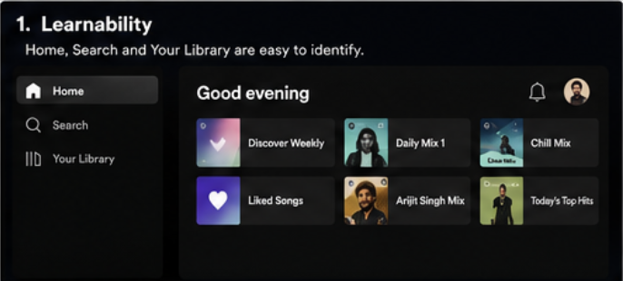

2. Usability

The application is generally easy to use for searching and playing music. Users can quickly search for songs, artists, albums, and podcasts. However, the large number of recommendations displayed on the Home screen can make it difficult to find recently played or desired content quickly.
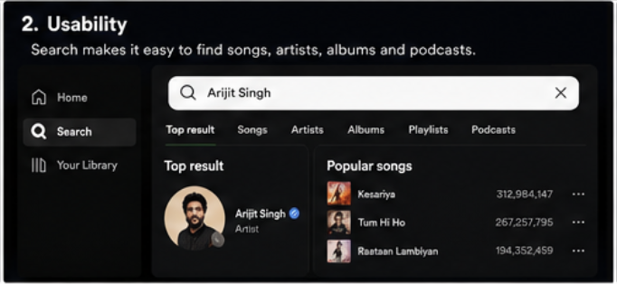
3. Consistency

Spotify maintains a consistent dark theme, typography, icon style, and card-based layout throughout the application. The green accent colour is used consistently for important actions. However, some controls and options change depending on whether the user is viewing a playlist, album, or podcast.
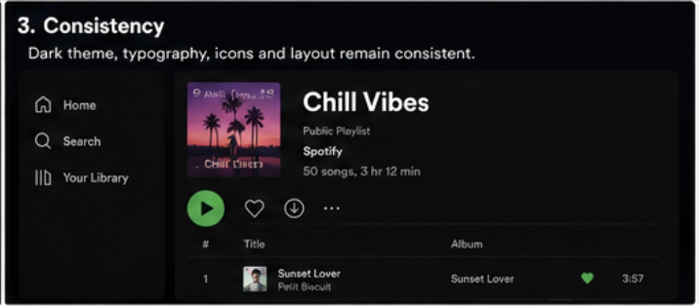

4. Use of Metaphors

Spotify uses familiar metaphors such as a magnifying glass for search, a house for Home, a plus symbol for adding content, and standard media player controls. These metaphors help users understand the functions without additional instructions.
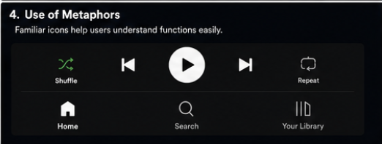

5. Navigation Structure

The main navigation structure is simple and organised around Home, Search, and Your Library. However, navigating through playlists, podcasts, audiobooks, and recommendations within the same application can sometimes feel crowded.
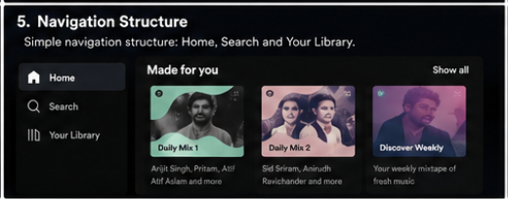

6. Visual Hierarchy

Album covers, playlist images, and large headings are used effectively to attract user attention. The currently playing content is also clearly visible. However, excessive recommendation sections on the Home page can reduce the importance of frequently used content.


7. Accessibility

Spotify provides readable text, clear icons, and support for accessibility features. However, the dark interface and smaller secondary text may create readability problems for some users. Some icon-only controls may also require familiarity with the application.
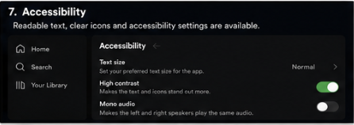

8. Responsiveness

The interface adapts well to mobile phones, tablets, and desktop screens. The layout changes according to screen size while maintaining similar functionality and visual identity.
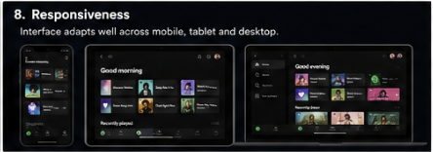

9. Efficiency of Interaction

Common actions such as playing, pausing, liking, and searching for music require very few steps. Quick access to recently played content improves efficiency. However, managing the Library and finding specific downloaded content can require additional navigation.
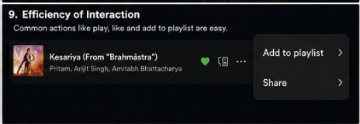

10. Feedback and System Status

Spotify provides clear feedback through progress bars, loading indicators, download icons, and changes in play or pause controls. The currently playing song is clearly highlighted. These elements help users understand the current system status.
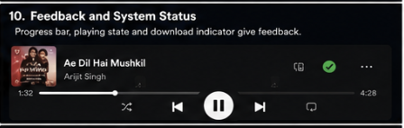

11. Error Prevention and Recovery

Users can easily undo actions such as removing and re-adding songs to playlists. However, accidental playlist modifications can occur, and some actions do not provide an immediate undo option.
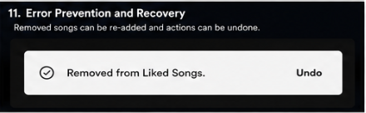

12. Aesthetic and Minimalist Design

Spotify has a modern and attractive design. The dark theme allows album artwork to stand out. However, the Home page can appear cluttered because of multiple recommendation categories and promotional content.
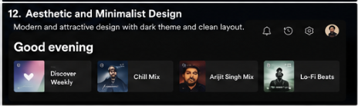

13. Content Readability

The application uses readable fonts and clear headings. Song names and artist names are visually separated. However, long song or podcast titles may be shortened, requiring users to open the content to view complete information.
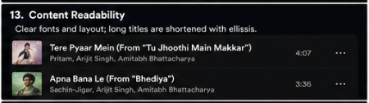

14. Search and Discoverability

Spotify has a powerful search function and provides category-based browsing and personalized recommendations. However, the mixing of music, podcasts, and other audio content can sometimes reduce discoverability.
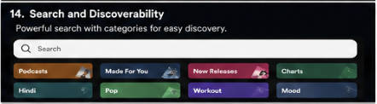

15. Performance Perception

Smooth animations, immediate playback controls, and loading indicators create a perception of good performance. Album artwork and recommendations generally load progressively.


16. Trust and Credibility

Spotify has a professional and consistent interface. Clear account and subscription sections increase user trust. Privacy and account settings are also available to users.


17. Personalization

Personalization is one of Spotify’s strongest features. Daily Mixes, Discover Weekly, personalised playlists, and listening recommendations are based on user behaviour and
Preferences.


18. User Satisfaction

Overall, Spotify provides an enjoyable and efficient user experience. Its major strengths are personalization, search, and familiar controls. The main improvement required is reducing Home screen clutter and simplifying the organisation of different types of audio content.



Shneiderman’s Golden Rules Analysis:

Spotify follows consistency through uniform colours and controls. It provides informative feedback for playback and downloads and reduces short-term memory load through recommendations and listening history. However, the application could improve universal usability by making advanced features more understandable and could provide easier reversal for accidental playlist actions.

Conclusion:

Spotify has a well-designed and user-friendly interface with strong personalization and familiar interaction patterns. However, excessive recommendations and the combination of music, podcasts, and other audio content can make the interface feel cluttered. A more customisable Home screen and clearer separation of content categories could improve the overall user experience.

