K means clustering – Pros – Works the same way on higher dimensional data
Cons – Need to know the number of clusters before applying algorithm

Step 1) Define k clusters
Step 2) Initialize centroids
Centroid is the centre of cluster, we randomly assume k centroids
Step 3) Assign cluster
Find Euclidian distance of each point with centroids and whichever distance is lowest, the point is assigned to that centroid’s cluster.
Step 4) Move centroids
Move the centroids about the new clusters by taking the mean of all the points about all axis in each clusters to get the new centroids.

Now keep repeating step 3 and step 4 till the centroids are the same as the previous step

Metric used: Euclidian Distance – Can be used in 2D, 3D……ND.
Method to find number of clusters: Elbow method
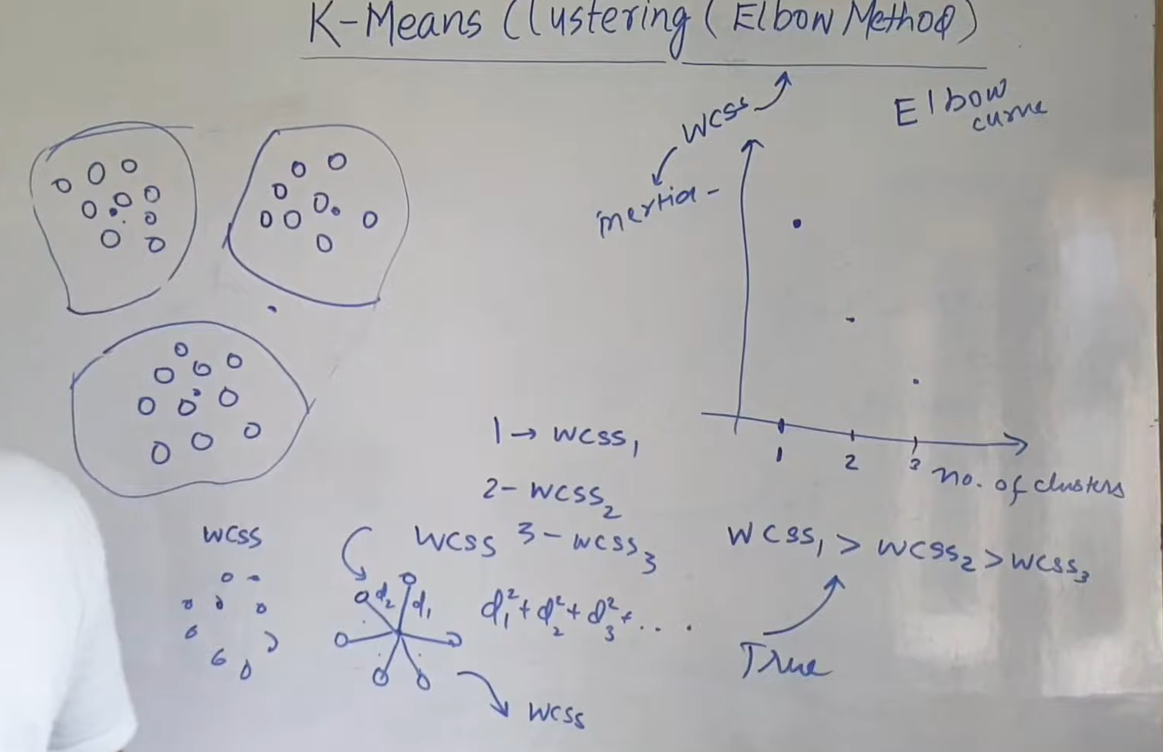
WCSS = within cluster sum of square – sum of squares of distance between centroid and all points of cluster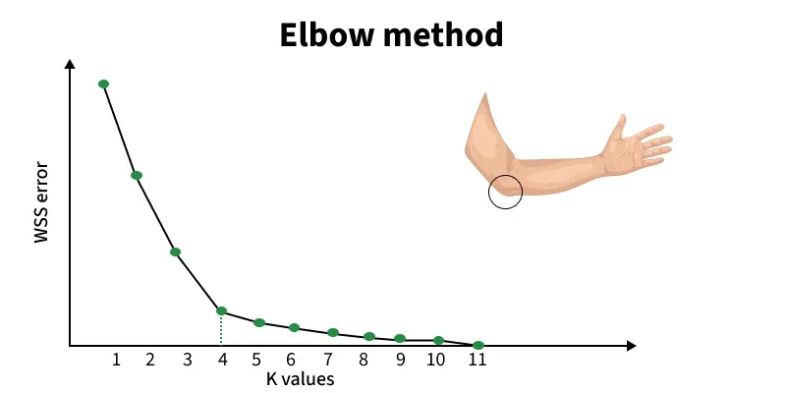
Here 4 clusters optimal.
Geometric intuition – since WCSS decreases rapidly from 1 to 2, 2 to 3, 3 to 4. Making 1,2,3,4 clusters was very beneficial. But since WCSS decreases slowly from 5,6,7,8… making more than 4 clusters is less beneficial.

Centroid initialization methods: random initialization, K-means++ (ensuring they are well-spread across the dataset), Naive Sharding (This deterministic method sorts the data based on a composite summation value and then splits it into k shards)

K means metrics: WCSS and silhouette score (The Silhouette Score is a metric used to evaluate the quality of clusters in a clustering algorithm. It measures how similar a sample is to its own cluster compared to other clusters. The score ranges from -1 to 1, where a higher score indicates better-defined clusters)

K means uses: image compression, data segmentation etc

K means is sensitive to outliers and assumes clusters to be spherical.

Support Vector Machine Algorithm - used for classification/regression (Supervised learning algorithm)
It tries to find the best boundary known as hyperplane that separates different classes in the data.
The main goal of SVM is to maximize the margin between the two classes. The larger the margin the better the model performs on new and unseen data.
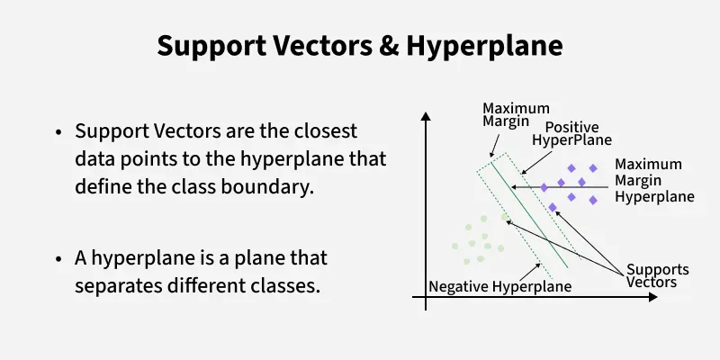

Hyperplane: wx+b = 0 in linear classification, its the decision boundary
Support vectors: closest points to the hyperplane, determines hyperplane and margin
Margin: The distance between the hyperplane and the support vectors.
Kernel: A function that maps data to a higher-dimensional space enabling SVM to handle non-linearly separable data.
Hard Margin: A maximum-margin hyperplane that perfectly separates the data without misclassifications. (end result/ideal ) (best hyperplane)
Soft Margin: Allows some misclassifications by introducing slack variables, balancing margin maximization and misclassification penalties when data is not perfectly separable.
C: A regularization term balancing margin maximization and misclassification penalties. A higher C value forces stricter penalty for misclassifications. (maybe a metric?)
- High C value = Narrower margin = overfitting
- Low C value = Wider margin = underfitting
- 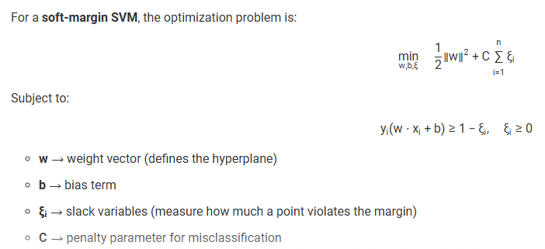
Hinge Loss: A loss function penalizing misclassified points or margin violations and is combined with regularization in SVM. (loss function) (another metric)
- If point correctly classified and within margin = no loss
- If point is incorrectly classified or violates the margin the hinge loss increases proportionally to the distance of the violation.
- 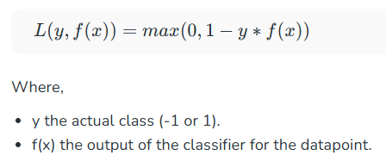

SVM is robust to outliers (it ignores the outliers)

The SVM optimizes the following equation to balance margin maximization and penalty minimization:

When data is not linearly separable i.e it can't be divided by a straight line, SVM uses a technique called kernels to map the data into a higher-dimensional space where it becomes separable. This transformation helps SVM find a decision boundary even for non-linear data.
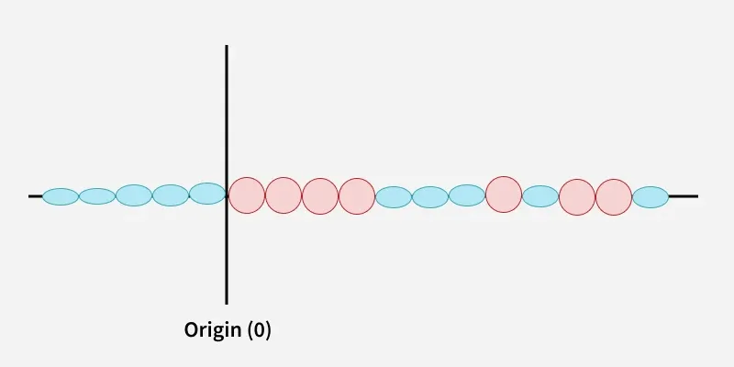
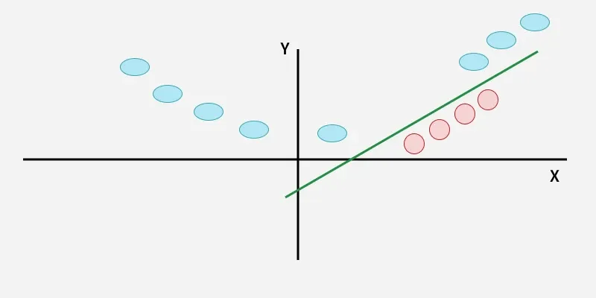
Kernel types:
- Linear Kernel: For linear separability.
- Polynomial Kernel: Maps data into a polynomial space.
- Radial Basis Function (RBF) Kernel: Transforms data into a space based on distances between data points.
Advantages of Support Vector Machine (SVM)
- High-Dimensional Performance: SVM excels in high-dimensional spaces, making it suitable for image classification and gene expression analysis.
- Nonlinear Capability: Utilizing kernel functions like RBF and polynomial SVM effectively handles nonlinear relationships.
- Outlier Resilience: The soft margin feature allows SVM to ignore outliers, enhancing robustness in spam detection and anomaly detection.
- Binary and Multiclass Support: SVM is effective for both binary classification and multiclass classification suitable for applications in text classification.
- Memory Efficiency: It focuses on support vectors making it memory efficient compared to other algorithms.
Disadvantages of Support Vector Machine (SVM)
- Slow Training: SVM can be slow for large datasets, affecting performance in SVM in data mining tasks.
- Parameter Tuning Difficulty: Selecting the right kernel and adjusting parameters like C requires careful tuning, impacting SVM algorithms.
- Noise Sensitivity: SVM struggles with noisy datasets and overlapping classes, limiting effectiveness in real-world scenarios.
- Limited Interpretability: The complexity of the hyperplane in higher dimensions makes SVM less interpretable than other models.
- Feature Scaling Sensitivity: Proper feature scaling is essential, otherwise SVM models may perform poorly.

DBSCAN Clustering - Performs well with arbitrary shaped clusters, noise and outliers
DBSCAN is a density-based clustering algorithm that groups data points that are closely packed together and marks outliers as noise based on their density in the feature space. It identifies clusters as dense regions in the data space separated by areas of lower density. Unlike K-Means or hierarchical clustering which assumes clusters are compact and spherical
Metrics/Key Parameters in DBSCAN
1. eps: This defines the radius of the neighborhood around a data point. If the distance between two points is less than or equal to eps they are considered neighbors. A common method to determine eps is by analyzing the k-distance graph. Choosing the right eps is important:
- If eps is too small most points will be classified as noise.
- If eps is too large clusters may merge and the algorithm may fail to distinguish between them.
2. MinPts: This is the minimum number of points required within the eps radius to form a dense region. A general rule of thumb is to set MinPts >= D+1 where D is the number of dimensions in the dataset.
For most cases a minimum value of MinPts = 3 is recommended.

Steps in the DBSCAN Algorithm
- Identify Core Points: For each point in the dataset count the number of points within its eps neighborhood. If the count meets or exceeds MinPts mark the point as a core point.
- Form Clusters: For each core point that is not already assigned to a cluster create a new cluster. Recursively find all density-connected points i.e points within the eps radius of the core point and add them to the cluster.
- Density Connectivity: Two points a and b are density-connected if there exists a chain of points where each point is within the eps radius of the next and at least one point in the chain is a core point. This chaining process ensures that all points in a cluster are connected through a series of dense regions.
- Label Noise Points: After processing all points any point that does not belong to a cluster is labeled as noise.
DBSCAN | K-Means
In DBSCAN we need not specify the number of clusters. | It is very sensitive to the number of clusters (k), which must be specified in advance.
Clusters formed in DBSCAN can be of any arbitrary shape. | Clusters formed are spherical or convex in shape
It can work well with datasets having noise and outliers | It does not work well with outliers data. Outliers can skew the clusters in K-Means to a very large extent.
In DBSCAN two parameters are required for training the Model | In K-Means only one parameter is required is for training the model

Decision Trees: Decision trees use hyperplanes which run parallel to any one of the axis to cut your data into hypercuboids. No need for feature scaling/ normalization in decision trees
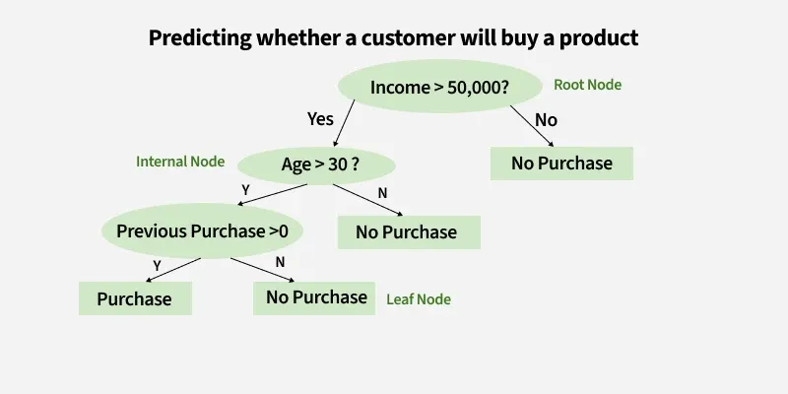
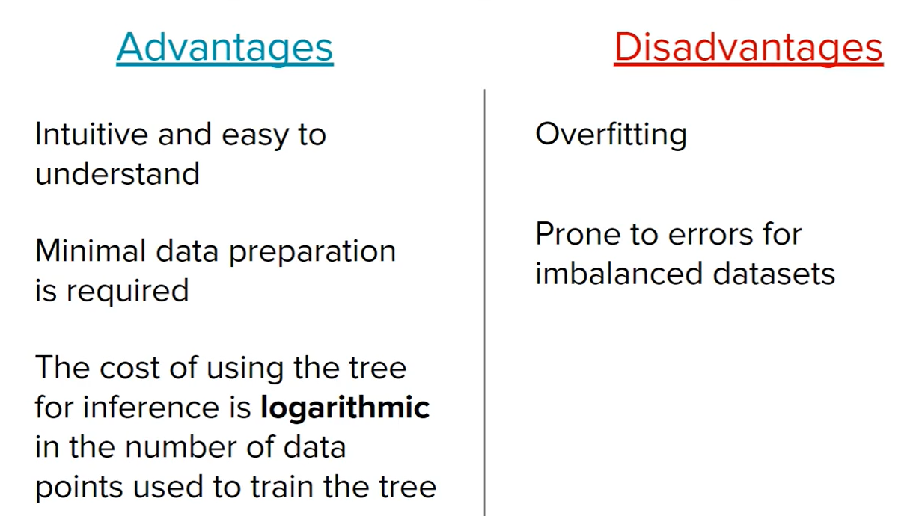
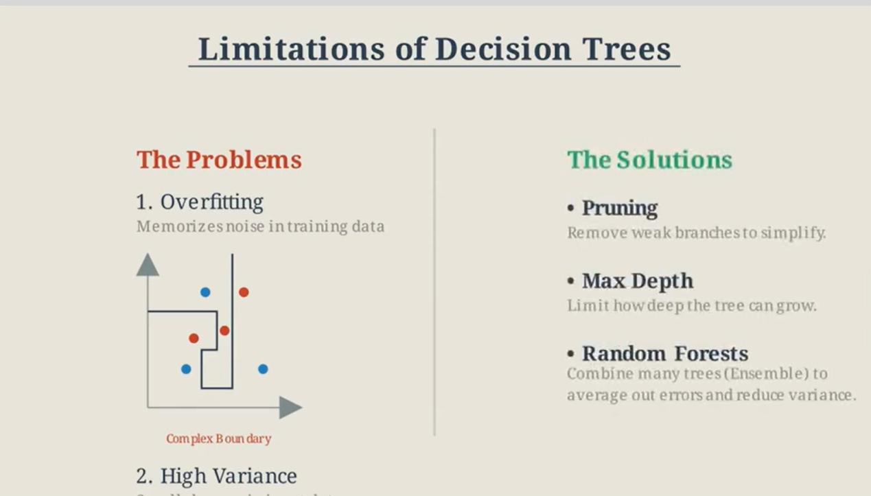
Decision trees mostly used for classification but can be used in regression trees (CART – Classification and Regression Trees).
Ex: Akinator

Decision Trees metrics:
1) Entropy: It is the measure of uncertainty of a random variable it characterizes the impurity of an arbitrary collection of examples. The higher the entropy more the information content (logarithmic time complexity)
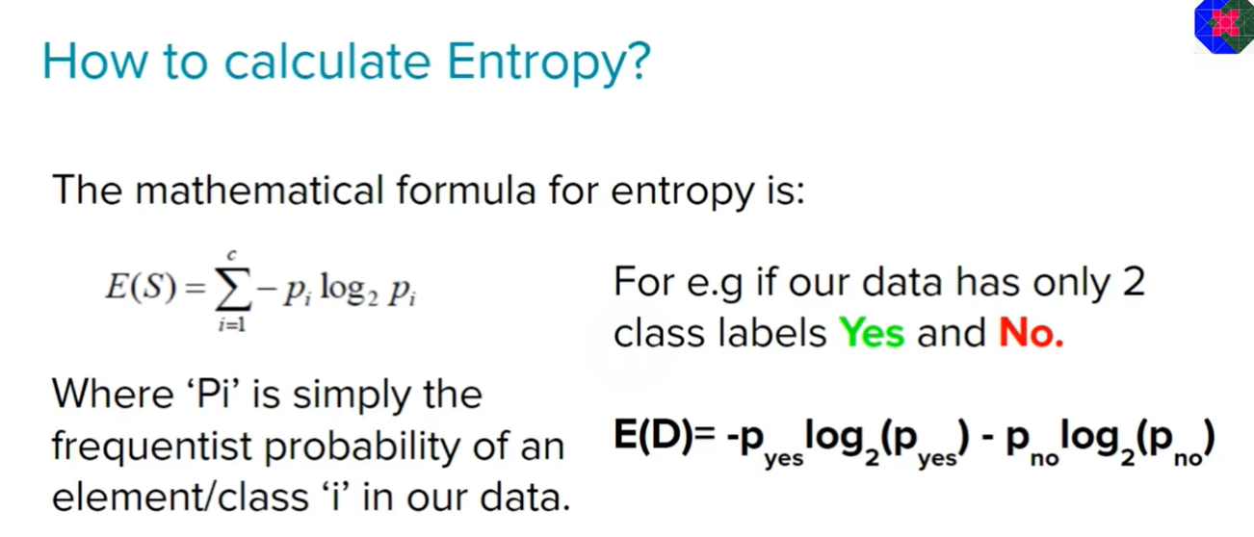
Both log base e and log base 2 can be used to calculate entropy
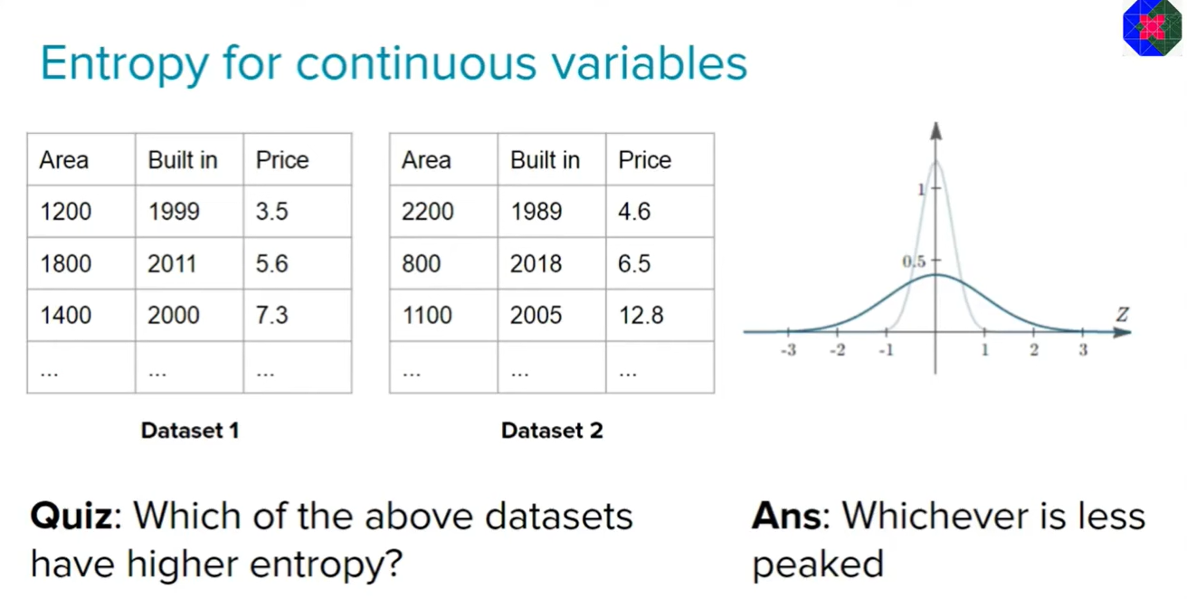

2) Information Gain: Information Gain tells us how useful a question (or feature) is for splitting data into groups. It measures how much the entropy decreases after the split. A good question will create clearer groups and the feature with the highest Information Gain is chosen to make the decision.

Benefit of using GINI Impurity over entropy: computationally faster since entropy has logarithmic calculations, however in certain data sets entropy gives balanced tree whereas gini impurity overfits.

3) (hyperparameter) Max depth: If max depth is none, then tree will overfit and if max depth is small (like 1) data will underfit (overfitting will work well with training data but perform poorly on testing data)

Steps in Decision Trees;
Step 1. Start with the Whole Dataset
We begin with all the data which is treated as the root node of the decision tree.
Step 2. Choose the Best Question (Attribute)
Pick the best question to divide the dataset. For example ask: "What is the outlook?"
Possible answers: Sunny, Cloudy or Rainy.
Step 3. Split the Data into Subsets
Divide the dataset into groups based on the question:
- If Sunny go to one subset.
- If Cloudy go to another subset.
- If Rainy go to the last subset.
Step 4. Split Further if Needed (Recursive Splitting)
For each subset ask another question to refine the groups. For example If the Sunny subset is mixed ask: "Is the humidity high or normal?"
- High humidity → "Swimming".
- Normal humidity → "Hiking".
Step 5. Assign Final Decisions (Leaf Nodes)
When a subset contains only one activity, stop splitting and assign it a label:
- Cloudy → "Hiking".
- Rainy → "Stay Inside".
- Sunny + High Humidity → "Swimming".
- Sunny + Normal Humidity → "Hiking".
Step 6. Use the Tree for Predictions
To predict an activity follow the branches of the tree. Example: If the outlook is Sunny and the humidity is High follow the tree:
- Start at Outlook.
- Take the branch for Sunny.
- Then go to Humidity and take the branch for High Humidity.
- Result: "Swimming".
Core Mechanism for Numerical Data
The primary mechanism involves recursive binary splitting, a top-down, greedy approach. At each node, the algorithm considers all available numerical features and their possible threshold values to find the "best" split.
- Identify Candidate Split Points: For a given numerical feature, the algorithm typically sorts the unique values. The midpoints between adjacent values are then considered as potential thresholds (split points).
- Evaluate Split Quality: For each potential split point, the algorithm calculates how well it separates the data into homogeneous (pure) subsets. The measure of purity or impurity depends on the task:
  - Classification: Uses metrics like Gini impurity or Information Gain (based on entropy) to maximize the homogeneity of class labels in the resulting child nodes.
  - Regression: Uses metrics like Mean Squared Error (MSE) or variance reduction to minimize the prediction error in the resulting child nodes.
- Select the Best Split: The algorithm chooses the feature and its corresponding threshold that yield the best result (e.g., maximum information gain or minimum MSE). This optimal split becomes the current node's decision rule (e.g., "Temperature <= 35.5").
- Recurse and Build Sub-trees: The process is repeated for each resulting child node with its respective subset of data. This continues until a stopping criterion is met, such as reaching a maximum tree depth, a minimum number of samples per leaf, or when no split provides a significant gain in purity.

XGBOOST – Extreme gradient boosting framework – library which uses several weak decision trees to predict classification (random forest) but features parallel processing/scalability etc

Random Forests:
Random Forest is a machine learning algorithm that uses many decision trees to make better predictions. Each tree looks at different random parts of the data and their results are combined by voting for classification or averaging for regression which makes it as ensemble learning technique (Ensemble learning combines multiple machine learning models (base learners) to produce a single, more accurate, and robust prediction than any individual model). This helps in improving accuracy and reducing errors.
Working of Random Forest Algorithm
- Create Many Decision Trees: The algorithm makes many decision trees each using a random part of the data. So every tree is a bit different.
- Pick Random Features: When building each tree it doesn’t look at all the features (columns) at once. It picks a few at random to decide how to split the data. This helps the trees stay different from each other.
- Each Tree Makes a Prediction: Every tree gives its own answer or prediction based on what it learned from its part of the data.
- Combine the Predictions: For classification we choose a category as the final answer is the one that most trees agree on i.e majority voting and for regression we predict a number as the final answer is the average of all the trees predictions.
- Why It Works Well: Using random data and features for each tree helps avoid overfitting and makes the overall prediction more accurate and trustworthy.

Principal Component Analysis (Used in data compression)
PCA (Principal Component Analysis) is a dimensionality reduction technique and helps us to reduce the number of features in a dataset while keeping the most important information. It changes complex datasets by transforming correlated features into a smaller set of uncorrelated components. It helps us to remove redundancy, improve computational efficiency and make data easier to visualize and analyze.


Variance measures a single variable's data spread from its mean (how volatile it is), while covariance measures how two variables change together, indicating if they move in the same (positive) or opposite (negative) directions

Advantages of Principal Component Analysis
- Multicollinearity Handling: Creates new, uncorrelated variables to address issues when original features are highly correlated.
- Noise Reduction: Eliminates components with low variance enhance data clarity.
- Data Compression: Represents data with fewer components reduce storage needs and speeding up processing.
- Outlier Detection: Identifies unusual data points by showing which ones deviate significantly in the reduced space.
Disadvantages of Principal Component Analysis
- Interpretation Challenges: The new components are combinations of original variables which can be hard to explain.
- Data Scaling Sensitivity: Requires proper scaling of data before application or results may be misleading.
- Information Loss: Reducing dimensions may lose some important information if too few components are kept.
- Assumption of Linearity: Works best when relationships between variables are linear and may struggle with non-linear data.
- Computational Complexity: Can be slow and resource-intensive on very large datasets.
- Risk of Overfitting: Using too many components or working with a small dataset might lead to models that don't generalize well.

