Convolution Operator example with vertical edge detection:
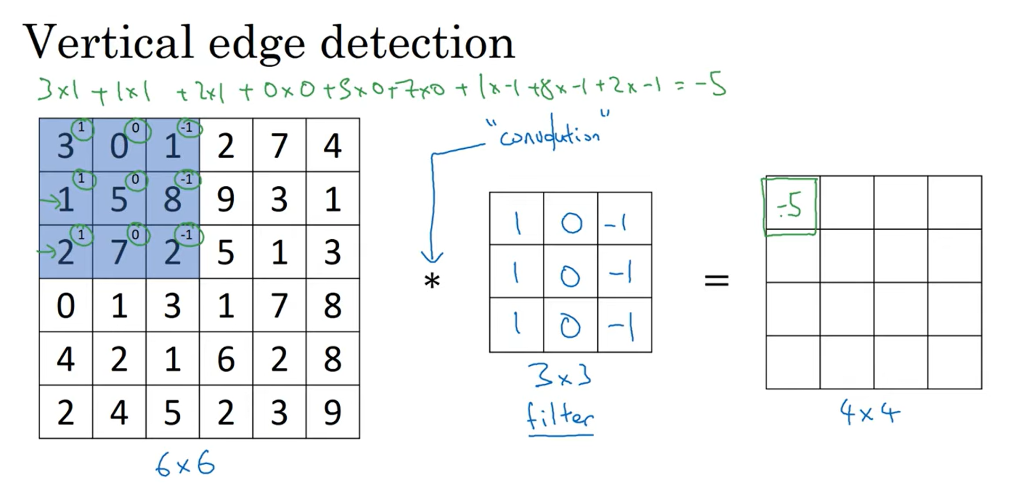
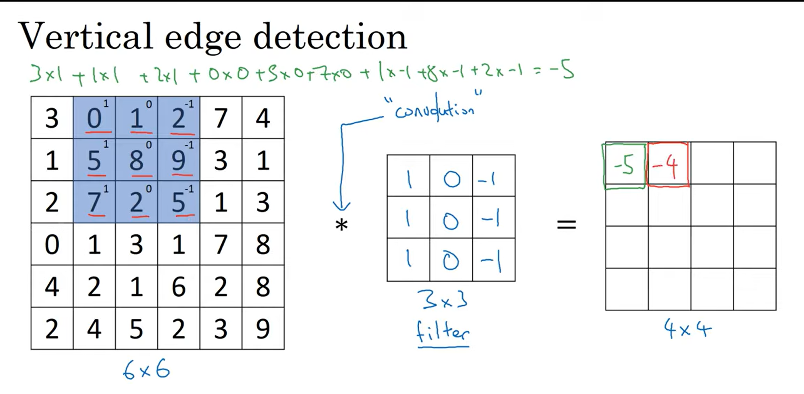
And so on…
(6,6)_{image(grayscale)} convolved (3,3)_{filter} = (4,4)_{image(grayscale)}

Working:
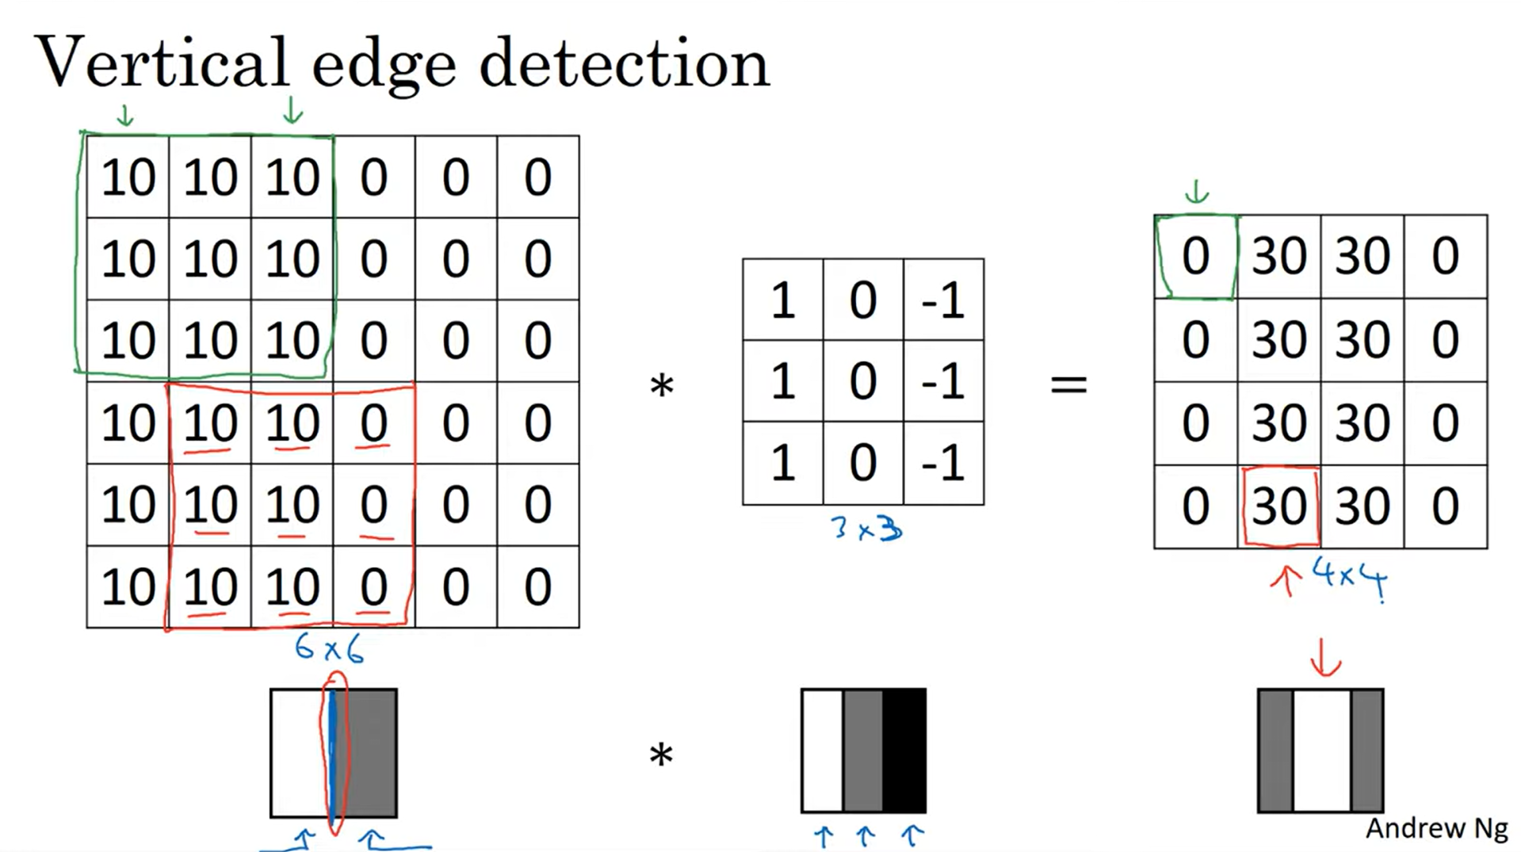
(6,6) matrix shows the image with the vertical edge, on applying the filter we get the image where the edges have higher values and rest have lower values.
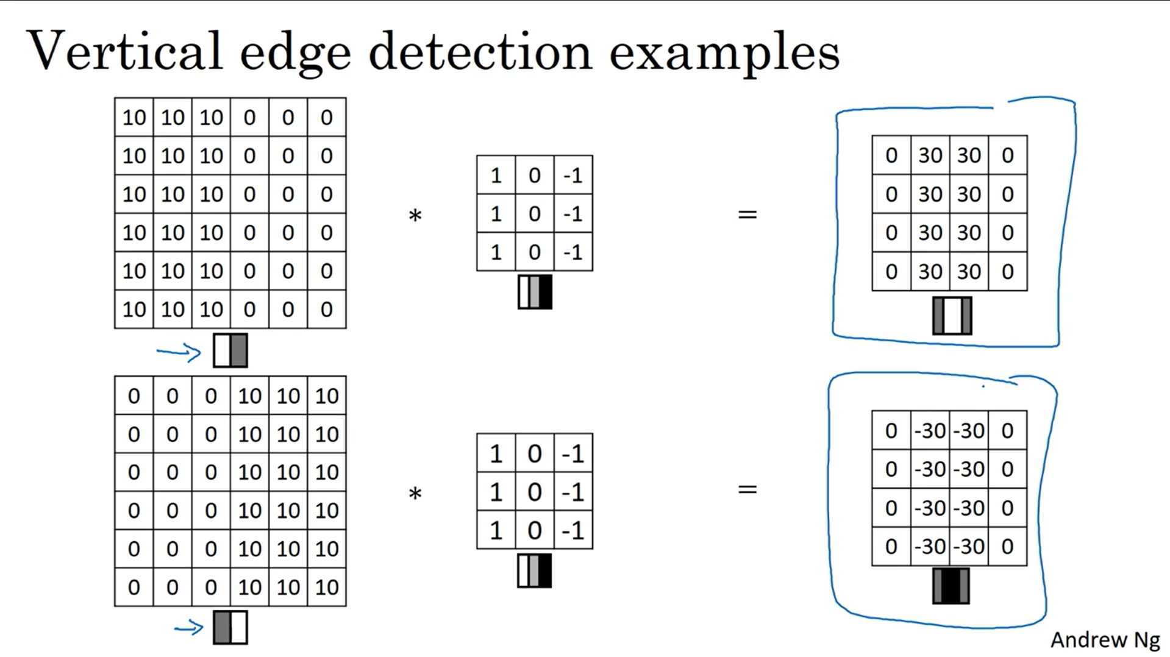
In this example since filter is left to right , the image has negative values on the edges. But we can take absolute values.
Horizontal Edge detection
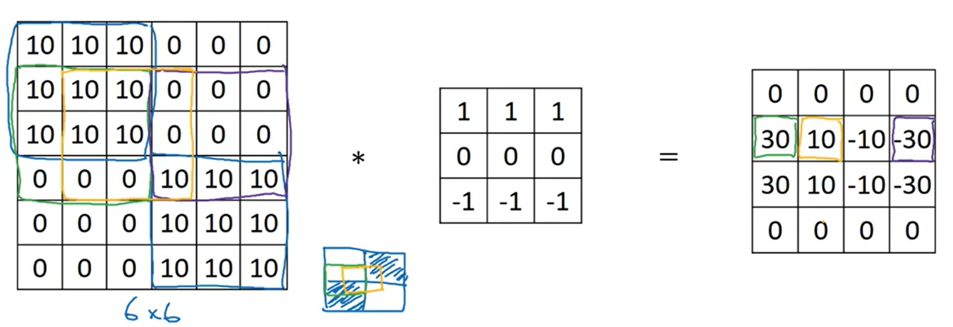
Sobel and Schorr Filter for vertical Edge detection
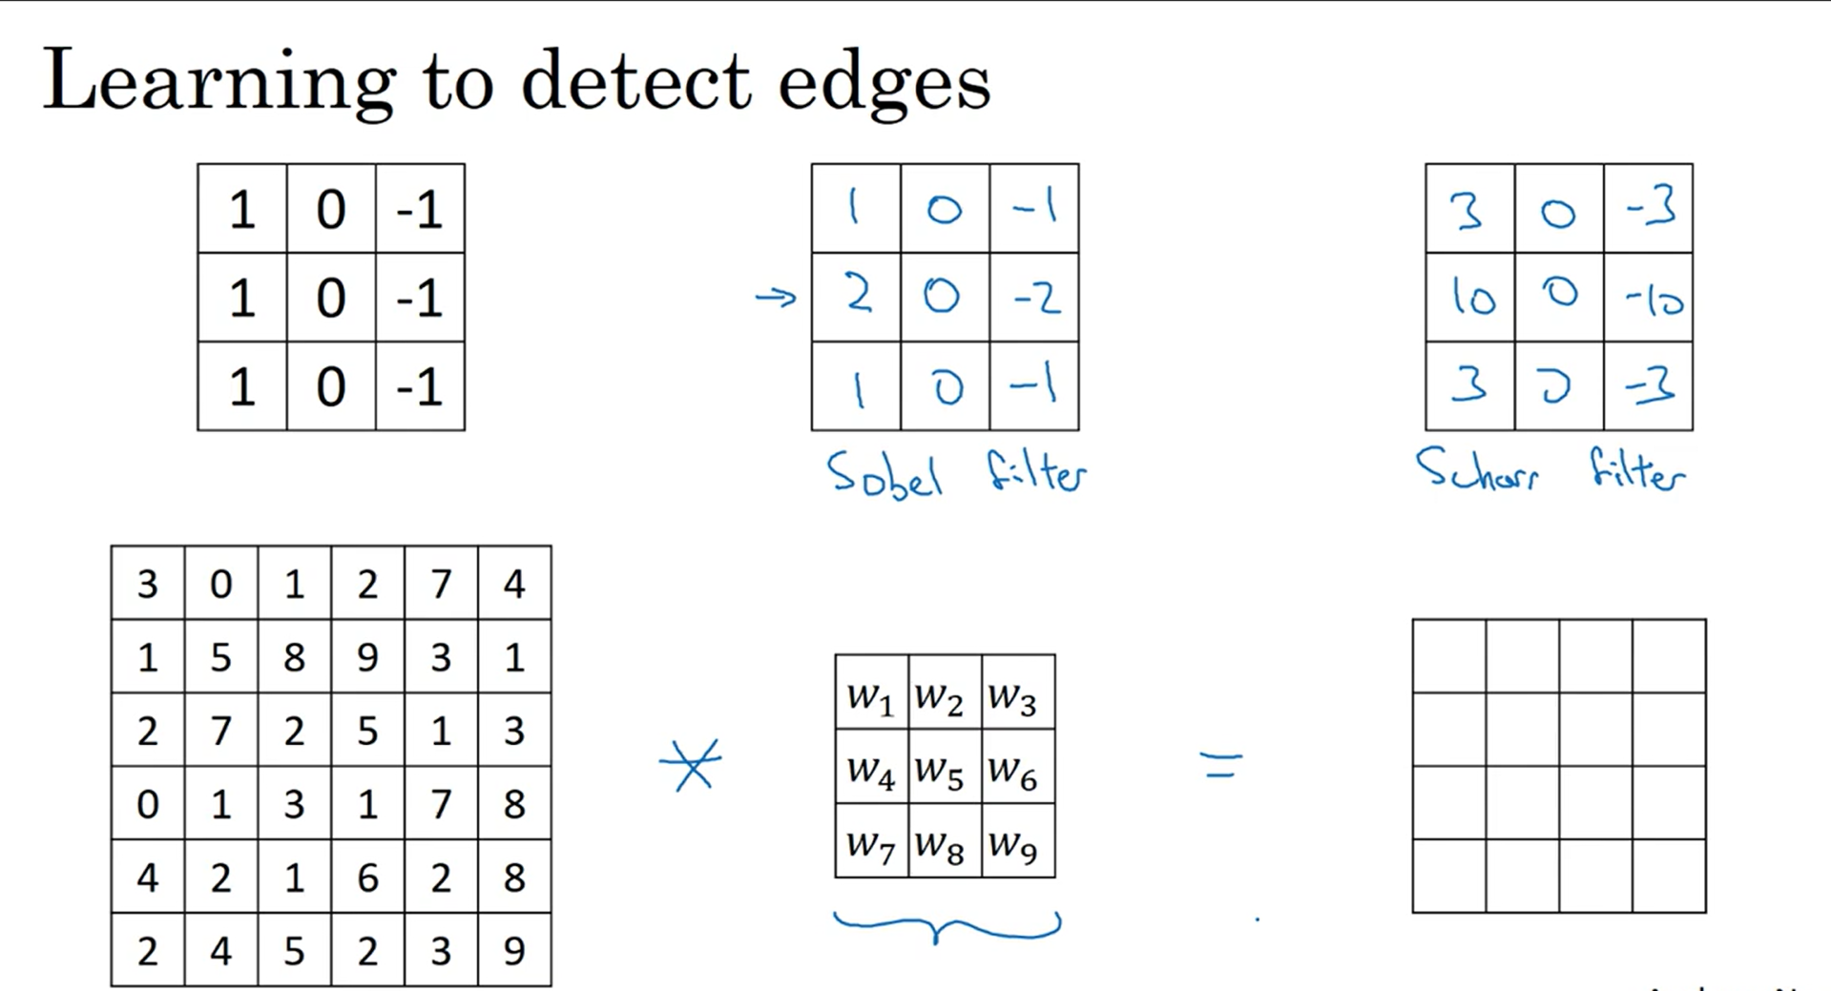

Laplacian Kernel:
Laplacian filter is a second-order derivative filter used in edge detection, in digital image processing. In 1st order derivative filters, we detect the edge along with horizontal and vertical directions separately and then combine both. But using the Laplacian filter we detect the edges in the whole image at once.
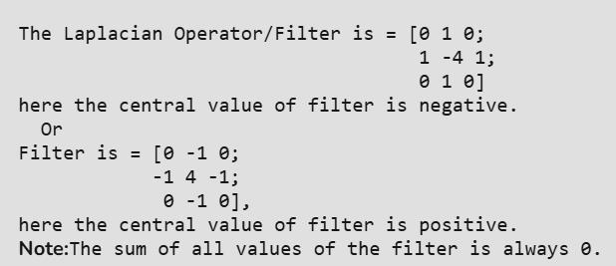

Dimension of output image (filter causes image to shrink and information on the edges is lost)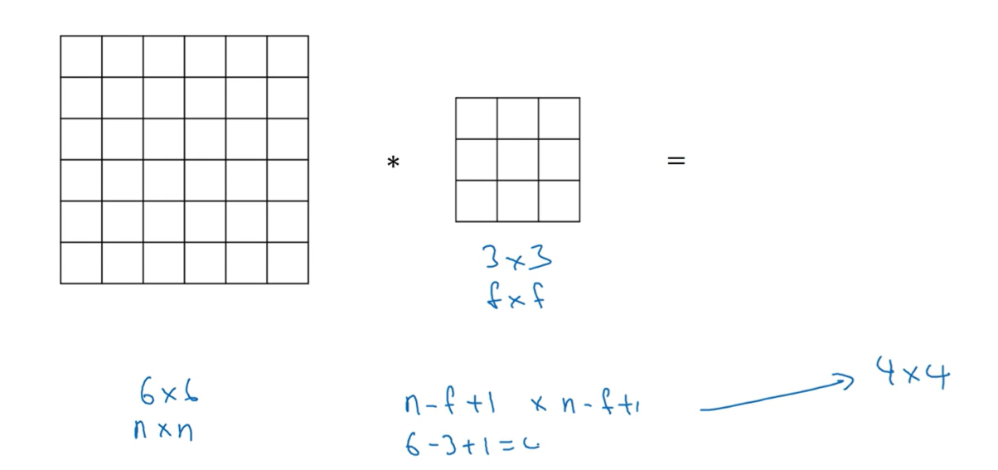

To prevent loss of information and image shrinking we use padding

Padding
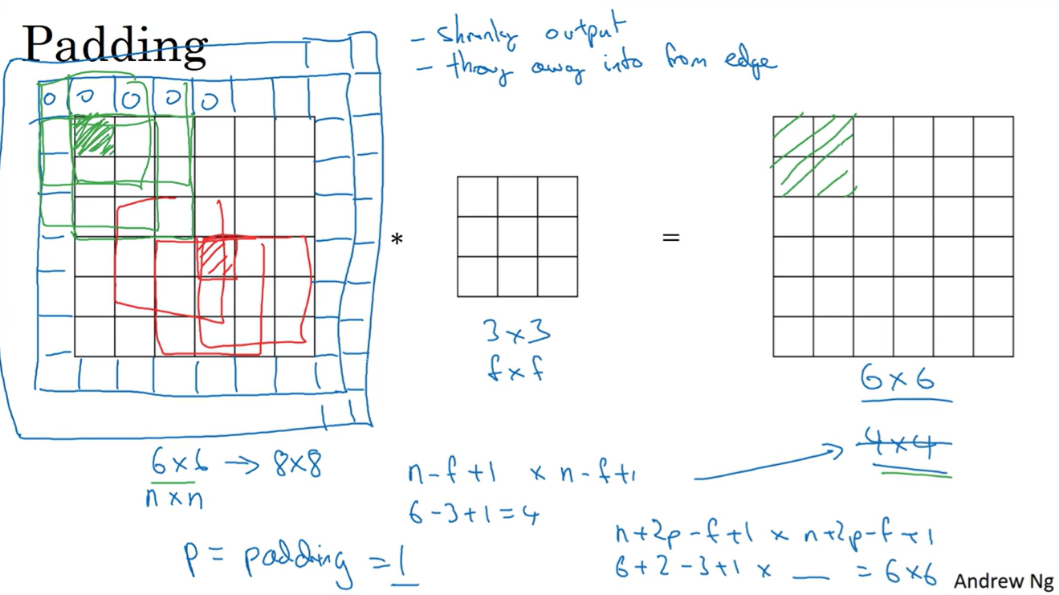
Padding Amount: How many pixels are added on each side (by convention the new padded pixels are 0)
Dimension of picture after padding and applying filter: n+2p-f+1 where p is padding amount
How to choose padding size?
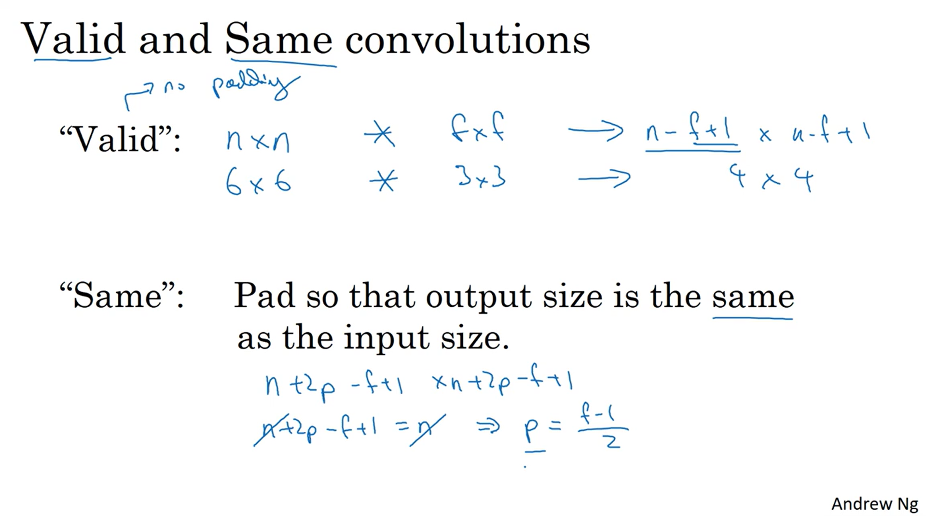
f (filter dimension) is usually odd since:
- even filter will give asymmetric padding
- odd filter will have a center position
Strided Convolution: No. of boxes moved when finding convolution
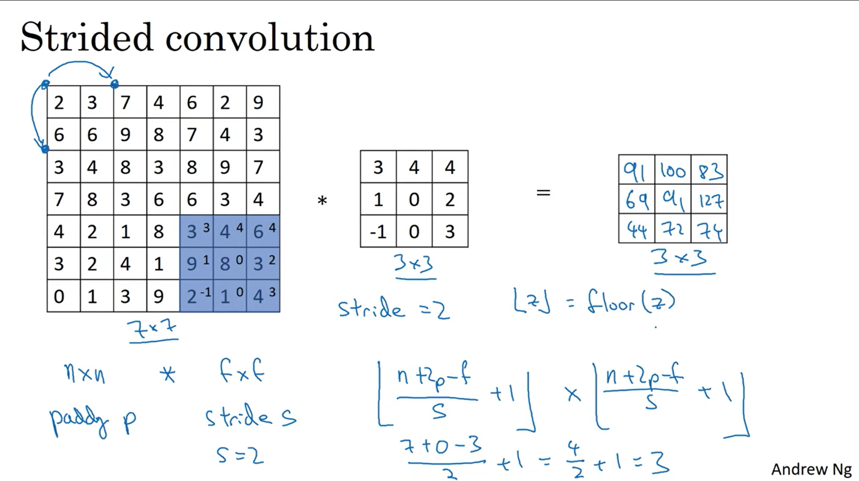
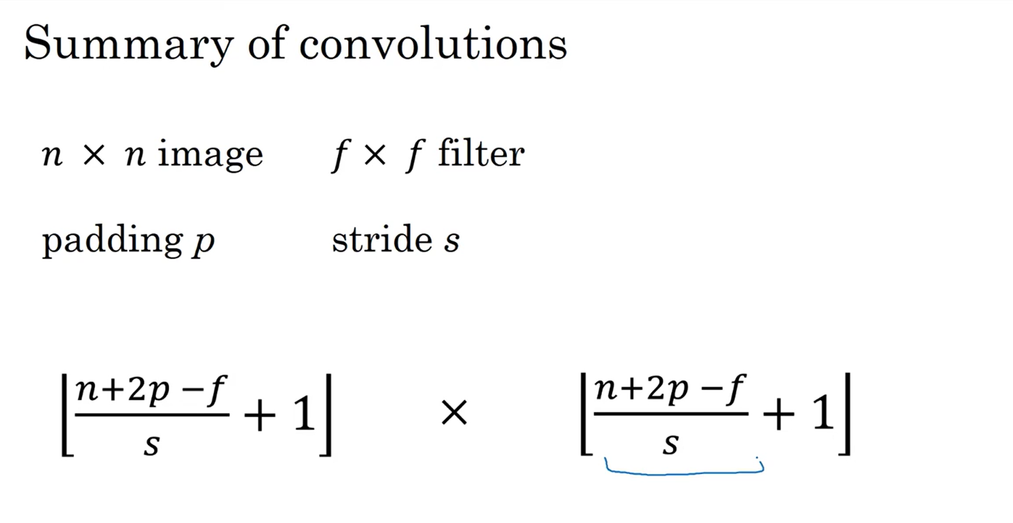

In reality this convolution operator is called the cross correlation operator. For the real convolution the filter matrix needs to be mirrored
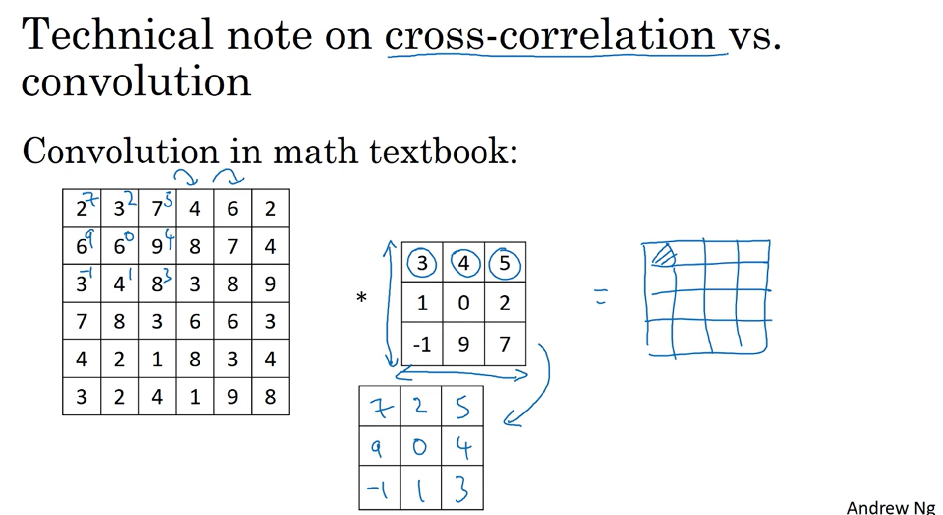

Convolutions on RGB image
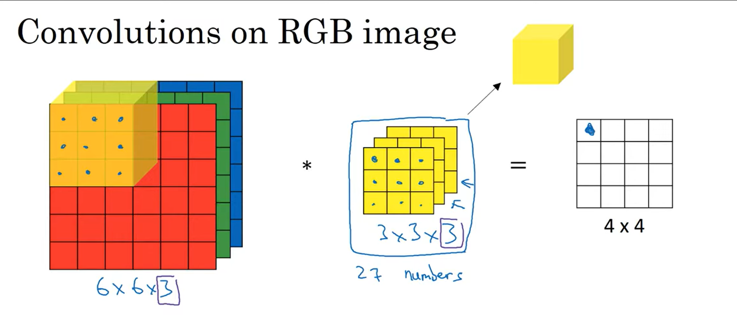
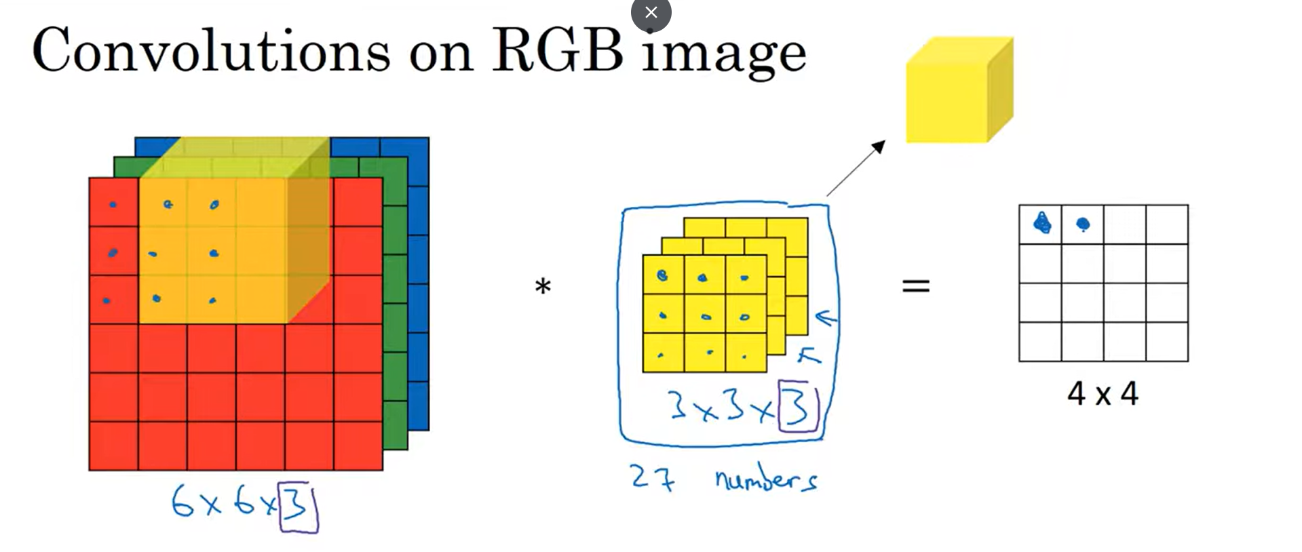

Convolutions on Volumes
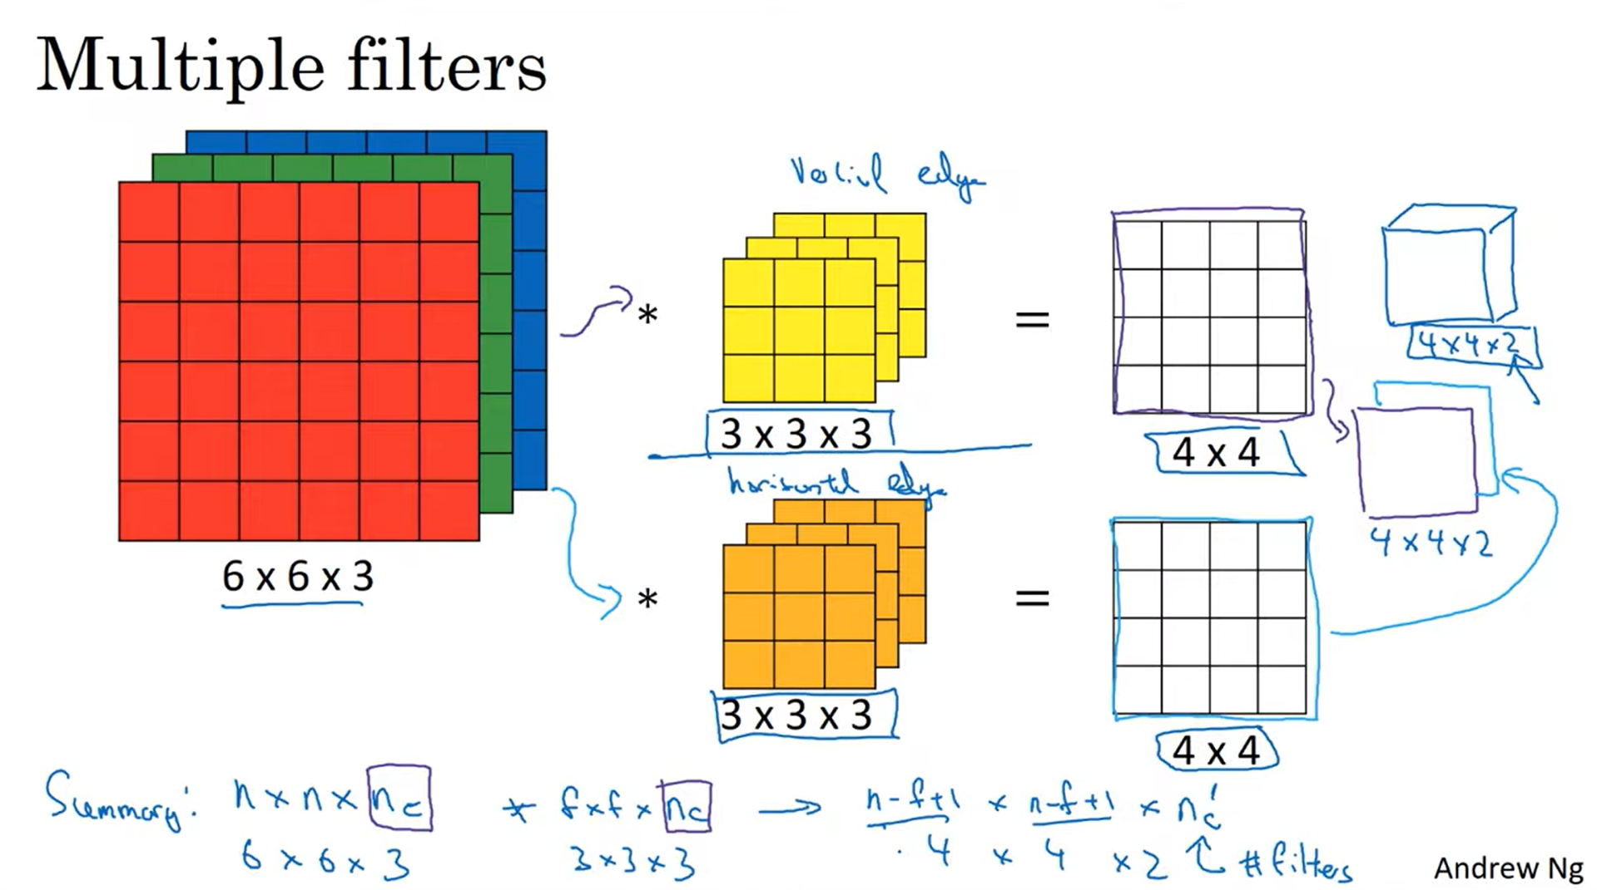
Where n,f,n_{c} are dimensions of input, filter and number of different filters used

One layer of CNN
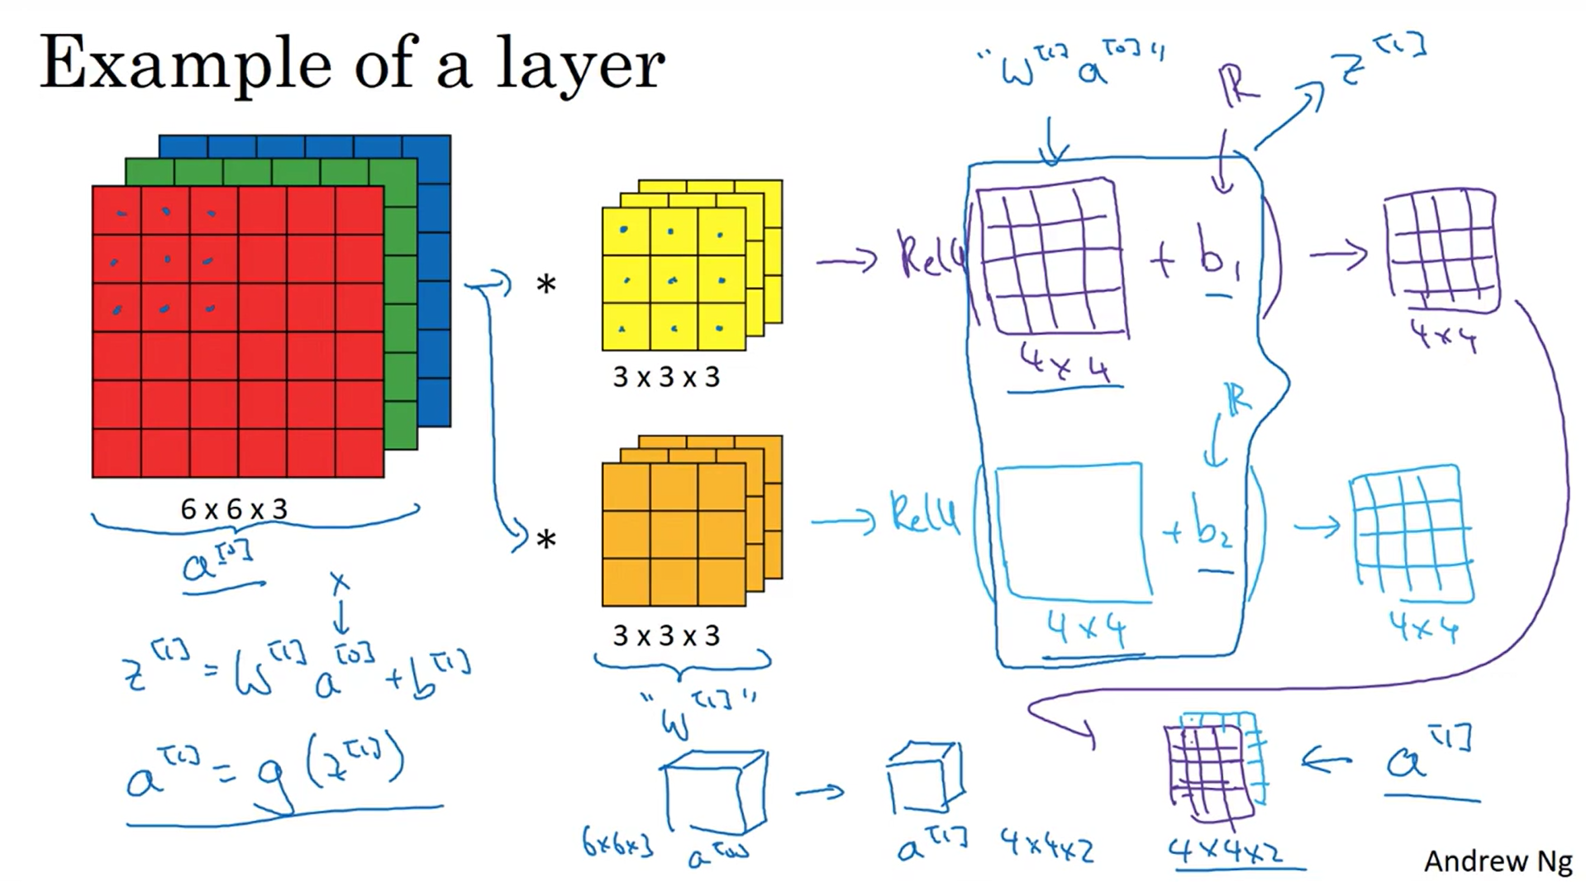
(add non linearity function on the output of convolution operator)

Dimensions of a layer
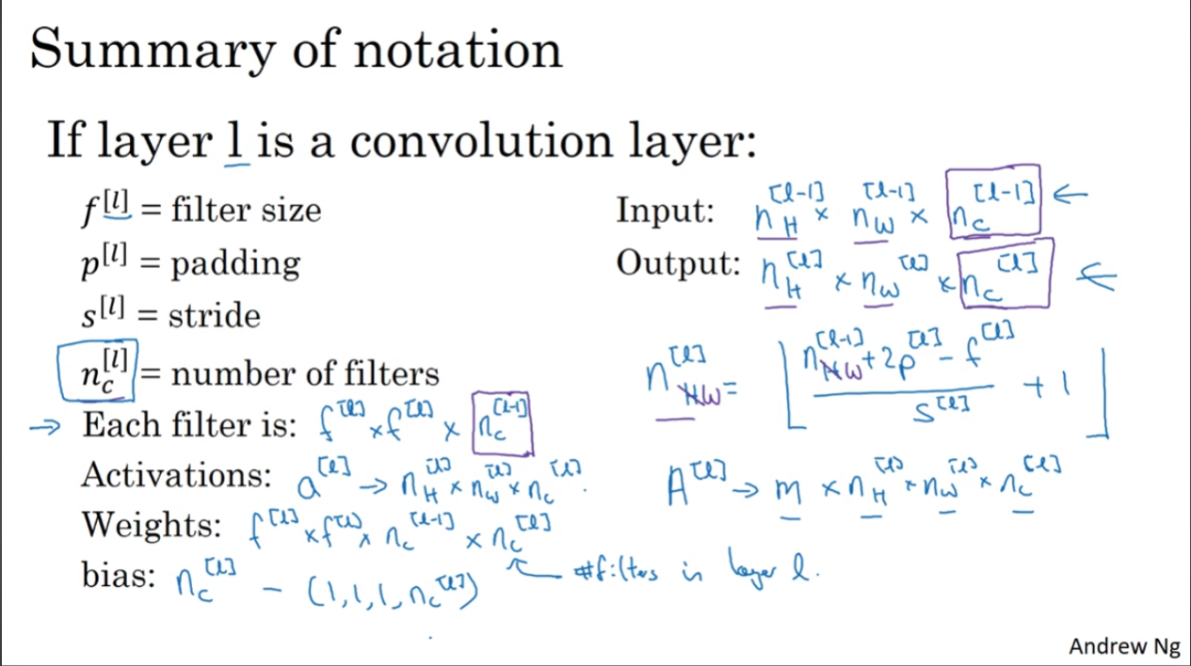
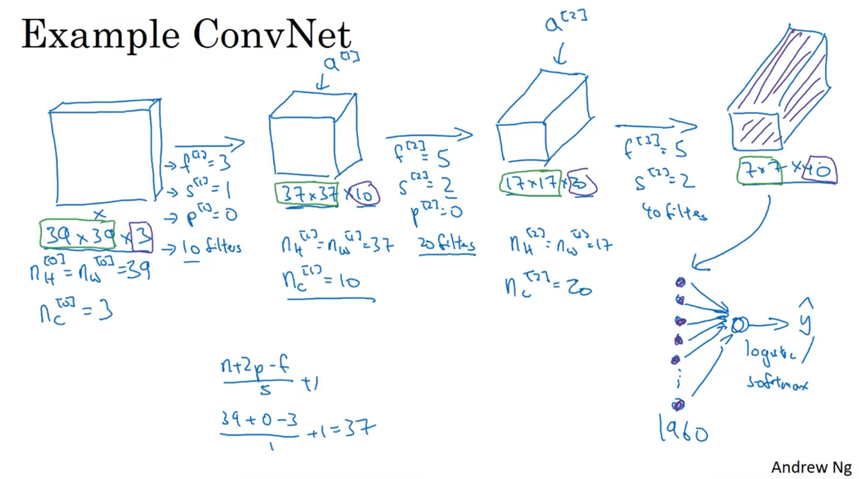
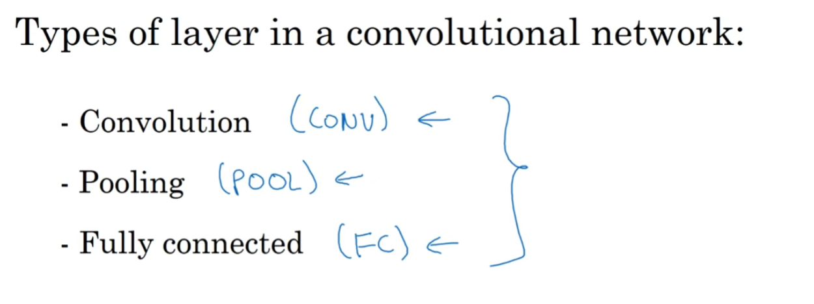

Pooling Layer: acts as a downsampling operation that reduces the spatial dimensions (height and width) of input feature maps
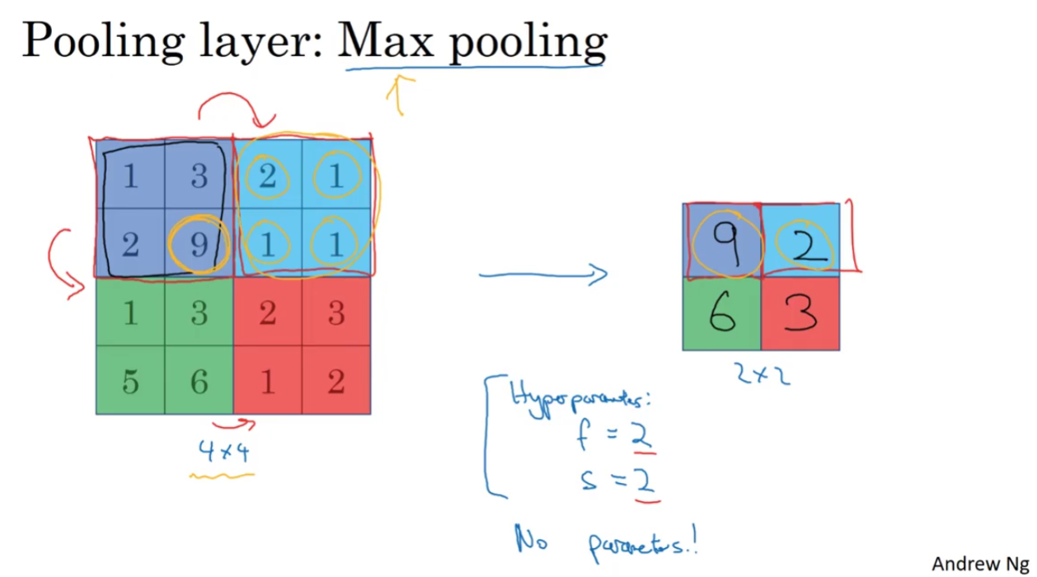
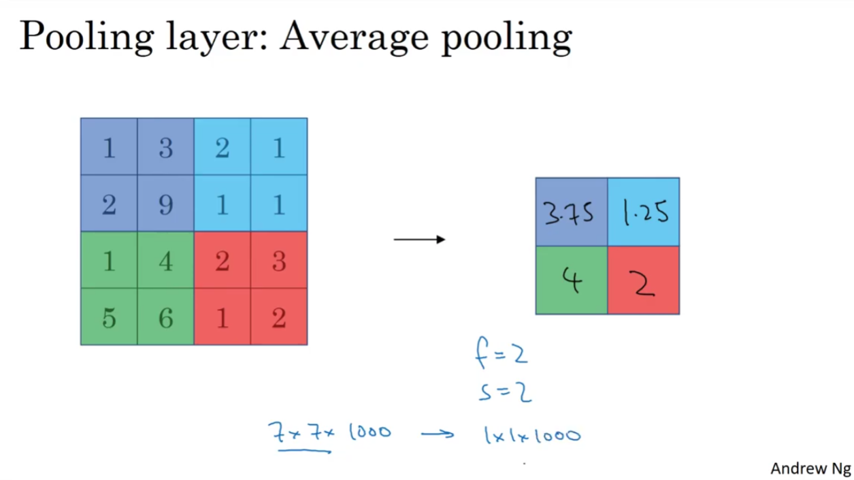
Backprop doesn’t have any parameters to adjust in pooling layers. Theres only hyperparameters here (f and s)
LeNet-5 type architecture
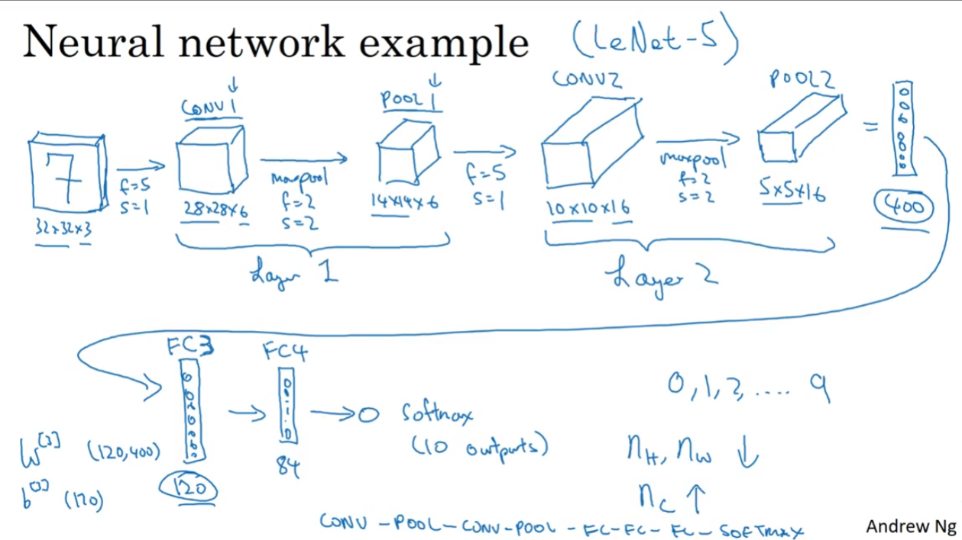
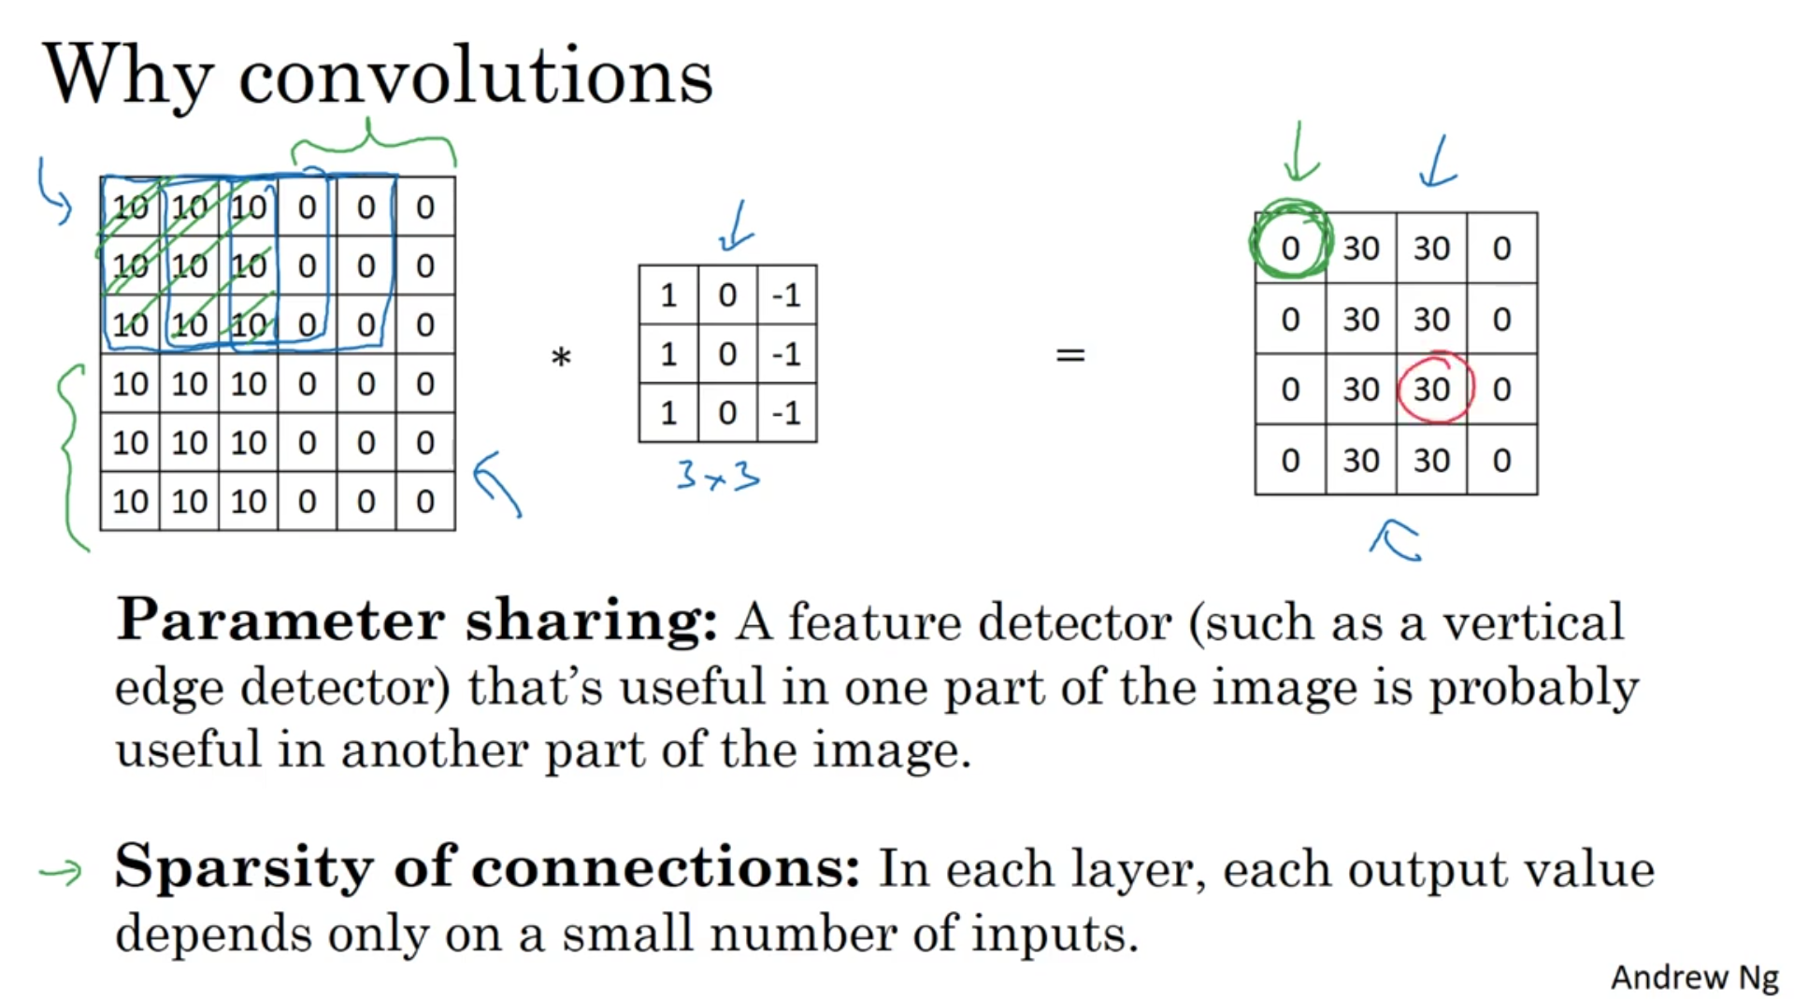
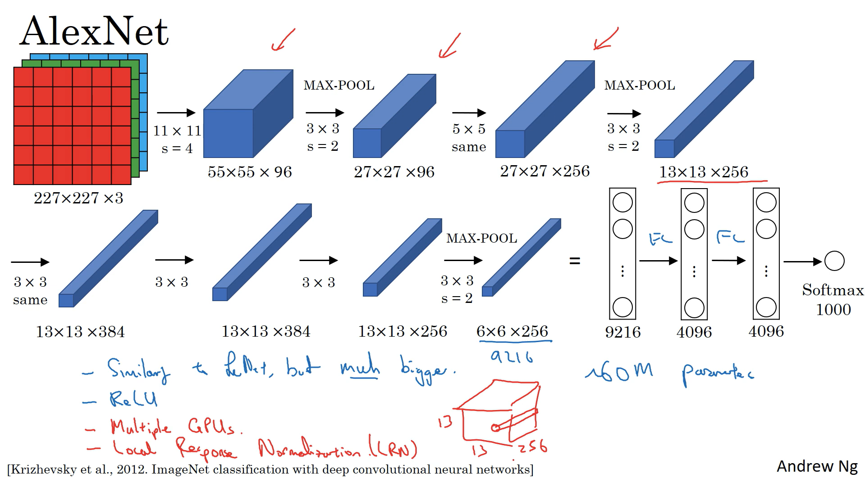
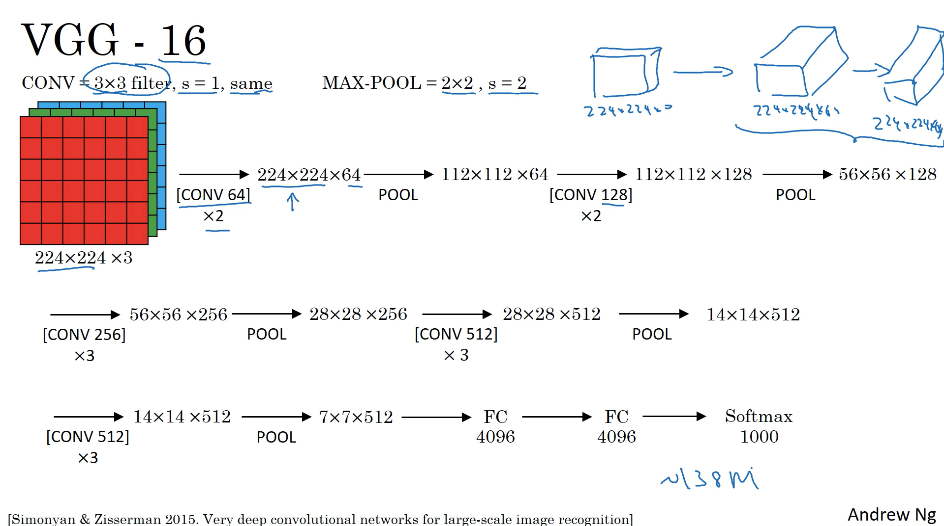

ResNet
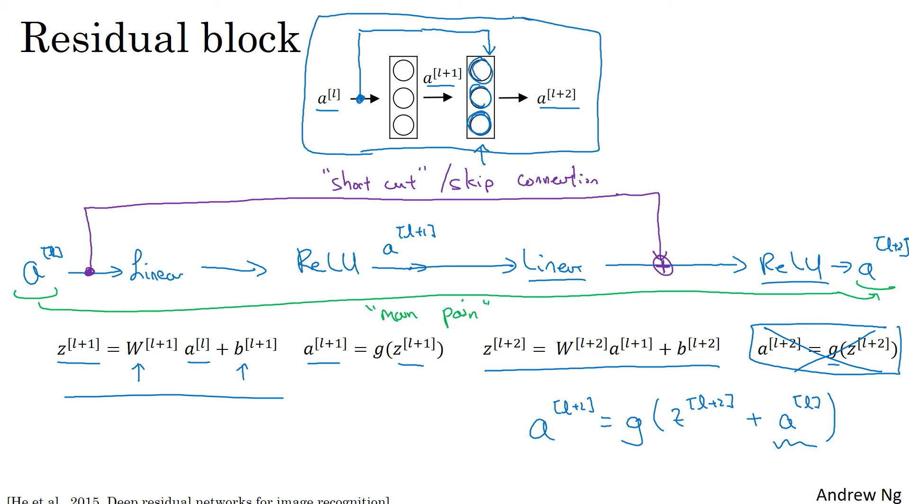
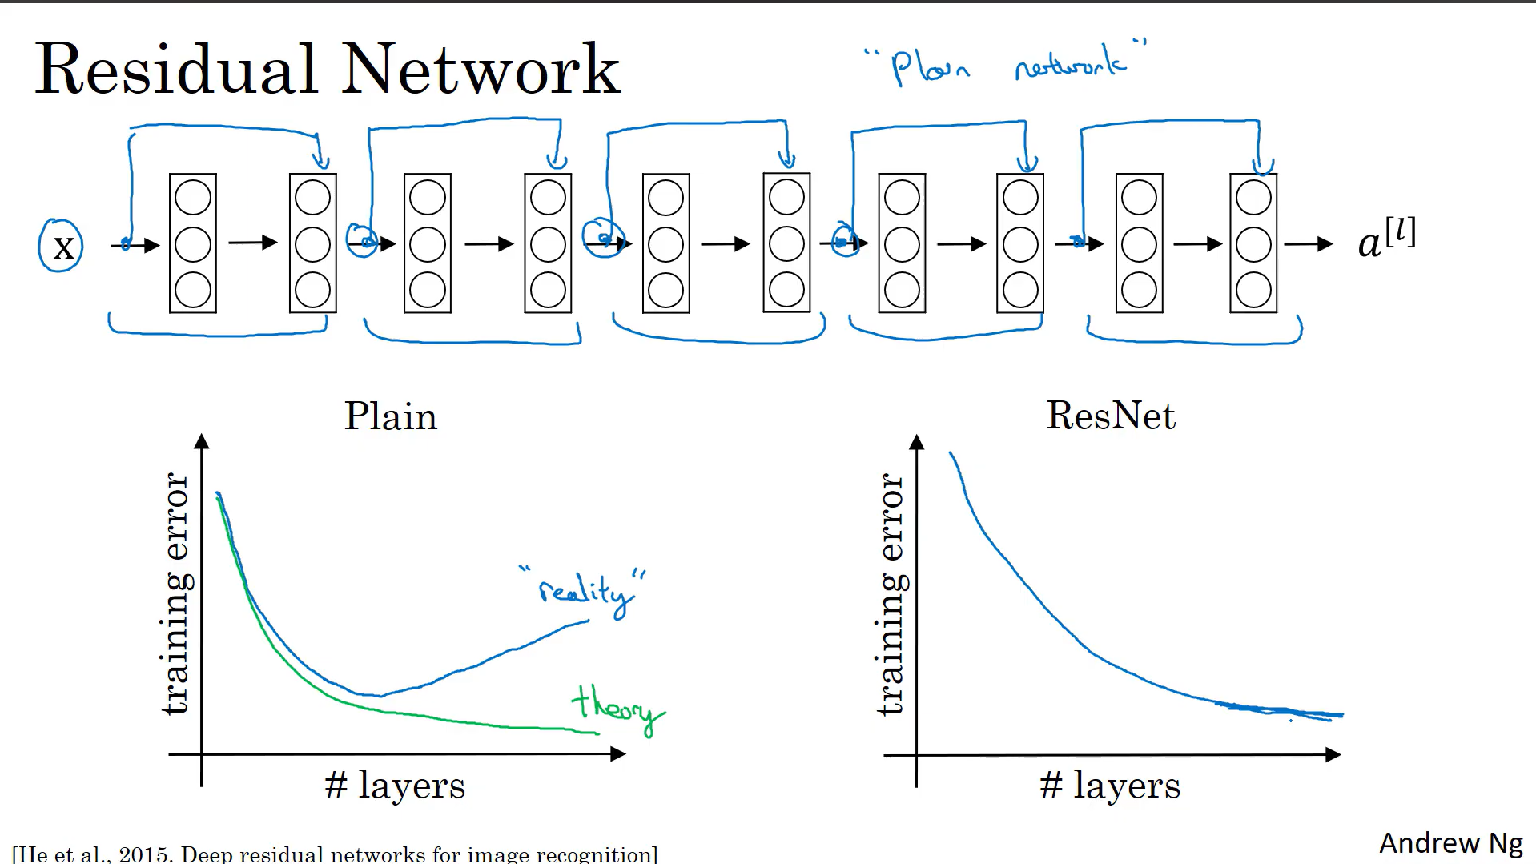
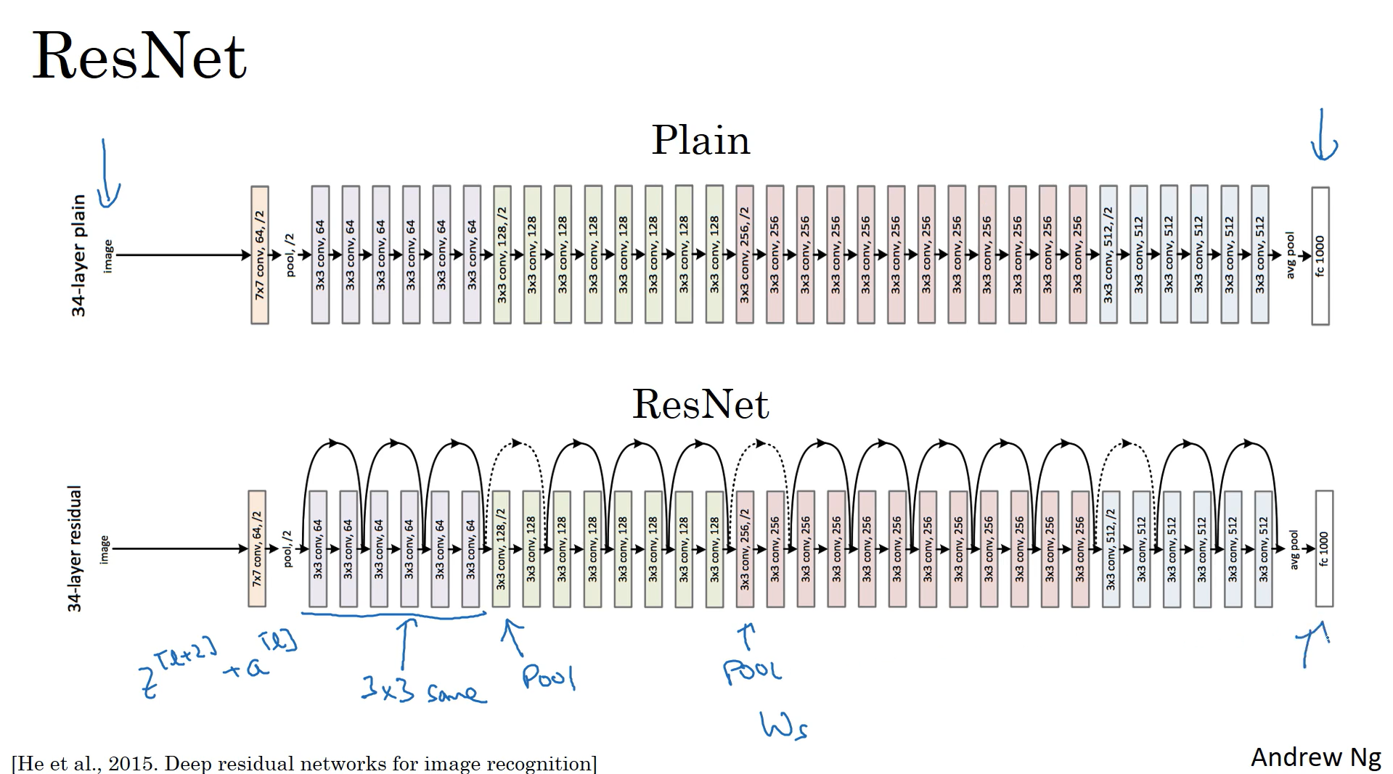

Network In Network (1x1 convolutions)
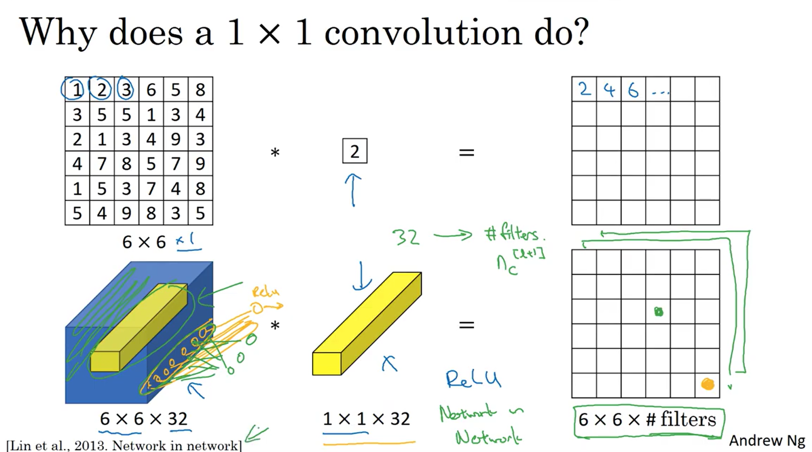
1x1 convolutions can be used to shrink number of channels without affecting output dimensions (a^{[l-1]})

Convolutional Neural Network (CNN) Architectures
Convolutional Neural Network(CNN) is a neural network architecture in Deep Learning, used to recognize the pattern from structured arrays. However, over many years, CNN architectures have evolved. Many variants of the fundamental CNN Architecture This been developed, leading to amazing advances in the growing deep-learning field.
Let's discuss, How CNN architecture developed and grow over time.
1. LeNet-5
- The First LeNet-5 architecture is the most widely known CNN architecture. It was introduced in 1998 and is widely used for handwritten method digit recognition.
- LeNet-5 has 2 convolutional and 3 full layers.
- This LeNet-5 architecture has 60,000 parameters.
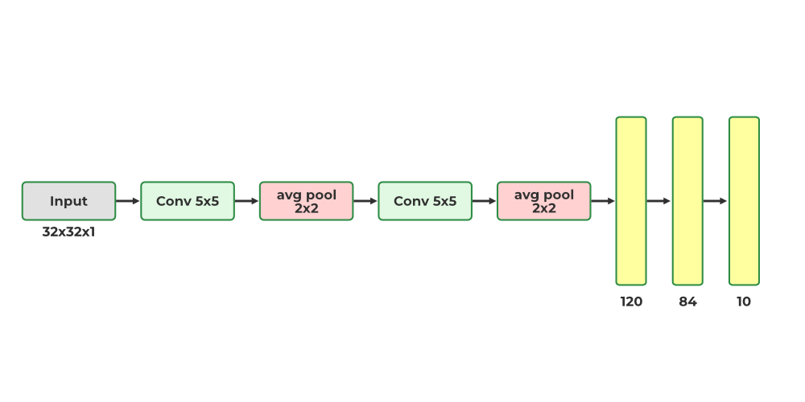
- The LeNet-5 has the ability to process higher one-resolution images that require larger and more CNN convolutional layers.
- The leNet-5 technique is measured by the availability of all computing resources

2. AlexNNet
- The AlexNet CNN architecture won the 2012 ImageNet ILSVRC challenges of deep learning algorithm by a large variance by achieving 17% with top-5 error rate as the second best achieved 26%!
- It was introduced by Alex Krizhevsky (name of founder), The Ilya Sutskever and Geoffrey Hinton are quite similar to LeNet-5, only much bigger and deeper and it was introduced first to stack convolutional layers directly on top of each other models, instead of stacking a pooling layer top of each on CN network convolutional layer.
- AlexNNet has 60 million parameters as AlexNet has total 8 layers, 5 convolutional and 3 fully connected layers.
- AlexNNet is first to execute (ReLUs) Rectified Linear Units as activation functions
- it was the first CNN architecture that uses GPU to improve the performance.
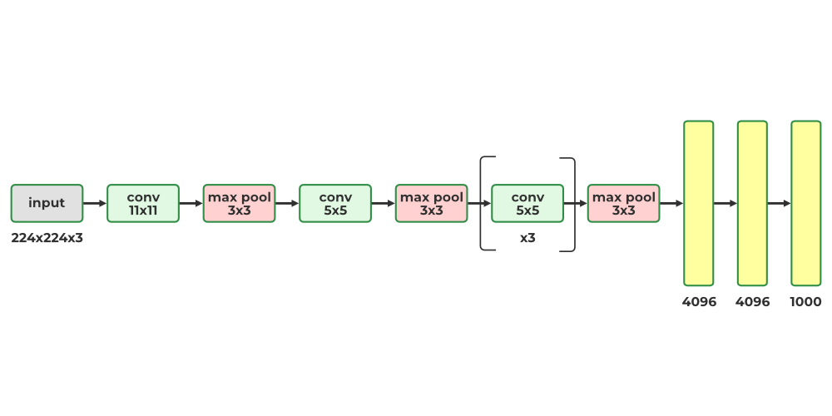

3. GoogleNet (Inception vl)
- The GoogleNet architecture was created by Christian Szegedy from Google Research and achieved a breakthrough result by lowering the top-5 error rate to below 7% in the ILSVRC 2014 challenge. This success was largely attributed to its deeper architecture than other CNNs, enabled by its inception modules which enabled more efficient use of parameters than preceding architectures
- GoogleNet has fewer parameters than AlexNet, with a ratio of 10:1 (roughly 6 million instead of 60 million)
- The architecture of the inception module looks as shown in Fig.
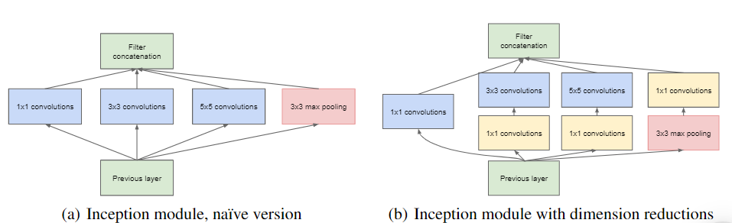
- The notation "3 x 3 + 2(5)" means that the layer uses a 3 x 3 kernel, a stride of 2, and SAME padding. The input signal is then fed to four different layers, each with a RelU activation function and a stride of 1. These convolutional layers have varying kernel sizes (1 x 1, 3 x 3, and 5 x 5) to capture patterns at different scales. Additionally, each layer uses SAME padding, so all outputs have the same height and width as their inputs. This allows for the feature maps from all four top convolutional layers to be concatenated along the depth dimension in the final depth concat layer.
- The overall GoogleNet architecture has 22 larger deep CNN layers.

4. ResNet (Residual Network)
- Residual Network (ResNet), the winner of the ILSVRC 2015 challenge, was developed by Kaiming He and delivered an impressive top-5 error rate of 3.6% with an extremely deep CNN composed of 152 layers. An essential factor enabling the training of such a deep network is the use of skip connections (also known as shortcut connections). The signal that enters a layer is added to the output of a layer located higher up in the stack. Let's explore why this is beneficial.
- When training a neural network, the goal is to make it replicate a target function h(x). By adding the input x to the output of the network (a skip connection), the network is made to model f(x) = h(x) - x, a technique known as residual learning.
F(x) = H(x) - x which gives H(x) := F(x) + x.
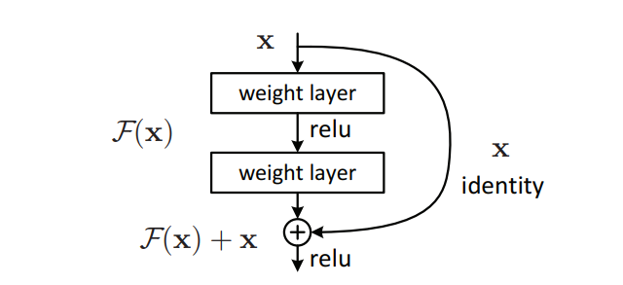
- When initializing a regular neural network, its weights are near zero, resulting in the network outputting values close to zero. With the addition of skip connections, the resulting network outputs a copy of its inputs, effectively modeling the identity function. This can be beneficial if the target function is similar to the identity function, as it will accelerate training. Furthermore, if multiple skip connections are added, the network can begin to make progress even if several layers have not yet begun learning.
- the target function is fairly close to the identity function (which is often the case), this will speed up training considerably. Moreover, if you add many skin connections, the network can start making progress even if several
- The deep residual network can be viewed as a series of residual units, each of which is a small neural network with a skip connection

5. DenseNet
- The DenseNet model introduced the concept of a densely connected convolutional network, where the output of each layer is connected to the input of every subsequent layer. This design principle was developed to address the issue of accuracy decline caused by the vanishing and exploding gradients in high-level neural networks.
- In simpler terms, due to the long distance between the input and output layer, the data is lost before it reaches its destination.
- The DenseNet model introduced the concept of a densely connected convolutional network, where the output of each layer is connected to the input of every subsequent layer. This design principle was developed to address the issue of accuracy decline caused by the vanishing and exploding gradients in high-level neural networks.
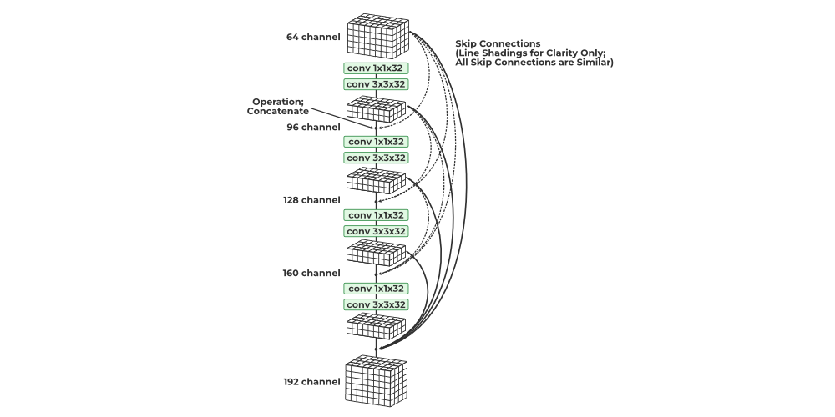
- All convolutions in a dense block are ReLU-activated and use batch normalization. Channel-wise concatenation is only possible if the height and width dimensions of the data remain unchanged, so convolutions in a dense block are all of stride 1. Pooling layers are inserted between dense blocks for further dimensionality reduction.
- Intuitively, one might think that by concatenating all previously seen outputs, the number of channels and parameters would exponentially increase. However, DenseNet is surprisingly economical in terms of learnable parameters. This is because each concatenated block, which may have a relatively large number of channels, is first fed through a 1x1 convolution, reducing it to a small number of channels. Additionally, 1x1 convolutions are economical in terms of parameters. Then, a 3x3 convolution with the same number of channels is applied.
- The resulting channels from each step of the DenseNet are concatenated to the collection of all previously generated outputs. Each step, which utilizes a pair of 1x1 and 3x3 convolutions, adds K channels to the data. Consequently, the number of channels increases linearly with the number of convolutional steps in the dense block. The growth rate remains constant throughout the network, and DenseNet has demonstrated good performance with K values between 12 and 40.
- Dense blocks and pooling layers are combined to form a Tu DenseNet network. The DenseNet21 has 121 layers, however, the structure is adjustable and can readily be extended to more than 200 layers
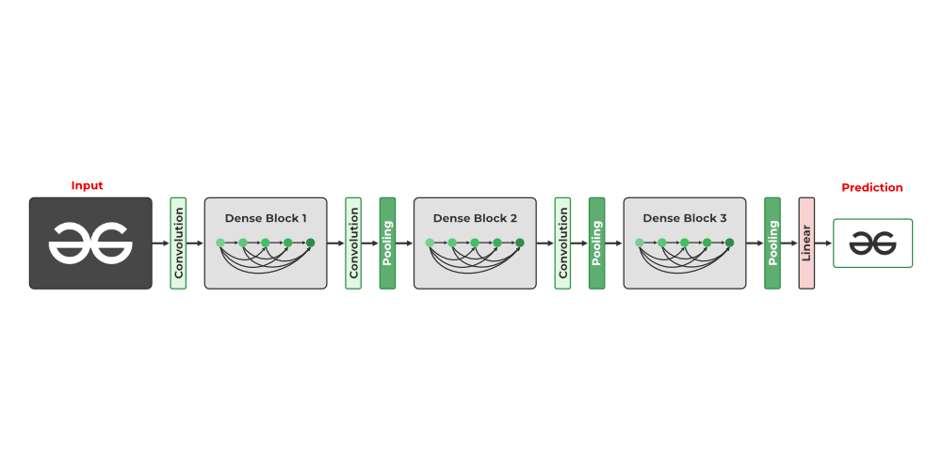

First when I initially ran my model I found out that it was reaching to 50% testing accuracy quickly but the validation loss and accuracy was increasing/35%. This meant that the model was confidentally giving wrong predictions, rather it was just predicting all the characters to be homer or bart due to the skewed training set. This allowed it to get higher accuracy but it was overfitting.
So I implemented class weights (higher weights on rarer characters) so the model was penalized heavily whenever it confidentally gave a wrong answer on a rare character.
Now the model wasn’t guessing the most common characters, so the testing accuracy was lower (36%) but on running more epochs (50) it started overfitting.
To fix this I added more data augmentation (random rotation, color jitters, random horizontal flip) to make it harder for the model to memorize the characters, and also implemented weight_decay to my optimizer (Adam).
Still the accuracy was low so I moved from a 3 layer CNN to a 4 layer CNN
Now I was getting accuracy around 40% after 15 epochs but the validation loss started increasing (overfitting) so I implemented a learning rate scheduler (ReduceLROnPlateau) and also increased image size from 64x64 to 128x128.
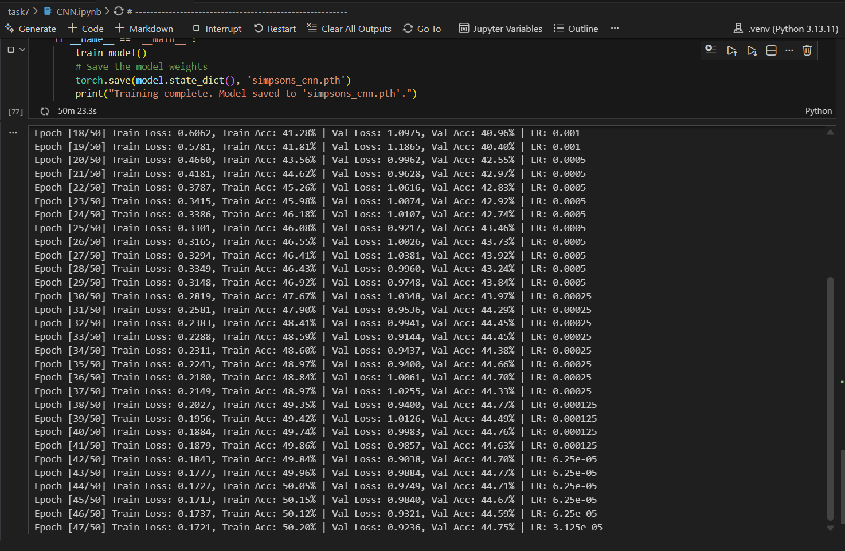
I was getting really low loss values but accuracy was still 50%, this was due to the class weights. The model was learning to train on the rarer characters since they had higher weights than the more common characters. Since getting rarer characters correctly will reduce loss more than getting common characters correctly.
Since 50% of the dataset is just bart, homer, Maggie etc the model is only focusing on the other 50%.
The model over corrected, it spent 50 epochs only learning the rare characters and ignoring the common characters.
To fix this I smoothened the class weights

