ANN
In simple representation (multilayer perceptron) the neurons are holding numbers and the weights and biases are knobs which we can tweak to adjust which neuron(s) the preceding layer sends the activation to and then finally get the result on the last layer.

Each neuron is connected to the entire previous layer by the weighted sum of all the activations of previous layer and (in case of number recognition) the weighted sum along with a bias are under the sigmoid function
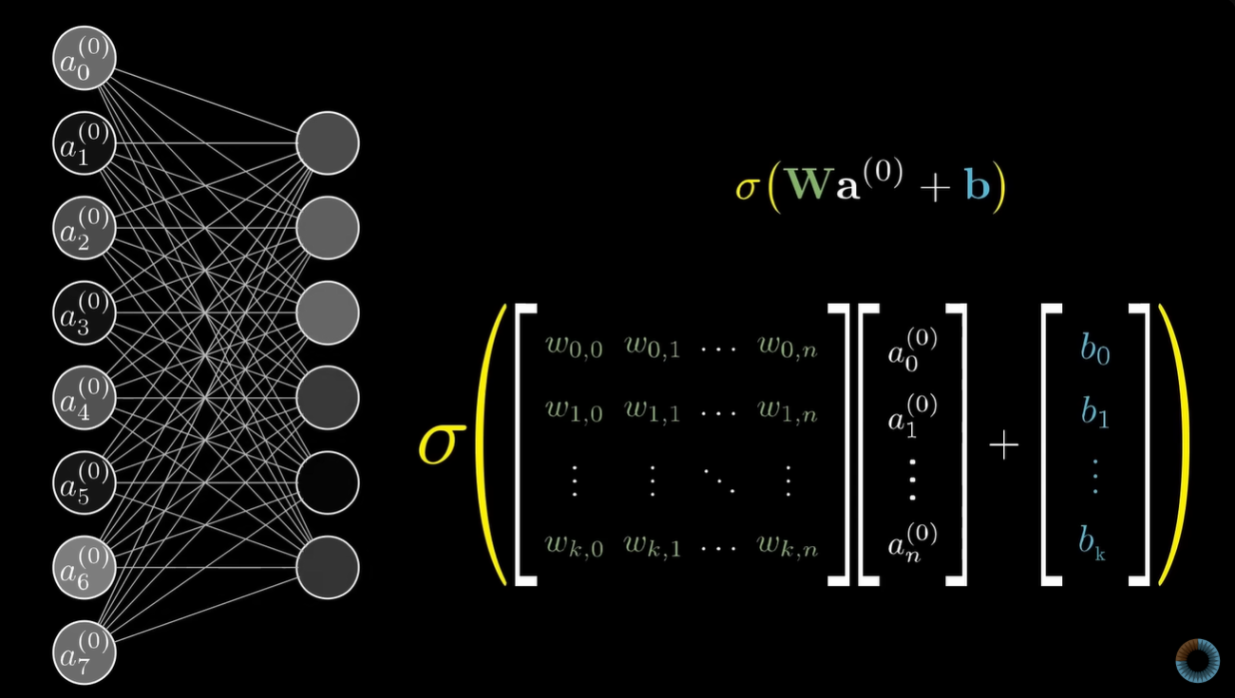
(this gives value of a single neuron)

The MNIST dataset (784) will have 28x28 pixel samples of handwritten numbers

According to 3B1B, we hoped the first layer has the brightness value of each pixel (784 pixels), the second layer detects which pixels forms the edges of certain shapes (line can be made with a few small shapes, similarly loops can be made with few curved shapes), the third layer finds out which shapes these edges forms (loops, lines), the fourth layer finds out which number is formed by these loops and lines (9 can be made with 1 loop and 1 line)

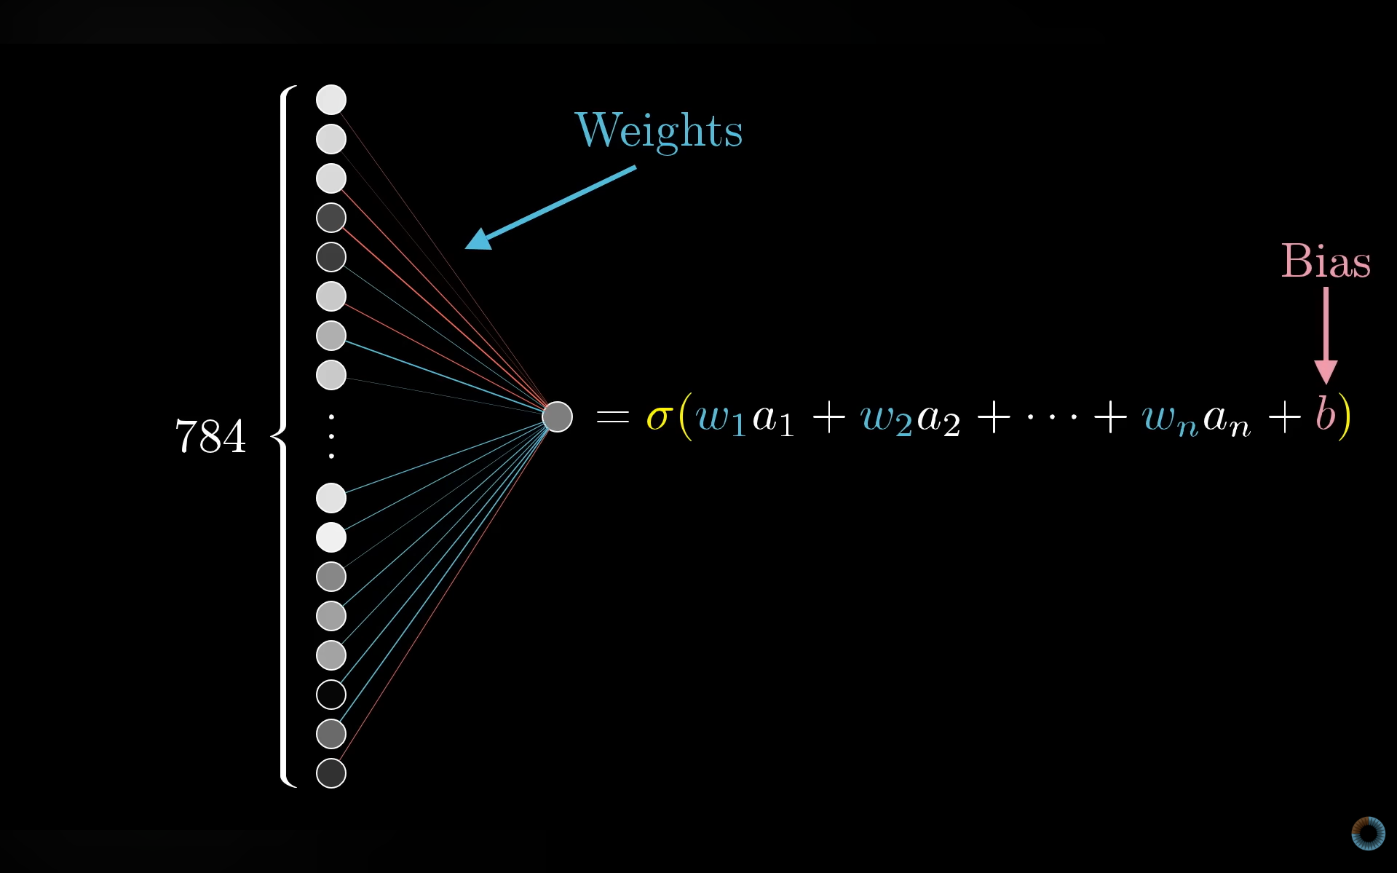
Weights are kinda like the strength of these connections and the bias defines the minimum value for the neuron to be active. 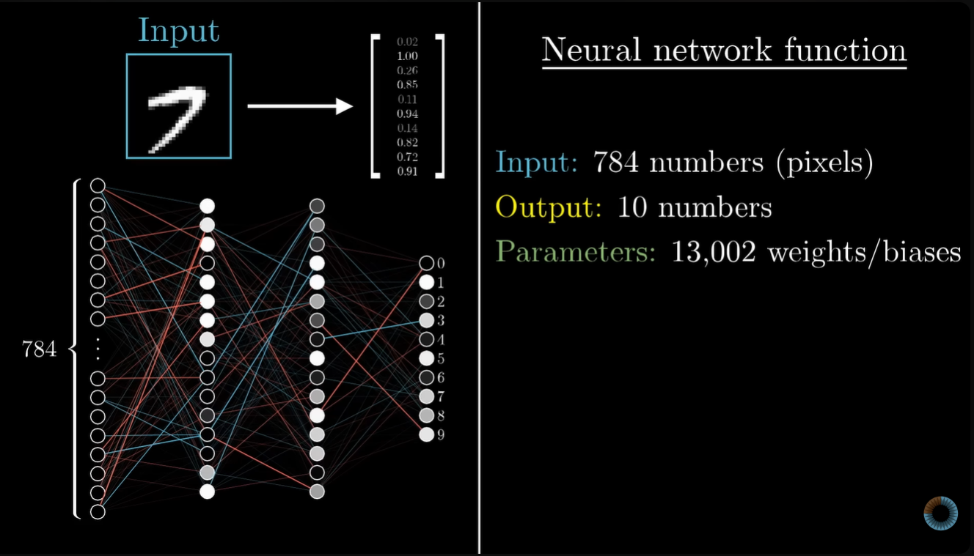

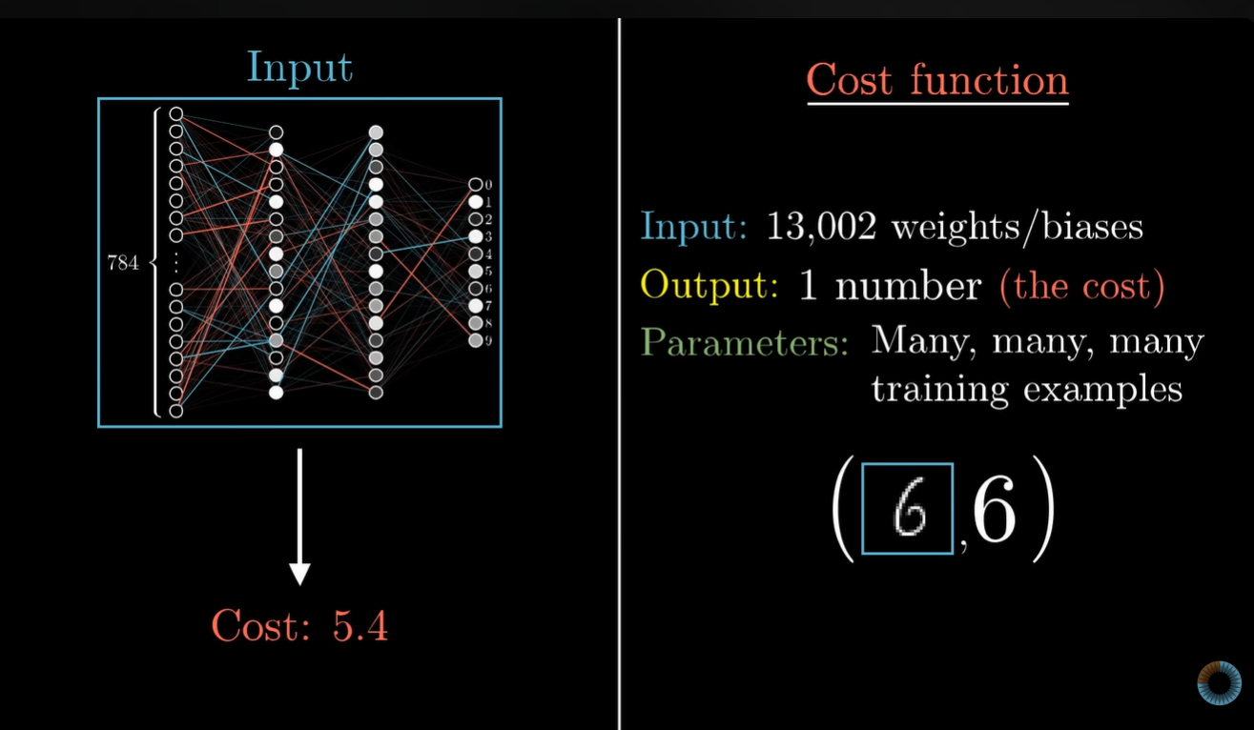

Key Components of an ANN
- Input Layer: This is where the network receives information. For example, in an image recognition task, the input could be an image.
- Hidden Layers: These layers process the data received from the input layer. The more hidden layers there are, the more complex patterns the network can learn and understand. Each hidden layer transforms the data into more abstract information.
- Output Layer: This is where the final decision or prediction is made. For example, after processing an image, the output layer might decide whether it’s a cat or a dog.
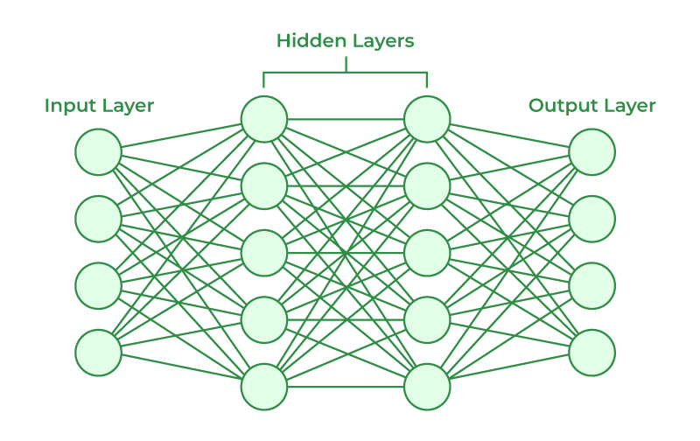
How do Artificial Neural Networks learn?
- Artificial Neural Networks (ANNs) learn by training on a set of data. For example, to teach an ANN to recognize a cat, we show it thousands of images of cats. The network processes these images and learns to identify the features that define a cat.
- Once the network has been trained, we test it by providing new images to see if it can correctly identify cats. The network’s prediction is then compared to the actual label (whether it's a cat or not). If it makes an incorrect prediction, the network adjusts by fine-tuning the weights of the connections between neurons using a process called backpropagation. This involves correcting the weights based on the difference between the predicted and actual result.
- This process repeats until the network can accurately recognize a cat in an image with minimal error. Essentially, through constant training and feedback, the network becomes better at identifying patterns and making predictions.
Common Activation Functions in ANNs
Activation functions are important in neural networks because they introduce non-linearity and helps the network to learn complex patterns. Lets see some common activation functions used in ANNs:
- Sigmoid Function: Outputs values between 0 and 1. It is used in binary classification tasks like deciding if an image is a cat or not.
- ReLU (Rectified Linear Unit): A popular choice for hidden layers, it returns the input if positive and zero otherwise. It helps to solve the vanishing gradient problem.
  - Vanishing Gradient Problem
Vanishing gradients occur when gradients become extremely small during backpropagation, causing early layers to learn very slowly or stop learning. During backpropagation the gradient of the loss
When activation functions like Sigmoid or Tanh are used, their derivatives are less than 1. Repeated multiplication through layers causes the gradient to vanish as it moves backwards, making the lower layers unable to learn.
  - Exploding Gradient Problem
Exploding gradients occur when gradients grow too large during backpropagation, leading to unstable weight updates and divergence in loss. When derivatives or weights are greater than 1, their repeated multiplication across layers leads to exponential growth.
  - Techniques to Fix Vanishing and Exploding Gradients
    - Proper Weight Initialization
Choosing the right weight initialization keeps gradients balanced during backpropagation.
        - Xavier Initialization: Keeps activation variance consistent across layers to stabilize gradients.
        - Kaiming Initialization: Scales weights for ReLU to preserve signal strength and prevent gradient decay.
    - Use Non Saturating Activation Functions
Sigmoid and Tanh can shrink gradients. Using ReLU or its variants prevents vanishing gradients:
        - ReLU: Basic rectified linear unit.
        - Leaky ReLU: Allows small gradients for negative inputs.
        - ELU / SELU: Helps maintain self normalizing properties.
    - Apply Batch Normalization
Normalizes layer inputs to have zero mean and unit variance, stabilizing gradients and accelerating convergence.
    - Gradient Clipping
Limits gradients to a maximum threshold to prevent them from exploding and destabilizing trainin
- Tanh (Hyperbolic Tangent): Similar to sigmoid but outputs values between -1 and 1. It is used in hidden layers when a broader range of outputs is needed.
- Softmax: Converts raw outputs into probabilities used in the final layer of a network for multi-class classification tasks.
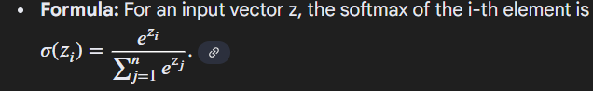
- Leaky ReLU: A variant of ReLU that allows small negative values for inputs helps in preventing “dead neurons” during training.
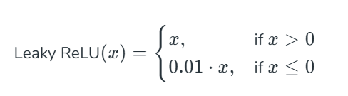
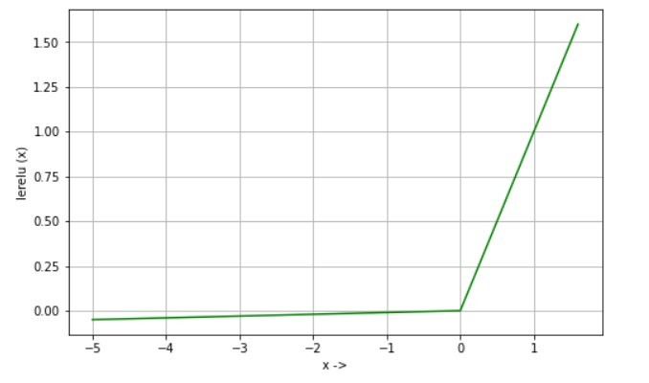
Optimization Algorithms in ANN Training
Optimization algorithms adjust the weights of a neural network during training to minimize errors. The goal is to make the network’s predictions more accurate. Lets see key algorithms:
- Gradient Descent: Most basic optimization algorithm that updates weights by calculating the gradient of the loss function.
- Momentum
Momentum-based gradient optimizers are advanced techniques used to enhance the training of machine learning models. Unlike classic gradient descent, they incorporate a "momentum" term that helps the optimizer navigate the loss surface more efficiently.
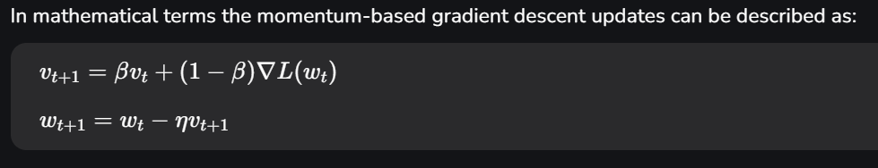
- $v_{t}$ is the velocity i.e., a running average of gradients
- $β$ is the momentum factor, typically a value between 0 and 1 (often around 0.9)
- $∇L(w_{t})$ is the current gradient of the loss function
- $η$ is the learning rate
  - Nesterov Accelerated Gradient (NAG)
Nesterov momentum is an advanced form of momentum-based optimization. It modifies the update rule by calculating the gradient at the upcoming position rather than the current position of the weights.
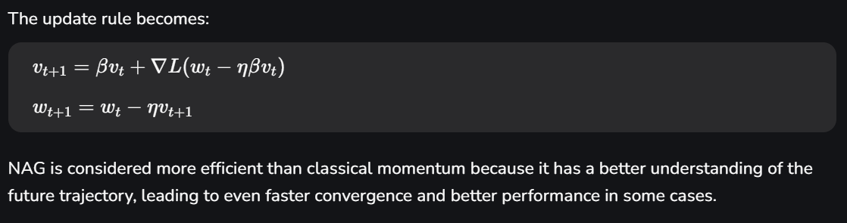
  - AdaMomentum
AdaMomentum combines the concept of adaptive learning rates with momentum. It adjusts the momentum term based on the recent gradients making the optimizer more sensitive to the landscape of the loss function. This can help in fine-tuning the convergence process.
  - RMSprop (Root mean square Propogation)
Although not strictly a momentum-based optimizer in the traditional sense RMSProp incorporates a form of momentum by adapting the learning rate for each parameter. It’s particularly effective when dealing with non-stationary objectives such as in training recurrent neural networks (RNNs).
RMSProp keeps a moving average of the squared gradients to normalize the gradient updates. By doing so it prevents the learning rate from becoming too small which was a drawback in AdaGrad and ensures that the updates are appropriately scaled for each parameter.
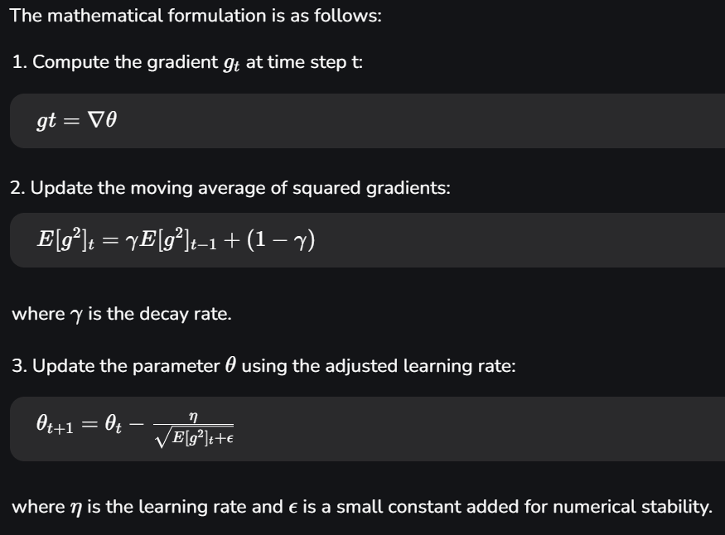
- Learning Rate ($η$): Controls the step size during the parameter updates. RMSProp typically uses a default learning rate of 0.001, but it can be adjusted based on the specific problem.
- Decay Rate ($γ$): Determines how quickly the moving average of squared gradients decays. A common default value is 0.9 which balances the contribution of recent and past gradients.
- Epsilon ($ϵ$): A small constant added to the denominator to prevent division by zero and ensure numerical stability. A typical value for $ϵ$ is 1e-8.

- Adagrad
Adagrad (Adaptive Gradient Algorithm) is an optimization method that adjusts the learning rate for each parameter during training. Unlike standard gradient descent with a fixed rate, Adagrad uses past gradients to scale updates making it effective for sparse data and varying feature magnitudes.
The primary concept behind Adagrad is the idea of adapting the learning rate based on the historical sum of squared gradients for each parameter.
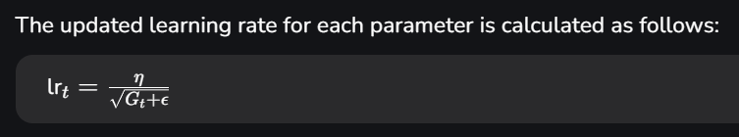
    - η is the global learning rate (a small constant value)
    - $G_{t}$​ is the sum of squared gradients for a given parameter up to time step $t$
    - $ϵ$ is a small value added to avoid division by zero (often set to $1e-8$)
- Adadelta
AdaDelta is another modification of Adagrad that focuses on reducing the accumulation of past gradients. It updates the learning rates based on the moving average of past gradients and incorporates a more stable and bounded update rule.
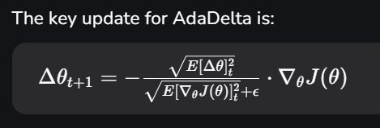
    - $\left[Δθ]_{t}^{2}\right.$ is the running average of past squared parameter updates

- Adam (Adaptive Moment Estimation):
An efficient version of gradient descent that adapts learning rates for each weight used in deep learning. Adam combines the benefits of both Adagrad and momentum-based methods. It uses both the moving average of the gradients and the squared gradients to adapt the learning rate. Adam is widely used due to its robustness and superior performance in various machine learning tasks.
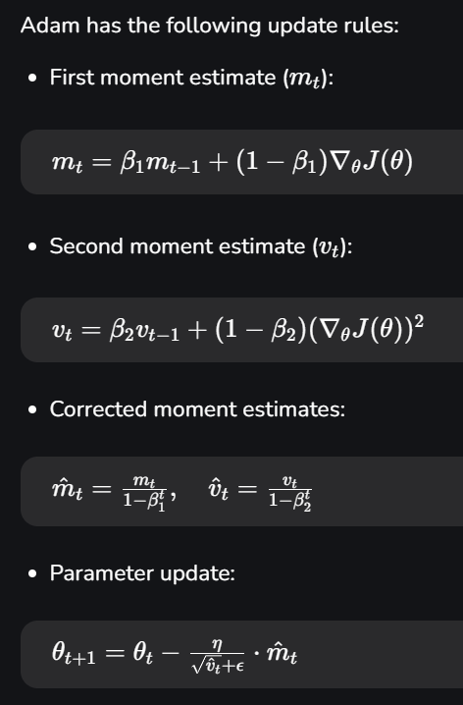
- Stochastic Gradient Descent (SGD):
In traditional gradient descent, the gradients are computed based on the entire dataset which can be computationally expensive for large datasets.
In Stochastic Gradient Descent, the gradient is calculated for each training example (or a small subset of training examples) rather than the entire dataset.
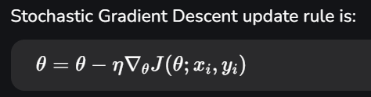
- $x_{i}$​ and $y_{i}$​ represent the features and target of the i-th training example.
        - The gradient $∇_{θ}J(θ;x_{i},y_{i})$ is now calculated for a single data point or a small batch.



BackPropogation
3 ways of increasing activation of a neuron :-
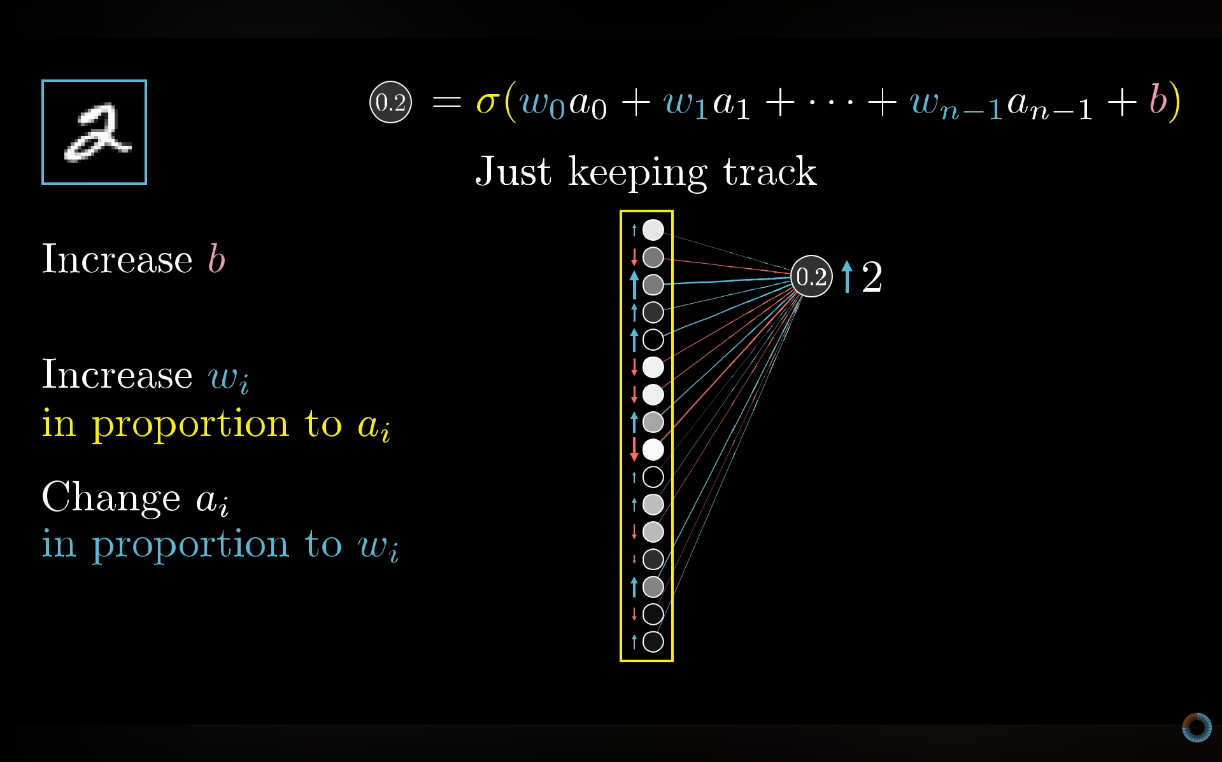

Back Propogation mathematically :-
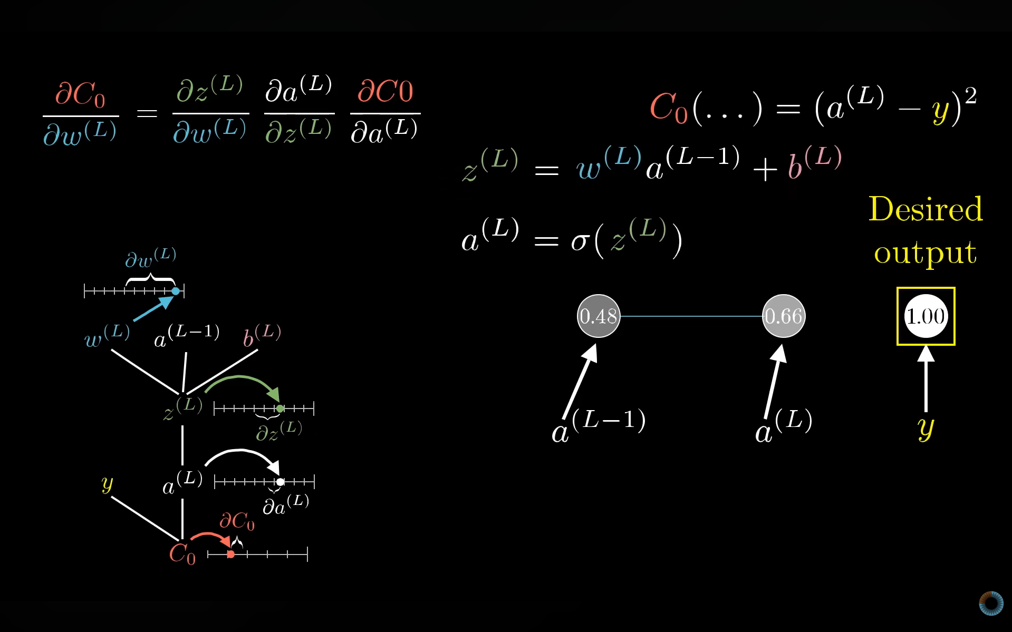

Working of Back Propagation Algorithm
The Back Propagation algorithm involves two main steps: the Forward Pass and the Backward Pass.
1. Forward Pass Work
In forward pass the input data is fed into the input layer. These inputs combined with their respective weights are passed to hidden layers. For example in a network with two hidden layers (h1 and h2) the output from h1 serves as the input to h2. Before applying an activation function, a bias is added to the weighted inputs.
Each hidden layer computes the weighted sum (`a`) of the inputs then applies an activation function like ReLU (Rectified Linear Unit) to obtain the output (`o`). The output is passed to the next layer where an activation function such as softmax converts the weighted outputs into probabilities for classification.

2. Backward Pass
In the backward pass the error (the difference between the predicted and actual output) is propagated back through the network to adjust the weights and biases. One common method for error calculation is the Mean Squared Error (MSE).
Once the error is calculated the network adjusts weights using gradients which are computed with the chain rule. These gradients indicate how much each weight and bias should be adjusted to minimize the error in the next iteration. The backward pass continues layer by layer ensuring that the network learns and improves its performance. The activation function through its derivative plays a crucial role in computing these gradients during Back Propagation.

METHOD:
First via forward pass find the activation value at output, then find the error
Next via back propagation

