Feature: Add References

Figma Link:

1. Business Functionality
The "Add References" feature allows shippers to include custom metadata (such as Purchase Order numbers, Customer IDs, or Department codes, internal routing codes etc) to the shipments so that they can search, reconcile and audit shipments faster. physical shipping labels and electronic carrier data.
Primary Business Goals
- Audit & Reconciliation: Enabling finance teams to match shipping invoices with internal orders or POs.
- Operational Clarity: Helping warehouse recipients identify the contents or owner of a package without opening it.
- Automation: Reducing manual entry errors by dynamically mapping store-front data to carrier-specific reference fields.
- Compliance: Meeting B2B requirements (e.g., Amazon Vendor Central or Walmart DSV) that mandate PO numbers on labels.

2. Overview
Shiplo will provide a few reference fields that map to specific categories and 2-3 custom categories. Because space is limited (typically 30–40 characters), a robust system must handle truncation and validation.

Business Rules:

- Standard reference fields such as Order ID, PO, Invoice, RMA, Internal Ref and the ability for shippers to enter 3 more custom references.
- Standard Reference Fields list can be found here for EasyPost Reference Codes, Ship Engine Advanced Options
- Truncation Logic: If a value exceeds the carrier's limit (e.g., 35 characters for UPS), the system should truncate from the right or provide a warning.
- Carrier Specifics: Some carriers (like FedEx) allow specific labels for references (e.g., "P/O Number," "Invoice Number"), whereas others are just generic strings.

Workflow:
- Shipper creates/edits a shipment/order and adds references.
- Shiplo validates format rules (length/charset/required fields).
- On label purchase, Shiplo maps eligible references to:
  - ShipEngine: API : POST /v1/labels; shipping_options.custom_field1, custom_field2
  - EasyPost shipment reference metadata API: POST /v2/shipments; options.print_custom_1, print_custom_2
- References are searchable in Shiplo and included in exports/logs.
- Webhooks/events carry the Shiplo references so external systems can reconcile.

3. Functional Requirements

ID | Requirement | Description / Acceptance Criteria | Preconditions
RF-01 | Add References on Shipment/Order | User can add/edit/delete references on Order and Shipment screens (multiple references allowed). | User has edit permissions.
RF-02 | Reference Types | Provide standard types: Order ID, PO, Invoice, RMA, Internal Ref, Other + free-text label. | Feature enabled.
RF-03 | Validations | Configurable rules: min/max length, allowed characters, required types per workflow. Show inline validation.
RF-04 | Checkbox/Toggle to see if should be included in the label | Map up to 3 references to ShipEngine label_messages.reference1–reference3 when supported by the chosen carrier/service. | Label creation initiated; carrier supports label messages.
RF-05 | Search | Search shipments/orders by reference value | Records exist.
RF-06 | Exports | Include references in CSV/XLSX exports as columns (e.g., Reference1..n or flattened list). | Export initiated.
RF-07 | Webhook/Event Payload | Include references in Shiplo outbound events (label created, status updates, manifest created, pickup scheduled). | Event emitted.
RF-08 | Integrations: Order Source | Capture order_source/channel (Shopify/Woo/Wix/Magento/API) and allow rules/filters based on it. | Integration connected or set on create.
RF-09 | Audit Trail | Log reference add/edit/remove with user, timestamp, and previous value. | Audit logging enabled.
RF-10 | Permissions | RBAC: only authorized roles can edit references; others view-only. | RBAC configured.

4. Non-Functional Requirements
- Performance: Search by reference returns results < 2s (P95) for typical tenant volumes.
- Reliability: Reference updates must not block label purchase; if label printing mapping fails, shipment still proceeds and logs warning.
- Security: References treated as business identifiers; avoid storing sensitive PII in references; audit logs retained per policy.
- Compatibility: Works with ShipEngine label message reference fields where the carrier supports it.

5. Stakeholders and System Interactions

Stakeholder/System | Role / Responsibility
Shipper (User) | Adds references, uses them for search, printing, and reconciliation.
Shiplo App (Frontend) | UI for managing references, validation messages, and search filters.
Shiplo Backend | Stores references, enforces policies, maps references to carrier payload fields, emits events/webhooks.
Aggregator APIs (ShipEngine/EasyPost/Heale) | Accept label/shipment payload; may print references on label (carrier-dependent).
eCommerce Platforms (Shopify/Woo/Wix/Magento) | Provide order identifiers and channel metadata used as references.

6. Assumptions and Constraints
Assumptions
- Shippers will use references for operational identifiers (PO/Order/Invoice/RMA).
- Shiplo can store multiple references per entity (order/shipment/package).

Constraints

- Only some carriers/services support printing label reference fields; ShipEngine label messages are carrier-dependent.
- Label reference printing supports up to 3 fields when using ShipEngine label messages.
- References should not be used for sensitive PII (avoid emails/phone numbers in ref fields).

7. Use Cases / User Stories

ID | User Story | Description | Preconditions | Acceptance Criteria
RF-US-01 | Add shipment references | As a shipper, I want to add PO/Order references to shipments so I can reconcile shipments quickly. | Shipment exists; permissions granted. | References saved and visible on shipment details + list view.
RF-US-02 | Print references on label | As a shipper, I want key references printed on the shipping label to help warehouse handling. | Carrier/service supports label messages. | Up to 3 references printed using label reference fields.
RF-US-03 | Search by reference | As a shipper, I want to search shipments/orders by reference value so I can find them instantly. | Records exist. | Search returns correct matches; supports partial match (configurable).
RF-US-04 | Enforce required PO | As an admin, I want PO to be mandatory for B2B shipments so compliance is met. | Company policy enabled. | Missing PO blocks label creation with clear validation error.
RF-US-05 | Audit reference changes | As an admin, I want an audit trail of reference edits for accountability. | Audit enabled. | Add/edit/delete events logged with before/after values.

8. Sequence Diagram (High-Level Flow)

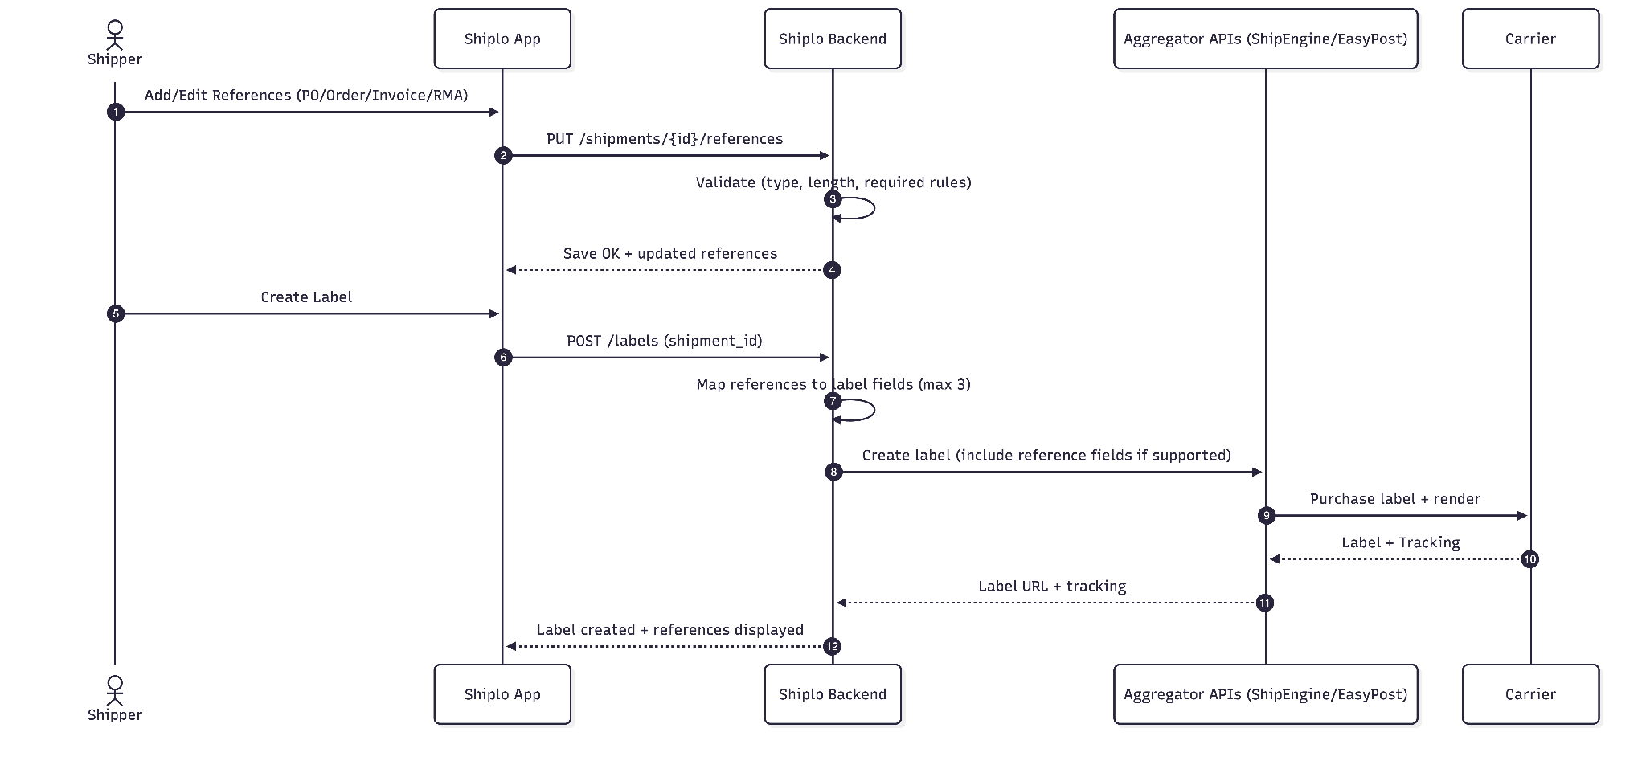

9. Technical Documentation

9.1 APIs

API Endpoint | Method | Description / Purpose
/shipments/{shipmentId}/references | GET | Fetch references linked to a shipment.
/shipments/{shipmentId}/references | PUT | Replace/update references for a shipment (supports add/edit/remove).
/orders/{orderId}/references | GET | Fetch references linked to an order.
/orders/{orderId}/references | PUT | Replace/update references for an order.
/labels | POST | Purchase label; backend maps references into aggregator payload (carrier-supported).
/webhooks/events | POST | Outbound event payload includes references for reconciliation.

9.2 Authentication & Authorization
- JWT/session auth for UI and API
- RBAC examples:
  - Admin / Ops Manager: create/edit references + configure validation policy
  - Agent: view + edit shipment references (optional)
  - Read-only: view only

9.3 Technical Considerations
- Store references as a child collection: {entity_type, entity_id, ref_type, ref_value, display_order}
- Implement mapping policy: choose the “top 3” printable references (configurable priority)
- Carrier support varies; if unsupported, omit label message fields and log a warning.
- Normalize references for search (trim, uppercase option, remove extra spaces)

10. Test Coverage
- Unit Tests: validation rules; mapping selection (top-3); audit logging.
- Integration Tests: label purchase payload includes reference fields where supported.
- System Tests: search/filter across large datasets; export includes references.
- Regression Tests: references persist across edits/merge/split/returns flows.
- Security Tests: RBAC enforcement; prevent PII leakage in logs.
- Usability Tests: inline validation clarity; reference pickers and priorities understandable.

11. Sample Screens

