DSTC 5360_07 Data Visualization for Analytics

Spring 2025 Mid-Term:

# Task 1: Comparing American and European Restaurants

## American Restaurants:

The Above scatters plot describes the performance and impact of the Americans Cuisines Restaurants in Varies Countries by plotting the AVG(Total Reviews Count) against AVG(Avg Rating), with Country as a Details.

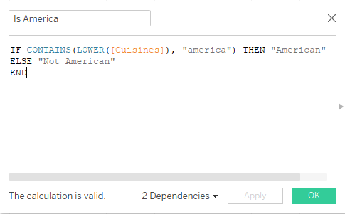

To separate the American Cuisines Restaurants from the Cuisines, we have used the above Calculated Field.

## European Restaurants

The above scatters plot describes the performance and impact of the European Cuisines Restaurants in Varies Countries by plotting the AVG (Total Reviews Count) against AVG(Avg Rating), with Country as a Details.

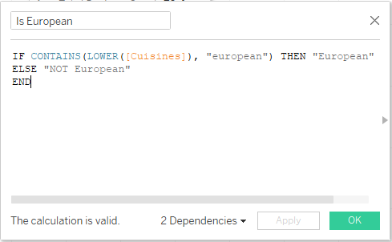

To separate the European Cuisines Restaurants from the Cuisines, we have used the above Calculated Field.

## Dashboard: Comparing American and European Restaurants

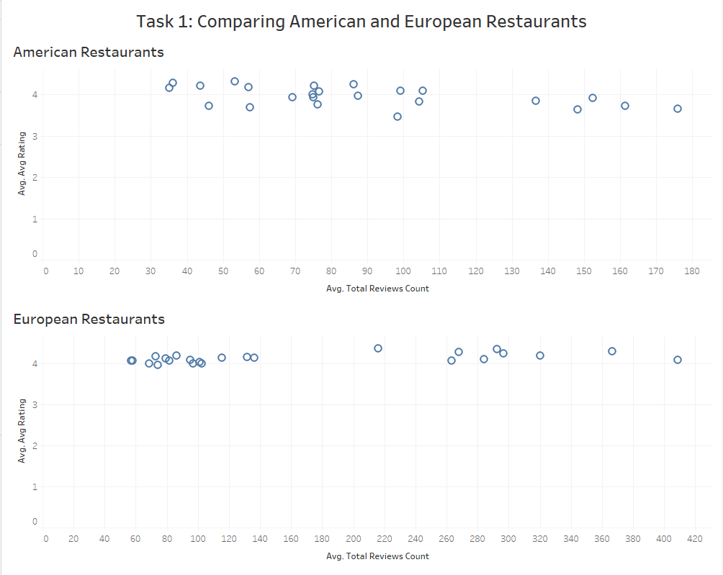

The above dashboard compares the American Cuisines Restaurants and European Cuisines Restaurants in Varies Countries.

## Question:

1. **Compare American and European restaurants' average ratings and review counts.  
   Which type of restaurant tends to have higher ratings and more reviews overall**?

* European Restaurants tends to have higher rating, and more reviews overall compared to American restaurants.

1. **Identify any countries where American or European restaurants perform  
   exceptionally well (e.g., high ratings with high review counts). Hypothesize why  
   this might be the case.**

* As per the above data, “Scotland” is the country where American or European restaurants perform exceptionally well (e.g., high rating with high review counts). Because Scotland brings together tradition and innovation, fusing traditional foods with European flair, international trends, and American flavor, to produce a rich contemporary culinary landscape celebrating local ingredients and diversity.

1. **Report any interesting patterns or differences between American and European  
   restaurants across Europe (e.g., regional preferences, consistency of ratings).**

* Most of the European Restaurants running successfully in the Europe. I think it is due to regional preferences, cuisines, and prices etc.

# Task 2: Cuisines Diversity and Price Level Analysis

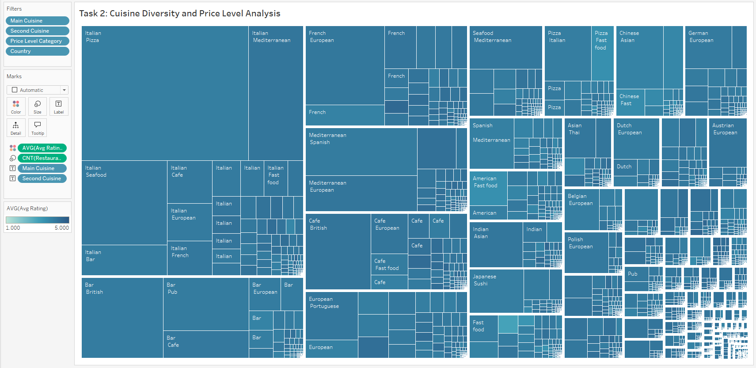

Filter the dataset to include only restaurants where Main Cuisine is not NULL. Developed a Tree map visualization with Main Cuisine on Rows, sized by the count of restaurants (CNT), coloured by AVG (Avg Rating). Filter out null values in Main Cuisine and Price. A screenshot of a computer

Created a calculation field to extract the first cuisine (Main Cuisine) from the Cuisines field,  
ensuring it is not NULL.

Use a calculation to extract the second cuisine (Second Cuisine) from the Cuisine field.

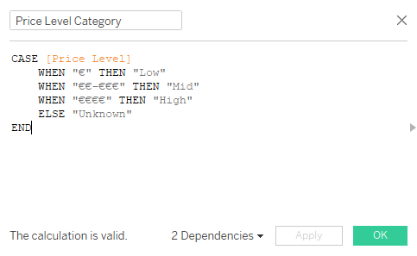

Use a calculation to categorize the price range field into three price levels: Low, Mid,  
and High, based on the grouped Price Level (group) field (e.g., € as Low, €€-€€€ as Mid,  
€€€€ as High).

## Questions:

1. **Which main cuisine has the lowest average rating, and how does its most common  
   second cuisine compare in terms of average rating?**

* Indian main Cuisine and Vietnamese second cuisine has the lowest average rating.

1. **Identify a main cuisine with a high restaurant count but a low average rating.  
   Hypothesize why this might occur across different price levels.**

* Italia main cuisine with a high restaurant counts but a low average rating. Because Some Italian restaurants may offer lower prices but compromise on quality, leading to lower ratings, and People may feel that they are not getting the value they expect for the price that they are paying.

1. **Report any interesting patterns in how prices (Low, Mid, High) are distributed  
   across main cuisines or countries (e.g., regional preferences).**

* For the most popular national cuisines, price does not influence sales, ratings, or reviews. However, for less well-known cuisines in European countries, price does have an impact.

# Task 3: Analysing Food Quality and Dietary Options

Used the provided Price Level Category field (Low, Mid, High) to categorize restaurants  
by price level. Develop a scatter plot to visualize the relationship between average food quality rating (AVG(Food)) and average overall rating (AVG (Avg Rating)), with Country as a detail, Price Level Category as a filter, and Vegetarian Friendly and Gluten Free as colour and shape dimensions respectively: Colour: Use Vegetarian Friendly (blue for No, orange for Yes). Shape: Use Gluten Free (square for No, X for Yes). Filter the dataset to include only restaurants with non-NULL values for Food and Avg Rating.

## Questions:

1. **Is there a noticeable relationship between food quality ratings (AVG(Food)) and  
   overall ratings (AVG (Avg Rating))? Provide evidence from the scatter plot.**

* There is a clear, strong, positive linear relationship between average food quality ratings and average overall ratings. The scatter plot reveals an unmistakable upward-sloping trend, indicating that as the average food quality rating rises, the average overall rating tends to increase as well.

1. **How do dietary options (Vegetarian Friendly, Gluten Free) influence the ratings?  
   Identify patterns across different price levels (Low, Mid, High).**

* Food availability (Gluten-Free and Vegetarian Friendly) appears to have a moderate, positive influence on Rating. Restaurants that offer these kinds of food are more highly rated, particularly in mid and high-end price ranges.

1. **Report on any interesting patterns related to food quality and dietary options across  
   different countries (e.g., regional differences in ratings for Vegetarian Friendly or  
   Gluten Free restaurants).**

* Many people in European countries prefer incorporating vegetarian-friendly or gluten-free options into their daily routines.

# Task 4: Independent Exploration and Dashboard Development

## Indian Restaurants:

This visualization displays data on Indian restaurants across various European countries. It uses a bar chart format, with the x-axis representing countries and the y-axis showing measure values. Two measures are compared: "Avg. Avg Rating" (average rating) and "Avg. Total Reviews Count" (average number of reviews). The chart reveals the average rating and review count for each country, allowing for quick comparisons. Notably, some countries like Bulgaria and Greece exhibit significantly higher average review counts compared to others. The average ratings, however, remain relatively consistent across different countries, hovering around 4.0-4.4.

To separate the Indian Cuisines Restaurants from the Cuisines, we have used the above Calculated Field.

## Italian Restaurants:

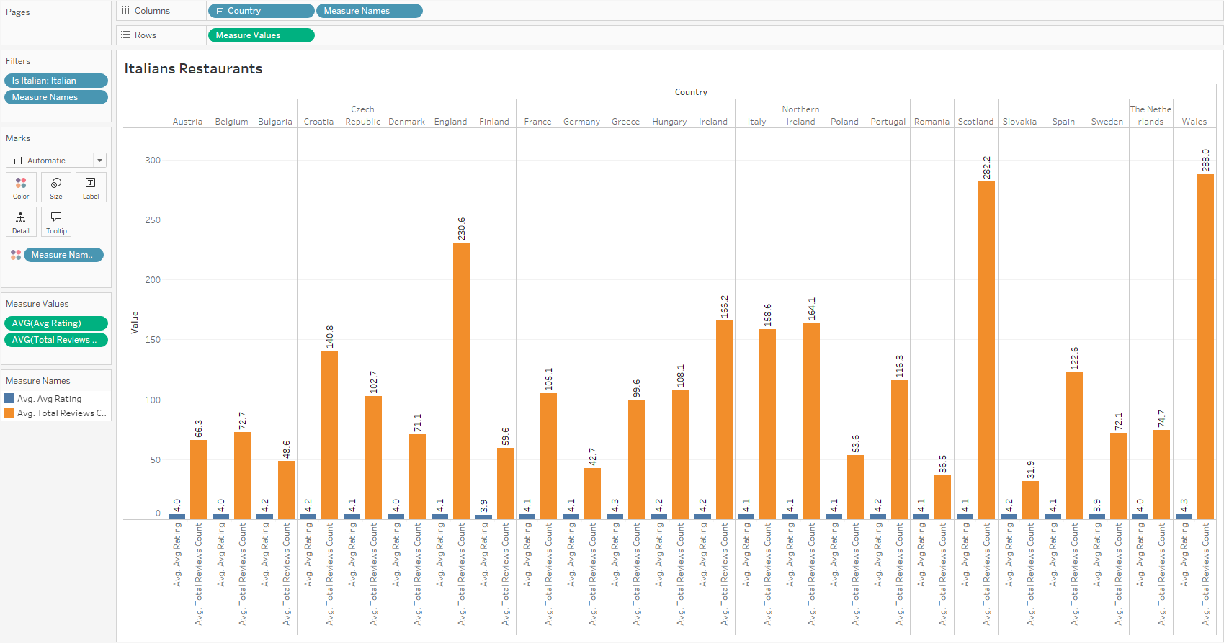

This visualization displays data on Italian restaurants across various European countries. It uses a bar chart format, with the x-axis representing countries and the y-axis showing measure values. Two measures are compared: "Avg. Avg Rating" (average rating) and "Avg. Total Reviews Count" (average number of reviews). The chart reveals the average rating and review count for each country, allowing for quick comparisons. Notably, some countries like Bulgaria and Greece exhibit significantly higher average review counts compared to others. The average ratings, however, remain relatively consistent across different countries, hovering around 3.9-4.3.

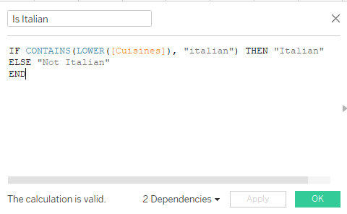

To separate the Italian Cuisines Restaurants from the Cuisines, we have used the above Calculated Field.

## Dashboard: Independent Exploration and Dashboard Development

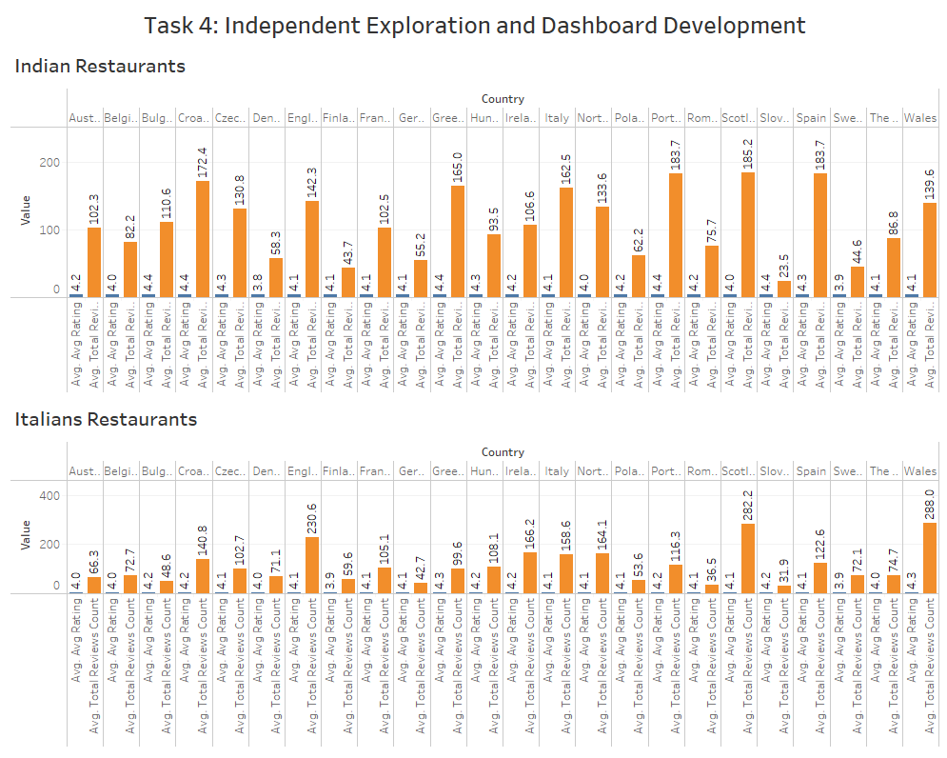

The above dashboard compares the Indian Cuisines Restaurants and Italian Cuisines Restaurants.

## Questions:

1. **What new insight did you discover, and which fields or calculations were key to this  
   discovery?**

* I have compared Indian and Italian restaurants in European countries based on their average ratings and review counts. To conduct this analysis, I utilized the 'Is Indian' and 'Is Italian' calculated fields.

1. **How do the visualizations in your dashboard work together to highlight this insight?**

* By the above two side-by-side bar chart, we can easily compare the performance and impact of the Indian and Italian Cuisines Restaurants in the European Countries and it also highlights the label to identify the value of Rating and Review Count.

1. **Suggest one potential business application or recommendation based on your insight.**

* By the above Dashboard, Scotland is the Best Country for both Indian and Italian Cuisines Restaurants Business.

# Reference:

Anon. n.d.-a. “TripAdvisor European Restaurants.” *Tableau Public*. Retrieved March 21, 2025 (https://public.tableau.com/app/profile/anatoliy.zhukov/viz/inwork_16540892832110/Dashboard1).

Anon. n.d.-b. “TripAdvisor European Restaurants Visualization.” *Tableau Public*. Retrieved March 21, 2025 (https://public.tableau.com/app/profile/safa.kazi/viz/TripAdvisorEuropeanRestaurantsVisualization/TripAdvisorEuropeanRestaurantsVisualization).

Anon. n.d.-c. “TripAdvisor Restaurants around Europe.” *Tableau Public*. Retrieved March 21, 2025 (https://public.tableau.com/app/profile/joe.stokes/viz/TripAdvisorRestaurantsaroundEurope/EuroTripadvisor).