Global Capital City Weather Analysis: Exploring Trends and Patterns

# Introduction and background:

# Our project is to find and study the trends and patterns in the climate and weather changes that have occurred in the environment and how it is impacting human beings in a daily life. This is the set which is worth studying to know the global weather patterns and how various weather parameters are interconnected. After observing the sudden change in the weather forecast, I developed the personal interest in examining the weather changes.

# Objective and Goals:

We are conducting this project to study the weather and climate changes of the world’s prominent cities. The Project shall be the visual representation of the following questions: What are the reasons that can be held responsible for the changes in temperature among the given locations? Which continent has the most uniformly distributed HOT, COLD, and MODERATE locations? What are the reasons that can be held responsible for the changes in temperature among various locations over time? In what ways do day length (daytime hours) influence temperature trends for different months?  In how many ways does the direction of the wind influence the variation of temperature with respect today and different day lengths? Towards the end of this project, we can have shortness clearly on sudden climatic changes. It is also advantageous to the people who need clarity on how livelihood and environment need to be balanced.

# Dataset:

This dataset provides day-to-day weather information for global capital cities. Unlike forecast information, this dataset provides a comprehensive list of features indicating the actual-time weather in the world. From August 29, 2023. It provides over 40+ features like temperature, wind, pressure, rain, humidity, visibility, air quality readings etc. The dataset is valuable for Global weather pattern analysis, climate trend study, and understanding the relationship among different weather parameters which is exacted from Popular Data Provider “Kaggle Websit” with 14.5 mb memory size.

# Visualization and Data Preprocessing Plan:

1. What are the reasons that can be held responsible for the changes in temperature among the given locations?

* It is important basic question to be found out from the data provided. We have used Horizontal Bar Graph and, we have used the variables like Location Name in row, Temperature Celsius and Temperature Fahrenheit in columns, Location Name in Filter, Location Name in Colours, Measure Values in Label, i.e., Measures Values contains Temperature Fahrenheit, Temperature Celsius, Temperature Difference, Longitude, Latitude, Last Updated Epoch, Day Length(Hours), Day Length, Count of Global Weather.csv. Day Length is a Calculated Field which is used to find the length of the daytime.

1. Which continent has the most uniformly distributed HOT, COLD, and MODERATE locations?

* It is most appropriate symbol map which will classify the cities in the data into 3 categories like HOT, COLD, and MODERATE. We have used Symbol Map to represent the cities in the world map. It is most effective way to visual and answer the above question. We have used Longitude and Latitude in the Columns and Rows respectively and Country in the Filters Section, and Location Name in Details Marks and Temperature Category in Colour Marks. Temperature Category is the Calculated Field which places the cities in the HOT, COLD, MODERATE categories with the help of Temperature recorded in the cities.

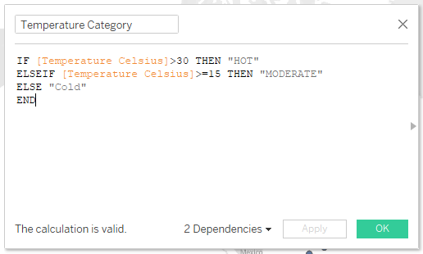

1. What are the reasons that can be held responsible for the changes in temperature among various locations over time?

* It is one of the curious questions to watch. For answering this question, we have used Lines (Continuous) Chart. To prepare the Line (Continuous) Chart, we have used Temperature Celsius and Date (Converted) on Row and Column, respectively, and Location name are under Filters, Colours Mark. In this Date (Converted) is the calculated field which will inform to convert an epoch timestamp to a day-only form. With that, it is easy to manage time-based data.

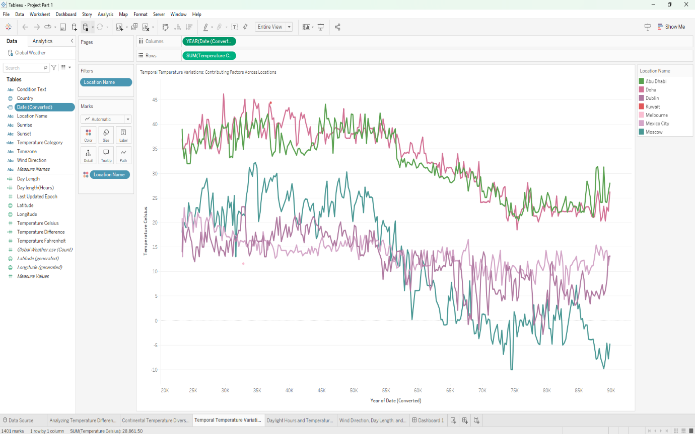

1. In what ways do day length (daytime hours) influence temperature trends for different months?

* This is most unlike chart of all the charts. It will show difference of temperature between months. We used Line (Discrete) Chart which is best to use for this question. For building the chart, we placed Month of Date (Converted) in Columns and Colour Marks, and we placed Temperature Celsius, Fahrenheit, and Difference in Rows. In this Temperature Difference is a Calculated field which is used to check for discrepancies between Fahrenheit and Celsius Values.

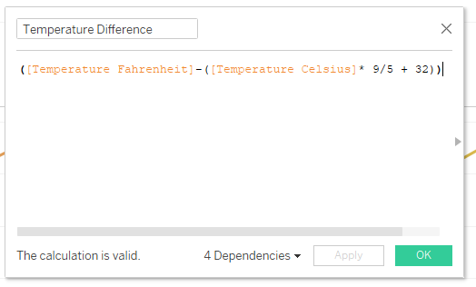

1. In how many ways does the direction of the wind influence the variation of temperature with respect today and different day lengths?

* This is a basic scatter plot (Lined) which is used to compare relation between Day Length, Wind Direction and Temperature Difference. To create this chart, we place Wind Direction in Columns, Day Length and Temperature Difference in Rows and Measure Name in Colour Marks.

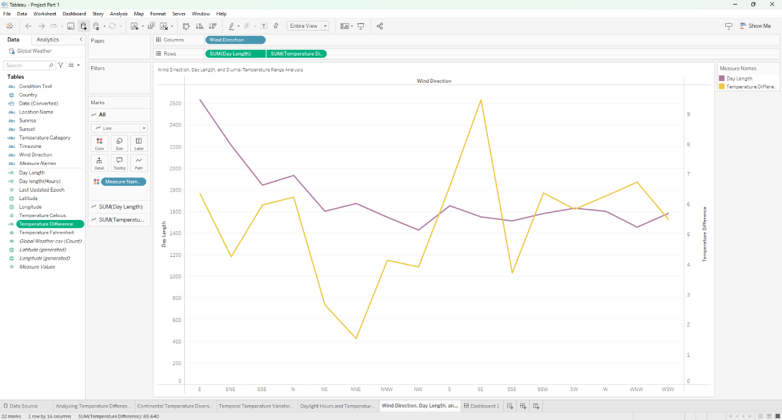

1. Dashboard Of the All 5 Draft Visualizations:

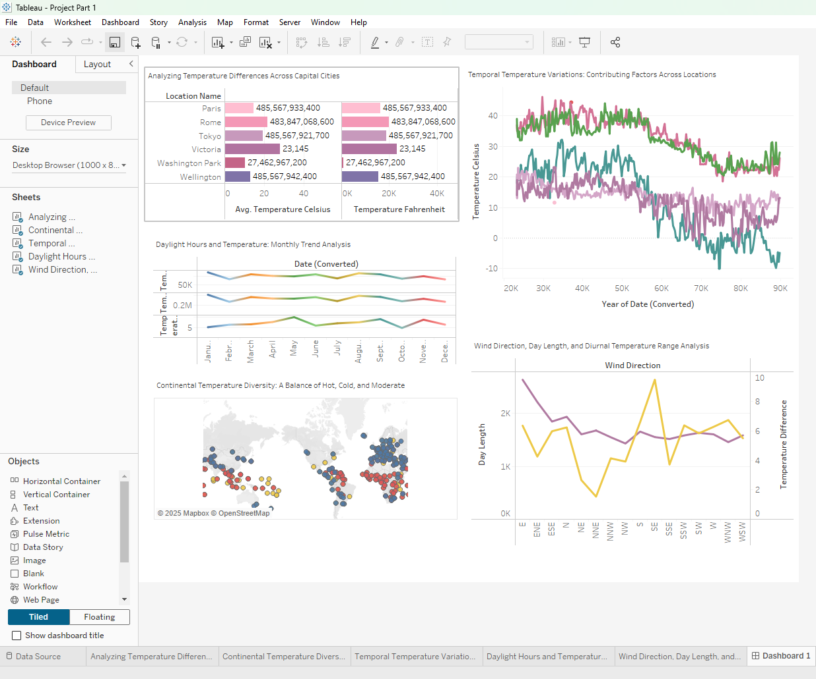

# Social Media Reactions:

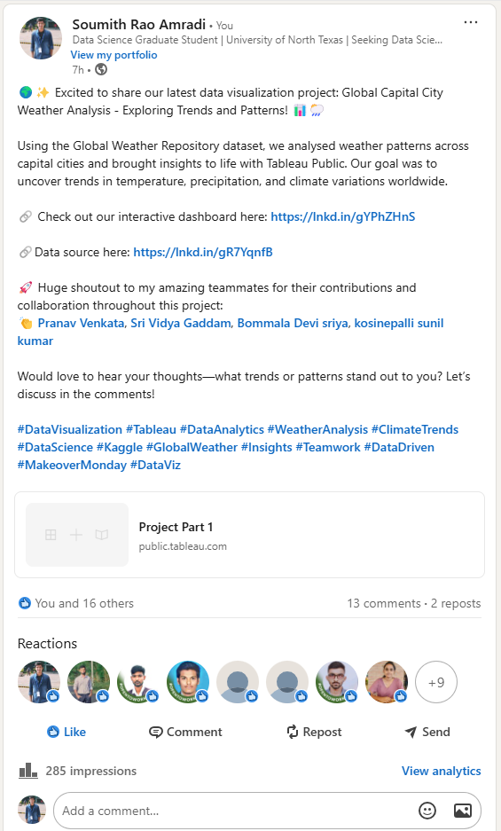

# References:

Anon. n.d.-a. “Create Proportional Symbol Maps in Tableau Example Workbook.” *Tableau Public*. Retrieved February 25, 2025 (https://public.tableau.com/app/profile/tableau.docs.team/viz/CreateProportionalSymbolMapsinTableauExampleWorkbook/Map).

Anon. n.d.-b. “Expences in Horizontal Bar.” *Tableau Public*. Retrieved February 25, 2025 (https://public.tableau.com/app/profile/tejasri8742/viz/expencesinhorizontalbar/Sheet3).

Anon. n.d.-c. “Line Chart with Line Legend.” *Tableau Public*. Retrieved February 25, 2025 (https://public.tableau.com/app/profile/jeffrey.shaffer/viz/Book2_22958/Sheet3).

Anon. n.d.-d. “Line Discrete Chart.” *Tableau Public*. Retrieved February 25, 2025 (https://public.tableau.com/app/profile/m.deepan2748/viz/linediscretechart/linediscretechart).

Anon. n.d.-e. “Scatter Plot & Line Chart.” *Tableau Public*. Retrieved February 25, 2025 (https://public.tableau.com/app/profile/shiyona.sreejith.m.k/viz/scatterplotlinechart/linechart).

# Contribution of Team Members to the Project:

1. Team Member: Devi Sriya Bommala

UNT ID: 11844596

Contribution: My contribution focused on data visualization and dataset accuracy analysis. I created visual representations such as charts, graphs, and maps to highlight weather trends, and collaborated with the team to enhance clarity and usability. I presented insights and communicated how we could further utilize weather data through interactive dashboards for decision making.

1. Team Member: Venkata Pranav Kumar Yarragolla

UNT ID: 11811575

Contribution: I gathered and prepared the dataset for a Tableau project, ensuring it was structured for effective visualizations like graphs, tables, and maps. My role involved data collection, cleaning, and optimization to enhance analytical insights.

1. Team Member: Sunil Kumar Kosinepalli

UNT ID: 11750300

Contribution: Helped with dataset collection and provided planning for data visualization. Prepared dashboards and reviewed the project to ensure everything was correct, identifying mistakes and making necessary corrections.

1. Team Member: Sri Vidya Gaddam

UNT ID: 11841395

Contribution: My contribution to this data visualization project centered around extracting the key information from the dataset and ensure a data-driven approach. I also reviewed the dataset and visualizations for accuracy and consistency, while actively working with team members to discuss observations, update insights, and enhance presentation of insights on a whole.

1. Team Member: Soumith Rao Amradi

UNT ID: 11840273

Contribution: I contributed to the project by assisting in finding relevant references for visualization based on the given questions. Additionally, I played Key role in preparing the project report, ensuring that the insights and findings were well-documented and structured effectively. My efforts helped in enhancing the clarity and effectiveness of the final presentation.