**README- DOS PROJECT 2**

WHAT IS WORKING:

The Gossip Simulator is working for both Gossip and Push-Sum algorithms and all the four topologies Full, 2D, Line and Imp2D for any number of nodes.

WHAT IS THE LARGEST NETWORK YOU MANAGED TO DEAL WITH FOR EACH TYPE OF TOPOLOGY AND ALGORITHM:

Largest network I managed to deal with for each type of topology and algorithm is:

|  |  |  |
| --- | --- | --- |
| Algorithm | Topology | Size of network |
| Gossip | Full | >1500 |
| Gossip | 2D | >1500 |
| Gossip | Line | >900 |
| Gossip | Imp2D | >2200 |
| Push-sum | Full | >5000 |
| Push-sum | 2D | >1400 |
| Push-sum | Line | >900 |
| Push-sum | Imp2D | >1400 |

Graphs Part1 :

Gossip Protocol :

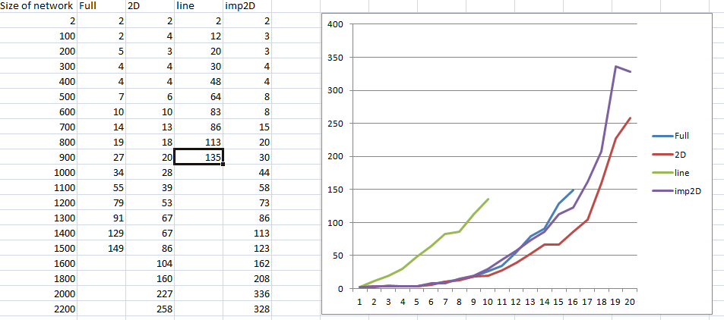

Push Sum Protocol:

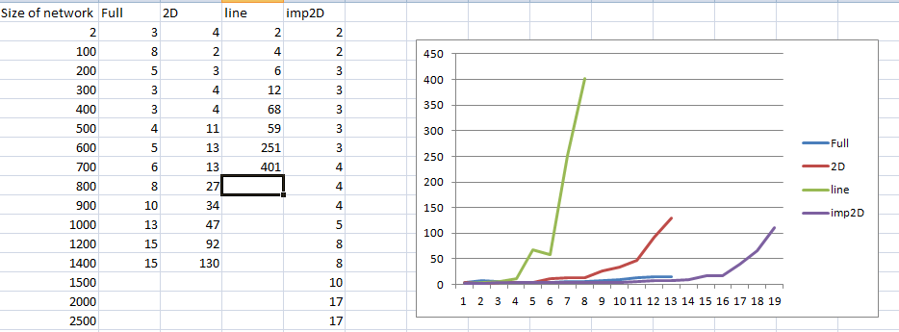

Observations :

2D topology seems to perform better than the imp2D protocol .The convergence time for imperfect2D topology are generally greater than the corresponding values of 2D topology.

There is a spike in line protocol and it rises very fast.

Bonus :

To Simulate the failure model , after initializing the nodes we randomly shutdown few nodes based on the user input.

We analyzed the Gossip protocol for failure scenario :

|  |  |  |  |  |
| --- | --- | --- | --- | --- |
| Algorithm | Topology | Size of network | convergence time(in s) | FailureNodeCount |
| gossip | full | 100 | 15 | 5 |
| gossip | full | 100 | 14 | 10 |
| gossip | full | 100 | 15 | 12 |
| gossip | full | 100 | 15 | 14 |
| gossip | full | 100 | 17 | 16 |
| gossip | full | 100 | 16 | 18 |
| gossip | full | 100 | 16 | 20 |
| gossip | full | 100 | 16 | 30 |
| gossip | full | 100 | 16 | 50 |
| gossip | full | 1000 | 30 | 100 |
| gossip | full | 1000 | 31 | 300 |
| gossip | full | 1000 | 16 | 500 |
| gossip | full | 1000 | 29 | 800 |
| gossip | 2D | 100 | 18 | 10 |
| gossip | 2D | 100 | 5 | 20 |
| gossip | 2D | 100 | NA | 30 |
| gossip | 2D | 100 | NA | 50 |
| gossip | line | 100 | NA | 30 |
| gossip | line | 100 | NA | 5 |
| gossip | line | 100 | NA | 1 |
| gossip | imp2D | 100 | 3 | 1 |
| gossip | imp2D | 100 | 14 | 5 |
| gossip | imp2D | 100 | 17 | 10 |
| gossip | imp2D | 100 | 16 | 20 |
| gossip | imp2D | 400 | 17 | 30 |
| gossip | imp2D | 500 | 17 | 50 |
| gossip | imp2D | 1000 | 28 | 100 |
| gossip | imp2D | 1000 | 31 | 200 |
| gossip | imp2D | 1000 | 13 | 300 |
| gossip | imp2D | 1000 | NA | 300 |

In the cases where convergence time is NA we needed to kill the process.

Interesting Observation:

One interesting observation that we observed was that in case of failure scenarios imp2D seems to perform better than 2D topology.