<https://solace.com/what-is-event-driven-architecture/#principles-event-driven-architecture>

*The 6 Principles of Event-Driven Architecture*

*There we have it, some main principles of event-driven architecture:*

1. Use a network of event brokers to make sure the right “things” get the right events.
2. Use topics to make sure you only send once and only receive what you need.
3. Use an event portal to design, document, and govern event-driven architecture across internal and external teams.
4. Use event broker persistence to allow consumers to process events when they’re ready (deferred execution).
5. Remember this means not everything is up to date (eventual consistency).
6. Use topics again to separate out different parts of a service (command query responsibility segregation).

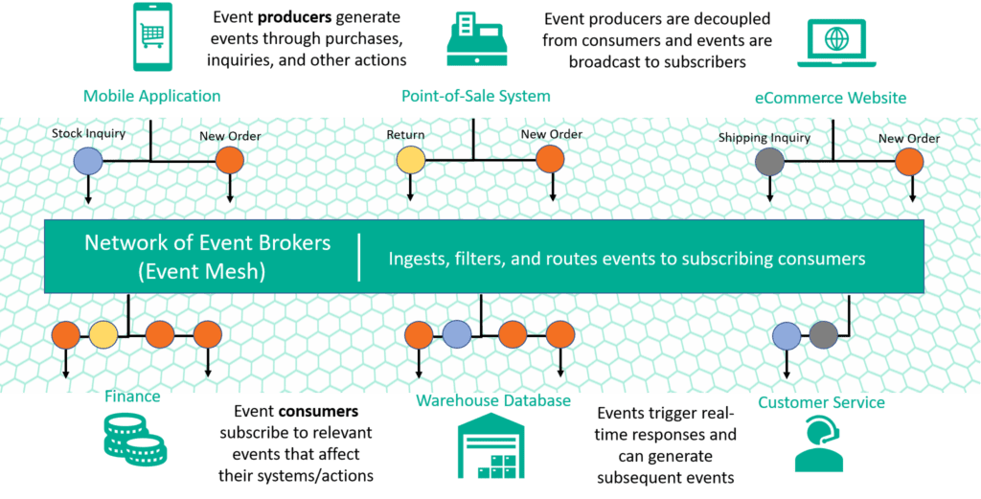

Solace provides an advanced event broker platform known for its ability to efficiently manage real-time data flow across distributed systems. The architecture of the Solace messaging platform is designed to handle high volumes of events with low latency, ensuring reliable message delivery and scalable operations.

Here is an overview of the key components and architecture of the Solace messaging platform:

**Core Components**

1. **Event Broker**:
   * The heart of the Solace platform, responsible for the routing, queuing, and delivering of messages.
   * Supports multiple messaging paradigms: publish/subscribe, request/reply, and message queuing.
   * Can be deployed on-premises, in public clouds, or in hybrid environments.
2. **Clients**:
   * Applications that publish and subscribe to messages.
   * Supported by various APIs and protocols such as JMS, MQTT, AMQP, REST, and WebSockets.
   * Clients can be written in multiple programming languages (Java, .NET, C, Python, etc.).
3. **Management Tools**:
   * **Solace PubSub+ Manager**: A web-based interface for configuring, managing, and monitoring the event broker.
   * **Solace CLI**: A command-line interface for advanced management tasks.
   * **Solace APIs**: Programmatic interfaces for automating management tasks.

**Architectural Layers**

1. **Data Plane**:
   * Handles the actual movement of messages.
   * Ensures efficient and reliable delivery with features like message persistence, high availability, and disaster recovery.
   * Implements intelligent routing to optimize the delivery path based on various criteria (e.g., topic, QoS).
2. **Control Plane**:
   * Manages the configuration, control, and monitoring of the data plane components.
   * Facilitates the dynamic discovery and configuration of clients and brokers.
   * Ensures consistent policy enforcement across the system.
3. **Management Plane**:
   * Provides interfaces and tools for monitoring and managing the overall system.
   * Supports operational tasks such as provisioning, scaling, and performance tuning.
   * Integrates with external monitoring and logging systems for comprehensive observability.

**Deployment Models**

1. **Software Event Broker**:
   * Deployed on virtual machines or bare-metal servers.
   * Offers flexibility in terms of infrastructure choice and customization.
2. **Hardware Event Broker**:
   * Purpose-built appliances optimized for high-performance messaging.
   * Provides the highest levels of throughput and low latency.
3. **Cloud Event Broker**:
   * Fully managed service available on public clouds like AWS, Azure, and Google Cloud.
   * Simplifies deployment and scaling in cloud environments.
   * Supports hybrid cloud deployments for seamless integration with on-premises systems.

**Key Features**

1. **High Performance and Scalability**:
   * Capable of handling millions of messages per second with sub-millisecond latency.
   * Supports horizontal scaling by adding more brokers to the system.
2. **Multi-protocol Support**:
   * Enables integration with diverse applications and devices using different messaging protocols.
   * Promotes interoperability and flexibility in choosing the right protocol for the use case.
3. **Security and Compliance**:
   * Provides robust security features such as TLS encryption, authentication, authorization, and audit logging.
   * Helps meet regulatory compliance requirements for secure data transmission.
4. **Disaster Recovery and High Availability**:
   * Implements mechanisms for fault tolerance and data redundancy.
   * Ensures continuous availability and quick recovery from failures.
5. **Operational Visibility**:
   * Comprehensive monitoring and analytics capabilities.
   * Helps in proactively identifying and resolving performance bottlenecks and issues.

**Use Cases**

* **Financial Services**: Real-time market data distribution, trade processing, and risk management.
* **IoT**: Data collection, processing, and command-and-control for IoT devices.
* **Telecommunications**: Network management, real-time billing, and customer experience management.
* **Healthcare**: Secure and timely sharing of patient data and medical records.
* **Retail**: Real-time inventory management, order processing, and personalized customer experiences.

Solace’s architecture is designed to provide a robust, scalable, and flexible messaging platform that meets the needs of modern, real-time applications across various industries.

***Solace vs Kafka***

Both Solace and Apache Kafka are robust messaging platforms used for building event-driven architectures, but they have different design philosophies, strengths, and use cases. Here’s a detailed comparison of Solace and Kafka across various dimensions:

**1. Architecture and Design**

* **Solace:**
  + **Event Broker Model:** Solace uses a centralized event broker model designed for high performance and low latency.
  + **Multi-Protocol Support:** Solace supports multiple protocols, including JMS, MQTT, AMQP, REST, and WebSockets, providing flexibility for various use cases.
  + **Intelligent Routing:** Solace includes built-in support for intelligent message routing, including topic-based, content-based, and header-based routing.
* **Kafka:**
  + **Distributed Log Model:** Kafka is based on a distributed commit log model, which ensures durability and order of messages.
  + **Topic-Centric:** Kafka relies heavily on the concept of topics for message organization and partitioning.
  + **Pull-Based Consumption:** Consumers pull data from Kafka topics, allowing them to read messages at their own pace.

**2. Performance and Scalability**

* **Solace:**
  + **High Throughput:** Solace is known for its high throughput and low latency, capable of handling millions of messages per second.
  + **Horizontal Scalability:** Solace can scale horizontally by adding more brokers, though it typically scales within a single broker more effectively.
* **Kafka:**
  + **Horizontal Scalability:** Kafka is designed to scale horizontally by adding more brokers and partitions, which distribute the load.
  + **Throughput and Latency:** Kafka also offers high throughput but might have higher latencies compared to Solace in some scenarios, especially for small messages.

**3. Message Delivery and Durability**

* **Solace:**
  + **Guaranteed Delivery:** Solace supports different levels of QoS, including at-most-once, at-least-once, and exactly-once delivery semantics.
  + **Durability:** Messages can be persisted in the broker to ensure durability.
* **Kafka:**
  + **Durability:** Kafka's log-based architecture inherently supports message durability. Messages are persisted to disk and replicated across brokers.
  + **Delivery Semantics:** Kafka supports at-most-once and at-least-once semantics natively. Exactly-once semantics can be achieved with additional configuration and use of idempotent producers and transactional writes.

**4. Protocol and API Support**

* **Solace:**
  + **Multi-Protocol Support:** Solace supports a wide range of protocols, making it versatile for different applications (JMS, MQTT, AMQP, REST, etc.).
  + **Broad Client Support:** Solace provides client libraries for many programming languages, enhancing integration flexibility.
* **Kafka:**
  + **Kafka Protocol:** Kafka has its own protocol and API, which are highly optimized for its architecture.
  + **Client Libraries:** Kafka has official client libraries for Java, and a wide range of third-party libraries for other languages (Python, Go, .NET, etc.).

**5. Operational Management and Monitoring**

* **Solace:**
  + **Comprehensive Management Tools:** Solace offers a web-based management interface, CLI, and APIs for configuration, management, and monitoring.
  + **Monitoring and Analytics:** Provides built-in support for operational visibility and performance monitoring.
* **Kafka:**
  + **Operational Tools:** Kafka requires additional tools for comprehensive management and monitoring (e.g., Confluent Control Center, Kafka Manager).
  + **Metrics and Monitoring:** Exposes metrics via JMX, which can be integrated with monitoring tools like Prometheus and Grafana.

**6. Ecosystem and Integrations**

* **Solace:**
  + **Integration Capabilities:** Solace integrates well with various enterprise systems and cloud services. It supports hybrid deployments and edge computing scenarios.
  + **Cloud and IoT:** Solace excels in environments requiring multi-cloud and IoT integrations.
* **Kafka:**
  + **Rich Ecosystem:** Kafka has a strong ecosystem, including Kafka Streams for stream processing, Kafka Connect for integration, and Confluent Platform for enhanced features.
  + **Community and Support:** Kafka has a large open-source community and commercial support from Confluent, which extends its capabilities and provides enterprise features.

**7. Use Cases**

* **Solace:**
  + **Real-Time Event Streaming:** Ideal for low-latency event streaming and messaging in financial services, telecommunications, and IoT.
  + **Multi-Protocol Environments:** Suitable for environments that require support for multiple messaging protocols.
* **Kafka:**
  + **Data Integration:** Frequently used for building data pipelines, stream processing, and event sourcing.
  + **Scalable Data Ingestion:** Commonly used in big data and analytics scenarios where large volumes of data need to be ingested and processed.

**Summary**

Both Solace and Kafka are powerful platforms with distinct advantages. Solace excels in multi-protocol support, low-latency messaging, and flexible deployment options, making it suitable for diverse real-time applications. Kafka's strengths lie in its distributed architecture, scalability, and rich ecosystem, making it a preferred choice for data integration and large-scale stream processing. The choice between them depends on specific use case requirements, existing infrastructure, and desired features.

<https://solace.com/differences/kafka/product-architecture/>