1. Pre-Internship Aptitude & Logic Assignment

Aptitude Questions

Q1. A train 360 m long is running at 45 km/h. In what time will it pass a bridge 140 m long?
Solution:
Total distance = Length of train + Length of bridge
= 360 + 140
= 500 m
Speed = 45 km/h
= (45 × 1000)/3600
= 12.5 m/s
Time = Distance ÷ Speed
= 500 ÷ 12.5
= 40 seconds
Answer: 40 seconds

Q2. The ratio of ages of two persons is 4:5 and their sum is 72.
Let ages be 4x and 5x.
4x + 5x = 72
9x = 72
x = 8
First age = 4 × 8 = 32
Second age = 5 × 8 = 40
Answer: 32 years and 40 years

Q3. A shopkeeper buys 80 articles for ₹2400 and sells them at 16% profit.
Cost price per article
= 2400 ÷ 80
= ₹30
Profit = 16% of 30
= ₹4.8
Selling price
= 30 + 4.8
= ₹34.8
Answer: ₹34.80 per article

2. Logical Reasoning

Q1. Find the next number in the sequence:
2, 6, 12, 20, ?
Pattern:
1² + 1 = 2
2² + 2 = 6
3² + 3 = 12
4² + 4 = 20
5² + 5 = 30
Answer: 30

Q2. If "MANGO" is written as "NZOHF", how is "APPLE" written?
Pattern:
M → N (+1)
A → Z (-1)
N → O (+1)
G → H (+1)
O → F (-1)
Applying same style:
A → B
P → O
P → Q
L → M
E → D
Answer: BOQMD

Q3. Statements:
- All engineers are hardworking.
- Some hardworking people are teachers.

Conclusions:
- Some engineers are teachers → Cannot be concluded.
- All engineers are hardworking → True.
- Some teachers are hardworking → True.
Answer: Conclusions 2 and 3 follow.

3. Programming Logic

Q1. Pseudocode to calculate factorial

START

INPUT n

factorial = 1

FOR i = 1 TO n

factorial = factorial * i

END FOR

PRINT factorial

STOP

Q2. Pseudocode to print even numbers from 1 to 20
START
FOR i = 1 TO 20
IF i MOD 2 = 0
PRINT i
END IF
END FOR
STOP

Q3. Trace logic to sum even numbers between 1 and 5
Even numbers:
2, 4
Sum = 2 + 4
= 6
Answer: 6

4. Data Interpretation
Assume the following enrollment data:
YEAR | AI | ML | DS
2020 | 120 | 100 | 80
2021 | 150 | 120 | 100
2022 | 190 | 160 | 140
2023 | 240 | 210 | 180

Total DS Students:
80 + 100 + 140 + 180
= 500

Highest Growth Course:
AI Growth = 240 − 120 = 120
ML Growth = 210 − 100 = 110
DS Growth = 180 − 80 = 100
Highest Growth: AI

Average AI Enrollment:
(120 + 150 + 190 + 240) ÷ 4
= 700 ÷ 4
= 175

3. Engaging Assignments
1. Mini Data Hunt - https://www.kaggle.com/competitions/titanic (Titanic Dataset)

Dataset Overview
- Total Passengers: 891
- Total Features (Columns): 12
- Dataset Type: Survival Analysis
- Find the Youngest Person
Name: Thomas, Master. Assad Alexander
Age: 0.42 years
- Find the Oldest Person
Name: Barkworth, Mr. Algernon Henry Wilson
Age: 80 years

- Most Frequent Category

Gender Distribution
- Male: Majority
- Female: Minority
Most Frequent Category: Male

- Highest Value

Highest Fare Paid
Fare: £512.3292

2. Meme Logic Challenge
Dataset used - https://www.kaggle.com/datasets/gpreda/reddit-wallstreetsbets-posts (Reddit Memes Dataset)

Example 1:
"It's not about the money, it's about sending a message 🚀💎🙌"

What's Wrong?
The statement ignores the primary purpose of investing (earning returns) and focuses entirely on emotion.

Suggested Correction
Invest based on research, risk assessment, and financial goals rather than emotions.

Example 2:

"Math Professor Scott Steiner says the numbers spell DISASTER for Gamestop shorts"

What's Wrong?
The statement exaggerates conclusions without presenting actual financial evidence.

Suggested Correction
Use verified market data and financial analysis before making conclusions.

Example 3:
"Exit the system"

What's Wrong?
Suggests abandoning the entire financial system because of a specific market event.

Suggested Correction
Evaluate individual issues objectively rather than rejecting an entire system.

Example 4:
"Can someone less retarded than me interpret this SEC filing?"

What's Wrong?
Assumes that complex financial documents can be understood without effort or learning.

Suggested Correction
Research financial terminology and consult reliable sources before making decisions.

Example 5:
"Buy now and become rich" (common WSB sentiment)

What's Wrong?
Assumes profit is guaranteed.

Suggested Correction
Acknowledge market risks and conduct proper analysis before investing.

3. Dataset Storytelling
Dataset used - https://www.kaggle.com/datasets/pavansubhasht/ibm-hr-analytics-attrition-dataset (HR Workforce Analysis)
A recent analysis of the company’s HR database revealed a workforce of 16,715 employees operating across multiple departments in Ohio. Engineering emerged as the largest department, employing more than 5,000 workers, highlighting the organization's strong focus on technical operations and innovation. Accounting ranked second, followed by Sales, Human Resources, and Services.
The workforce shows a relatively balanced gender distribution, with male employees slightly outnumbering female employees. The dataset also indicates that most positions are currently filled, with only a small percentage of roles remaining open. This suggests stable staffing levels and effective workforce planning.
Human resource experts note that the strong presence of engineering professionals reflects growing demand for technical talent in modern organizations. Meanwhile, support functions such as accounting and human resources continue to play a critical role in maintaining business operations.
Overall, the data portrays a well-established organization with a diverse workforce and a significant emphasis on engineering excellence.

4. Pair Programming Logic Puzzle
Problem 1: Print Prime Numbers from 1 to 50
print("Prime Numbers from 1 to 50:")
for num in range(2, 51):
is_prime = True
for i in range(2, int(num**0.5) + 1):
if num % i == 0:
is_prime = False
break
if is_prime:
print(num, end=" ")

Problem 2: Find the Second Largest Number

Python Code
numbers = [10, 45, 23, 67, 89, 34]
numbers.sort()
print("Second Largest Number:", numbers[-2])

Problem 3: Reverse a Number

Python Code
num = 12345
reverse = int(str(num)[::-1])
print("Reversed Number:", reverse)

Problem 4: Check Palindrome Number

Python Code
num = 121
if str(num) == str(num)[::-1]:
print("Palindrome")
else:
print("Not Palindrome")

Problem 5: Find Largest Number in a List

Python Code
numbers = [25, 18, 67, 89, 45]
largest = max(numbers)
print("Largest Number:", largest)

5. Chart the Weird Challenge
Dataset used - https://www.kaggle.com/datasets/kaggle/us-baby-names
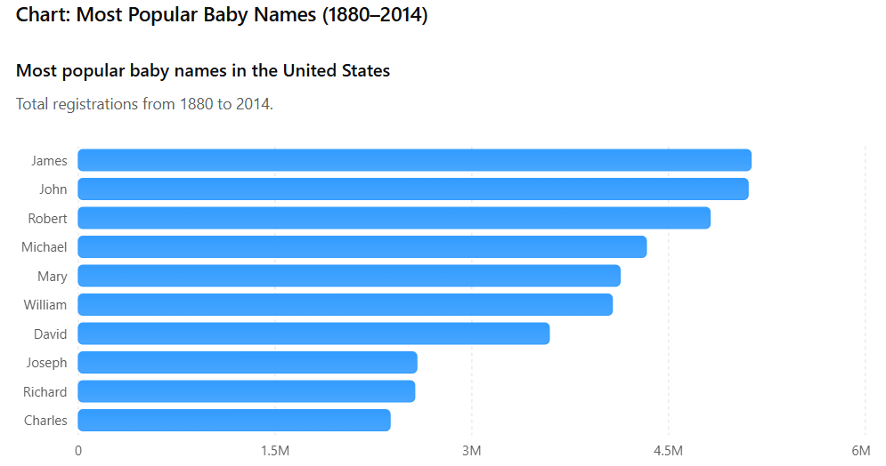
Caption:
The baby names dataset provides a fascinating look into more than a century of naming trends in the United States. The chart reveals that James and John were the most popular names overall, each being assigned to more than five million babies between 1880 and 2014. Traditional names such as Robert, William, Mary, and Charles also remained consistently popular across generations. The dominance of these names suggests that cultural traditions and family influences played a significant role in naming choices. Although modern parents tend to choose more unique names, historical records show that a small group of classic names shaped the identities of millions of Americans. This analysis highlights how social preferences evolve over time while certain names continue to maintain enduring popularity.

