### Performance Analysis

### Performance of DDL Statement in local vs RDS:

Screenshots of DDL Statement in local:

Create statement:

DROP Statement:

Screenshots of DDL Statement in RDS:

Create statement:

DROP Statement:

Screenshots of DML Statement in Local:

Insert Statement:

Select Statement that fetches thousands of rows:

Select statement that fetches 100s of rows:

Screenshots of DML Statement in AWS RDS:

Insert Statement:

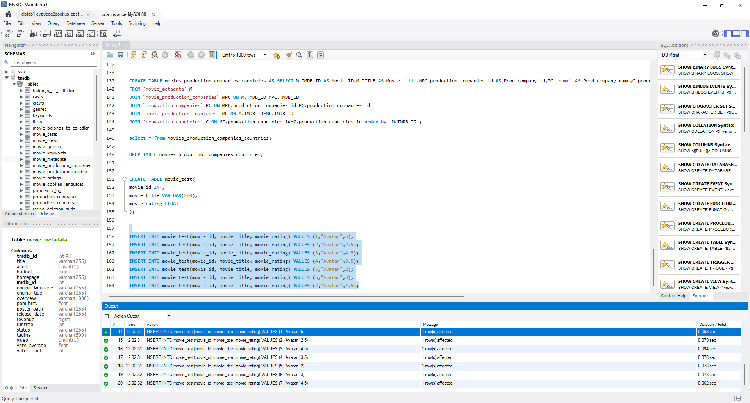

Select Statement that fetches 1000s of rows:

Select Statement that fetches 100s of rows:

|  |  |  |  |  |
| --- | --- | --- | --- | --- |
| S.NO | Command | DML/DDL | Local Instance- Time Taken in seconds | AWS RDS- Time Taken  in seconds |
| 1 | CREATE | DDL | 0.031 | 0.156 |
| 2 | DROP | DDL | 0.031 | 0.125 |
| 3 | INSERT | DML | 0.000 | 0.078 |
| 4 | SELECT | DML | 0.047 | 0.109 |

By analyzing the time taken, we see that the performance in local is faster than RDS for both DDL and DML commands.