## SQL Queries

1. Find all comedy movies.

SELECT m.title, k.`name`

FROM movie_metadata m

INNER JOIN movie_keywords mk ON m.tmdb_id = mk.tmdb_id

JOIN keywords k ON mk.keywords_id = k.keywords_id

WHERE k.`name` = 'Comedy';

Screenshot 1:

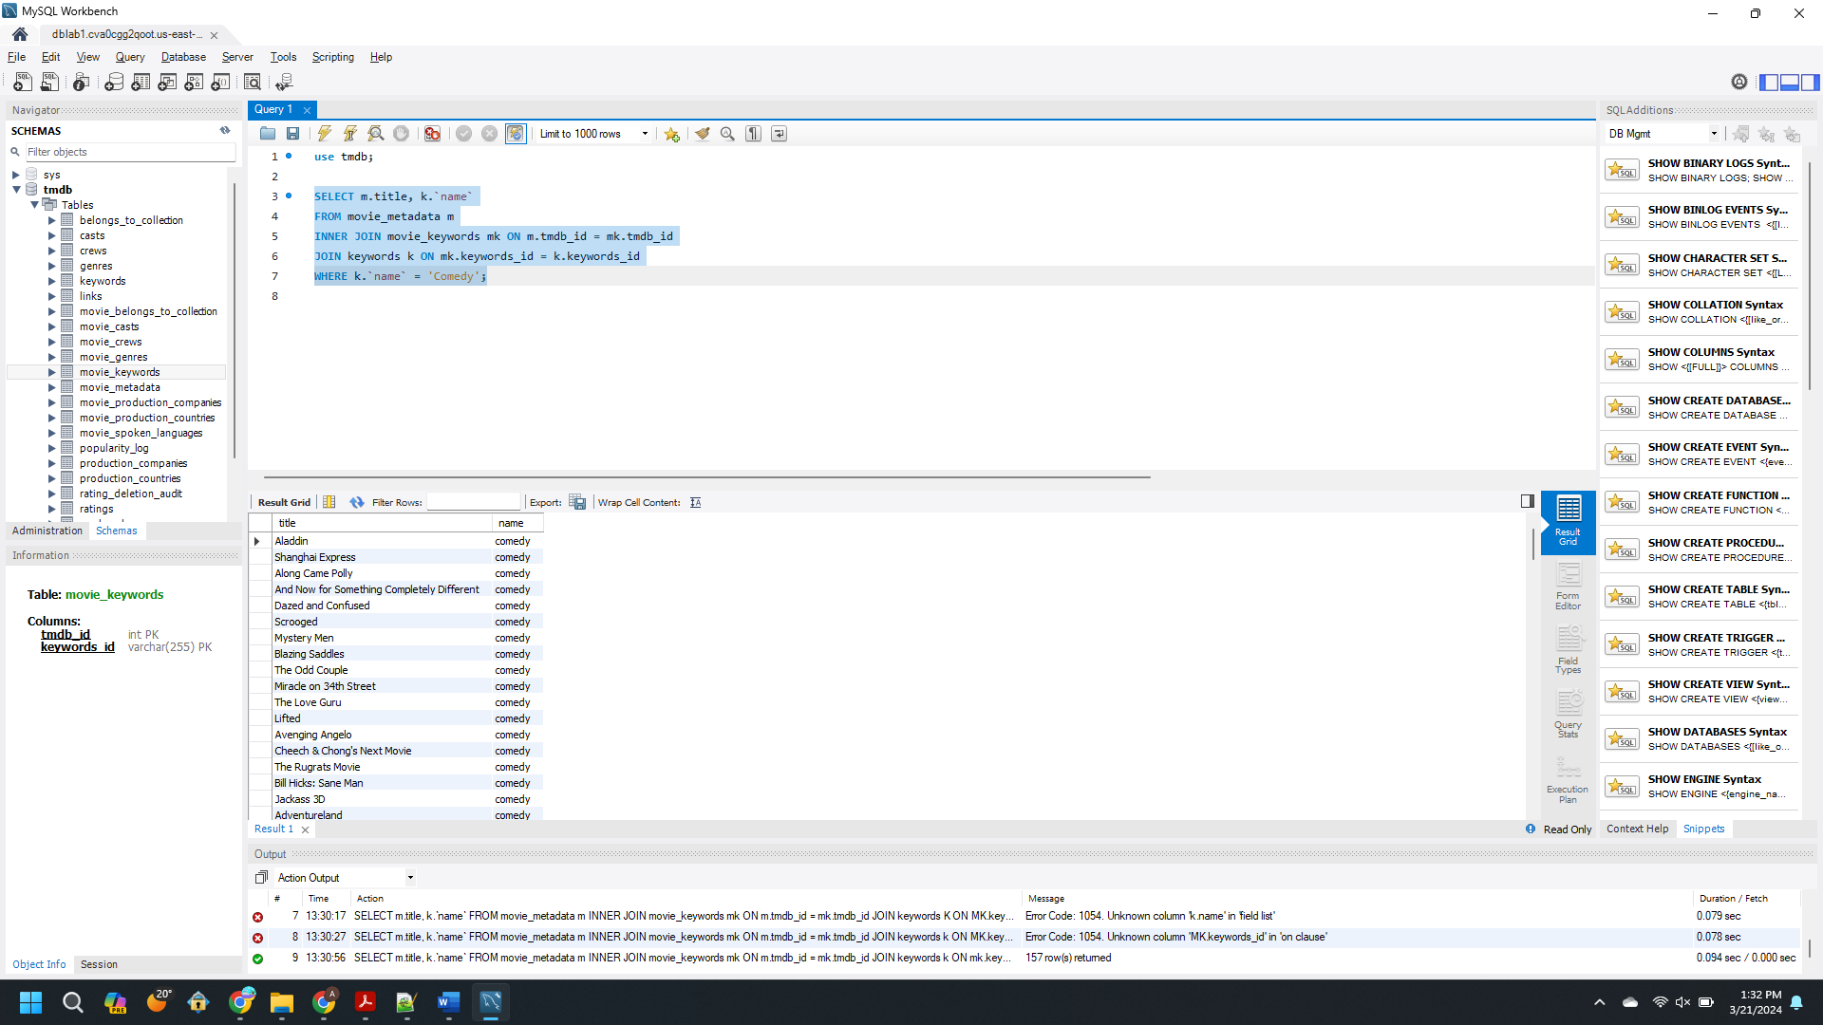

2. Get the average rating of movies and order by highly rated movies.

SELECT m.title, AVG(r.rating) AS average_rating

FROM movie_metadata m

JOIN links l ON m.tmdb_id=l.tmdb_id

JOIN ratings r ON l.movie_id = r.movie_id GROUP BY m.title ORDER BY average_rating DESC;

Screenshot 2:

3. Get the cast and crew of Ariel movie.

SELECT mcr.tmdb_id,m.title,ca.cast_id,ca.name as Cast_name,ca.character_name,cr.id as crew_id,cr.name as crew_name,cr.department,cr.job FROM

movie_crews mcr

JOIN movie_casts mc on mcr.tmdb_id=mc.tmdb_id

JOIN `casts` ca ON mc.credit_id=ca.credit_id

JOIN crews cr ON mcr.credit_id=cr.credit_id

JOIN links l ON l.tmdb_id=mcr.tmdb_id

JOIN movie_metadata m ON l.tmdb_id=m.tmdb_id where m.title="Ariel";

Screenshot 3:

4. Fetch the movies production company and country.

SELECT M.TMDB_ID AS MOVIE_ID,M.TITLE,MPC.production_companies_id,PC.`name`,C.production_countries_id,C.`name` FROM `movie_metadata` M

JOIN `movie_production_companies` MPC ON M.TMDB_ID=MPC.TMDB_ID

JOIN `production_companies` PC ON MPC.production_companies_id=PC.production_companies_id

JOIN `movie_production_countries` MC ON M.TMDB_ID=MC.TMDB_ID

JOIN `production_countries` C ON MC.production_countries_id=C.production_countries_id order by M.TMDB_ID ;

Screenshot 4:

5. Fetch the collection that has more than 50 movies.

Query 5:

Select BC.name AS Collection_name, count(M.title) AS Number_of_Movies from `movie_belongs_to_collection` MBC

JOIN movie_metadata M ON MBC.tmdb_id=M.tmdb_id

JOIN belongs_to_collection BC ON MBC.belongs_to_collection_id=BC.belongs_to_collection_id

Group by BC.NAME having Number_of_Movies>10 order by Number_of_Movies;

Screenshot 5:

6. Top 10 movies based on revenue generated

SELECT

original_title AS 'Movie Title',

FORMAT(budget / 1000000, 2) AS 'Budget in Millions',

FORMAT(revenue / 1000000, 2) AS 'Revenue in Millions',

FORMAT((revenue - budget) / 1000000, 2) AS 'Profit in Millions'

FROM

movie_metadata

ORDER BY revenue DESC

LIMIT 10;

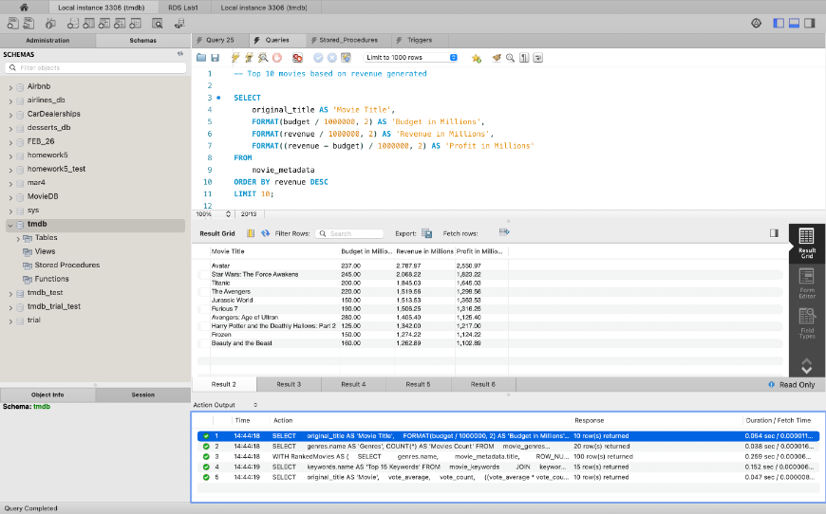

7. Number of Movies in each genre

SELECT

genres.name AS 'Genres', COUNT(*) AS 'Movies Count'

FROM

movie_genres

JOIN

genres ON genres.genres_id = movie_genres.genres_id

GROUP BY movie_genres.genres_id

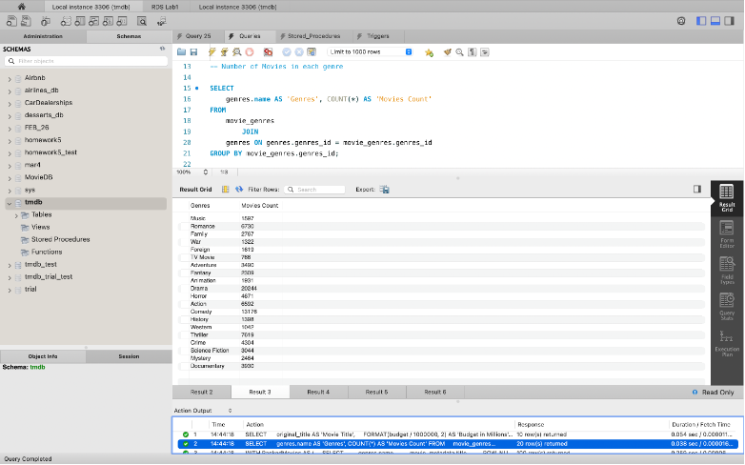

8. Top 5 movies based on Popularity score in each genre

WITH RankedMovies AS (

SELECT

genres.name,

movie_metadata.title,

ROW_NUMBER() OVER(PARTITION BY movie_genres.genres_id ORDER BY movie_metadata.popularity DESC) AS genre_rank

FROM

movie_genres

JOIN

movie_metadata ON movie_metadata.tmdb_id = movie_genres.tmdb_id

JOIN

genres on genres.genres_id = movie_genres.genres_id

)

SELECT

genre_rank AS 'Popularity Rank',

name AS 'Genres',

title AS 'Movie name'

FROM

RankedMovies

WHERE

genre_rank <= 5;

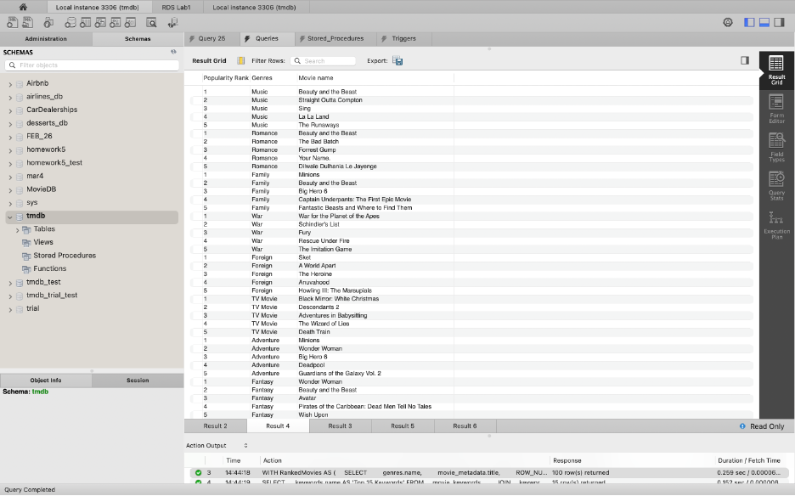

9. Top 15 Keywords

SELECT

keywords.name AS 'Top 15 Keywords'

FROM

movie_keywords

JOIN

keywords ON keywords.keywords_id = movie_keywords.keywords_id

GROUP BY movie_keywords.keywords_id

ORDER BY COUNT(*) DESC

LIMIT 15;

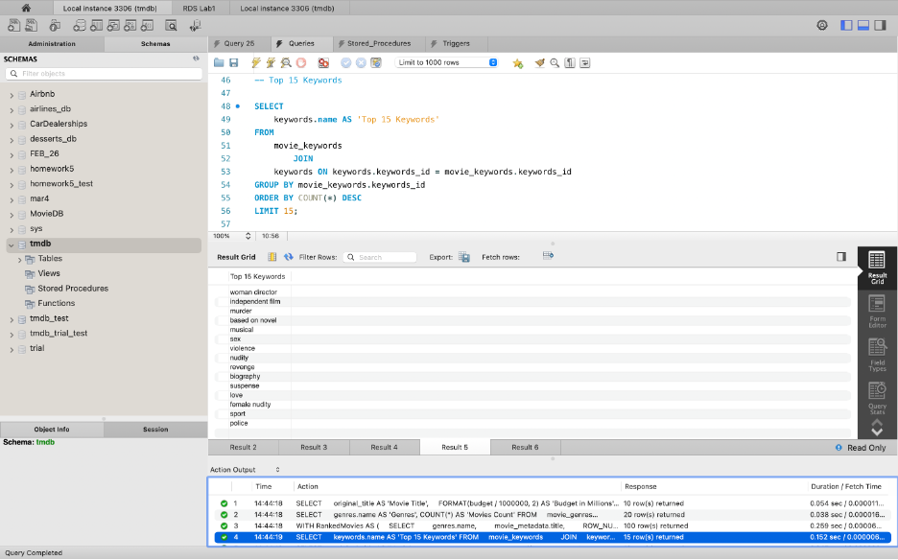

10. Weighted Rating based on Number of Votes and Vote Average

SELECT

original_title AS 'Movie',

vote_average,

vote_count,

((vote_average * vote_count) + ((SELECT

AVG(vote_average)

FROM

movie_metadata) * 109)) / (vote_count + 109) AS weighted_rating

FROM

movie_metadata

ORDER BY weighted_rating DESC

LIMIT 5;

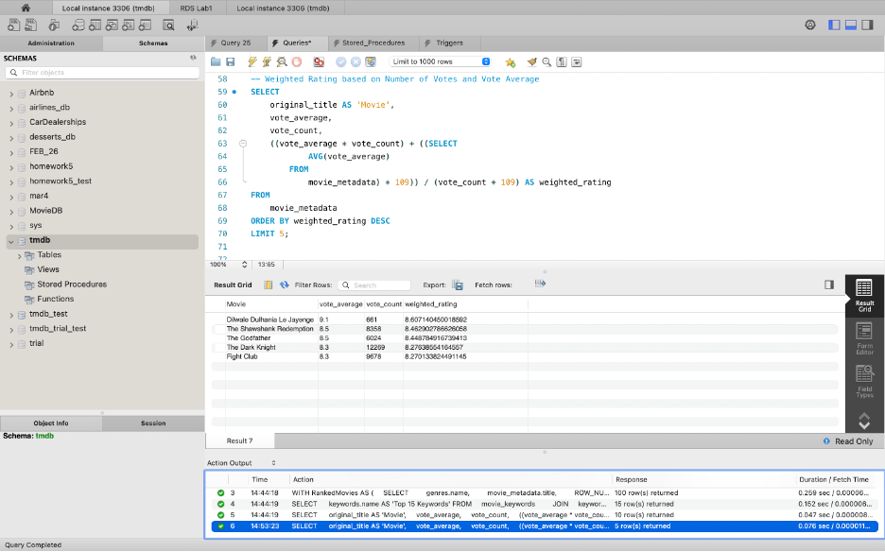

## Views

CREATE VIEW movie_details AS

SELECT mm.*, mbc.belongs_to_collection_id, mg.genre_id, mk.keyword_id

FROM movie_metadata AS mm

JOIN movie_belongs_to_collection AS mbc ON mm.tmdb_id = mbc.tmdb_id

JOIN movie_genres AS mg ON mm.tmdb_id = mg.tmdb_id

JOIN movie_keywords AS mk ON mm.tmdb_id = mk.tmdb_id;

