1. Enforce a unique constraint on movie title and release year to prevent duplicate entries:

Trigger 1:

DELIMITER $$

CREATE TRIGGER enforce_unique_title_year

BEFORE INSERT ON movie_metadata

FOR EACH ROW

BEGIN

DECLARE existing_movie INT;

SELECT COUNT(*) INTO existing_movie

FROM movie_metadata

WHERE title = NEW.title AND release_date = NEW.release_date;

IF existing_movie > 0 THEN

SIGNAL SQLSTATE '45000' SET MESSAGE_TEXT = 'Duplicate movie entry!';

END IF;

END

$$

DELIMITER ;

INSERT INTO movie_metadata (tmdb_id,title,release_date) VALUES (2,"Ariel","1988-10-21");

Screenshot 1:

1. Maintain a table with the latest average rating for each movie (instead of updating the movie table directly):

Trigger 2:

DELIMITER $$

CREATE TRIGGER update_average_rating_log

AFTER INSERT ON ratings

FOR EACH ROW

BEGIN

INSERT INTO movie_ratings (movie_id, rating_date, average_rating)

VALUES (NEW.movie_id, CURDATE(), (

SELECT AVG(rating) FROM ratings WHERE movie_id = NEW.movie_id

));

END

$$

INSERT INTO ratings(user_id,movie_id,rating) values (1,2,5);

SELECT * from movie_ratings;

Screenshot 2:

1. Trigger to prevent negative ratings:

Trigger 3:

DELIMITER $$

CREATE TRIGGER prevent_negative_rating

BEFORE INSERT ON ratings

FOR EACH ROW

BEGIN

DECLARE rating_valid INT;

SET rating_valid = (NEW.rating >= 0 AND NEW.rating <= 5);

IF NOT rating_valid THEN

SIGNAL SQLSTATE '45000' SET MESSAGE_TEXT = 'Rating must be between 0 and 5!';

END IF;

END

$$

INSERT INTO ratings(user_id,movie_id,rating) values (1,2,-5);

Screenshot:

1. Trigger to keep track of popularity score updation

DELIMITER //

CREATE TRIGGER log_popularity_update

AFTER UPDATE ON movie_metadata

FOR EACH ROW

BEGIN

IF OLD.popularity <> NEW.popularity THEN

INSERT INTO popularity_log (tmdb_id, old_popularity, new_popularity, updated_at)

VALUES (NEW.tmdb_id, OLD.popularity, NEW.popularity, NOW());

END IF;

END //

DELIMITER ;

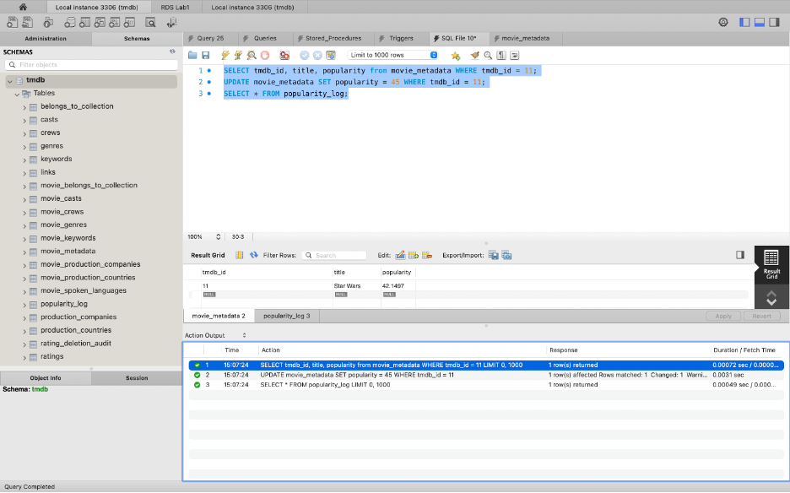

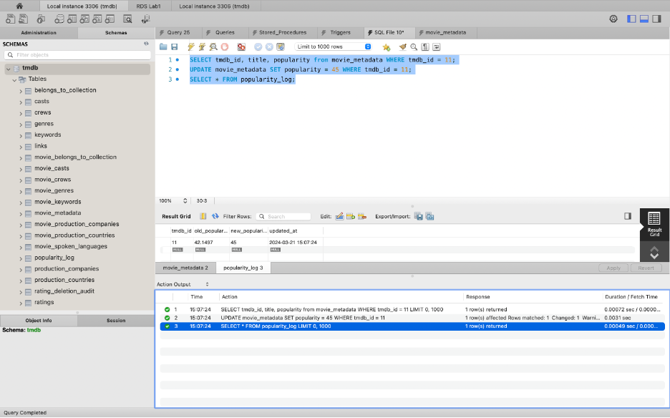

1. Trigger to add limit number of Genres linked to a movie

DELIMITER //

CREATE TRIGGER check_genre_limit

BEFORE INSERT ON movie_genres

FOR EACH ROW

BEGIN

DECLARE genre_count INT;

SELECT COUNT(*) INTO genre_count

FROM movie_genres

WHERE tmdb_id = NEW.tmdb_id;

IF genre_count >= 10 THEN

SIGNAL SQLSTATE '45000'

SET MESSAGE_TEXT = 'Cannot add more than 10 genres for a movie.';

END IF;

END //

DELIMITER ;

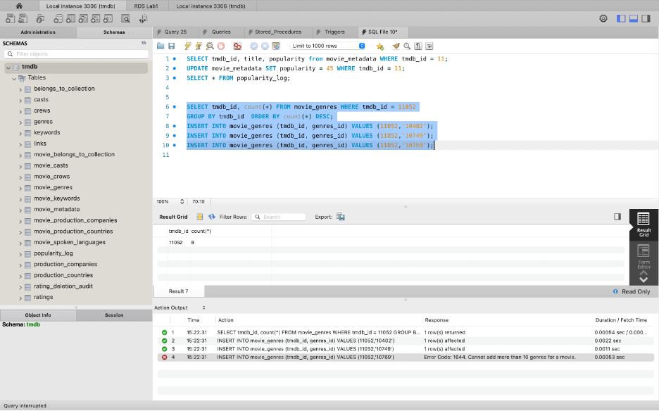

1. Trigger to keep track of ratings deletion

DELIMITER //

CREATE TRIGGER rating_deletion_audit

AFTER DELETE ON ratings

FOR EACH ROW

BEGIN

INSERT INTO rating_deletion_audit (user_id, movie_id, rating, deleted_at)

VALUES (OLD.user_id, OLD.movie_id, OLD.rating, NOW());

END //

DELIMITER ;

