Q1. What is responsive design?

Ans. A design in which the page responds to a change in the screen size.

The term responsive design was [coined by Ethan Marcotte in 2010](https://alistapart.com/article/responsive-web-design/) and described the use of three techniques in combination:

1. Fluid grids:Fluid grids are built using columns that are considered fluid columns. When the screen size is changed, the widths of these columns will adjust proportionally to its parent container. Eg. <https://www.w3schools.com/w3css/tryit.asp?filename=tryw3css_grid_example&stacked=h>
2. Fluid-images: Using a very simple technique of setting the max-width property to 100%, images would scale down smaller if their containing column became narrower than the image's intrinsic size, but never grow larger.
3. Media queries

Q2. What is adaptive design?

Ans. Adaptive design typically uses multiple fixed layout sizes—when the system detects the browser size, it selects the layout *most* appropriate for the screen (e.g., a smartphone’s).

Where responsive design relies on changing the design pattern to fit the real estate available to it, adaptive design has multiple fixed layout sizes. When the site *detects* the available space, it *selects*the layout most appropriate for the screen. So, when you open a browser on the desktop, the site chooses the best layout for that desktop screen; resizing the browser has no impact on the design.

Q3. Difference between responsive and adaptive design?

Example:

https://codepen.io/Luxplanjay/full/Ovoyoo

Ans. (1) the content follows a *fixed* layout size in adaptive design, while it moves *dynamically* in responsive design.

In other words, adaptive design uses *a few fixed layouts*, and then selects the best layout for the current screen size. In adaptive design, developing six designs for the six most common screen widths—320, 480, 760, 960, 1200, and 1600 pixels—is standard practice for designers.

 On the other hand, responsive design uses *a single layout*, which resizes according to the screen size.

(2) A strength of adaptive design is that it feels more *relevant* to the modern user experience, whereas responsive design shows a more desktop-centric approach (with the demands of other devices taking a secondary, almost passive place)

(3) adaptive sites are often 2-3 times faster than responsive ones and give rather less data to the user in order to deliver the user experience.

(4) There are drawbacks to adaptive design. Firstly, it’s usually a lot more work than creating a responsive design.

(5) Secondly, adaptive designs can leave out users “in the middle”. Tablet or notebook users might be left “hanging” because designers have only catered to desktop and smartphone users. Therefore, it’s important to offer a link to let the user toggle between versions.

(6) Generally, you would begin by designing for a low-resolution viewport and work your way up to ensure that the design doesn’t become constrained by the content.

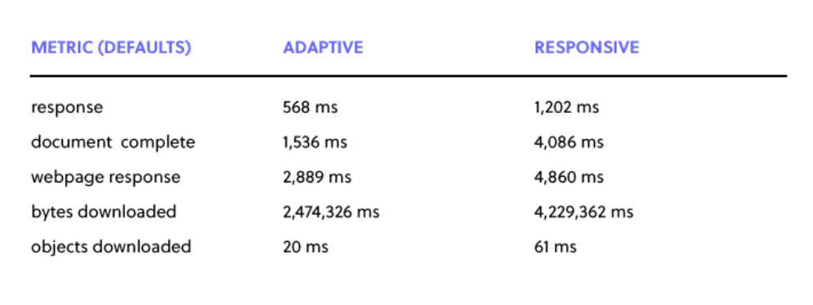

Sources: <https://www.interaction-design.org/literature/topics/adaptive-design>

<https://www.uxpin.com/studio/blog/responsive-vs-adaptive-design-whats-best-choice-designers/>

<https://developer.mozilla.org/en-US/docs/Learn/CSS/CSS_layout/Responsive_Design>

Creating a print friendly style-sheet:

Q1. Why and where?

Ans. For making the printed web accessible.

* printing travel or concert tickets
* reproducing route directions or timetables
* saving a copy for offline reading
* accessing information in an area with poor connectivity

Q2. How?

Ans. (1)

<link rel="stylesheet" media="screen" href="main.css" />

<link rel="stylesheet" media="print" href="print.css" />

(2) Overriding screen css:

@media print {

Your notes

}

Example:

<!DOCTYPE html>

<html lang="en">

<head>

    <meta charset="UTF-8">

    <meta http-equiv="X-UA-Compatible" content="IE=edge">

    <meta name="viewport" content="width=device-width, initial-scale=1.0">

    <title>Document</title>

</head>

<style>

    .box{

        width:500px;

        height:500px;

        background-color: black;

        color:white;

        border:2px red dashed;

    }

    @media print{

        .box{

            background-color: white;

            border:2px solid black;

            color:black;

        }

        .parent-box::after{

            content:'© Soumy Sharma';

        }

    }

</style>

<body>

    <div class="parent-box">

        <div class="box">

            This is a box

        </div>

    </div>

</body>

</html>

Source:

<https://www.sitepoint.com/css-printer-friendly-pages/>