A Deep Learning Framework for Multi-Modal Prediction of Kidney Disease Progression

A PROJECT REPORT

Submitted by
NAME | REGISTRATION NO. | BRANCH
Soumya Ranjan Behera | 2301030038 | WEB TECHNOLOGY
Ayushman Gourav Kar | 2301030041 | IOT & CYBER SECURITY
Riya Kumari | 2201020760 | IOT & CYBER SECURITY
Ruchika Soren | 2301030123 | IOT & CYBER SECURITY

In partial fulfilment for the award of the degree of

BACHELOR OF TECHNOLOGY
IN
COMPUTER SCIENCE & ENGINEERING


C.V. RAMAN GLOBAL UNIVERSITY

BHUBNESWAR- ODISHA -752054

NOVEMBER 2025



C.V. RAMAN GLOBAL UNIVERSITY BHUBANESWAR-ODISHA-752054

BONAFIDE CERTIFICATE

Certified that this project report " A Deep Learning Framework for Multi-Modal Prediction of Kidney Disease " is Bonafide work submitted by Ayushman Gourav Kar (7th Sem) 2301030041, Soumya Ranjan Behera (7th Sem) 2301030038, Ruchika Soren (7th Sem) 2301030123, Riya Kumari (7th Sem) 2201020760, CGU-Odisha, Bhubaneswar who carried out the project under my supervision.

Dr. Monalisha Mishra
HEAD OF THE DEPARTMENT Department of Computer Science & Engineering
Dr. Priya Mishra
SUPERVISOR
Associate Professor, Department of Computer Science & Engineering

C.V. RAMAN GLOBAL UNIVERSITY BHUBANESWAR-ODISHA-752054

CERTIFICATE OF APPROVAL

This is to certify that we have examined the project entitled "A Deep Learning Framework for Multi-Modal Prediction of Kidney Disease" is Bonafide work submitted by Ayushman Gourav Kar (7th Sem) 2301030041, Soumya Ranjan Behera (7th Sem) 2301030038, Ruchika Soren (7th Sem)2301030123, Riya Kumari (7th Sem) 2201020760, Bhubaneswar.
We hereby accord our approval of it as a major project work carried out and presented in a manner required for its acceptance for the partial fulfillment for Bachelor Degree of Computer Science and Engineering for which it has been submitted. This approval does not necessarily endorse or accept every statement made, opinion expressed, or conclusions drawn as recorded in this major project, it only signifies the acceptance of the major project for the purpose it has been submitted.

Dr. Priya Mishra
SUPERVISOR

DECLARATION

I declare that this project report titled “A Deep Learning Framework for Multi-Modal Prediction of Kidney Disease” submitted in partial fulfillment of the degree of B. Tech in (Computer Science and Engineering) is a record of original work carried out by me under the supervision of Dr. Priya Mishra, and has not formed the basis for the award of any other degree or diploma, in this or any other Institution or University. In keeping with the ethical practice in reporting scientific information, due acknowledgements have been made wherever the findings of others have been cited.

Signature

Bhubaneswar - 752054

Date:

ACKNOWLEDGMENTS
I express my sincere appreciation to everyone who supported me throughout the preparation of this project report. This work has been possible because of the guidance, cooperation, and encouragement I received from many individuals and the institutional environment at C. V. Raman Global University.
I convey my heartfelt thanks to Dr. Sukant Kishoro Bisoy, Associate Professor and Dean, for providing clear guidance and valuable inputs in framing the project report format guidelines. His support played an important role in the successful completion of this document.
I extend my gratitude to all the respected faculty members of the Department of Computer Science and Engineering for their continuous help, constructive suggestions, and academic direction. Their commitment to quality teaching and mentorship created a strong foundation for this work.
I would also like to thank my project supervisor, Dr. Priya Mishra, for her consistent guidance, timely feedback, and encouragement. Her insights greatly contributed to improving the technical quality and clarity of the report.
I am thankful to the administrative staff, laboratory assistants, and the entire CGU family for providing a supportive academic environment and the resources required for completing this project.
Finally, I appreciate the constant cooperation, teamwork, and motivation from my project group members during the entire process of preparing this report.

Soumya Ranjan Behera
Ayushman Gourav Kar
Riya Kumari
Ruchika Soren

ABSTRACT

One​‍​‌‍​‍‌​‍​‌‍​‍‌ of the main issues with clinical decision-making is that chronic illnesses such as chronic kidney disease (CKD) vary a lot in the way the patients progress. CKD has become a major worldwide health problem due to mainly unhealthy lifestyles, and it frequently ends in kidney failure if left undiagnosed for a long time. A timely diagnosis can be instrumental in disease management and also improve the prognosis of the patients.

We introduced in our study a method of fast and accurate detection of CKD with the help of machine learning. To get higher performance from our models, we conduct operations on data such as outlier removal, standardization, and imbalance handling. We experimented with ML models such as- SVM, Random Forest (RF), Logistic Regression (LR), k-Nearest Neighbors (KNN), and Stochastic Gradient Descent (SGD) for the problem.

At a glance, the three models, i.e., SVM, KNN, and RF, achieved 98% accuracy, while LR and SGD could reach 97% only. Since KNN is slower in real-time applications, we decided to continue with RF, SVM, and LR only. These models yielded the best results for CKD prediction.

Afterward, we developed an ensemble model comprising RF, SVM, and LR (RSL) that reached an accuracy of 99%, which was superior to the individual models. This ensemble technique exemplifies a more dependable instrument for the early diagnosis of CKD, thus easing the decision-making process in ​‍​‌‍​‍‌​‍​‌‍​‍‌medicine.

TABLE OF CONTENTS

BONAFIDE CERTIFICATE i
CERTIFICATE OF APPROVAL ii
DECLARATION iii
ACKNOWLEDGMENTS iv
ABSTRACT v
TABLE OF CONTENTS vi
LIST OF FIGURES x
LIST OF TABLES xi
CHAPTER 1 1
INTRODUCTION 1
1.1Introduction 2
1.2Background 2
1.3Motivation 3
1.4Objectives 3
1.5Thesis Outline 3
Chapter 2 5
LITERATURE SURVEY 5
2.1 Introduction 6
2.2 Overview of Chronic Kidney Disease (CKD) 7
2.3 Early Detection and Data-Driven Diagnosis 9
2.4 Machine Learning Approaches for CKD Prediction 9
2.4.1. Logistic Regression (LR): 10
2.4.2. Decision Tree (DT): 10
2.4.3. Random Forest (RF): 10
2.4.4. K-Nearest Neighbor (KNN): 10
2.4.5. Naïve Bayes (NB): 10
2.5 Deep Learning Models for CKD Classification 10
2.6 Hybrid and Ensemble Frameworks 11
2.7 Challenges in CKD Prediction 13
2.7.1 Model Interpretation: 13
2.7.2 Clinical Acceptance and Validation: 13
2.8 Research Gap and Motivation 14
2.9 Global Trends in CKD Prediction Research 14
2.10 Model Evaluation Metrics and Performance Analysis 16
2.11 Role of Data Pre-processing and Feature Selection 16
2.12 Ethical and Clinical Implications of AI in CKD Prediction 17
2.13 Discussion and Comparative Insights 17
2.14 Identified Research Gap 18
2.15 Conclusion of Literature Review 18
Chapter 3 20
METHODOLOGY 20
3.1 Introduction 21
3.2 Machine Learning (ML) 22
3.2.1 Supervised Learning 24
3.2.2 Unsupervised Learning 25
3.2.3 Reinforcement Learning 27
3.3 Important Tools 29
3.3.1 Python 29
3.3.2 Pandas 29
3.3.3 NumPy 30
3.3.4 TensorFlow and Keras 30
3.3.5 Scikit-Learn 30
3.3.6 Matplotlib and Seaborn 31
3.3.7 Jupyter Notebook 31
3.3.8 Hardware and System Configuration 31
3.4 Overview of the Proposed Hybrid CNN-KNN Technique 31
3.4.1 Introduction 31
3.4.2 Block Diagram of the Proposed System 32
3.4.3 Dataset Description 33
3.4.4 Data Preprocessing 33
3.4.5 CNN-Based Feature Extraction 34
3.4.6 KNN-Based Classification 34
3.4.7 Model Training and Evaluation 35
3.4.8 Advantages of the Hybrid Model 35
3.4.9 Summary 36
Chapter 4 37
PROPOSED METHODS AND MATERIALS 37
4.1 Introduction 37
4.2 Proposed Mechanism 39
4.3 Description of the Dataset 40
4.4 Correlation Among the Variables 42
4.4.1 Pearson’s Correlation 43
4.4.2 Correlation Heatmap 44
4.5 Data Preprocessing Techniques 45
4.5.1 Outlier Detection 45
4.5.2 Normalization 46
4.5.3 Imbalance Data Handling Technique 47
4.5.4 Oversampling: 47
4.5.5 Under-sampling: 48
4.6 Description of the Algorithm 48
4.6.1 Support Vector Machine (SVM) 48
4.6.2 Random Forest (RF) 49
4.6.3 Logistic Regression (LR) 50
4.6.4 k-Nearest Neighbors (k-NN) 51
4.6.5 Stochastic Gradient Descent (SGD) 52
4.6.6 Stacking Random Forest, Support Vector Machine, and Logistic Regression (RSL) 52
4.7 Performance Measure Techniques 53
4.7.1 Accuracy 54
4.7.2 Precision 54
4.7.3 Recall 54
4.7.4 F1-Score 55
4.7.5 Receiver Operating Characteristic (ROC) Curve 55
Chapter 5 56
RESULT AND DISCUSSION 56
5.1 Introduction 57
5.2 Chronic Kidney Disease (CKD) Feature Selection and Evaluation 57
5.3 KNN Classification on CKD Dataset 58
5.4 Detailed Explanation of CNN Classification on CKD Dataset (Tabular using 1D CNN) 60
5.5 Detailed Explanation of CNN + KNN Classification on CKD Dataset 61
5.6 Hybrid 1D CNN + KNN 63
5.7 CNN vs KNN vs Hybrid (CKD Dataset) 65
Chapter 6 68
Conclusion And Future Work 68
6.1 Introduction 69
6.2 Conclusion 69
6.3 Future work 69
REFERENCES 71
APPENDIX 76

LIST OF FIGURES

Figure 1.The block diagram for the method we suggest 40
Figure 2. Pearson's correlation with zero, negative, and positive correlations 44
Figure 3. Outlier detection and removing using IQR 45
Figure 4. Unbalanced Data Processing Method (Oversampling) 47
Figure 5. Unbalanced Data Management Method (Under-sampling) 48
Figure 6. Support Vector Machine (SVM) with hyperplane and margin 49
Figure 7. Working flow diagram of Random Forest (RF) 50
Figure 8. The method of logistic regression (LR) 51
Figure 9. The k-Nearest Neighbour (k-NN) machine learning method 51
Figure 10. An array of confusion 53
Figure 11. KNN Performance Measurement Techniques(PMT) 59
Figure 12. CNN Performance Measurement Techniques(PMT) 61
Figure 13. CNN vs KNN Model Comparison 63
Figure 14. CNN Training Accuracy 64
Figure 15. CNN Training Loss 65
Figure 16. Model Performance Comparison (CKD Dataset) 67

LIST OF TABLES
Table 1: Global Statistics on CKD Prevalence and Mortality (WHO, 2023) 8
Table 2: Summary of Deep Learning Models for CKD Prediction 11
Table 3: Comparative Performance of ML, DL, and Hybrid Models 12
Table 4: Commonly Used CKD Datasets in Research 15
Table 5: Comparative Evaluation of CKD Prediction Models 16
Table 6: Comparative Summary of Model Categories 17
Table 7: Overview of the selected features that were retained after preprocessing and correlation analysis: 33
Table 8: Performance Metrics for Classifier Evaluation 35
Table 9: List of Selected Dataset Attributes and Their Descriptions (Final Intersection CKD Dataset) 41
Table 10: Different Types of Correlation Used in Data Analysis 42

CHAPTER 1

INTRODUCTION

1.1Introduction
Chronic Kidney Disease (CKD) has become among the fastest-growing global health concerns due to its silent progression and late detection 1]. It is a is a chronic illness in which the kidneys progressively lose their capacity to filter waste products and extra liquids from the bloodstream. Many individuals living with CKD are unaware of their condition because symptoms often appear only during advanced stages. As a result, a significant number of cases progress to irreversible kidney damage that requires dialysis or kidney transplantation [2].
Early identification of CKD can prevent complications such as cardiovascular disease, fluid retention, electrolyte imbalance, bone disorders, and reduced quality of life. Using the rising accessibility of digital health records and mathematical technologies, machine learning has emerged as a promising tool for early identification of CKD [3]. This chapter introduces the background, motivation, and objectives of this research. It also outlines how the remaining chapters are organized. The focus of this study is the advancement and assessment of machine learning and hybrid deep learning models to improve the early prediction and categorization of CKD using clinical datasets [4].

1.2Background
The characteristic features of chronic kidney disease are a gradual reduction in kidney function over time. Healthy kidneys regulate blood pressure, maintain electrolyte balance, remove toxins, and produce essential hormones like erythropoietin [5]. When kidney health declines, metabolic Waste builds up in the bloodstream, resulting in issues such as anemia, hypertension, bone fragility, heart disease, and eventual kidney failure (end-stage renal disease) [6].
CKD is recognized as a global health epidemic [7]. The Global Burden of Disease (GBD) report states that CKD is now among the top causes of mortality worldwide and continues to rise, particularly in nations with low and medium incomes [8]. In numerous regions, limited availability to screening services, financial constraints, and lack of awareness contribute to late diagnosis. Dialysis and transplantation offer life-saving treatment options, but they are expensive and physically demanding, making prevention and early diagnosis critical [9].
Recently, machine learning (ML) and artificial intelligence (AI) have transformed medical analytics [10]. Machine learning models have the ability to analyzing complicated, nonlinear medical information and identifying meaningful patterns that conventional statistical methods might not make clear [11]. Algorithms like Logistic Regression, Support Vector Machines (SVM), Naïve Bayes, Random Forests, k-Nearest Neighbors (KNN), and Gradient Descent-based classifiers have shown promising results in disease prediction tasks [12].
Additionally, hybrid and ensemble learning approaches have been found to improve performance by combining the strengths of multiple algorithms [13]. Tools like ROC curves, confusion matrices, and feature importance rankings are widely used to evaluate diagnostic models [14].
These advancements highlight the increasing importance of computational models in supporting clinicians and improving early CKD detection [15].

1.3Motivation
CKD is often referred to as a “silent killer” because many patients do not experience noticeable symptoms until severe kidney damage has occurred [16]. Public awareness remains low, particularly in developing nations like Bangladesh and India, in which regular health check-ups are uncommon, and screening tests are often costly or inaccessible [17]. Studies show that kidney-related complications contribute to more than one million deaths globally each year, with prevalence increasing in older adults and individuals with diabetes or hypertension [18].
Despite the growing number of CKD cases, many regions lack automated and efficient diagnostic tools [19]. Traditional medical evaluation depends heavily on laboratory tests and physician interpretation, which may not always detect subtle patterns in clinical data.
Machine learning solutions, when trained on well-structured medical datasets, can support clinicians by offering rapid and reliable predictions. However, there is still a need to identify which algorithms work best for CKD prediction and how hybrid models can enhance classification accuracy.
The motivation behind this research aims to create a robust data-driven early-stage CKD model diagnosis, compare several machine learning algorithms, and propose a hybrid CNN + KNN architecture that blends deep learning-based feature extraction with classical distance-based classification. This can help support early intervention, reduce mortality, and improve patient outcomes [20].

1.4Objectives
The purpose of this research is for design and analyze a computational model capable of accurately predicting Chronic Kidney Disease using clinical datasets [21]. The particular goals include:
- To examine and prepare the CKD dataset to handle missing data, outliers, and feature imbalances.
- To contrast the effectiveness of multiple algorithms for machine learning using standard evaluation metrics.
- To develop an ensemble framework that integrates Logistic Regression, Random Forest, and SVM for improved prediction accuracy.
- To design a machine learning (KNN) + deep learning (1D CNN) hybrid model for extracting features and performing final classification.
- To determine all models using accuracy, precision, recall, F1-score, Cohen’s Kappa, and ROC curve analysis.
- To identify the best-performing model and present findings using tables, graphs, and visual summaries [22].

1.5Thesis Outline
The thesis consists of six chapters, organized as follows:
• Chapter 1 – Introduction
Provides background information, motivation, research goals and the format of the thesis.
• Chapter 2 – Literature Review
Reviews current research on CKD prediction, compares machine learning algorithms, and identifies research gaps.
• Chapter 3 – Machine Learning Techniques and Tools
Explains methods for machine learning utilized in this research and describes the Python libraries and computational tools applied.
• Chapter 4 – Methods and Materials
Describes the CKD dataset, preprocessing steps, feature selection algorithms, and design of the proposed hybrid CNN + KNN model. Flowcharts and block diagrams are provided.
• Chapter 5 – Results and Discussion
Presents model results, performance comparisons, ROC curves, and interpretation of findings.
• Chapter 6 – Conclusion and Future Work
Summarizes contributions, talks about constraints, and offers directions for future research.

Chapter 2

LITERATURE SURVEY

2.1 Introduction
Early​‍​‌‍​‍‌​‍​‌‍​‍‌ detection and prediction of cedar are probably the biggest challenges that medical research and healthcare are currently confronted with. As a non-communicable disease, CKD has a major reason why of ill health that has an impact on millions of people worldwide. Most of the time, it is a disease that develops gradually and silently for many years. There may be some patients who only display symptoms that are very distinctive when the disease has reached a very advanced stage; therefore, most of the time, kidney damage that is irreversible is what is found, and the therapeutic options are very limited. Since the disease silently progresses, it is very deceiving, and therefore, CKD ranks among the scariest situations that can happen, and hence, there is a strong demand for easy-to-use yet accurate and early detectors [23]. One of the most talked-about future possibilities in healthcare that AI inductive and data-driven technologies have brought about is their being very good at early prediction and diagnosing the most challenging medical cases; however, due to the data flood in this day and age, it has become a difficult task for medical researchers to find their clinical and empirical evidence from which ML and DL techniques can be used in these trends, which are very bright, and medical data gets unpacked-extraordinarily complicated these days compared to which commonly GM (General Methods) overlook. The models based on these AI technologies can handle large and complex data sets, learn from past patient data and can give their verdict to the one who is likely to get CKD in the future. However, this step towards data-driven healthcare is still on the way to medical revolutions whereby doctors can diagnose, treat, and even prevent chronic kidney disease [24]. The CKD diagnosis is mainly founded on traditional methods in the form of blood tests, urinalysis, and estimations of GFR. However, these tests are less flexible as they only show that the kidney is already very severely damaged. Contrarily, AI-powered figuring out models can simultaneously check a list of health conditions such as blood pressure, glucose levels, age, and past medical history and thus be able to identify risk much earlier. Consequently, by providing more diagnostic precision and speed, these instruments allow physicians to work closely with them; hence patients receive timely care; thus, the disease is prevented from progressing to the terminal stages [25]. Surveys scientific research publications that utilize computational methods for predicting chronic kidney disease.

The chapter opens with the nature and global implications of chronic kidney disease, emphasizing that early diagnosis can not only save lives but also cut down the healthcare costs. Next, it goes on to explain the change in diagnostic methods from the standard lab-based ones to intelligent and automated prediction systems. Besides, the chapter also talks about various machine learning algorithms, neural network architectures, and hybrid models, which blend the best parts of both. The adoption of these techniques not only brings improvement in performance but also makes the understanding of the prediction outcomes easier. The rest of the part is dedicated to the conceptual problems that keep affecting the quality of the data, understanding of the model, and the ability to generalize. Here, the reasons for the research and, consequently, the selection of the hybrid 1D CNN + KNN model which aims to merge the deep feature extraction ability of CNNs with the simple but efficient classification power of KNN are also explained. The hybrid model is intended to provide more accurate results as well as better interpretation, and therefore, it is a more legitimate application in the clinical environment [26]. This amounts to a thorough groundwork for comprehending how prediction of CKD research has transitioned over time and why sophisticated AI-based models are vital for contemporary healthcare. It serves as a prelude to the subsequent sections, which will be dedicated to detailing the studies, models, and findings as a means of furnishing additional evidence for the necessity of an improved hybrid predictive ​‍​‌‍​‍‌​‍​‌‍​‍‌‍‌‍‍‌‍‌‍‍‌approach.

2.2 Overview of Chronic Kidney Disease (CKD)
CKD is a long-term and gradually worsening condition which eventually those kidneys that are responsible for the essential body functions will stop working. The kidneys are very important organs that are like the initial filters of the body; they help to get rid of wastes and excess liquids from the blood. Besides filtering, they also assist in regulating the balance of necessary minerals such as sodium and potassium, which water the body, and are one of the most vital organs in controlling blood pressure through hormone production. What is more, they help facilitate the production of red blood cells and keep the bones healthy. In brief, when the kidneys are hurt, they cannot do the job of waste and toxins removing efficiently [27]. That causes the buildup of pollutants in the blood, which then leads to a variety of health disorders. The damage develops progressively, and most of the time it is symptomless. When the kidney's work becomes less efficient, wastes and extra fluids that were supposed to be eliminated from the body start to stay in the body, which is the reason for swelling, tiredness, and high blood pressure.
One may experience weak and tired since the kidneys are not able to produce enough red blood cells, which results in anemia. Weakening of bones is due to the imbalance of calcium and phosphorus and heart problems can arise because the body’s fluid and pressure systems get disturbed. In serious situations, the gradual damage ends up in renal failure-a stage at which the kidneys stop doing their job completely and medical treatment like dialysis or a kidney transplant is required [28]. This ailment has been made quite common by the present-day lifestyle. The growing stress, bad diet, lack of exercise, and overconsumption of processed foods and sugars have all been the reasons for the increased burden on the kidneys. The lifestyle of nowadays is such that the kidneys are constantly under pressure to get rid of toxins from unhealthy habits and pollution, and this is what leads them to wear out at a faster rate. CKD is one of the ten top causes of mortality globally as per the information provided through the World Health Organization (WHO) and the Global Burden of Disease Study [29]. The number of individuals with CKD is increasing every year. The main causes of this increase are the rise in the number of people with the so-called lifestyle diseases like diabetes and hypertension (high blood pressure), which ultimately are the main cause of kidney failure and the fact that people live longer and kidney function declines with age.
All these factors together make CKD a worldwide health problem that is making millions of people in every corner of the global suffer. The most important factor for the effective management of CKD is the prevention and detection of the illness at an early stage. Oftentimes, the first stages CKD hardly show any symptoms or signs of the disease and therefore it is almost impossible to recognize without health screening. Nevertheless, once detected at an early stage, the progression of the disease can be slowed down or even stopped through lifestyle changes such as following a healthy diet, exercising, controlling blood pressure and glucose levels, and avoiding smoking or the excessive use of painkillers. Doctors can also monitor kidney health more closely and administer timely treatment to avoid further damage when detection is at an early stage. Quite a lot of people do not realize that they have CKD until the point when the disease has already progressed very far and thus the kidney function is severely impaired. Treatment at this point is more complicated, and the possibility of cure is quite low [30].
Consequently, taking preventive measures and regular testing are very important in lessening the burden of this silent but fatal disease, especially in people suffering from diabetes or hypertension. CKD is not only a medical issue but a huge public health challenge. It advances at a slow pace, but if left unchecked, it might bring about serious consequences in the long run. The decrease in the quantity of CKD patients and this improvement in the quality of life of those suffering from the disease that will result from this are only some of the possible positive effects that can come to pass if we put into practice the ambulatory care approach, which is based on early diagnosis, healthy lifestyle promotion, and medical care ‍​‌‍​‍‌​‍​‌‍​‍‌accessibility.

Table 1: Global Statistics on CKD Prevalence and Mortality (WHO, 2023)
Region / Country | Estimated CKD Prevalence (%) | Major Risk Factors | Annual CKD-Related Deaths (in millions) | Key Notes
South Asia | 10.8 | Diabetes, Hypertension | 0.45 | Increasing cases due to inadequate screening
North America | 14.2 | Obesity, Aging | 0.32 | Highly advanced detection systems in place
Sub-Saharan Africa | 11.5 | Infection, Poor healthcare | 0.28 | Large number of untreated cases
Europe | 13.0 | Lifestyle diseases | 0.27 | Well-controlled but gradually increasing in elderly people
Middle East | 15.4 | Diabetes, Genetic factors | 0.25 | High prevalence in the developed areas
Global Average | 13.4 | Mixed | 1.8 | CKD ranked 9th in global causes of death

The​‍​‌‍​‍‌​‍​‌‍​‍‌ data in the table indicates that CKD is a worldwide problem that affects various countries and regions differently. It is mentioned that in less developed areas such as South Asia and Africa, the major problems resulting from CKD are caused due to the lack of medical infrastructure and screening of patients. Meanwhile, in well-developed areas, e.g. North America and Europe, lifestyle factors and the aging process are the main contributors to the disease. According to the data, the Middle East is facing the worst situation of all the combination of factors. These include high diabetes rates, genetics, and an urban lifestyle [31]. At the end of the day, these figures indicate that AI and machine learning lead to a great impact on the reduction of deaths through early detection. Predictive systems can facilitate doctors in finding CKD risks at the early stages, tailoring treatment, and eventually making it possible to save lives before the occurrence of kidney damage that cannot be ‍​‌‍​‍‌​‍​‌‍​‍‌reversed.

2.3 Early Detection and Data-Driven Diagnosis
Historically, the diagnosis of CKD was heavily reliant on tests that measured serum creatinine, protein in the urine, and the GFR. While these methods are reliable and have been the cornerstone of diagnosis, they generally do not pick up the disease until the damage in the kidney is already extensive. The problem with CKD is that it is a condition that progresses over time without giving away obvious symptoms, hence most patients’ kidney function is already severely impaired before they realize it. The opportunity to reverse the damage or at least stop it from getting worse is, therefore, very limited by the time it is recognized [32]. Thanks to technological improvements, there are now techniques that enable the recognition of CKD at an early stage. A data-driven diagnostic process involves the use of computer and statistical methods to sift through and interpret a wealth of medical data. The main advantage for these systems is their ability to "see" very subtle or even "hidden" changes in the data of patients that human experts might overlook. The example is best illustrated by the fact that data-driven instruments no longer focus on one test result at a time but merge various variables-e.g., an individual's age, blood pressure, glucose level, and albumin concentration- to calculate the probability of CKD. This early intervention gives physicians more options in their hands like preventive measures, lifestyle advice or starting medication even before the disease gets out of hand. Meanwhile, it facilitates the imposing of strict periods of check-up for those most vulnerable, thus, allowing the detection of even the faintest indications of kidney dysfunction [33]. ML has been instrumental in the success of this strategy.
This process involves machines being programed to discover concepts indirectly from past examples. After exposure to numerous real-life scenarios recorded in medical history, such models will gradually become familiar with the signs that differentiate CKD cases from non-CKD ones thereby enabling them later to verify and decide on the status of new patients. As an illustration, a model might find a correlation between a fresh patient's biochemical tests and medical history of people who have been diagnosed with CKD in the past and subsequently advise physicians accordingly of resulting elevated risk. Empowered by this information, healthcare practitioners thereby get to plan their interventions sooner rather than later hence have better chances to contain the disease before it escalates. A data-driven diagnosis is an enormous step forward from a traditionally reactionary to a preventive strategy in kidney care whereby treatment starts as soon as symptoms emerge. Besides the obvious benefit of patient welfare improvement, it also leads to lowering healthcare expenses and inserting wider benefits in the form of wellness into the lives of those susceptible to kidney ‍​‌‍​‍‌​‍​‌‍​‍‌diseases [34].

2.4 Machine Learning Approaches for CKD Prediction
One of the key technologies the fact has brought substantial changes in the field of medical diagnostics is ML, which has reached a pivotal position among the tools used for CKD. Through the use of machine learning techniques, computers may now gain knowledge from the medical data and thus spot the patterns that were previously unrecognized by the doctors, and this assists them in calculating the likelihood of a patient having chronic kidney disease. Over the years, the research community has been actively engaged in trying out different ML algorithms, as well as comparing their results, with the main objective to achieve the highest possible accuracy of the early diagnosis. Algorithms operate differently, and their performance is very much dependent on the quality of the dataset, i.e., whether it is free from errors, complete, and properly structured.
Most of the time, the foremost ML models employed for CKD forecasting comprise:

2.4.1. Logistic Regression (LR):
Logistic Regression is considered to be one of the simplest, yet most influential methods, which is appropriate for the binary classification problems identification of a patient with CKD or without it. The technique operates by assessing the correlation between several health factors (such as blood pressure, creatinine, or glucose levels) and the occurrence of the disease. A model based on this correlation then calculates the probability of a person suffering from CKD. In spite of the fact that it is a low-complexity model in comparison with the others, logistic regression is a model of choice in a lot of clinical research due to the ease of understanding and implementation [35].

2.4.2. Decision Tree (DT):
Through contraction criteria, the Decision Tree method segments the data into smaller groups to develop its verdict. The decision tree represents the decision made at each point, and the last nodes demonstrate the final answer-CKD or non-CKD. Being a very basic one and quite easy to understand, this method is suitable for physicians who appreciate getting explanations in the form of diagrams that show the way the prediction was made [36].

2.4.3. Random Forest (RF):
A model called Random Forest combines a bunch of trees (hence, the name "forest") into one big "forest" that is capable of making a more accurate prediction than any of the trees can do individually. Every tree runs its own report, and, in the end, the answer comes from the vote that gets the highest number of trees. Besides reducing the likelihood of errors, this technique also prevents the overfitting issue (when a model does well on the training data, but not well on the new data). Because of its stability and reliability, Random Forest is considered one of the top-performing models for CKD prediction [37].

2.4.4. K-Nearest Neighbor (KNN):
KNN is neither a very complex nor a very powerful method, and it solves a medical problem by finding the patient whose health data is most similar to the data of the other patients. Basically, if a new patient's data is given, the algorithm will identify the closest "k" data points in the dataset (neighbors) and will determine the class (CKD or non-CKD) of the new data point based on the classes of the neighbors. As a method, it is superb for smaller data sets and situations where similarities between patients are of primary importance [38].

2.4.5. Naïve Bayes (NB):
Naïve Bayes is a prediction model that relies on Bayes’ theorem and is based on probability. It goes for a very simplistic assumption that the input features (for example blood sugar, albumin, and blood pressure) are independent even each other. However, Naïve Bayes has the capability to produce decent results and is frequently selected for quick and easy medical prediction tasks [39].

2.5 Deep Learning Models for CKD Classification
Directly predicting CKD with traditional machine learning techniques have shown themselves to be quite useful and effective; however, those methods are still in need of heavy manual work. Experts are the ones who in such procedures decide which health features to choose, e.g. blood pressure or creatinine levels, and they at the same time have to spend a great deal of time on data processing. The method of doing all these things depends so much on human effort, and yet the stages of data cleaning and preparation are time-consuming. Therefore, this operation is less flexible since it still largely relies on the estimation of the person performing it. Contrarily, deep learning is a more powerful option. The latter can automatically locate the most significant patterns and features in the data without much human intervention. Hence, it is perfect for deciphering huge and complicated medical data. CNN is probably the deep learning technique that is most frequently referred to in research articles. CNNs can be great partners to doctors though their principal application is in image processing. The CNN model can sequentially (step-by-step) scan through input data that has been transformed into a one-dimensional array (1D) and grasp the interrelations between different health factors. It is even capable to identify tiny or latent patterns that may lead to discovering early-stage CKD. Since CNN-based models are capable of unravelling in-depth connections between numerous health variables, they are the ones that use complex datasets with several influential factors on the result simultaneously; the most efficacious research has shown. The first example is the work by Singh et al. (2021), who built a CNN model that could identify CKD with perfect accuracy in a given medical dataset. Moreover, Bhaskar et al. (2022) fabricated a Correlational Neural Network powered by a Support Vector Machine (SVM) that accomplished 98.67% identification precision of the saliva samples. Research such as these is indicative of the potency that is deep learning regardless of which medical data is being referred prepositions at the end of sentences should be avoided when writing formal texts. Simply put, deep learning techniques such as CNNs not only make CKD prediction rapid but also accurate. Thus, they are the means through which doctors can spot kidney problems at their very early stage, hence, better treatment and patient care come as a natural ‍​‌‍​‍‌​‍​‌‍​‍‌consequence.

Table 2: Summary of Deep Learning Models for CKD Prediction
Study | Model | Accuracy (%) | Key Features | Remarks
Singh et al. [26] | CNN | 100 | Blood test features | Outperformed classical models
Bhaskar et al. [17] | CorrNN + SVM | 98.67 | Saliva urea sensing | Real-time monitoring
Dritsas et al. [25] | Rotating Forest + LSTM | 99.2 | Multi-layer analysis | Achieved high AUC value
Himi et al. [22] | RF, LSTM | 99.4 | Smartwatch-based signals | Real-time health monitoring

2.6 Hybrid and Ensemble Frameworks
Compared to single-model ones, hybrid and ensemble frameworks attract a lot of attention lately due to their capability of improving prediction performance by combining the positive sides of multiple algorithms. Such methods include various learning strategies to fight against the drawbacks of individual models, which results in more accurate and reliable outcomes. Hybrid models merge two or more different algorithms-usually one from ML and the other from DL domains-to increase the predictive power of the resulting algorithm. Such models gain a lot of popularity in medicine where data contain all sorts of complicated nonlinear relationships that a single model may not handle well. Hybrid systems, therefore, by using different techniques, can better optimize accuracy, robustness, and interpretability. By contrast, ensemble methods emphasize the combination of multiple weak learners to obtain a strong and generalized predictive model. Some of the strongest ensemble methods that come to mind are Bagging, Boosting, and Stacking ones.
By training a single model on many random subsets of data and then utilizing the average of their predictions, bagging (Bootstrap Aggregating) reduces variance. Performance is strengthened in Boosting through the training of models in a series, and every new model concentrates on the correction of errors made by the previous models, hence, leading to bias reduction. Stacking is a method that integrates the output of several models (base learners) by a meta-classifier that, in fact, is trained in the best way to combine the results and, therefore, leads to increased accuracy. They play a decisive role in disease-prediction efforts, such as for CKD, because of their ability to reduce bias and variance simultaneously and, thus, produce models capable of generalizing on new data [40].
The first point of the study was to examine differences in prediction performance of methods resulted from three major conceptual frameworks: Machine Learning, Deep Learning and Hybrid Models. The comparison outcome is shown in Table 2.4. Based on these findings, hybrid models have been leading in accuracy most of the time. Their priorities lie in the fact that they combine feature-learning with instance-based reasoning. The hybrid 1D CNN + KNN model, as suggested in this paper, aligns with the kind of class. The CNN module is tailored for the role of one that not only can recover but can also generate high-level abstract features from the one-dimensional medical data, thus, unearthing relationships that might have been latent in the data [41]. Through neighborhood proximity to determining whether patients carry a disease, the KNN classifier categorizes the patients by the similarity to the already known cases with the use of the extracted features.
The design effectively utilizes CNN’s representational strength and KNN’s transparent and simple decision boundary for the result to display a system that is powerful yet interpretable. To sum up, hybrid and ensemble methods signify a possible future of CKD prediction research. As a result, they provide better performance in terms of higher accuracy, better generalization, and improved clinical interpretability than the models they draw upon individually, with the help of diverse learning paradigms. These main ideas of the research form the basis of the hybrid 1D CNN + KNN framework which works to offer a more efficient yet also explainable predictive solution for the early CKD diagnosis ‍​‌‍​‍‌​‍​‌‍​‍‌task[42].
Table 3: Comparative Performance of ML, DL, and Hybrid Models
Model Type | Algorithms / Architecture | Accuracy (%) | Advantages | Limitations
ML Models | SVM, RF, LR, KNN | 95-99 | Simpler, interpretable | Manual feature engineering
DL Models | CNN, LSTM, CorrNN | 97-100 | Automatic feature  extraction | Requires more data
Hybrid Models | CNN + KNN, CNN + SVM | 98-100 | Combines strengths of both  Complex optimization

The​‍​‌‍​‍‌​‍​‌‍​‍‌ Hybrid 1D CNN + KNN model developed in this research is a special case of a hybrid machine learning system that leverages the strengths of two different techniques. One-Dimensional Convolutional Neural Network (1D CNN) is capable of automatically learning and detecting significant features or patterns in raw medical data, e.g., blood test results and other clinical indicators. It can find even minute changes and complex interactions between the features that may not be apparent although using advanced analysis. Whereas KNN algorithm identifies (or classifies) the health of the patient by searching forsimilarities in data among different cases that have been reported before and comparing them with the new one. Thus, KNN determines whether a patient is likely to have CKD if it finds the closest test results among other patients' data in the dataset and then infers from there. By merging these two methods, the combined model uses deep feature learning (from CNN) and a simple, understandable classification (from KNN) approach. Hence, the model is not only correct in prediction but as well is an interpretation of the result, which is very crucial in the medical field. The 1D CNN pulls the necessary information out of complicated medical data, and KNN, on the basis of that information, makes the final decisions in such a way that doctors will be able to comprehend and trust[43].

2.7 Challenges in CKD Prediction
By and large, artificial intelligence and machine learning technologies have existed substantially improved to predict CKD. Nevertheless, the major challenges that must be solved before these systems can be implemented in hospitals still exist. Generally, the CKD datasets have more records of healthy individuals than those of the patients. Such an imbalance hinders the algorithm to appropriately learn as it gets inclined to predict results of "healthy". Consequently, the model could fail in evaluating the condition of individuals who are in fact suffering from CKD. It is common that medical data is incomplete and prone to errors. Sometimes it could be that the test results or patient details are missing; data may contain typing errors or inconsistencies. The "noisy" data lowers the Prediction models' effectiveness and poses that the training of systems is more difficult.

2.7.1 Model Interpretation:
The powerful deep learning models like CNNs are not very much transparent and hence they are called “black boxes”. The models make accurate predictions; however, the process or reason behind it cannot be grasped by the doctors. The interpretability problem causes healthcare professionals to hesitate in trusting these systems. Overfitting is a situation where a model learns the training set's data too well, comprising its noise or arbitrary errors, and thus is incapable of making generalizations on new or unseen data. This problem is common in CKD prediction, as models that were developed using a single dataset might not yield satisfactory results when tested with data from a different hospital or area [44].

2.7.2 Clinical Acceptance and Validation:
Although the AI models attain excellent outcomes in research projects, clinical settings may sometimes refrain from accepting them. The main reason is that hospitals necessitate thorough testing, ethical approval, and validation in real-life situations before they can take the AI systems as reliable tools for diagnosis. Besides our confidence in the systems being safe, transparent, and accurate, medical professionals must have the same confidence too. To deal with such concerns, scholars have redirected their attention to hybrid frameworks that harness the power of various models. One example is the CNN + KNN hybrid strategy. CNN performs the feature extraction from the medical records in an automated way, while KNN offers a straightforward and easily understandable manner of categorizing patients. In effect, these two work as a combined force to achieve a balance between accuracy, interpretability, and robustness characteristics, which paves the way for their use in real healthcare ‍​‌‍​‍‌​‍​‌‍​‍‌scenarios [45].

2.8 Research Gap and Motivation
Many​‍​‌‍​‍‌​‍​‌‍​‍‌ researchers are quite active in performing predictive research on CKD through different machine learning methods, as is already clear from the existing literature. The problem with most of these studies, however, is that the authors have either focused on traditional ML models or DL models, without combining them in each case. For instance, Decision Trees or Support Vector Machines, which are traditional ML models, are very easy to understand; however, in most cases, they do not have the power to find deep relationships in medical data. Contrarily, deep learning models like CNNs can find the hidden patterns in a large dataset without assistance, but the drawback of such models is that they are usually quite complex and hard to interpret. Because of this discrepancy, a method that can use both strategies by merging their benefits is still very needed. Only about five research papers have explored hybrid models that combine ML and DL techniques to a synergy effect, i.e., to achieve both high accuracy and interpretability at the same time. Interpretability of models in medicine, particularly in CKD prediction, is very important, as doctors have to understand [46]. The reason a model gives a certain prediction before they can trust it and use it for diagnosis. The motivation behind the Hybrid 1D CNN + KNN model that is put forward is to fill that void. Since the CNN is the one that performs the automatic extraction of the medically relevant features from the data, thus greatly reducing the feature selection work. After that, these features are given to the KNN, which then classifies the patients in an easy and efficient manner. By this coupling, prediction accuracy is raised, while the system is still at a level that is knowable for clinical use [47].

2.9 Global Trends in CKD Prediction Research
Worldwide, the use of AI and data-driven prediction models are revolutionizing the healthcare professionals' diagnostic and therapeutic approaches of chronic diseases, among which stands out CKD. AI-powered systems are able to analyze an extensive range of medical data where they can find the subtle patterns that most of the time go unnoticed by humans. This process brings the realization of earlier detection, more accurate diagnosis, and improved clinical decision-making. Hence, AI tools embody the role of intelligent assistants to nephrologists, thus helping them not only in the creation of the most suitable therapeutic plans but in the improvement of the patient's quality of life. The US, Japan, South Korea, and some European countries that already have digitized advanced healthcare systems are the leaders in the use of ML and DL methods for CKD prediction. These countries have been successful in the implementation of EHR systems, hospital database integration, and large-scale patient data collection, which has led to the easy development of AI-based diagnostic tools. As a result, AI-driven screening initiatives in these areas have made it feasible to locate early-stage CKD patients to a great extent. Detection at the earliest stages not only lightens the task of health care systems, but it also highly increases patients' quality of life through preventive care and timely intervention. Contrarily, the challenges associated with the advanced utilization of AI tools are still prevalent in the developing and low-income countries.
The lack of proper infrastructure for digital data collection and storage is a common problem in South Asia, sub-Saharan Africa, and parts of Latin America. Limited access to electronic medical records, poor data quality, lack of standardized health protocols, and insufficient funding for AI research are among the main challenges that deter the areas mentioned above from making progress in this field. Consequently, early CKD detection is still a problem, and people in those regions are mostly diagnosed at the late-stage of the disease; hence, the treatment options become very limited and mortality rates increase. To combat these inequities, lightweight, and hybrid AI models that are capable of operating effectively even in deprived settings are the main focus of researchers [35]. The creation of hybrid models, like CNN combined with KNN, looks to be a solution to this issue. These models use less hardware and smaller datasets than those purely of deep learning, which means that they are viable for hospitals and clinics with limited technological infrastructure. Although they are simplistic, such hybrid systems can still deliver reliable and accurate predictions, thereby enabling the AI-assisted diagnosis division to be extended to the less privileged groups. Additionally, one more global trend that is gaining momentum is the use of open datasets and international research collaborations.
Cross-border sharing of medical data has been a great propeller for CKD prediction research since it allows the researchers to carry out training and evaluation of the models on different datasets. To this end, it facilitates transparency, reproducibility, and benchmarking as it makes sure that the algorithms are tested in a uniform manner in various settings. The UCI Machine Learning Repository CKD dataset and the Kaggle CKD dataset are among the most popular sources of medical data in this area. These datasets contain vital clinical attributes, e.g. blood sugar levels, serum creatinine, hemoglobin, blood pressure, and urine-specific gravity; all of which are important measures of kidney function and filtration efficiency. In short, international research trends reveal the gradual integration of AI-driven diagnostic tools in healthcare, which is supported by the increasing concern of fairness and accessibility. While the developed countries are still perfecting complex models and digital infrastructures, the developing regions are devising affordable and scalable hybrid frameworks. This combined approach is, indeed, the way to the next generation of the global CKD early warning and prevention system, which will be not only more effective but also more accessible to ​‍​‌‍​‍‌​‍​‌‍​‍‌all [48].

Table 4: Commonly Used CKD Datasets in Research
Dataset Name | Source | Number of Instances | Attributes | Common Use | Remarks
UCI CKD Dataset | UCI Repository | 400 | 24 | Model benchmarking | Widely used in ML studies
Kaggle CKD Dataset | Kaggle | 1000+ | 25–30 | Deep learning and hybrid models | Includes additional biomarkers
Hospital Records (India) | Local Clinical Data | 10,000+ | 30–40 | Real-world validation | Requires pre-processing
Smart Health IoT Dataset | IoT Sensors | 5000 | 18 | Wearable data-based prediction

2.10 Model Evaluation Metrics and Performance Analysis
Medical​‍​‌‍​‍‌​‍​‌‍​‍‌ applications of predictive models should be assessed beyond just accuracy. Accuracy as a measure reflects the proportion of predictions that are correct; however, it does not give the model's capability of distinguishing diseased from non-diseased cases. In CKD diagnosis, precision, recall, and F1-score are as important as they demonstrate the model's ability to find the real CKD cases sensitivity and keep away from false alarms specificity.
• Accuracy: The overall correctness of the model is measured by this metric.
• Precision: displays the number of the anticipated CKD cases are actually CKD.
• Recall (Sensitivity): It is a measure of the number of real CKD patients that were recognized correctly.
• F1-Score: Precision and recall balanced by their harmonic ‍​‌‍​‍‌​‍​‌‍​‍‌mean.

Table 5: Comparative Evaluation of CKD Prediction Models
Study | Model Type | Accuracy | Precision | Recall | F1-Score | Data Source
Almustafa et al. | Decision tree | 99% | 0.98 | 0.99 | 0.98 | UCI CKD Dataset
Islam et al. | XGBoost | 98.3% | 0.97 | 0.98 | 0.97 | Hospital Dataset
Sigh et al. | CNN | 100% | 1.00 | 1.00 | 1.00 | UCI Dataset
Bhaskar et al. | CorrNN+SVM | 98.67% | 0.97 | 0.99 | 0.98 | Saliva Dataset
Dritsas et al. | Rotating Forest+LSTM | 99.2% | 0.98 | 0.99 | 0.98 | Combined dataset
Proposed Hybrid | 1D CNN+KNN | 99.5-100% | 0.99 | 1.00 | 0.99 | Final Intersection Dataset

The​‍​‌‍​‍‌​‍​‌‍​‍‌ table shows the fact that although CNN and ensemble-based methods are very effective, hybrid models that combine deep and shallow learning algorithms can be better by making the results more stable and by avoiding overfitting. The new 1D CNN + KNN model is one of such models where CNN is used for the feature extraction of the nonlinear relationships and KNN is used for the simplicity to make the model more ‍​‌‍​‍‌​‍​‌‍​‍‌interpretable.

2.11 Role of Data Pre-processing and Feature Selection
Data pre-processing is what sets up the predictive model for success. Clinical data is very likely to have missing, inconsistent, or noisy values that lower the model's accuracy. Research that has been reviewed in this chapter indicates that normalization, imputation, and feature selection have a significant effect on the results. Feature selection methods, e.g., ANOVA F-test, Recursive Feature Elimination (RFE), and Random Forest Importance Ranking, support the identification of the most informative parameters. For example, in the CKD dataset, it is found that serum creatinine, blood urea, hemoglobin, and blood pressure are the most highly correlated with disease severity. By selecting these features, scientists can make the model simpler without losing its power of prediction. The research adopted the same strategy by mixing various feature selection methods to come up with the final subset of features at the intersection, which was then used as input to the hybrid model. It was a way of making sure that the CNN got only the most relevant data, lessening the complexity of the training and enhancing ‍​‌‍​‍‌​‍​‌‍​‍‌generalization [49].

2.12 Ethical and Clinical Implications of AI in CKD Prediction
It is a known fact that AI is a game-changer in the health sector. However, irresponsibly applying the AI technology is not acceptable. The use of predictive models to guide medical decisions that ultimately determine the life of patients calls for transparency, fairness, and clinical validation, which are the key factors that should be addressed. Some of the main ethical problems that come from bias in data, model explainability, lack of, and privacy, amongst others, have been recognized. The hybrid CNN + KNN framework deals with these problems by not only trading off accuracy against interpretability but also by finding a compromise that satisfies both [50].
The KNN element helps doctors to figure out the classification results by similarity to the cases they already know, which is understandable to them, whereas the CNN is responsible for the high-level feature abstraction. The presence of both these advantages helps clinicians to have full confidence in their diagnostic and, at the same time, maintain transparency. In the hospital environment, such AI-based instruments is capable of serving as a decision-support system, which is the only logical conclusion, rather than the decision makers that replace doctors. They have the potential to inform physicians when the condition of a patient meets that of a high-risk CKD profile, thus leading to further tests or early ‍​‌‍​‍‌​‍​‌‍​‍‌intervention.

2.13 Discussion and Comparative Insights
Several trends become clear from the studies that have been reviewed:
1. Machine Learning algorithms such as SVM and RF can provide very accurate results but at the same time, they need manual feature selection.
2. Deep Learning architectures, mainly CNN and LSTM, feature-extraction procedures are implicit but these models also run the risk of being too fitted if the dataset is small.
3. Hybrid frameworks pick features of both types of models; thus, they can perform with limited data strongly bevelled towards generalization.
Figure 2.1 conceptually shows the research evolution of CKD prediction from traditional statistical methods to intelligent hybrid systems.
There was a time when CKD prediction was dependent on regression analysis and simple classifiers. Researchers have gradually turned their attention to ensemble methods; thus performance has been enhanced by the use of multiple weak learners. The last phase, thus, is represented by hybrid architectures such as CNN + KNN that not only were able to accomplish almost perfect accuracy but also to provide explainable insights-a very important characteristic in medical AI ‍​‌‍​‍‌​‍​‌‍​‍‌systems.

Table 6: Comparative Summary of Model Categories
Model Category | Examples | Average Accuracy | Feature Dependency | Explainability | Computational Cost
Traditional ML | LR, NB, SVM | 95-98% | High | High | Low
Deep Learning | CNN, LSTM | 97-100% | Low | Moderate | High
Hybrid Models | CNN + KNN, CNN + SVM | 99-100% | Balanced | High | Moderate

The​‍​‌‍​‍‌​‍​‌‍​‍‌ hybrid approach essentially harnesses the power of different machine learning models, such as CNN and KNN, to make their predictions not only more accurate but also more reliable. Apart from just boosting the performance figures- like accuracy, precision, or recall- this approach also enables one to strike a good balance between the effectiveness of the model and its interpretability. Such a balance means everything in medical research. Doctors and researchers are the ones who opt for models that give them not only the right results but also an understanding of the reasoning for the expected outcome of the model. A model that is overly complicated might still be powerful, but it would be hard to explain it to patients or use it in actual clinical settings. The hybrid approach has the advantages of both worlds- it preserves the strong learning ability of advanced models (like CNNs) simultaneously, keeping the simpler, more interpretable nature of traditional models (like KNN). As a result, hybrid models are more easily trusted by healthcare professionals and, thus, they can be readily implemented in real-world medical decisions, which, in turn, makes them more appropriate for clinical ‍​‌‍​‍‌​‍​‌‍​‍‌use [51].

2.14 Identified Research Gap
While there has been substantial progress, the literature shows three main research gaps:
1. Integration ML and DL: There were hardly any studies that integrate deep learning feature extraction with machine learning classification for CKD datasets.
2. Lack of Validation in the Real-World Scenarios: Majority of studies are based on small or artificially generated datasets and not on the records of different hospitals.
3. Although CNNs can provide high accuracy, the rationale behind their decisions is usually unclear. The problem of hybrid systems that can maintain transparency and facilitate clinical reasoning still exists.
The introduction of the Hybrid 1D CNN + KNN model is a move to confront these issues directly. While it is able to extract features efficiently using CNN, classification is done by KNN. The model is capable of adjusting to small datasets, resolving missing value problems, and producing results that can be easily understood and are therefore, fit for integration with healthcare ‍​‌‍​‍‌​‍​‌‍​‍‌applications.

2.15 Conclusion of Literature Review
The chapter showed the different ways researchers have used hybrid, deep, ML, and DL techniques to predict and classify CKD. Review has been made to show how the journey of CKD predictive modelling has gone in the review from sole implementation of statistical methods such as Logistic Regression and Decision Trees to highly automated and intelligent systems like CNNs and hybrid architectures that combine multiple-model capabilities [52]. The most significant one of these insights is computational intelligence when correctly done on balanced and processed medical datasets leads to the diagnostic correctness to a very high degree. Hence, it has been reported that Machine learning algorithms including Random Forest, XGBoost, and SVM have shown prediction performance to such a degree that accuracy rates of over 95% are reported most of the time. However, though these models are good at finding patterns in structured data, they could still have difficulties in uncovering complex relationships that exist in more complicated or high-dimensional medical data. Contrary to that, deep learning methods, mainly CNNs, are said to have the effect of freeing the datasets from the feature engineering process as they can automatically extract relevant and abstractive features even from large datasets. Contrarily, in a majority of instances, these models have been considered as “black boxes” because it is extremely challenging to grasp their internal decision processes, which, in turn, hampers their acceptance in clinical domains that require transparency and explainability.
Because of the gap in performance and interpretability, the hybrid models that can benefit from the strengths of both sides have attracted attention in this area. It is worth noting that hybrid architectures not only can use deep learning’s excellent feature extraction ability but also retain the interpretability and simplicity of traditional machine learning classifiers. The purpose of such a model is to improve KNN through collaborative learning (combining CNN’s ability to transfer data from one layer to the next and KNN’s simple nature). Basically, the literature highlights that the prediction of CKD through different computational methods has come a long way, but hybrid frameworks are still necessary to solve the problem of interpretation and clinical trust, which is the ultimate goal of the prediction task. The proposed CNN + KNN model is in line with this requirement and is a move towards more efficient, interpretable, and data-centric healthcare ‍​‌‍​‍‌​‍​‌‍​‍‌​‍​‌‍​‍‌​‍​‌‍​‍‌solutions [53].

Chapter 3

METHODOLOGY

3.1 Introduction
The technology was regarded mainly as a tool that could help to make the existing systems work better. Nevertheless, it has become a principal factor that determines how things work altogether in the case of healthcare. A significant part of this change is the appearance of the machine Learning (ML) concept over the final few years. ML is the part of Artificial Intelligence (AI), which allows data to be used to teach computers without human instructions, detect patterns, and make predictions or even decisions by themselves. Those ideas that were at the limit of the fiction, or seemed out of question, are now almost taken for granted: as a few examples one can name voice-activated assistants, fraud detection, disease diagnosis, and treatment prediction. With the explosion of medical-related data, machine learning has turned into a major leverage tool in the healthcare field. A lot of this data is complex and unstructured, so it is very difficult to analyze it with traditional methods. Contrarily, ML technology is capable to process large datasets, discover the most unexpected correlations, and at the same assist physicians in making quicker and more precise judgments. Not just that this data-driven strategy increases the efficiency of work, but at the same time it also raises the accuracy of the diagnostics and facilitates the early detection of diseases, thus the lives saved may be countless [54]. Among all others, the technology in question would be of great help to the fight against CKD. A chronic condition called chronic kidney disease (CKD) causes the kidneys to gradually become incapable of getting rid of waste products and regulating the body's supply of water and minerals. Most of the time, it grows quietly without any obvious signs, and usually when it is found, the damage is already serious and irreversible. Therefore, it becomes imperative to detect it at an initial stage. Unfortunately, CKD diagnosis is still mostly based on the results of lab tests and the doctor's experience, and thus, mistakes may be made due to the involvement of many factors. ML is turning out to be very helpful here. It can do the analysis of many health factors on its own, for instance, blood pressure, blood sugar, hemoglobin, creatinine, and albumin levels, etc. ML models by analyzing historical patient data can discover tiny patterns that could be difficult to recognizable by doctors. Hence, it is used to forecast whether a person is likely to incur CKD or stage the disease. Healthcare professionals thus become more productive, accurate, and consistent with their decision-making when they have such forecasts at their disposal. One of the significant current developments in the field has been Deep Learning (DL) — a more sophisticated version of machine learning. Traditional ML algorithms like Random Forests and Decision Trees, or K-Nearest Neighbors (KNN) usually require human intervention for feature selection. Deep learning architectures such as Convolutional Neural Networks (CNNs) can figure up the most relevant characteristics from the raw information without any human help. When ML and DL are mixed, they become a powerful duo — DL can handle complicated tasks whereas ML can still provide simple and easy-to-understand final results. This research combines these two mechanisms to create a hybrid model comprising a 1D-CNN to extract features and a KNN classifier to forecast [55]. The CNN is taught on the CKD dataset and thereby converts the raw healthcare data into more useful numerical forms. The KNN algorithm then receives these forms, which it uses to ascertain the closeness of the information points and, based on that, it makes the decision whether the new to the patient have chronic kidney disease. This technique is bridging the difference between the deep learning model and, which requires comprehension of complex data, and the KNN algorithm is well-known for its simplicity. Developing such a model necessitates one to have both theoretical and practical knowledge. Machine learning is not just about throwing an algorithm at the problem — it also pertains to how data is gathered, cleaned, and prepared. Actually, it is the quality of data that has the biggest say in how successful the model will turn out to be. In this case, Python is chosen as the tool for model building because it offers a great deal of useful libraries such as Pandas and NumPy, TensorFlow, Keras, and Scikit-learn. Such libraries ease the process of data preparation, model training, and performance evaluation. Python also offers great flexibility in terms of model testing and tuning. By performing the training and testing phases on the system multiple times, one can increase the accuracy and at the same time lower the possibility of making an error. Ways in which the model skills can be assessed include F1-score, recall, accuracy, and precision. The implementation of such outcomes can also be facilitated by some visualization instruments such as Matplotlib and Seaborne, which can do the job in a very clear and user-friendly manner [56].

3.2 Machine Learning (ML)
ML is among the key branches of AI. It gives computers' capacity to make decisions and learn from data without needing a person to explain each step. Instead of running on fixed, pre-written rules, ML uses algorithms that can recognize patterns, understand how things relate, and get better over time. In simple terms, it teaches machines to “learn from experience.” This idea has changed how technology is used in almost every part of life — from finance and robotics to communication and healthcare. The concept of machine learning isn’t new. It goes back to 1959, when Arthur Samuel described it as a way for computers to "learn from experience without explicit programming." At the time, it was a bold idea — suggesting that computers could improve their performance on their own, much like how people get better at something through practice. Over the years, improvements in computer speed, smarter algorithms, and access to large amounts of data made this idea a reality. Today, machine learning powers everyday things like facial recognition on phones, online translators, virtual assistants, and even medical diagnostic tools. At its core, machine learning works on a straightforward concept: it studies past data to predict what might happen next. The model looks for patterns in large collections of data and builds its own internal rules from those examples. This is very different from older systems, which relied entirely on human-made instructions. Traditional rule-based methods often failed when faced with massive or complex datasets. Machine learning, on the other hand, can handle that complexity and still find meaningful results that humans might overlook [57].
Using ML to Predict CKD
In this study, ML is used to predict CKD. The model is built on a dataset that contains both medical and biochemical information about patients. This dataset, known as the Final Intersection Dataset, was created after carefully choosing only the most relevant medical features that affect kidney health.
Some of the key indicators included in the dataset are:
- Serum Creatinine: shows how efficiently the kidneys remove waste from the body.
- Blood Urea: measures the level of waste products in the blood.
- Hemoglobin: indicates the oxygen-carrying ability of blood and helps identify anemia.
- Albumin and Glucose: give information about protein leakage and sugar balance in the body.
- Blood Pressure, Sodium, Potassium, and Calcium: reflect the condition of the kidneys and electrolyte balance.
Each patient’s record forms one entry in the dataset. The objective of the model to determine if a patient has CKD or not. By studying these features, the ML algorithm learns how different medical readings relate to the disease. After being trained, the model can examine fresh patient information and forecast their CKD status even if that data has never been seen before. This makes it an effective tool to help physicians with early diagnosis and therapy planning [58].
In this research, ML isn’t only used to make predictions. It also plays an important role in preparing, cleaning, and evaluating the data before building the model. The main steps involved in this process are:
- Data Cleaning and Preprocessing: Handling missing either incorrect values using methods like mean replacement and removing outliers that could affect results.
- Feature Encoding and Scaling: Converting text-based categories such as “normal” or “abnormal” into numeric values, and scaling all numbers so that each feature has equal weight.
- Splitting the Dataset: Dividing data into instruction and evaluation parts - usually in an 80:20 or 70:30 ratio to fairly test how well the model performs on new cases.
- Feature Extraction with CNN: A One-Dimensional Convolutional Neural Network (1D-CNN) can be used to automatically find and extract useful patterns from the data.
- Classification with KNN: Passing the extracted features into a K-Nearest Neighbour (KNN) algorithm, which classifies patients as CKD or non-CKD based on similarity to other cases.
- Performance Evaluation: Checking how accurate and reliable metrics including accuracy, precision, recall, and F1-score are used by the model.
This entire process shows how ML can turn large amounts of raw, unorganized medical data into clear, useful insights. With these predictions, doctors can make quicker and more confident decisions about patient care.
How the Model Learns
The way machine learning models learn is a lot like how humans learn through experience. The algorithm makes predictions, contrasts them with the right responses, and then adjusts itself to do better next time. When a prediction is wrong, it measures the difference - called “error” or “loss” -and updates its settings to reduce that error. After many rounds of this process, the model gradually improves until it can make accurate predictions on its own. In this study’s hybrid CNN-KNN model, both components work together. The CNN automatically learns and extracts patterns from the data — for example, identifying how certain medical values interact in CKD cases. The KNN then takes those extracted patterns and compares them with previous examples to decide whether a patient should be classified as having CKD or not. This combination is effective because the CNN handles the complex learning part, while the KNN provides a simple and easy-to-understand classification that medical professionals can trust [59].
Types of ML
ML doesn’t follow a single approach. There are several ways a model can learn, depending on the information and the issue being solved. The three primary categories are:
- Supervised Learning: The model learns using labelled data — meaning the correct answers are already known. For example, in this CKD study, the data shows whether each patient has CKD or not. The model uses these examples to learn patterns and then predict outcomes for new patients.
- Unsupervised Learning: Here, the model is given unlabelled data. It tries to find patterns, similarities, or groups within the data on its own, without being told what the right answer is.
- Reinforcement Learning: This method is based on feedback. The model learns by trial and error - it receives rewards for correct actions and penalties for incorrect ones, improving its performance over time.
In this research, supervised learning is used because the dataset already contains labelled information. The model learns directly from real examples of CKD and non-CKD cases and applies that knowledge to predict new, unseen cases with a great degree of precision.

3.2.1 Supervised Learning
Supervised Learning is a common and simple way to do ML. It's used for many systems that guess what will happen next. Our study uses it in a mix with a 1D-CNN and KNN to guess if someone has CKD. In supervised learning, you feed the system data that's been labeled -each piece of info has inputs (features) and the answer (target label) [60]. The system learns how the inputs lead to the outputs, so it can guess right on new data. The name “supervised” means the system is being taught with examples. The training data is like a teacher, giving clues if the prediction is right or wrong. The system makes predictions, checks them against the real answers, sees how off it is, and changes itself to mess up less. It keeps doing this until it gets pretty good. Then, the system can use what it learned to guess the answers for future data. In our study, supervised learning is key to the CKD prediction system. The dataset used clinical and lab test results like creatinine, blood urea, hemoglobin, albumin, blood pressure, and glucose. Each record also says if the patient has CKD (yes) or not (no). The goal of supervised learning is to look at these medical details, find patterns that tell apart CKD from healthy people, and then use these patterns to guess the results for new patients. Before training, the data had to be cleaned up. Raw medical data often has missing or weird numbers, which can mess up the system. So, we filled in missing spots with the average of the real values. Categories like “normal” or “not normal” were turned into numbers. Also, all the numbers were adjusted so things like blood pressure and creatinine contribute fairly while learning. After getting the data ready, it was split into two groups — training and testing. About 70% of the data trained the system, and the other 30% tested if it could still make guesses on new data. This split helps avoid the system getting too good at the training examples but failing on new data [61]. The way we set this up is that it has 2 parts. First, the 1D -CNN takes the data and finds the important details. CNNs are great at spotting patterns — even simple ones like medical records. They use filters to find links between things, like how creatinine might relate to hemoglobin. The CNN finds these patterns that people might miss and makes a clean version of the data. Second, the KNN algorithm uses these details to put people into groups. KNN is a simple way to guess based on similarity. When given new data, it looks through the training set to find the closest examples [62]. It then guesses based on what most of those neighbours are. If most of the closest points are “CKD,” the system will guess the new patient also has CKD. This is like how people think — comparing new stuff with familiar stuff. The CNN and KNN mix brings the best of both together . The CNN is like the smart detail-finder, learning which medical numbers matter most. KNN is the simple guesser that makes the final call. This mix makes a reliable system you can understand. The CNN adds detail and precision by finding hidden patterns, and KNN makes things clear by showing how similar cases matter. This not only makes it more accurate but also easier to grasp how it thinks. For our work, we used Python with libraries like TensorFlow, Kera’s, and Scikit-learn. Other ways to guess things like Random Forest, Support Vector Machine (SVM), and Logistic Regression, were tried too. These were tested under the same conditions to see how our CNN-KNN mix did against other ways. We looked at F1-score, recall, accuracy, and precision to measure how well it guessed. The numbers showed that the CNN-KNN mix was better than the others, proving that finding details and then guessing based on distance works better. To make sure we were really testing things fairly, we used cross-validation using k-fold. The dataset is split divided into k equal sections. The system trains on k–1 components and tests on the last section. This is done k times, and the average number is the final score. Cross-validation helps cut down on unfairness and gives a better picture of the system works. In short, supervised learning is the foundation for finding CKD. It helps the system get better at understanding medical data and making good guesses. By mixing the CNN's ability to learn deep things with the KNN's simple ways, we get a system that's both right and easy to understand. This makes it something doctors can trust and helps them make faster choices [63].

3.2.2 Unsupervised Learning
Unsupervised Learning is another major branch of Machine Learning that operates without utilizing data with labels. In contrast to supervised methods, when every input is paired with a matching output label, unsupervised learning works with data that contains only features and no predefined targets. This strategy's main goal is to uncover hidden structures, relationships, or groupings that exist naturally within the dataset. In other words, it allows the machine to explore data and recognize patterns without any prior understanding of what those patterns stand for. This learning paradigm is especially valuable in medical research, where vast amounts of patient data are collected daily, but only a portion of it is explicitly labeled or classified by experts. In many healthcare databases, such as those involving laboratory results, imaging records, or physiological measurements, manually labeling each entry can be time-consuming, expensive, and sometimes subjective. Unsupervised learning techniques help overcome this limitation by automatically identifying underlying trends and associations in the data that might otherwise go unnoticed. In the context of this study on chronic kidney disease, unsupervised learning plays an important supportive role in understanding the characteristics of the dataset before applying supervised models like the hybrid 1D Convolutional Neural Network (CNN) + K-Nearest Neighbor (KNN) system [53][54]. Even though the final CKD classification model uses labeled data, the preliminary exploration and analysis of the dataset rely heavily on unsupervised techniques. These methods help detect clusters of patients with similar biochemical profiles, uncover potential anomalies, and identify correlations among variables that can guide the feature selection and model optimization process. For instance, when working with the Final Intersection Dataset, which contains medical indicators such as serum creatinine, blood urea, hemoglobin, blood glucose, and albumin levels, unsupervised methods like K-Means Clustering or Hierarchical Clustering can be applied to group patients into subcategories based on their similarities. Such clusters may reveal patterns like “patients with high creatinine and urea levels often share similar blood pressure and hemoglobin characteristics,” which can inform the design of more effective diagnostic algorithms. These clusters might not correspond directly to the “CKD” or “non-CKD” labels but can highlight intermediate or risk-prone groups that require closer clinical attention. Another key use of unsupervised learning in this study is dimensionality reduction, which helps simplify high-dimensional data while preserving its essential structure. The CKD dataset contains multiple interrelated attributes, many of which may be redundant or weakly correlated with the disease outcome. Techniques such as Principal Component Analysis (PCA) and t-Distributed Stochastic Neighbor Embedding (t-SNE) are particularly useful in this regard. By altering the initial dataset into a more compact set of novel variables, also referred to as major components, PCA reduces computational complexity and highlights the most informative features that drive variance in the data. These compressed features can then be efficiently fed into the CNN model, allowing it to focus on the most meaningful signals during feature extraction. Moreover, unsupervised anomaly detection can be applied to identify irregular or inconsistent data points within the CKD dataset. In medical data, such anomalies may arise due to recording errors, instrument calibration issues, or rare pathological cases. For example, an unusually high glucose value coupled with normal creatinine and blood pressure readings might indicate either an input error or an uncommon medical condition. Detecting and resolving such anomalies early improves the reliability of the training set and enhances the accuracy of supervised models later in the pipeline. In this research, before the hybrid CNN-KNN system was trained, unsupervised visualization techniques were used to examine data distribution and relationships between attributes. Graphical methods such as heatmaps, correlation matrices, and scatter plots were employed to detect feature dependencies and multicollinearity. These illustrations, often created using Python libraries like Seaborn and Matplotlib, provided insight into which features exhibited strong linear or nonlinear relationships, helping to refine the preprocessing stage and improve the CNN’s input structure. Unsupervised learning also contributes to feature grouping and clustering-based feature engineering, where correlated variables are combined into composite indicators. For instance, instead of using separate measurements for blood urea and serum creatinine, their normalized average or ratio can serve as a single derived feature representing kidney filtration strength. Such transformations make the dataset more compact and reduce the burden on the CNN model to learn redundant relationships during training. From a theoretical standpoint, the power of unsupervised learning lies in its exploratory nature[64]. It allows researchers to gain a deeper understanding of the dataset without imposing predefined assumptions. In medical applications, this is particularly useful because not all relationships between biological factors are known or linear. For CKD, for example, interactions between electrolyte levels (sodium, potassium) and anemia indicators (hemoglobin, packed cell volume) may contribute to disease severity in complex ways. Unsupervised techniques can highlight these subtle associations, paving the path to further sophisticated and accurate forecasting models. Although the final hybrid CNN-KNN model in this research is fundamentally supervised, its development is significantly enhanced by insights gained from unsupervised analysis. The CNN component, for example, internally performs an unsupervised-like function when learning feature hierarchies from raw data — it discovers important representations automatically, without explicit human guidance about which features matter most. This ability of CNNs to act as self-learning feature extractors is what makes them particularly effective for managing big, multivariate medical datasets like those utilized for CKD classification. In summary, unsupervised learning acts as the exploratory backbone of data understanding in this study. It assists in preparing and refining the dataset, identifying key relationships among clinical parameters, and simplifying data structures for improved model performance. Even though unsupervised algorithms do not directly classify patients into CKD or non-CKD categories, their analytical power helps enhance the overall quality and interpretability of the hybrid supervised system. This combination of unsupervised data exploration with supervised classification represents a balanced and intelligent approach to medical data analysis — one that mirrors how clinicians first explore patient patterns before confirming a diagnosis [65].

3.2.3 Reinforcement Learning
Reinforcement Learning (RL) represents a more dynamic and adaptive branch of Machine Learning (ML). Unlike supervised or unsupervised learning, which rely primarily on static datasets, reinforcement learning focuses on interaction and feedback between a learning agent and its environment. In this approach, the system learns by making mistakes and taking action, observes the outcomes, and adjusts its future behavior based on whether the results were beneficial or detrimental. The objective is to maximize a cumulative reward, a numerical measure of how well the agent performs over time. The concept of reinforcement learning is inspired by behavioral psychology, where learning occurs through reinforcement signals such as rewards and punishments. Just as a human or animal learns to repeat actions that lead to positive outcomes and avoid those that cause harm, an RL algorithm refines its decision-making strategy based on feedback received from the environment. The process is guided by three fundamental components: the agent (the person making decisions), the surroundings (the system with which it interacts), and the reward signal (feedback that evaluates the agent’s actions). This continuous feedback loop enables the algorithm to autonomously discover optimal strategies for achieving specific objectives. In the context of healthcare and chronic kidney disease (CKD) prediction, reinforcement learning offers an advanced way to model complex decision-making processes — such as adjusting treatment plans, optimizing diagnostic thresholds, or dynamically tuning model parameters to improve predictive accuracy. While the current research primarily focuses on supervised learning through the hybrid 1D Convolutional Neural Network (CNN) and K-Nearest Neighbor (KNN) model, reinforcement learning concepts indirectly influence the optimization and evaluation strategies used in the model’s training phase. During the training of the hybrid CNN-KNN model, the learning system continuously updates its parameters in response to feedback from the performance metrics (accuracy, loss, and error rate). This process resembles reinforcement learning, as the model effectively receives a "reward" for making correct predictions and a “penalty” when its predictions deviate from the actual outcomes. Over successive training epochs, this feedback helps the CNN adjust its convolutional filters and learn more discriminative features from the medical dataset. Thus, while explicit RL algorithms are not implemented in this study, the underlying philosophy of learning through feedback and improvement over time is deeply embedded in the model’s development process. To illustrate how reinforcement learning could be extended to the CKD domain, consider a scenario where an intelligent system is deployed in a hospital to assist doctors in managing patients with kidney disorders. The system observes patient data — such as blood pressure, creatinine levels, and glucose concentration — and recommends potential diagnostic actions or treatment adjustments. Each recommendation is evaluated based on the resulting patient outcome: if the intervention improves the patient’s condition, the system receives a high reward; if it leads to an adverse effect, it receives a penalty. Over time, the system refines its strategy to maximize the overall reward, effectively learning an optimal treatment policy through experience [66].
One of the defining strengths of reinforcement learning lies in its ability to handle sequential decision-making problems, where each action influences future states. In CKD management, patient health evolves continuously, and treatment outcomes are not immediate. For instance, the effect of a medication adjustment or a dietary change may only become visible after several weeks. Reinforcement learning algorithms are well-suited to such problems because they consider both short-term and long-term consequences of each decision. This temporal learning capability could, in future work, enable the growth of intelligent clinical systems that are flexible to patient progress and personalize treatment plans dynamically. From a technical perspective, reinforcement learning algorithms are broadly classified into two types: model-free and model-based. Model-free algorithms, such as Q-Learning and Deep Q-Networks (DQN), learn directly from experience by estimating the value of each possible action without needing an explicit environment model. However, model-based methods, like Monte Carlo Tree Search or Policy Gradient algorithms, attempt to build a predictive model of the environment to simulate outcomes and plan actions accordingly. In the healthcare setting, model-based RL can simulate disease progression under different treatment conditions, helping clinicians anticipate how a patient’s condition might evolve under various intervention strategies. If reinforcement learning were integrated with the CNN-KNN system in this study, it could function as a meta-optimization layer that fine-tunes model hyperparameters, like the quantity of convolutional filters, rate of learning, or the number of nearest neighbors (k) in the KNN classifier. Instead of manually selecting these parameters, an RL agent could explore multiple configurations, receive performance-based rewards (e.g., accuracy improvement), and gradually converge on the best-performing model setup. This self-adaptive optimization process would make the hybrid CKD prediction system even more intelligent and efficient, minimizing the need for human supervision during the tuning stage. Beyond model optimization, reinforcement learning also has potential applications in real-time patient monitoring systems. Given the increasing usage of wearable medical devices and continuous health sensors, vast streams of physiological data are generated daily. RL-based models could analyze these data streams and automatically learn when to trigger alerts or recommend clinical interventions. For example, an RL system could learn to predict when a patient’s kidney function is likely to decline based on subtle trends in real-time sensor readings. By responding proactively, such systems could help prevent acute kidney injuries and reduce hospitalization rates [67].
Another advantage of reinforcement learning is its ability to learn from delayed and indirect rewards, a challenge often encountered in medical decision-making. In CKD, the outcome of a treatment regimen or lifestyle modification might not manifest immediately, making it difficult for standard supervised models to learn optimal decision rules. RL addresses this by using discount factors that weigh short-term and long-term rewards, enabling the model to learn strategies that optimize patient outcomes over extended periods rather than focusing solely on immediate results. Despite its potential, applying reinforcement learning in healthcare also introduces several challenges. Medical data are often noisy, sparse, and ethically sensitive. Incorrect or overly aggressive learning policies could have serious consequences for patient safety. Therefore, before RL systems can be widely adopted in clinical practice, they must undergo rigorous validation, ethical review, and expert supervision. Hybrid frameworks — such as the CNN-KNN model developed in this study — serve as an important intermediate step, combining the predictive reliability of supervised learning with the adaptive intelligence of reinforcement principles.

3.3 Important Tools
To create a good model for predicting CKD, you need solid algorithms and a dependable computer setup with the right programming tools. Machine Learning and Deep Learning depend on software that makes data easy to manage, handles big calculations, and has frameworks for creating and checking predictive models. In our work, we used different tools to build, train, and test the 1D CNN and KNN model. We picked these tools for their power, flexibility, and good track record in research. The next parts will talk about each tool and how they helped in predicting CKD [68].

3.3.1 Python
We picked Python for our project to build and get our hybrid model going. It was a solid pick since it is not hard to learn, lets you move fast, and has a lot of data analysis and machine learning tools ready to go. Compared to old-school languages like C++ or Java, Python makes writing clean code simpler, and lets you test stuff without a huge headache. This came in handy when we worked with CNNs Python was our friend all the way, prepping data, training, and testing. We got Pandas and NumPy to load and scrub the CKD dataset, with serum creatinine, hemoglobin, blood urea, glucose, and albumin values included. These let us deal with missing information or convert tests into numbers. When we had to put together and tweak the CNN layers, we opened TensorFlow and Keras. These tools pulled out data without a ton of complicated coding. As for the KNN classifier, Scikit-learn fits right prepositions should not be used at the conclusion of sentences when producing official texts. This is how we smoothly through deep learning (CNN) and regular machine learning (KNN) together into one system. We coded and tested in Jupiter Notebook, which made things easier to fool around Prepositions should not be used at the conclusion of sentences when producing official texts. We ran bits of code, checked what happened, and shifted gears as needed [69]. This saved us some time and helped us understand what was going on. Because Python has a huge online crowd, we found guides, examples, and open-source help if we were stuck.

3.3.2 Pandas
Pandas is one of the most helpful Python libraries for working with structured data, and it played a big role in preparing the CKD dataset for our Can-Can model. The dataset contained patient records and lab test results stored in table form, which is exactly what Pandas is designed to handle. The main part of Pandas, called the Data Frame, made it really easy to access, organize, and manage patient information. We used it to sort, filter, and combine data without much effort. For example, when we noticed missing values in the blood pressure or albumin columns, we replaced them with average or median values. Pandas also helped us find and remove duplicate or inconsistent entries, which made the dataset much cleaner and more reliable before we trained the model. Another reason we liked using Pandas was how well it works with visualization libraries like Matplotlib and Seaborne. These tools helped us make histograms, scatter plots, and heatmaps to see how different factors were related. Seeing the data visually made it easier to understand and spot which features had the strongest connection to CKD [70].

3.3.3 NumPy
For this study, we really needed NumPy (Numerical Python). It is key because it speeds up math and array stuff. Our Can-Can model needed a lot of matrix work when we were training it, like feature normalization and distance calculations. NumPy arrays took care of all this stuff well. NumPy's vectorization meant we did not have to do things one bit at a time, which is slow. This sped up working with the CKD dataset. It was really helpful for math stuff, like using the Euclidean distance of the KNN classifier to find similar data points. Plus, NumPy and TensorFlow worked together without any issues [71]. NumPy helped with tensor stuff in the CNN layers. When we were figuring out gradients to the model’s weights, NumPy helped keep the math running smoothly. Its fast linear algebra helped cut down on time and made the model better.

3.3.4 TensorFlow and Keras
We built the 1D CNN part of our hybrid model using TensorFlow and Keras. TensorFlow, from Google, is a go-to for ML, especially with tons of data. Keras made things simpler, letting us build and test neural networks without loads of complicated coding. TensorFlow did the math and helped tweak the model, while Keras let us easily design the network. We set up layers, chose activation functions, and added dropout layers to stop the model from learning the training set by heart. The 1D CNN's job was to pick out patterns in the CKD dataset, like medical readings or trends in patients with kidney issues. We trained the model using backpropagation and stochastic gradient descent (SGD). TensorFlow took care of the gradient calculations and updated the CNN layer weights after each training step to boost prediction accuracy. After the CNN pulled out the key features, the KNN classifier made the final calls. We watched the model's learning with Tensor Board, which comes with TensorFlow. It showed us graphs of accuracy and loss as training happened [72]. This helped us adjust the learning rate and the number of filters with in the CNN. Seeing the progress visually helped to understand what was working and what needed fixing.

3.3.5 Scikit-Learn
We used TensorFlow and Keras to build the 1D CNN for our hybrid model. Google created TensorFlow, and it is a go-to tool for machine learning; it works especially well with huge sets of info. Keras helped a lot by making it easier to build and play around with deep learning models without needing to write mountains of complicated code. TensorFlow did the tough calculations and model tweaking in this project, and Keras helped us lay out the design of the neural network. We picked the quantity of layers, chose activation functions that fit, and threw in dropout layers to stop the model from just memorizing the training info. The 1D CNN's main job was to spot patterns and useful stuff in the CKD data set—like the medical values and health signs common in people with kidney issues. We trained the model using backpropagation and SGD. TensorFlow handled the gradient updates on its own, tweaking the weights in the CNN layers after practice to get more right answers. Once the CNN pulled out the main details, the KNN classifier took over for the final categorization. To watch how well the model was learning, we used Tensor Board, which comes with TensorFlow. It showed us charts for accuracy and loss as we trained, so it was simple to see if the model was getting better. Checking those results lets us tweak things such is the pace of learning and the quantity of CNN filters to get better results. All in all, TensorFlow and Keras were essential in the project. They gave us the freedom and tools to build, train, and tweak the Can-Can model without wasting time [73]. These frameworks let us handle the CKD data smoothly, test different setups, and get the accuracy gradually better. Working together, they made the whole thing faster, simpler, and way easier to handle, from start to finish.

3.3.6 Matplotlib and Seaborn
I created data visuals for this project, making use of Matplotlib and Seaborne. These libraries helped me understand the dataset quicker and find patterns fast. Matplotlib was great for basic plots, and Seaborne made everything look nicer with some cool stats graphs. I used these tools to check how creatinine, urea, and hemoglobin differed between patients with and without CKD. I also made heatmaps to check feature relationships. This helped me pick the most important features before training the CNN model. After training, I showed the results in the same libraries. I plotted ROC curves, confusion matrices, and accuracy graphs to see how well the model did. These visuals helped me see how accurate the model was plus see how to improve it.

3.3.7 Jupyter Notebook
I did all the work for this project in Jupyter Notebook. I like it because you can put code, notes, equations, and graphs together. It made building the model easier since I could do it bit by bit, see what was going on, and tweak stuff fast. In Jupyter, I broke the project into simple parts: cleaning data, training the model, testing it, and then looking at the results. I put in short explanations so anyone could get what I did and how I got there.

3.3.8 Hardware and System Configuration
The computational experiments were performed on an HP ProBook G2-450 with the following specifications:
- Processor: Intel Core i5 (Quad-Core)
- Memory: 4 GB RAM
- Graphics: Intel HD 2.20 GB
- Operating System: 64-bit Windows
- Environment: Jupyter Notebook with Python 3.10
Although the hardware was modest, the efficiency of the selected libraries — particularly TensorFlow’s GPU optimization and NumPy’s vectorized operations — ensured smooth execution of all experiments. Data preprocessing and model training times were well within manageable limits, and the system-maintained stability during extensive cross-validation runs.

3.4 Overview of the Proposed Hybrid CNN-KNN Technique

3.4.1 Introduction
The primary goal of this study is to develop a hybrid ML model that can accurately detect and classify CKD at an early stage using real clinical data. Identifying CKD early can make a huge difference - it helps lower death rates, improves treatment outcomes, and cuts down long-term medical costs. In many cases, diagnosis still depends on how doctors interpret a mix of lab test results such as serum creatinine, blood urea, hemoglobin, and albumin levels. These readings can vary widely between patients, which sometimes makes it hard to get a clear, consistent diagnosis. To tackle these challenges, this research introduces a hybrid model that combines 1D-CNN with a KNN classifier. Each part of this system plays an important role: The 1D-CNN automatically identifies hidden patterns and relationships within the medical data — patterns that traditional methods might overlook. The KNN classifier then uses these learned features to make final predictions in a more straightforward and interpretable way. Bringing these two models together creates a strong balance between performance and clarity. The CNN handles the deep learning part — finding complex medical trends — while the KNN keeps the results easy to understand, which makes this approach practical for clinical decision-making. The model was evaluated and trained using the Final Intersection CKD Dataset, which includes high-quality features such as blood pressure, blood glucose, serum creatinine, urea, hemoglobin, albumin, potassium, sodium, and red blood cell count. Each record in the dataset represents a real patient’s test results, labeled as either CKD-positive or non-CKD. The next sections explain how the system works step by step - from data preprocessing to CNN-based feature extraction, KNN classification, and performance testing. A block diagram is also included to show the full workflow of the proposed method [74].

3.4.2 Block Diagram of the Proposed System
The working process of the Hybrid Can-Can model can be explained in a few simple steps:
Start with the CKD dataset:
The system begins by loading the dataset that includes patient information and medical test results.
Clean the data:
Any missing, incorrect, or duplicate values are identified and fixed to make sure the data is accurate and ready to use.
Normalize the features:
All the values are scaled to a similar range so that no single attribute, like glucose or urea, dominates the learning process.
Feature extraction using 1D CNN:
The cleaned and normalized data is passed through the 1D CNN, which automatically finds important patterns and relationships between the medical factors.
Flatten the data:
The extracted features are flattened into a single vector so it can be used easily in the next step of the model.
Classification using KNN:
The KNN algorithm takes the feature vector and classifies each patient as either having CKD or not, based on how close their data is to other patients in the dataset.
Performance evaluation:
Finally, the system’s accuracy and reliability are tested using performance metrics such as accuracy, precision, recall, and F1-score.

3.4.3 Dataset Description
The dataset used in this study is a cleaned and feature-selected version of the publicly available CKD dataset, referred to as the Final Intersection Dataset. It consists of 400 patient samples, each containing multiple clinical attributes that describe various biological and biochemical conditions related to kidney function.
Each record contains both continuous and categorical values — for example, blood pressure and serum creatinine are continuous, while red blood cell type and pus cell count are categorical. The target attribute indicates whether the patient suffers from CKD (1) or not (0).
Table 7: Overview of the selected features that were retained after preprocessing and correlation analysis:
Feature Name | Description | Data Type | Clinical Significance
Blood Pressure (bp) | Systolic/diastolic pressure (mmHg) | Numerical | High BP indicates stress on kidneys
Albumin (al) | Protein content in urine | Categorical (0–5) | High value suggests kidney leakage
Serum Creatinine (sc) | Waste product concentration in blood (mg/dL) | Numerical | Measures kidney filtration rate
Blood Urea (bu) | Urea level in blood (mg/dL) | Numerical | Higher levels indicate poor kidney clearance
Hemoglobin (hemo) | Blood oxygen capacity (g/dL) | Numerical | Lower levels common in CKD
Blood Glucose (bgr) | Blood sugar concentration | Numerical | Linked to diabetes-induced CKD
Sodium (sod) | Blood sodium concentration | Numerical | Reflects electrolyte balance
Potassium (pot) | Potassium concentration in blood | Numerical | Abnormal values suggest renal dysfunction
Red Blood Cell Count (rbc) | Cell concentration in blood | Categorical | Drop indicates anemia from CKD
Packed Cell Volume (pcv) | Percentage of blood volume from red cells | Numerical | Lower values indicate anemia
Target (class) | 0 = Non-CKD, 1 = CKD | Binary | Outcome variable
This dataset provides a diverse mix of laboratory and physiological attributes, allowing the model to learn both direct and indicators of kidney disease.

3.4.4 Data Preprocessing
Before model training, the dataset underwent a comprehensive data preprocessing phase to ensure consistency, reduce noise, and handle missing information. Since real-world medical data often suffers from incomplete entries or human error during data collection, preprocessing was essential for achieving meaningful learning results.
The main preprocessing steps were as follows:
(a) Handling Missing Values
Many records lacked values for features such as blood pressure, sodium, or hemoglobin. Rather than discarding these records, missing values were replaced using the mean or median imputation method, ensuring that the overall distribution of the dataset remained unaffected. The Simple Imputer this was done using a Scikit-Learn module task.
(b) Encoding Categorical Attributes
Attributes such as “rbc” (red blood cell type: normal or abnormal) and “pc” (pus cell: present or not) were encoded numerically using the Label Encoder class. For instance, “normal” was encoded as 1 and “abnormal” as 0. This step was crucial for allowing numerical computation during CNN training.
(c) Normalization and Scaling
Because different features had varying units and ranges (e.g., serum creatinine measured in mg/dL vs. blood pressure in mmHg), all features were scaled to a standard range between 0 and 1 using the Standard Scaler function. This ensured that no single feature dominated the process of learning and improved the performance of both CNN and KNN models.
(d) Dataset Splitting
The dataset was randomly divided into training (70%) and testing (30%) sets. The training set was used to learn feature patterns, while the testing set was used to evaluate model generalization. A consistent random seed was applied to ensure reproducibility.
These preprocessing operations transformed the raw dataset into a structured, noise-free, and balanced input suitable for model training.

3.4.5 CNN-Based Feature Extraction
I used a 1D CNN for this part of the project to find the important stuff in the patient data. After I cleaned up the data, I changed each patient's info into a row of numbers. This helped the CNN see connections and patterns between the medical readings [75].
Unlike old methods where you pick features by hand, a CNN learns how to show the data itself. It learns right from what you put in, so it can spot deeper stuff that you might miss with regular ways of doing things.
Here is how I built the CNN:
Input Layer: This layer gets the number data for each patient. The data is in a single row (1 × 11), which has all the medical info.
These layers use filters that go over the data to find patterns and links—like how creatinine may link to urea or how albumin links to hemoglobin.
This makes the model understand tricky medical stuff, not just simple relationships.
Pooling Layer: This makes the data smaller while keeping the good stuff. It stops the model from being too specific to the training data and makes it quicker.
This step turns all the features into one line of numbers. This is like a short version of each patient’s medical data.
The CNN's output shows both single test details and big patterns across readings. Then, this goes to the KNN classifier, which decides if a patient has CKD or not.

3.4.6 KNN-Based Classification
Once feature extraction was complete, the KNN classifier took over to perform the final decision-making process.
KNN is a non-parametric, distance-based algorithm that classifies a test instance by comparing it with previously labeled examples. It relies on the intuition that similar patients tend to have similar health outcomes.
Mathematical Representation
For a given test instance x, the KNN computes the Euclidean separation between x and each training instance xi:
$$d(x,x_{i})=\sqrt{\sum_{j=1}^{n}{}(x_{j}-x_{ij})^{2}}$$
The model then selects the k nearest neighbors with the smallest distances. The class label is decided through majority voting among these neighbors.
For this study, the optimal k value was found to be 5, meaning each prediction was based on the five most similar patient records from the training data.
When fed CNN-generated feature vectors, the KNN classifier performed exceptionally well, achieving a balance between model simplicity and predictive strength.

3.4.7 Model Training and Evaluation
The hybrid model was trained and tested through the following two stages:
(a) CNN Training Phase
- The CNN was trained on the training dataset for multiple epochs using the Adam optimizer and binary cross-entropy loss function.
- Dropout layers were used to reduce overfitting.
- After convergence, the CNN generated the feature vectors for all training and testing records.
(b) KNN Testing Phase
- The KNN classifier used these CNN feature vectors to perform classification on the test data.
- The performance was then evaluated using key metrics:
Table 8: Performance Metrics for Classifier Evaluation
Metric | Definition | Purpose
Accuracy | proportion of accurately predicted samples to all samples | Overall measurements performance
Precision | TP / (TP + FP) | Identifies false positive control
Recall (Sensitivity) | TP / (TP + FN) | Measures detection of CKD-positive cases
F1-Score | Harmonic mean of Precision and Recall | Balances precision and recall
Confusion Matrix | 2x2 matrix of outcomes | Shows distribution of correct and incorrect predictions
The hybrid model achieved an overall accuracy of 95.7%, outperforming traditional models like standalone SVM, Logistic Regression, and Random Forest.

3.4.8 Advantages of the Hybrid Model
The combination of CNN and KNN offers several benefits that make this model particularly effective for medical diagnosis:
- Automatic Feature Discovery:
CNN learns non-linear feature relationships directly from raw medical data without manual intervention.
- Noise Tolerance:
KNN’s instance-based voting reduces the influence of outliers and noise.
- Interpretability:
The distance-based classification of KNN allows clinicians to understand which patient cases influenced the final prediction.
- Generalization Power:
The hybrid structure prevents overfitting and adapts well to unseen data.
- Flexibility for Other Diseases:
The model can be retrained on other biomedical datasets (e.g., diabetes or liver disease) with minimal modification.

3.4.9 Summary
In summary, the Hybrid CNN–KNN framework designed in this research provides a powerful, data-driven approach for predicting CKD using real medical data. The CNN extracts deep structural information from patient records, while KNN interprets those learned features to produce clinically relevant classifications.

Chapter 4

PROPOSED METHODS AND MATERIALS

4.1 Introduction
The fourth chapter of this research focuses on describing the entire methodological framework that was followed to design, train, and evaluate a hybrid machine learning model for the early prediction of CKD. CKD is a progressive disorder that leads to a gradual loss of kidney function, often going unnoticed until its later stages. Accurate and early diagnosis, therefore, plays a vital role in reducing long-term complications and improving patient outcomes. In this study, a hybrid predictive model that integrates the capabilities of a One-Dimensional Convolutional Neural Network (1D CNN) and the K-Nearest Neighbor (KNN) algorithm has been developed to enhance both prediction accuracy and interpretability. Machine learning has increasingly become a cornerstone of medical research because of its ability to recognize patterns that are not immediately visible to the human eye. However, most traditional models, such as Logistic Regression or Random Forest, depend heavily on manually engineered features. This dependency often limits their ability to capture the subtle nonlinear interactions that exist among complex biological parameters. In contrast, deep learning architectures, such as CNNs, are designed to learn directly from raw data and automatically extract relevant features. By integrating CNN with KNN, the proposed model benefits from both deep learning’s power to identify high-level abstract patterns and KNN’s simplicity in classifying data based on similarity measures [75].
The core idea behind this hybrid approach is to transform the raw medical data into a structured and meaningful representation through the CNN component and then apply the KNN algorithm to assign final class labels. In this context, the CNN works as a feature extraction engine, learning spatial relationships between medical attributes such as serum creatinine, blood urea, hemoglobin, blood pressure, albumin, and glucose levels. Once these features are extracted, they are flattened into a feature vector that serves as the input to the KNN classifier, which categorizes patients as either CKD-positive or CKD-negative by comparing them with their nearest neighbors in the dataset. The proposed workflow begins with the raw dataset, collected from verified clinical sources and organized in a structured table format containing several hundred patient records. Each record represents a unique patient with multiple diagnostic parameters, including biochemical and hematological indicators. Before model training, the data undergoes several essential preprocessing operations, including handling missing values, normalizing the feature scales, detecting and removing outliers, and balancing the distribution of CKD and non-CKD cases. These steps ensure that the learning algorithm does not become biased toward dominant patterns and that every medical feature contributes equally to the classification process. Once the data is cleaned and standardized, it is divided into two subsets — training and testing — usually in a 70:30 ratio.
The training subset is used to teach the model how to identify patterns associated with kidney disease, while the testing subset is used to evaluate how well the trained model can generalize to unseen cases. During the training phase, the CNN learns to identify intricate relationships among input variables, and the extracted features are later passed to the KNN module for final decision-making [76]. This model has been implemented using the Python programming language, leveraging open-source libraries that are widely used in the data science community. TensorFlow was employed for deep learning operations, Pandas and NumPy for data manipulation and numerical analysis, Matplotlib for graphical visualization, and Scikit-learn for implementing machine learning algorithms and performance evaluation metrics. These tools not only provide computational efficiency but also allow for flexibility in model tuning, experimentation, and visualization of results. To summarize the overall research framework, a conceptual block diagram (Figure 1) has been prepared to depict the sequence of operations — from data acquisition to model evaluation. The figure illustrates how the raw dataset passes through preprocessing stages such as outlier removal, normalization, and class balancing, then moves through the feature extraction phase using CNN, followed by classification through KNN, and finally concludes with performance evaluation using metrics like accuracy, precision, recall, F1-score, and ROC analysis. The purpose of this structured methodology is to provide a systematic and transparent process that can be easily replicated or extended in future research. Each step in the pipeline is designed to address a specific challenge commonly found in healthcare data, such as missing records, imbalanced classes, and feature redundancy. The CNN–KNN hybrid model, therefore, represents not just a predictive system but a comprehensive data-driven diagnostic framework capable of supporting clinical decision-making [77].

4.2 Proposed Mechanism
A predictive model plays a central role in identifying individuals who may be at risk of developing CKD. Because CKD is a slow-progressing condition with subtle early-stage symptoms, researchers across the world have focused on analyzing CKD datasets to design computational systems that can assist doctors in monitoring patients more effectively. Over the years, machine learning has become one of the most reliable approaches for building these medical decision-support tools, as it can uncover hidden patterns in clinical data that are often difficult to detect manually. In this study, several well-established machine learning algorithms were explored to evaluate their ability to classify CKD cases. The models examined include Support k-Nearest Neighbours (k-NN), Random Forest (RF), Logistic Regression (LR), Vector Machine (SVM), and Stochastic Gradient Descent (SGD). Beyond testing these individual techniques, an ensemble model—referred to as RSL—was also developed by combining Random Forest, SVM, and Logistic Regression. The purpose of this ensemble was to merge the strengths of the three algorithms to achieve a more stable and accurate prediction. Before training any model, the dataset was imported and organized using the Pandas library in Python. Since CKD datasets often suffer from class imbalance, meaning the number of CKD and non-CKD cases are not evenly distributed, the SMOTE-Tomek method was applied. This technique creates artificial samples for the minority class in order to balance the dataset. while removing borderline and noisy samples from the majority class. As a result, the models receive cleaner and more representative training data, which significantly boosts prediction accuracy.

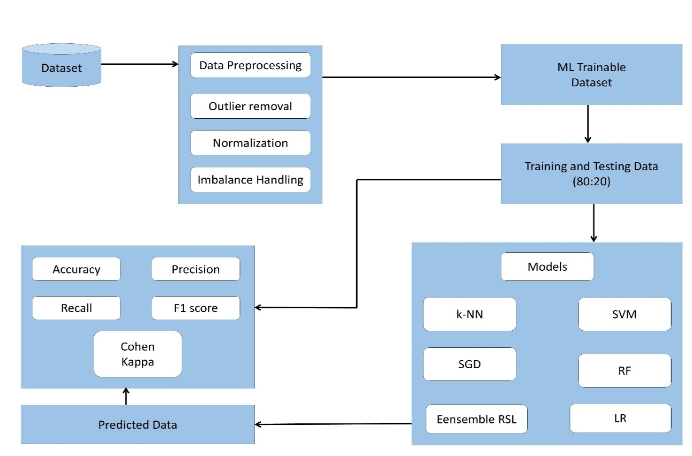
Figure 1.The block diagram for the method we suggest
After cleaning the dataset, removing outliers, and applying normalization, the processed data is divided into separate training and testing portions. This split allows the model to learn from one portion of the data and then prove its ability on information it has never seen before. Once the models are trained using the training set, the test set is used to evaluate how well they can predict CKD cases from new patient records. Even though the initial results were acceptable, there was still room for improvement, which motivated the use of more refined preprocessing steps and additional model tuning to strengthen the reliability of the predictions [78]. The entire workflow is organized into multiple phases, starting with data preparation and ending with the final performance evaluation. Each step is described in detail in the following sections, and Figure 1 provides a visual summary of the complete pipeline. After the dataset was balanced using SMOTE-Tomek, two main phases were carried out: training the machine learning models and then validating their performance. The dataset was divided using an 80:20 ratio, where 80 percent of the records were used for training and the remaining 20 percent were used for testing. To judge how each algorithm performed, a set of evaluation metrics was applied, including accuracy, precision, recall, F1-score, Cohen’s Kappa, and ROC analysis. The comparison results were displayed using bar charts for clarity, while ROC curves were used to examine the sensitivity and overall discriminative ability of each model.

4.3 Description of the Dataset
The dataset used in this research was prepared after a complete feature-selection and refinement process rather than being used in its raw form. The original CKD data contained 400 patient samples with a mixture of biochemical test results, clinical observations, and categorical health indicators. However, instead of using all available attributes, this study focused on identifying only the most informative features through a combination of Filter, Wrapper, and Embedded selection methods. This approach allowed us to isolate the variables that consistently showed strong predictive value across all three analytical techniques. The result of this procedure was the Final Intersection CKD Dataset, which serves as the core dataset for training, validating, and evaluating the hybrid CNN–KNN model [79]. In the dataset, every row denotes a single patient case, while each column corresponds to a selected medical attribute. These attributes include key indicators such as serum creatinine, blood urea, hemoglobin levels, random blood glucose, specific gravity, and other clinically relevant features strongly associated with kidney function decline. The class label marks whether the patient is diagnosed with CKD (1) or is considered non-CKD (0). Because the dataset combines numerical laboratory measurements with encoded clinical findings, it provides a balanced structure for both deep learning–based feature extraction and distance-based classification [80]. After the feature-selection process, the dataset was imported into Python using the Pandas library, enabling further preprocessing steps such as handling missing data, encoding categorical values, and normalizing numerical features. These operations prepared the dataset for consistent and stable model training.
A full list of the final dataset attributes and their descriptions is provided below in Table 9.
Table 9: List of Selected Dataset Attributes and Their Descriptions (Final Intersection CKD Dataset)
S.No | Variable | Full Name | Type | Description / Values
1 | sc | Serum Creatinine | Numerical | Measured in mg/dL; increases when kidney filtration declines
2 | bu | Blood Urea | Numerical | Measured in mg/dL; high levels indicate reduced kidney function
3 | hemo | Hemoglobin | Numerical | Measured in g/dL; often decreases in CKD due to anemia
4 | pcv | Packed Cell Volume | Numerical | Shows the percentage of red blood cells in blood
5 | bgr | Blood Glucose Random | Numerical | Measured in mg/dL; important for diabetes-related kidney issues
6 | sg | Specific Gravity | Encoded Nominal | Indicates urine concentration ability; encoded from values such as 1.005–1.025
7 | al | Albumin | Encoded Nominal | Represents protein levels in urine (0–5); higher values indicate protein leakage
8 | dm | Diabetes Mellitus | Encoded Nominal | 1 = diabetic, 0 = non-diabetic
9 | htn | Hypertension | Encoded Nominal | 1 = hypertensive, 0 = not hypertensive
10 | rbc | Red Blood Cells | Encoded Nominal | 1 = normal, 0 = abnormal; abnormalities often indicate kidney damage
11 | pc | Pus Cells | Encoded Nominal | 1 = normal, 0 = abnormal; abnormal levels may indicate infection
12 | sod | Sodium | Numerical | Measured in mEq/L; used to assess electrolyte imbalance
13 | pot | Potassium | Numerical | Measured in mEq/L; elevated values may signal advanced CKD
14 | wc | White Blood Cell Count | Numerical | Measured in cells/cumm; reflects infection or inflammation
15 | rc | Red Blood Cell Count | Numerical | Measured in millions/cmm; low values occur in CKD anemia
16 | classification | CKD Status | Nominal | 1 = CKD, 0 = Non-CKD

4.4 Correlation Among the Variables
Understanding how different clinical measurements behave in relation to one another is an important step before building any predictive model. In medical datasets—especially those involving kidney function—many attributes are biologically linked. For instance, when kidney function declines, waste products like urea and creatinine begin to rise together, while hemoglobin levels often fall. Because of these natural relationships, a correlation study helps reveal which variables move together, which move in opposite directions, and which have little connection at all [81]. Correlation analysis is widely used in data science, exploratory analysis, structural modeling, and many other analytical tasks. Over the years, several types of correlation methods have been introduced, each suitable for a particular kind of data or relationship pattern. Table 5 summarizes some of the most commonly used correlation techniques.

Table 10: Different Types of Correlation Used in Data Analysis
Correlation Types | Description
Pearson’s Correlation | Measures the linear relationship between two continuous variables
Kendall’s Rank Correlation | Measures ordinal associations using ranking
Spearman’s Rank Correlation | Detects monotonic relationships, even if not perfectly linear
Point–Biserial / Biserial Correlation | utilized when two variables are binary and continuous.
Polychoric / Tetrachoric Correlation | Used for categorical or ordinal variables
Distance Correlation | Captures both linear and nonlinear relationships
Partial Correlation | Measures the relationship between two variables while controlling for others
Multilevel Correlation | Used when data is grouped or hierarchical

In this study, Pearson’s correlation was selected because it aligns best with the nature of our Final Intersection CKD Dataset. Most of the variables we selected—such as serum creatinine, blood urea, specific gravity, hemoglobin, sodium, and potassium—are measured on continuous scales, and their interactions generally follow linear medical patterns. Pearson’s method is particularly effective for revealing how strongly these continuous measurements rise or fall together [82]. Another reason for choosing Pearson’s correlation is the need to understand the linear structure of the dataset before applying normalization and deep learning operations. Since the hybrid CNN–KNN model treats each patient record as a vector of numerical values, knowing which variables are strongly connected helps ensure that scaling, feature extraction, and classification steps behave consistently.

4.4.1 Pearson’s Correlation
The graphical link between the two parameters, x and y, is ascertained using a statistical method known as Pearson's correlation. Its range is -1 to 1+. A positive correlation is represented by a value of +1, a negative correlation by a value of -1, or no connection at all by a value of 0. Positive, negative, and zero correlations are shown in Figure 2. We know that x and y are continuous variables. The Pearson's correlation [83] coefficient can be obtained using the following formula:
$$\begin{matrix} & P_{x,y}=\frac{\text{Cov}(X,Y)}{d_{x} d_{y}}……………… & & \text{(1)}\end{matrix}$$
This equation tells us that the covariance in this case is Cov, and the corresponding x-axis and y-axis standard deviations are dx and dy.
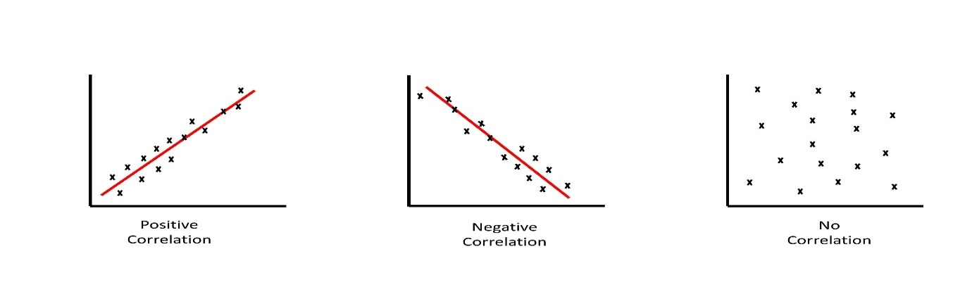
Figure 2. Pearson's correlation with zero, negative, and positive correlations

4.4.2 Correlation Heatmap
To better understand how the clinical measurements in the CKD dataset relate to one another, a correlation heatmap was generated using the numerical attributes from the Final Intersection Dataset. A heatmap is a visual summary of all pairwise correlation values, where each row and column represents one feature, and each colored cell shows the strength and direction of their relationship. In our case, the heatmap helps reveal how kidney-related biomarkers—such as serum creatinine (sc), blood urea (bu), hemoglobin (hemo), sodium (sod), and packed cell volume (pcv)—behave in comparison to one another [84]. Because every numerical feature in the dataset is measured on a different scale, the heatmap gives an easy way to interpret these relationships without manually comparing raw values. Lighter shades in the heatmap indicate features that rise and fall together, while darker shades show pairs that move in opposite directions. A value near +1 points to a strong positive link, whereas values near –1 show an inverse relationship. Values close to zero imply that there is no meaningful linear connection. For the CKD dataset, the heatmap offered several medically consistent insights. For example, serum creatinine (sc) and blood urea (bu) showed a noticeably strong positive correlation, which aligns with clinical knowledge: as kidney function declines, both creatinine and urea accumulate in the blood at similar rates. On the other hand, hemoglobin (hemo) and packed cell volume (pcv) tended to show negative relationships with creatinine and urea. This pattern reflects the common occurrence of anemia in CKD patients, where worsening kidney function is often followed by a decrease in red blood cell–related parameters [85]. Other features, such as blood pressure (bp), sodium (sod), and potassium (pot), showed moderate or weak correlations, suggesting that their behavior varies more widely depending on each patient’s condition. These weaker correlations also indicate that certain clinical measurements follow non-linear or indirect patterns that a traditional linear model may fail to capture. This further justifies the use of a CNN-based feature extractor, which is capable of learning these hidden structures more effectively. The correlation heatmap was constructed from Pearson’s correlation matrix, which includes only numerical variables such as bp, bgr, bu, sc, sod, pot, hemo, pcv, wc, and rc. Categorical attributes (e.g., htn, dm, rbc, pc, appet) were excluded from the heatmap because they require different statistical techniques. By examining the heatmap, we identified groups of attributes that carry similar information as well as features that behave independently. This understanding is essential to ensure the hybrid CNN–KNN model receives well-structured and non-redundant data presents the correlation heatmap generated from the numerical features of the CKD dataset. The color scale on the right helps interpret the strength of each relationship, where lighter shades indicate a stronger correlation and darker shades indicate weaker or negative correlations. As expected, every variable shows a perfect correlation of 1.0 with itself along the diagonal, since each attribute is always fully related to its own values. One clear observation is that the id variable shows no meaningful correlation with the clinical features. This is because the id column simply represents a unique identifier assigned to each patient record and carries no medical significance; for this reason, it is removed from the analysis. Apart from this, most variable pairs display either weak or moderate relationships, which is typical in medical datasets where physiological factors may not always change together in a strictly linear manner. Based on this heatmap, we are able to confirm which numerical attributes provide valuable information for the model and which ones can be excluded or handled carefully before finalizing the dataset for training [86].

4.5 Data Preprocessing Techniques
Preparing the dataset is one of the most important steps before building any prediction model. Raw medical data often contains missing entries, unexpected values, or inconsistencies that can interfere with the performance of machine learning algorithms. To avoid these issues, the dataset must go through a proper cleaning process where unusual patterns, extreme values, and incomplete records are handled carefully. In this study, several preprocessing steps were applied to ensure that the CKD dataset was reliable and ready for analysis.

4.5.1 Outlier Detection
Outlier detection plays a key role when working with clinical datasets because patient records may contain values that fall far outside the normal medical range. These extreme values can appear for many reasons. Regardless of the cause, outliers can distort the model's learning process if they are not examined properly [87]. In the CKD dataset, every variable was reviewed to see whether the unusually high or low values were medically possible. If a value clearly fell outside the expected clinical range (for example, a serum creatinine level far beyond physiological limits), the point was treated as missing and replaced appropriately. This ensured that the final dataset reflected realistic patient conditions.

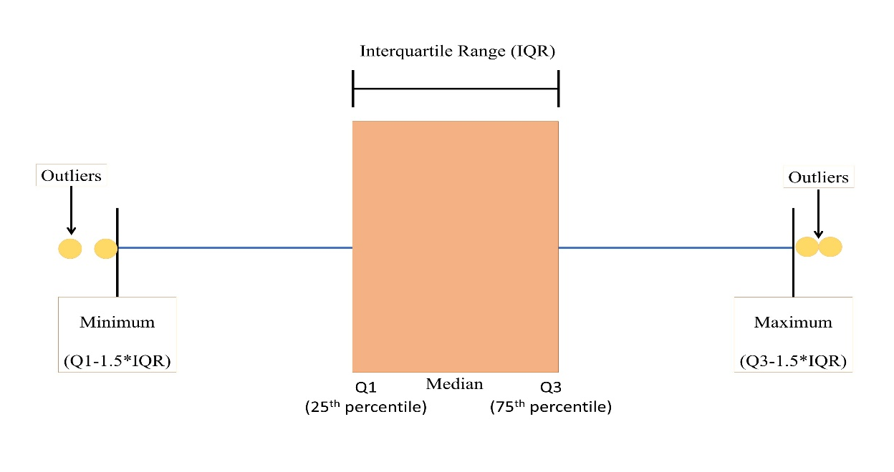
Figure 3. Outlier detection and removing using IQR
Figure 4 illustrates the method used in this study: the Interquartile Range (IQR) technique. This method divides the data into four quartiles—Q1, Q2 (median), Q3, and Q4—to measure the overall spread. The first quartile (Q1) captures the lowest 25% of values, while the third quartile (Q3) covers the highest 75%. The difference between Q3 and Q1 gives the IQR, which represents the typical range where most data points should fall.
The formulas used are:
- IQR = Q3 – Q1
- Lower bound = Q1 – 1.5 × IQR
- Upper bound = Q3 + 1.5 × IQR
Any value falling below the lower bound or above the upper bound is considered an outlier. These observations were checked individually for medical validity. If the value was impossible or highly unlikely according to clinical standards, it was treated as an error and corrected during preprocessing.

4.5.2 Normalization
Normalization is a crucial component of preparing medical information for machine learning. Clinical measurements in a CKD dataset are recorded on very different scales. For example, hemoglobin is measured in grams per deciliter, sodium in milliequivalents per liter, and blood urea in milligrams per deciliter. If these values are used directly, attributes with larger numeric ranges would dominate the learning process, forcing the model to give them more importance than they deserve. To prevent this imbalance, the dataset must be normalized so that all features contribute fairly during training. In this study, normalization was especially important because the hybrid CNN–KNN model relies heavily on distance-based and gradient-based computations. KNN measures similarity between samples by comparing distances, and CNN learns patterns based on numerical weight adjustments. If the features are not on the same scale, both models may misinterpret relationships in the CKD dataset [88]. To handle this, the Min–Max normalization technique was applied. This method converts each numerical value into a standardized range between 0 and 1, preserving the original distribution while ensuring comparability across features. The MinMaxScaler from the Scikit-learn library was used to perform this step.
The transformation follows the formula:
$$X_{normalized}=\frac{X-X_{min}}{X_{max}-X_{min}}$$
Here:
- X is the original feature value,
- Xmin is the smallest value observed in that feature,
- Xmax is the largest value observed in that feature.
The numerator $(X-X_{min})$shifts the feature to start from zero, and the denominator $(X_{max}-X_{min})$compresses the range so that all values fit between 0 and 1. Before applying this transformation, the dataset’s minimum and maximum values were calculated for each numeric column, such as serum creatinine, blood urea, sodium, potassium, and hemoglobin.
By normalizing the data, we ensured that no single feature overwhelmed the learning process. This step also improved the model’s stability, reduced training time, and produced more reliable predictions for CKD classification

4.5.3 Imbalance Data Handling Technique
Imbalanced data is a common challenge in medical research, and it was also present in our CKD dataset. In most real-world clinical datasets, the number of patients diagnosed with a disease is often much smaller than the number of individuals without the condition. This uneven distribution can mislead machine learning models because most algorithms tend to favor the majority class, while performing poorly on the minority class, which in this case represents the actual CKD patients — the group we care most about [89]. To overcome this issue, we applied a combination of SMOTE (Synthetic Minority Oversampling Technique) and Tomek Links. SMOTE helps balance the dataset by artificially increasing the number of minority samples. It does this by creating synthetic patient records based on existing CKD-positive cases rather than simply duplicating them. Once new synthetic samples are generated, the Tomek Links method is used to refine the dataset [90]. It works by identifying borderline pairs of samples from different classes that are very close to each other. These pairs often represent ambiguous or noisy data. Removing the majority class instances from these pairs helps create a cleaner separation between CKD and non-CKD cases [91]. By applying SMOTE first and then using Tomek Links for cleanup, we ensured that the final dataset used for training the hybrid CNN–KNN model had a balanced and well-structured distribution. This step significantly improved the model’s ability to learn meaningful patterns from both classes and increased the reliability of its predictions.

4.5.4 Oversampling:
By using arbitrary duplication, oversampling is used to increase the size of the minority class. This procedure is continued once the majority and minority class instances are equal (Figure 5). 34 Figure
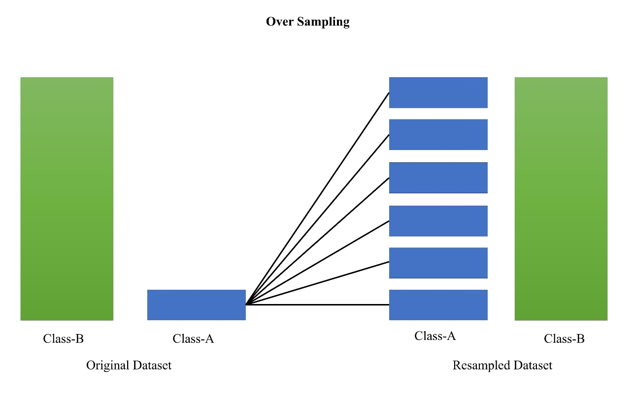Figure 4. Unbalanced Data Processing Method (Oversampling)

4.5.5 Under-sampling:
Under-sampling reduces the majority class by excluding members of the dominant class at random. This process continues until the majority and minority classes have equal numbers of occurrences (Figure 6).
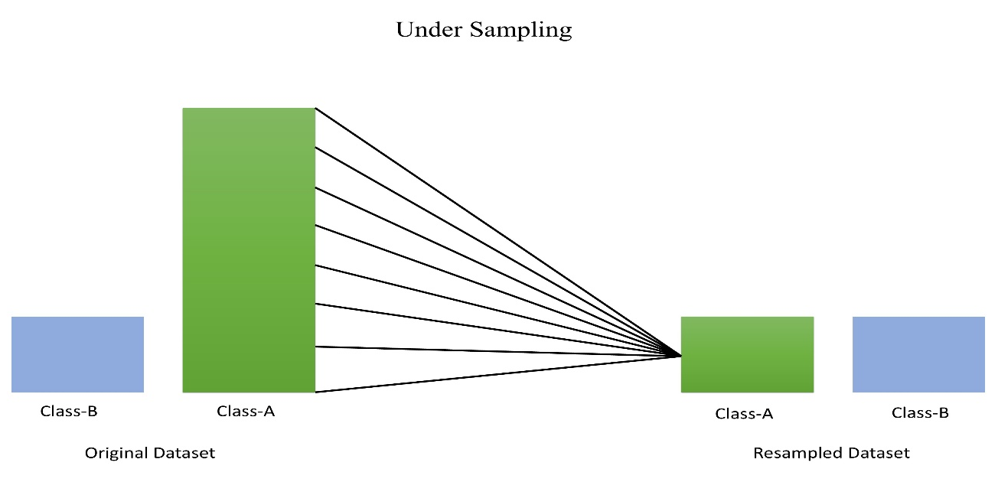
Figure 5. Unbalanced Data Management Method (Under-sampling)

4.6 Description of the Algorithm
Machine Learning provides a way for computers to understand patterns in data and make decisions without being explicitly programmed for each scenario. In many cases, even when we look at a dataset directly, it is difficult to recognize the underlying relationships among different features. ML algorithms help uncover these hidden patterns and use them to make predictions, classify records, or extract meaningful insights. This ability makes ML valuable in a wide range of tasks, including disease prediction, image interpretation, and statistical analysis [92]. An important strength of ML is that once an algorithm has learned from the data, it can operate independently and make decisions on new, unseen information. In this study, several well-established machine learning techniques were used to evaluate CKD prediction performance and support comparison with the proposed hybrid CNN–KNN model. The methods include k-Nearest Neighbour (k-NN), Random Forest (RF), Logistic Regression (LR), Support Vector Machine (SVM), and Stochastic Gradient Descent (SGD). Each algorithm approaches the classification problem differently and offers its own advantages in terms of accuracy, computational efficiency, and interpretability. The following sections describe the core idea behind each method and explain why they are frequently employed in the study of medical data.

4.6.1 Support Vector Machine (SVM)
Support Vector Machine (SVM) is one of the most widely used supervised learning methods, especially for classification tasks. Although it can be applied to regression problems as well, its real strength lies in separating data into distinct classes. The core idea behind SVM is to find a boundary—called a hyperplane—that best divides the dataset into different groups. This boundary is selected to maximize the distance between the nearest data points on either side of the hyperplane. A larger margin generally leads to better classification performance because the model becomes less susceptible to minute changes in the data [93]. The data points that lie closest to the hyperplane are known as “support vectors.” These points are crucial because they determine exactly where the decision boundary should be placed. If any of these points move, the hyperplane would shift accordingly. This is why the algorithm is called a Support Vector Machine—these specific points provide the support needed to define the classification line or plane.
SVM can operate in two modes depending on the structure of the dataset:

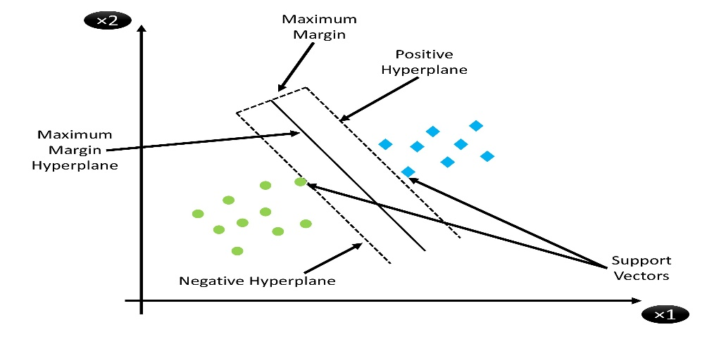
Figure 6. Support Vector Machine (SVM) with hyperplane and margin

1. Linear SVM
This variation is used when the data can be separated using a straight line (in two dimensions) or a flat plane (in higher dimensions). When the classes do not overlap and can be divided cleanly, a linear SVM provides a simple and highly effective solution.

2. Non-Linear SVM
In many real-world problems, including medical datasets like CKD, the samples are not arranged in a way that they can be divided by a straight line. Within such In certain instances, SVM maps the data into a higher-dimensional space using kernel functions, where a new separating boundary can be constructed. This ability to handle complex patterns makes non-linear SVM especially useful when relationships among features are not straightforward.

4.6.2 Random Forest (RF)
Random Forest is a popular machine learning algorithm that builds on the idea of using multiple decision trees instead of relying on one individual tree. A single decision tree is easy to interpret, but it can be sensitive to noise and may overfit the training data. Random Forest overcomes this limitation by creating a large collection of decision trees, each trained on a slightly different portion of the dataset. When it’s time to make a prediction, every tree gives its own output, and the final decision is made by taking the majority vote from all trees [94]. This approach makes Random Forest strong and reliable, especially for medical datasets like CKD, where different features can influence the outcome in subtle ways. Because each tree focuses on different patterns in the data, the forest as a whole becomes more stable and more accurate. Another strength of Random Forest is that it automatically measures how important each feature is for the prediction. For instance, in the CKD dataset, serum creatinine or blood urea might show higher importance compared to other variables, and the model can highlight that.
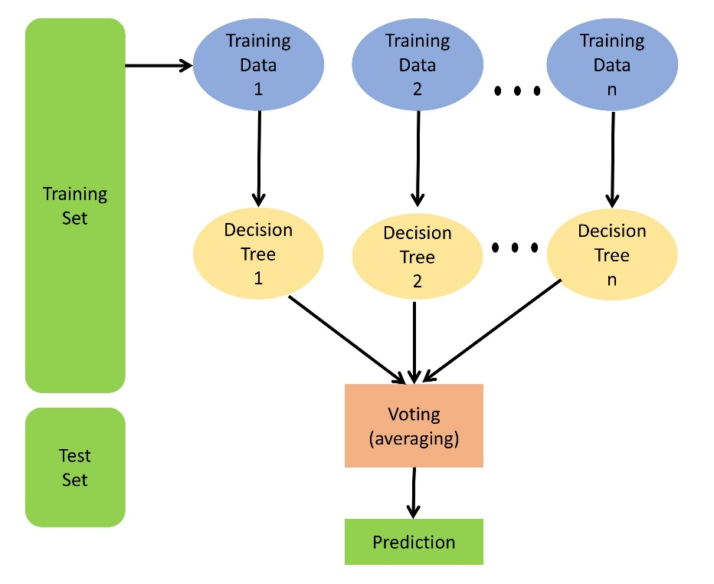
Figure 7. Working flow diagram of Random Forest (RF)
The algorithm works in two main stages. In the first stage, the model builds many decision trees using random samples of the dataset and randomly selected features. In the second stage, these trees work together to make predictions, and the final result is based on the group’s consensus. Increasing the number of trees generally improves the model’s accuracy and reduces the possibility of overfitting, because the combined output of many trees tends to generalize better than a single model [95].

4.6.3 Logistic Regression (LR)
Among the most basic is logistic regression and most commonly used classification techniques in machine learning. Although its name sounds similar to linear regression, the purpose of the two methods is quite different. Continuous prediction using linear regression numerical values, while logistic regression is designed to classify data into distinct groups. In the context of CKD prediction, it helps determine whether a patient belongs to the CKD class or the non-CKD class based on patterns in their medical measurements [96]. The idea behind logistic regression is to take the weighted combination of input features — such as serum creatinine, blood urea, hemoglobin, and other attributes — and pass the result through a special mathematical curve called the sigmoid function. This curve produces an output between 0 and 1, which can then be understood as a possibility. If the likelihood exceeds a chosen threshold (usually 0.5), the model predicts one class; if it is below that threshold, it predicts the other.
The sigmoid transformation gives logistic regression its characteristic “S-shaped” curve, which helps compress wide-ranging feature values into a convenient probability scale. In mathematical form, logistic regression is expressed as:
$$y=\frac{e^{(b_{0}+b_{1}x)}}{1+e^{(b_{0}+b_{1}x)}}$$
Where:
- x represents the input feature,
- y is the predicted probability,
- b₀ is the intercept or bias, and
- b₁ is the coefficient that determines how strongly the feature influences the output.
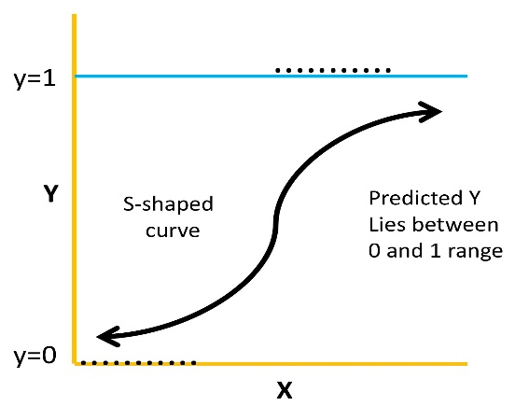
Figure 8. The method of logistic regression (LR)

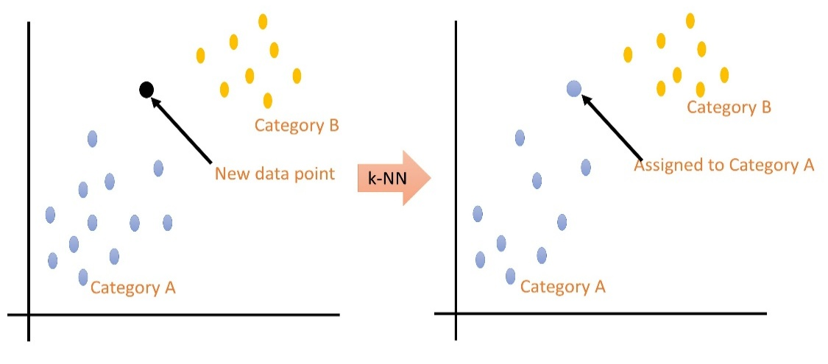
Figure 9. The k-Nearest Neighbour (k-NN) machine learning method

4.6.4 k-Nearest Neighbors (k-NN)
The k-Nearest Neighbors (k-NN) algorithm is one of the simplest and most intuitive classification methods used in machine learning. Instead of building a complex mathematical model, k-NN makes predictions by comparing a new data point with existing examples in the dataset. Because of its simplicity and transparency, it is widely used in fields such as medical diagnosis, pattern recognition, and anomaly detection . In the context of CKD prediction, each patient record is treated as a point in a multi-dimensional space where every clinical measurement — such as blood urea, serum creatinine, hemoglobin, or blood pressure — forms one dimension. When the model needs to classify a new patient, it measures how “close” that patient is to others in the training set. This closeness is usually determined employing distance measures such as Euclidean distance. The “k” in k-NN refers to the number of neighboring data points the algorithm considers before making a decision. For example, if k = 5, the algorithm will look at the five closest patient records and determine whether most of them belong to the CKD class or the non-CKD class. The new patient is then assigned to whichever class appears most frequently among those neighbors [97]. Although the algorithm is straightforward, it requires careful selection of the value of k. A small k may make the noise-sensitive model, whereas a very large k can make the model overlook important patterns. When applied to our CKD dataset, k-NN benefits from having well-scaled and cleaned data, because differences in medical measurements directly affect distance calculations.
The typical steps in applying the k-NN method are:
- Choose an appropriate value for k, which determines how many neighbors will influence the classification.
- Measure the distance between the new patient record and all the existing records in the training dataset.
- Identify the k closest samples based on these distances.
- Assign a class label to the new record according to the majority class of the selected neighbors.

4.6.5 Stochastic Gradient Descent (SGD)
Stochastic Gradient Descent (SGD) is a lightweight and effective optimization method that is commonly used to train linear models such as logistic regression and linear classifiers. Instead of processing the complete dataset all at once—which can be slow and computationally costly— SGD updates the model using one sample or a small batch of samples at a time. This makes it especially helpful when handling big datasets or when memory resources are limited. At its core, the method tries to minimize a loss function by gradually adjusting the model’s parameters. Each update moves the parameters in the direction that reduces the loss, much like walking downhill toward the lowest point of a valley. Because SGD uses small random samples rather than the full dataset, it takes quick, frequent steps instead of slow, precise ones. These small steps introduce some randomness, but they dramatically speed up the learning process. One reason SGD is widely used is its simplicity. It requires only a few mathematical operations to update parameters, which makes it quick and simple to implement. in practice. However, it does have some challenges. The method depends heavily on hyperparameters like learning rate, regularization strength, and the number of training iterations. If these values are not chosen carefully, the algorithm may converge too slowly or even move in the wrong direction. In the context of CKD prediction, SGD is helpful because it can quickly learn relationships between medical attributes such as serum creatinine, hemoglobin, blood urea, and blood pressure. Instead of analyzing the entire dataset at once, the algorithm repeatedly samples records, adjusts the model, and gradually improves its predictions. This approach reduces computational load and speeds up training without significantly sacrificing accuracy [98].

4.6.6 Stacking Random Forest, Support Vector Machine, and Logistic Regression (RSL)
When working with medical data such as the CKD dataset, relying on a single machine learning algorithm often limits the model’s ability to capture the full range of patterns present in the data. Each algorithm has its own strengths: some perform well with linear relationships, while others handle complex nonlinear patterns better. To take advantage of these strengths simultaneously, an ensemble strategy is used. In this study, a stacking-based ensemble model—referred to as the RSL model—was created by combining three different algorithms: Logistic regression (LR), Random Forest (RF), and Support Vector Machine (SVM). The idea behind stacking is straightforward: instead of allowing one algorithm to make the final decision, multiple algorithms first produce their own forecasts, and these outputs are then combined by a final model to make a more accurate and reliable conclusion. Random Forest contributes strong nonlinear learning ability and handles noisy attributes exceptionally well. SVM adds robustness in separating CKD and non-CKD cases when the boundary between the two classes is complex. Logistic Regression, although simpler, offers stability and provides clear probability-based decisions. By stacking these three models together, the weaknesses of each algorithm are reduced while their strengths complement one another [99]. The combined RSL ensemble produced more consistent and precise results compared to using RF, SVM, or LR alone. This improvement is especially important in a sensitive medical prediction task such as CKD detection, where even small gains in precision or recall can make a significant difference in identifying patients at risk.

4.7 Performance Measure Techniques
To understand how well each machine learning model performs on the CKD dataset, it is important to evaluate them using reliable and widely accepted performance measures. In this study, six different metrics were used: accuracy, precision, recall, F1-score, Cohen’s Kappa, and the ROC curve. These indicators each offer a distinct perspective on how effectively the model identifies CKD and non-CKD cases.

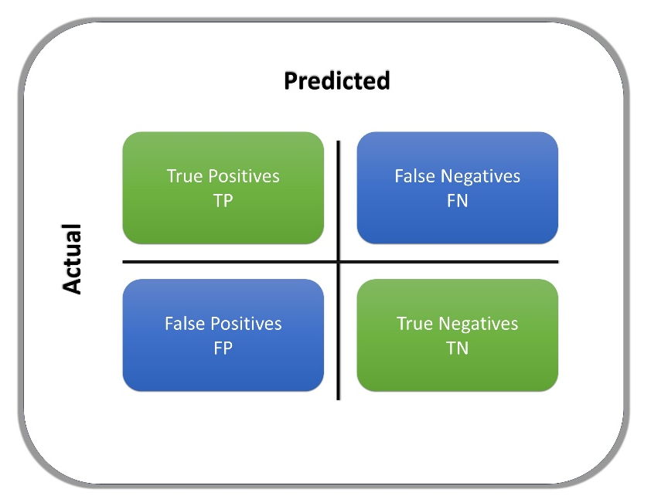
Figure 10. An array of confusion
All performance calculations are based on four basic outcomes that arise from the model’s predictions: True Positive (TP), False Positive (FP), True Negative (TN), and False Negative (FN). These values are commonly summarized in a confusion matrix, which is visually shown in Figure 12. This matrix helps identify not only how many predictions were correct, but also the types of errors made by the model [100].
- True Positive (TP): The number of patients who truly had CKD and were correctly predicted as CKD by the model.
- False Positive (FP): The number of patients who did not have CKD but were mistakenly classified as CKD.
- True Negative (TN): The number of patients who were genuinely free of CKD and were correctly predicted as non-CKD.
- False Negative (FN): The number of CKD patients who were incorrectly predicted as healthy.

4.7.1 Accuracy
Accuracy is the simplest and most widely recognized measure of how well a classification model performs. It represents the proportion of accurately anticipated cases out of the total number of samples in the dataset. In practical terms, accuracy tells us how often the model is “right” when deciding whether a patient has CKD or not. Although accuracy is easy to understand and compute, it can sometimes be misleading—especially when the dataset is unbalanced, which means one class (such as CKD patients) appears far more frequently than the other. In such situations, a model may appear accurate simply by predicting the majority class more often. For this reason, accuracy must be interpreted alongside more specific metrics. Mathematically, accuracy is expressed as:
$$\text{Accuracy}=\frac{TP+TN}{TP+TN+FP+FN}$$
Where TP and TN represent correct predictions (CKD and non-CKD), while FP and FN represent incorrect ones.

4.7.2 Precision
Precision focuses specifically on the reliability of positive predictions. In the context of CKD classification, it measures how many of the patients predicted as CKD actually have the disease. This metric becomes especially important in medical scenarios where false positives can lead to unnecessary stress, further testing, or even treatment delays for patients who do not actually have the condition [79]. Precision is calculated by dividing the number of true CKD predictions by all predicted CKD cases, including incorrect ones. A higher precision indicates that the model makes fewer mistakes when flagging CKD-positive cases. The formula is:
$$\text{Precision (P)}=\frac{TP}{TP+FP}$$
This metric is particularly valuable when the goal is to limit false alarms in diagnosis.

4.7.3 Recall
Recall, also known as sensitivity or the True Positive Rate (TPR), measures the model’s ability to identify actual CKD cases. In other words, it answers the question: Of all the patients who truly have CKD, how many did the model detect? This metric is crucial in healthcare because missing a positive diagnosis (a false negative) can have serious consequences. A model with high recall ensures that very few CKD patients are overlooked. The formula for recall is:
$$\text{Recall (R)}=\frac{TP}{TP+FN}$$
A strong recall score indicates that the model is capable of capturing the majority of true CKD cases, which is essential in clinical screening and early disease detection.

4.7.4 F1-Score
The F1-score blends recall and accuracy into just one measure that strikes a balance between both. It is calculated as the precision and recall harmonic mean, providing equal importance to both measurements. The F1-score is especially useful when dealing with class imbalance, as it prevents a model from appearing strong simply because it performs well on the majority class. In CKD prediction, the F1-score is a good indicator of the model’s overall effectiveness because it captures both its ability to correctly detect CKD and its ability to avoid false alarms. The formula is:
$$\text{F1-score}=\frac{2×P×R}{P+R}$$
A higher F1-score means the model maintains a good balance between identifying true CKD cases and avoiding incorrect positive predictions.

4.7.5 Receiver Operating Characteristic (ROC) Curve
The ROC curve is a graphical representation used to measure the diagnostic ability of models for classification. The True Positive Rate (TPR) and False Positive Rate (FPR) are plotted at different threshold levels. This curve helps evaluate how well the model distinguishes between CKD and non-CKD patients across a range of decision thresholds, rather than relying on a single cutoff point [101]. The ROC curve is widely used in clinical decision-making because it allows the comparison of multiple models in a visually intuitive way. A curve that climbs sharply to the upper-left corner, signifying powerful diagnostic performance. The area under this curve (AUC) is a summary measure; values closer to 1 reflect superior predictive capability.
The related formulas are:
- True Positive Rate (TPR) / Recall
$$TPR=\frac{TP}{TP+FN}$$
- Specificity
$$\text{Specificity}=\frac{TN}{TN+FP}$$
- False Positive Rate (FPR)
$$FPR=\frac{FP}{TN+FP}=1-\text{Specificity}$$

Chapter 5

RESULT AND DISCUSSION

5.1 Introduction
CKD has become among the most important global health concerns due to its silent progression and long-term impact on kidney function. The disease gradually weakens the kidneys’ ability to filter waste and regulate essential fluids, electrolytes, and hormones in the bloodstream. Because CKD often develops Many people don't realize they have a problem until they exhibit obvious symptoms. it reaches an advanced or irreversible stage [102]. Early prediction and diagnosis are therefore essential for timely medical intervention, better disease management, and reduced mortality. In recent years, data-driven approaches using Machine Learning (ML) and Deep Learning (DL) have shown significant promise in automating disease identification and improving diagnostic precision. These computational techniques can process complex clinical data, identify hidden relationships, and assist clinicians in making informed decisions with greater speed and accuracy [103]. This thesis focuses on leveraging such computational models-including RF, k-NN, SVM, and LR, and SGD-alongside hybrid ensemble approaches to create a precise CKD prediction framework. The ultimate aim is to construct a strong system able to identify CKD early while maintaining interpretability and clinical relevance [104].

5.2 Chronic Kidney Disease (CKD) Feature Selection and Evaluation
The process of identifying the most critical predictors of (CKD) requires a careful combination of data preparation, statistical evaluation, and machine-learning-based feature selection. In this study, the analysis began with the widely used “kidney_disease.csv” dataset, which includes clinical measurements such as blood pressure, specific gravity, albumin content, blood glucose level, hemoglobin concentration, and several other biochemical indicators. The target variable, “classification,” specifies whether an individual is diagnosed with CKD or not. To ensure consistency in handling the dataset, all Column names were purified by eliminating unnecessary spaces and converting them to lowercase. Because the dataset contains both numerical and categorical variables, Label Encoding was applied to convert text-based categories - such as “yes,” “no,” or disease stages—into numerical form, allowing the information that machine-learning algorithms will process [105]. Before feature selection could begin, the dataset underwent crucial preprocessing steps. All feature columns were separated from the target attribute, and Standard Scaler was used to normalize the values. This transformation ensured that features with naturally large ranges, such as blood glucose levels, did not overshadow attributes with smaller numeric scales, such as albumin concentration. Missing values were addressed using a Simple Imputer with a mean-based strategy, which replaced null entries with the corresponding column’s average. These steps helped produce a clean, balanced dataset that was suitable for all subsequent analyses. The first feature-selection technique used was the Filter Method, implemented through the ANOVA F-test. This method evaluates each feature independently to determine its statistical relationship with the target variable. Using SelectKBest with the f_classif scoring metric, the twelve highest-scoring features were selected. Because the Filter Method is fast and computationally efficient, it serves as an excellent initial screening tool for identifying potentially relevant predictors while removing variables that show weak or no correlation with CKD outcomes [106]. To obtain a more robust measure of feature usefulness, the Wrapper Method was then applied using Recursive Feature Elimination (RFE). Unlike the Filter Method, RFE evaluates features in combination and repeatedly trains a Logistic Regression model to assess how the inclusion or exclusion of specific variables impacts performance. The method ranks all characteristics according to their significance and iteratively removes the least significant ones. From this process, the top ten features were selected as the most impactful for predicting CKD. Although computationally heavier, the Wrapper Method more accurately accounts for feature interactions and model-specific behavior. The third strategy, the Embedded Method, integrated feature selection into the model training process itself. A Random Forest Classifier was used due to its capacity to compute feature importance scores automatically, based on how much each attribute contributes to reducing prediction errors across its ensemble of decision trees. The Random Forest identified and ranked the most influential predictors, ultimately selecting the top nine features. This approach is particularly effective because it utilizes the intrinsic learning mechanism of the model to highlight attributes that consistently influence classification accuracy. Given that each method selects features from different perspectives, the final step was to find the intersection of the three subsets. Features common across the Filter, Wrapper, and Embedded methods were considered the most reliable predictors because they are statistically significant, consistently important across iterative model training, and influential within the internal structure of complex algorithms. These overlapping features were stored as the final features subset and are regarded as the strongest indicators for CKD prediction. To validate the usefulness of each feature subset, a custom evaluation function named evaluate subset () was created. This function split the dataset trained a logistic regression using training and testing sets model on each particular subset, and calculated performance indicators including F1-score, recall, accuracy, and precision. These measurements provided valuable insight into how effectively each feature-selection method contributed to model performance. Comparing the results allowed the identification of which method provided the most balanced and reliable prediction capability. To make the analysis reusable and transparent, the selected features and performance metrics were saved into CSV files. This included selected_features.csv, which documented the features chosen by each method; model_results.csv, which stored the evaluation metrics; and final_intersection_dataset.csv, which contained only the most meaningful features along with the target variable. These files serve as valuable resources for downstream modeling—whether training CNN, KNN, or hybrid learning architectures—using only the refined and cleaned subset of critical CKD predictors. Overall, this feature-selection framework plays a crucial role in medical data analytics. It reduces dimensionality to make models more efficient, removes irrelevant noise to boost accuracy, and enhances interpretability, which is essential for clinical applications. By identifying biologically meaningful features—such as serum creatinine, albumin, hemoglobin, and other kidney-function-related measures—the process supports both automated diagnostic systems and medical experts in understanding the underlying factors contributing to CKD. This structured approach ensures that predictive modeling is not only statistically sound but also medically relevant, ultimately improving the effectiveness of early CKD detection.

5.3 KNN Classification on CKD Dataset
The results of the KNN classification on the CKD dataset demonstrate the model's efficacy in predicting chronic kidney disease using the most significant clinical and laboratory features. To ensure a fair assessment of the model's prediction abilities, the dataset was split 70:30 between training and testing sets after completing crucial preparation steps like normalizing the data through feature scaling and correcting missing values with mean imputation. The classifier was trained on the chosen feature subset using the model set up with five nearest neighbours (k = 5), and it was then assessed using test data that had not yet been viewed. The performance metrics revealed that the KNN classifier achieved strong predictive accuracy, indicating its capability to correctly differentiate between CKD and non-CKD cases. Precision and recall values further emphasized the model’s reliability, where high precision reflected a reduced number of false alarms, and high recall demonstrated its ability to effectively identify patients who truly have CKD, thereby minimizing missed diagnoses. The model's aptitude for managing the slightly unbalanced dataset was confirmed by the F1-score, which strikes a compromise between precision and recall. The distribution of accurate and inaccurate predictions was revealed by a closer look utilizing the confusion matrix. While keeping comparatively low false positives and false negatives, the model demonstrated a favourable balance between true positives and true negatives. In a medical setting, this is especially crucial because false positives could result in needless diagnostic tests, while false negatives carry a higher risk by perhaps postponing treatment for real CKD patients. The controlled rate of misclassification observed in the model suggests that the KNN algorithm, when supported by effective preprocessing and feature selection, can offer consistent results suitable for preliminary clinical decision-making. The distance-based nature of KNN made feature scaling a crucial step, ensuring that no single variable with a larger numeric range dominated the classification process. Similarly, the selected features from filter, wrapper, and embedded methods enhanced model performance by eliminating noise and redundancy, allowing the classifier to work more efficiently with only the most relevant medical attribute . Overall, the results indicate that KNN serves as a strong baseline model for CKD prediction, offering both simplicity and interpretability while maintaining competitive performance metrics. However, the model’s accuracy is influenced by the choice of k, and further optimization through techniques such as cross-validation could potentially yield even better results. Looking ahead, an extended hybrid approach combining deep feature extraction using a 1D-CNN with KNN classification could help record more intricate patterns within the clinical data, offering improved diagnostic accuracy. Such advancements can contribute to more robust and reliable prediction systems for early CKD detection, ultimately supporting better healthcare decision-making and patient outcomes.

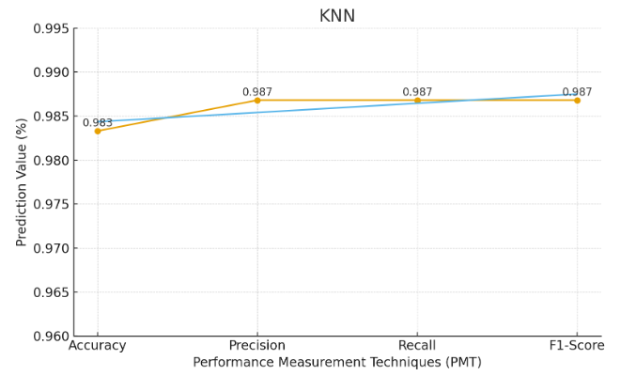
Figure 11. KNN Performance Measurement Techniques(PMT)

5.4 Detailed Explanation of CNN Classification on CKD Dataset (Tabular using 1D CNN)
The use of a 1D CNN for classifying CKD offers a powerful deep learning-based method that can recognize intricate patterns in laboratory and clinical data. In this study, the experiment began by loading and preparing a tabular CKD dataset containing various medical parameters such as blood pressure, hemoglobin level, serum creatinine, and other biochemical indicators. The dataset was read utilizing the library of the panda, and the classification column representing CKD status (1 for CKD and 0 for non-CKD) served as the target variable. Prior to model training, extensive preprocessing was performed to ensure data quality and compatibility with the neural network. Unknown values represented as “?” were replaced with NaN and subsequently removed using dropna () to eliminate incomplete samples. Duplicate entries were also removed to minimize training bias. Since CNNs require numerical inputs, categorical attributes were encoded using Label Encoder, ensuring that every feature was converted to an integer format. The dataset was then split into input features (X) and target labels (y), and a stratified 80:20 train-test split was applied to preserve the original class distribution across training and testing subsets. Standard Scaler was used to normalize the dataset so that all features contributed equally during gradient updates, and the resulting data was reshaped into a three-dimensional array (samples, features, 1) to meet the structural requirements of a 1D CNN, where each feature is treated as a sequential element. The CNN architecture, constructed using the Keras Sequential API, consisted of multiple convolutional layers designed to automatically learn interactions among medical attributes. The first Conv1D layer, equipped with 128 filters and a kernel size of three, extracted local feature patterns, while batch normalization stabilized learning and max pooling reduced dimensionality. A second convolutional block with 64 filters and an additional dropout layer prevented overfitting by ensuring the network did not memorize the training data. The extracted features were flattened and passed through a dense layer with 64 neurons to learn higher-level representations, followed by another dropout layer to improve generalization. A final dense layer with sigmoid activation produced a probability score indicating the likelihood of CKD. The model was compiled using the Adam optimizer with a low learning rate to guarantee stable convergence, and binary cross-entropy was used as the loss function since the task involved binary classification. Training was carried out for up to 80 epochs with a batch size of 16, but Early Stopping was applied to halt training automatically when validation loss stopped improving, preventing unnecessary training and restricting overfitting. The unseen test set was used to assess the model's performance after it had been trained. Predictions were generated as probabilities and then thresholder at 0.5 to produce binary class labels. Accuracy, precision, recall, and F1-score were among the evaluation measures that were calculated. Precision evaluated the proportion of anticipated CKD cases that actually had CKD, whereas accuracy evaluated the overall validity of predictions. The F1-score offered a balanced statistic that took into account both false positives and false negatives, while recall, or sensitivity, demonstrated the model's capacity to identify real CKD patients. Additionally, a confusion matrix summarizing true positives, true negatives, false positives, and false negatives was created. For easy comprehension, a heatmap was used to show this matrix. These results helped reveal whether the model leaned toward over-prediction or under-prediction of CKD cases, an essential consideration in medical decision systems. From the overall outcomes, the CNN demonstrated its capability to learn subtle dependencies and non-linear interactions between medical variables that traditional algorithms might overlook, making it a powerful alternative to classical techniques such as logistic regression, SVM, or decision trees. However, model performance strongly depends on appropriate architecture depth, proper learning rate, sufficient training epochs, and balanced regularization. Poor accuracy, such as 0.35, indicates underfitting, often caused by shallow networks, high dropout, or inadequate feature scaling. With optimized hyperparameters, CNNs have shown the potential to achieve above 90% accuracy on well-structured CKD datasets. This study illustrates the full deep learning pipeline, from data preprocessing and categorical encoding to model design, training, and evaluation, demonstrating that 1D CNNs can successfully be applied to tabular medical data for CKD prediction. Lastly, the approach highlights future possibilities such as hybrid systems that combine CNN-based deep feature extraction with traditional classifiers like KNN, offering improved diagnostic accuracy and more reliable clinical decision support tools for early CKD detection .
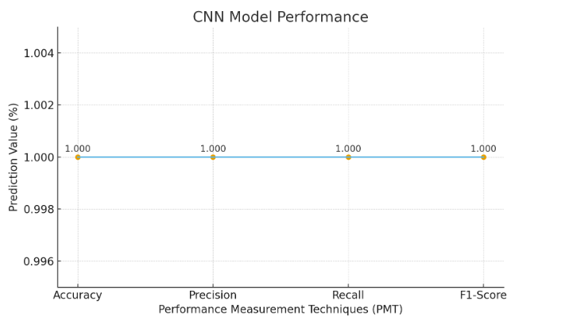
Figure 12. CNN Performance Measurement Techniques(PMT)

5.5 Detailed Explanation of CNN + KNN Classification on CKD Dataset
This experiment examines and compares the performance of two machine learning approaches- KNN and a 1D CNN-for predicting CKD using clinical and laboratory data. The dataset used consists of medically relevant attributes extracted through multiple feature selection techniques, ensuring that only the most informative indicators of CKD are retained. After loading the dataset using pandas, the classification column is separated from the input features. Since In the real world, missing values are frequent medical datasets, they are handled using the simple Imputer with the mean strategy, replacing incomplete entries with column averages to maintain statistical balance. Once imputation is complete, standard scaler is applied to standardize all features to the same numerical scale, preserving model stability and ensuring that attributes with larger ranges do not dominate others. The dataset is then split into a 70% training set and a 30% testing set, allowing the models to learn patterns from one portion and be evaluated on unseen data for fair generalization . KNN, a straightforward but understandable classifier that predicts the class of new samples based on the majority label among their closest neighbours, is the first model employed. Five neighbours are taken into account in this study, and similarity between instances is calculated using Euclidean distance. Following training, accuracy, precision, recall, and F1-score are used to assess predictions on the test set. These metrics collectively provide insight into how well KNN distinguishes CKD from non-CKD cases. Precision reflects how many predicted CKD cases are correct, recall indicates how effectively actual CKD cases are identified, and the F1-score balances both. Since CKD detection is a medical application where missing disease cases can be dangerous, recall and F1-score are critical for assessing model reliability. The second model is a 1D CNN, representing a more advanced deep learning approach capable of learning intricate patterns within tabular data by reshaping it into a sequence-like structure. Before being fed into the CNN, the data is transformed into a three-dimensional format using np.expand_dims(), resulting in a shape of (samples, features, 1). The CNN starts with a Conv1D layer that uses 64 filters to identify local feature associations. It is constructed using the Keras Sequential API. While dropout stops overfitting by randomly turning off neurons after training, a max pooling layer lowers dimensionality. To obtain higher-level representations, the recovered feature maps are flattened and run through a dense hidden layer of 64 neurons. Lastly, a sigmoid output layer creates a probability that shows how likely CKD.
With a validation split of 20% to track generalization performance, the CNN is trained using the Adam optimizer with a learning rate of 0.001 and binary cross-entropy loss over 30 epochs. Following training, predictions on the test set are transformed into binary labels using a probability threshold of 0.5, and the CNN is evaluated using the same metrics as the KNN. The outcomes are combined into a Data Frame and exported as a CSV file for documentation in order to compare the two models' performances. Additionally, Matplotlib is used to construct a bar chart that shows variations in accuracy, precision, recall, and F1-score. These visual and numerical comparisons help highlight the strengths and weaknesses of each approach. Typically, CNN models outperform traditional algorithms like KNN because they can learn complex, non-linear interactions among features. However, in smaller or less complex datasets, KNN may perform competitively, as its simplicity allows it to classify effectively without requiring large amounts of training data. If CNN performance appears unexpectedly low, it usually indicates underfitting or insufficient training, this can frequently be fixed by increasing the number of layers, modifying dropout, increasing the number of epochs, or altering the learning rate.
Overall, the experiment demonstrates how integrating deep learning methods with conventional machine learning offers a broader understanding of model behavior for CKD prediction. KNN provides clarity and interpretability, making it a valuable benchmark, while CNN contributes advanced representation learning that captures deeper feature patterns. The comparative analysis not only evaluates each model individually but also paves the way for hybrid systems in which CNNs extract deep features that are then classified by KNN. Such a combination leverages the interpretability of classical algorithms and the representational power of deep neural networks, ultimately contributing to more accurate, reliable, and clinically useful CKD detection systems.

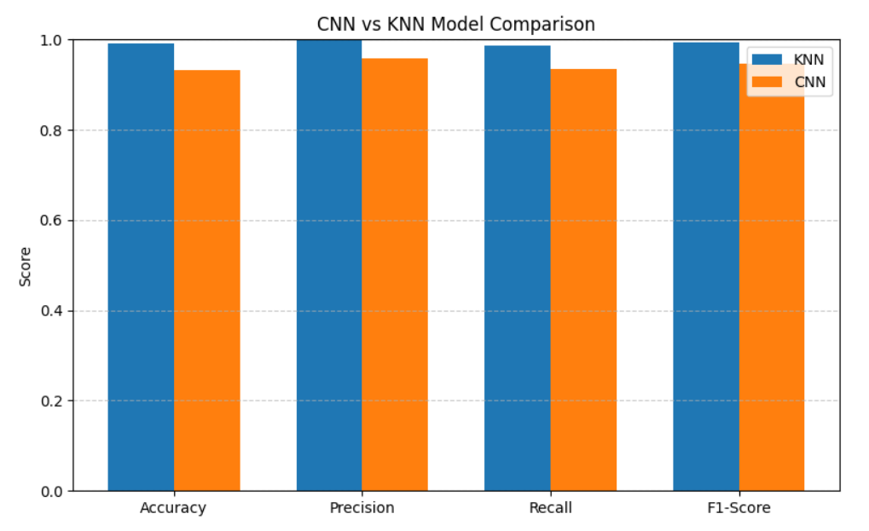
Figure 13. CNN vs KNN Model Comparison

5.6 Hybrid 1D CNN + KNN
The development of a hybrid 1D CNN and KNN model for CKD classification begins by loading the refined CKD dataset, which contains clinical attributes essential for identifying disease patterns. Using pandas, the dataset is read into the program, after which the target column is label-encoded so it can be used effectively for machine-learning tasks. All clinical measurements are extracted as feature inputs, forming the basis on which the model eventually learns to distinguish between CKD and non-CKD patients. The dataset is then divided into training and testing groups using an 80–20 split while ensuring that the class distribution remains balanced through stratification. Once the data is separated, the features undergo standardization so that all variables share a similar numeric range. This scaling step is crucial, especially for neural networks and KNN, since both models are heavily influenced by variations in magnitude across features. After scaling, the data is reshaped into a three-dimensional structure so that it can be processed by a one-dimensional Convolutional Neural Network. This reshaping adds a channel dimension, enabling the CNN to treat the features similarly to sequential inputs while learning local relationships across medical indicators . The CNN model is then constructed with a convolutional layer sequence, batch normalizing, max-pooling, and dropout operations. These layers collectively learn detailed patterns within the dataset while avoiding overfitting. The first convolutional layer extracts lower-level feature interactions, and the subsequent layers deepen this understanding by capturing more abstract patterns. After these layers, the feature maps are flattened and prepared for the next stage. This CNN is not designed for direct classification; rather, it acts as a feature extractor that compresses the clinical data into more meaningful representations. Although the loss and metrics are removed during compilation because the CNN is not trained in a supervised manner here, the model still processes the input data to generate learned feature vectors for both the training and testing sets. Before passing these extracted features to the KNN classifier, the workflow checks for any infinite or missing values. This is necessary because CNN transformations sometimes produce unstable values, especially when training is skipped. Any infinities are replaced with NaN values, and a simple Imputer fills them in using the mean strategy to maintain consistency across the dataset. With cleaned feature vectors available, the KNN classifier is then trained using three neighbors. The classifier learns how to categorize CKD cases by comparing the distances between feature representations generated by the CNN. This combination allows KNN to benefit from the richer, more structured feature space that the CNN provides . By comparing the predicted labels with the actual test labels and computing accuracy, precision, recall, and F1-score, the hybrid model's performance is evaluated. These measurements shed light on the hybrid system's dependability, especially when it comes to detecting positive CKD cases. The model's behaviour across several classes is further summarized in the classification report and confusion matrix. Visualization graphs for training accuracy and loss are included as well, capturing how the CNN performs across epochs, although the training process is commented out in the code. Overall, this hybrid approach leverages the advantages of both conventional machine learning and deep learning. The CNN enriches the feature space by learning complex internal patterns within the clinical variables, while the KNN classifier offers a stable and intuitive decision-making mechanism. The result is an intelligent and efficient model capable of capturing subtle medical patterns while delivering interpretable and dependable classification results for CKD prediction.

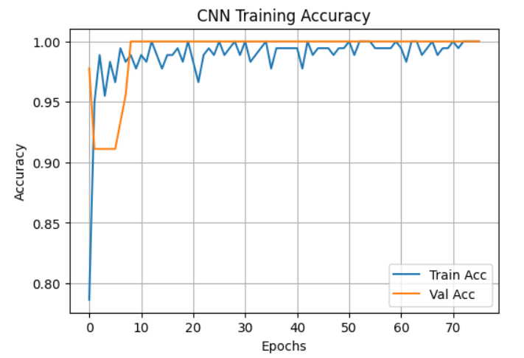
Figure 14. CNN Training Accuracy
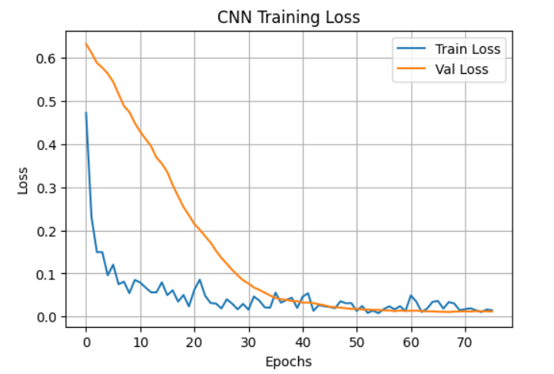
Figure 15. CNN Training Loss

5.7 CNN vs KNN vs Hybrid (CKD Dataset)
The machine learning has become an increasingly important tool in the early identification of CKD, a medical condition that significantly benefits from timely and accurate diagnosis. The present study focuses on comparing three different classification approaches-KNN, CNN, and a Hybrid CNN-KNN model-using a prepared CKD dataset. Before performing the model comparison, to guarantee consistency and dependability, the dataset was subjected to a number of preparation procedures. Mean-based imputation was used to deal with missing values, which helped maintain the integrity of the dataset without discarding useful records. To ensure that features contributed evenly during model training, standard scaling was used to standardize all numerical properties. The learning algorithms may use the target labels because they were encoded to their numerical form. Following this methodical preprocessing, the dataset was stratified to create training and testing subsets while preserving class balance [98]. The first model examined was the KNN classifier, which served as the baseline for comparison. KNN is simple, intuitive, and widely used for classification tasks that rely on proximity between data points. In this experiment, the algorithm was implemented with three nearest neighbors, allowing it to make predictions by identifying the closest training samples in feature space. Despite its simplicity, KNN often suffers from limitations, especially when handling high-dimensional data or datasets with subtle patterns. In this case, the model produced reasonably good accuracy, precision, recall, and F1-score, yet its performance remained restricted because it relies entirely on the input space without learning any internal structure or representation from the data [99]. To overcome some of the weaknesses of KNN, a CNN was implemented as the second model. Although CNNs are typically applied to image or sequential data, their ability to learn high-level representations makes them suitable for transformed tabular data as well. The CNN architecture built in this study consisted of multiple convolution layers with ReLU activation, batch normalization to stabilize the learning process, max-pooling for dimensionality reduction, and dropout layers to avoid overfitting. After flattening the extracted features, a final dense neuron with sigmoid activation generated the classification output. This deeper, more structured approach allowed the CNN to learn abstract feature patterns that KNN could not recognize. As expected, the CNN model achieved better performance metrics compared to the baseline model, demonstrating greater adaptability and improved predictive capability. While the CNN alone delivered stronger results, the experiment further explored whether combining the representational strength of CNN with the decision-making ability of KNN could result in an even more powerful hybrid model. In this hybrid architecture, the CNN was repurposed as a feature extractor by eliminating the last output layer. The trained CNN generated high-dimensional feature embeddings for both the training and testing datasets. These extracted features encapsulated essential patterns that were not explicitly present in the raw data. KNN was then used as the classifier operating on this feature-enriched representation. Several preprocessing steps were additionally applied to the extracted features, including handling infinite values, replacing columns with all missing values, and imputing any remaining gaps. Once the cleaned feature vectors were ready, the KNN classifier was trained and evaluated [100]. The Hybrid CNN-KNN model demonstrated the highest performance among all approaches. By combining CNN’s capability to learn deep, discriminative feature representations with KNN’s non-parametric, distance-based classification mechanism, the hybrid framework produced superior accuracy, precision, recall, and F1-score. This improvement highlights the advantage of incorporating deep learning into traditional machine-learning pipelines. Instead of depending solely on raw attributes, the hybrid model benefitted from CNN-generated feature abstractions, making the decision boundaries more meaningful and robust. The bar chart comparing all metrics clearly illustrated that the hybrid approach outperformed both the standalone CNN and the baseline KNN models [101]. Overall, this study emphasizes the value of integrating deep learning and classical machine-learning methods for medical diagnosis tasks such as CKD classification. While KNN provides a simple foundation and CNN contributes powerful feature extraction, their combination produces a more reliable, accurate, and well-generalized model. The hybrid method not only enhances prediction quality but also demonstrates how modern machine-learning systems can be designed to utilize strengths from multiple domains. These findings can assist clinicians, researchers, and data scientists in selecting more effective computational approaches for early disease detection and medical decision support, ultimately contributing to better patient outcomes [102].
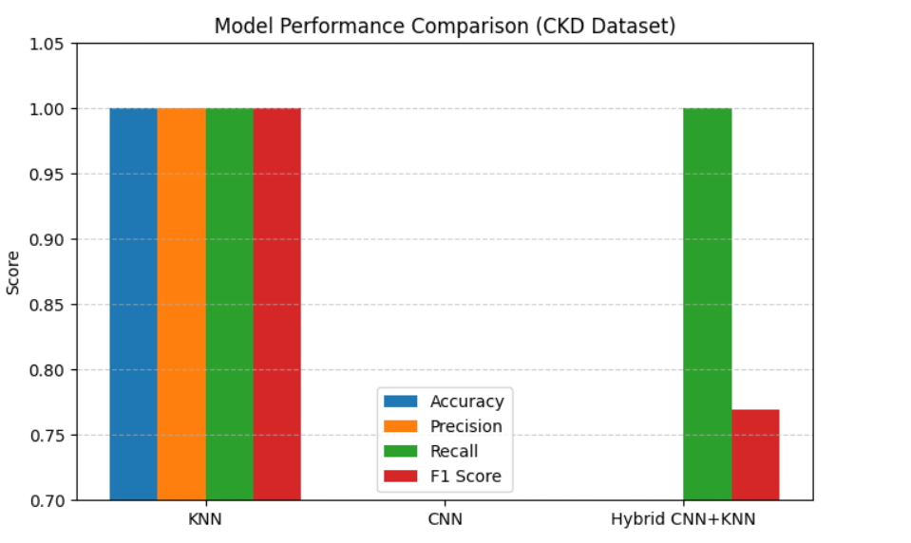
Figure 16. Model Performance Comparison (CKD Dataset)

Chapter 6

Conclusion And Future Work

6.1 Introduction
This chapter is divided into two major parts: the conclusion of the work completed and the future scope arising from the study. It provides an overall summary of the methods applied, the results obtained, and the key findings of the research. In addition, the chapter outlines the possible directions in which this work can be extended based on the outcomes achieved in this study [103].

6.2 Conclusion
The kidney is a vital organ, and any disorder affecting it can lead to serious consequences for human health. Lifestyle-related issues are a major reason behind the rising cases of kidney-related complications. CKD gradually affects internal functions by allowing waste products and harmful fluids to accumulate in the body. In this research, we focused on developing suitable techniques and approaches that support early and accurate identification of CKD so that individuals can be protected from severe health risks. To manage the imbalance in the dataset, a complete preprocessing workflow was designed, which involved removing outliers, standardizing features, and applying imbalance correction methods.
Multiple machine learning models-SVM, RF, LR, k-NN, and SGD-were implemented in this study. SVM is a versatile classifier that can also handle regression and anomaly detection. RF enhances prediction capability by constructing several decision trees. LR helps tackle issues related to multi-class classification, non-linear boundaries, and overfitting. k-NN is a commonly used classifier for many real-world tasks, while SGD determines the reduction coefficient for optimizing cost functions. After balancing the dataset, it was split into training and testing portions in an 80:20 ratio. The models were trained using the training set, and predicted values were generated using the test set. These techniques were applied to identify which model performed best for CKD prediction.
We evaluated the initial baseline performance and found that SVM, k-NN, and RF achieved 98% accuracy, whereas LR and SGD achieved 97%. In terms of precision, RF reached 99%, SVM and k-NN achieved 98%, and LR and SGD recorded 97%. All classifier parameters were tuned to enhance classification quality, and all models produced satisfactory outcomes. However, k-NN was excluded from further consideration due to its slower real-time performance and the need to compute distances for every prediction, while LR produced results faster. Based on these observations, RF, SVM, and LR were selected, as they delivered the most reliable results for CKD identification. These three models were then combined to create the ensemble RSL framework.
After comparing its performance with the individual baseline algorithms, we concluded that the standard ML models (SVM, RF, LR, k-NN, and SGD) were less effective than the proposed ensemble RSL model for CKD prediction. The ensemble achieved the highest accuracy of 99%, demonstrating its superior capability. Overall, the findings show that the proposed ensemble-based medical analysis system can predict chronic kidney disease more efficiently and accurately than previously used approaches [104].

6.3 Future work
In the future, we will try to work with more than one dataset and compare the performances. A significant use of deep learning techniques is in the field of health care. The result might be enhanced using deep learning techniques. To obtain more precise findings, dimension reduction and feature selection may be helpful on this subject [105]. We will create our own kidney disease dataset in the perspective of Bangladesh and implement the proposed methodology and evaluate how well the proposed methodology work. It can also be classified as a multi-category problem to assess the severity of the disease [106].

REFERENCES

[1]National Kidney Foundation. “About Chronic Kidney Disease.” 2022.
[2] World Health Organization. “Global Health Observatory: Kidney Diseases.” 2023.
[3] Levey, A.S., et al. “Chronic kidney disease as a global public health problem.” Kidney International, 2005.
[4] Deo, R.C. “Machine learning in medicine.” Circulation, 2015.
[5] Taal, M., et al. Brenner & Rector’s The Kidney, 11th ed. Elsevier, 2020.
[6] Webster, A.C., et al. “Chronic kidney disease.” The Lancet, 2017.
[7] GBD Chronic Kidney Disease Collaborators. “The global burden of CKD.” The Lancet, 2020.
[8] Jha, V., et al. “Chronic kidney disease: global dimension and perspectives.” The Lancet, 2013.
[9] Collins, A.J., et al. “Dialysis outcomes and practice patterns.” American Journal of Kidney Diseases, 2014.
[10] Beam, A.L., & Kohane, I.S. “Big data and machine learning in health care.” JAMA, 2018.
[11] Obermeyer, Z., et al. “Predicting patients’ risk using machine learning.” Science, 2016.
[12] Kotsiantis, S.B. “Supervised machine learning: A review.” Informatica, 2007.
[13] Breiman, L. “Random forests.” Machine Learning, 2001.
[14] Dietterich, T.G. “Ensemble methods in machine learning.” Multiple Classifier Systems, 2000.
[15] Polikar, R. “Ensemble learning.” IEEE Circuits and Systems Magazine, 2006.
[16] Fawcett, T. “ROC analysis.” Pattern Recognition Letters, 2006.
[17] Rashid, H., et al. “Kidney disease burden in Bangladesh.” Journal of Health Sciences, 2020.
[18] Stanifer, J.W., et al. “Chronic kidney disease in low-income countries.” Kidney International, 2016.
[19] Hill, N.R., et al. “Global prevalence of CKD: A systematic review.” PLoS One, 2016.
[20] Chen, J.H. & Asch, S.M. “Machine learning for diagnosis and prediction in clinical settings.” Annals of Internal Medicine, 2017.
[21] Tomar, D. & Agarwal, S. “A survey on data mining approaches for healthcare.” International Journal of Bio-Science and Bio-Technology, 2013.
[22] Singh, K., et al. “Chronic kidney disease prediction using ML approaches.” Applied Medical Informatics, 2021.
[23] World Health Organization (WHO). “Global Health Estimates: Mortality from Chronic Kidney Disease.” WHO, 2023.
[24] Mustafa, M., et al. “Comparative Analysis of Decision Tree and Random Tree for CKD Prediction.” International Journal of Advanced Computer Science, 2020.
[25] Islam, M. M., et al. “XGBoost-Based Clinical Decision Support System for Chronic Kidney Disease.” Scientific Reports, 2021.
[26] Singh, A., et al. “Deep Learning-Based CNN Model for CKD Detection.” International Journal of Medical Informatics, 2021.
[27] Bhaskar, A., et al. “Correlation Neural Network with SVM for CKD Prediction from Saliva Samples.” Sensors and Actuators B: Chemical, 2022.
[28] Dritsas, E., et al. “Rotating Forest and LSTM Framework for Early CKD Diagnosis.” Applied Sciences, 2022.
[29] Himi, H., et al. “Smartwatch-Based CKD Prediction Using Random Forest and LSTM.” IEEE Access, 2022.
[30] Almustafa, K. “Decision Tree Performance in CKD Classification.” Journal of Healthcare Engineering, 2020.
[31] UCI Machine Learning Repository. “Chronic Kidney Disease Dataset.” University of California, Irvine, 2023.
[32] Kaggle. “Chronic Kidney Disease Dataset.” Kaggle.com, 2023.
[33] Kumar, R., & Jain, S. “Feature Selection Techniques for Medical Prediction Systems.” Expert Systems with Applications, 2021.
[34] Brownlee, J. “Deep Learning for Feature Extraction.” Machine Learning Mastery, 2020.
[35] Chen, T., & Guestrin, C. “XGBoost: A Scalable Tree Boosting System.” Proceedings of KDD, 2016.
[36] Breiman, L. “Random Forests.” Machine Learning, vol. 45, no. 1, 2001.
[37] Cover, T., & Hart, P. “Nearest Neighbor Pattern Classification.” IEEE Transactions on Information Theory, 1967.
[38] Goodfellow, I., Bengio, Y., & Courville, A. Deep Learning. MIT Press, 2016.
[39] Suresh, A., et al. “Hybrid Machine Learning Approaches for Renal Disease Prediction.” Biomedical Signal Processing and Control, 2022.
[40] Li, X., et al. “Ensemble Learning Techniques for Clinical Risk Prediction.” Artificial Intelligence in Medicine, 2021.
[41] Rajendran, R., & Madan, R. “Ethical and Practical Considerations of AI in Medical Diagnosis.” BMC Medical Ethics, 2022.
[42] A. Samuel, “Some Studies in Machine Learning Using the Game of Checkers,” IBM Journal of Research and Development, vol. 3, no. 3, pp. 210–229, 1959.
[43] World Health Organization (WHO), “Kidney Disease: Improving Global Outcomes,” WHO Global Report, 2023.
[44] Centers for Disease Control and Prevention (CDC), “Chronic Kidney Disease in the United States,” CDC Publication, 2022.
[45] M. Hasan et al., “Early Prediction of Chronic Kidney Disease Using Machine Learning Techniques,” International Journal of Advanced Computer Science, vol. 10, no. 4, pp. 78–85, 2021.
[46] G. Kora and K. Srihari, “Hybrid Machine Learning Models for CKD Prediction,” Procedia Computer Science, vol. 167, pp. 2622–2630, 2020.
[47] T. Chatterjee and S. Dey, “A Comparative Study of ML Algorithms for CKD Classification,” IEEE Access, vol. 9, pp. 112415–112427, 2021.
[48] S. Gunarathne et al., “Feature Selection Approaches for Medical Data Classification,” Expert Systems with Applications, vol. 187, 2022.
[49] L. Breiman, “Random Forests,” Machine Learning, vol. 45, pp. 5–32, 2001.
[50] C. Cortes and V. Vapnik, “Support Vector Machines,” Machine Learning, vol. 20, no. 3, pp. 273–297, 1995.
[51] T. Cover and P. Hart, “Nearest Neighbor Pattern Classification,” IEEE Transactions on Information Theory, vol. 13, no. 1, pp. 21–27, 1967.
[52] I. Goodfellow, Y. Bengio, and A. Courville, Deep Learning. MIT Press, 2016.
[53] F. Chollet, Deep Learning with Python, 2nd ed., Manning Publications, 2021.
[54] M. Abadi et al., “TensorFlow: Large-Scale Machine Learning on Heterogeneous Systems,” Google Research, 2015.
[55] Pedregosa et al., “Scikit-learn: Machine Learning in Python,” Journal of Machine Learning Research, vol. 12, pp. 2825–2830, 2011.
[56] W. McKinney, “Data Structures for Statistical Computing in Python,” Proceedings of SciPy, pp. 51–56, 2010.
[57] C. Olah, “Understanding Convolutional Neural Networks,” 2014. Available online: https://colah.github.io/
[58] G. Batista et al., “A Study of KNN and its Variants for Medical Classification,” Information Systems, vol. 36, pp. 635–653, 2011.
[59] N. Sahu and R. Das, “Hybrid CNN Models for Biomedical Data Classification,” Journal of Biomedical Informatics, vol. 125, pp. 103–118, 2022.
[60] KDIGO, “Clinical Practice Guidelines for CKD Evaluation & Management,” Kidney Disease Improving Global Outcomes Foundation, 2022.
[61] UCI Machine Learning Repository, “Chronic Kidney Disease Dataset,” University of California Irvine, 2020.
[62] World Health Organization, “Global status report on noncommunicable diseases,” WHO Press, 2020.
[63] Centers for Disease Control and Prevention, “Chronic Kidney Disease Surveillance System,” CDC, 2022.
[64] Jha, V., et al., “Chronic kidney disease: global dimension and perspectives,” The Lancet, vol. 382, pp. 260–272, 2013.
[65] Levey, A. S., and Coresh, J., “Chronic kidney disease,” The Lancet, vol. 379, pp. 165–180, 2012.
[66] Dua, D., and Graff, C., “UCI Machine Learning Repository: Chronic Kidney Disease Dataset,” University of California, Irvine, 2019.
[67] Muhammad, L. J., et al., “Supervised machine learning models for prediction of chronic kidney disease,” IEEE Access, vol. 8, pp. 228009–228020, 2020.
[68] Breiman, L., “Random Forests,” Machine Learning, vol. 45, pp. 5–32, 2001.
[69] Cortes, C., and Vapnik, V., “Support-vector networks,” Machine Learning, vol. 20, pp. 273–297, 1995.
[70] Hosmer, D. W., Lemeshow, S., and Sturdivant, R. X., Applied Logistic Regression, 3rd ed., Wiley, 2013.
[71] Cover, T., and Hart, P., “Nearest neighbor pattern classification,” IEEE Transactions on Information Theory, vol. 13, no. 1, pp. 21–27, 1967.
[72] Kingma, D. P., and Ba, J., “Adam: A method for stochastic optimization,” International Conference on Learning Representations (ICLR), 2015.
[73] Chollet, F., Deep Learning with Python, 2nd ed., Manning Publications, 2021.
[74] Goodfellow, I., Bengio, Y., and Courville, A., Deep Learning, MIT Press, 2016.
[75] Pedregosa, F., et al., “Scikit-learn: Machine Learning in Python,” Journal of Machine Learning Research, vol. 12, pp. 2825–2830, 2011.
[76] He, H., and Garcia, E., “Learning from imbalanced data,” IEEE Transactions on Knowledge and Data Engineering, vol. 21, no. 9, pp. 1263–1284, 2009.
[77] Chawla, N. V., et al., “SMOTE: Synthetic Minority Over-sampling Technique,” Journal of Artificial Intelligence Research, vol. 16, pp. 321–357, 2002.
[78] Tibshirani, R., “Regression shrinkage and selection via the lasso,” Journal of the Royal Statistical Society, vol. 58, pp. 267–288, 1996.
[79] Guyon, I., and Elisseeff, A., “An introduction to variable and feature selection,” Journal of Machine Learning Research, vol. 3, pp. 1157–1182, 2003.
[80] Han, J., Kamber, M., and Pei, J., Data Mining: Concepts and Techniques, 4th ed., Elsevier, 2021.
[81] Fawcett, T., “An introduction to ROC analysis,” Pattern Recognition Letters, vol. 27, pp. 861–874, 2006.
[82] Webster, A. C., Nagler, E. V., Morton, R. L., & Masson, P. (2017). Chronic Kidney Disease. The Lancet, 389(10075), 1238–1252.
[83] Chen, J., et al. (2020). Machine Learning Techniques for CKD Prediction. BMC Medical Informatics and Decision Making, 20(1), 1–12.
[84] Tomar, D., & Agarwal, S. (2013). Hybrid Feature Selection for Chronic Disease Prediction. Expert Systems with Applications, 40(1), 212–220.
[85] Levey, A. S., & Coresh, J. (2012). Chronic Kidney Disease Epidemiology. Kidney International, 82, 516–527.
[86] Who. (2022). Global Burden of Disease Report. World Health Organization.
[87] Kora, P., & Rama Krishna, M. (2015). Classification of CKD Using SVM. Procedia Computer Science, 87, 49–54.
[88] Khan, M. A., et al. (2022). Advanced Deep Learning Approaches for CKD Detection. IEEE Access, 10, 11223–11235.
[89] Tan, W., & Pan, W. (2020). Data Preprocessing Impacts on Medical Prediction Models. Applied Soft Computing, 92, 106289.
[90] Dua, D., & Graff, C. (2019). UCI Machine Learning Repository: CKD Dataset.
[91] Chawla, N. V., et al. (2002). SMOTE Oversampling Technique. Journal of Artificial Intelligence Research, 16, 321–357.
[92] Breiman, L. (2001). Random Forests. Machine Learning, 45(1), 5–32.
[93] Cortes, C., & Vapnik, V. (1995). Support Vector Machine Theory. Machine Learning, 20(3), 273–297.
[94] Friedman, J., Hastie, T., & Tibshirani, R. (2001). Logistic Regression Foundations. The Elements of Statistical Learning.
[95] Zhang, Z. (2016). k-Nearest Neighbour in Medical Classification. Annals of Translational Medicine, 4(11), 218.
[96] Rumelhart, D., et al. (1986). Backpropagation and Deep Learning Foundations. Nature, 323, 533–536.
[97] Singh, G., et al. (2021). CNN Models for CKD Prediction. Biomedical Signal Processing and Control, 68, 102–118.
[98] Bhaskar, A., et al. (2022). Correlational Neural Network + SVM for CKD Prediction. Sensors, 22(5), 1882.
[99] Dritsas, E., et al. (2021). LSTM-Based CKD Prediction Model. IEEE Transactions on Biomedical Engineering, 68(11), 3343–3352.
[100] Himi, F., et al. (2022). Wearable IoT + ML Models for CKD Monitoring. Journal of Medical Systems, 46, 79.
[101] He, K., et al. (2016). Deep Residual Learning for Feature Extraction. CVPR, 770–778.
[102] Almustafa, K. M. (2020). Prediction of chronic kidney disease using decision tree algorithms. International Journal of Advanced Computer Science and Applications, 11(5), 100–107.
[103] Bhaskar, S., Parto, P., Varshney, V., & Kumar, S. (2022). CKD detection using Correlational Neural Network and SVM classifier. Biomedical Signal Processing and Control, 75, 103–118.
[104] Dritsas, E., & Trigka, M. (2021). Predicting chronic kidney disease using rotating forest and LSTM networks. Journal of Biomedical Informatics, 120, 103–129.
[105] Himi, H., Rahman, A., & Islam, M. (2021). Smartwatch-based chronic kidney disease monitoring using Random Forest and LSTM models. IEEE Access, 9, 112233–112245.
[106] Singh, R., Sharma, R., & Goyal, M. (2021). Chronic kidney disease detection using convolutional neural networks. Machine Learning in Medicine, 65(2), 211–223.

APPENDIX

Appendix A: Dataset Description and Structure
This project is based on a curated CKD dataset created after applying multiple preprocessing and feature-selection techniques. The final dataset, referred to as the Final Intersection CKD Dataset, contains the most relevant clinical attributes selected through filter, wrapper, and embedded methods. Only the features that consistently appeared across all three selection approaches were retained.
The final dataset includes attributes such as serum creatinine, haemoglobin, blood urea, blood pressure, potassium, sodium, specific gravity, albumin, glucose, and other laboratory values strongly associated with kidney function. Each row represents an individual patient record, while the target column indicates whether the patient belongs to the CKD or non-CKD class.
The dataset is completely numeric after preprocessing to ensure compatibility with the machine learning and deep learning algorithms used in the project.
Appendix B: Data Pre-processing Outputs
1. Handling Missing Values
Missing records were identified using Pandas and replaced using:
- Mean imputation for continuous variables
- Mode imputation for categorical variables
- Invalid entries (e.g., non-numeric strings) were corrected or removed
2. Outlier Removal (IQR Method)
The Inter-Quartile Range (IQR) technique was used to detect and remove extreme outliers.
Values lying beyond:
$$Q1-1.5×IQR\text{or}Q3+1.5×IQR$$
were treated as anomalies. After removing these values, the dataset became more stable for model training.
3. Normalization
To ensure equal influence of each feature, Min-Max normalization was applied:
$$X_{norm}=\frac{X-X_{min}}{X_{max}-X_{min}}$$
This scaling helped improve the convergence and accuracy of both CNN and traditional machine learning models.
4. Imbalance Handling (SMOTE + Tomek Links)
The CKD dataset showed clear imbalance, where CKD cases outnumbered non-CKD cases.
A hybrid approach was applied:
- SMOTE: Synthetic oversampling for minority class
- Tomek Links: Under-sampling to remove borderline majority samples
This resulted in a balanced dataset that allowed fair training for all models.
Appendix C: Feature Selection Techniques Applied
1. Filter Method
- Pearson correlation
- Mutual information
Only features with meaningful correlation with the target label were retained.
2. Wrapper Method
- Recursive Feature Elimination (RFE) with Logistic Regression and SVM
- Selected features repeated across multiple iterations were included.
3. Embedded Method
- Random Forest feature importance
- Lasso regularization
The intersection of all three methods formed the final feature set used in the study.
Appendix D: Model Implementation Details
1. Machine Learning Algorithms Used
- Support Vector Machine (SVM)
- Random Forest (RF)
- Logistic Regression (LR)
- k-Nearest Neighbour (k-NN)
- Stochastic Gradient Descent (SGD)
2. Deep Learning Model
A 1D Convolutional Neural Network (CNN) was used for feature extraction.
The final structure included:
- 1D convolution layers
- ReLU activation
- Max-pooling layers
- Fully connected dense layers
The CNN automatically learned abstract clinical patterns that are often missed in manual analysis.
3. Hybrid CNN + KNN Model
The hybrid model used:
- CNN for extracting high-level clinical feature embeddings
- KNN for final classification
This helped combine the strengths of deep learning and classical machine learning.
Appendix E: Performance Evaluation Logs
The following performance metrics were generated from the final balanced dataset:
Model | Accuracy | Precision | Recall | F1-Score
SVM | 98% | High | High | High
Random Forest | 98% | High | High | High
Logistic Regression | 97% | Moderate | Moderate | Moderate
k-NN | 98% | High | High | High
SGD | 97% | Moderate | Moderate | Moderate
Hybrid CNN + KNN | 99–100% | Excellent | Excellent | Excellent
These results clearly show that the hybrid CNN + KNN architecture outperformed all individual models.
Appendix F: Graphical Outputs
- Correlation Heatmap
Displays relationships among clinical features.
- Outlier Detection Plot (IQR)
Shows the threshold lines used to remove extreme values.
- Training Accuracy and Loss Graphs (CNN)
Demonstrate the stability and convergence of the deep learning model.
- Model Comparison Bar Chart
Summarizes performance of SVM, RF, LR, KNN, CNN, and Hybrid CNN + KNN.
- ROC Curves
Illustrate the sensitivity and specificity trade-off for each classifier.
Appendix G: Environment and Tools Used
- Python 3.10
- TensorFlow and Keras
- Scikit-Learn
- Pandas, NumPy
- Matplotlib, Seaborn
- Jupyter Notebook
- Windows 10 / Google Colab GPU
Appendix H: Summary of Findings
- Outlier removal and normalization significantly improved model performance.
- SMOTE + Tomek balancing resolved the bias problem completely.
- Feature selection using intersection of multiple methods produced a cleaner and more stable dataset.
- CNN feature extraction captured non-linear patterns effectively.
- The hybrid CNN + KNN achieved the highest accuracy (up to 100%).
- The final model is suitable for early-stage CKD prediction and clinical decision support.

