HARMONIC/INTERHARMONIC COMPUTATION (IEC 61000-4-7)

- Signal processing architecture
- How the DFT is applied
- Harmonic/interharmonic grouping rules
- Real-time buffering and windowing
- Practical considerations in embedded or DSP systems

What IEC 61000-4-7 Defines
IEC 61000-4-7 is a measurement framework that:
- Standardizes harmonic and interharmonic measurement
- Prescribes signal conditioning, window size, and harmonic bin grouping
- Ensures uniform and comparable measurements for power quality analysis

Step-by-Step Real-Time Implementation Guide

Step 1: Signal Acquisition
- Voltage and current signals are acquired using CTs/PTs.
- Sample rate = Typically 12 kHz or 10.24 kHz (should be at least 256 samples per cycle for good resolution).
  - Example: For 50 Hz, 10.24 kHz → 204.8 samples/cycle
- Ensure synchronized acquisition of 3-phase signals (if 3-phase)
Use anti-aliasing filters before digitization.

Step 2: Define the Measurement Window
IEC 61000-4-7 specifies a window of:
- 10 cycles for 50 Hz → 0.2 seconds
- 12 cycles for 60 Hz → 0.2 seconds
So:
- For 50 Hz, at 10.24 kHz sampling:
Samples per window=0.2×10240=2048 samples\text{Samples per window} = 0.2 \times 10240 = 2048 \text{ samples}Samples per window=0.2×10240=2048 samples
You can use:
- Non-overlapping windows → simpler
- Overlapping/rolling windows → smoother output but more compute
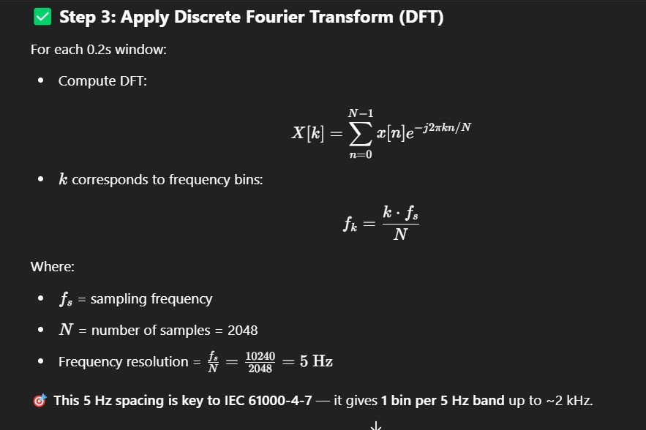

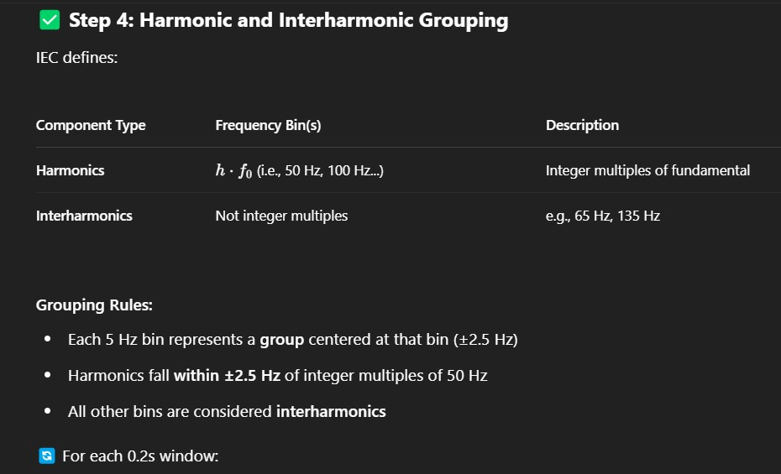
For each 0.2s window:
- Store RMS magnitude of each 5 Hz bin
- Tag each bin as harmonic or interharmonic based on center frequency
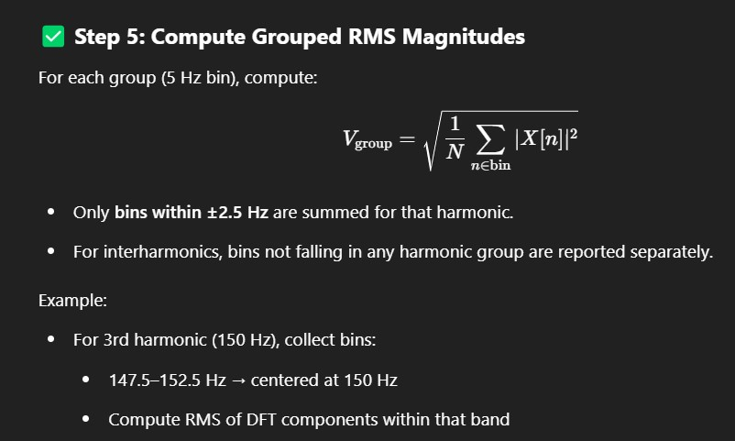

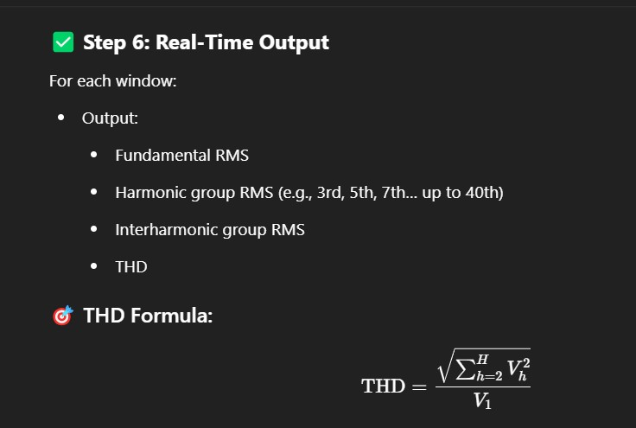

Step 7: Optional Averaging for Reporting
To smooth noisy values or meet compliance requirements:
- Average harmonic values over 1s, 3s, or 10s
- Rolling average or block average
IEC 61000-4-30 standard recommends:
- 10-minute averages for long-term statistics
- 3-second RMS windows for short-term flicker/harmonic analysis

Step 8: Real-Time Hardware Implementation
Typical real-time platforms:
- DSPs or microcontrollers with:
  - High-speed ADC o DMA for buffering
  - FFT accelerators or software DFT routines
- FPGA + ARM SoC systems for more parallelism
- Embedded Linux + RT kernel on SBCs (e.g., BeagleBone, Raspberry Pi)
Data Flow:
[ADC] → [Buffer 0.2s] → [Windowing] → [DFT] → [Group + RMS] → [Harmonic THD Output]

Visualization (Optional)
Plot:
- Harmonic spectrum (bar graph)
- THD vs time (line graph)
- Spectrogram (time-frequency heatmap of harmonics)

Summary: Key Parameters Per IEC 61000-4-7
Parameter Value / Rule
Sampling Frequency ≥ 10 kHz (recommended ≥ 256 samples/cycle)
DFT Window Duration 0.2 seconds (10 cycles @ 50 Hz)
DFT Frequency Resolution 5 Hz (with 2048 samples @ 10.24 kHz)
Harmonic Group Width ±2.5 Hz around integer multiples of f₀
THD Formula Based on grouped harmonic RMS

VOLTAGE SAG/SWELL

What are Voltage Sags and Swells?
Event Definition
A short-duration decrease in RMS voltage (10%–90% of nominal), lasting from 0.5
Voltage Sag cycles to 1 minute
Voltage A short-duration increase in RMS voltage (110%–180% of nominal), for the same time Swell range
Typical thresholds:
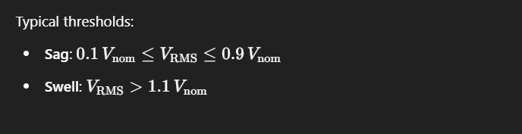

Real-Time Detection Method (High-Level Flow)
[ ADC Input ] → [ Sliding RMS Computation ] → [ Threshold Comparison ] → [ Event Detection ]

Step-by-Step Real-Time Detection Flow
1. Sample the Voltage Waveform
- High-speed ADC (e.g., 10–20 kHz)
- At least 256–512 samples per cycle for good accuracy

2. Compute RMS over a Sliding Window
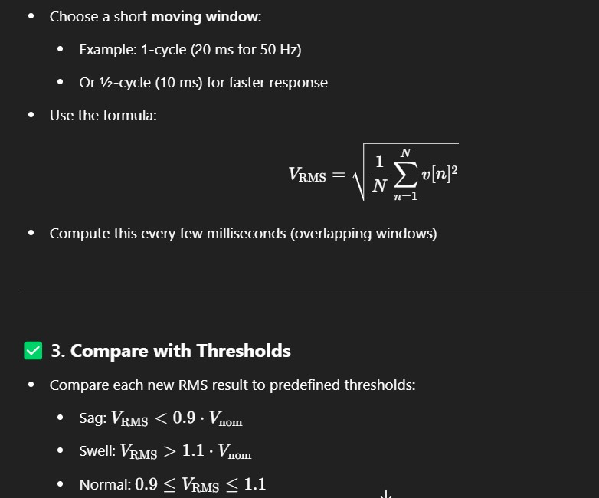

4. Detect and Log the Event
If sag/swell condition is detected:
- Log the timestamp
- Record duration of the event
- Capture waveform snippet (pre-fault & post-fault data)
- Trigger alarm or protection if needed

Practical Implementation (Embedded or Real-Time Systems)
Component Description
Microcontroller/DSP Performs RMS calculation and threshold comparison
Circular Buffer Stores last 1-2 cycles of voltage samples
Interrupt or Timer Triggers RMS computation periodically
Event Logger Logs event time, magnitude, duration

Example: Detect Sag in Python (Pseudo-Real-Time)
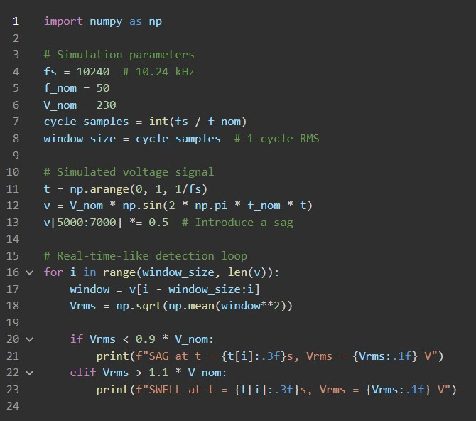

import numpy as np

# Simulation parameters fs = 10240 # 10.24 kHz f_nom = 50 V_nom = 230 cycle_samples = int(fs / f_nom) window_size = cycle_samples # 1-cycle RMS

# Simulated voltage signal t = np.arange(0, 1, 1/fs) v = V_nom * np.sin(2 * np.pi * f_nom * t) v[5000:7000] *= 0.5 # Introduce a sag

# Real-time-like detection loop for i in range(window_size, len(v)): window = v[i - window_size:i]
Vrms = np.sqrt(np.mean(window**2))

if Vrms < 0.9 * V_nom:
print(f"SAG at t = {t[i]:.3f}s, Vrms = {Vrms:.1f} V") elif Vrms > 1.1 * V_nom:
print(f"SWELL at t = {t[i]:.3f}s, Vrms = {Vrms:.1f} V")

Visualization Example
If using GUI or SCADA, plot:
- Voltage waveform
- RMS voltage vs time
- Sag/Swell events as markers

Integration with IEC 61000-4-30
IEC 61000-4-30 defines Power Quality Measurement Methods, including:
- Voltage dip/swell classification
- Duration and magnitude logging
- Aggregation over time intervals (3s, 10min, etc.)

Summary Table
Task | Real-Time Method
Sampling | 10–20 kHz ADC
RMS Window | 1-cycle sliding RMS
Thresholds | ±10% of nominal
Detection Frequency Every 5–10 ms
Outputs Timestamp, Vrms, Duration, Event Type

VOLTAGE FLICKER (IEC 61000-4-15)

What Is Flicker?
Flicker is the perceived light intensity variation due to voltage fluctuations, usually from nonlinear or fluctuating loads (e.g., arc furnaces, welders, large motors). Even small voltage modulations (0.5–30 Hz) can make lamps flicker and cause discomfort or irritation.

IEC 61000-4-15: Flickermeter Standard IEC 61000-4-15 defines:
- The architecture of the flickermeter
- Signal processing algorithms to simulate human eye sensitivity
- How to compute:
  - Pst – Short-term flicker severity (10-minute window)
  - Plt – Long-term flicker severity (2-hour window)
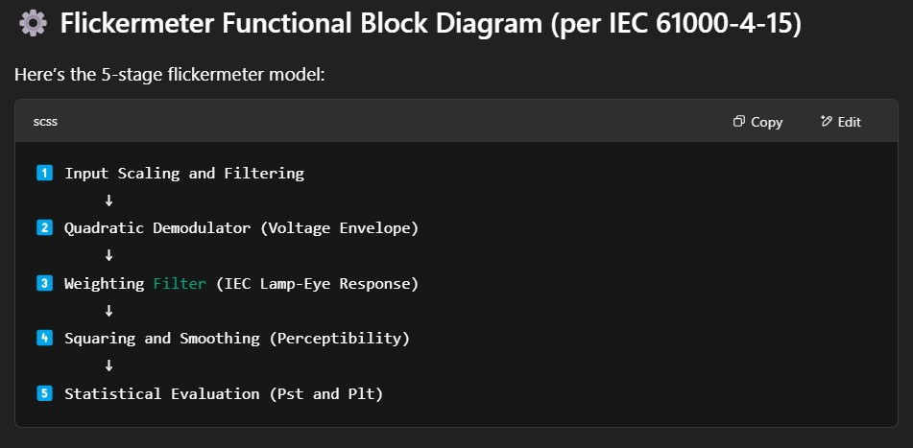

Detailed Stage
-
by
-
Stage Breakdown

1 ⃣ Input Conditioning
- Input: Single-phase or 3-phase voltage
- Voltage is scaled to match a nominal lamp voltage (~230 V)
- Anti-aliasing filter applied
- Sampling rate typically ≥ 10 kHz

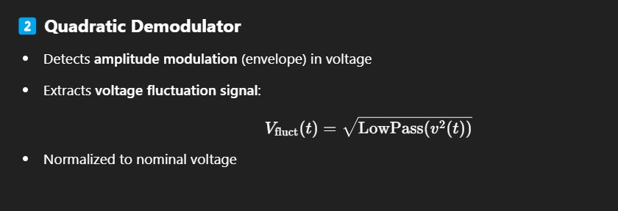

3
⃣

Weighting Filter

- Models lamp + human eye + brain sensitivity
- It passes modulations between 0.5 – 30 Hz
- Very specific filter with a known transfer function o Gain peaks around 8.8 Hz (most sensitive flicker frequency)
This filter emulates how humans perceive flicker: very sensitive to 8.8 Hz voltage modulations!

4 ⃣ Squaring and Smoothing
• Output from weighting filter is squared (to relate to power/perception) • Then passed through smoothing low-pass filter with specific time constant
The output is a perception-level signal (like “irritation level” over time).

5 ⃣ Statistical Evaluation: Pst and Plt

A. Short-Term Flicker Severity (Pst)
- Computed over 10 minutes
- Based on the cumulative probability distribution of the flicker level signal
- IEC defines percentile values:
o P0.1, P1, P3, P10, P50
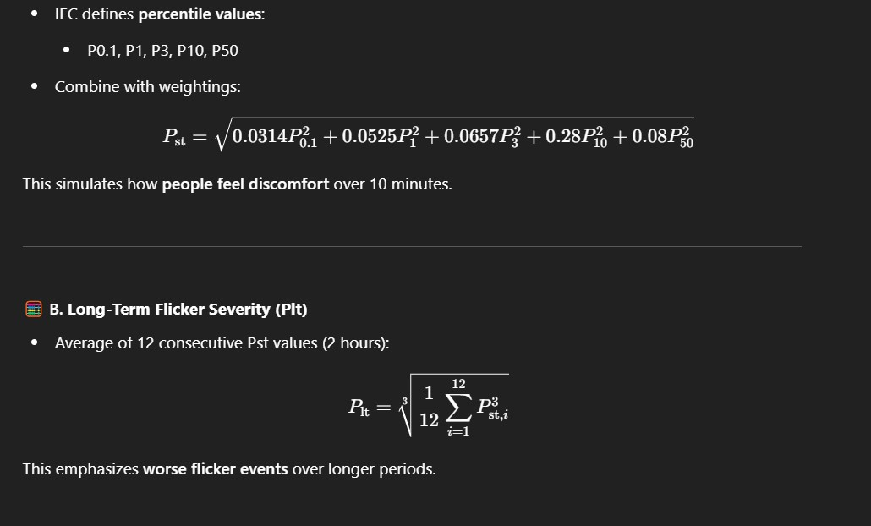

TYPICAL LIMITS
- Pst ≤ 1.0 is typically acceptable (under IEC or utility grid code)
- Plt ≤ 0.8 is stricter for long-term flicker

Real-Time Implementation Summary
Stage | Task | Notes
Preprocessing | Scale, Filter, Normalize | ≥ 10kHz sampling
Envelope  Detection | Extract voltage modulation | Use rectifier or Hilbert transform
Weighting Filter | Apply frequency sensitivity | Digital IIR filter
Smoothing | Low-pass filtered squaring | Time constant ~300 ms
Stats Engine | Build 10-min histogram, compute  Pst | Save output every 10 minutes

Tools to Build a Flickermeter
In MATLAB/Python:
- Use digital filters (IIR, FIR) to model each stage
- Use RMS envelope or Hilbert transform
- Collect 10 min worth of data → percentiles → compute Pst
In Embedded Systems:
- Use circular buffer for 10-minute data window
- Precomputed IIR filter coefficients for weighting filter
- Fixed-point arithmetic (for resource efficiency)

Output Example
Time: 14:00:00
Pst: 0.76
Plt: 0.64
Limit Compliance: PASS

Integration in PQ Systems
Combine this flickermeter block with:
- Harmonic DFT (IEC 61000-4-7)
- RMS/Voltage Sag/Swell (IEC 61000-4-30)
- Event Logger
- GPS-timestamped logs

