
MAJOR PROJECT
SYNOPSIS REPORT
For

“A Multimodal Retrieval-Augmented Generation Framework for
Automated Chest X-Ray Report Generation’’

Submitted By
Specialization/Batch | SAP ID | Name
B. Tech CSE (AI & ML) B2 | 500119436 | Soumya Jain
B. Tech CSE (AI & ML) B2 | 500122041 | Priyal Sharma
B. Tech CSE (AI & ML) B1 | 500125397 | Yash Gupta

School Of Computer Science
UNIVERSITY OF PETROLEUM & ENERGY STUDIES,
DEHRADUN– 248007, Uttarakhand

Dr. Anish Kumar Vishwakarma
Associate Professor (SG), Artificial Intelligence Cluster
Project Mentor

Table of Contents
1. Introduction
a) Technical Concepts (Algorithms)
b) Motivation
c) Problem Statement
d) Area of Application
e) Dataset and Input Format
2. Literature Review
3. Objectives
4. Methodology
a) Reference Software Model
b) Steps
c) Timeline
5. References

1. Introduction
Chest radiography remains one of the most frequently used imaging examinations in clinical practice, while the number of radiologists available to interpret growing imaging volumes is limited. This creates a practical need for computer-assisted systems that can prepare a first draft of a radiology report for expert verification. Automated chest X-ray report generation has therefore become an active research area, with the goal of improving reporting efficiency without replacing clinical judgment.
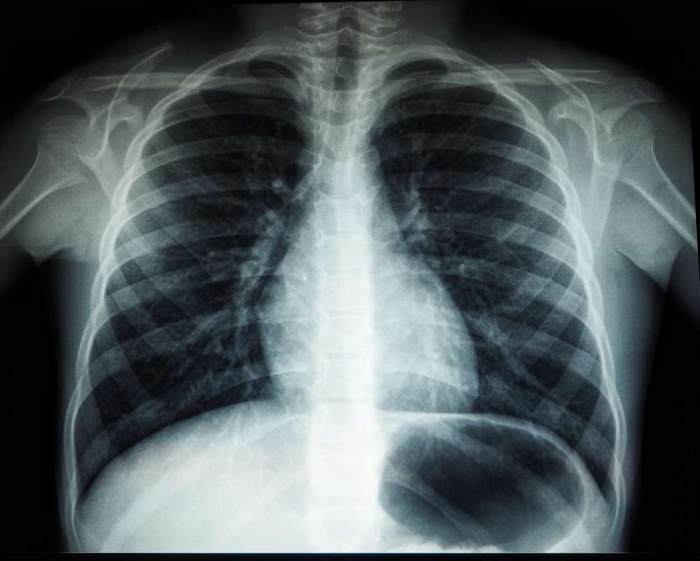
Early approaches treated report generation as an image-captioning problem. A convolutional or transformer-based image encoder produced visual features and a recurrent or transformer decoder converted those features into free text. Although these systems could generate fluent reports, fluency did not necessarily imply clinical correctness. Because normal findings are common in chest X-ray datasets, generation-only models can reproduce common language patterns or introduce findings that are not supported by the current image.
Retrieval-based methods provide an alternative by supplying the generator with evidence from previously observed cases. X-REM demonstrated that fine-grained image-text matching can improve the relevance of retrieved reports compared with simple similarity-based retrieval (Jeong et al., 2024). Retrieval-augmented generation further extends this idea by using retrieved evidence as context for a large language model, thereby providing material that can constrain generation and reduce unsupported statements (Ranjit et al., 2023).
Recent multimodal systems have also begun to incorporate domain-specific vision-language alignment, multi-view information, and historical examinations. MAIRA-1 combines a chest-X-ray-specific image encoder with a language model, while STREAM explicitly models current and historical studies together and retrieves regional semantic entities as textual prompts (Hyland et al., 2024; Yang et al., 2025). These developments motivate the proposed framework, which treats retrieval, multi-view information, and temporal context as connected components rather than isolated additions.
The proposed project focuses on a multimodal retrieval-augmented framework for generating structured chest X-ray reports. The intended output consists of Findings followed by Impression. The current study is treated as the primary evidence source, while similar prior cases, historical examinations when genuinely available, and structured clinical or anatomical knowledge are used as supporting evidence.

a) Technical Concepts (Algorithms)
• Vision Transformers for medical imaging – Patch-based transformer encoders, such as ViT-style or Swin-style backbones adapted for chest radiographs, will be considered for extracting global and, where available, patch-level visual representations.
• Contrastive representation learning – A CLIP/InfoNCE-style objective will be used to align matching chest X-ray and report representations in a shared embedding space while separating mismatched image-report pairs.
• Dense retrieval and vector search – Vector representations will be indexed for approximate nearest-neighbour retrieval. FAISS will be used as the initial prototype retrieval system.
• Retrieval-Augmented Generation – The generation model will receive retrieved evidence in addition to the current-study representation, with the aim of grounding generated statements in available evidence.
• Spatial and temporal fusion – Frontal and lateral views from the same study will be combined, while genuinely available historical examinations will be incorporated as optional temporal context.
• Clinical and factuality evaluation – The framework will use lexical metrics such as BLEU, ROUGE-L, METEOR and BERTScore together with clinically oriented measures such as CheXbert F1, RadGraph F1 and factuality or unsupported-claim analysis.

b) Motivation
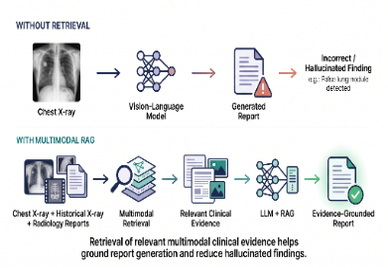
Purely generative report models do not inherently provide a mechanism for connecting each generated statement to evidence from the current examination. A model may produce fluent clinical language while still making unsupported claims. This makes factuality a central concern for automated report generation.
Retrieval-augmented generation provides a mechanism for introducing relevant evidence before generation. Instead of relying only on learned language priors, the generator can use similar cases, report evidence, and structured clinical knowledge as explicit context. The proposed framework therefore treats retrieval as a first-class component and evaluates it independently rather than assuming that better retrieval automatically produces better reports.
Multi-view and longitudinal information provide additional motivation. Radiologists commonly interpret frontal and lateral views together and compare current examinations with prior studies when available. STREAM demonstrates the value of spatio-temporal modeling for chest X-ray report generation (Yang et al., 2025). The proposed framework builds on this direction while maintaining a clear separation between current evidence and retrieved historical or similar case evidence.

c) Problem Statement
Given a current chest X-ray study, optionally containing frontal and lateral views and, where genuinely available, one or more prior studies for the same patient, the proposed system will generate a structured radiology report containing Findings and Impression. The generated report should remain clinically relevant and consistent with the available evidence, while reducing unsupported or hallucinated statements compared with a generation-only baseline. The system should also operate when only a single view or no prior study is available.

d) Area of Application
• Radiology departments require first-draft reporting assistance for routine chest X-ray examinations.
• Emergency and night-shift workflows where reporting demand may be high.
• Resource-limited healthcare environments where imaging volume is large relative to radiologist availability.
• Quality-assurance systems that can compare generated statements against available evidence.
• Research and educational settings in which similar retrieved cases can support analysis and learning.

e) Dataset and Input Format
The primary dataset under consideration is MIMIC-CXR, which contains chest radiographs paired with free-text radiology reports and supports research involving multi-view and longitudinal studies (Johnson et al., 2019). IU X-Ray (Open-i) will be considered as a smaller dataset for early prototyping and cross-dataset comparison. Patient-level separation will be maintained across training, validation, and test partitions to reduce the risk of information leakage.
Each input record will be organized at the study level and is expected to contain one or more chest X-ray images, view information such as frontal or lateral, the associated report, study date or temporal marker, and links to genuinely available prior studies. Where obtainable, weak structured labels from tools such as CheXpert/CheXbert may be retained for evaluation. Images will be resized and normalized according to the selected vision encoder, while augmentation will remain conservative because excessive transformations may alter clinically meaningful image features.

2. Literature Review
Automated chest X-ray report generation has progressed from direct image-to-text captioning toward retrieval-based, multimodal, and retrieval-augmented systems. The literature reviewed for this project is organized around the development of report generation, the role of retrieval, multimodal alignment, and the incorporation of multi-view and temporal information.

Evolution of the Field
Early report-generation systems used image encoders and sequence decoders to translate visual features into narrative reports. Chen et al. (2020) introduced a memory-driven Transformer that incorporated relational memory into the decoding process and evaluated report generation on IU X-Ray and MIMIC-CXR. Such work demonstrated that transformer-based generation could improve report fluency and medical terminology, but it did not by itself solve the grounding problem.
Retrieval-based methods attempted to reuse reports associated with visually similar studies. Jeong et al. (2024) introduced X-REM, which uses image-text matching rather than only image-image similarity to retrieve reports. The work showed that fine-grained interaction between image and text can improve retrieval relevance and report quality.
Ranjit et al. (2023) investigated retrieval-augmented generation using multimodally aligned embeddings to retrieve relevant radiology text and then condition a generative language model on that retrieved evidence. This provides a direct motivation for the proposed project because retrieval is used as a mechanism to constrain generation rather than merely as a final ranking step.
Domain-specific multimodal models have subsequently strengthened the image-language interface. MAIRA-1 uses a chest-X-ray-specific image encoder together with a fine-tuned language model and reports improvements on radiology-oriented evaluation metrics (Hyland et al., 2024). CXR-LLAVA similarly explores multimodal large-language-model-based interpretation of chest X-rays (Lee et al., 2023).
More recent work has emphasized the clinical importance of multiple views and prior examinations. STREAM models current and historical studies and uses retrieved regional semantic entities as textual prompts (Yang et al., 2025). RA-RRG further explores retrieval of clinically important key phrases rather than complete reports and demonstrates multi-view retrieval by aggregating phrases from multiple images (Park et al., 2026).
Evaluation has also become an important research issue. Yu et al. (2023) showed that conventional lexical metrics do not always align well with radiologist assessment and introduced clinically oriented evaluation using entity and relation overlap and the RadCliQ composite metric. This supports the use of clinical and factuality measures alongside BLEU, ROUGE and other language metrics.

Comparative Summary of Key Systems
System | Contribution | Principal Limitation
Memory-driven Transformer (Chen et al., 2020) | Memory-enhanced transformer generation for radiology reports. | Primarily generation-based; retrieval and explicit evidence grounding are limited.
RAG with GPT models (Ranjit et al., 2023) | Retrieves multimodally aligned report evidence and conditions a generative model on it. | Primarily retrieval-plus-generation; multi-view and longitudinal reasoning are not the central focus.
X-REM (Jeong et al., 2024) | Fine-grained image-text matching for retrieval-based report generation. | Focuses mainly on case/report retrieval rather than a broader spatio-temporal framework.
MAIRA-1 (Hyland et al., 2024) | Chest-X-ray-specific multimodal encoder paired with a language model. | Not primarily an external-evidence RAG architecture.
STREAM (Yang et al., 2025) | Joint spatio-temporal modeling with regional semantic retrieval. | Requires longitudinal context and specialized temporal handling.
RA-RRG (Park et al., 2026) | Key-phrase retrieval with multimodal retrieval and LLM generation; supports multi-view retrieval. | Phrase extraction and retrieval errors can propagate into generation.

Table 1. Comparison of key systems relevant to multimodal retrieval-augmented chest X-ray report generation.

Research Gaps Identified
• Retrieval is not always conditioned jointly on anatomy, view, and clinical context, leaving a risk that a visually similar but clinically different case may be retrieved.
• Longitudinal retrieval introduces patient-level leakage risks if current and prior studies are not separated correctly across training, validation, and testing.
• Rare findings are underrepresented in commonly used datasets, limiting the expected generalization of report-generation systems to uncommon abnormalities.
• Cross-institution evaluation remains limited, so robustness to differences in scanners, populations, acquisition protocols, and reporting practices is not fully established.
• Factuality evaluation is inconsistent across systems, and lexical similarity alone does not adequately measure whether generated clinical claims are correct.

Strengths, Weaknesses, Opportunities and Threats
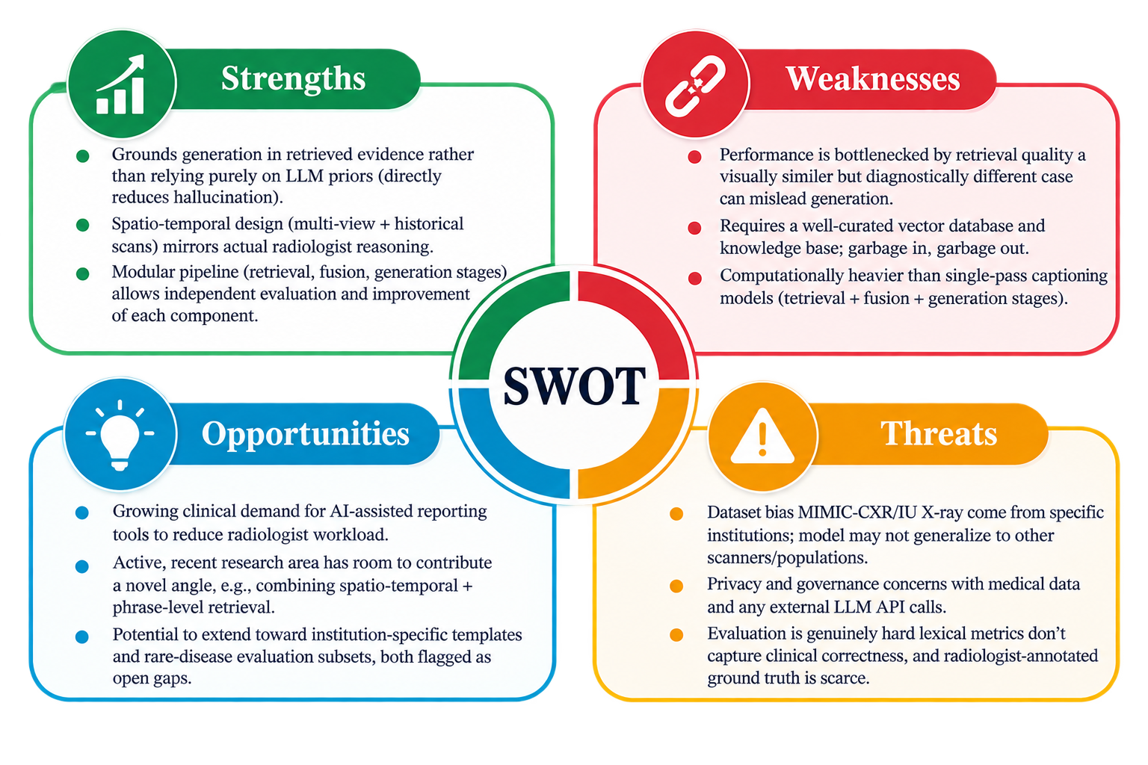
Table 2. SWOT summary of the proposed multimodal retrieval-augmented approach.

Synthesis
The reviewed literature suggests three directions that directly motivate the proposed framework. First, retrieval quality must be treated as a measurable component rather than an implicit assumption. Second, multi-view and historical information should be represented explicitly because chest X-ray interpretation is not limited to a single image. Third, evaluation must extend beyond lexical overlap to clinical correctness and factuality. The proposed methodology combines these directions into a single framework while maintaining a strict evidence hierarchy in which the current study remains the primary source of findings.

3. Objectives
1) To design a multimodal retrieval-augmented generation framework that represents current and, where available, historical multi-view chest X-rays together with their associated radiology reports.
2) To develop a contrastive image-text alignment module so that matching image-report pairs are represented closely in a shared embedding space while mismatched pairs are separated.
3) To implement spatial fusion for multiple views and temporal fusion for genuinely available historical studies.
4) To construct a vector-indexed retrieval store capable of returning relevant prior cases, report evidence, and anatomical or clinical evidence for a new study.
5) To generate a grounded Findings and Impression report using retrieved evidence and a large language model, with explicit instructions to avoid unsupported claims.
6) To evaluate retrieval quality, language quality, clinical correctness and factuality, and to conduct ablation experiments to isolate the contribution of contrastive learning, retrieval, multi-view fusion and temporal information.

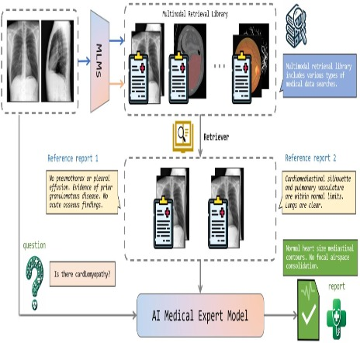

4. Methodology
The proposed methodology is organized into two connected stages: (i) multimodal knowledge-base construction and (ii) multimodal retrieval-augmented report generation. The first stage learns a shared representation from chest X-ray images and associated radiology text and stores the resulting joint multimodal embeddings in a vector database. The second stage processes a new case, constructs a multimodal query embedding, retrieves relevant evidence from the vector database, and supplies the retrieved evidence together with the current-case representation to a decoder/large language model for grounded report generation.
During knowledge-base construction, current chest X-ray studies and, where available, historical examinations containing frontal and lateral views will be organized at the study level. Images will be encoded using a selected medical vision transformer, and multi-view and historical information will be incorporated through spatial-temporal fusion. In parallel, associated radiology reports will be encoded using a medical language encoder to obtain text embeddings.
The visual and textual representations will be aligned using a contrastive learning objective so that matching image-report pairs occupy nearby positions in a shared embedding space while mismatched pairs are separated. The resulting joint multimodal embeddings, together with relevant study, view, anatomical and temporal metadata, will form the retrieval store.
For a new study, the available X-ray information and accompanying textual clinical context will be encoded using the same learned representation modules to form a multimodal query embedding. This query will be used to retrieve the most relevant cases and evidence from the vector database. Retrieved evidence will then be passed to the decoder/LLM together with the current multimodal representation to generate the structured Findings and Impression report.
The complete framework will be evaluated at four levels: retrieval quality, language quality, clinical correctness and factuality. Baseline and ablation experiments will isolate the contribution of contrastive alignment, retrieval, multi-view fusion and temporal information. The current examination will remain the primary evidence source, while historical and retrieved information will be treated as supporting context.

a) Reference Software Model
The reference software model is divided into two complementary pipelines. The first pipeline builds the multimodal vector database by encoding chest X-ray data and radiology text, applying spatial-temporal fusion and contrastive alignment, and storing joint multimodal embeddings. The second pipeline uses a new multimodal case to construct a query embedding, retrieve relevant evidence from the vector database, and generate a grounded report through a decoder/LLM. The two figures below represent these stages separately.
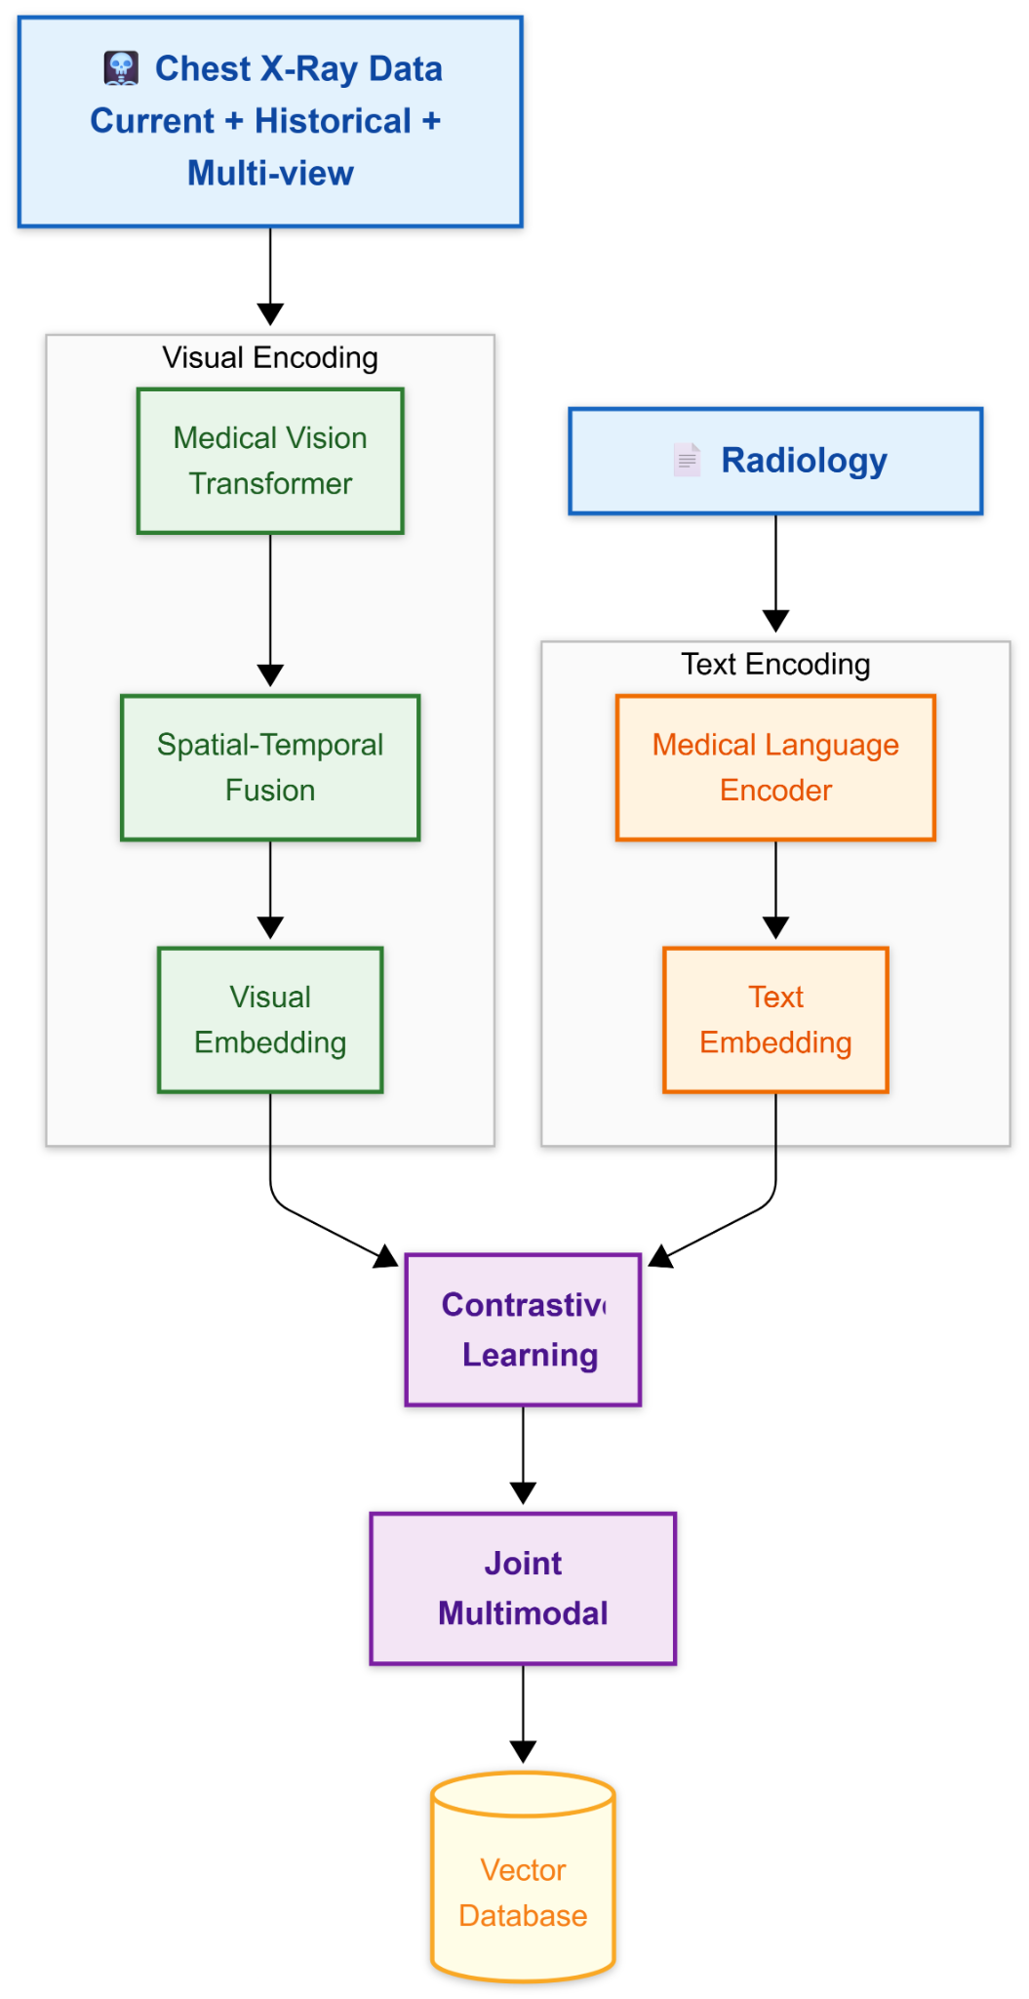
Figure 1. Multimodal knowledge-base and vector database construction pipeline.
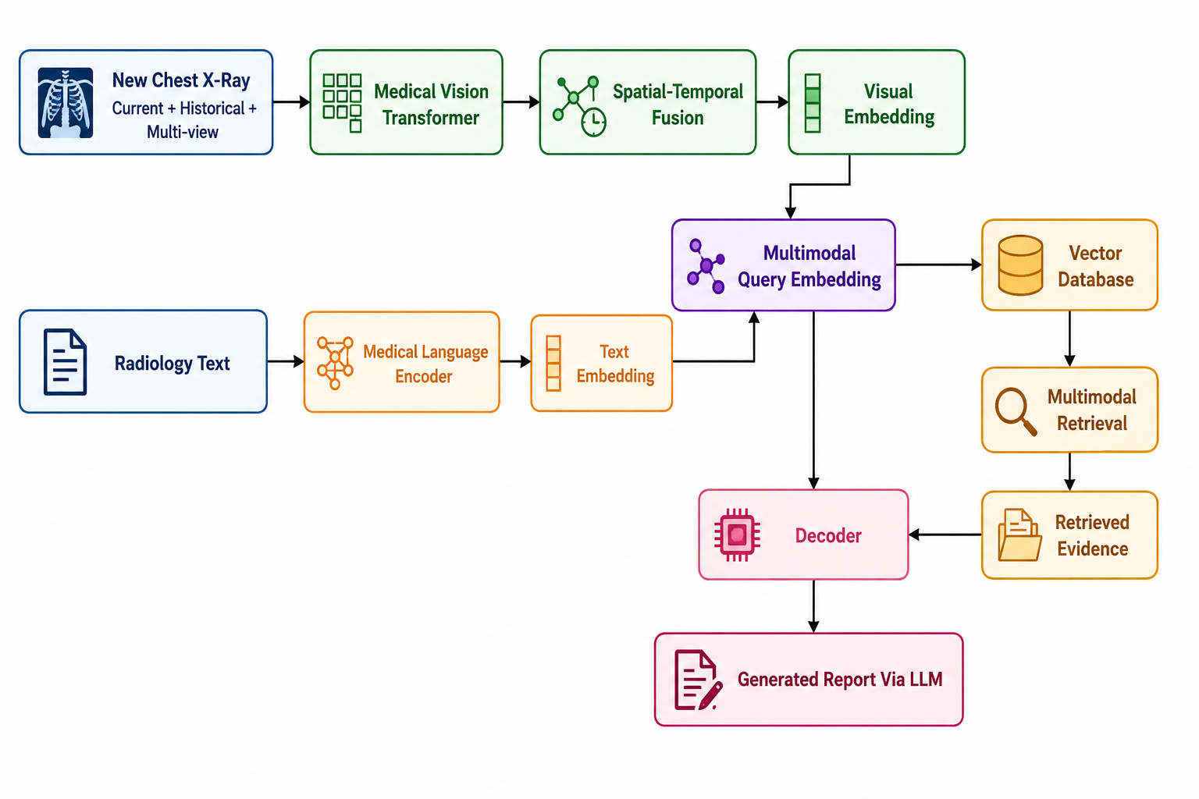
Figure 2. Multimodal retrieval and RAG-based report generation pipeline.

b) Steps
Step 1 – Acquire and organize data:
The selected datasets will be organized at the study level, linking each chest X-ray image with its associated report, view type, study identifier, study date and available historical examinations. Patient-level separation will be maintained across training, validation and testing to prevent information leakage. Each study will preserve the relationship between current images, multiple views and genuinely available prior examinations.
Step 2 – Preprocess images and metadata:
Images will be resized and normalized according to the selected medical vision encoder. View type, study identifier, study date and temporal relationships to available prior examinations will be recorded as metadata. Image augmentation will remain conservative because excessive geometric or intensity transformations may alter clinically meaningful radiographic features.
Step 3 – Encode chest X-ray images:
Each image will be passed through the selected pretrained medical vision transformer to obtain a visual representation. Where intermediate patch-level representations are available, they may be retained for fine-grained visual or anatomical retrieval. Images from the same study will remain separately identifiable before multi-view and temporal fusion.
Step 4 – Fuse multiple views and historical studies:
Frontal and lateral views belonging to the same study will be combined into a study-level visual representation using a lightweight fusion mechanism such as feature concatenation followed by projection or attention-based fusion. Historical examinations, when genuinely available, will be incorporated as optional temporal context. If only one view or no prior study exists, the framework will fall back to the available information without fabricating missing observations.
Step 5 – Encode radiology reports and text:
The Findings and Impression sections of the associated radiology reports will be encoded using a medical language encoder to obtain text embeddings. Where available, structured anatomical or clinical entities may also be retained as supporting evidence and metadata. Historical reports will be associated with their corresponding examination dates so that they can be distinguished from the current study.
Step 6 – Learn a joint multimodal representation:
A contrastive CLIP/InfoNCE-style objective will align the visual representation of a study with its corresponding text representation. Matching image-report pairs will be pulled closer in the shared embedding space, while mismatched pairs will be pushed apart. Hard negatives may be introduced using visually or anatomically similar cases with different clinical findings to improve discrimination between clinically distinct cases.
Step 7 – Construct the vector database:
The learned joint multimodal embeddings will be indexed using a vector-search system, with FAISS serving as the initial prototype retrieval implementation. Each indexed item will retain the associated evidence and metadata, including study identifier, view type, anatomical information and temporal information. Training, validation and test partitions will remain strictly separated during indexing to prevent retrieval leakage.
Step 8 – Construct the multimodal query and retrieve evidence:
For a new study, the available chest X-ray information is encoded through the trained vision pipeline, while the available textual clinical context is encoded through the medical language encoder. These representations are combined to form a multimodal query embedding. The query is compared against the joint multimodal embeddings stored in the vector database, and the most relevant prior cases and evidence are retrieved using similarity-based search. Retrieval quality will be measured independently using Recall@K, Precision@K and Mean Reciprocal Rank (MRR).
Step 9 – Generate the grounded report:
The current multimodal query representation and the retrieved evidence will be supplied to the decoder/large language model through a retrieval-augmented prompt. The prompt will explicitly distinguish observations supported by the current examination from historical and retrieved supporting evidence. The intended evidence priority is: current visual evidence > legitimately available historical evidence > retrieved similar cases > general clinical knowledge. The generated output will contain Findings followed by Impression.
Step 10 – Evaluate the complete system:
The proposed system will be evaluated at retrieval, language, clinical and factuality levels. Retrieval metrics will determine whether relevant evidence is returned, language metrics will assess similarity to reference reports, and clinical metrics will assess correctness of findings. Unsupported claims and hallucinations will be analyzed at the clinical-claim level to determine whether generated statements are supported by the current examination or by legitimately available supporting evidence.

Evaluation Framework
Level | Guiding Question | Representative Metrics
Retrieval | Is relevant evidence retrieved? | Recall@K, Precision@K, MRR
Language | How closely does the generated report match reference text? | BLEU, ROUGE-L, METEOR, BERTScore
Clinical | Are reported findings clinically correct? | CheXbert F1, RadGraph F1, expert review; optionally RadCliQ
Factuality | Does the generated report remain grounded in available evidence? | Hallucination rate, unsupported-claim rate, expert factuality assessment

Baseline and Ablation Experiments
Experiment | Configuration
B0 – Generation-only baseline | Current image → report generator, without retrieval.
B1 – Independent retrieval | Separate image/text embeddings with retrieval.
B2 – Contrastive retrieval | Joint image-text embeddings learned using contrastive learning.
B3 – RAG baseline | Contrastive retrieval + retrieved evidence + LLM generation.
B4 – Multi-view RAG | B3 + frontal/lateral view fusion.
B5 – Temporal RAG | B3 + historical-study information.
B6 – Full proposed framework | Contrastive retrieval + RAG + multi-view + temporal fusion.

These controlled experiments will be performed on the same evaluation set and under the same evaluation protocol. The comparisons will determine whether contrastive alignment improves retrieval quality, whether retrieval reduces unsupported findings, whether multi-view fusion improves clinical correctness, whether historical information improves interval-change reasoning, and whether the complete framework improves over a generation-only baseline.

c) Timeline
The project timeline will follow the approved activity chart prepared for the major project. The final timeline figure will be inserted in this section without modifying its task sequence. The planned workflow progresses from dataset preparation and literature review through multimodal representation learning, vector-database construction, retrieval and report generation, multi-view and temporal fusion, evaluation, ablation studies and final documentation.

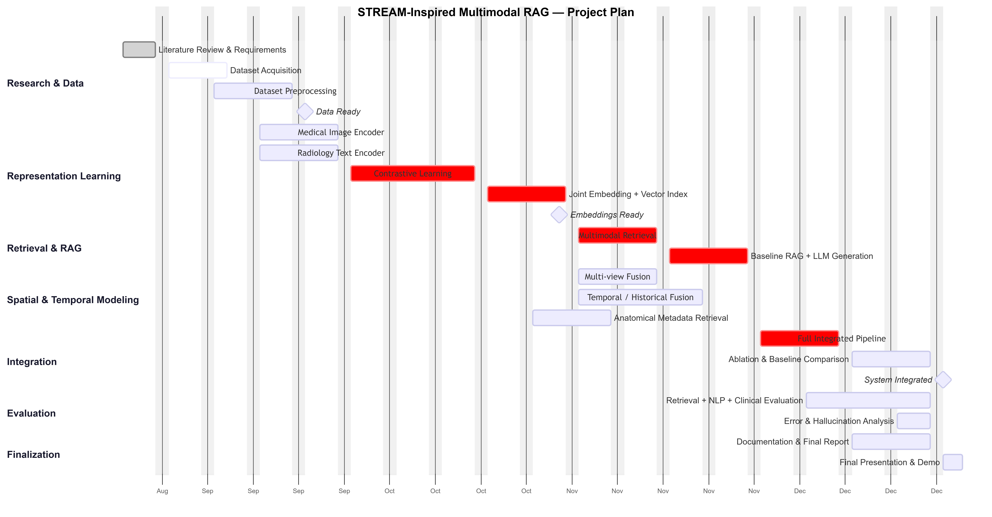

Figure 3. Project timeline / activity chart.

5. References
Chen, Z., Song, Y., Chang, T.-H., & Wan, X. (2020). Generating radiology reports via memory-driven Transformer. In Proceedings of the 2020 Conference on Empirical Methods in Natural Language Processing (EMNLP) (pp. 1439–1449). Association for Computational Linguistics. https://doi.org/10.18653/v1/2020.emnlp-main.112
Hyland, S. L., Bannur, S., Bouzid, K., Castro, D. C., Ranjit, M., Schwaighofer, A., Pérez-García, F., Salvatelli, V., Srivastav, S., Thieme, A., Codella, N., Lungren, M. P., Wetscherek, M. T., Oktay, O., & Alvarez-Valle, J. (2024). MAIRA-1: A specialised large multimodal model for radiology report generation. arXiv. https://arxiv.org/abs/2311.13668
Jeong, J., Tian, K., Li, A., Hartung, S., Adithan, S., Behzadi, F., Calle, J., Osayande, D., Pohlen, M., & Rajpurkar, P. (2024). Multimodal image-text matching improves retrieval-based chest X-ray report generation. Medical Imaging with Deep Learning, 227, 978–990. https://proceedings.mlr.press/v227/jeong24a.html
Johnson, A. E. W., Pollard, T. J., Berkowitz, S. J., Greenbaum, N. R., Lungren, M. P., Deng, C.-Y., Mark, R. G., & Horng, S. (2019). MIMIC-CXR, a de-identified publicly available database of chest radiographs with free-text reports. Scientific Data, 6, 317. https://doi.org/10.1038/s41597-019-0322-0
Lee, S., Youn, J., Kim, H., Kim, M., & Yoon, S. H. (2023). CXR-LLAVA: A multimodal large language model for interpreting chest X-ray images. arXiv. https://arxiv.org/abs/2310.18341
Park, J., Yoon, B., Kim, S., & Choi, K. (2026). RA-RRG: Multimodal retrieval-augmented radiology report generation with key phrase extraction. In Findings of the Association for Computational Linguistics: ACL 2026 (pp. 5029–5048). Association for Computational Linguistics. https://doi.org/10.18653/v1/2026.findings-acl.247
Ranjit, M., Ganapathy, G., Manuel, R., & Ganu, T. (2023). Retrieval augmented chest X-ray report generation using OpenAI GPT models. arXiv. https://arxiv.org/abs/2305.03660
Yang, Y., You, X., Zhang, K., Fu, Z., Wang, X., Ding, J., Sun, J., Yu, Z., Huang, Q., Han, W., & Yu, J. (2025). Spatio-temporal and retrieval-augmented modeling for chest X-ray report generation. IEEE Transactions on Medical Imaging, 44(7), 2892–2905. https://doi.org/10.1109/TMI.2025.3554498
Yu, F., Endo, M., Krishnan, R., Pan, I., Tsai, A., Reis, E. P., Fonseca, E. K. U. N., Lee, H. M. H., Abad, Z. S. H., Ng, A. Y., Langlotz, C. P., Venugopal, V. K., & Rajpurkar, P. (2023). Evaluating progress in automatic chest X-ray radiology report generation. Patterns, 4(9), 100802. https://doi.org/10.1016/j.patter.2023.100802

