**Home.html**

<!doctype html>

<html>

<head>

<meta charset="utf-8">

<title>Home</title>

</head>

<body>

<h1 align="center"><u><i>TOURISM GUIDE TO INDIA AND FRANCE</i></u></h1>

<br>

<table border="1" align="center">

<tr>

<td><a href="Home.html">HOME</a></td>

<td><a href="introduction.html">INTRODUCTION</a></td>

<td><a href="moreinfo.html">GALLERY & INFO</a></td>

</tr>

</table>

<br><br>

<table border="1" align="center">

<td>

<u>Main Places in Visit</u>

<br><br><br>

<br><u>TAJ MAHAL</u><br>

<img src="images/tajmahal1.jpg" width="250px"><br>

<br>

<img src="images/tajmahal2.jpg" width="250px"><br>

<br><br><br><br>

<br><u>EIFFEL TOWER</u><br>

<img src="images/eiffeltower1.jpg" width="250px"><br>

<br>

<img src="images/eiffeltower2.jpg" width="250px"><br>

</td>

<td>

<h2 align="center">India</h2>

<br><br>

India, is a country in South Asia. It is the second-most populous country, the seventh-largest country by land area, and

the most populous democracy in the world. Bounded by the Indian Ocean on the south,

the Arabian Sea on the southwest, and the Bay of Bengal on the southeast, it shares land borders with Pakistan to the west;China,

Nepal, and Bhutan to the north; and Bangladesh and Myanmar to the east. In the Indian Ocean,

India is in the vicinity of Sri Lanka and the Maldives; its Andaman and Nicobar Islands share a maritime border with

Thailand, Myanmar and Indonesia.

<br><br><br>

<h3 align="center">Agra</h3>

<br>

Agra is a city on the banks of the Yamuna river in the Indian state of Uttar Pradesh, about 210 kilometres (130 mi) south of the national

capital New Delhi. With a population of roughly 1.6 million, Agra is the fourth-most populous city in Uttar Pradesh and twenty-third most

populous city in India.

Agra's notable historical period began during Sikandar Lodi's reign, but the golden age of the city began with the Mughals. Agra was the foremost

city of the Indian subcontinent and the capital of the Mughal Empire under Mughal emperors Babur, Humayun, Akbar, Jahangir and Shah Jahan. Under

Mughal rule, Agra became a centre for learning, arts, commerce, and religion, and saw the construction of the Agra Fort, Sikandra and Agra's most

prized monument, the Taj Mahal, built by Shah Jahan as a mausoleum for his favourite empress. With the decline of the Mughal empire in the late

18th century, the city fell successively first to Marathas and later to the East India Company. After Independence, Agra has developed into an

industrial town, with a booming tourism industry, along with footwear, leather and other manufacturing. The Taj Mahal and the Agra Fort are UNESCO

World Heritage Sites. The city features mild winters, hot and dry summers and a monsoon season, and is famous for its Mughlai cuisine. Agra is

included on the Golden Triangle tourist circuit, along with Delhi and Jaipur; and the Uttar Pradesh Heritage Arc, a tourist circuit of Uttar Pradesh,

along with Lucknow and Varanasi.

<br><br>

<h3 align="center">10 Reasons to visit India</h3><br>

<ul>

<li>The Historical Gem</li>

<li>Vibrant Culture</li>

<li>Land Of Peace & Spirituality</li>

<li>The Natural Paradise</li>

<li>The Best In Hospitality</li>

<li>An Adventurer’s Resort</li>

<li>Fairyland Of Boundless Festivals</li>

<li>Kingdom Of Luxury</li>

<li>Heart Of Performing Arts</li>

<li>The Shopaholic’s Favorite</li>

</ul>

<br><br><br><br>

<a href="homeparis.html">Click here for France</a>

</td>

</table>

</body>

</html>

**Homeparis.html**

<!doctype html>

<html>

<head>

<meta charset="utf-8">

<title>Home</title>

</head>

<body>

<h1 align="center"><u><i>TOURISM GUIDE TO INDIA AND FRANCE</i></u></h1>

<br>

<table border="1" align="center">

<tr>

<td><a href="Home.html">HOME</a></td>

<td><a href="introduction.html">INTRODUCTION</a></td>

<td><a href="moreinfo.html">GALLERY & INFO</a></td>

</tr>

</table>

<br><br>

<table border="1" align="center">

<td>

<u>Main Places in Visit</u>

<br><br><br>

<br><u>TAJ MAHAL</u><br>

<img src="images/tajmahal1.jpg" width="250px"><br>

<br>

<img src="images/tajmahal2.jpg" width="250px"><br>

<br><br><br><br>

<br><u>EIFFEL TOWER</u><br>

<img src="images/eiffeltower1.jpg" width="250px"><br>

<br>

<img src="images/eiffeltower2.jpg" width="250px"><br>

</td>

<td>

<h2 align="center">France</h2>

<br><br>

France is a transcontinental country spanning Western Europe and several overseas regions and territories. Its metropolitan area extends from the Rhine to the Atlantic Ocean and from the Mediterranean Sea to the English Channel and the North Sea; overseas territories include French Guiana in South America and several islands in the Atlantic, Pacific and Indian Oceans. France borders Belgium, Luxembourg, and Germany to the northeast, Switzerland, Monaco and Italy to the east, Andorra and Spain to the south, as well as the Netherlands, Suriname, and Brazil in the Americas. Its eighteen integral regions (five of which are overseas) span a combined area of 643,801 km2 (248,573 sq mi) and over 67 million people (as of May 2021).[12] France is a unitary semi-presidential republic with its capital in Paris, the country's largest city and main cultural and commercial centre.

<br><br><br>

<h3 align="center">Paris</h3>

<br>

Paris is the capital and most populous city of France, with an estimated population of 2,175,601 residents as of 2018, in an area of more than 105 square kilometres (41 square miles).Since the 17th century, Paris has been one of Europe's major centres of finance, diplomacy, commerce, fashion, gastronomy, science, and arts. The City of Paris is the centre and seat of government of the region and province of Île-de-France, or Paris Region, which has an estimated population of 12,174,880, or about 18 percent of the population of France as of 2017.The Paris Region had a GDP of €709 billion ($808 billion) in 2017.[6] According to the Economist Intelligence Unit Worldwide Cost of Living Survey in 2018, Paris was the second most expensive city in the world, after Singapore and ahead of Zürich, Hong Kong, Oslo, and Geneva.Another source ranked Paris as most expensive, on a par with Singapore and Hong Kong, in 2018.

Paris received 38 million visitors in 2019, measured by hotel stays, with the largest numbers of foreign visitors coming from the United States, the United Kingdom, Germany, and China.s It was ranked as the second-most-visited travel destination in the world in 2019, after Bangkok and just ahead of London. Due to the city's international recognition, a number of places around the world, such as Bucharest and Leipzig, have been nicknamed Little Paris.

<br><br>

10 Reasons to visit France<br>

<ul>

<li>Incredible cities</li>

<li>Picturesque villages</li>

<li>World-known culture, art, and cinema</li>

<li>Old Architecture </li>

<li>Amazing French food</li>

<li>The café culture</li>

<li>Worldpackers experiences</li>

<li>Shopping opportunities</li>

<li>Shopping opportunities</li>

<li>The mountains (and some excellent skiing)</li>

</ul>

<a href="homeparis.html">Click here to go back to India</a>

</td>

</table>

</body>

</html>

**Introduction.html**

<!doctype html>

<html>

<head>

<meta charset="utf-8">

<title>Introduction</title>

</head>

<body>

<h1 align="center"><u><i>TOURISM GUIDE TO INDIA AND FRANCE</i></u></h1>

<br>

<table border="1" align="center">

<tr>

<td><a href="Home.html">HOME</a></td>

<td><a href="introduction.html">INTRODUCTION</a></td>

<td><a href="moreinfo.html">GALLERY & INFO</a></td>

</tr>

</table>

<br><br>

<table border="1" align="center">

<td>

<u>Main Places in Visit</u>

<br><br><br>

<br><u>TAJ MAHAL</u><br>

<img src="images/tajmahal1.jpg" width="250px"><br>

<br>

<img src="images/tajmahal2.jpg" width="250px"><br>

<br><br><br><br>

<br><u>EIFFEL TOWER</u><br>

<img src="images/eiffeltower1.jpg" width="250px"><br>

<br>

<img src="images/eiffeltower2.jpg" width="250px"><br>

</td>

<td>

<h2 align="center">Taj Mahal</h2>

<br>

An immense mausoleum of white marble, built in Agra between 1631 and 1648 by order of the Mughal emperor Shah Jahan in memory of his favourite wife, the Taj Mahal is the jewel of Muslim art in India and one of the universally admired masterpieces of the world's heritage.<br>

The Taj Mahal is an ivory-white marble mausoleum on the southern bank of the river Yamuna in the Indian city of Agra. It was commissioned in 1632 by the Mughal emperor Shah Jahan (reigned from 1628 to 1658) to house the tomb of his favourite wife, Mumtaz Mahal; it also houses the tomb of Shah Jahan himself. The tomb is the centrepiece of a 17-hectare (42-acre) complex, which includes a mosque and a guest house, and is set in formal gardens bounded on three sides by a crenellated wall.

<br>

The Taj Mahal was designated as a UNESCO World Heritage Site in 1983 for being "the jewel of Muslim art in India and one of the universally admired masterpieces of the world's heritage". It is regarded by many as the best example of Mughal architecture and a symbol of India's rich history. The Taj Mahal attracts 7–8 million visitors a year and in 2007, it was declared a winner of the New 7 Wonders of the World (2000–2007) initiative.

<br><br>

<h4>History</h4>

The plans for the complex have been attributed to various architects of the period, though the chief architect was probably Ustad Aḥmad Lahawrī, an Indian of Persian descent. The five principal elements of the complex—main gateway, garden, mosque, jawāb (literally “answer”; a building mirroring the mosque), and mausoleum (including its four minarets)—were conceived and designed as a unified entity according to the tenets of Mughal building practice, which allowed no subsequent addition or alteration. Building commenced about 1632. More than 20,000 workers were employed from India, Persia, the Ottoman Empire, and Europe to complete the mausoleum itself by about 1638–39; the adjunct buildings were finished by 1643, and decoration work continued until at least 1647. In total, construction of the 42-acre (17-hectare) complex spanned 22 years.<br>

A tradition relates that Shah Jahān originally intended to build another mausoleum across the river to house his own remains. That structure was to have been constructed of black marble, and it was to have been connected by a bridge to the Taj Mahal. He was deposed in 1658 by his son Aurangzeb, however, and was imprisoned for the rest of his life in Agra Fort.

<h4>Design and Construction</h4>

Named the Taj Mahal in honor of Mumtaz Mahal, the mausoleum was constructed of white marble inlaid with semi-precious stones (including jade, crystal, lapis lazuli, amethyst and turquoise) forming intricate designs in a technique known as pietra dura.<br>

Its central dome reaches a height of 240 feet (73 meters) and is surrounded by four smaller domes; four slender towers, or minarets, stood at the corners. In accordance with the traditions of Islam, verses from the Quran were inscribed in calligraphy on the arched entrances to the mausoleum, in addition to numerous other sections of the complex.<br>

Inside the mausoleum, an octagonal marble chamber adorned with carvings and semi-precious stones housed the cenotaph, or false tomb, of Mumtaz Mahal. The real sarcophagus containing her actual remains lay below, at garden level.<br>

The rest of the Taj Mahal complex included a main gateway of red sandstone and a square garden divided into quarters by long pools of water, as well as a red sandstone mosque and an identical building called a jawab (or “mirror”) directly across from the mosque. Traditional Mughal building practice would allow no future alterations to be made to the complex.

<a href="introduction2.html"><h3>Next Page</h3></a>

</td>

</table>

</body>

</html>

**Introduction2.html**

<!doctype html>

<html>

<head>

<meta charset="utf-8">

<title>Introduction</title>

</head>

<body>

<h1 align="center"><u><i>TOURISM GUIDE TO INDIA AND FRANCE</i></u></h1>

<br>

<table border="1" align="center">

<tr>

<td><a href="Home.html">HOME</a></td>

<td><a href="introduction.html">INTRODUCTION</a></td>

<td><a href="moreinfo.html">GALLERY & INFO</a></td>

</tr>

</table>

<br><br>

<table border="1" align="center">

<td>

<u>Main Places in Visit</u>

<br><br><br>

<br><u>TAJ MAHAL</u><br>

<img src="images/tajmahal1.jpg" width="250px"><br>

<br>

<img src="images/tajmahal2.jpg" width="250px"><br>

<br><br><br><br>

<br><u>EIFFEL TOWER</u><br>

<img src="images/eiffeltower1.jpg" width="250px"><br>

<br>

<img src="images/eiffeltower2.jpg" width="250px"><br>

</td>

<td>

<h2 align="center">Eiffel Tower</h2>

<br>

The Eiffel Tower is a wrought-iron lattice tower on the Champ de Mars in Paris, France. It is named after the engineer Gustave Eiffel, whose company designed and built the tower.<br>

Locally nicknamed "La dame de fer" (French for "Iron Lady"), it was constructed from 1887 to 1889 as the entrance to the 1889 World's Fair and was initially criticised by some of France's leading artists and intellectuals for its design, but it has become a global cultural icon of France and one of the most recognisable structures in the world. The Eiffel Tower is the most-visited paid monument in the world; 6.91 million people ascended it in 2015.<br>

The tower is 324 metres (1,063 ft) tall, about the same height as an 81-storey building, and the tallest structure in Paris. Its base is square, measuring 125 metres (410 ft) on each side. During its construction, the Eiffel Tower surpassed the Washington Monument to become the tallest man-made structure in the world, a title it held for 41 years until the Chrysler Building in New York City was finished in 1930. It was the first structure in the world to surpass both the 200 meter and 300 meter mark in height. Due to the addition of a broadcasting aerial at the top of the tower in 1957, it is now taller than the Chrysler Building by 5.2 metres (17 ft). Excluding transmitters, the Eiffel Tower is the second tallest free-standing structure in France after the Millau Viaduct.

<br><br>

<h4>History</h4>

The design of the Eiffel Tower is attributed to Maurice Koechlin and Émile Nouguier, two senior engineers working for the Compagnie des Établissements Eiffel. It was envisioned after discussion about a suitable centrepiece for the proposed 1889 Exposition Universelle, a world's fair to celebrate the centennial of the French Revolution. Eiffel openly acknowledged that inspiration for a tower came from the Latting Observatory built in New York City in 1853.In May 1884, working at home, Koechlin made a sketch of their idea, described by him as "a great pylon, consisting of four lattice girders standing apart at the base and coming together at the top, joined together by metal trusses at regular intervals". Eiffel initially showed little enthusiasm, but he did approve further study, and the two engineers then asked Stephen Sauvestre, the head of company's architectural department, to contribute to the design. Sauvestre added decorative arches to the base of the tower, a glass pavilion to the first level, and other embellishments.<br>

<h4>Design and Construction</h4>

The plan to build a tower 300 metres high was conceived as part of preparations for the World's Fair of 1889.<br>

The wager was to "study the possibility of erecting an iron tower on the Champ-de-Mars with a square base, 125 metres across and 300 metres tall". Selected from among 107 projects, it was that of Gustave Eiffel, an entrepreneur, Maurice Koechlin and Emile Nouguier, both engineers, and Stephen Sauvestre, an architect, that was accepted.<br>

Emile Nouguier and Maurice Koechlin, the two chief engineers in Eiffel's company, had the idea for a very tall tower in June 1884. It was to be designed like a large pylon with four columns of lattice work girders, separated at the base and coming together at the top, and joined to each other by more metal girders at regular intervals.<br>

The tower project was a bold extension of this principle up to a height of 300 metres - equivalent to the symbolic figure of 1000 feet. On September 18 1884 Eiffel registered a patent "for a new configuration allowing the construction of metal supports and pylons capable of exceeding a height of 300 metres".<br>

In order to make the project more acceptable to public opinion, Nouguier and Koechlin commissioned the architect Stephen Sauvestre to work on the project's appearance.<br>

The assembly of the supports began on July 1, 1887 and was completed twenty-two months later.

<br>

All the elements were prepared in Eiffel’s factory located at Levallois-Perret on the outskirts of Paris. Each of the 18,000 pieces used to construct the Tower were specifically designed and calculated, traced out to an accuracy of a tenth of a millimetre and then put together forming new pieces around five metres each. A team of constructors, who had worked on the great metal viaduct projects, were responsible for the 150 to 300 workers on site assembling this gigantic erector set.<br>

<a href="introduction.html"><h3>Go Back</h3></a>

</td>

</table>

</body>

</html>

**Moreinfo.html**

<!doctype html>

<html>

<head>

<meta charset="utf-8">

<title>Gallery & Information</title>

</head>

<body>

<h1 align="center"><u><i>TOURISM GUIDE TO INDIA AND FRANCE</i></u></h1>

<br>

<table border="1" align="center">

<tr>

<td><a href="Home.html">HOME</a></td>

<td><a href="introduction.html">INTRODUCTION</a></td>

<td><a href="moreinfo.html">GALLERY & INFO</a></td>

</tr>

</table>

<br><br>

<table border="1" align="center">

<td>

<u>Main Places in Visit</u>

<br><br><br>

<br><u>TAJ MAHAL</u><br>

<img src="images/tajmahal1.jpg" width="250px"><br>

<br>

<img src="images/tajmahal2.jpg" width="250px"><br>

<br><br><br><br>

<br><u>EIFFEL TOWER</u><br>

<img src="images/eiffeltower1.jpg" width="250px"><br>

<br>

<img src="images/eiffeltower2.jpg" width="250px"><br>

</td>

<td>

<h2>Gallery</h2>

<img src="images/tm1.jpg" width="500px">

<img src="images/tm2.jpg" width="500px"><br>

<img src="images/tm3.jpg" width="500px"><br>

<br><br>

<img src="images/et1.jpg" width="500px">

<img src="images/et2.jfif" width="500px"><br>

<img src="images/et3.jpg" width="500px"><br>

<h2>For More Information Visit :</h2>

<a href="https://www.tajmahal.gov.in/">Official Site for Taj Mahal</a><br>

<a href="https://www.toureiffel.paris/en">Official Site for Eiffel Tower</a>

</td>

</table>

</body>

</html>

**Images**

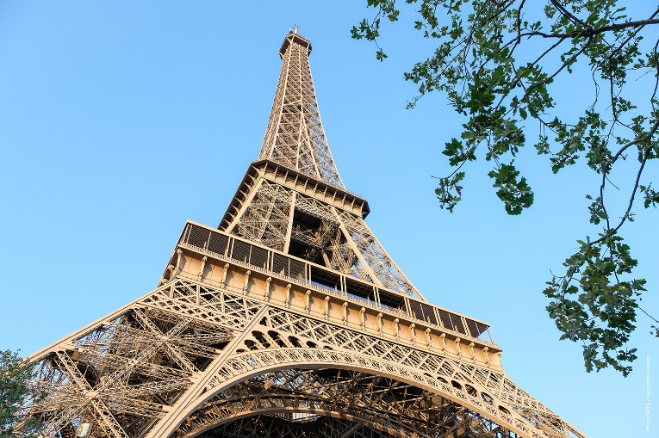 eiffeltower2.jpg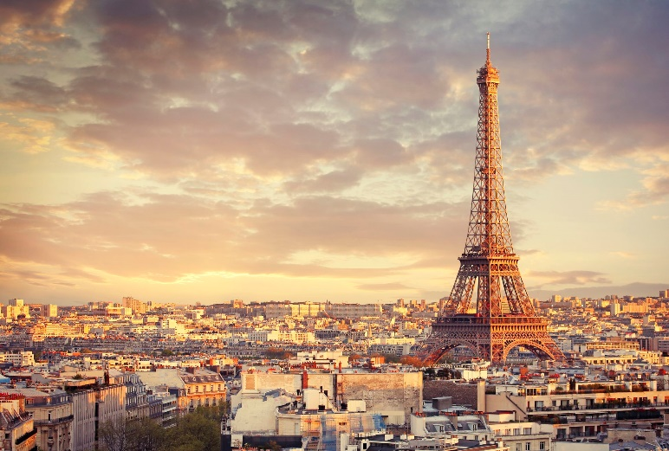 et1.jpg

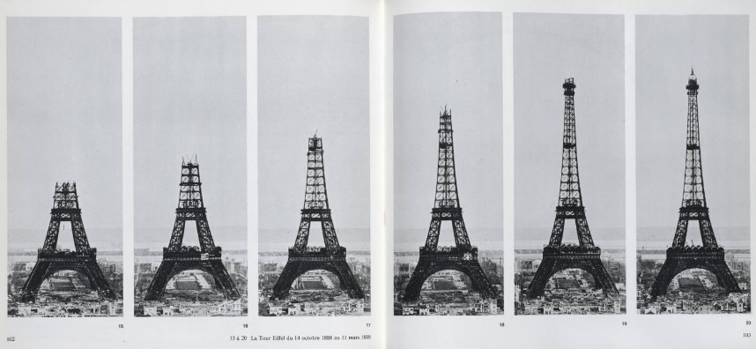 et3.jpg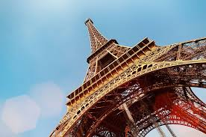 et2.jfif

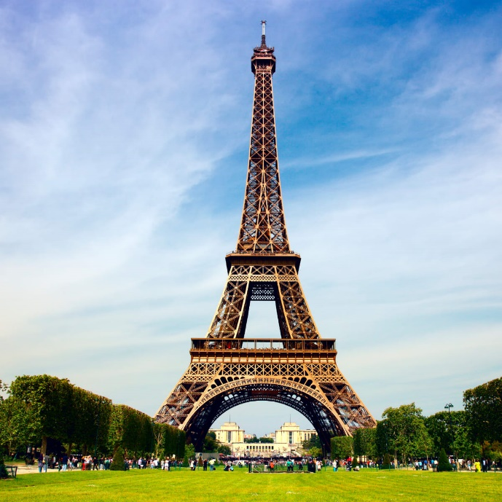 eiffeltower1.jpg

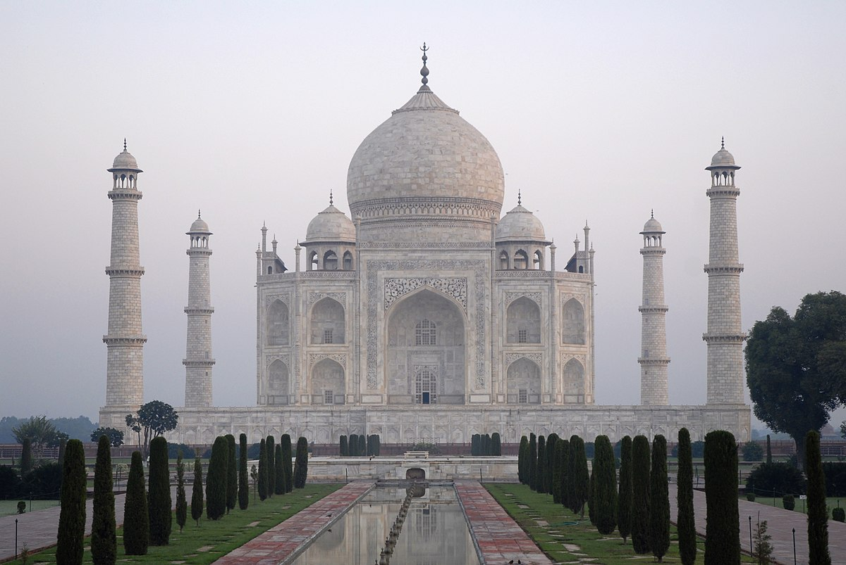 tajmahal1.jpg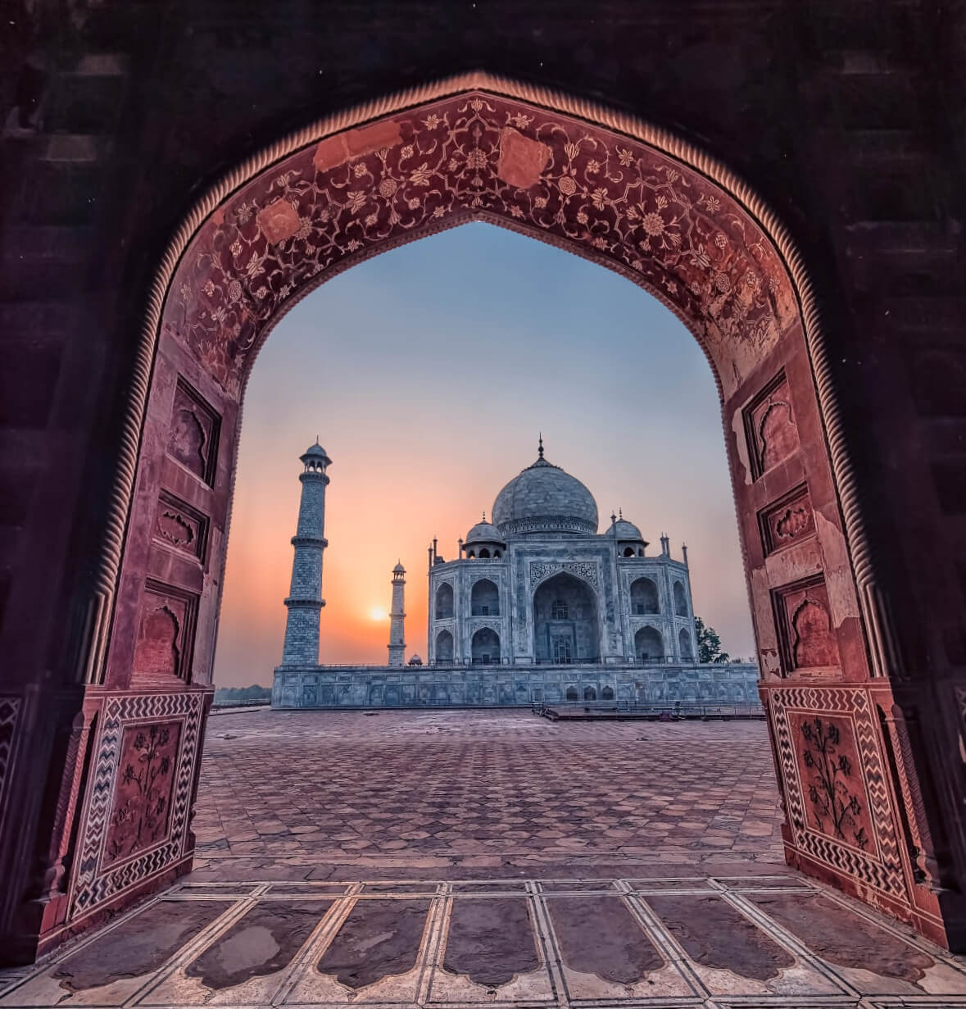 tajmahal2.jpg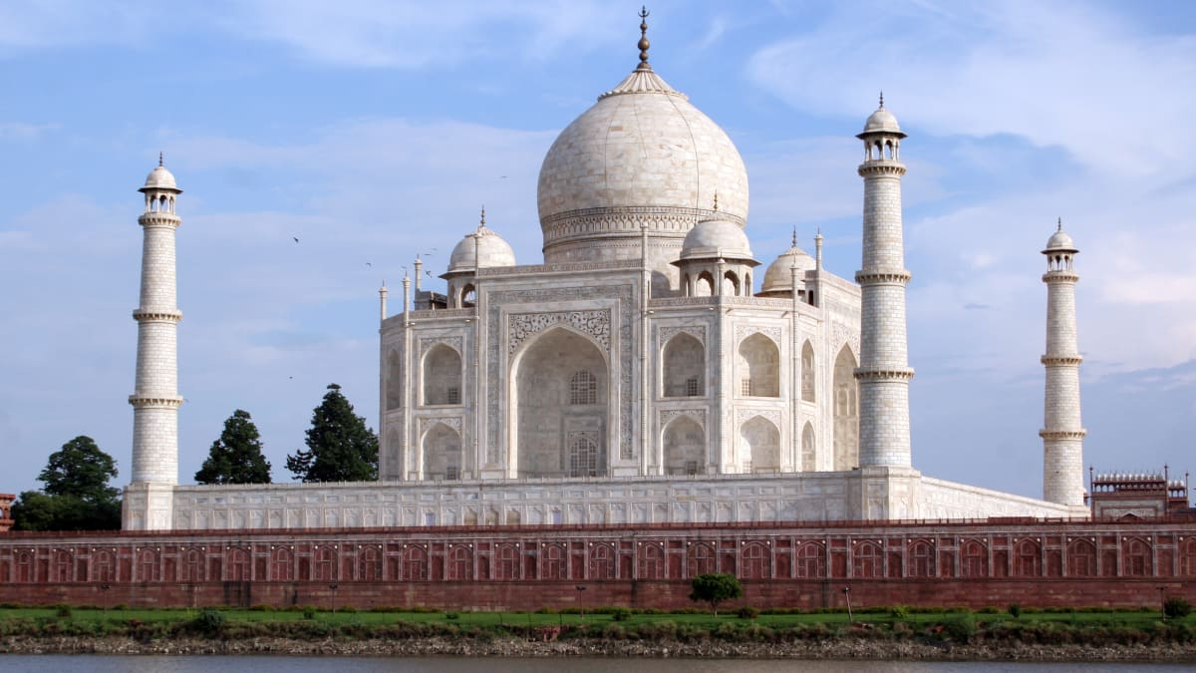 tm1.jpg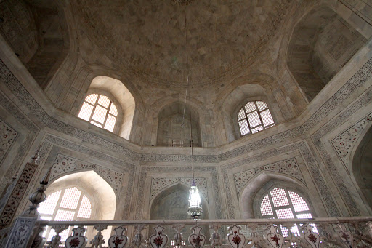 tm2.jpg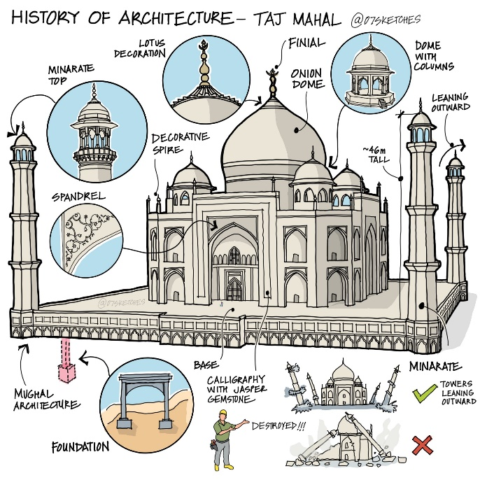tm3.jpg